Smart Electric Vehicle Charging Network Management Platform
Agile Sprint Planning and User Story Workshop

VOLTFlow OS
Sprint 1 Planning Document

A comprehensive Agile planning document covering project vision, stakeholders, epics, user stories, acceptance criteria, product backlog prioritization, Sprint 1 planning, story-point estimation, sprint goal, and expected deliverables.

Prepared By: S.Venkata Subhash Reddy
Reg.no: 192372195
CSA1012-Software Engineering
Guide : Dr.K.Anita Davaman
Date : August 10, 2026

Table of Contents & Document Roadmap
This Agile sprint planning report translates the VoltFlow OS Software Requirement Specification into an actionable first sprint. The planning approach retains the project's event-driven architecture, real-time telemetry, smart-grid load balancing, fault diagnostics, technician dispatch, responsive dashboard, security, OCPP interoperability, and scalability themes described in the supplied SRS.
- Chapter 1: Project Vision, Objectives & Stakeholder Identification
- Chapter 2: Product Scope, Agile Release Context & Definition of Done
- Chapter 3: Epics and User Story Workshop
- Chapter 4: Acceptance Criteria for Selected User Stories
- Chapter 5: Product Backlog Prioritization
- Chapter 6: Sprint 1 Backlog & Actionable Development Tasks
- Chapter 7: Story Point Estimation & Planning Poker Justification
- Chapter 8: Sprint Goal, Expected Deliverables & Success Measures
- Chapter 9: Sprint Risks, Dependencies & Review/Retrospective Plan
- Chapter 10: Rubrics for Calculation

Chapter 1: Project Vision, Objectives & Stakeholder Identification
VoltFlow OS is a Smart EV Charging Network Management Platform intended to improve the operational management of distributed EV charging infrastructure. The supplied SRS describes a decoupled platform with a React presentation layer, a Node.js/Express REST gateway, an IoT state-machine simulator, WebSocket telemetry, smart-grid load management, fault simulation, technician dispatch, security controls, OCPP 2.0.1 interoperability, and production-scale data infrastructure.

1.1 Project Vision
To provide charging-network operators with a responsive, real-time management platform that makes charger state, charging sessions, grid load, alerts, and maintenance activity visible and actionable, while protecting local grid capacity and supporting future integration with physical charging hardware.

1.2 Project Objectives
- Provide live visibility into stations, charger sockets, active charging sessions, alerts, and technicians.
- Transmit telemetry through persistent WebSocket connections so dashboard state updates without repeated polling.
- Model EV charging sessions using state-of-charge and charging-rate behavior described in the SRS.
- Prevent local grid overload by monitoring station demand and applying proportional throttling/load shedding.
- Detect and simulate charger faults, create maintenance alerts, and support technician dispatch workflows.
- Expose REST APIs for station telemetry, analytics, fault operations, EV arrival simulation, maintenance dispatch, and grid-spike control.
- Maintain a responsive operator dashboard suitable for desktop, tablet, and mobile layouts.
- Provide a foundation for production security, OCPP 2.0.1 integration, time-series telemetry storage, and Redis-based state caching.

1.3 Key Stakeholders
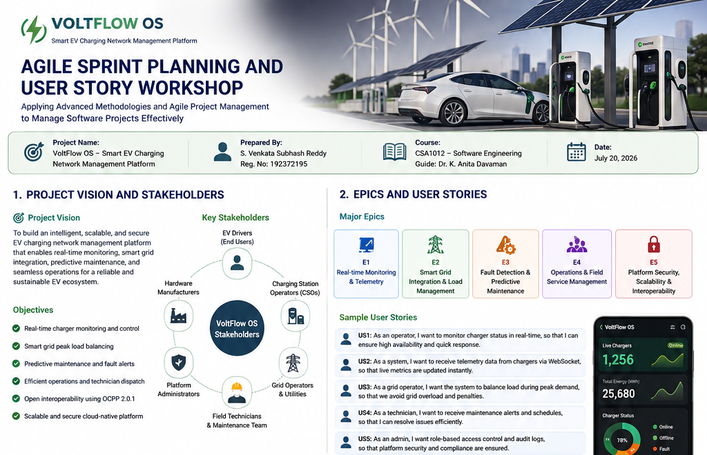
Figure: VoltFlow OS Project Vision, Stakeholders and Agile Epics visual summary.

Chapter 2: Product Scope, Agile Release Context & Definition of Done

2.1 Product Scope for the Agile Backlog
The backlog is derived from the supplied VoltFlow OS SRS. The first sprint focuses on the minimum operational path required to observe charger state in real time and manage basic charging/grid behavior. Later stories address advanced diagnostics, technician dispatch, responsive UI, security, OCPP integration, and production scaling.

2.2 Agile Release Themes
Release Theme | Representative Capability | Priority
Real-Time Operations | Station/socket telemetry, WebSocket INIT and UPDATE events | Very High
Charging Simulation | EV arrivals, SoC updates, charging curves and session metrics | High
Grid Protection | Capacity monitoring, load shedding and 30kW peak cap | Very High
Diagnostics & Maintenance | Fault generation, maintenance ticket, technician dispatch | High
Operator Experience | Dashboard, alerts, responsive layouts and operational color coding | High
Security | HTTPS/WSS, JWT, CORS restrictions and rate limiting | High
Interoperability | OCPP 2.0.1 charger messages and smart-charging profiles | Medium
Production Scale | Time-series database and Redis state caching | Medium

2.3 Definition of Ready
- User story has a clear user, feature, and business/operational benefit.
- Acceptance criteria are testable and understandable by development and testing roles.
- Dependencies and API/data requirements are identified.
- The story is small enough to complete within the sprint or is explicitly split.
- The team can estimate the story using a shared story-point scale.

2.4 Definition of Done
- Implementation is completed according to the selected acceptance criteria.
- REST/WebSocket behavior is tested for the affected workflow.
- Simulator state transitions and edge cases are verified where applicable.
- UI changes are connected to the required API/telemetry data where applicable.
- No known critical defect remains for the completed story.
- The feature is demonstrated as a working increment during Sprint Review.
- Relevant documentation or API notes are updated.

Chapter 3: Epics and User Story Workshop
The following epics decompose the SRS into user-centered capabilities. User stories use the required Agile form: As a <user>, I want <feature>, so that <benefit>.

3.1 Epic E1 – Real-Time Station & Charger Monitoring
ID | User Story | Priority
US-01 | As an operations operator, I want to view all active stations and charger socket states, so that I can identify available, charging, maintenance, and offline equipment. | Must Have
US-02 | As an operations operator, I want the dashboard to receive live charger telemetry, so that I can monitor network changes without manually refreshing the page. | Must Have
US-03 | As an operations operator, I want an initial complete state packet when I connect, so that the dashboard can render the current network state immediately. | Should Have

3.2 Epic E2 – EV Charging Session Simulation
ID | User Story | Priority
US-04 | As an operator, I want to simulate an EV arrival with vehicle name and battery capacity, so that I can test charging workflows without physical hardware. | Must Have
US-05 | As an operator, I want active sessions to update SoC, power draw, energy delivered, and cost, so that the simulator represents a realistic charging session. | Must Have
US-06 | As an operator, I want charging power to taper above 80% SoC, so that simulated behavior reflects the SRS charging model. | Should Have

3.3 Epic E3 – Smart Grid Load Management
ID | User Story | Priority
US-07 | As a grid-aware operator, I want total charger demand compared with the configured substation capacity, so that I can detect capacity pressure before an overload occurs. | Must Have
US-08 | As a grid operator, I want charger output throttled when demand exceeds capacity, so that the station remains within safe grid limits. | Must Have
US-09 | As an operator, I want peak alerts to cap fast-charger output at 30kW, so that grid spikes can be controlled while charging remains active. | Must Have

3.4 Epic E4 – Fault Diagnostics & Maintenance
ID | User Story | Priority
US-10 | As an operator, I want charger faults to create critical alerts and move the charger to Maintenance, so that unsafe or failed equipment is isolated. | Must Have
US-11 | As a dispatcher, I want to assign an available technician to a maintenance alert, so that faulty chargers can be restored quickly. | Should Have
US-12 | As a technician, I want my work status to move through Dispatched, On Site, and Resolved states, so that the operations center can track repair progress. | Should Have

Chapter 3: Epics and User Story Workshop (Continued)

3.5 Epic E5 – Operator Dashboard & Analytics
ID | User Story | Priority
US-13 | As an operations operator, I want operational alerts highlighted by state, so that faults, warnings, and charging activity can be scanned quickly. | Should Have
US-14 | As an operations manager, I want historical and forecasted demand data, so that I can understand network usage patterns. | Should Have
US-15 | As a field operator, I want the dashboard to adapt to mobile screens, so that I can use the management console while working away from a desktop. | Could Have

3.6 Epic E6 – Security & Administration
ID | User Story | Priority
US-16 | As a system administrator, I want administrative and dispatch endpoints protected by JWT authentication, so that only authorized users can issue operational commands. | Must Have
US-17 | As a system administrator, I want trusted-origin CORS controls and rate limiting, so that the API is protected from unauthorized cross-origin use and excessive requests. | Should Have
US-18 | As a system administrator, I want REST and WebSocket traffic secured using TLS, so that telemetry and commands are protected in transit. | Should Have

3.7 Epic E7 – OCPP Interoperability
ID | User Story | Priority
US-19 | As a charging-platform integrator, I want OCPP 2.0.1 BootNotification and Heartbeat support, so that physical chargers can register and maintain connectivity. | Could Have
US-20 | As a charging-platform integrator, I want StatusNotification and TransactionEvent messages handled, so that charger state and session information can enter the platform. | Could Have
US-21 | As a grid-aware operator, I want SetChargingProfile commands supported, so that smart charging can apply central power limits. | Could Have

3.8 Epic E8 – Production Scale Infrastructure
ID | User Story | Priority
US-22 | As a platform engineer, I want high-frequency telemetry stored in a time-series database, so that large telemetry volumes remain efficient to query. | Could Have
US-23 | As a platform engineer, I want active charger state cached in Redis, so that multiple backend instances can access current state quickly. | Could Have

Chapter 4: Acceptance Criteria for Selected User Stories
Sprint 1 selects the highest-value foundational stories. The acceptance criteria below use Given–When–Then statements so that each story can be demonstrated and tested objectively.

US-01: View station and socket states
- Given the backend contains active stations, when the operator opens the monitoring view, then the system displays the available station and socket telemetry.
- Given a socket state is Available, Charging, Maintenance, or Offline, when the state is rendered, then the corresponding operational state is visible.
- Given the station data is unavailable, when the operator requests station information, then the system returns a controlled error response.

US-02: Receive live telemetry
- Given a dashboard client is connected, when the simulator changes charger state, then the server broadcasts an update event to connected clients.
- Given an UPDATE message is received, when the client parses the JSON payload, then the affected dashboard values are refreshed without a full page reload.
- Given multiple clients are connected, when a telemetry update occurs, then each active client receives the update.

US-04: Simulate EV arrival
- Given an available charger socket, when the operator submits station, charger, vehicle name, and battery capacity, then a charging session is created.
- Given the target charger is unavailable, when an arrival is requested, then the API rejects the operation with a clear response.
- Given a valid session is created, when the next simulator tick runs, then the session appears in active telemetry.

US-05: Update charging session metrics
- Given an active charging session, when a simulator tick occurs, then SoC and energy-delivered values are updated.
- Given power is delivered during the session, when the billing calculation runs, then the accrued cost changes consistently with energy delivered.
- Given the target SoC is reached, when the simulator processes the session, then the charging session no longer continues beyond the target.

US-07: Monitor substation capacity
- Given multiple chargers are active, when total demand is calculated, then the platform computes aggregate charger power consumption.
- Given the configured capacity is 3300kW, when demand is compared with capacity, then the system identifies whether demand is within or above the limit.
- Given demand exceeds capacity, when the grid check runs, then an overload/peak condition becomes visible to the operator.

US-08: Apply proportional load shedding
- Given active demand exceeds configured capacity, when load balancing executes, then charger outputs are scaled using the capacity-to-demand relationship.
- Given demand is within capacity, when load balancing executes, then unnecessary throttling is not applied.
- Given throttling occurs, when the new values are broadcast, then clients receive the updated charger power levels.

US-09: Apply 30kW peak cap
- Given a grid peak alert is active, when fast-charger power is calculated, then no affected charger exceeds 30kW.
- Given the calculated charger output is below 30kW, when the cap is applied, then the lower value is retained.
- Given a peak alert is active, when the dashboard receives telemetry, then the grid warning state is visible.

US-10: Create fault alert and isolate charger
- Given a connector lock, temperature overload, or power converter fault is generated, when the simulator processes the fault, then the charging session is aborted.
- Given a fault is active, when charger state is updated, then the charger status becomes Maintenance.
- Given a critical fault occurs, when the alert is emitted, then the operations log/dashboard receives a critical alert.

US-03: Send initial state on WebSocket connection
- Given a client opens a WebSocket connection, when the server accepts the handshake, then the connection is stored as active.
- Given the connection is accepted, when initialization completes, then a complete state packet containing stations, alerts, technicians, gridAlertsActive, and history is sent.

Chapter 5: Product Backlog Prioritization
Backlog priority is based on business value, customer/operator need, architectural dependency, risk reduction, and the ability of a story to unlock later capabilities. The MoSCoW labels are used for product priority, while the numeric order indicates the recommended implementation sequence.
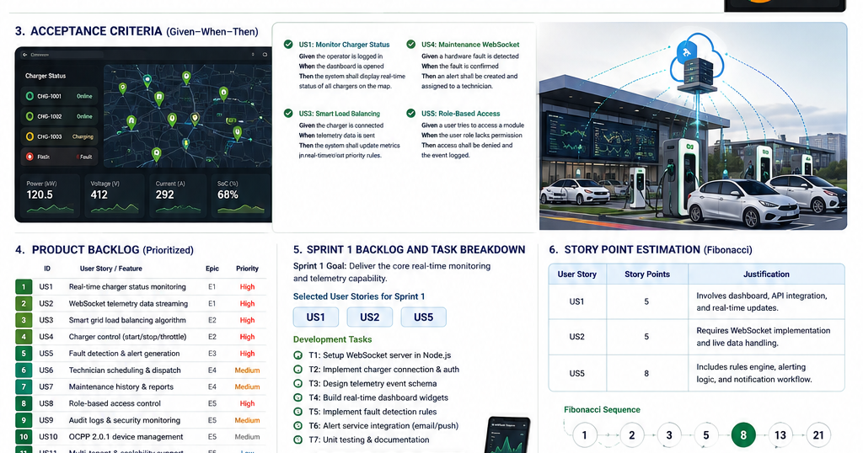
Figure: VoltFlow OS Product Backlog and Sprint 1 visual summary.

5.1 Sprint Selection Principle
Sprint 1 should establish a thin but demonstrable vertical slice: station state retrieval, WebSocket initialization and updates, EV session simulation, basic session telemetry, and grid-capacity monitoring. This sequence creates the operational data path required by later load-shedding, dashboard, diagnostics, and maintenance stories.

Chapter 6: Sprint 1 Backlog & Actionable Development Tasks

6.1 Sprint 1 Scope
Recommended Sprint duration: 2 weeks. The sprint is planned around a small cross-functional team capable of backend, frontend, simulation, testing, and documentation work. The sprint does not attempt to complete the full production system.
Story | Sprint Story | SP | Actionable Tasks
US-01 | Station/socket monitoring | 5 | Backend API, data model, UI state card, tests
US-03 | WebSocket INIT state | 3 | Connection handler, INIT payload, client parser, tests
US-02 | WebSocket live updates | 5 | Broadcast loop, UPDATE payload, UI refresh, tests
US-04 | EV arrival simulation | 3 | API route, validation, simulator session creation, tests
US-05 | Charging session metrics | 5 | Tick updates, SoC/energy/cost calculations, tests
US-07 | Substation capacity monitoring | 3 | Aggregate demand, capacity comparison, alert state, tests

6.2 Detailed Task Breakdown
Task | Description | Story | Role | Target
T01 | Inspect simulator state model and station/socket fields | US-01 | Backend | Day 1
T02 | Implement/verify GET /api/stations response | US-01 | Backend | Day 1
T03 | Build station/socket monitoring view | US-01 | Frontend | Days 2–3
T04 | Add WebSocket connection lifecycle and active-client registry | US-03 | Backend | Day 2
T05 | Construct INIT payload with stations, alerts, technicians, grid flag and history | US-03 | Backend | Day 3
T06 | Parse INIT payload and populate client state | US-03 | Frontend | Day 3
T07 | Broadcast UPDATE payload after simulator state changes | US-02 | Backend | Days 4–5
T08 | Refresh telemetry widgets from UPDATE events | US-02 | Frontend | Days 5–6
T09 | Add POST /api/iot/simulate-arrival validation | US-04 | Backend | Day 6
T10 | Create active session on selected charger | US-04 | Simulator | Day 7
T11 | Update SoC, power, energy and cost per simulation tick | US-05 | Simulator | Days 7–8
T12 | Display session telemetry in dashboard | US-05 | Frontend | Day 8
T13 | Aggregate active charger demand | US-07 | Backend | Day 9
T14 | Compare demand against configured substation threshold | US-07 | Backend | Day 9
T15 | Add automated tests for core acceptance criteria | US-01/02/03/04/05/07 | QA | Days 9–10
T16 | Sprint demo preparation and technical documentation | All | Team | Day 10

6.3 Sprint Dependency Flow
- US-01 establishes the station/socket data needed by the dashboard.
- US-03 must provide initial WebSocket state before continuous updates are useful.
- US-02 depends on the simulator producing state changes that can be serialized and broadcast.
- US-04 creates active charging sessions that supply data for US-05.
- US-05 provides charging metrics that can later feed analytics and dashboard visualizations.
- US-07 depends on charger power values and becomes the input for the later US-08/US-09 grid-control stories.

Chapter 7: Story Point Estimation & Planning Poker Justification
The Fibonacci sequence (1, 2, 3, 5, 8, 13) is used for relative story-point estimation. The team considers complexity, integration effort, uncertainty, testing effort, and dependency risk rather than treating points as hours. The selected Sprint 1 backlog totals 24 story points.

Figure: VoltFlow OS Sprint planning and Fibonacci estimation visual summary.

7.1 Sprint Capacity
Metric | Value
Sprint duration | 2 weeks / 10 working days
Selected stories | 6
Total story points | 24
Planning assumption | Small cross-functional student team with backend, frontend, simulator and testing capability
Commitment principle | Complete the highest-value vertical slice first; move lower-confidence work only if acceptance criteria remain achievable

7.2 Planning Poker Decision Logic
- 3 points: Small, well-bounded change with limited integration and predictable tests.
- 5 points: Multiple components or moderate uncertainty, especially when backend and frontend must coordinate.
- 8 points: Significant integration, infrastructure, or uncertainty; stories at this size are preferably split before Sprint 1.
- 13 points: Too large or uncertain for the first sprint and should normally be decomposed into smaller stories.

Chapter 8: Sprint Goal, Expected Deliverables & Success Measures

8.1 Sprint Goal
“Build a working real-time operational slice of VoltFlow OS that allows an operator to view charger states, receive live telemetry, simulate an EV charging session, observe charging metrics, and monitor aggregate station demand against grid capacity.”

8.2 Expected Sprint Deliverables
- Working station/socket monitoring through the station telemetry API.
- WebSocket connection lifecycle with an INIT state payload.
- WebSocket UPDATE messages that refresh live dashboard state.
- EV arrival simulation using the specified station, charger, vehicle name, and battery capacity inputs.
- Active session telemetry containing SoC, target SoC, power draw, energy delivered, and accrued cost.
- Aggregate charger demand calculation and comparison with a configured substation capacity.
- Automated/structured tests covering the acceptance criteria of selected stories.
- Sprint Review demonstration and updated technical documentation.

8.3 Sprint Success Measures
Measure | Target
Station visibility | All available station/socket telemetry can be retrieved and displayed.
Real-time update behavior | Connected dashboard clients receive simulator changes without manual refresh.
Session simulation | A valid simulated EV arrival produces an active charging session.
Charging telemetry | SoC, power, energy and cost change during simulator ticks.
Grid visibility | Aggregate active charger demand is calculated and compared with capacity.
Quality | All selected-story acceptance criteria are demonstrated or explicitly reported as incomplete.
Sprint outcome | A coherent, demonstrable vertical slice is available for Sprint Review.

8.4 Sprint Review Demonstration Sequence
- Open the operations dashboard and show current station/socket states.
- Connect a client and demonstrate the INIT payload populating the dashboard.
- Trigger a telemetry/state change and show the UPDATE event without page reload.
- Simulate an EV arrival and demonstrate creation of an active charging session.
- Allow simulator ticks to update SoC, power, energy and cost.
- Show aggregate charger demand and the configured substation capacity comparison.
- Explain which later backlog stories build on the completed Sprint 1 foundation.

Chapter 9: Sprint Risks, Dependencies & Review/Retrospective Plan

9.1 Sprint Risks
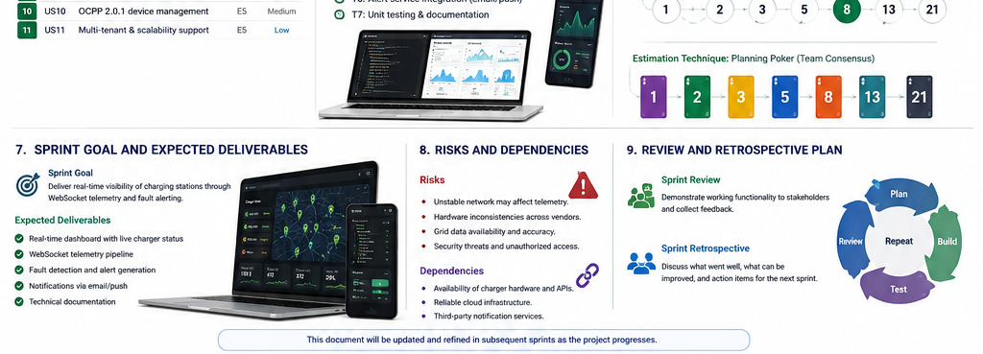
Figure: VoltFlow OS Sprint Goal, Risks, Dependencies, Review and Retrospective visual summary.

9.2 External / Technical Dependencies
- Node.js/Express backend must be available for REST and WebSocket work.
- The React/Vite client requires stable endpoint and message formats.
- The simulator must expose reliable station, charger, and session state before real-time UI stories can be verified.
- Later security and production deployment stories depend on the base API architecture established here.
- OCPP integration is a later-stage dependency and is not required to complete the Sprint 1 simulated-hardware slice.

9.3 Daily Scrum Focus
- What was completed since the previous meeting?
- What will be completed next?
- Is any dependency or blocker threatening the Sprint Goal?
- Are acceptance criteria or task estimates changing?

9.4 Sprint Retrospective Questions
- What helped the team deliver the real-time vertical slice?
- Where did backend/frontend/simulator integration create avoidable delays?
- Which acceptance criteria were most useful for identifying defects?
- Which stories should be split or re-estimated before the next sprint?
- What single process improvement will the team apply in Sprint 2?

Chapter 10: Rubrics for Calculation
Criteria | Excellent (5 Marks) | Good (3 Marks) | Satisfactory (2 Marks) | Needs Improvement (1 Mark)
Project Vision & Stakeholder Identification | Project vision is clear, comprehensive, and aligned with the problem statement. All relevant stakeholders and their roles are correctly identified. | Vision is clear with minor omissions. Most stakeholders are correctly identified. | Vision is partially defined. Some stakeholders are missing or incorrectly identified. | Vision is unclear or incomplete. Stakeholders are poorly identified or missing.
Epics & User Stories | Epics are well-defined and user stories are complete, follow Agile format, and fully capture functional requirements. | Epics and user stories are mostly complete with minor formatting or requirement issues. | User stories are partially complete with limited Agile structure. | User stories are incomplete, unclear, or do not follow Agile practices.
Acceptance Criteria | Acceptance criteria are specific, measurable, testable, and aligned with all user stories. | Acceptance criteria are mostly clear and testable with minor gaps. | Acceptance criteria are partially defined and lack clarity or completeness. | Acceptance criteria are missing or not aligned with user stories.
Product Backlog Prioritization & Sprint Planning | Product backlog is logically prioritized, sprint backlog is realistic, and task breakdown is complete. | Backlog prioritization and sprint planning are mostly appropriate with minor issues. | Prioritization or sprint planning is partially complete with limited justification. | Backlog prioritization and sprint planning are poorly organized or incomplete.
Story Point Estimation, Sprint Goal & Presentation | Story point estimation is well justified, sprint goal is clear, deliverables are realistic, and presentation is professional and well organized. | Estimation and sprint goal are mostly appropriate with minor inconsistencies. Presentation is clear. | Estimation or sprint goal lacks justification. Presentation is adequate but incomplete. | Estimation is unrealistic or missing. Sprint goal, deliverables, and presentation are unclear or incomplete.

10.1 Mark Allocation
Criteria | Mark
Project Vision & Stakeholder Identification | /5
Epics & User Stories | /5
Acceptance Criteria | /5
Product Backlog Prioritization & Sprint Planning | /5
Story Point Estimation, Sprint Goal & Presentation | /5
TOTAL | /25

Selected dense tables have been replaced with project-related visual figures to improve readability and reduce table-heavy pages. Detailed acceptance criteria, tasks, estimation rationale, risks, and rubric content remain in the document.

Conclusion
This Sprint 1 plan converts the supplied VoltFlow OS SRS into a practical Agile delivery increment. The plan prioritizes the real-time operational data path first because station state, WebSocket telemetry, charging-session simulation, and grid-demand visibility form the foundation for later load shedding, diagnostics, maintenance dispatch, security, OCPP interoperability, and production-scale infrastructure. The resulting backlog is measurable through explicit acceptance criteria and can be reviewed through a demonstrable Sprint Goal.

