SUJAL PAWAR (EXCS)

Cloud Computing Practical Examination
Prepared by: Imran Sayyed (Course Instructor)

Instructions
Perform all tasks using your Linux Virtual Machine.
Capture screenshots wherever required.
Store all shell scripts inside a folder named practical_exam.
Push all scripts and supporting files to a GitHub repository.
Submit a PDF report containing screenshots, outputs and GitHub repository URL.

Part A – Cloud & Linux VM Setup
Task 1: Create a Linux Virtual Machine with Public IP and SSH access enabled.
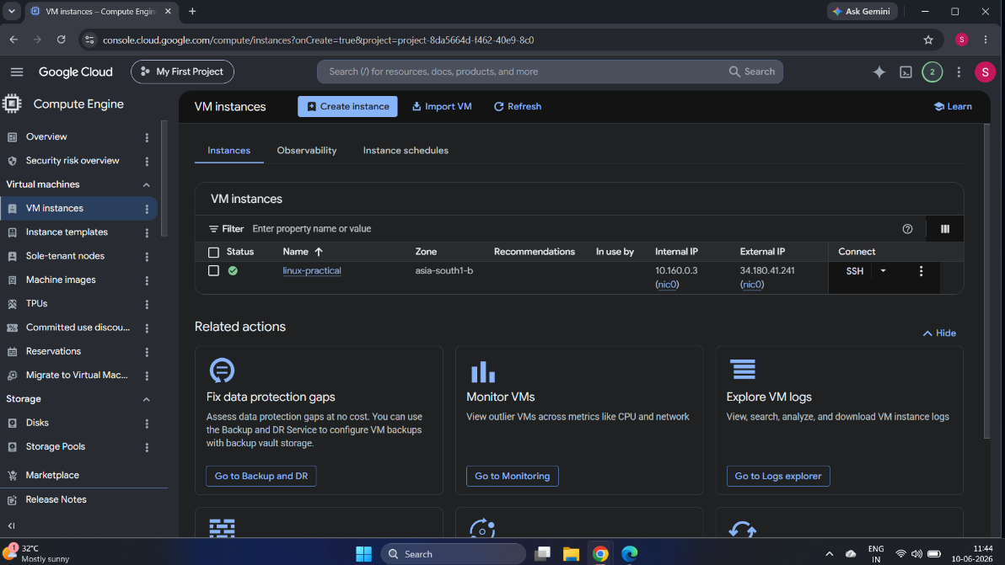
Task 2: Connect to the VM using SSH and capture screenshots.
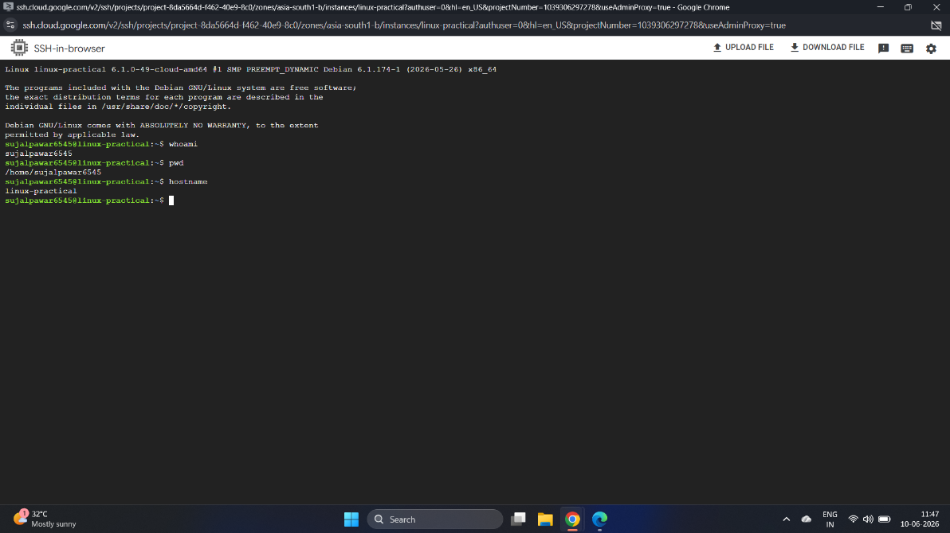
Task 3: Create practical_exam/scripts, practical_exam/outputs and practical_exam/logs.
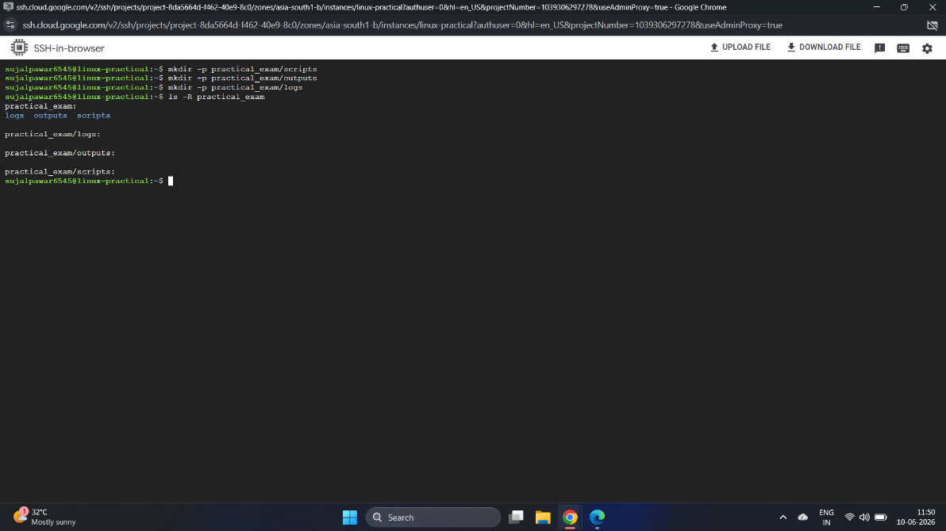

Part B – Linux Commands
Task 4: Display current working directory, current user and hostname. Save output.
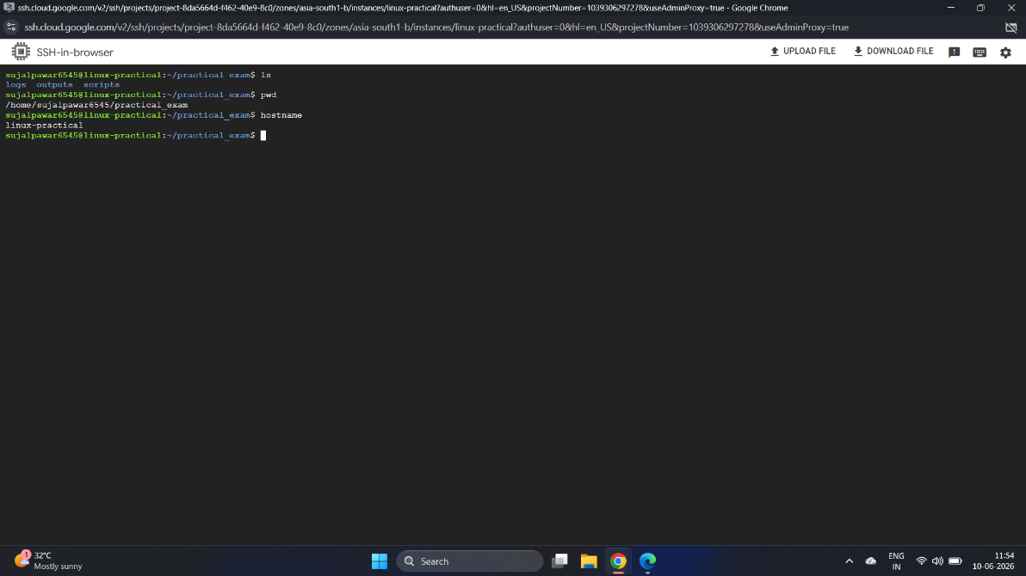
Task 5: Create 5 files inside scripts folder.
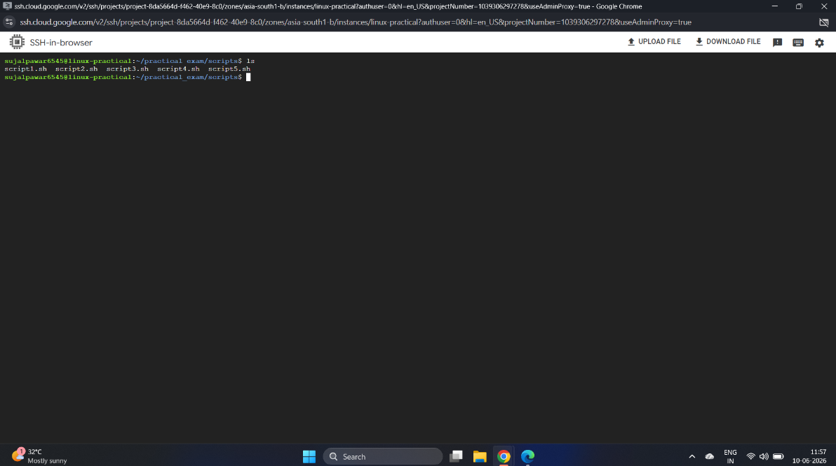
Task 6: Copy two files into outputs folder.
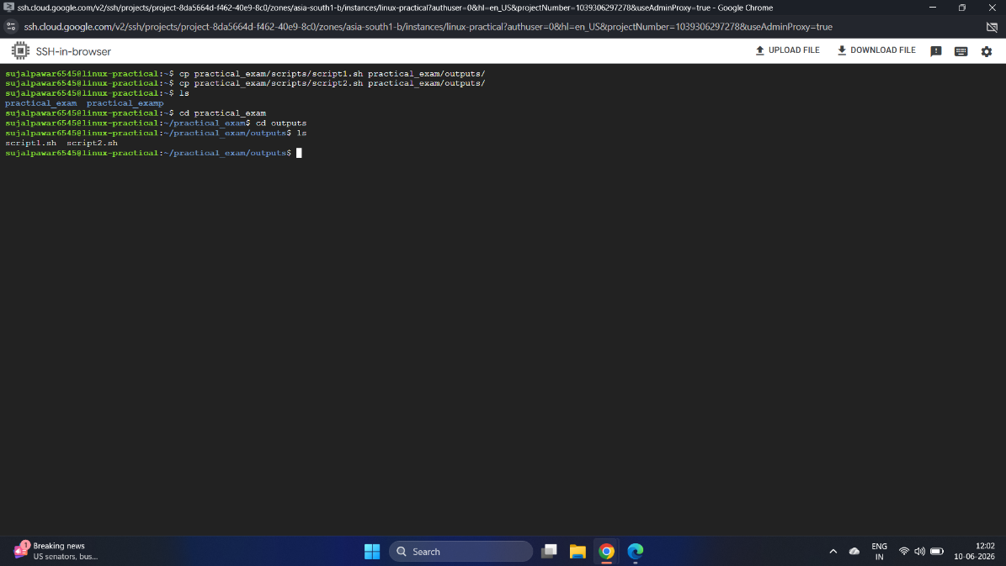
Task 7: Rename one file.
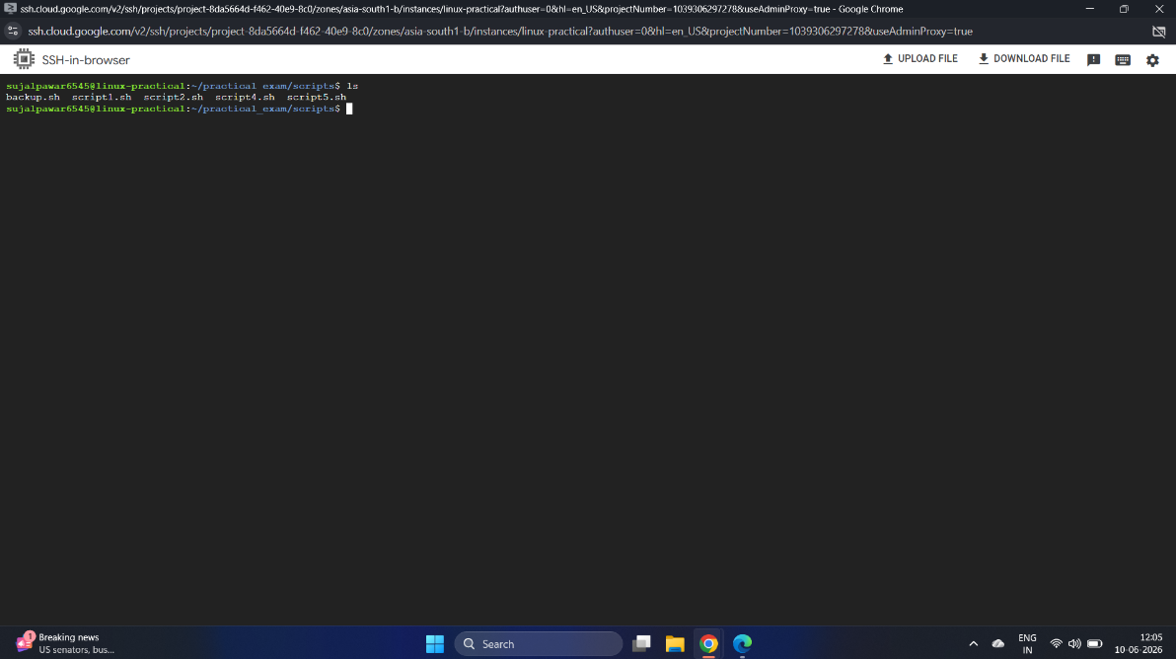
Task 8: Delete one file.
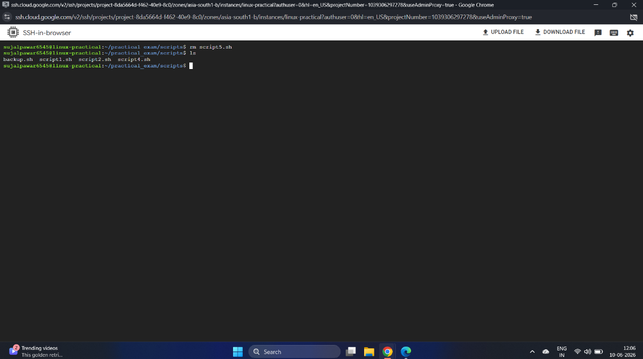
Task 9: Display hidden files.
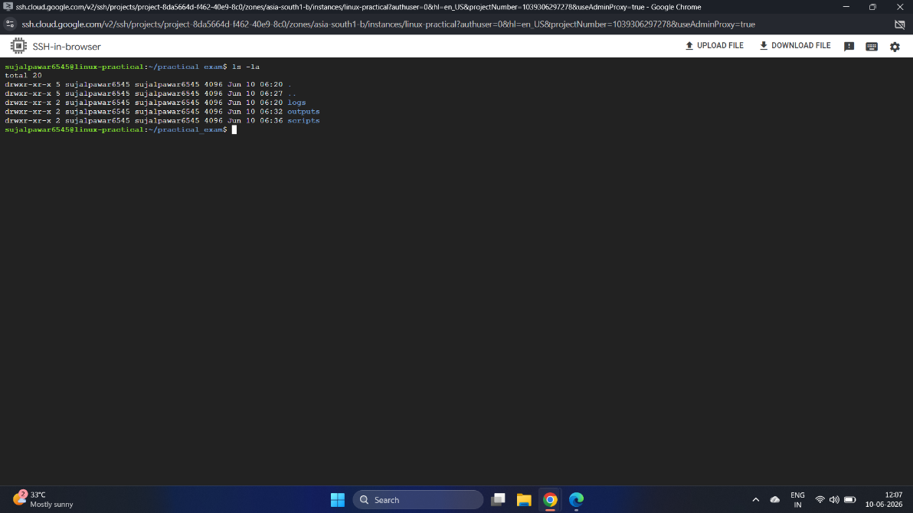
Task 10: Display disk usage information.
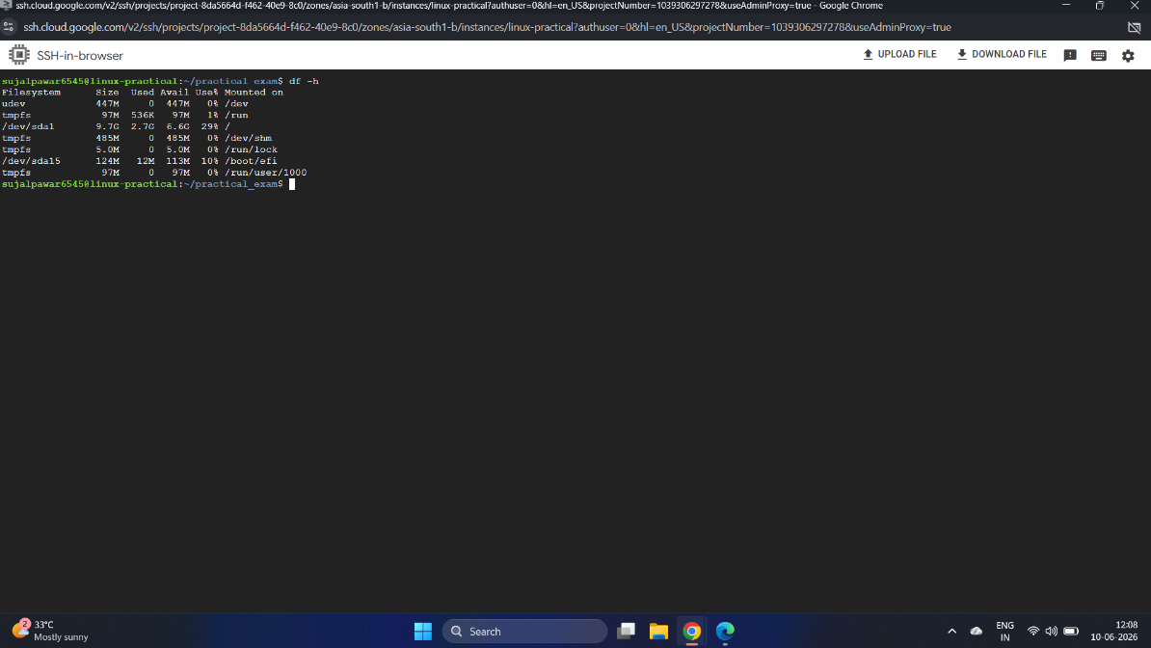
Task 11: Display memory usage information.
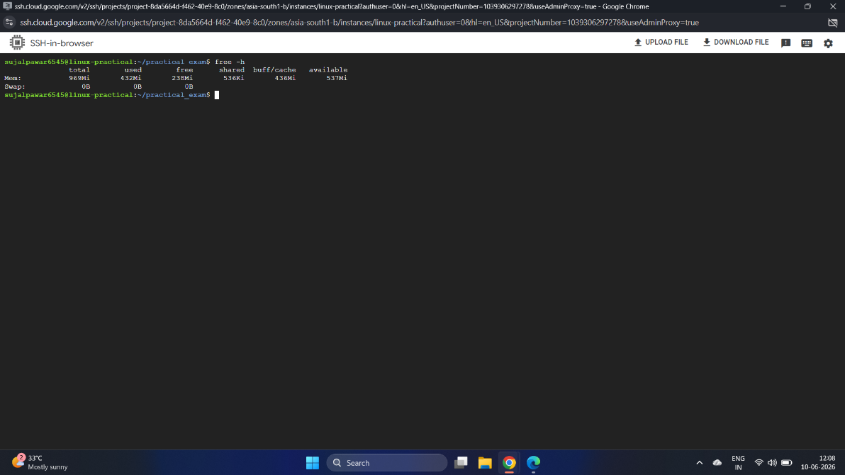
Task 12: Display running processes.
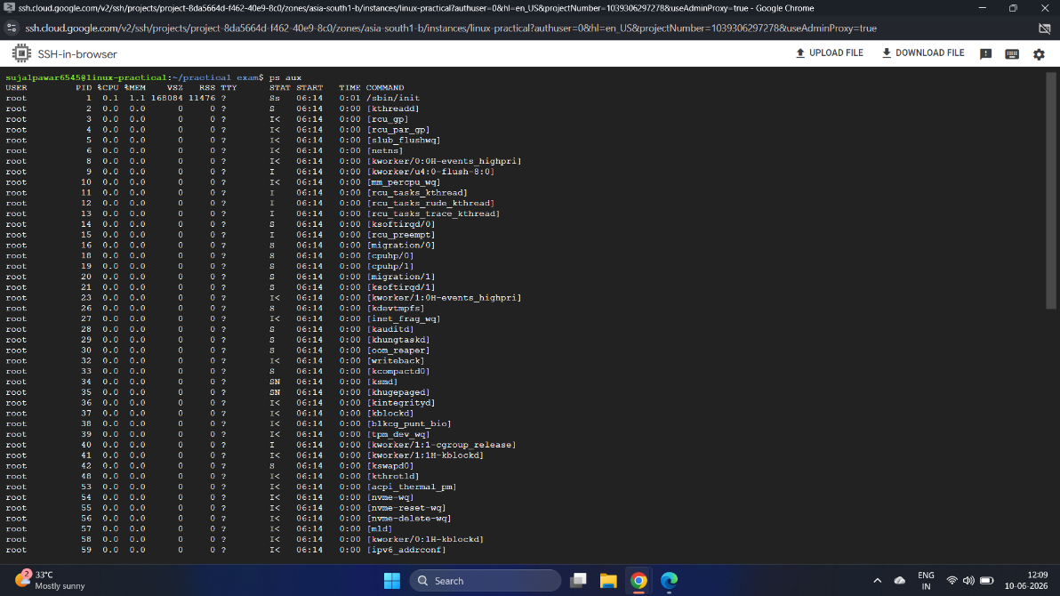
Task 13: Find all .sh files inside practical_exam.
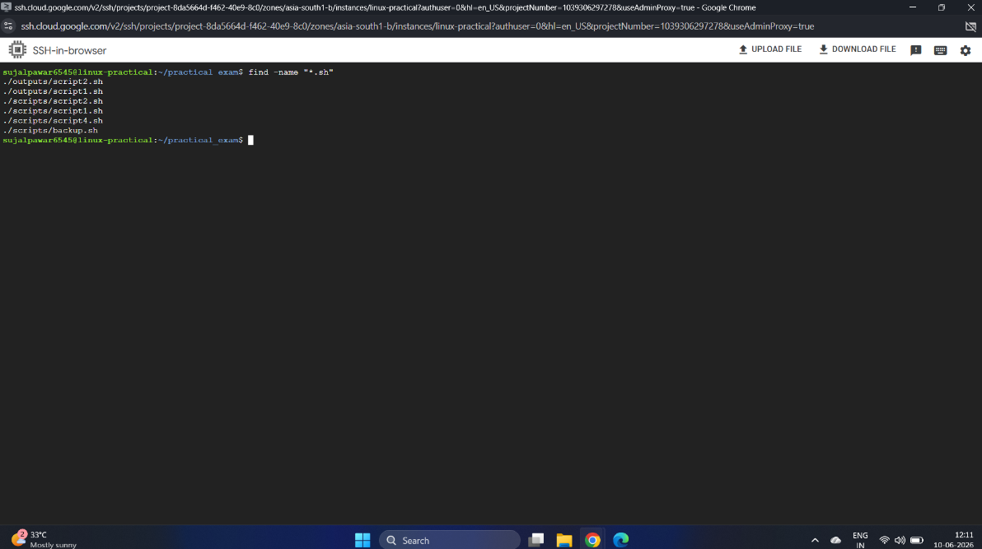

Part C – Permissions & Users
Task 14: Create secure_data.txt and apply permission 640.
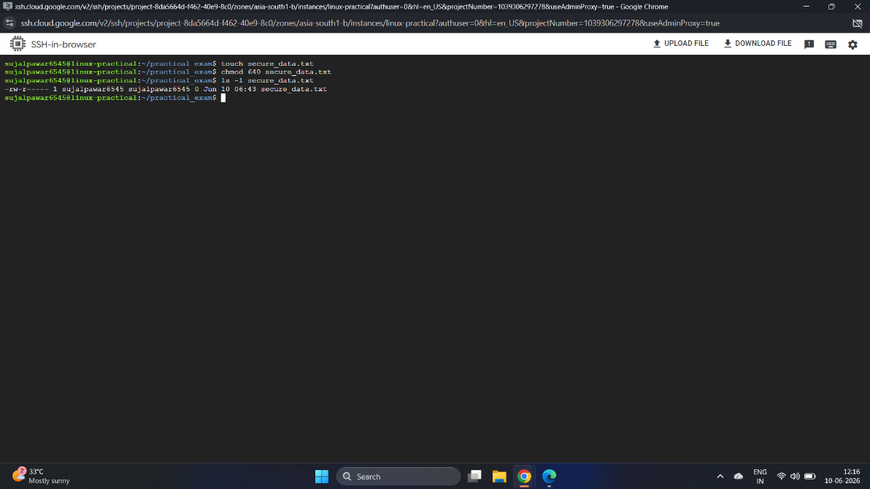
Task 15: Demonstrate Owner, Group and Others using commands.
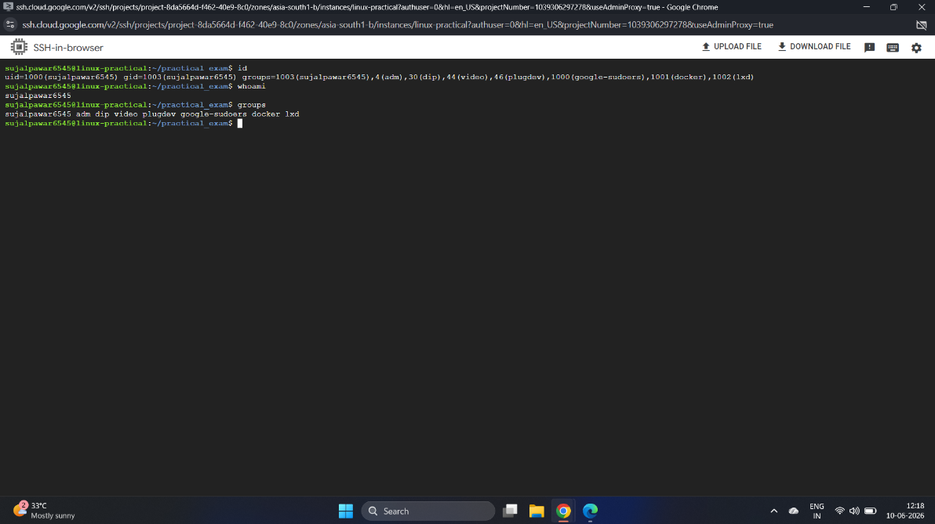
Task 16: Display User ID, Group ID and assigned groups.


Part D – Shell Scripting
Task 17: Script to print Welcome to Cloud Computing.
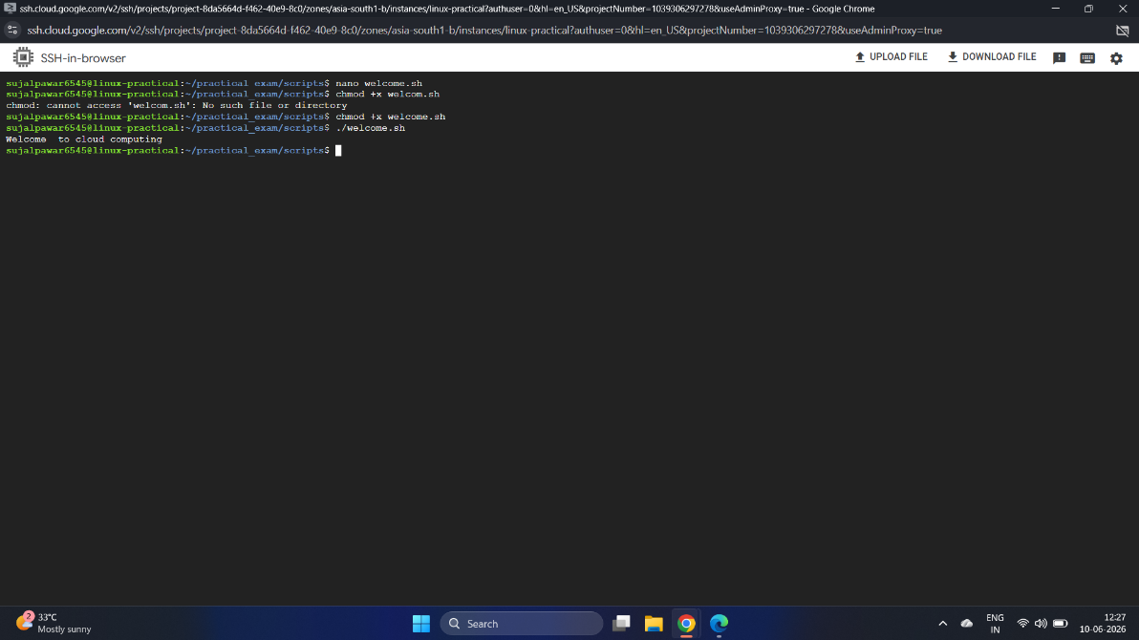
Task 18: Script accepting username and displaying Welcome .
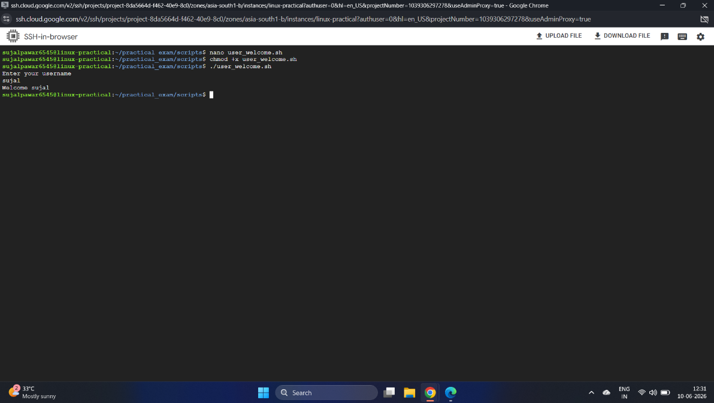
Task 19: Script to find larger of two numbers using if-else.
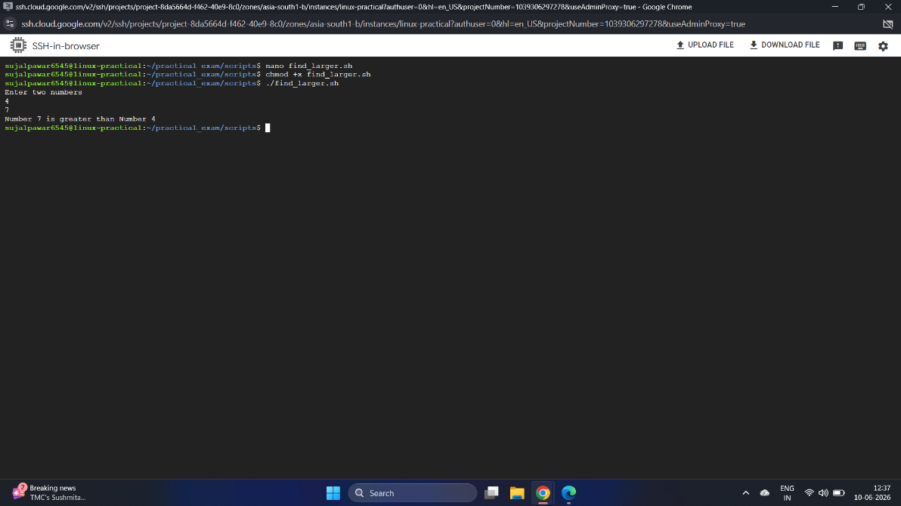
Task 20: Script to determine even or odd number.
Task 21: For loop displaying 1 to 20.
Task 22: While loop displaying 20 to 1.
Task 23: Multiplication table script.
Task 24: Count files inside scripts directory.
Task 25: Display all shell script filenames.
Task 26: Display current date and time and save output.

Part E – Processes & Scheduling
Task 27: Save running processes to outputs/processes.txt.
Task 28: Identify top 5 memory-consuming processes.
Task 29: Create a cron job appending current date and time every minute.
Task 30: Verify cron execution with evidence.

Part F – Git & Submission
Task 31: Create GitHub repository cloud-practical-exam.
Task 32: Initialize Git in practical_exam directory.
Task 33: Add all files.
Task 34: Commit changes with message Cloud Practical Exam Submission.
Task 35: Push files to GitHub.
Task 36: Verify repository contains scripts, outputs, screenshots and documentation.

Final Deliverables
PDF report containing screenshots and outputs.
GitHub Repository URL.
All shell scripts.
Evidence of cron execution.
Evidence of successful SSH connection.

