**Documentation**

**Step to be followed:**

1. Make a folder in which you want to do the analysis. Let’s name this folder as SL.
2. Make a folder named “1” inside “SL” folder.
3. Copy all the images to /SL/1 and /SL.
4. Copy codes of SL given to /SL folder.
5. Open code named Foveal_est_13 in matlab which is inside SL folder.
6. Run the code in matlab.
7. All variable provides parameters in sequence as mentioned below.
   1. Area
   2. Diameter
   3. Major axis
   4. Minor axis
   5. Perimeter
   6. Eccentricity
   7. Fmin
   8. Fmax
   9. Inner circle radius
   10. Circum circle radius
   11. Orientation
   12. Vad
   13. Vid
8. If some image doesn’t get processed, we don’t have first 10 parameters of it. But we can still get vad,vid and tortuosity. First 10 parameters are zero in this case. So when working in excel these rows can be removed.
9. Fy named variable provides name of the images processed in sequence.
10. For calculating tortuosity open code name tortuosity.m
11. Run the code in matlab.
12. Variable named tortuosity stores tortuosity values in sequence.

**Modifications needed in code: -**

If some images are of 3mm instead of 6mm, for proper scaling of parameters is needed. Considering no of 3mm images is relatively smaller than 6mm, hard coding is done.

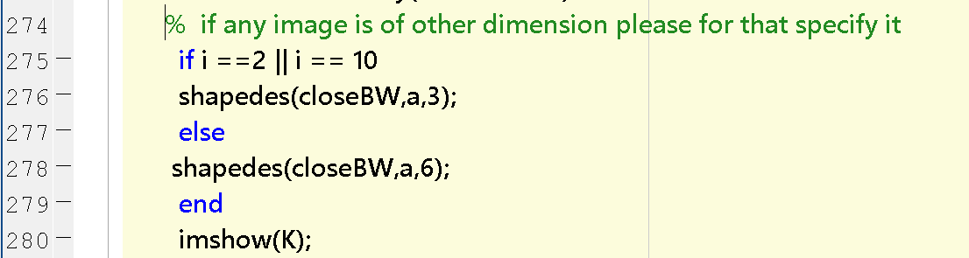

Here image number 2nd and 10th were 3mm so they are mentioned above. If more are to be added, they can be written after “||” sign.

Similar steps are followed for DL and manually segmented images. For Manually segmented images vad, vid and tortuosity are not calculated. Codes for all three are kept separately in the folder given.