# Question 2

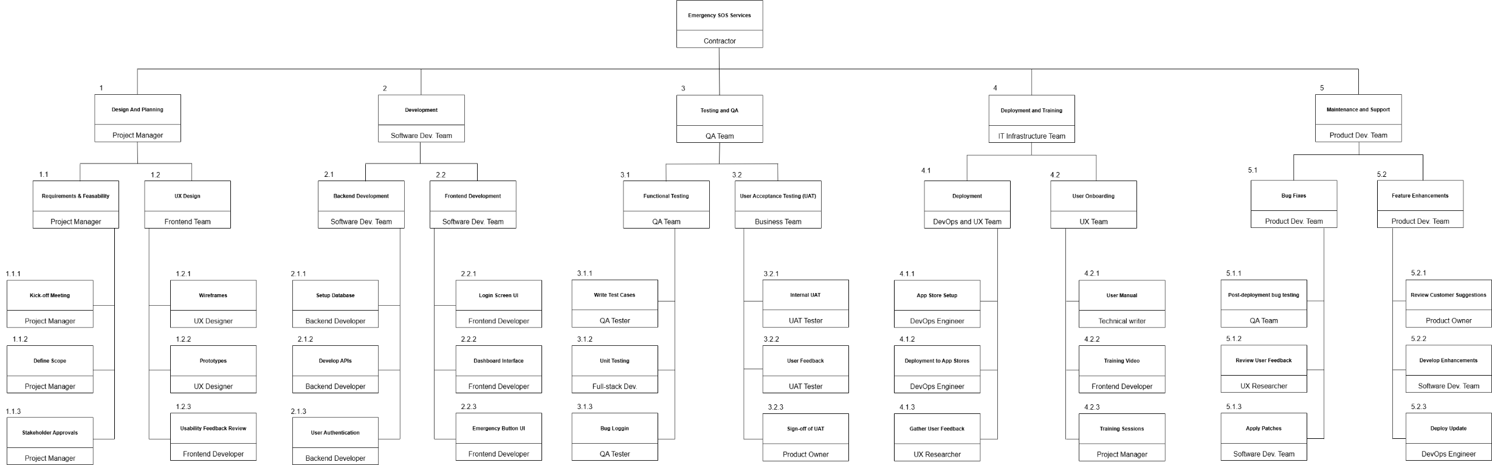

Figure : (Gido, et al., 2018)

# Bibliography

Gido, J., Clements, J. & Baker, R., 2018. *Successful Project Management.* 7th ed. Boston: Cengage.