Employee Resignation, Withdrawal & Exit Process

1. Actors & Roles
- Employee – initiates resignation, may withdraw, completes exit tasks
- Reporting Manager – reviews, approves/rejects, recommends LWD
- HR – validates policy, final approval, manages exit process
- IT / Admin / Finance – clearance & asset recovery
- System – notifications, SLA tracking, document generation
2. High-Level Process Flow
Employee
│
▼
Submit Resignation
│
▼
Manager Review
│ ├── Reject → Back to Employee
│ └── Approve
▼
HR Review & Approval
│ ├── Put On Hold
│ └── Approve
▼
Resignation Accepted
│
├── Withdrawal Request (optional)
│ ├── Manager + HR Approval
│ └── Withdrawn / Rejected
│
▼
Exit Process Initiated
│
▼
Clearance & Handover
│
▼
Final Settlement
│
▼
Exit Completed

3. Employee Portal – UI & Flow

3.1 Dashboard (Employee)
[ Apply Resignation ]
3.2 Apply Resignation Screen
--------------------------------------------------
| Apply Resignation |
--------------------------------------------------
| Reason for Resignation * |
| ( ) Career Growth |
| ( ) Higher Studies |
| ( ) Personal Reasons |
| ( ) Others [_____________] |
--------------------------------------------------
| Proposed Last Working Day * |
| [ 30-Sep-2025 ] |
--------------------------------------------------
| Comments |
| [_________________________________________] |
--------------------------------------------------
| [ Submit ] [ Cancel ] |
--------------------------------------------------
System Actions:
- Validate notice period
- Auto-calculate tentative LWD
- Notify Manager
3.3 Resignation Status View
--------------------------------------------------
| My Resignation |
--------------------------------------------------
| Status: Pending Manager Approval |
| Applied On: 01-Sep-2025 |
| Proposed LWD: 30-Sep-2025 |
--------------------------------------------------
| [ Withdraw Resignation ] (enabled until HR OK) |
--------------------------------------------------

4. Manager Portal – UI & Flow

4.1 Manager Dashboard
--------------------------------------------------
| Team Requests |
--------------------------------------------------
| Employee | Type | Status | Action |
| Kiran | Resignation | Pending | [View] |
--------------------------------------------------

--------------------------------------------------
| Resignation Review – Kiran |
--------------------------------------------------
| Reason: Career Growth |
| Proposed LWD: 30-Sep-2025 |
| Policy LWD: 15-Oct-2025 |
--------------------------------------------------
| Manager Recommended LWD |
| [ 15-Oct-2025 ] |
--------------------------------------------------
| Manager Comments |
| [_________________________________________] |
--------------------------------------------------
| [ Approve ] [ Reject ] [ Discuss ] |
--------------------------------------------------

5. HR Portal – Approval & Control

5.1 HR Review Screen
--------------------------------------------------
| HR Resignation Approval |
--------------------------------------------------
| Employee: Kiran |
| Manager Approved LWD: 15-Oct-2025 |
| Notice Period Met: Yes |
--------------------------------------------------
| HR Final LWD |
| [ 15-Oct-2025 ] |
--------------------------------------------------
| Exit Type |
| ( ) Voluntary ( ) Early Release |
--------------------------------------------------
| [ Approve ] [ Put On Hold ] [ Reject ] |
--------------------------------------------------

6. Withdrawal of Resignation Flow

6.1 Employee – Withdraw Request
--------------------------------------------------
| Withdraw Resignation |
--------------------------------------------------
| Reason for Withdrawal * |
| [_________________________________________] |
--------------------------------------------------
| [ Submit Withdrawal Request ] |
--------------------------------------------------

6.2 Approval Flow
Employee → Manager Approval → HR Approval
└── Reject → Status: Resignation Active
└── Approve → Status: Withdrawn

7. Exit Process (Post Approval)

--------------------------------------------------
| Exit Tasks |
--------------------------------------------------
| Knowledge Transfer | Pending |
| Asset Handover | Pending |
| Exit Survey | Pending |
--------------------------------------------------

7.2 Department Clearance (IT / Admin / Finance)
--------------------------------------------------
| Clearance – IT |
--------------------------------------------------
| Laptop Returned [ Yes / No ] |
| Access Revoked [ Yes ] |
| Comments |
--------------------------------------------------
| [ Approve Clearance ] |
--------------------------------------------------
(Similar UI for Admin & Finance)

8. Final Settlement – HR / Finance
--------------------------------------------------
| Final Settlement Summary |
--------------------------------------------------
| Salary Till LWD : ₹ 45,000 |
| Leave Encashment : ₹ 12,000 |
| Deductions : ₹ 5,000 |
--------------------------------------------------
| Net Payable : ₹ 52,000 |
--------------------------------------------------
| [ Generate Payslip ] [ Release Payment ] |
--------------------------------------------------

9. Exit Completion

• SLA reminders for Manager/HR
• Full audit log (who, when, action)

12. Optional Enhancements
- Exit interview scheduling
- Analytics dashboard (attrition, reasons)
- Policy-based auto-approval
- Mobile-friendly UI
- Overall Process Flow (Swimlane Style – Textual)

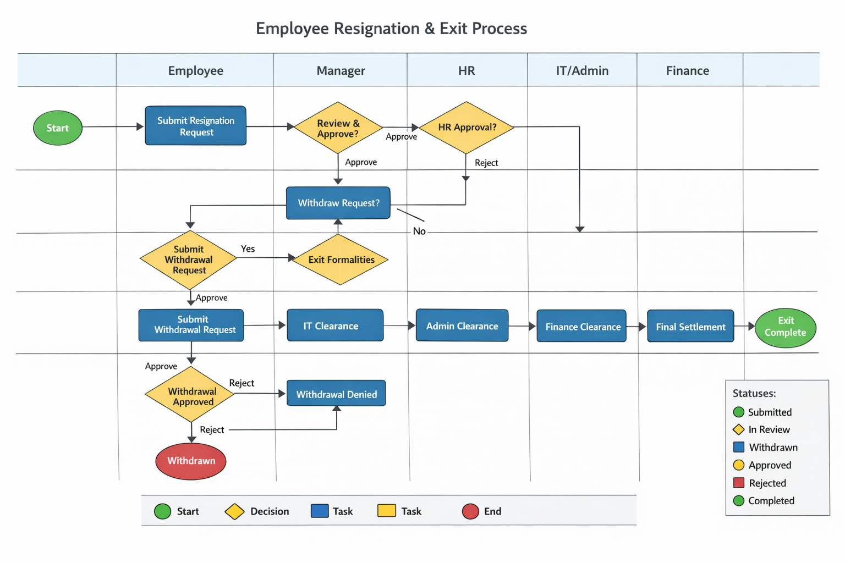

IT/Service Request Process
