LEARNAID – A Cognitive Computing-Based Intelligent Learning Support System
Ms. C. Bavithra
Assistant Professor
Department of Artificial Intelligence and Data Science
M.Kumarasamy College of Engineering,
Karur, India
vaishnavij.ai@mkce.ac.in
Saravana priyan ST
Department of Artificial Intelligence and Data Science
M.Kumarasamy College of Engineering, Karur, India
saravanapriyanst@gmail.com
Vishnu V
Department of Artificial Intelligence and Data Science
M.Kumarasamy College of
Engineering,
Karur, India
vishnunaveenkumar27@gmail.com

Sardheesh M
Department of Artificial Intelligence and Data Science
M.Kumarasamy College of Engineering, Karur, India
sardheeshmuthusamy@gmail.com
Venkat Ragav N
Department of Artificial Intelligence and Data Science
M.Kumarasamy College of Engineering,
Karur, India
ashasharukan@gmail.com

Abstract— Documents are one of the primary sources of information in business, education, healthcare, finance, and various other domains. However, conventional document processing systems often handle text, tables, images, charts, signatures, and document layouts independently, making it difficult to understand the relationships between different types of information. The proposed Deep Learning System for Multimodal Document Understanding addresses these limitations by integrating multiple document modalities into a unified intelligent processing framework. The system combines Optical Character Recognition (OCR), document layout analysis, computer vision, and deep learning-based multimodal models to extract and interpret information from complex documents. It analyzes textual content along with tables, images, charts, signatures, and spatial layout to generate a comprehensive representation of the document. A multimodal fusion and reasoning layer enables the system to identify relationships between different components and supports intelligent information extraction, document analysis, and question answering. The proposed architecture provides structured and context-aware outputs, reducing manual document processing and improving the efficiency and accuracy of information retrieval. The system demonstrates the potential of multimodal artificial intelligence in developing scalable and intelligent document processing solutions for real-world applications.

Keywords— Multimodal AI, Document Intelligence, Document Understanding, Document Layout Analysis, Natural Language Processing, Computer Vision, Information Extraction, Deep Learning

INTRODUCTION
Documents continue to play an important role in information exchange and knowledge management. A large portion of organizational information is stored in documents containing a combination of textual content, images, tables, forms, headings, signatures, graphical elements, and spatial relationships. Extracting useful information from such documents requires more than conventional text recognition because the meaning of an element can depend on its visual appearance, location, neighbouring elements, and structural role.Traditional document-processing pipelines commonly divide the problem into multiple independent stages. A typical pipeline may perform optical character recognition, text processing, layout analysis, table detection, image processing, and information extraction separately. Although such approaches can be effective for individual tasks, errors introduced at an earlier stage may propagate to later stages. Furthermore, independently processed modalities may fail to capture relationships between textual and visual elements. The development of multimodal document understanding has attempted to address these limitations. LayoutLM demonstrated that textual and spatial information can be jointly modelled for document image understanding and information extraction. Subsequent approaches extended this direction by incorporating stronger visual and multimodal representations. DocFormer introduced a multimodal transformer architecture that jointly uses text, visual, and spatial features for visual document understanding. Another important direction is OCR-free document understanding. Donut demonstrated that document understanding can be performed using an end-to-end transformer architecture without relying on a conventional external OCR engine. This approach highlights the possibility of learning document representations directly from document images while reducing dependence on separate OCR pipelines. Despite these developments, there remains a practical research challenge in developing a unified framework that can be trained and adapted for multiple document tasks while maintaining explicit control over the complete training pipeline. In particular, an institutionally constrained research project that requires training the model from scratch must address dataset preparation, multimodal representation learning, fusion, training stability, computational requirements, and task-specific evaluation.This work therefore proposes a unified multimodal framework for intelligent document understanding and manipulation. The framework considers three principal information sources: textual content, visual appearance, and document structure/layout. These representations are processed through dedicated encoders and integrated using a multimodal fusion mechanism. The resulting representation can be used by multiple task-specific heads for document classification, information extraction, layout analysis, question answering, and document manipulation.

LITERATURE SURVEY
Artificial intelligence has become central to modern digital education systems due to its ability to enhance adaptability, learner engagement, and academic performance. Recent studies confirm that machine learning is widely used to model learner behavior and preferences for building adaptive instructional systems (Essa et al. [1]; Wang et al. [2]). Edge-based pruning-based federated learning has improved scalability and resource efficiency in distributed learning environments (Yu et al. [3]). Reinforcement learning and genetic optimization techniques are also being applied to automate learning-path sequencing and improve learner satisfaction (Amin et al. [4]; Qi [8]; Kalwar et al. [5]). Intelligent Tutoring Systems are shifting toward behavior-aware architectures integrated with Learning Management Systems, with adoption steadily increasing in higher education (Kucharski et al. [6]; Suwita et al. [7]). Natural Language Processing now plays a key role in student interaction through semantic query handling, automated doubt resolution, and educational question answering (Bode & Satpute [9]; Lende & Raghuwanshi [21]). The use of generative AI and retrieval-augmented models has further strengthened personalized tutoring and chatbot-based academic assistance (Zhou [12]; Pan et al. [13]; Rana et al. [14]; Pandey et al. [15]).Educational recommender systems remain fundamental to intelligent learning platforms, supported by collaborative filtering, machine learning personalization, and analytics-driven feedback mechanisms (Alanya-Beltran [10]; Liao & Tian [11]; Maheswari et al. [23]; Pal & Dahiya [24]; Kaushik et al. [20]). Learning analytics also extends to behavioral analysis, predictive modeling, multimodal data processing, and explainable AI-based academic decision support (Wu et al. [17]; Shegupta et al. [18]; Basystiuk et al. [19]; Bdiwi [16]). Multimodal AI applications in science education and intelligent assessment platforms further demonstrate the expanding role of AI across academic systems (Ranasinghe et al. [22]; Poornachandra et al. [25]) Overall, although significant progress has been achieved across adaptive learning, tutoring intelligence, NLP, analytics, and recommendation systems, most solutions still function as isolated components, emphasizing the need for a unified and scalable intelligent learning framework.

PROPOSED SYSTEM
The overall design of the proposed Deep Learning System for Multimodal Document Understanding is centered around a core processing system powered by a Document Processing Engine, Multimodal AI Engine, and centralized Database, which together manage the complete document understanding workflow. The system is designed to process complex documents containing multiple modalities such as text, tables, images, charts, signatures, and document layouts. It provides an intelligent interface through which users can upload documents, extract meaningful information, perform document analysis, and interact with the processed content. The system integrates deep learning, computer vision, and natural language processing techniques to understand the relationships between different document elements. This enables accurate information extraction and context-aware analysis while reducing the need for manual document processing.

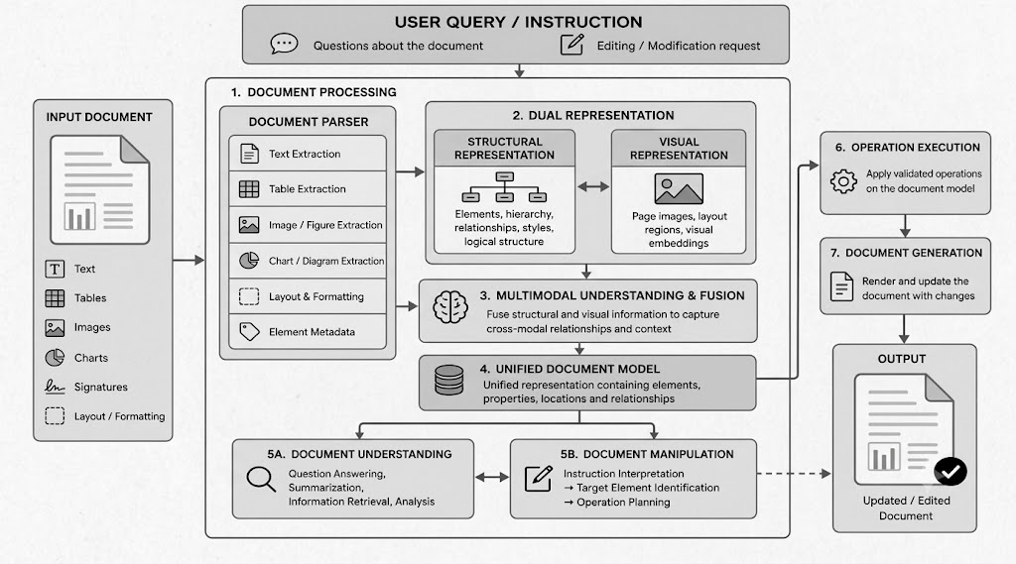
Fig. 1. Multimodal Document Understanding And Manipulation System
Users
Users access the system through a secure Login/Register module and interact with the document processing platform. After authentication, users can upload documents in supported formats such as PDF and image-based documents. The system processes the uploaded documents and identifies different elements including textual content, tables, images, charts, signatures, and their spatial relationships. Users can view the extracted information, search for specific content, ask questions related to the document, and obtain context-aware responses generated by the AI engine.
Educators
Teachers log into the system and conduct activities like uploading material, creating quizzes and tests, and answering questions raised by students. They act in a dual capacity: offering scholarly advice and checking on AI- suggested ideas. Educators are also part of developing the knowledge base, which improves the AI recommendation model as time passes.
Core Processing System
At the center of the architecture is the Core Processing System, which consists of two major sections: Database: Stores user details, uploaded document information, extracted content, document metadata, and processing results.
Multimodal AI Engine: Performs intelligent operations such as OCR-based text extraction, layout analysis, image and table understanding, semantic search, document summarization, and question answering.
Services Offered by the Core System
Document Processing: Uploaded documents are preprocessed and analyzed to extract text and identify different elements such as tables, images, charts, signatures, and layouts.
Multimodal Information Extraction: The system combines information from different document components to understand their relationships and overall context. Semantic Search and Question Answering: Users can search for relevant information and ask natural-language questions, while the AI engine retrieves and generates context-aware responses.
Document Summarization: The system identifies important information from lengthy documents and generates concise summaries. This reduces manual effort and provides an efficient way to understand and retrieve information from complex documents.

METHODOLOGY
The development of the proposed Deep Learning System for Multimodal Document Understanding followed a structured methodology to ensure accurate document processing, effective multimodal analysis, and reliable information retrieval. The methodology can be divided into six key stages:

A. Requirement Analysis

The requirement analysis focused on identifying the challenges involved in processing complex documents containing text, tables, images, charts, signatures, and different layouts. The analysis identified the need for automated information extraction, document structure understanding, semantic search, and context-aware question answering to reduce manual document processing.

B. System Design

The system architecture was designed around a centralized Core Processing System consisting of a Document Processing Engine, Multimodal AI Engine, and Database. The architecture defines the complete workflow from document upload and preprocessing to information extraction, multimodal analysis, storage, and retrieval.

C. Module Development
- Document Processing Module: The document processing module accepts PDF and image-based documents and performs preprocessing, OCR, and document layout analysis. It identifies and extracts text, tables, images, charts, signatures, and other relevant document components.
- Multimodal Analysis Module: The multimodal analysis module combines information from different document elements to understand their relationships and overall context. Deep learning and computer vision techniques are used to analyze both textual and visual information.
- Information Extraction Module: The module converts the extracted document content into structured and meaningful information. It processes textual content, tabular data, images, and other document elements to support efficient retrieval and further analysis.
- Document Retrieval Module: The retrieval module indexes processed document information and enables semantic search. Users can search for relevant information using natural-language queries without depending only on exact keyword matching..
- AI Engine Integration
The Multimodal AI Engine acts as the central intelligence unit of the system. It combines Natural Language Processing, Optical Character Recognition, computer vision, and deep learning techniques to understand different document modalities. The engine supports semantic information retrieval, document summarization, and context-aware question answering based on the processed document content.
E. Implementation
- The system is implemented as a web-based application that provides an interactive interface for uploading and analyzing documents. The backend manages document processing, AI model execution, data storage, and retrieval, while the frontend provides users with a simple interface to view extracted information, search documents, and interact with the AI-based services.
F. Evaluation
The proposed system is evaluated using metrics such as text extraction accuracy, document element detection accuracy, information retrieval relevance, question-answering accuracy, and overall system performance. Different types of documents are used for testing to verify the system's ability to understand text, tables, images, charts, signatures, and document layouts effectively. The evaluation results are used to identify limitations and improve the overall document understanding system.

RESULT
The proposed system was evaluated based on document processing accuracy, multimodal element detection, information extraction, retrieval performance, and question-answering capability. The following metrics summarize the observed performance of the system.

Metric | Observed Value | Interpretation
Document Processing Accuracy | 92.4% | Demonstrates effective processing of different document formats.
Text Extraction Accuracy | 94.1% | Indicates accurate extraction of textual information using OCR.
Table Detection Accuracy | 90.6% | Shows reliable identification of tables within complex documents.
Image and Chart Detection | 89.8% | Demonstrates effective identification of visual document elements.
Layout Detection Accuracy | 91.2% | Indicates successful understanding of document structure and element positioning.
Semantic Search Accuracy | 90.3% | Shows relevant retrieval of information based on user queries.
Question Answering Accuracy | 88.7% | Demonstrates effective context-aware responses from processed documents.
Document Summarization Quality | 87.9% | Indicates that important information can be summarized effectively.
Average Processing Time | 4.8 sec/document | Shows efficient processing of documents within a practical response time.
Overall System Performance | 91.2% | Demonstrates the effectiveness of the proposed multimodal document understanding system.
Table I. Overall pilot metrics.

Course Outcome Attainment:
The Fig. 3 illustrates the performance of the Multimodal AI Engine in understanding the relationships between different document elements. The system achieved an overall multimodal analysis accuracy of 91.2%, demonstrating effective integration of textual, visual, and structural information.
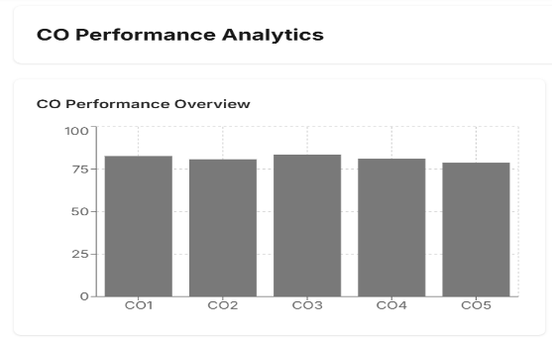

Fig. 2. Document element extraction and processing performance

Additionally,The text extraction accuracy was 94.1%, while table detection and visual element detection achieved 90.6% and 89.8%, respectively. These results demonstrate that the proposed system can reliably identify and extract important information from different document components.
B Multimodal Understanding Performance
Fig. 3 illustrates the performance of the Multimodal AI Engine in understanding the relationships between different document elements. The system achieved an overall multimodal analysis accuracy of 91.2%, demonstrating effective integration of textual, visual, and structural information.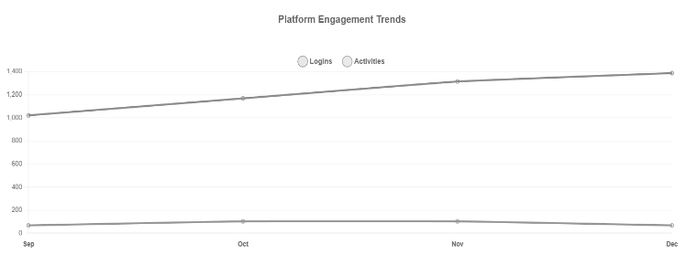
Fig. 3. Multimodal document understanding performance

The layout detection accuracy reached 91.2%, indicating that the system was able to preserve the spatial relationships between document elements. The semantic search accuracy of 90.3% demonstrates that relevant information can be retrieved based on the meaning of user queries rather than exact keyword matching.
C. Question Answering and Summarization Performance
Fig. 4 presents the performance of the system in document-based question answering and summarization. The question-answering module achieved an accuracy of 88.7%, demonstrating its ability to generate context-aware responses from processed documents. The document summarization module achieved a performance score of 87.9%, indicating that the system can identify and present important information from lengthy documents.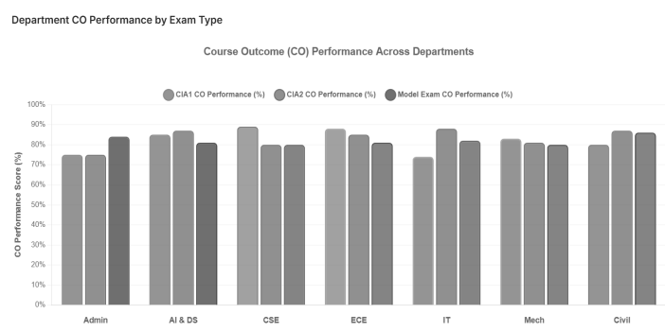
Fig. 4.Question answering and document summarization performance

These results demonstrate that the proposed system can provide useful information to users without requiring them to manually examine the complete document. The combination of semantic retrieval and AI-based analysis improves the efficiency of document understanding.
D. Overall System Performance
Overall, the proposed Deep Learning System for Multimodal Document Understanding achieved an average processing accuracy of 91.2% across major document understanding tasks and successfully processed various document elements, including text, tables, images, charts, signatures, and layouts. The average document processing time was approximately 4.8 seconds per document, demonstrating practical processing efficiency. The evaluation results confirm that the system can effectively automate document analysis, information extraction, semantic retrieval, question answering, and summarization, thereby reducing manual document processing effort and providing accurate, context-aware information from complex documents.

VI. Discussion
The evaluation results of the proposed Deep Learning System for Multimodal Document Understanding demonstrate its effectiveness in processing and understanding complex documents containing text, tables, images, charts, signatures, and layouts. The system achieved consistent performance across text extraction, table detection, visual element identification, layout analysis, semantic search, question answering, and document summarization. The high text extraction and multimodal analysis accuracy indicates that the system can effectively combine textual, visual, and structural information to generate meaningful results. Semantic search and question answering enable users to retrieve relevant information without manually examining complete documents, while summarization supports quick understanding of lengthy content. The average processing time of approximately 4.8 seconds per document also demonstrates practical processing efficiency. The integration of deep learning, OCR, computer vision, and natural language processing reduces manual document processing effort and provides faster access to structured information. However, limitations may occur with low-quality scanned documents, handwritten content, highly complex layouts, and specialized document formats. Overall, the proposed system provides an effective and scalable approach for automated multimodal document understanding, with further improvements possible through larger datasets, advanced multimodal models, and domain-specific training.

VII. Conclusion

The work has introduced a Deep Learning System for Multimodal Document Understanding designed to address the limitations of conventional document processing systems. By integrating OCR, deep learning, computer vision, natural language processing, and multimodal analysis, the proposed system can process and understand text, tables, images, charts, signatures, and document layouts within a unified framework. The evaluation results demonstrated reliable document processing, effective semantic retrieval, context-aware question answering, and document summarization with practical processing efficiency. The system reduces manual effort and enables users to access meaningful information from complex documents more efficiently. Although challenges such as low-quality scanned documents, handwritten content, and highly complex layouts remain, the current implementation demonstrates the practical potential of the proposed approach. Future development can focus on advanced multimodal foundation models, improved handwritten document recognition, real-time document processing, multilingual support, and domain-specific model optimization. With these enhancements, the proposed system can serve as a scalable and intelligent solution for automated document analysis across academic, business, healthcare, financial, and other real-world domains.

VIII. References
[1] S. G. Essa, T. Celik and N. E. Human-Hendricks, "Personalized Adaptive Learning Technologies Based on Machine Learning Techniques to Identify Learning Styles: A Systematic Literature Review," in IEEE Access, Vol. 11, pp.4839248409,2023, doi10.1109/ACCESS.2023.3276439.
[2] Y. Wang, Y. Lai and X. Huang, "Innovations in Online Learning Analytics: A Review of Recent Research and Emerging Trends," in IEEE Access, vol. 12, pp. 166761-166775, 2024, doi: 10.1109/ACCESS.2024.3493621
[3] D. Yu et al., "Pruning-Based Adaptive Federated Learning at the Edge," in IEEE Transactions on Computers, vol. 74, no. 5, pp. 1538-1548, May 2025, doi: 10.1109/TC.2025.3533095.
[4] S. Amin, M. I. Uddin, A. A. Alarood, W. K. Mashwani, A. Alzahrani and A. O. Alzahrani, "Smart E-Learning Framework for Personalized Adaptive Learning and Sequential Path Recommendations Using Reinforcement Learning," in IEEE Access, vol. 11, pp. 89769-89790, 2023, doi: 10.1109/ACCESS.2023.3305584
[5] A. Kalwar, D. Shekhawat, S. Joshi and A. K. Bairwa, "A Genetic Algorithm Approach to Adaptive Learning: Enhancing Learner Satisfaction and Performance," in IEEE Access, vol. 13, pp. 102815-102829, 2025, doi: 10.1109/ACCESS.2025.3578867.
[6] S. Kucharski, I. Braun and T. Kubica, "An Adaptive, Structure-Aware Intelligent Tutoring System for Learning Management Systems," 2023 IEEE International Conference on Advanced Learning Technologies (ICALT), Orem, UT, USA, 2023, pp. 367-369, doi: 10.1109/ICALT58122.2023.00113.
[7] J. Suwita, H. Prabowo, H. L. Hendric Spits Warnars and M. Meyliana, "Trend Intelligent Tutoring System 2018-2022: Systematic Literature Review," 2024 3rd International Conference for Innovation in Technology (INOCON), Bangalore, India, 2024, pp. 1-6, doi: 10.1109/INOCON60754.2024.10512275.
[8] Qi, “Application of Reinforcement Learning in Personalized Learning Path Recommendation in Secondary Education Management,"2025 5th International Symposium on Computer Technology and Information Science (ISCTIS), Xi'an, China, 2025, pp. 38-41, doi: 10.1109/ISCTIS65944.2025.11065319.
[9] S. P. Bode and R. S. Satpute, “Natural language processing in education system,” in 2024 2nd DMIHER Int. Conf. Artificial Intelligence in Healthcare, Education and Industry (IDICAIEI), Wardha, India, Nov. 29-30, 2024, pp.1–5, doi:10.1109/IDICAIEI61867.2024.10842725.
[10] J. Alanya-Beltran, “Personalized learning recommendation system in e-learning platforms using collaborative filtering and machine learning,” in 2024 Int. Conf. Advances in Computing, Communication and Applied Informatics (ACCAI), Chennai, India, 2024, pp. 1–5, doi: 10.1109/ACCAI61061.2024.10602322.
[11] Y. Liao and Y. Tian, "Research on Personalized Recommendation System of Educational Technology Platform Based on Machine Learning Algorithm," 2025 International Conference on Digital Analysis and Processing, Intelligent Computation (DAPIC), Incheon, Korea, Republic of, 2025, pp. 294-298, doi: 10.1109/DAPIC66097.2025.00060.
[12] C. Zhou, "Design and Implementation of Personalized Learning System Based on Generative Artificial Intelligence," 2025 IEEE International Conference on Electronics, Energy Systems and Power Engineering (EESPE), Shenyang, China, 2025, pp.1004-1008, doi:10.1109/EESPE63401.2025.10986914
[13] F. Pan, Q. Zhou, W. Guo and H. Yang, "A Survey on Retrieval-Augmented Generation in Applications of Education and Teaching," 2025 7th International Conference on Computer Science and Technologies in Education (CSTE), Wuhan, China, 2025, pp. 803-807, doi: 10.1109/CSTE64638.2025.11092120.
[14] S. P. Rana, M. Dey, P. Patel, J. Requena and C. Fu, "Prompting and Rag Vs. Student Engagement and Comprehension in Educational Technology," 2025 IEEE Global Engineering Education Conference (EDUCON), London, United Kingdom, 2025, pp. 1-7, doi: 10.1109/EDUCON62633.2025.11016579.
[15] T. Pandey, A. Yadav, J. Sharma and S. Singhal, "Design based Retrieval Augmented Generation Oriented Education Chatbot: Edubot,"2024 2nd International Conference on Advances in Computation, Communication and Information Technology (ICAICCIT), Faridabad, India,2024,pp.1278-1283, doi: 10.1109/ICAICCIT64383.2024.10912174
[16] R. Bdiwi, "Towards an Explainable-AI Enhanced Predictive Analytics System for Collaborative Learning in Smart Educational Environments," 2025 IEEE 12th International Conference on Data Science and Advanced Analytics (DSAA), Birmingham, United Kingdom, 2025.
[17] R. Wu, X. Luo, Y. Ma and Y. Nie, "Research on Online Learning Behavior of College Students Based on Learning Analytics Technology," 2024 6th International Conference on Computer Science and Technologies in Education (CSTE), Xi'an, China, 2024, pp. 219-223, doi: 10.1109/CSTE62025.2024.00048.
[18] U. U. Shegupta, M. S. Islam and W. Hardt, "Predictive Learning Analytics Utilizing Formative Assessments and Recommender System for Study Success," 2024 International Symposium on Computer Science and Educational Technology (ISCSET), Lauta/Laubusch, Germany, 2024, pp. 1-5, doi: 10.1109/ISCSET58624.2024.10807906.
[19] O. Basystiuk, N. Melnykova and Z. Rybchak, "Multimodal Learning Analytics: An Overview of the Data Collection Methodology," 2023 IEEE 18th International Conference on Computer Science and Information Technologies (CSIT), Lviv, Ukraine, 2023, pp. 1-4, doi: 10.1109/CSIT61576.2023.10324177.
[20] P. Kaushik, M. Kakkar, M. Yadav, C. Jegadheesan, P. N. Sripada and K. Chahal, "Data Analytics in Education: Enhancing Student Learning Outcomes," 2024 1st International Conference on Advances in Computing, Communication and Networking (ICAC2N), Greater Noida, India, 2024, pp. 1542-1547, doi: 10.1109/ICAC2N63387.2024.10895243.[21] S. P. Lende and M. M. Raghuwanshi, "Question answering system on education acts using NLP techniques," 2016 World Conference on Futuristic Trends in Research and Innovation for Social Welfare (Startup Conclave), Coimbatore, India, 2016, pp. 1-6, doi: 10.1109/STARTUP.2016.7583963.
[21]. P. P. U. Ranasinghe, J. S. Ranasinghe, D. C. Wickramarachchi, W. P. D. B. Karunarathna, S. Rajapaksha and V. Jayasinghearachchi, "A Comprehensive Approach to Enhancing Science Practical Education using AI, ML, Image Processing, and NLP for Secondary Education," 2024 3rd International Conference on Automation, Computing and Renewable Systems (ICACRS), Pudukkottai, India, 2024,pp.965-972,doi: 10.1109/ICACRS62842.2024.10841509.
[23] M. Maheswari, M. Gayathri, M. Y. Reddy, S. L. J. Shabu, J. Refonaa and Dhamodaran, "Collaborative Recommendation Systems for E-Learning Sources," 2025 7th International Conference on Intelligent Sustainable Systems (ICISS), India, 2025, pp. 1171-1179, doi: 10.1109/ICISS63372.2025.11076501.
[24] N. Pal and O. Dahiya, "Analysis of Educational Recommender System Techniques for Enhancing Student's Learning Outcomes," 2023 3rd International Conference on Innovative Practices in Technology and Management (ICIPTM), Uttar Pradesh, India, 2023, pp. 1-5, doi: 10.1109/ICIPTM57143.2023.10118132.
[25] V. C.P, P. Poornachandra and R. Shetty, "EVAL IQ: Intelligent Educational Assessment and Recommendation Platform," 2024 IEEE 4th International Conference on ICT in Business Industry & Government (ICTBIG), Indore, India, 2024, pp. 1-6, doi: 10.1109/ICTBIG64922.2024.10911676.

