**ST10019972 - Guillaume Swanevelder**

**ST10019838 - Damian Dare**

**OPSC7311**

**POE Part-1: Research**

28 March 2024

Table of Contents

1. Introduction 3

2. Research on Time Tracking Apps 4

2.1. App 1: Toggl Track 4

2.1.1. Overview 4

2.1.2. Strengths 6

2.1.3. Weaknesses 7

2.1.4. Innovative Features 7

2.2. App 2: Harvest 8

2.2.1. Overview 8

2.2.2. Strengths 11

2.2.3. Weaknesses 11

2.2.4. Innovative Features 11

2.3. App 3: Clockify 12

2.3.1. Overview 12

2.3.2. Strengths 14

2.3.3. Weaknesses 14

2.3.4. Innovative Features 15

3. Comparison of the Researched Apps 16

4. Best Features we Aim to Include 17

4.1. Offline Tracking 17

4.2. Time Rounding 17

4.3. Marking entries as billable 17

4.4. Marking entries as a favourite 17

4.5. Widgets 17

4.6. Timer Notification 17

4.7. Reminders 17

4.8. Having a timeline 17

4.9. Locked time entries 17

4.10. Having a completely free application 17

5. Conclusion 18

6. References 19

# Introduction

Welcome!

This document pertains to the research conducted in the pursuit of our project’s objective to create an Android time tracking application. The research being conducted is on three existing timesheet applications, being Toggl Track, Harvest, and Clockify. This document separates the research into three distinct sections being “Research on Time Tracking Apps”, “Comparison of the Researched Apps”, and “Best Features We Aim to Include”.

The “Research on Time Tracking Apps” section aims at displaying our research, providing an overview, an outline of the strengths, weaknesses, and innovative features for each of the applications being researched; the “Comparison of the Researched Apps” section aims at visually comparing our research via the use of an infographic; and the “Best Features We Aim to Include” section aims at formulating a list of the best features from each of these apps, that we would like to incorporate into our application.

Ultimately, the purpose of this research and this document is to display and compare the strengths (pros), weaknesses (cons), and best features of existing timesheet applications so that we can identify the best approaches for what our application should do, how it should look, how it should feel, and how we can innovate to make our application stand out amongst its peers.

# Research on Time Tracking Apps

## App 1: Toggl Track

### Overview

Toggl Track distinguishes itself in the competitive time tracking applications market by prioritising simplicity and efficiency (Toggle Track, n.d.). Created to be user-friendly from the outset, it provides a simplified experience allowing users to initiate and cease tracking with just one tap of a button (Jibble, 2024). Some of Toggl Tracks prominent aspects include:

1. A streamlined layout, focusing on easy navigation and reducing distractions (Toggle Track, n.d.)
2. Project classification, allowing users to efficiently organize their various work streams and activities (Toggle Track, n.d.)
3. Powerful reporting features, enabling users to extensively analyse their time usage (Toggle Track, n.d.)
4. Various calendar integrations, all with the objective to improve productivity (Toggle Track, n.d.)

The following figures, taken from Google Play (n.d.), depict some examples of Toggl Track’s features:

Figure 1: Toggl Track’s new method of tracking time

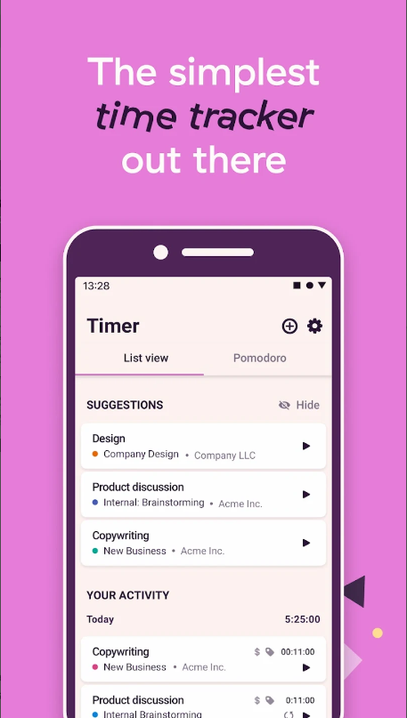

Figure 2: Toggl Track’s timer feature

Figure 3: Toggl Track’s reporting feature

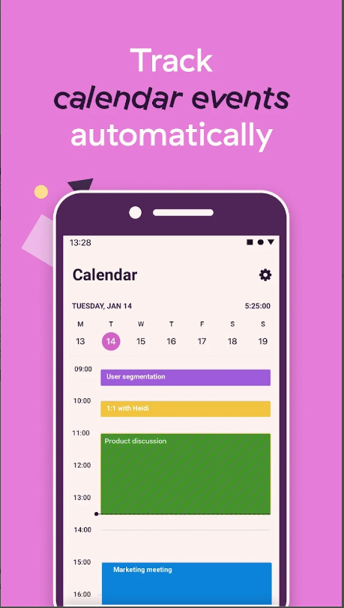

Figure 4: Toggl Track’s calendar feature

Figure 5: Toggl Track’s Pomodoro timer

Figure 6: Toggl Track’s device synchronization feature

Figure 7: Toggl Track’s widget feature

### Strengths

1. Toggl Track's user interface is intuitive, allowing users to quickly learn how to use the program and focus more on utilising its capabilities (Toggle Track, n.d.). Professionals benefit greatly from the convenience of this feature since it allows them to monitor time without disrupting their job (Dias, 2024).
2. The software stands out for its detailed reporting capabilities, which can transform time tracking data into useful insights (Toggle Track, n.d.). Users can assess their work patterns over time, pinpoint areas for enhancement, and make informed choices to boost productivity (gdprinfo, 2023).
3. Toggl Track's adaptability is enhanced by its ability to integrate with third-party tools (Toggle Track, n.d.). Integrations such as Trello and Asana for project management and calendars for scheduling help users optimise their workflows and consolidate their productivity tools (Czerwonka, 2024).

### Weaknesses

1. Toggl Track's variety of choices and settings may be confusing for users who only need a basic stopwatch feature (Toggle Track, n.d.). Its thoroughness may not be attractive to people looking just basic functionality (Clockk, 2023).
2. Due to the large amounts of dead space in Toggl Track’s user interface, project visibility is limited, hindering the management of large quantities of projects or tasks in addition to causing the more complex aspects of project management to be messy (Bancu, 2024).
3. The free version of Toggl Track has limited functionality, which may require users to subscribe to access additional features (Toggle Track, n.d.). This criterion may hinder individuals or small teams with restricted funding (Time Analytics, 2023).

### Innovative Features

1. Toggl Track will suggest items to track based on your most often used entries, further simplifying, and speeding up the process of tracking your time (Google Play, n.d.).
2. Toggl Track has built in shortcuts that allow for faster time entry creation and organization (Google Play, n.d.).

## App 2: Harvest

### Overview

Harvest is a complex application that combines time tracking, invoicing, and cost management features into one unified platform (Software Advise, n.d.). Harvest is designed for small to medium-sized business owners to manage time for different jobs and projects (Harvest, n.d.). It features a user-friendly layout that emphasises simplicity and productivity (Software Advise, n.d.). Harvest's integration of financial and project management capabilities makes it a full solution for professionals looking to improve their workflow and financial procedures (Timeular, 2023).

The following figures, taken from Google Play (n.d.), depict some examples of Harvest’s features:

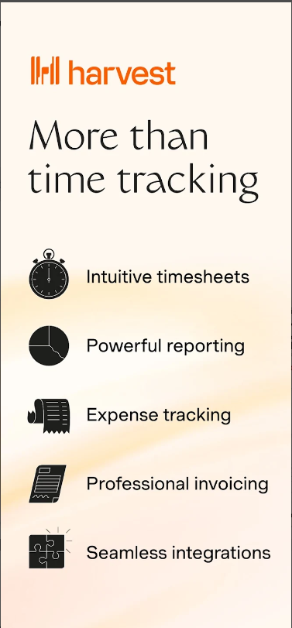

Figure 8: A list of Harvest’s features

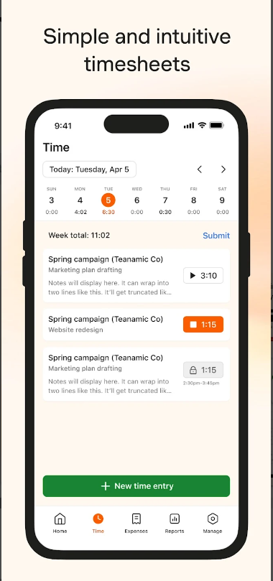

Figure 9: Harvest’s timesheet feature

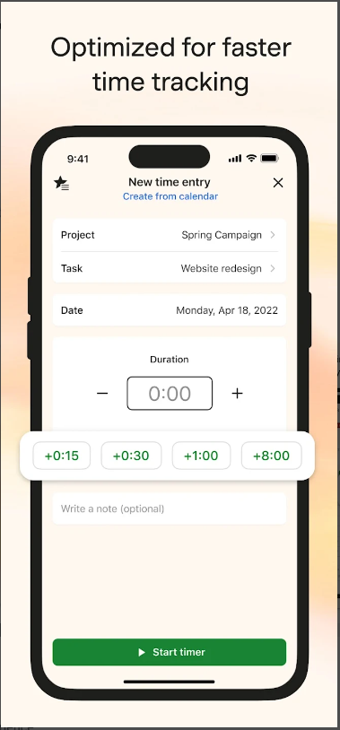

Figure 10: Harvest’s time capturing feature

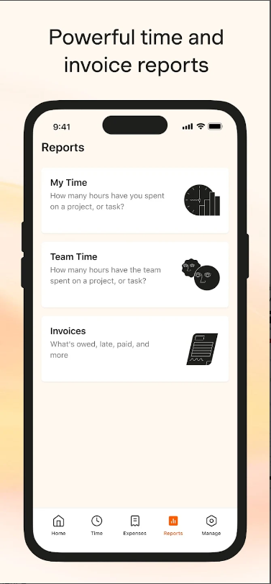

Figure 11: Harvest’s report selection feature

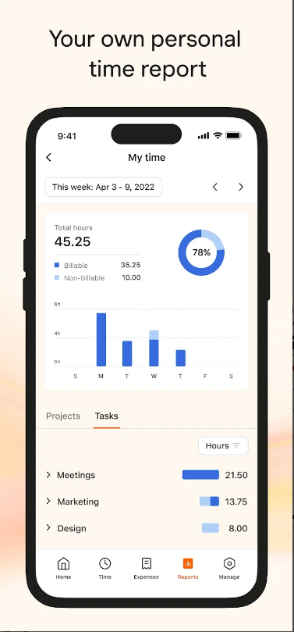

Figure 12: Harvest’s personal time report feature

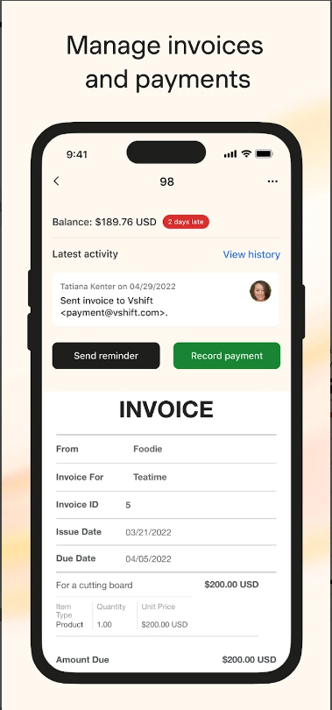

Figure 13: Harvest’s invoice and payment feature

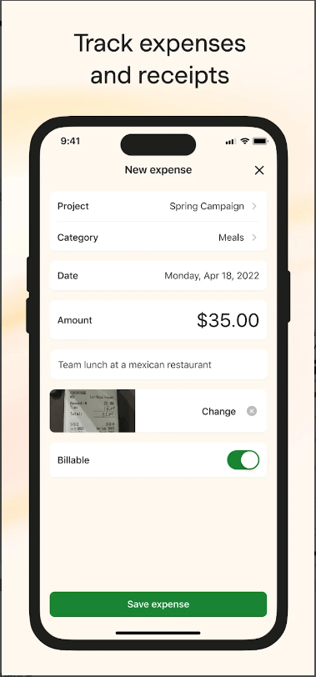

Figure 14: Harvest’s expense and receipt feature

Figure 15: Harvest’s device synchronization feature

### Strengths

1. Harvest distinguishes itself with its comprehensive feature set, providing time tracking, invoicing, and cost management all in one platform (Software Advise, n.d.). This extensive range of features minimises the requirement for several tools, streamlining the user's workflow (Bancu, 2024).
2. The application interfaces with other project management and accounting tools such as QuickBooks, Asana, and Slack (Harvest, n.d.). This connection guarantees that users can continue using their current processes while taking advantage of Harvest's features (Software Advise, n.d.).

### Weaknesses

1. Harvest’s capabilities are relatively restricted and lacking in the project management department, causing many users to find working with projects annoying and difficult (Bancu, 2024).
2. Harvest has a less satisfactory user experience due to it having an outdated user interface and many performance issues (Bancu, 2024).
3. Harvest's pricing structure may be a challenge for individual users or small teams with limited financial resources (Harvest, n.d.). The free tier provides limited features, while a subscription unlocks the full range of services (Harvest, n.d.).

### Innovative Features

1. Harvest streamlines billing by offering in-app invoicing and payment tracking features (Harvest, n.d.). Users may create invoices using monitored time and expenses, submit them from the app, and track payment statuses, simplifying the entire billing process (Opijnen, 2023).
2. Harvest has several integrations with accounting and payment software, enabling online payments and automated invoice generation through the app, simplifying the entire accounting process (Harvest, n.d.).

## App 3: Clockify

### Overview

Clockify is a flexible tool for monitoring time and managing timesheets, suitable for teams of all sizes without incurring significant costs (Stojanovic, 2024). It is known for providing a wide range of time monitoring functions for free (Clockify, n.d.) This platform was created to make it easy to track labour hours on various projects, with a user-friendly layout that encourages simplicity and productivity (Qureshi, 2024).

The following figures, taken from Google Play (n.d.), depict some examples of Clockify’s features:

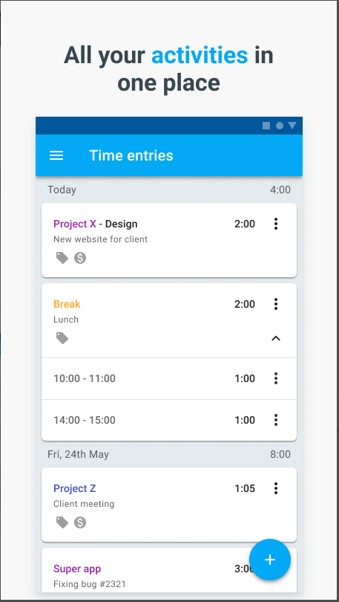

Figure 16: Clockify’s time entries feature

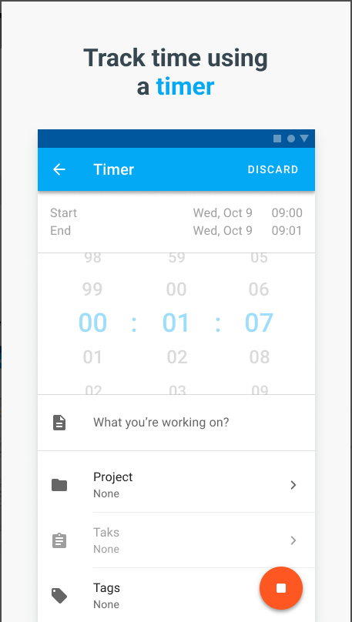

Figure 17: Clockify’s time capturing feature

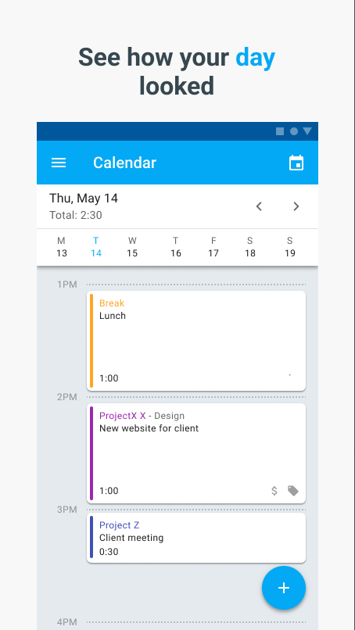

Figure 18: Clockify’s calendar feature

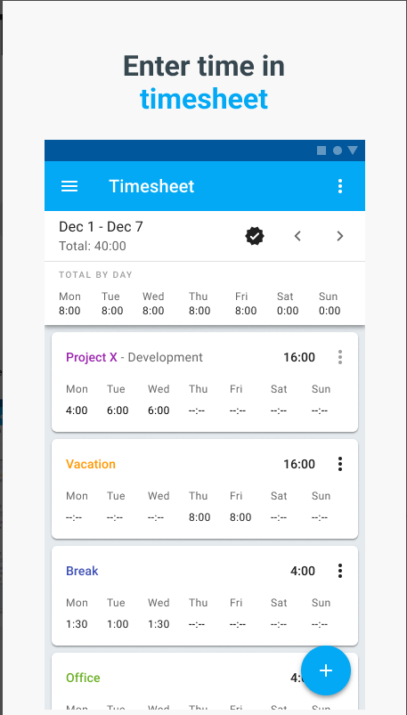

Figure 19: Clockify’s timesheet feature

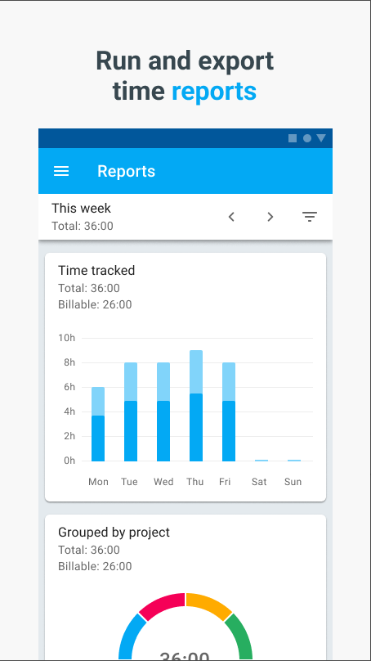

Figure 20: Clockify’s reporting feature

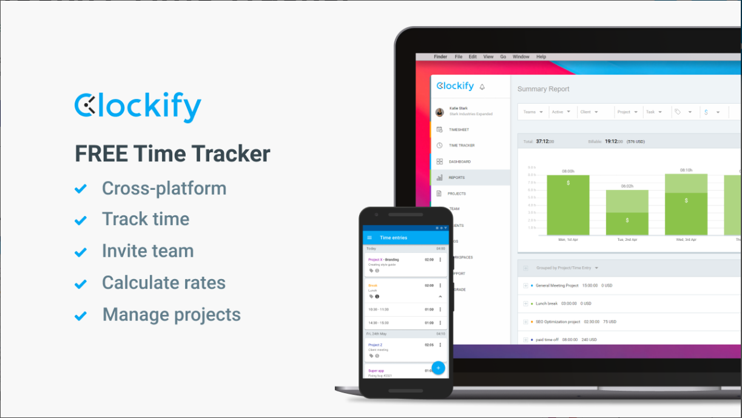

Figure 21: A list of Clockify’s features

### Strengths

1. Clockify's main benefit is that it provides basic time monitoring features for free, which makes it available to a wide range of users, such as startups and non-profit organisations (Holznienkemper, 2023).
2. Clockify prioritises simplicity, allowing users to effortlessly switch between tasks and projects, minimising the usual challenges of using time management applications (Coguric, 2023).

### Weaknesses

1. To access advanced features on Clockify, a subscription is required, while the fundamental capabilities are available for free (Clockk, 2023). For larger teams requiring more than the essentials, this paradigm could lead to substantial expenses (Holznienkemper, 2023).
2. Clockify has fewer third-party connectors/integrations than its rivals, potentially restricting its usefulness for those that depend on a wider range of productivity tools (Kanai, 2023).
3. The GPS time tracking functionality of Clockify may cause trust and privacy issues as some team members may deem it intrusive (Bancu, 2024).

### Innovative Features

1. Clockify offers a real-time dashboard tool that gives customers an instant overview of current tasks and productivity levels, enabling prompt modifications and insights (Ginn, 2024).
2. Clockify provides GPS-enabled time tracking functionality, automatically logging the hours a user spends at a particular location (Bancu, 2024). This enables verifiable client site visits, enhancing client transparency; allows for appropriate billing for the time spent at each site; and reduces travel related fatigue (Bancu, 2024).
3. Clockify has a feature called Kiosk which allows users to start and end their work shifts by entering a pin code from a shared device (Clockify, n.d.). This feature simultaneously tracks attendance and displays who is currently clocked in and what task they are working on (Clockify, n.d.).
4. The ability to customise reports according to specific user or team needs stands out as a particularly innovative feature as it enables detailed analysis and tracking of time spent on projects (Clockify, n.d.).

# Comparison of the Researched Apps

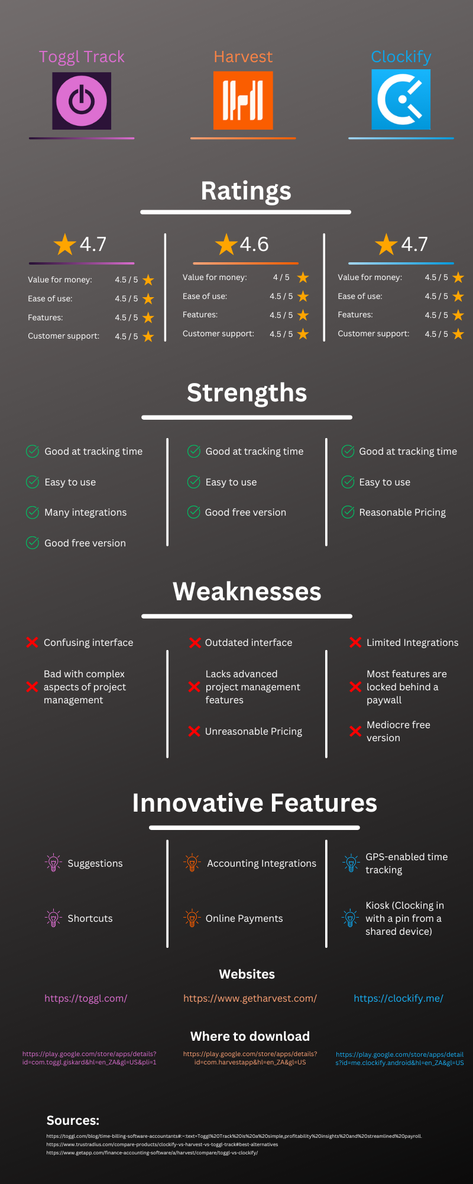

Figure 22: An infographic comparing Toggl Track, Harvest, and Clockify

# Best Features we Aim to Include

To create a time management app, much consideration must be given to selecting features that fulfil essential functions and improve user satisfaction. Below are the best features (excluding the basics) gathered from our research, that we want to include in our app, alongside explanations regarding why they are advantageous:

## Offline Tracking

This ensures that users can track their time even when they are not connected to the internet (Google Play, n.d.). Once a connection is re-established, their progress and data will be resynced with their account (Google Play, n.d.).

## Time Rounding

This enables time entries to be rounded up or down to the nearest interval, allowing for better time capturing experience and a simpler display of the entry (Toggle Track, n.d.).

## Marking entries as billable

This not only provides an indication on what activities are generating revenue but can also provide better organization and sorting of time entries (Toggle Track, n.d.).

## Marking entries as a favourite

By favouriting an entry or project, not only can it provide better organization and sorting of time entries but can also create a shortcut that enables faster and easier access to that favourited entry (Google Play, n.d.).

## Widgets

This will enable users to place widgets on their screen, which will allow them to start, stop and view their timer without opening the app (Google Play, n.d.).

## Timer Notification

Similar to widgets, the user will be able to view, start, and stop their timer from through their status bar, without having to open the app (Google Play, n.d.).

## Reminders

This feature will send push notifications or reminders to users who have not tracked or reached their desired daily or weekly goals of hours worked (Toggle Track, n.d.).

## Having a timeline

This feature will assist in providing the user with an accurate record of their time entries by tracking and displaying the order in which their entries were recorded (Toggle Track, n.d.).

## Locked time entries

This will prevent time entries from being altered after a certain date and time, ensuring that reports are accurately completed and not maliciously tampered with (Toggle Track, n.d.).

## Having a completely free application

The purpose of this feature is to ensure that anyone can have and access the application without a fee, preventing any hinderance to teams or individuals.

# Conclusion

In conclusion, this study did an in-depth examination of three existing time tracking apps, pinpointing their characteristics, strengths, weaknesses, and innovative features. This study additionally highlighted the importance of user experience, integration capabilities, and unique features and how they all contribute to an applications success. These analytical findings suggest a design plan for a new app that includes the recognised best practices to enhance productivity and user engagement. This design will be further explored and presented in our design document. Furthermore, this method showcases a careful combination of analytical assessment and practical application design, establishing a basis for developing a user-focused and feature-packed time tracking application.

# References

Bancu, L., 2024. *Top 20 Time Tracking Software for Consultants.* [Online]   
Available at: https://www.paymoapp.com/blog/time-tracking-consultants/

[Accessed 09 March 2024].

Clockify, n.d. *Features.* [Online]   
Available at: https://clockify.me/features/  
[Accessed 09 March 2024].

Clockk, 2023. *Toggl Track Pros and Cons.* [Online]   
Available at: https://clockk.com/alt/toggl-track-pros-and-cons-2023  
[Accessed 09 March 2024].

Coguric, T., 2023. *Importance of time management + 10 time management tips.* [Online]   
Available at: https://clockify.me/blog/productivity/importance-time-management/  
[Accessed 09 March 2024].

Czerwonka, E., 2024. *Best Online Work Timer Clocks.* [Online]   
Available at: https://buddypunch.com/blog/work-timer/#Toggl-Track  
[Accessed 09 March 2024].

Dias, E., 2024. *Toggl Review: Pros & Cons of Using Toggl Track in 2024.* [Online]   
Available at: https://clickup.com/blog/toggl-review/  
[Accessed 09 March 2024].

gdprinfo, 2023. *Best Time Tracking Software: Boosting Productivity and Efficiency.* [Online]   
Available at: https://gdprinfo.eu/best-time-tracking-software-boosting-productivity-and-efficiency  
[Accessed 09 March 2024].

Ginn, D., 2024. *Clockify Review.* [Online]   
Available at: https://www.cloudwards.net/clockify-review/  
[Accessed 09 March 2024].

Google Play, n.d. *Clockify Time Tracker.* [Online]   
Available at: https://play.google.com/store/apps/details?id=me.clockify.android&hl=en_ZA&gl=US  
[Accessed 06 March 2024].

Google Play, n.d. *Harvest: Track Time & Invoice.* [Online]   
Available at: https://play.google.com/store/apps/details?id=com.harvestapp&hl=en_ZA&gl=US  
[Accessed 06 March 2024].

Google Play, n.d. *Toggl Track - Time Tracking.* [Online]   
Available at: https://play.google.com/store/apps/details?id=com.toggl.giskard&hl=en_ZA&gl=US&pli=1  
[Accessed 09 March 2024].

Harvest, n.d. *Invoicing & Payments.* [Online]   
Available at: https://www.getharvest.com/features/invoicing-and-payments  
[Accessed 09 March 2024].

Harvest, n.d. *Pricing.* [Online]   
Available at: https://www.getharvest.com/pricing  
[Accessed 09 March 2024].

Holznienkemper, L., 2023. *Clockify Review 2024: Features, Pros & Cons.* [Online]   
Available at: https://www.forbes.com/advisor/business/software/clockify-review/  
[Accessed 09 March 2024].

Jibble, 2024. *5 Ways Toggl Track is Great.* [Online]   
Available at: https://www.jibble.io/reviews/toggl/5-ways-toggl-track-is-great/  
[Accessed 09 March 2024].

Kanai, P., 2023. *The Pros and Cons of Using Clockify Software.* [Online]   
Available at: https://projectmanagers.net/the-pros-and-cons-of-using-clockify-me-software/  
[Accessed 09 March 2024].

Opijnen, E. v., 2023. *Project Management Software With Invoicing: Top 15 Tools to Accelerate Cashflow.* [Online]   
Available at: https://www.getrodeo.io/blog/project-management-software-with-invoicing  
[Accessed 09 March 2024].

Qureshi, A., 2024. *Honest Review: Clockify.* [Online]   
Available at: https://www.jibble.io/reviews/clockify/  
[Accessed 09 March 2024].

Software Advise, n.d. *Harvest.* [Online]   
Available at: https://www.softwareadvice.com/za/project-management/harvest-profile/  
[Accessed 09 March 2024].

Stojanovic, M., 2024. *How to explain the need for time tracking to your team.* [Online]   
Available at: https://clockify.me/blog/business/explain-time-tracking/  
[Accessed 09 March 2024].

Time Analytics, 2023. *Toggl Track Pricing Guide for 2024.* [Online]   
Available at: https://timeanalyticssoftware.com/toggl-track-pricing/  
[Accessed 09 March 2024].

Timeular, 2023. *The 10 Best Project Cost Management Software in 2024.* [Online]   
Available at: https://timeular.com/blog/best-project-management-software/  
[Accessed 09 March 2024].

Toggle Track, n.d. *Toggle Track Features.* [Online]   
Available at: https://toggl.com/track/features/  
[Accessed 09 March 2024].