Damian Dare
Student Number: ST10019838
PATHWAY: PROG7312
Lecturer: Dr. Nobubele Shozi
18 November 2024

POE - Report
Table of Contents

1. INTRODUCTION 3
2. IMPLEMENTATION REPORT 4
2.1. Basic Tree Explanation 4
2.2. Graph Explanation 8
3. PROJECT COMPLETION REPORT 15
3.1. What was completed during the project 15
3.2. Challenges faced and how I overcame them 16
3.3. Key learnings acquired, including skills, problem solving approaches and programming techniques 21
4. TECHNOLOGY RECOMMENDATIONS 23
5. CONCLUSION 30
REFERENCE LIST 31

TABLES, DIAGRAMS AND FIGURES
Figure 1: Example of a basic tree 5
Figure 2: A visual representation of the basic tree implemented 6
Figure 3: Example of the display from the implemented basic tree 6
Figure 4: Example of a basic graph 8
Figure 5: Visual representation of the different directions of graph edges 9
Figure 6: Visual representation of weighted and directed of graph edges 10
Figure 7: Visual representation of the implemented graph 11
Figure 8: Example of the display from the implemented graph 13

1. INTRODUCTION
Welcome!

This document contains the final conclusive report to the PROG7312 POE. Here, the data structures that were implemented in Part 3 and how they contribute to the efficiency of the “Service Request Status” feature will be discussed under the “IMPLEMENTATION REPORT” section; the challenges that I faced and how I overcame them, in addition to the key learnings I acquired throughout the project will be discussed under the “PROJECT COMPLETION REPORT” section; and finally, my suggested recommendations of technologies that can improve upon the municipality application we will discussed under the “TECHNOLOGY RECOMMENDATIONS” section.

2. IMPLEMENTATION REPORT
The “Service Request Status” feature was required to comprise of two very important components being:
- A component that provides an efficient mechanism the retrieval and organization of service request information.

- A component that manages and optimizes the display of the service request status.

For the first component, out of the available options to choose from being Basic Trees, Binary Trees, Binary Search Trees, AVL Trees and Red-Black Trees, the one that stood out as most optimal was the Basic Tree.

For the second component, out of the available options to choose from being Heaps, Graphs, Graph Traversal and Minimum Spanning Trees, the one that stood out as most optimal was the Graph.

2.1. Basic Tree Explanation
- Background on data structure
According to Jamro (2018), a basic tree consists of multiple nodes, all originating from one root node. Additionally, each node contains a parent apart from the root node (Jamro, 2018). In a basic tree, each node can have any number of child nodes (Jamro, 2018). Nodes without children are known as leafs and child nodes that have the same parent node are siblings (Jamro, 2018). The following figure depicts an example of a basic tree.

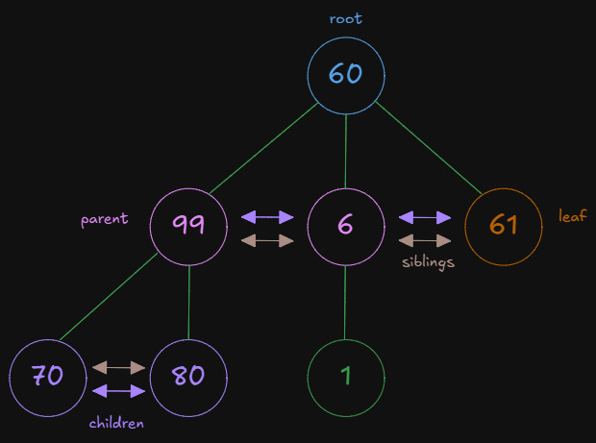
Figure 1: Example of a basic tree

The reason why a basic tree was chosen was because there are no rules that govern the relationships between nodes, enabling us to utilize the basic tree to create an accurate representation and implementation of the service request data that would be stored, sorted, and managed, ensuring the data following a natural and logical hierarchy.

- Implementation of data structure
My approach to implementing this data structure is as follows. The primary role and purpose of this basic tree is to sort, search and display service requests by their category. To do this, each node in the tree contains a list of all service requests that pertain to a certain category, e.g. IT or Transportation, all apart from the root node which contains a list of all service requests to ensure there is an easier source of data to search through and find / track a service request. The current basic tree implementation will never have a height of more than 2 as the first level will be the root and the second level will be all the categories of service requests that stem from the root. The following figure depicts this basic tree implementation and how the service request data is broken and sorted by their categories.

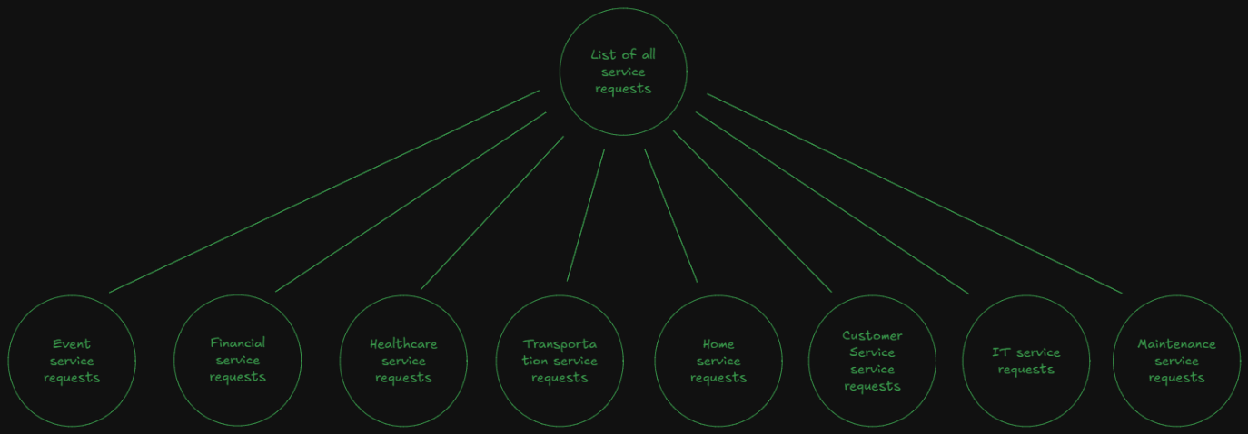
Figure 2: A visual representation of the basic tree implemented

The following figure depicts an example of how this data structure is implemented in the application.

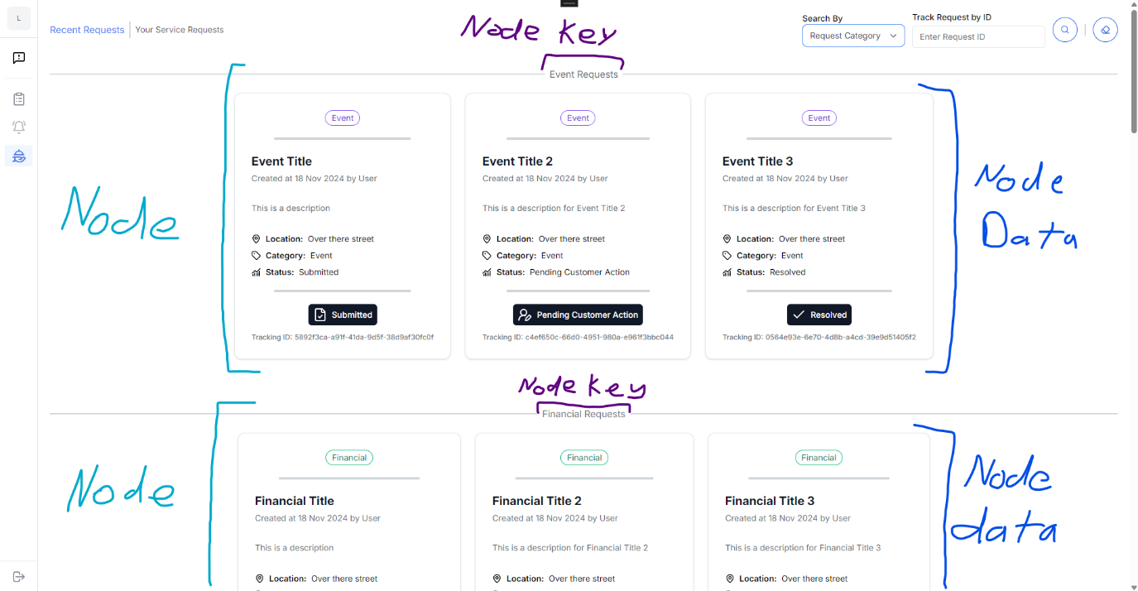
Figure 3: Example of the display from the implemented basic tree

In the implemented data structure, each node is comprised of two main components being the key, which indicates the category of service requests that the node stores, and the data, which is all the service requests belonging to a specific category. In the above figure, the two nodes and their data being displayed on screen are the “Events” and the “Financial” nodes. Thanks to the natural and logical hierarchy of the implemented basic tree, we are able efficiently and easily display all the appropriate data in an aesthetically pleasing manner by simply retrieving each of the second level nodes in the tree then rendering out its corresponding data, using the nodes key to form a section header and using the nodes data to show each of the service requests in a card format.

The way in which this tree data structure contributes to efficiency is best explained by OpenAI (2024) and aayushi2402 (2024a). The following list contains these explanations.
- Trees offer a more space-efficient method of storing and managing hierarchical data structures than linear data structures such as arrays or linked lists (OpenAI, 2024).

- There are several proven and efficient tree-based algorithms, like binary search for example, that can be utilized to enhance the efficiency the applications data processing and manipulation capabilities (OpenAI, 2024).

- Trees are particularly efficient at data manipulation, data retrieval, data searching, data insertion, and data deletion (aayushi2402, 2024a). Although it is not as good as hashing, trees are still better than arrays and linked lists whilst providing other efficient advantages such as sorted data and searching for the floor and ceiling of data (aayushi2402, 2024a).

- The hierarchical representation of data provided by trees makes organization and navigation of data much more efficient (aayushi2402, 2024a).

- The recursive nature of trees provides an easier and more efficient way to traverse and manipulate data (aayushi2402, 2024a).

- The natural hierarchical organization of trees provides an efficient way to representing a diverse range of data and relationships, ensuring any and all data is properly managed (aayushi2402, 2024).

- Trees have the ability to grow and shrink dynamically by simply adding and removing nodes, which makes them efficient and effective at handling the size of data that may change over time (aayushi2402, 2024).

2.2. Graph Explanation
- Background on data structure
According to Jamro (2018), a graph is a data structure that comprises of nodes (also called vertices), which are basically points that contain the data, and edges which are the connections between each node. Typically, the graph data structure does not require any rules about how the nodes should be connected (Jamro, 2018). The following diagram depicts a basic graph data structure, that colour codes the nodes (green) and edges (blue) to provided clarity and assist in its understanding.

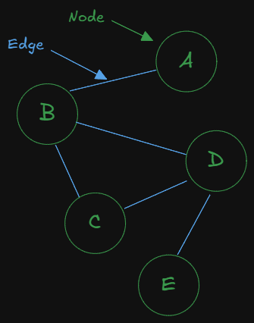
Figure 4: Example of a basic graph
Jamro (2018) continues by explaining that there is more depth to creating the edges (connections) between each node in a graph, specifying that an edge can contain a direction and or a weight / cost. If an edge contains a direction, it is referred to as a directed edge, and if it contains a weight, it is referred to as a weighted edge (Jamro, 2018).

The direction of an edge indicates a traversal direction, which describes how the graph should be traversed and how to travel between specific nodes (Jamro, 2018). Furthermore, an edge can be either undirected, which is essentially a bidirectional edge that allows travel between both nodes in both directions, or directed, which indicates the specific direction in which nodes can be travelled (Jamro, 2018). It is important to note that a directed edge and be bidirectional (Jamro, 2018). If a graph contains these directed edges, it can then be named a directed graph (Jamro, 2018). The following diagram depicts these types of edges.

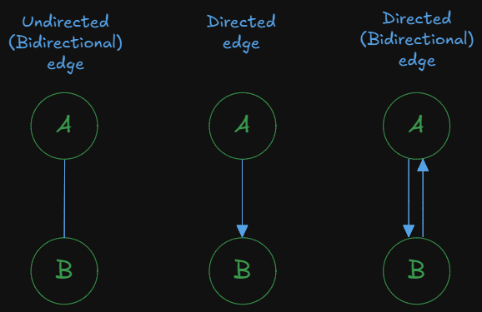
Figure 5: Visual representation of the different directions of graph edges

The weight of an edge on the other hand, specifies the cost of travelling between nodes (Jamro, 2018). If a graph contains these weighted edges, it can then be named a weighted graph (Jamro, 2018). The following diagram depicts an example of these weighted edges.
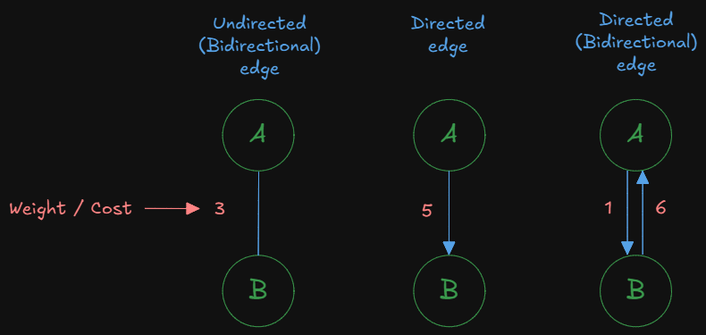
Figure 6: Visual representation of weighted and directed of graph edges

Jamro (2018) provides several useful examples to assist in the understanding of the use cases of a graph. One example is storing the structure of friends in social media (Jamro, 2018). In this example, each node represents a contact / person, and each edge represents the relationship between certain people (node) (Jamro, 2018). In this scenario, an unweighted and undirected graph is utilized (Jamro, 2018). Another example provided by Jamro (2018) is that of a map, utilizing a directed and weighted graph to calculate the shortest path between two points. In this example, each node represents a point on the map, each directed edge represents the roads and how they can be travelled, and each weight represents the time (cost) it takes to travel down that road (Jamro, 2018).

- Implementation of data structure
After conducting some research to understand how the status aspect of service requests work and after OpenAI (2024) indicated the different types of request status, I discovered there is not only a bunch of different states (statuses) the request can be in, but there is also a flow as to how one status move from one state to another. My initial discoveries of the statuses and flows were:
- The basic process: Submitted -> Assigned -> In Progress -> Resolved
- The “other” statuses (States): On Hold, Pending Customer Action, Escalated, Cancelled, Closed, and Reopened.
The basic flow is easy to comprehend and implement as it moves it simply moves from “Submitted” down the chain until the service request is “Resolved”. However, after factoring in the other statuses (such as “On Hold”, “Escalated”, “Cancelled”, etc) and figuring out how and where they fit within the basic flow, both the flow and its relationships got rather complex. The following figure depicts complex flow of the service request status process.

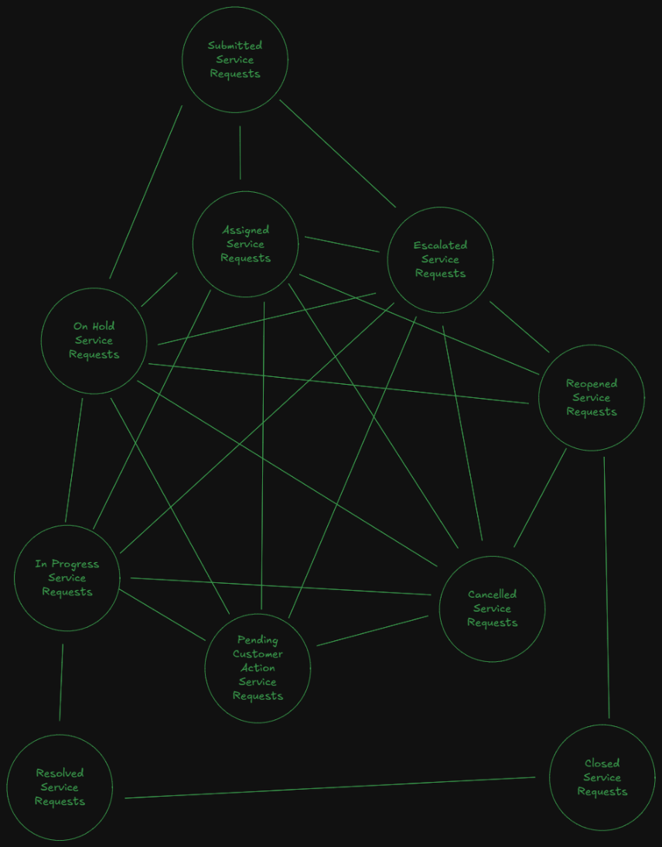
Figure 7: Visual representation of the implemented graph

Notice how the above flow looks very similar to that of a graph. That’s because it is a graph. A service request will start in the “Submitted” status (node) and move (traverse) through the flow (the graph) from status (node) to status (node) until the service request has been “Resolved” (node) and then “Closed” (node). This graph, however, is not a weighted graph as there are no meaningful, useful, or consistent weight / cost of moving between nodes, and is not a directional graph as the complexity of the flow requires a status to be able to change / move in any direction.

For example, a service request is currently “Assigned” to someone to be completed. But then that someone has other responsibilities and cannot complete the request, moving the service request to “On Hold” until the service request can be re- “Assigned” to someone else. This process is Assigned -> On Hold -> Assigned.

Another example is another service request is also currently “Assigned” to someone but then that someone requires further information to complete the request, then in which the request is moved to “Pending Customer Action”. As that person still does not know how to proceed after customer provides some action, the service request moves to “On Hold” until someone figures out what to do. But by the time the problems get resolved and can finally be continued, another person could be assigned to complete the service request. This process is Assigned -> Pending Customer Action -> On Hold -> Assigned.

Ultimately, the graph data structure was chosen to accurately represent the service request status flow whilst providing the necessary tools to manage and organize the complicated data that will arise from the complex situations and relationships during the service request status flow that is depicted in Figure 7. Additionally, this graph implementation will ensure that all scenarios and complex situations can be handled and not cause errors within the application.

The primary role and purpose of this graph data structure is to sort, search and display service requests by their status. The way in which this graph is utilized in the application is that each node contains a list of all service requests of that status. For example, the “Submitted” node contains a list of all service requests with the status of “Submitted” and the “Assigned” node contains a list of all service requests with the status of “Assigned”. This is done for better organization of the service request data and to make it easier for the application to display the service requests of a particular status to the users. The following figure depicts an example of how this data structure is implemented in the application.

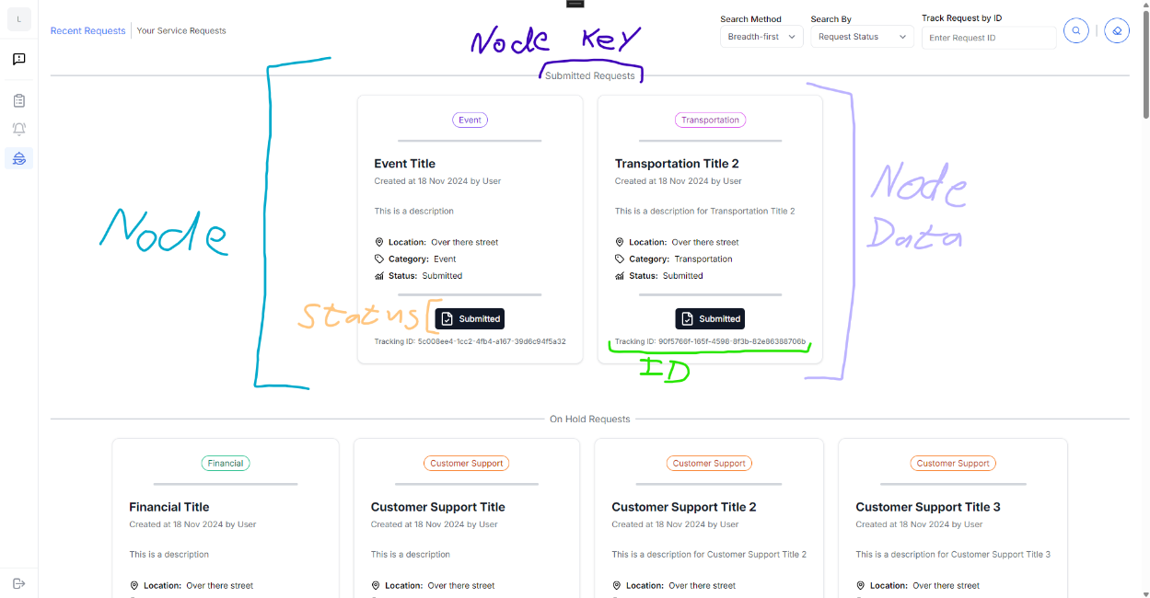
Figure 8: Example of the display from the implemented graph

In the implemented data structure, similar to the basic tree that was implemented, each node is comprised of two main components being the key, which indicates the status of service requests that the node stores, and the data, which is all the service requests in a specific status. In the above figure, the two nodes and their data being displayed on screen are the requests that are in the “Submitted” and the “On Hold” statuses. The efficient and logical structure of the graph allows us to easily display all the appropriate data in an aesthetically pleasing manner by simply traversing the graph and rendering out the corresponding data of each node along the way, using the nodes key to form a section header and using the nodes data to show each of the service requests in a card format.

Unlike the basic tree implemented, there is a feature that enables users to select a method of how the graph should be searched, traversed and displayed. These options that a user a can select include the Breadth-First Search (BFS) method or the Depth-First Search (DFS) method. As the graph has quite a few complex relationships and edges, the difference between the BFS and the DFS methods are very minor. Although probably not practical in a production environment, I thought the ability to allow the user to select how the graph is traversed would be a nice touch for the user whilst demonstrating functionality and understanding. This functionality is displayed in the part 3 tutorial video.

The way in which this graph data structure contributes to efficiency is best explained by Jamro (2018), OpenAI (2024) and aayushi2402 (2024b). The following list contains these explanations.
- Graphs can efficiently represent, manage, and organize diverse data (Jamro, 2018).

- Graphs are able to efficiently represent complex data and can assist in identifying patterns, trends, and insights that may have been difficult to detect using other conventional methods (aayushi2402, 2024b).

- Graphs also contribute to efficient data processing as there are efficient graph specific algorithms that can be utilized to perform quick and complex operations on large datasets (aayushi2402, 2024b).

- The visualization capabilities of graphs make it easier to communicate complex data and relationships, whilst also being useful for presentations, reports and even data analysis, all assisting and contributing to efficient communication (aayushi2402, 2024b).

- Graph algorithms often allow for parallel processing which not only enables faster computation times but also enhances computation efficiency (OpenAI, 2024).

- Graphs can efficiently cluster and classify data points which can aid in data analysis and can improve decision making processes (OpenAI, 2024).

3. PROJECT COMPLETION REPORT

3.1. What was completed during the project
For this project, our objective was to develop a C# .NET Framework application with the intent of streamlining municipal services in South Africa, providing and efficient and user-friendly platform that citizens can access and request services.

For Part 1 of the project, we had to research user engagement strategies to better understand what they are, then choose the strategies that will be most applicable and useful to drive user engagement in the municipality application, which will then later be implemented in the application. Additionally, we started developing the municipality application by creating the “Issue Reporting” feature, which included a form (consisting of a location input, a category selection, a description box, an optional media attachment, an engagement feature, and a submit button) to report issues and a page to display them.

For Part 2 of the project, we extended the functionality of the application by creating and adding the “Local Events and Announcements” feature which displays upcoming local events and announcements to users in a pleasing manner, enabling users to search and find events and announcements based on categories and dates. Additionally, we had to create an algorithm or utilize a data structure to recommend events and announcements to users based on their analysed user search patterns and preferences.

For the final part (Part 3) of the project, we closed out the functionality of the municipality application by implementing the “Service Request Status” feature that involved using appropriate data structures, such as trees and graphs, to efficiently organize, manage, retrieve and display service requests and their statuses to the users, additionally enabling users to track the progress of their service requests by incorporating and adding unique identifiers to service requests. Furthermore, we created reports about the implemented data structures implemented in Part 3, the completion and learnings from the project, and any technological suggestions to improve the application.

3.2. Challenges faced and how I overcame them
This entire project provided us with exposure to several unique challenges that required us to learn, understand, and implement new concepts that are important in the IT industry. Here are my personal challenges that I faced, and how I overcame them.

For Part 1:
- Challenge 1
Understanding what user engagement strategies are, what are some examples of them, and choosing which engagement strategies would be most appropriate / useful for the municipality application.

- Solution to Challenge 1
This challenge was overcome by conducting informal research and finding and reading through as much online content as possible to enhance my understanding and decision-making processes.

- Challenge 2
Understanding the different types of categories that a reported issue can have.

- Solution to Challenge 2
This challenge was overcome by conducting research and reading as much online content as possible.

- Challenge 3
Displaying the files (in app) that were uploaded for reported issues.

- Solution to Challenge 3
This challenge was overcome by simply not displaying them as it wasn’t a requirement. I spent hours, if not days, reading through countless articles and solutions, trying my absolute best to get the feature working, however, I simply could not find a valid working solution. The furthest I got in this was that the files were never being displayed right after reporting an issue but were only properly displayed after restarting the application. In the end, I thought it would be best not to “roll out” and submit the feature as it’s never good practice to distribute a faulty feature, fully knowing in advance that it does not work.

For Part 2:
- Challenge 4
Understanding how priority queues worked and how to implement them in C#.

- Solution to Challenge 4
This challenge was overcome by intensely reading through the textbook and external sources online to better understand the data structure.

- Challenge 5
Figuring out how I would approach making the “recommendation” algorithm that recommends and displays local events and announcements to users based on their searches.

- Solution to Challenge 5
This challenge was overcome by dissecting the problem into its basic components then following the flow of how they all come together. After breaking down the problem, I realised that a recommendation feature based on user searches, at its core, involves simply counting and keeping track of the users’ searches, then finding data that matches and aligns with the users’ most searched for content / data. From there, I chose to implement a priority queue data structure as it can not only keep a count of the users’ searches but can also order them, enabling easier identification of users’ most searched for data.

For Part 3:
- Challenge 6
Understanding what a service request is and the different statuses it can be in.

- Solution to Challenge 6
This challenge was overcome by researching and reading content online.

- Challenge 7
Understanding what tree data structures and graph data structures are and how to implement them in C#.
- Solution to Challenge 7
This challenge was overcome by reading through the textbook and consuming as much online content as possible.

- Challenge 8
Deciding which data structures would best be suited to create the service request status feature.

- Solution to Challenge 8
This challenge was overcome by first breaking down what needed to be stored; then understanding the different statuses and data required to make a service request and how they all connect; then drawing / diagramming out the connections and relationships to visually understand how the data will be structured and to see which data structure can best and accurately represent it. From there, I found that the best data structures to use were basic trees and graphs.

Throughout the entire project:
- Challenge 9
Understanding what the Poe required of me and understanding what needed to be done.

- Solution to Challenge 9
This challenge was overcome by pestering the lecturer with non-stop questions, getting the opinions and perspective of friends and conducting research on existing municipality applications.
- Challenge 10
Finding and figuring out how to adhere to the best and proper programming standards for the .NET application.

- Solution to Challenge 10
This challenge was overcome by reading articles online to try and find the best approaches to certain areas.

- Challenge 11
Figuring out how the data can best be displayed to the users.

- Solution to Challenge 11
This challenge was overcome by reading through online content and visually looking at several different examples and approaches online.

Overall conclusions:
Throughout the entirety of this project, majority of the challenges I encountered boiled down to understanding what needed to be done and understanding how do it. Surprisingly enough, the solution to most of these challenges was to simply just read through as much content as possible. There were a few instances where this was not the case, with certain challenges requiring deeper thinking and occasionally stepping away from the computer before breaking something, however, outside of all of that, I am satisfied with the challenges I encountered and how I worked to solve them.

3.3. Key learnings acquired, including skills, problem solving approaches and programming techniques
As mentioned prior, this entire project provided us with exposure to several unique challenges and in doing so, we were able to learn, understand, and implement new concepts that are important in the IT industry. The following indicates my key learnings from this project.

For Part 1:
- How to make a C# form using data annotations and validations
- How to work with files and file streams in C#
- How to combine several techniques and technologies like JavaScript, HTML and C# to create an application
- How to start / run scripts when an application starts in C#
- How to create a container that manages state (state container) and then register it as a service so that the entire application can access and utilize it in a C# application
- How to add tailwind css to a C# blazor hybrid project

For Part 2:
- How to make a recommendation algorithm using priority queues to count and provide the most searched data
- How stacks, queues and priority queues work and how to implement them in C#
- That there is so much diversity and creativity in programming that concepts can be utilized in unique ways with a little bit of creativity and outside of the box thinking

For Part 3:
- What tree data structures are and how to implement them in C#
- What graph data structures are and how to implement them in C#

Throughout the entire project:
- How to dissect a problem into its basic components and then use those components and its connections / relationships with one another to solve the problem
- How to ask the right questions / provide the right prompts to AI to assist in learning and understanding key concepts such as algorithms and data structures
- How to see and develop an application from the user’s perspective to ensure the application is developed in an efficient manner and provides a positive and impactful experience
- How to reflect on previous work and use those reflections to improve your work for the future

Overall conclusions:
The POE required out of the box thinking to choose and implement data structures that best fit the task at hand, which provided unique opportunities and repetitions to enhance my problem-solving skills whilst ultimately learning something new. Additionally, with the amount of research and reading I had to do to try and understand everything, I may have actually improved my reading ability and focus skills a little bit.

4. TECHNOLOGY RECOMMENDATIONS
This section will discuss my thoughts on the areas that can be improved in the municipality application and my recommendations for tools or technologies that I think can best assist in improving these areas. For clarification, any AI that was used in this section was not used to find and generate the areas and technologies would best enhance the municipality application, instead, AI was used to assist in gathering information about my chosen technologies and assisting in elaborating their importance and benefits.

The identified areas that could use improvement in the municipality application include:
- A lack of a database
- A lack of accessibility and portability
- A lack of hosting (conditional)
- A lack of notifications
- A lack of real-time chat functionality
- A lack of an API

- Database
As there wasn’t any requirement mentioned in the Poe, any database implementation would be highly beneficial for the municipality application. This is because it will enable persistent storage of the applications data, allowing users to exit or log out of the application and return later to find their data intact. Additionally, a database will enable users to view and consume the most up to date data that has been posted to the application by other users, such as reported issues, events, announcements and service requests for example. Some databases that could work well with the project include:
- Supabase
Built on top of PostgreSQL, Supabase is an open source, scalable and performant database solution (Wilson, 2022). According to Wilson (2022), some of Supabase’s prevalent features were added to reach feature parity with Firebase. These features, according to Wilson (2022), include:
- Auto Generated API: which will allow for the municipality application to easily consume, query and connect to the database and the other features Supabase has to offer.

- Realtime updates: which will allow users to view changes in data in real time.

- Authentication: which will provide an additional layer of security to the application and its database, ensuring only authenticated users can access and consume the applications resources.

- Edge Functions: which enable serverless functions to be created and deployed globally, at the edge, close to the users, which allows faster and more performant data retrieval.

- Storage: which will enable the storage of files such as images, videos and pdfs. This will be beneficial for the municipality application as it will enhance any features required to upload any information, proof, or visuals in the form of a file, such as the “Report Issues” functionality.

- Firebase
Firebase is a scalable and performant database solution that utilized a document storage system that follows a No SQL approach (Wilson, 2022). According to Wilson (2022), Firebase offers several useful features such as auth, cloud functions and file storage. To view the benefits of Firebase, refer to the above explanation of the benefits of Supabase as, according to Wilson (2022), Supabase’s prevalent features were added to reach feature parity with Firebase.

- SQL Server
According to OpenAI (2024), SQL Server is a Microsoft developed, robust relational database management system (RDBMS) that has several benefits and is used for a variety of reasons, which include reliability, scalability, security, performance, advanced analytics, support and community and backup and recovery. Additionally, SQL Server provides easy integration with other Microsoft products, which will be beneficial for the municipality application as it was developed in .NET (OpenAI, 2024).

Overall, all forementioned databases will do the job, but considering the other features and tools that will be discussed and recommended later, Firebase may be the most optimal to create a unified, consistent, and coherent application.

- Accessibility and Portability
As it currently stands, the municipality application was developed in the .NET framework for the sole purpose of creating a Windows desktop application. For a municipality application, this approach will not suffice. A Windows desktop application will not provide the accessibility and portability that a municipality application requires to make a significant impact and enhancement of its users’ lives and its user experience. For example, if someone wants to check if there have been any accidents in the area before driving home from a night out, they won’t be able to as they simply won’t be carrying around a laptop or a desktop. Additionally, not everyone in the municipality will be fortunate enough to have a laptop or desktop, which will ultimately deprive them of the benefits and access to the application. However, a device that most people in the municipality will have, is a mobile phone. To provide an accessible and portable municipality application, the application must be developed in such a way that it caters for mobile devices. There are three ways to achieve this:
- Develop the same application for mobile devices using the devices native language (Kotlin for Android, Swift for iOS).

- Convert the application to a cross-platform development language and tools that allows you to develop an application once and produce an application for all native devices. Examples include Expo (built on top of React Native), Flutter, .NET MAUI and Blazor Hybrid (combining Blazor and .NET MAUI).

- Convert the application to a web application, which will have no device restrictions, ensuring that any device can access the application at any time. Tools and frameworks for this include Next.js (built on top of React) and Blazor (built on top of ASP.NET) for example.

The first approach, although doable, will not be ideal as it will require more resources and time to achieve. This leaves the most optimal approaches being the second and third approaches mentioned above. No matter which approach is taken, additional work will be required to bring the municipality application to mobile platforms. However, to at least speed up the development process, I would recommend using a Microsoft C# product like .NET MAUI, Blazor Hybrid, or Blazor as it will be easy to convert to (as the application is already developed in C#), will contain familiar tooling, and will maintain a consistent development environment and experience.

- Application Hosting (Conditional)
As forementioned, there are several methods to make the municipality application more accessible, one of which being a conversion from a desktop application to a web application. If this approach is used, it is a necessity that a hosting provider be employed as it will ensure that the application is safely deployed and distributed to its users. Self-hosting can be done, however I personally do not recommend it as it may require more resources, such as time, money, and effort, to set up, manage, and secure.

There are many viable hosting platforms out there such as Vercel, AWS, Netlify and Heroku to name a few (Lee, 2024). For this particular application, I would recommend using Microsoft Azure as it aligns with the recommended C# technologies due to them sharing the similar if not exact tooling, having a similar development experience and being a part of the same ecosystem, being the Microsoft ecosystem.

- Notifications
Notifications are a crucial part of any municipal application as it is essential for notifying users, that are not currently using the application, when anything important happens, such as informing the community of a massive road accident, updating a user on their service request, updating users on any important announcements or alerts like water or power outages, and so much more. The tool I would recommend for this functionality is Firebase FCM (Firebase Cloud Messaging) as it is a reliable and performant cloud-based messaging service that has several SDKs and APIs that enable easy integration (OpenAI, 2024). Therefore, if the application has to be converted to support any other platform (such as web or mobile), Firebase FCM will have enough connections and integrations that will ensure that no matter what happens during development, the notifications functionality will still be provided. Additionally, as Firebase FCM has an SDK for .NET, the municipality application will be able to seamlessly integrate Firebase FCM and provide the desired notification functionality with ease.

- Realtime Chat
Another important feature that is currently missing from the municipality application is the ability to chat or send messages in real time to other users and essentially have a discussion online. OpenAI (2024) suggests several reasons as to why this will be important to the municipality application. These reasons, indicated by OpenAI (2024), include:
- Instant Communication: which will be beneficial in emergency situations, speeding up issue resolution, and providing residents with immediate assistance and information.
- Enhanced Engagement: as it provides a direct channel for residents to ask questions, report any issues, provide feedback to other residents, or seek information. Not only does this assist in fostering a sense of community among the residents, but it also contributes the municipality application’s goal of having high level of user engagement (as discussed in Part 1 of the Poe).

- Efficient Issue Resolution: as residents can report issues and complaints in real time, the proper authorities can respond faster and more efficiently, allowing for faster response times and improved service delivery.

- Personalized Assistance: as users can receive personalized responses to their requests or queries.

- Feedback and Insights: as the chat feature will enable real time feedback and insights to be provided, not only improving services but also addressing community concerns.

- Accessibility: as it provides users with another means of interacting with other users on the application.

The tool that I would recommend be utilized for this application is Firebase as it contains all the required features needed to build the chat functionality, being a real-time database, authentication, cloud functions or cloud APIs, cloud storage, and notifications (OpenAI, 2024). Additionally, as some of the other features of Firebase are recommended to improve the functionality of the municipality application, namely a database and notifications, using Firebase will be beneficial as it will assist in the development process as it will enable consistency, coherency and integrability.

- API
APIs are crucial for modern applications as they enable code to be modular, reusable, flexible, and scalable for the purpose creating an interoperable and compatible solution that allows several applications to efficiently communicate with one another (OpenAI, 2024). As it is recommended for the municipality application to support mobile devices, an API would be essential to making this happen, ensuring that no matter which approach is taken, the system as whole will share the same data and work in the same way. Several technologies can be utilised to create an API, being Next.js, Express, ASP.NET and Blazor server to name a few.

The abovementioned API technology recommendations are not a bad choice to use at all, however, in terms of the municipality application, I would recommend that Firebase Cloud Functions be utilized as it aligns with the forementioned recommendations and features, ultimately aligning with the development process and the other tools recommended, whilst providing further consistency and coherency in the application, creating a unified and simple solution to the municipality application.

5. CONCLUSION
In conclusion, this document served as the final report for the PROG7312 POE, discussing the data structures that were implemented in Part 3 and how they contribute to the efficiency of the “Service Request Status” feature; discussing the challenges that I personally faced and how I overcame them, in addition to the key learnings I acquired throughout the project; and finally, discussing my suggested recommendations of technologies that can improve upon the municipality application.

REFERENCE LIST
aayushi2402. 2024a. Advantages and Disadvantages of Tree, 22 October 2024. [Online]. Available at: https://www.geeksforgeeks.org/applications-advantages-and-disadvantages-of-tree/ [15 November 2024].

aayushi2402. 2024b. Applications, Advantages and Disadvantages of Graph, 30 July 2024. [Online]. Available at: https://www.geeksforgeeks.org/applications-advantages-and-disadvantages-of-graph/ [15 November 2024].

Jamro, M. 2018. C# Data Structures and Algorithms. Birmingham: Packt.

Lee, E. 2024. Best 8 Deployment and Hosting for Next.js App, 4 October 2024. [Online]. Available at: https://dev.to/ethanleetech/best-8-deployment-and-hosting-for-nextjs-dip [17 November 20234].

OpenAI. 2024. Chat-GPT (Version 3.5 Turbo). [Large language model]. Available at: https://poe.com/ [Accessed: 14 November 2024].

Wilson, A. 2022. Supabase vs Firebase, 26 May 2022. [Online]. Available at: https://supabase.com/alternatives/supabase-vs-firebase [14 November 202].

