Team Quaternary:

ST10019838 - Damian Dare

ST10019972 - Guillaume Swanevelder

ST10091991 - Christiaan Versfeld

ST10158660 - Ruan Zwarts

Module: XBCAD7319

Lecturer: Ms. Mmaphuti Matau

Documentation: Requirements

Table of Contents

1. REQUIREMENTS 3

1.1. User Roles 3

1.2. User Stories 4

1.3. User Experience Journey Map 21

Maybe add heading for each of the tables

# REQUIREMENTS

## User Roles

* Client / Consumer

The client / consumer is a user whose sole intention is to consume / use our applications services. For example, a customer at a grocery store doesn’t work at said grocery store, but rather purchases goods that the store has to offer. A client / consumer has limited functionality within the system compared to the other user roles. Majority of the systems users will be clients.

* Coach

A coach is a user that organizes and conducts lessons for the clients and assigns levels / ranks to clients to indicate their skill level. This user role is similar to that of a coach in a sports team. A coach has access to both its own functionality as well as the client’s functionality.

* Administrator / Admin

An administrator is a user that will have full access to the application to ensure that everything is running properly. This user role will have access to both of the coach’s and client’s functionality with additional unique features that only administrators can access.

## User Stories

As a user I want to be able to successfully book skill appropriate lessons for a month in advance within a reasonable time frame, so that I can plan and budget my monthly horse-riding costs as well as book suitable time slots (configurable) to fit into my monthly schedule.

**Users:**

|  |  |  |  |
| --- | --- | --- | --- |
|  | **Given** | **When** | **Then** |
| 1) | The user wants to select a lesson date | The user selects a specific date on the calendar component | The user selects the year, followed by the relevant month and lastly the desired booking date  **and**  the system should automatically display the available skill appropriate time slots for the client to select from  **and**  disable to add and edit lessons buttons since this functionality is only available to the systems admin and coaches |
| 2) | The user wants to select an available lesson time slot displayed | The user selects a specific time slot on the displayed lesson component | The following information will be displayed on the screen:   * Detailed description of lesson * Coach’s name with a profile picture * The address of the venue the lesson will take place at * Contact details such as phone number and email address for further enquiries * Payment details to enable for an easy eft of the lesson cost * The Start and end times of the lesson * The Upload proof of payment button to allow for the proof of the eft to be sent * Book a slot to save the slot specified by the user * The payment confirmation indicator will be either red for not yet confirmed or green for confirmed * the select a horse drop down will be for selecting the horse that will be used during the lesson * The pending slots indicator (lesson/s unpaid) give the user an idea of how many people are going to want to attend the selected lesson * The slots taken indicator is the amount of slots taken out of the total number of slots available for the selected lesson |
| 3) | The user wants to view booked lessons displayed in booked section of the screen | When the configured time lapse has passed | The booked lesson is automatically displayed  **and**  subsequent bookings will automatically be displayed after the configured time elapsed |
| 4) | The user wants to view pending booked lessons displayed in booked section of the screen | When the configured time lapse has passed | The pending booked lesson is automatically displayed  **and**  subsequent pending bookings will automatically be displayed after the configured time elapsed |

As a coach I want to be able to successfully add and edit lessons as well as be able to view all participants who are enrolled in a specific lesson, all users and all horses. As a coach I also want to be able to edit the skill level of horses and users.

**Coaches:**

|  |  |  |  |
| --- | --- | --- | --- |
|  | **Given** | **When** | **Then** |
| 1) | The coach wants to select a lesson date | The coach selects a specific date on the calendar component | The coach selects the year, followed by the relevant month and lastly the desired booking date  **and**  the system should automatically display the already created lesson for that specific date  **and**  the add and edit lessons buttons to allow the admin to add or edit selected lessons |
| 2) | The coach wants to see the selected lesson information | The coach selects a specific time slot on the displayed lesson component | The following information will be displayed on the screen:   * Detailed description of lesson * Coach’s name with a profile picture * The address of the venue the lesson will take place at * Contact details such as phone number and email address for further enquiries * Payment details to enable for an easy eft of the lesson cost * The Start and end times of the lesson * The pending slots indicator (lesson/s unpaid) give the admin an idea of how many people haven’t yet paid for the lesson * The slots taken indicator is the amount of slots taken out of the total number of slots available for the selected lesson * The participants as well as selected horses and indicator of exactly which users have paid for the lesson and which haven’t (indicated next to the user with the selected horse) |
| 3) | The coach wants to create a lesson | The coach selects the “Add Lesson” button | A pop-up screen with the following information will need to be entered.   * Date for the lesson * Start time for lesson * End time for lesson * Coach drop down menu to select a coach * Skill level drop down menu to select the skill level of the lesson * Total slots where the total amount of people for the lesson will be added * Payment details where the relevant information about how to pay for the lesson will be added * Contact details where the relevant details of how to contact either an admin or coach about enquiries will be added * Address details where the address of where the lesson will be taking place * The description of the lesson as well as any special notes for the lesson   **and**  A cancel button which will take you back to the previous page  **and**  A create button which will create the lesson and then store it in the relevant database |
| 4) | The coach wants to edit or delete a lesson | The coach selects the desired lesson from the lesson component which will then be highlighted  **and**  The “Edit Lesson” button | A pop-up screen with the following information will need to be entered   * Date for the lesson * Start time for lesson * End time for lesson * Coach drop down menu to select a coach * Skill level drop down menu to select the skill level of the lesson * Total slots where the total amount of people for the lesson will be added * Payment details where the relevant information about how to pay for the lesson will be added * Contact details where the relevant details of how to contact either an admin or coach about enquiries will be added * Address details where the address of where the lesson will be taking place * The description of the lesson as well as any special notes for the lesson   **and**  A cancel button which will take you back to the previous page  **and**  A edit button which will edit the selected lesson and then store it in the relevant database  **and**  A delete button which will deleted the selected |
| 5) | The admin wants to edit a user’s skill level | Navigate to the Users tab  **and**  select the ellipses  **and**  select edit | A pop-up with the following information will be shown for the coach to edit   * Skill level (Drop down menu)   **and**  The pop-up will view the following information which cannot be edited   * Full Name * Initial password * Email address * Phone number   **and**  An edit button which when selected will store the new user data into the relevant database |
| 6) | The coach wants to edit a horses skill level | Navigate to the Horses tab  **and**  select the ellipses  **and**  select edit | A pop-up with the following information will be shown for the coach to edit   * Skill level (Drop down menu)   **and**  The pop-up will view the following information which cannot be edited   * Created by which admin/coach * Name * Breed * Age * Years worked   **and**  An edit button which when selected will store the new horse data into the relevant database |

As an admin I want to be able to create, delete, view and edit lessons, horses, users, contact details, payment details and addresses.

**Admin:**

|  | **Given** | **When** | **Then** |
| --- | --- | --- | --- |
| 1) | The admin wants to select a lesson date | The admin selects a specific date on the calendar component | The admin selects the year, followed by the relevant month and lastly the desired booking date  **and**  the system should automatically display the already created lesson for that specific date  **and**  the add and edit lessons buttons to allow the admin to add or edit selected lessons |
| 2) | The admin wants to see the selected lesson information | The admin selects a specific time slot on the displayed lesson component | The following information will be displayed on the screen:   * Detailed description of lesson * Coach’s name with a profile picture * The address of the venue the lesson will take place at * Contact details such as phone number and email address for further enquiries * Payment details to enable for an easy eft of the lesson cost * The Start and end times of the lesson * The pending slots indicator (lesson/s unpaid) give the admin an idea of how many people haven’t yet paid for the lesson * The slots taken indicator is the amount of slots taken out of the total number of slots available for the selected lesson * The participants as well as selected horses and indicator of exactly which users have paid for the lesson and which haven’t (indicated next to the user with the selected horse) |
| 3) | The admin wants to create a lesson | The admin selects the “Add Lesson” button | A pop-up screen with the following information will need to be entered   * Date for the lesson * Start time for lesson * End time for lesson * Coach drop down menu to select a coach * Skill level drop down menu to select the skill level of the lesson * Total slots where the total amount of people for the lesson will be added * Payment details where the relevant information about how to pay for the lesson will be added * Contact details where the relevant details of how to contact either an admin or coach about enquiries will be added * Address details where the address of where the lesson will be taking place * The description of the lesson as well as any special notes for the lesson   **and**  A cancel button which will take you back to the previous page  **and**  A create button which will create the lesson and then store it in the relevant database |
| 4) | The admin wants to edit or delete a lesson | The admin selects the desired lesson from the lesson component which will then be highlighted  **and**  The “Edit Lesson” button | A pop-up screen with the following information will need to be entered   * Date for the lesson * Start time for lesson * End time for lesson * Coach drop down menu to select a coach * Skill level drop down menu to select the skill level of the lesson * Total slots where the total amount of people for the lesson will be added * Payment details where the relevant information about how to pay for the lesson will be added * Contact details where the relevant details of how to contact either an admin or coach about enquiries will be added * Address details where the address of where the lesson will be taking place * The description of the lesson as well as any special notes for the lesson   **and**  A cancel button which will take you back to the previous page  **and**  A edit button which will edit the selected lesson and then store it in the relevant database  **and**  A delete button which will deleted the selected |
| 5) | The admin wants to add a user | Navigate to the Users tab  **and**  select the “Add User” button | A pop-up with the following information will be shown for the admin to fill in   * Full Name * Initial password * User role (Drop down menu) * Email address * Phone number * Skill level (Drop down menu)   **and**  A create button which when selected will store the user into the relevant database |
| 6) | The admin wants to view a user | Navigate to the Users tab | All users will be displayed with the following information   * Role * Name * Phone number * Email address * Skill level |
| 7) | The admin wants to search for a specific user | Navigate to the Users tab  **and**  type the relevant information wanted to search by into the search bar | The database is searched through to find all relevant users that match the searched for information |
| 8) | The admin wants to filter for a specific user/s | Navigate to the Users tab  **and**  type the relevant information wanted to filter by into the filter bar | The database is filtered through to find all relevant users that match the filtered for information |
| 9) | The admin wants to edit a user | Navigate to the Users tab  **and**  select the ellipses  **and**  select edit | A pop-up with the following information will be shown for the admin to edit   * Full Name * Initial password * User role (Drop down menu) * Email address * Phone number * Skill level (Drop down menu)   **and**  An edit button which when selected will store the new user data into the relevant database |
| 10) | The admin wants to delete a user | Navigate to the Users tab  **and**  select the ellipses  **and**  select delete | The selected user will be deleted off the relevant database |
| 11) | The admin wants to add a horse | Navigate to the Horses tab  **and**  select the “Add Horse” button | A pop-up with the following information will be shown for the admin to fill in   * Horse Name * Breed * Age * Years worked * Skill level (Drop down menu)   **and**  A create button which when selected will store the horse into the relevant database |
| 12) | The admin wants to view a horse | Navigate to the Horses tab | All horses will be displayed with the following information   * Created by which admin/coach * Name * Breed * Age * Years worked * Skill level (drop down menu) |
| 13) | The admin wants to search for a specific horse/s | Navigate to the Horses tab  **and**  type the relevant information wanted to search by into the search bar | The database is searched through to find all relevant horses that match the searched for information |
| 14) | The admin wants to filter for a specific horse/s | Navigate to the Horses tab  **and**  type the relevant information wanted to filter by into the filter bar | The database is filtered through to find all relevant horses that match the filtered for information |
| 15) | The admin wants to edit a horse’s information | Navigate to the Horses tab  **and**  select the ellipses  **and**  select edit | A pop-up with the following information will be shown for the admin to edit   * Horse Name * Breed * Age * Years worked * Skill level (Drop down menu)   **and**  An edit button which when selected will store the horse into the relevant database |
| 16) | The admin wants to delete a horse’s information | Navigate to the Horses tab  **and**  select the ellipses  **and**  select delete | The selected horse will be deleted off the relevant database |
| 17) | The admin wants to add an address | Navigate to the Horses tab  **and**  select the “Add Address” button | A pop-up with the following information will be shown for the admin to fill in   * Full Address   **and**  A create button which when selected will store the address into the relevant database |
| 18) | The admin wants to view an address | Navigate to the Addresses tab | All addresses will be displayed with the following information   * Number of the address * The address |
| 19) | The admin wants to search for a specific address | Navigate to the Addresses tab  **and**  type the relevant information wanted to search by into the search bar | The database is searched through to find all relevant addresses that match the searched for information |
| 20) | The admin wants to filter for a specific address/s | Navigate to the Addresses tab  **and**  type the relevant information wanted to filter by into the filter bar | The database is filtered through to find all relevant addresses that match the filtered for information |
| 21) | The admin wants to edit an addresses information | Navigate to the addresses tab  **and**  select the ellipses  **and**  select edit | A pop-up with the following information will be shown for the admin to edit   * Full Address   **and**  An edit button which when selected will store the address into the relevant database |
| 22) | The admin wants to delete an addresses information | Navigate to the addresses tab  **and**  select the ellipses  **and**  select delete | The selected address will be deleted off the relevant database |
| 23) | The admin wants to add contact details | Navigate to the Contact Details tab  **and**  select the “Add Contact Details” button | A pop-up with the following information will be shown for the admin to fill in   * Contact Details (such as email and phone number)   **and**  A create button which when selected will store the contact details into the relevant database |
| 24) | The admin wants to view contact details | Navigate to the Contact Details tab | All contact details will be displayed with the following information   * The phone number * The Contact details (Such as email) |
| 25) | The admin wants to search for specific contact details | Navigate to the Contact Details tab  **and**  type the relevant information wanted to search by into the search bar | The database is searched through to find all relevant contact details that match the searched for information |
| 26) | The admin wants to filter for specific contact details | Navigate to the Contact Details tab  **and**  type the relevant information wanted to filter by into the filter bar | The database is filtered through to find all relevant contact details that match the filtered for information |
| 27) | The admin wants to edit the contact details information | Navigate to the Contact details tab  **and**  select the ellipses  **and**  select edit | A pop-up with the following information will be shown for the admin to edit   * Contact Details (such as email and phone number)   **and**  An edit button which when selected will store the contact details into the relevant database |
| 28) | The admin wants to delete the contact details information | Navigate to the Contact details tab  **and**  select the ellipses  **and**  select delete | The selected contact details will be deleted off the relevant database |
| 29) | The admin wants to add payment details | Navigate to the Payment Details tab  **and**  select the “Add Payment Details” button | A pop-up with the following information will be shown for the admin to fill in   * Payment details (such as the exact bank, account number and any other necessary instructions)   **and**  A create button which when selected will store the payment details into the relevant database |
| 30) | The admin wants to view payment details | Navigate to the Payment Details tab | All payment details will be displayed with the following information   * The phone number * The Contact details (Such as email) |
| 31) | The admin wants to search for specific payment details | Navigate to the Payment Details tab  **and**  type the relevant information wanted to search by into the search bar | The database is searched through to find all relevant payment details that match the searched for information |
| 32) | The admin wants to filter for specific payment details | Navigate to the payment Details tab  **and**  type the relevant information wanted to filter by into the filter bar | The database is filtered through to find all relevant payment details that match the filtered for information |
| 33) | The admin wants to edit the payment details information | Navigate to the payment details tab  **and**  select the ellipses  **and**  select edit | A pop-up with the following information will be shown for the admin to edit   * Payment details (such as the exact bank, account number and any other necessary instructions)   **and**  An edit button which when selected will store the payment details into the relevant database |
| 34) | The admin wants to delete the payment details information | Navigate to the payment details tab  **and**  select the ellipses  **and**  select delete | The selected payment details will be deleted off the relevant database |

# 1.3. User Experience Journey Map

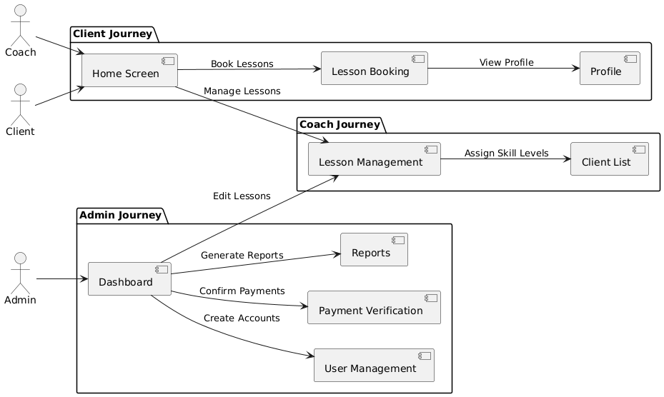

(PlantText, 2024)

The PlantUML diagram visually represents the User Experience Journey Map for the application. It outlines the navigation paths and accessible screens for the three distinct user roles: Client, Coach, and Administrator. Each user role is encapsulated in a separate package to highlight role-specific functionalities and restrictions.

* Client Journey:
  + Begins at the Home Screen, where users view upcoming lessons and notifications.
  + From the Home Screen, clients can navigate to Lesson Booking to schedule lessons and upload proof of payment.
  + The final step allows clients to access their Profile, where they can update personal information and review their booking history.
* Coach Journey:
  + Starts at the Home Screen, showing the coach’s lesson schedule.
  + Coaches can proceed to Lesson Management, where they organise lesson times and availability.
  + The journey concludes at the Client List, enabling coaches to assign skill levels and track client progress.
* Admin Journey:
  + Administrators access the Dashboard, which provides an overview of the system.
  + From the Dashboard, they can navigate to User Management to create or modify user accounts, Payment Verification to confirm client payments, Reports for system activity analysis, and Lesson Management for editing lesson schedules.

This diagram demonstrates how the application ensures clear, role-specific navigation paths, reducing overlaps and maintaining a secure, intuitive user experience.

## User Lessons

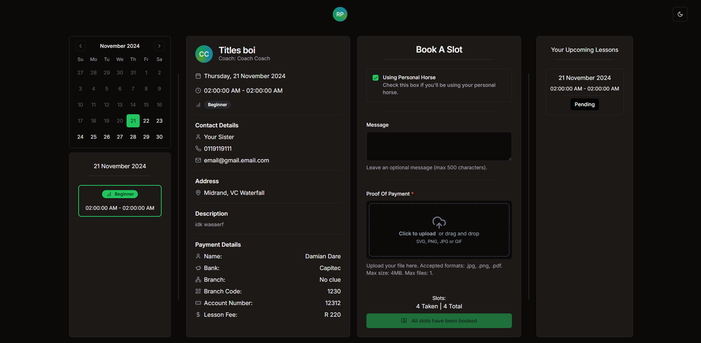

## Admin Lessons

## Admin Coach Lesson Form

## Admin Users

## Admin Addresses

## Admin Contact Details

## Admin Payment Details

