PATHWAY: OPSC 7312

Lecturer: Mr. Handsome Mpofu

30 September 2024

[Word Count: 100]

OPEN-SOURCE CODING (INTERMEDIATE)

Part 2 – AI Write UP

ST10033851 – Jereshan Sinan

ST10079389 - Kaushil Dajee

ST10030291 - Avish Judnarain

ST10091324- Eben Mwema

OpenAI. 2024. Chat-GPT (Version 3.5). [Large language model]. Available at: <https://chat.openai.com/> [Accessed: 09 September 2024].

We used Chat GPT to help me with the set budget pop-up, as before the pop-up would not work when using the Android Studio Emulator but was working on the Blue Stacks Emulator. And I used it to show a scenario as to how it should be, and then I used that code to help me fix my adapter, as that was the issue because I did not have this one method, but that was where I used Chat GPT.

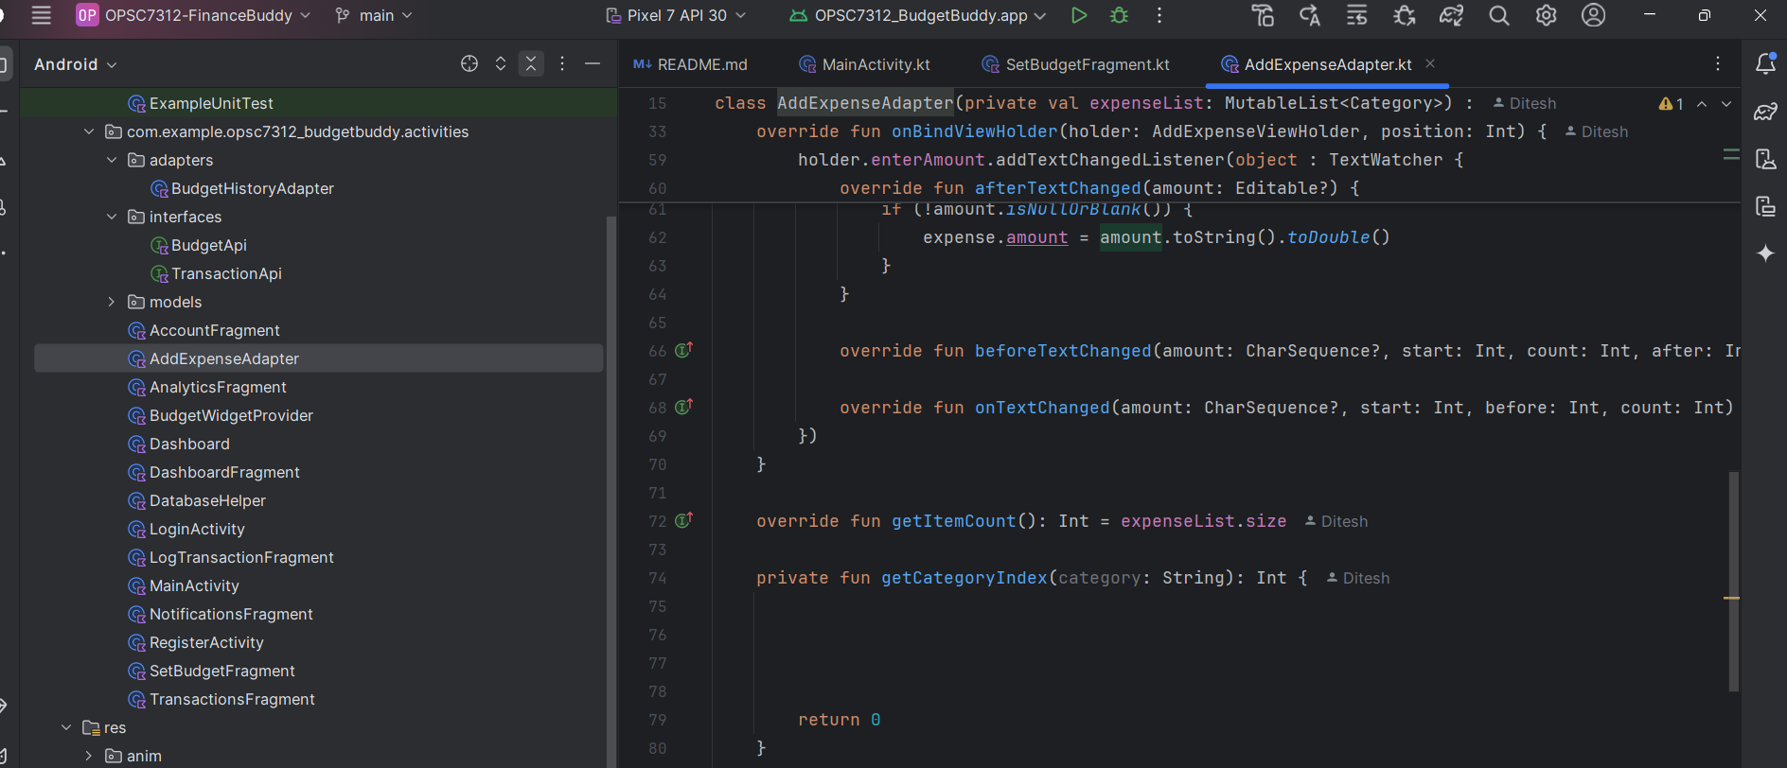

The two methods getItemCount() and getCategoryIndex was taken from ChatGPT

This was the code I took from Chat GPT:

