9/30/2024

Read Me

Documentation

ST10050487 - Tanaka Talent Kandima [Group Leader]

ST10053561 – Venkata Vikranth Jannatha

ST10082866 - Abdulrahman Ba Yazed

ST10082729 – Fares Ba Wareth

Table of Contents

Project Title 2

Purpose of the App 2

Design Considerations 3

GitHub & GitHub Automation Utilization 4

Guidelines for Maps 6

Conclusion 10

# Project Title

Eventat

# Purpose of the App

EventAt is an Android mobile application that incorporates leading-edge technology and is being launched to transform the event management process. It aims users of an extensive range of features that assist them in creating, promoting, and managing events without difficulty. EventAt is accessible to all kinds of events, ranging from the smallest local meetings to the largest conferences, and it helps organizers with such tasks as ticketing, loading participant lists, setting schedules, and providing real-time information. The value makes available to the organizers the capability to manage each stage of their event lifecycle, from the very start of the planning process through the time of the event itself and the evaluation period to their users and thus end up being attended with great success.

Furthermore, the registration process can be automated through features such as a user-friendly interface. In the meantime, the notifications keep going to be the focus of this platform. EventAt, as a product, is promoted through social media, in-app communication with users as well as analytics, and this it does to the organizers and the participants by optimizing event management, saving time and enhancing engagement.

# Design Considerations

EventAt’s approach to user interface design involved the use of Figma, a design platform which allows many users to collaborate in class due to its real time teamwork and feedback harvesting application. In Figma we drew elaborate wireframes and mock design of all screens with app operating machinery incorporated in the mock screens. This approach allowed for speed and effectiveness as user cantered design could be employed in actual designing for the existing system.

The whole design process had a clear emphasis on user experience (UX) hence the aim was to make the interface functional and pleasing to the eye. Striking features such as simple usage, ease of understanding the categories of events and quick access to features such as purchasing tickets and setting a time for the event were made primary to aid and simplify the work of event management to the organizers. We also included certain aspects of design like buttons, layouts and user event specifics which kept the users active.

Placing an emphasis on UX UI best practices and utilizing Figma's collaboration tools, we have a hope of creating an application that is good looking and feature rich so that the users can confidently and easily handle all the internal and external event management processes.

# GitHub & GitHub Automation Utilization

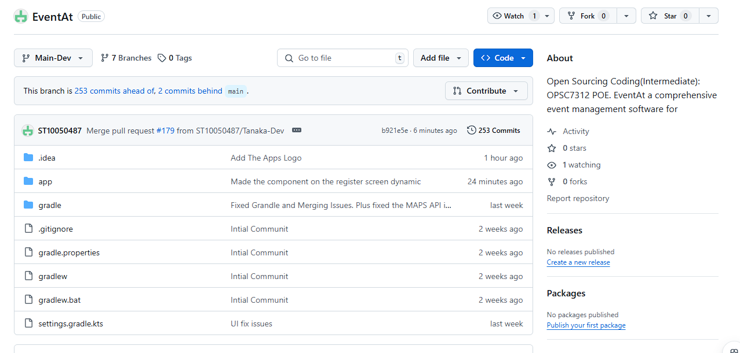

The repository ‘eventat’ was created over the course of this project under the supervision of our team leader. This repository also has a corresponding working structure, which contains six working branches. The first four branches were assigned to the individual team members, allowing them to perform their tasks independently. As soon as a member finished working, they would push their changes to their corresponding branch.

In my position as a group captain, I created a branch known as ‘main_dev’. This is the point where we normally bring together the work done in the other branches. The specific function of this ‘main_dev’ branch is to hold the final application for testing prior to the actual incorporation in the root-master branch.

In addition to the tasks allocated to each team member, an overall breakdown of the work of the app was provided. After implementation of the tasks allocated, a member took their changes to their corresponding branches. This was after we had taken in the changes in the main_dev and updated all team members by pulling changes. Using this process enhanced our teamwork and helped in the accuracy of the project carried out.

Some of these folders contained the Android Studio project files while the key folders in the repository contained the Android Studio project files. This approach organised the project in that activities and fragments were separated, with each activity containing several fragments. This helped in upholding the order within the project, which in turn made it easy to work with and relate every part of the application to its corresponding activity.

Having merged the code developed into the master dev branch and thereafter executing automation tests, an issue unexpectedly arose. While the project seemed to have been proceeding as it was supposed to, unfortunately, there was a last failure caused as a result of the use of different API versions in the team. One of the members of the group had used a higher API version than the rest, and this came to our attention too late to rectify the situation. This caused problems when developing a primary function of the software, resulting in other issues.

It is truly unfortunate that this simple issue has had such a huge impact on our work, and it is even more disheartening knowing how near we were to getting it right. Because of this, there is a problem but otherwise, everything else is functioning very well, and we are sure that we will be able to fix the problem in no time. I regret the trouble this has caused, and we are working towards making sure it does not occur again.

# Guidelines for Maps

Update Google Maps

You might get this message when you try to use google maps when you Google Play Services is not up to date. To fix this issue click on the ‘UPDATE’ button.

After clicking on the ‘UPDATE’ button, you will be taken to the screen below to enter your email (only if you are not signed in to you device with you google account) Enter your email and click on the next button.

After clicking on the ‘Next’ button, Enter your password and click on the ‘Next' button

Complete the 2-Step verification to verify your account and once you have been redirected to the Google Play Services Update/Downloand page on Player Store, update or download the latest version of Google Play Services and return back to the ‘EventAt’ app

# Conclusion

To Encompass Everything, EventAt is an all-encompassing event planning app that aims to make the management of various events effortless. Whether it is a few people coming together in a community or a congress, the application adopts state-of-the-art technologies to help customers design, market, and handle events with ease. Essential components like tickets, times, participants, and live information enable the event organizers to control and manage every stage of the event process, thus improving effectiveness and user interaction.

The design process, which was based on the user experience and the user interface, was done thoroughly in Figma. This enabled a very engaging and time-consuming process of design because the interaction of the app is equally important as its design. Therefore, designers place limitations on what features can be used and what layouts can be provided within the application in terms of practicality and usability.

As for the development process, the project was helmed successfully with the use of GitHub and GitHub Automation for effective management of affairs within the team. Due to effective systematization and branch management, the members were able to cooperate on the code without compromising its quality and order. Owing to the trivial delay brought about by the differences in the API version during the automation testing, the situation has not been bad as the growth cycle has gone on well and the group is optimistic about settling the problem very soon.

As demonstrated by the development of EventAt, there is no doubt that careful preparation, design, and teamwork carry significance. Merging a well-thought-out user interface and an organized development process, EventAt will serve the purpose of the event organizers, who wish to run events that would be successful and well-coordinated.

***The video is divided into three parts that is part of the folder***