**OPSC7311**

**TimeWise**

Introduction

TimeWise is a time-tracking app that is designed to keep detailed records of projects that have been or are being worked on and how much time was spent on them. It is going to keep details about each timesheet entry including the category of work being done and an option to attach photographs to the timesheets. TimeWise will additionally have a calendar feature to store previous entries by date and plan for future entries, a time-estimate function which provides the user with recommendations based on previous entries and a team TimeShare function to record total hours worked by the whole team on a specific project separately and store the total hours.

Functional Requirements

* The application shall have a log-in function: The app will cater to each user specifically so if they were to want to work elsewhere, their details and projects can be accessed with ease.
* The user shall be able to create timesheets with categories, date, start and end time and description: The user shall be able to record the time they spend on a specific project at a specific time, and it will record the date, start and end times, the category of work and a description of the work done.
* The user shall be able to optionally add photograph to each timesheet: Each timesheet can potentially have a photograph added for more detail or if it is a necessity to the work.
* The user shall be able to set a minimum daily goal for hours worked as well as a maximum daily goal: The user shall be able to set goals for themselves to promote work and encourage discipline in themselves
* The user shall be able to view the list of all the timesheet entries created during the users selected period, if there is a photo attached to the timesheet the user shall be able to access it: All the timesheet entries made by the user shall be accessible from the app and the user can view all the details attached to the entry as well as the photograph, should there be any.
* The user shall be able to view the total number of hours spent on each category during the user selected period: Within the timesheet entry list, the user shall be able to sort the entries into the categories they belong to and view the number of hours spent on each category.
* The user shall be able to view a graph showing the total hours worked each day over a selected period and the graph must also display the minimum and maximum goals: The app shall have a graph displaying each day’s hours worked in comparison to their daily maximum and minimum goals.
* The application shall display in a visual format how well the user is doing with staying between their minimum and maximum goals over the past month: The app shall also display a visual graph of how well the user has done over the previous month in terms of their daily maximum and minimum goals.
* The application shall store all its data in an online database: All the user’s data shall be stored online in a database, thus making it accessible to them from any device where they are logged in.

Features to add

* Calendar function to store previous projects and entries and plan for future projects or entries.
* Time estimates for each entry that can help a user gauge how long a specific task might take them.
* TimeShare to allow team members to record their hours worked and pool their hours together to get the total number of hours worked on a specific project.

User Interface

**Register Pages**

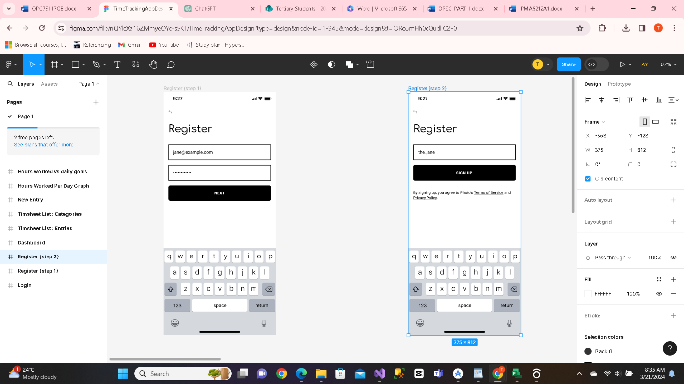

Upon first contact with the app, the user will be required to register themselves using their email and a password they select.

These will be their login details which they will use every time they login to the app and all their data shall be accessible only once logged in.

After creating their login details, they will be redirected to a page where they shall create a unique username for themselves to be displayed in-app.

**Login Page**

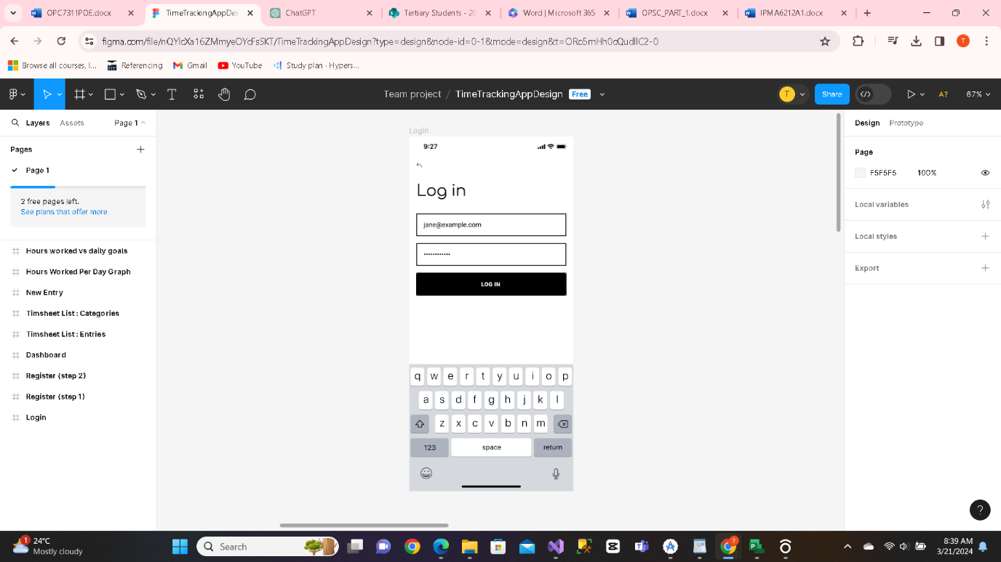

Once a user has created their account, they shall be redirected to the login page.

Every time they access the app, they will be required to provide their email and password to gain access to their data.

**Dashboard**

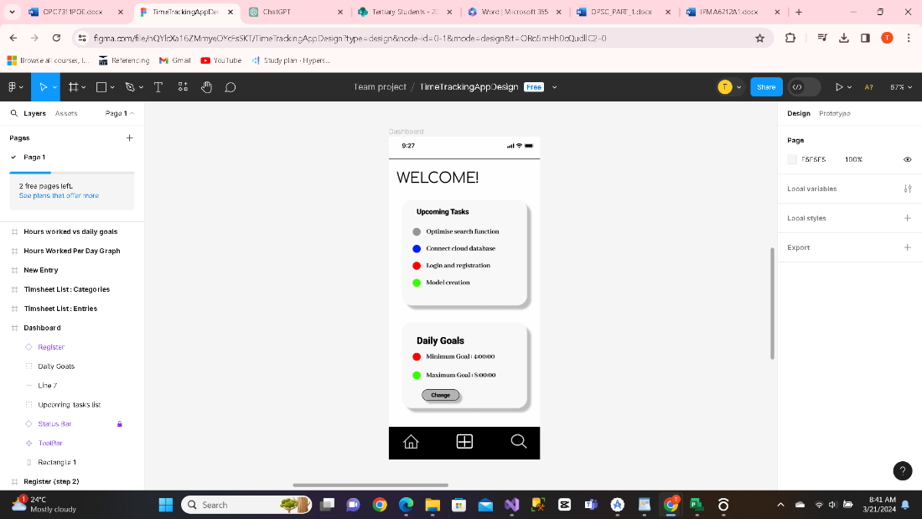

This can be considered the landing page of the application.

After logging in, the user will be redirected to the dashboard where their upcoming tasks will be displayed to them alongside daily goals and other previously planned urgent work.

**Timesheet list**

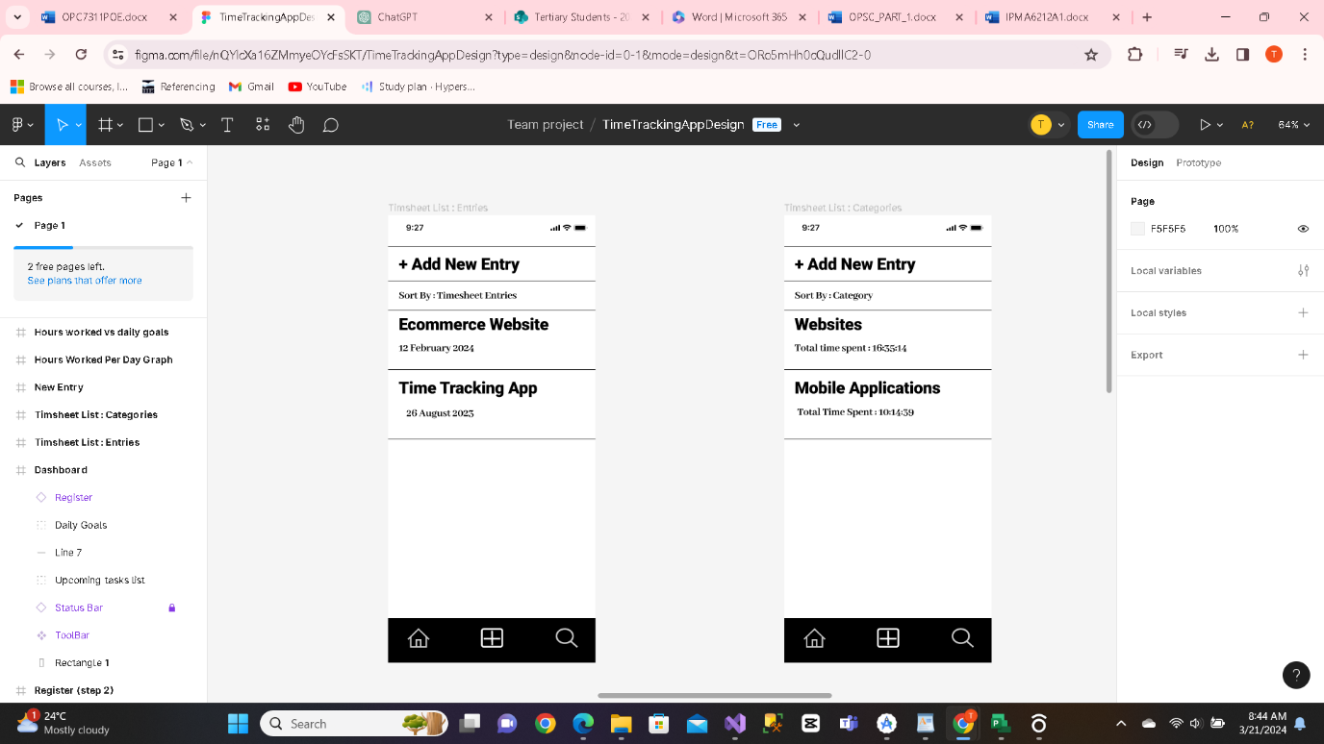

On this page the user will have access to all their previous entries, and they will be able to sort the list by entry or by category.

Should they wish to add a new entry they may click the button at the top of the screen that says “+ Add New Entry”.

**New Timesheet Entry**

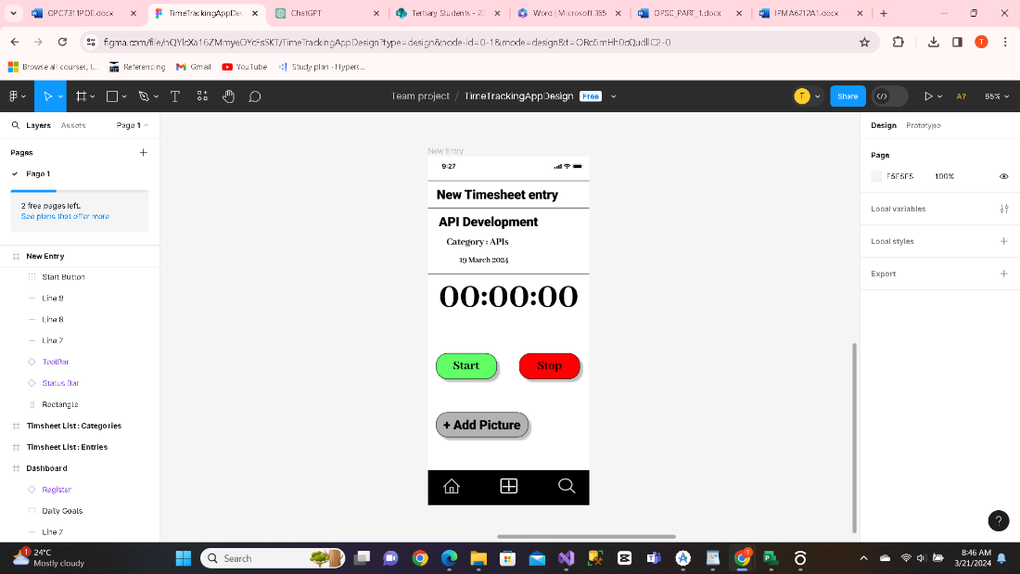

The new timesheet entry page is the page where the user records the time spent on their project or task.

The user can set the category for the timesheet entry and the date will be automatically set according to the current date before starting the timer.

The user will need to click on the start button to begin the timer and once they have completed their work they can click the stop button.

Once the entry is complete the user can add a description to the entry at the end and it will be stored in the timesheet list.

**Graph Pages**

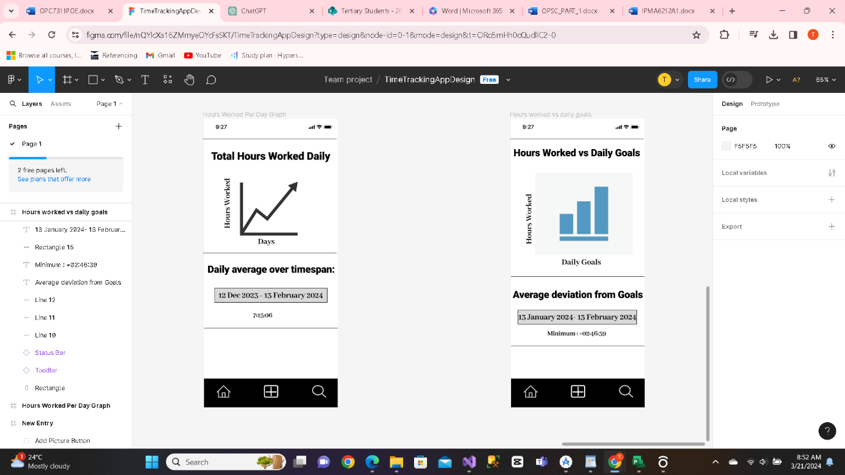

The two graph pages will show the user’s work hours in comparison to their daily goals. These pages can be used as gauges as to whether they need to work harder or not.

The user shall be able to set the dates they want to view for the daily deviation from the maximum and minimum goals but for the second graph it will be over the previous month so it will be a graph that is not changeable.

Project Plan