ST10084270 - Asheena Ramnarain

APDS POE DOCUMENTATION

Contents

App Screenshots 2

Student Details 8

References 8

# App Screenshots

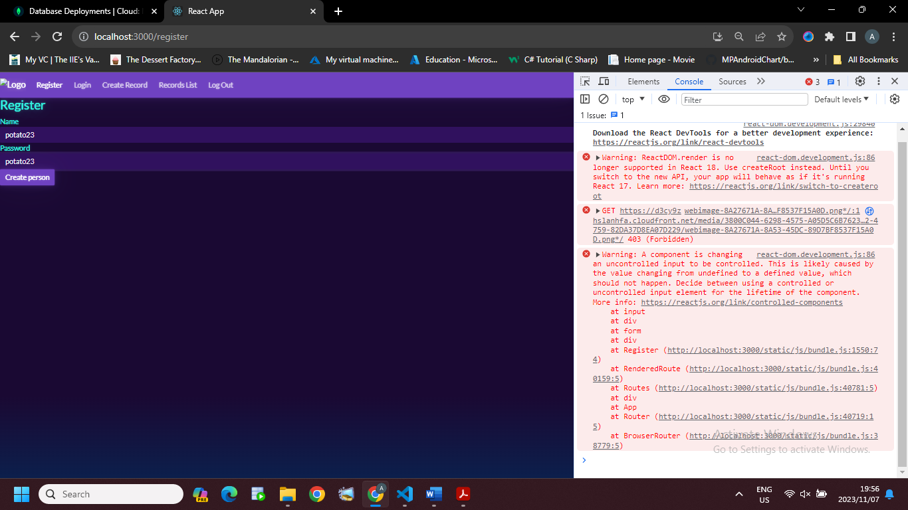

Figure : Registering a user

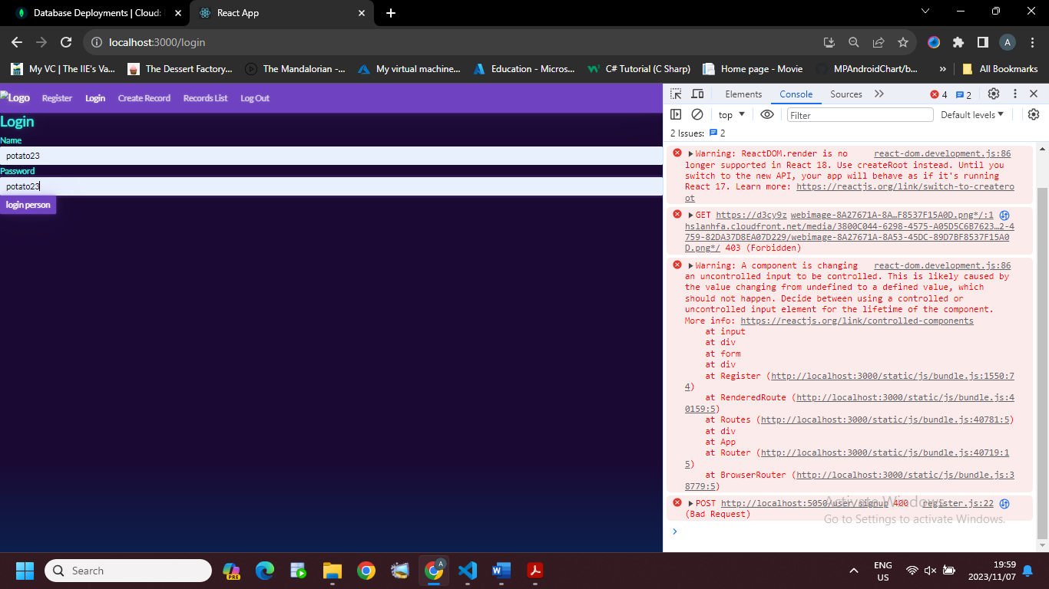

Figure : Logging in a user

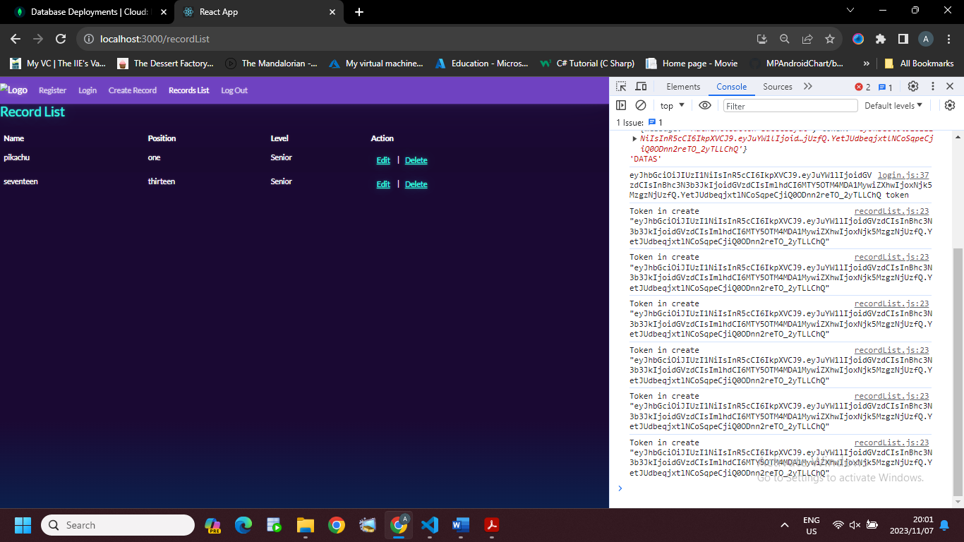

Figure : The page that contains a list of all records

Figure : Creating a new record

Figure : The record list with new records

Figure : Editing an existing record

Figure : an updated version of the records list

Figure : An item from the record list has been deleted

Figure : Logging out

Figure :

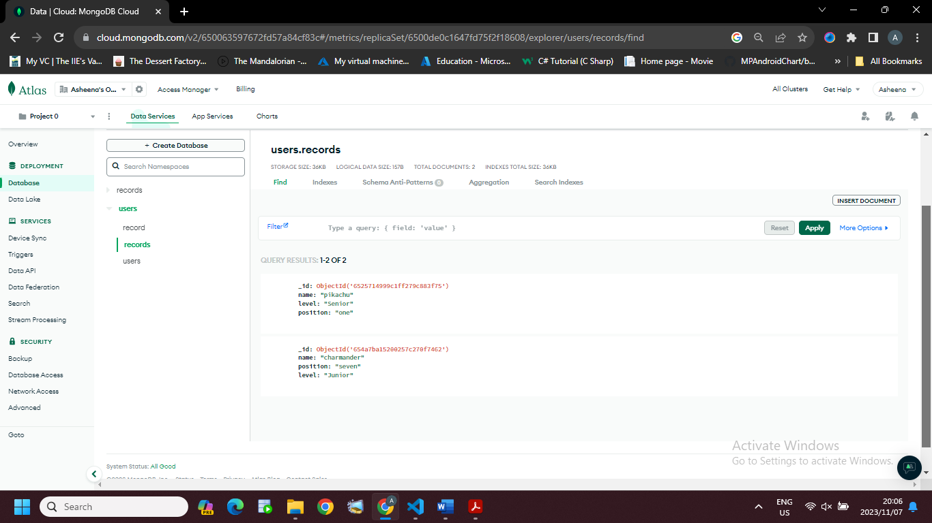

Figure : A screenshot from the database displaying records created

# 

Figure : A screenshot from the database displaying users created

# 

# Student Details

Asheena Ramnarain – ST10084270

[st10084270@vcconnect.edu.za](mailto:st10084270@vcconnect.edu.za)

[asheena.ramnarain.23@gmail.com](mailto:asheena.ramnarain.23@gmail.com)

# References

(2023) *CANVA: Visual suite for everyone*. Available at: https://www.canva.com/ (Accessed: 06 November 2023).

*Free themes for Bootstrap* (2023) *Bootswatch*: Available at: https://bootswatch.com/ (Accessed: 06 November 2023).