README File

Part 2: Programming6221:

Creating a Recipe Book:

Visual Studio and C# was used to create the command-line application. The application is responsible for recording recipe details such as the ingredients and steps, along with having the ability to scale the entire recipe, measure the calories and state the food group of each ingredient.

* Please refer to the Zip File titled: Prog_Part2_FinalZipFile

CONTENTS

Requirements-----------------------------------------------------1

How to apply------------------------------------------------------1-2

Functionality------------------------------------------------------2

Non-functional requirements----------------------------------2

Credits and Contact Information------------------------------2-3

References---------------------------------------------------------3

Screenshots of GitHub Repository-----------------------------3

Screenshots of Unit Testing-------------------------------------3

Feedback Of Part 1-----------------------------------------------3-4

GitHub link(s)------------------------------------------------------5

Requirements

You need the following to use the application:

* Microsoft Visual Studio 2019 or the later versions.
* NET Core 3.1 or the later versions.

xml version 1.0, encoding wtf.8, suppportedRuntime version v4.0, NETFramework version 4.7.2.

How to apply

* Download the source code or clone the repository.
* Launch Visual Studio and then open the recipe’s solution.
* Launch the program.
* Choose from the different options given.
* Follow the instructions given by each option on the command line, which include entering the recipe information, being able to view the recipe, scaling and/or deleting the recipe.

Functionality

The application has the following criteria:

* The user can enter information of a recipe. This includes the name of the recipe, the ingredients and their names, quantity, unit of measurement, calories and food group and the steps needed to be taken for the recipe.
* The user can view all the details they’ve entered.
* The user can scale the recipe by any factor including 0,5, 2 and 3. The entire recipe or all quantities of the ingredients is changed accordingly, and it can be viewed.
* The user once they’ve scaled a recipe, can always reset the quantities of the ingredients to its original form.
* The user has the choice of deleting the entire recipe and then entering a new recipe.
* The application does not save the user data.

Non-functional Requirements

* The application adheres to internationally accepted coding standards.
* The application contains classes, methods and variable names.
* The application stores the ingredients in a type of array.

Credits and Contact Information

* Aleesha Praemchand is the author of the application.
* If you have any queries, please contact via this email: [st10084533@vcconnect.edu.za](mailto:st10084533@vcconnect.edu.za)

Screenshots of the Unit Testing for the Recipe

Feedback from Part 1

Based off my lecturer’s feedback, I’ve made numerous changes accordingly. Firstly, I’ve made changes whilst actively submitting my work in order to view the code and not just the zip file(s). I have also added screenshots of the GitHub repository, along with the required screenshots such as the unit testing for the recipe console application and the GitHub repository commit history. I have also added the feature of color in the console application. This feature allows different functions to appear in different colors whilst the user interacts with the recipe application.

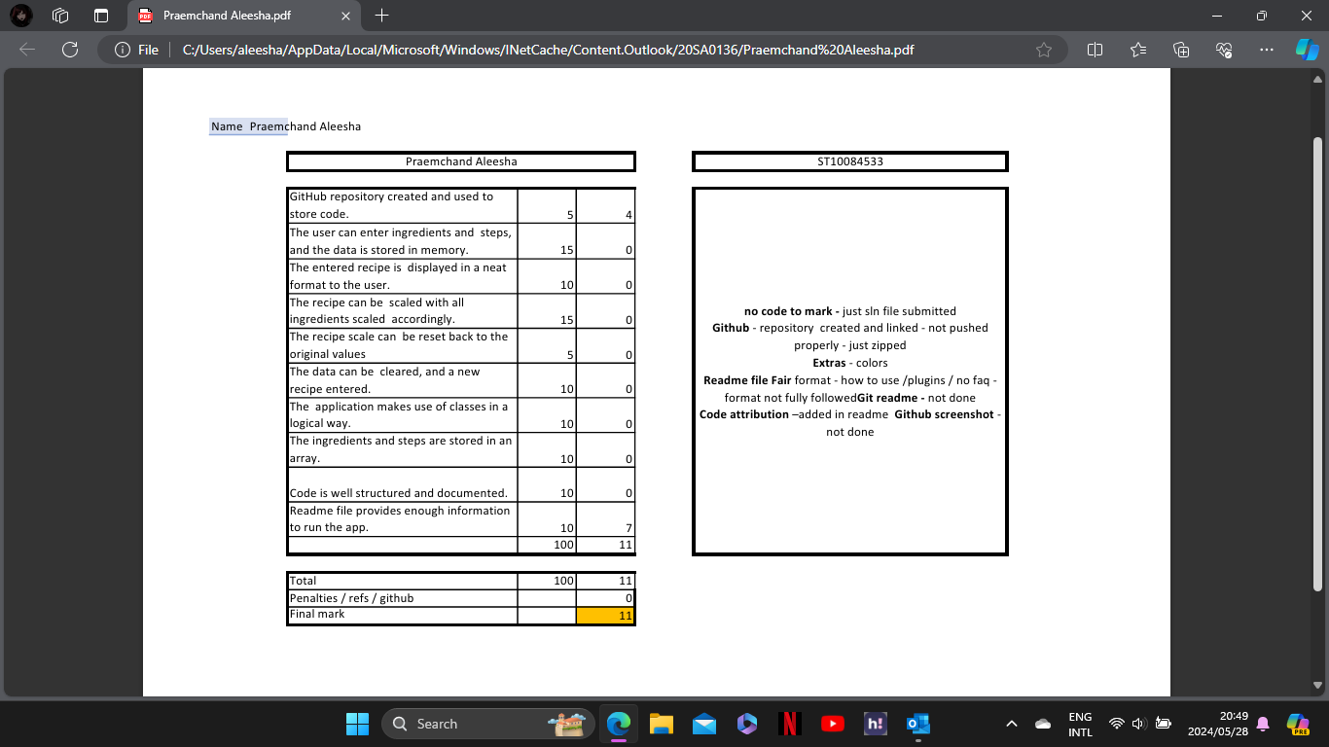

Screenshots of colored feature in application

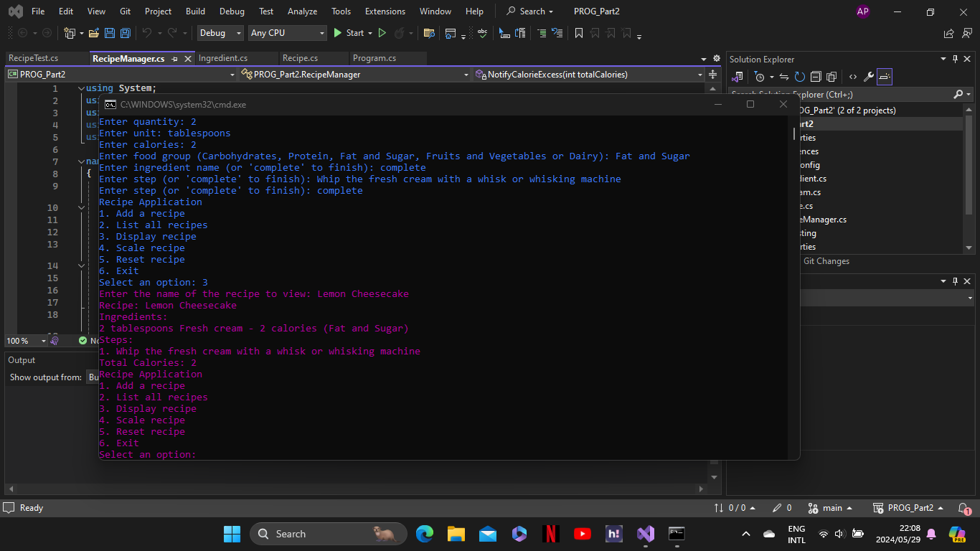

References

* Andrew Troelsen, P. J. (2022). *Pro C# 10 with .NET 6: Foundational Principles and Practices in Programming.* CA: Apress Berkeley.

GitHub Link

Varsity College GitHub Link

* <https://github.com/VCWVL/prog6221---programming-2a---part-2-ST10084533>

Personal GitHub Link

* <https://github.com/ST10084533/PROG_Part2>
* https://github.com/ST10084533/RecipeApp2