SmartLeaveAPI – Professional API Documentation

1. Introduction
SmartLeaveAPI is a RESTful API developed using ASP.NET Core and Entity Framework Core. The purpose of this system is to manage employee leave requests and late arrival notifications within an organization. The API allows employees to register in the system, submit leave requests, notify managers of late arrivals, and allows managers or HR staff to approve or review those requests.

2. System Architecture
The system follows a layered architecture where client applications communicate with an ASP.NET Core Web API, which then interacts with a SQL Server database using Entity Framework Core.
Architecture Flow:
Client (Swagger / Frontend)
↓
ASP.NET Core Web API
↓
Entity Framework Core (ORM)
↓
SQL Server Database

3. Technologies Used
- ASP.NET Core Web API
- Entity Framework Core
- Microsoft SQL Server
- Swagger UI (API Testing)
- Visual Studio 2022

4. Database Tables
- Employees – stores employee information
- LeaveRequests – stores leave request records
- LateArrivals – stores employee late arrival notifications
- LeaveApprovals – stores approval actions for leave requests
- Departments – stores company departments
- LeaveTypes – stores types of leave

5. API Endpoints

5.1 Employees
POST /api/Employees – Create a new employee
GET /api/Employees – Retrieve all employees
Example Request Body:
{
"name": "Sarah Smith",
"email": "sarah@company.com",
"department": "HR"
}
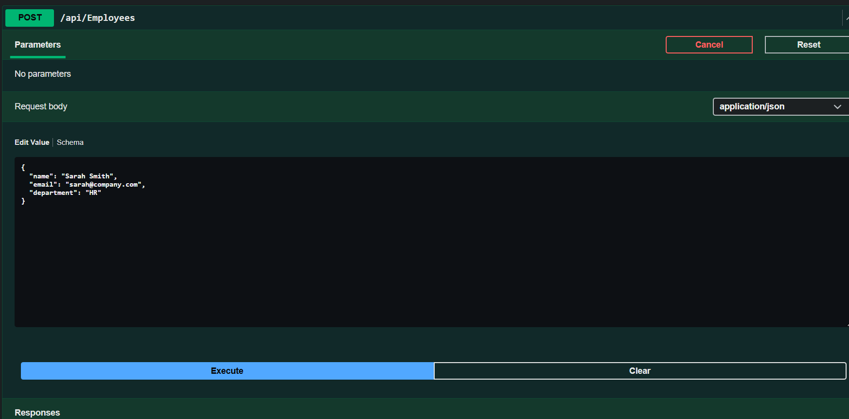
Screenshot Placeholder:
screenshot 1

Screenshot 2 of response
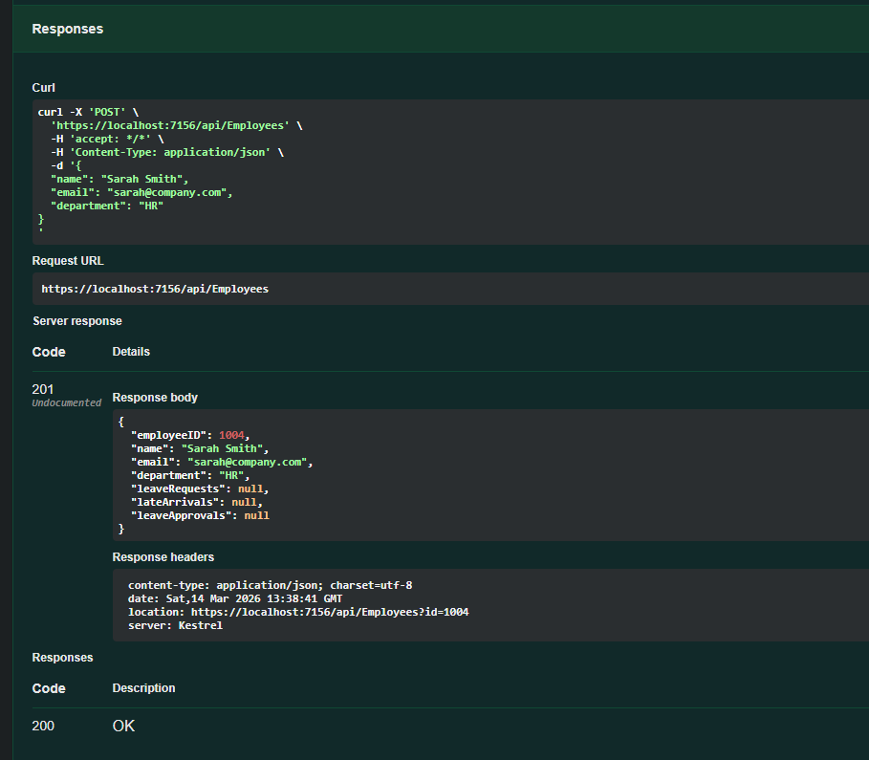

5.2 Leave Requests
POST /api/LeaveRequests – Employee submits a leave request
GET /api/LeaveRequests – Retrieve all leave requests
GET /api/LeaveRequests/{id} – Retrieve a specific leave request
PUT /api/LeaveRequests/{id} – Update leave request status
Example Request Body:
{
"employeeID": 1,
"leaveType": "Annual Leave",
"startDate": "2026-03-20",
"endDate": "2026-03-22",
"status": "Pending"
}
Screenshot Placeholder:
screenshot of Swagger POST /api/LeaveRequests request and response here.

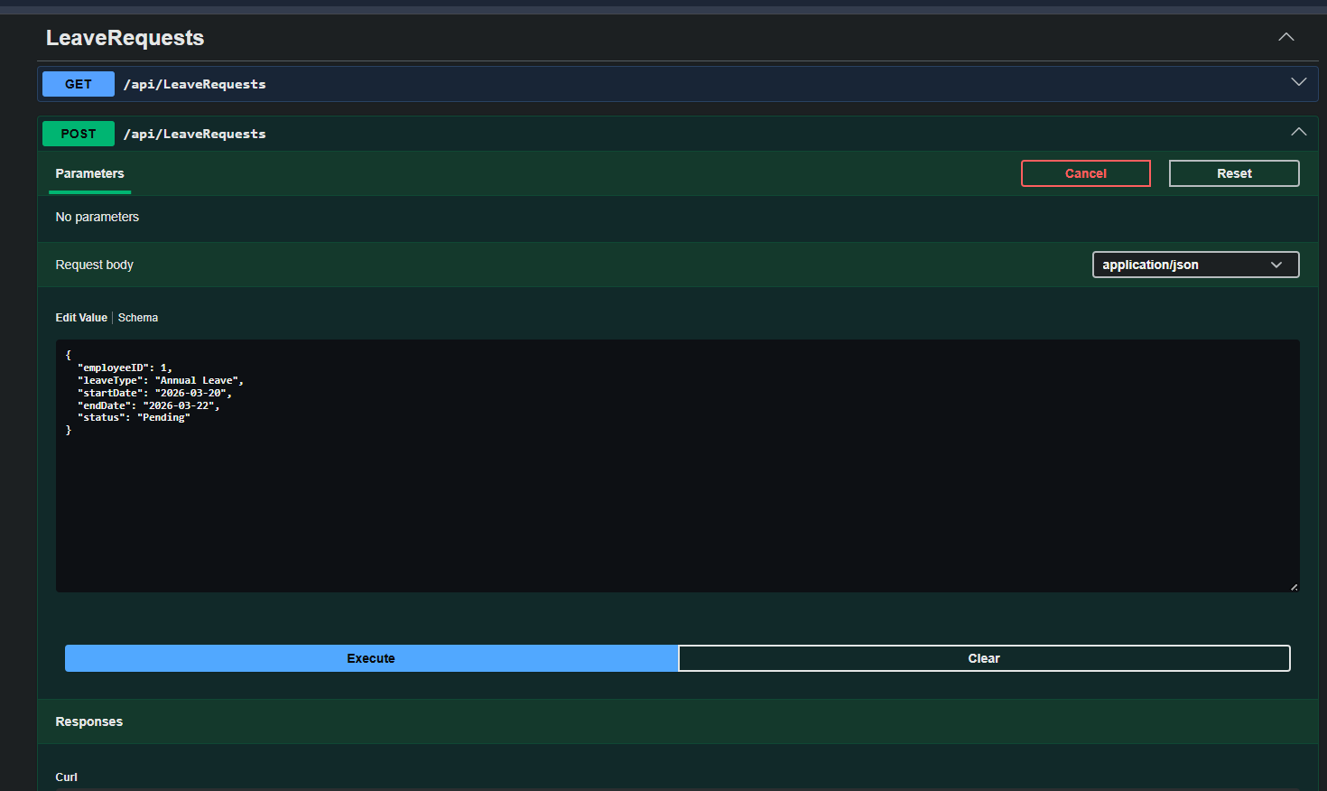
Screenshot 1
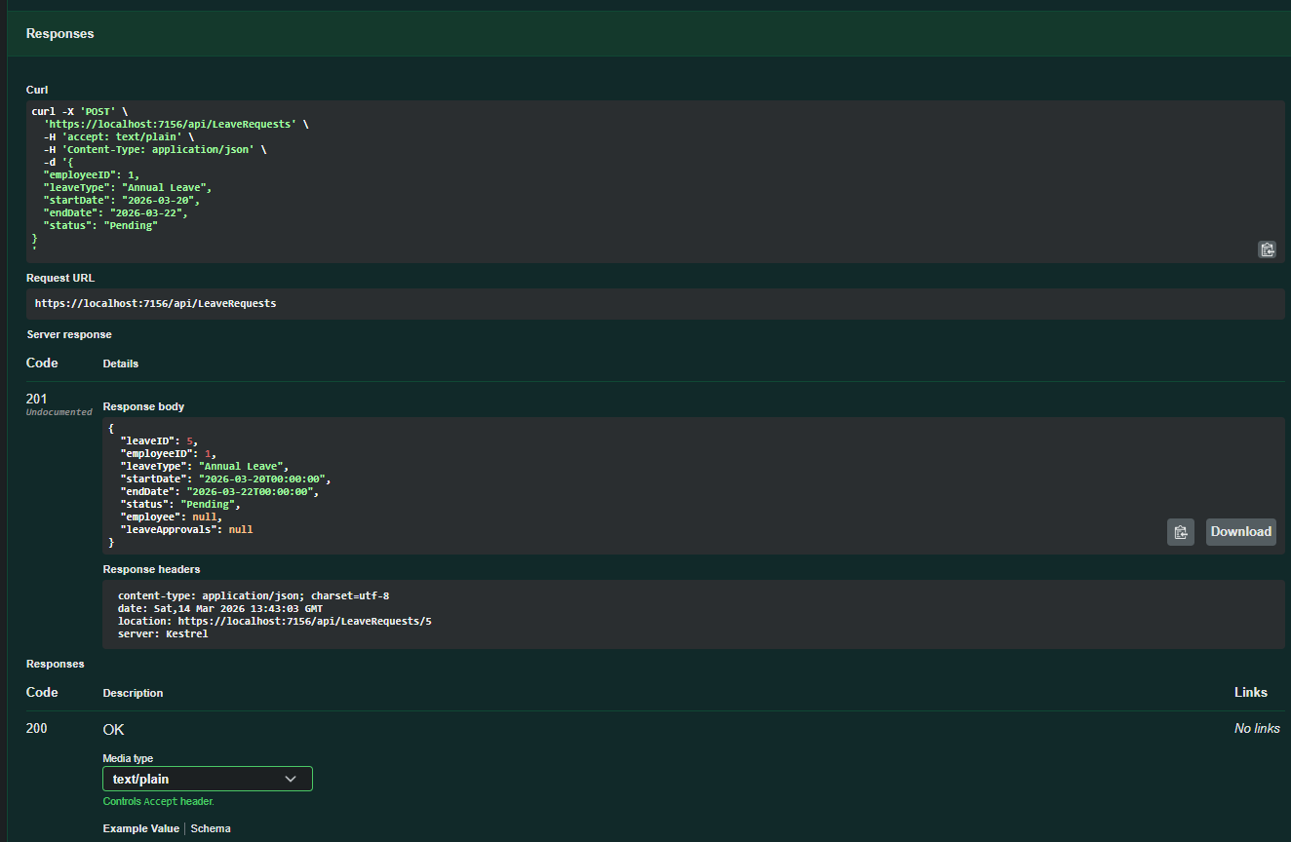
Screenshot 2
Screenshot Placeholder:
screenshot of Swagger PUT /api/LeaveRequests/{id} approving a leave request.
Screenshot 1
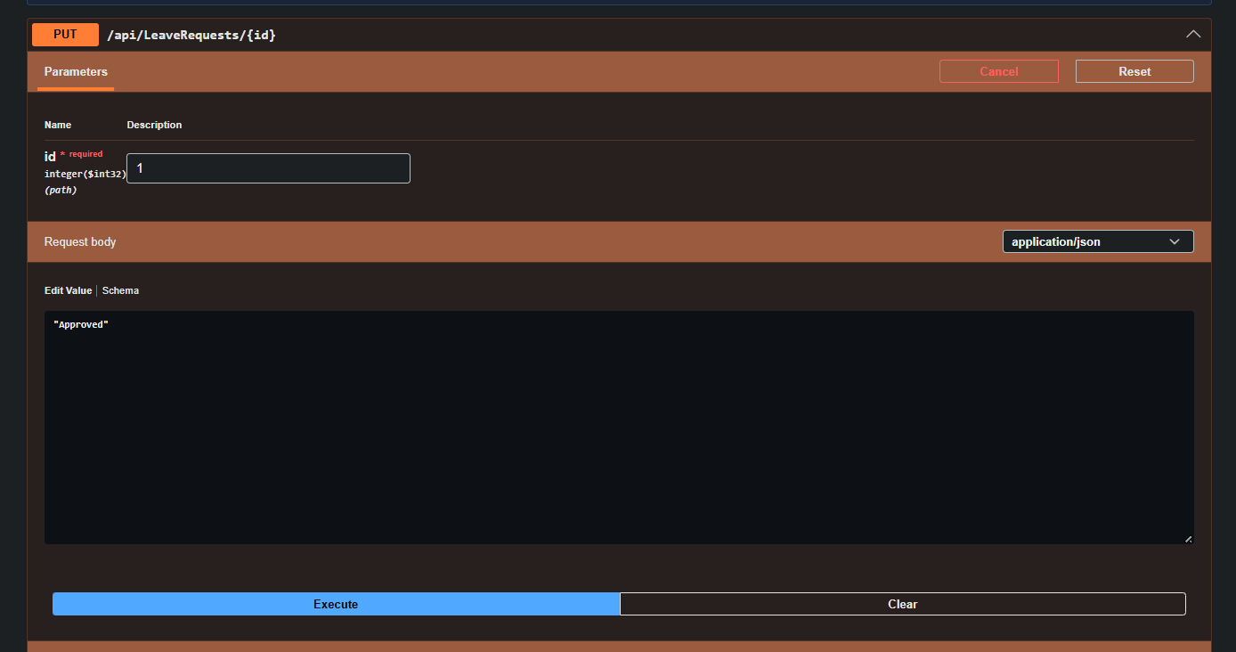
Screenshot 2
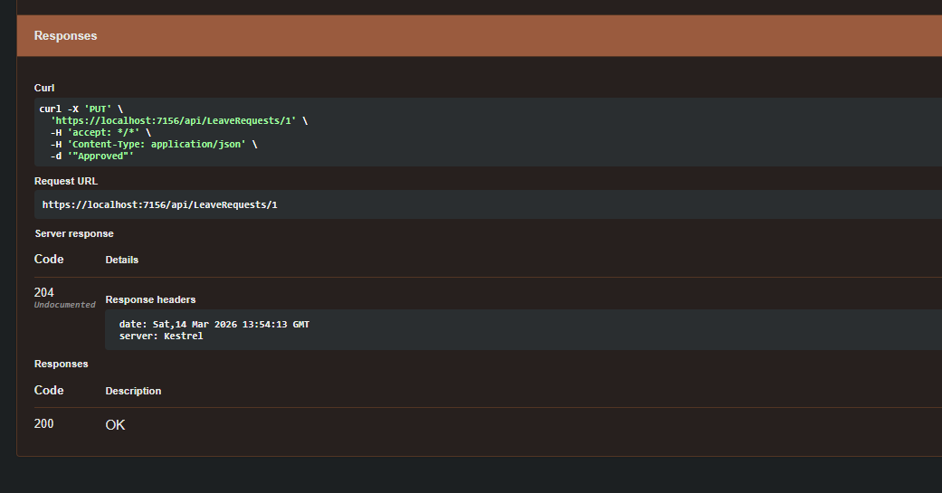

5.3 Late Arrivals
POST /api/LateArrivals – Employee submits late arrival notification
GET /api/LateArrivals – Retrieve all late arrivals
GET /api/LateArrivals/{employeeId} – Retrieve late arrivals for an employee
PUT /api/LateArrivals/{lateId} – Update late arrival status
Example Request Body:
{
"employeeID": 1,
"date": "2026-03-13",
"expectedArrival": "09:30",
"reason": "Traffic delay",
"status": "Pending"
}
Screenshot Placeholder:
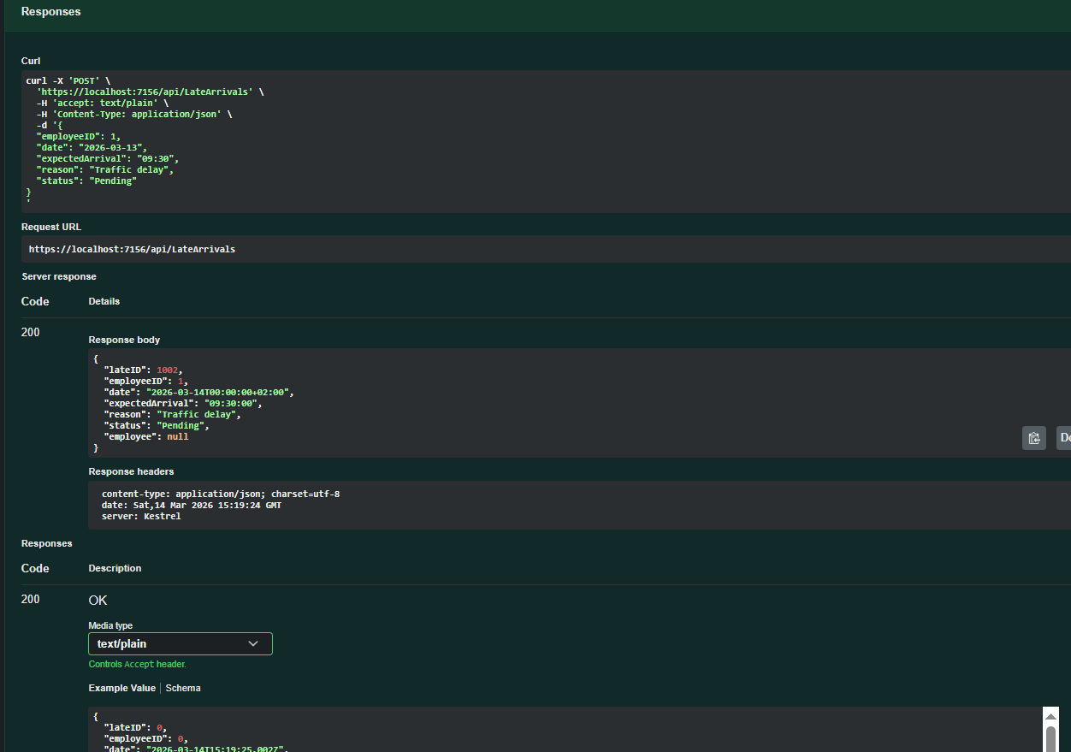
screenshot of Swagger POST /api/LateArrivals request and response here.
Screenshot 1
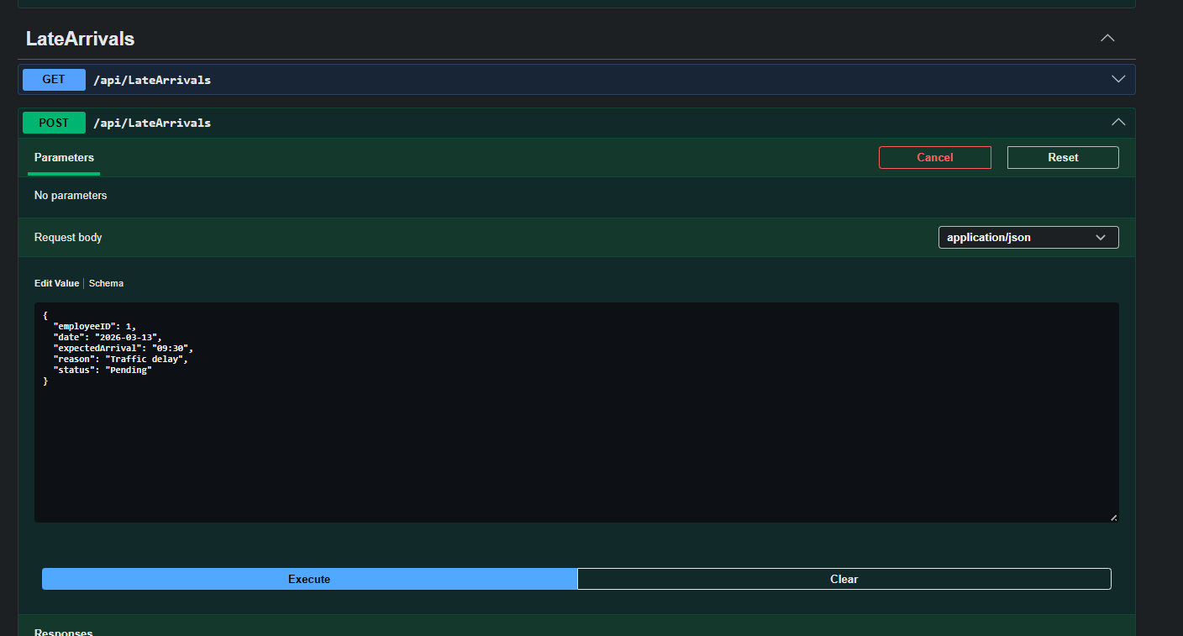
Screenshot 2
Screenshot Placeholder:
screenshot of Swagger PUT /api/LateArrivals/{id} updating status.
Screenshot 1
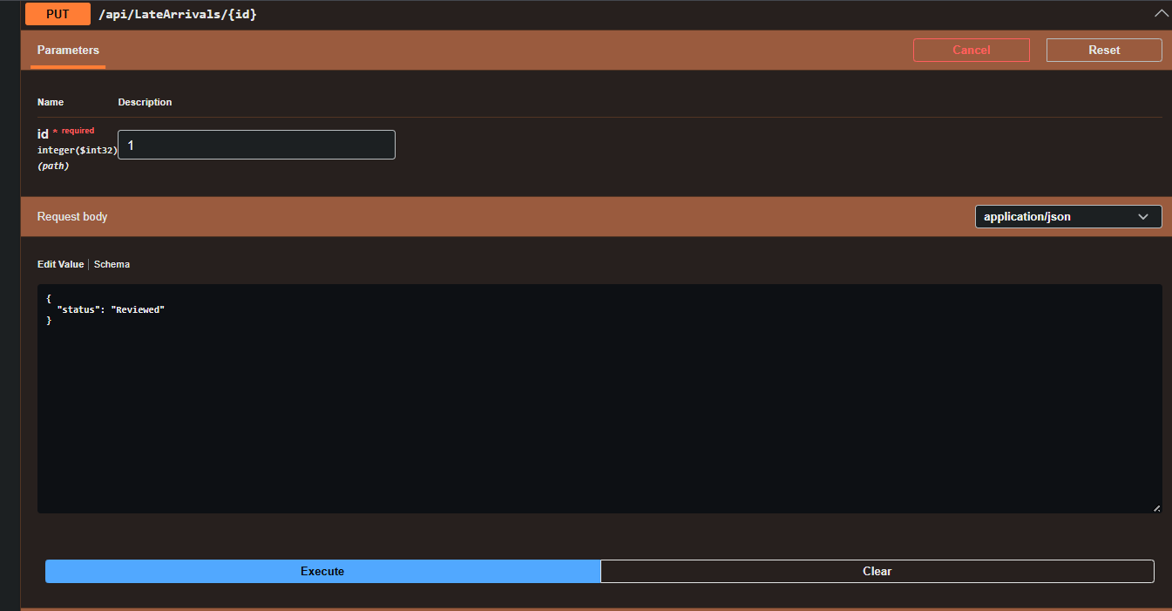
Screenshot 2
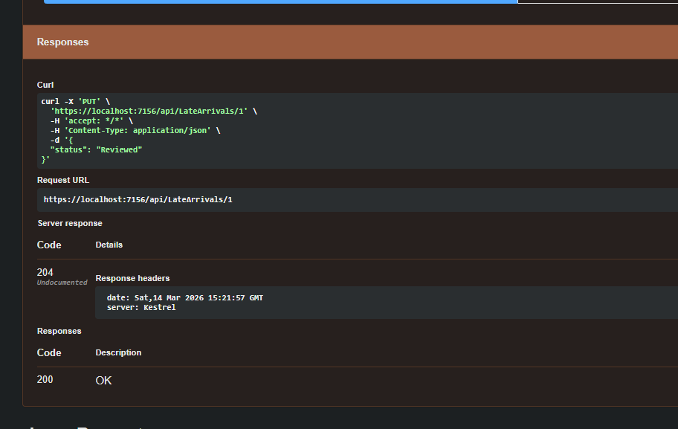

6. Testing the API
The API was tested using Swagger UI. All endpoints were verified to ensure correct functionality, including creating employees, submitting leave requests, notifying late arrivals, and updating request statuses.
.

7. Conclusion
The SmartLeaveAPI successfully demonstrates the implementation of a RESTful API for managing employee attendance processes. The system supports full CRUD operations and demonstrates integration between ASP.NET Core, Entity Framework Core, and SQL Server.

