XISD6329 — TASK 1, Group 13
Work Integrated Learning 3B
Updated Project Plan, Site Map & Wireframes
Oladayo Williams Oladele, Nkuna Kuhlula, Gqoboka Lukhanyo, Muti Mulweli
SAFEZONE SACommunity Security & Smart Incident Reporting Platform
Table of Contents
Update Project Plan 3
Project Background &Update 3
Client Needs and Problem Description 3
Project Scope 3
Project Objectives 3
Team Roles and Deliverable Allocation 4
DevOps Lifecycle 4
Development Technologies and Tools 5
Project Deliverables 5
Project Timeline 6
Risks, Controls and Recommendations 7
Site Map 8
SAFEZONE SA- WEBSITE & MOBILE SITE MAP 8
Wireframes 9
Website Wireframes 9
Mobile Application Wireframes 10

Figure 1: Website and Mobile Site Map 8
Figure 2: Website Wireframes 9
Figure 3: Mobile Application Wireframes 10

Update Project Plan

Project Background &Update
SafeZone SA is a community security and smart incident reporting platform. The project analysis and design into implementation, testing, version control and deployment. The solution retains incident reporting, moderation, assignment, tracking, reporting and audit concepts while adding a mobile application and a DevOps-oriented development lifecycle.

Client Needs and Problem Description
SafeZone SA addresses the need for a structured digital channel through which community members can submit safety incidents and monitor their progress. Analysis identified the need for accessible reporting, better visibility, structured moderation, and centralized incident information. The solution provides web and mobile access while maintaining privacy, security, role-based access and accountability.

Project Scope
In scope:
- Responsive website for public and authenticated users.
- Android mobile application for incident reporting and tracking.
- Registration and login.
- Community dashboard and incident submission.
- Incident status tracking.
- Moderator review, approval/rejection and assignment.
- Administrator user management and reporting concepts.
- PHP API used by the mobile application.
- MySQL database for users, incidents, locations, media, assignments and audit records.
- Azure DevOps Kanban lifecycle management and testing evidence.

Project Objectives
- Implement a functional Android mobile application using the SafeZone SA API.
- Connect both clients to the same database-backed service.
- Apply validation and role-based access to the prototype.
- Use Azure DevOps/Kanban to manage the application lifecycle.
- Create and execute appropriate unit/functional tests.
- Prepare installation and help information

Team Roles and Deliverable Allocation

Team Member | Role | Responsibilities | Deliverables
Nkuna Kuhlula | Project Manager / DevOps | Coordination, sprint planning, Azure DevOps/Kanban, progress tracking | Project plan, Azure evidence, repository coordination
Gqoboka Lukhanyo | Software Developer / Development Lead | Website, backend and API implementation | Website pages, PHP/API components
Oladele Oladayo | Security Champion / Business Analyst | Requirements, security, POPIA-aware design, documentation | Analysis, security controls, documentation
Muti Mulweli | Software Developer / QA Lead | Mobile development, testing and QA | Android screens, tests, QA evidence

DevOps Lifecycle
The development approach follows a continuous lifecycle in which planning, development, testing, release and feedback inform the next iteration. Azure DevOps is used for lifecycle and Kanban management.
Stage | SafeZone Activity | Tool / Evidence | Output
Plan | Backlog, prioritization and work allocation | Azure DevOps Kanban | Tasks / priorities
Code | Website, API, database and Android development | GitHub / Android Studio / VS Code | Source code / commits
Build | Compile and validate project components | Android Studio / local environment | Build artefacts
Test | Unit/functional testing and defect correction | Azure DevOps + test evidence | Results / fixes
Release | Prepare stable demonstration version | GitHub versioning | Release candidate
Deploy | Run website/API and install Android prototype | XAMPP / hosting / emulator | Running prototype
Operate | Observe behavior and resolve issues | Logs / issue tracking | Operational feedback
Feedback | Use feedback to update backlog | Azure DevOps | Improvement tasks

Development Technologies and Tools

Area | Technology / Tool | Purpose
Website | PHP, HTML, CSS, JavaScript | Web interface and server-side processing
API | PHP REST-style endpoints | Communication between Android and database-backed service
Mobile | Android Studio, Kotlin, Retrofit | Android client and API communication
Database | MySQL | Persistent data storage
Source Control | GitHub | Version control
Lifecycle | Azure DevOps Kanban | Backlog, tasks and lifecycle management

Project Deliverables

- Updated project plan.
- Website and mobile application site maps.
- Website and mobile wireframes.
- Working website prototype.
- Working Android mobile prototype.
- Connected database and API prototype.
- GitHub repository with README and organized assets.
- Azure DevOps Kanban evidence.
- Unit/functional testing evidence.
- Installation/help instructions.

Project Timeline

Phase | Activities | Evidence | Responsible
1. Planning | Review Semester 1; update scope; backlog; allocation | Updated plan / Kanban | All / PM
2. Design | Update sitemap and web/mobile wireframes | Sitemap / wireframes | BA + Developers
3. Website & DB | Implement website, database and server functions | Website / database | Development
4. API & Mobile | Implement PHP API and Android Retrofit integration | API / Android | Development
5. Testing | Execute tests and fix defects | Test evidence | QA + team
6. DevOps & Release | Commits, Kanban updates, demo build | GitHub / Azure evidence | PM + team
7. Presentation | Prepare slides and live demonstration | Presentation / demo | All

Risks, Controls and Recommendations

Risk | Impact | Mitigation | Owner
API/mobile connectivity failure | High | Verify emulator networking, API base URL and endpoints. | Development / QA
Database inconsistency | High | Use defined relationships, validation and repeatable SQL setup. | Development
Security/privacy weakness | High | Minimize PII, validate input, use RBAC and audit information. | Security Champion
Scope creep | Medium | Prioritize MVP backlog and manage changes through Azure DevOps. | PM
Version conflicts | Medium | Use regular GIT commits and coordinated changes. | All
Weak evidence | Medium | Capture screenshots of key workflows and prepare a timed demo. | All

Site Map
The SafeZone SA navigation is organized around public access, authentication and role-based functions. The mobile application mirrors the core community workflow while keeping navigation suitable for smaller screens.

SAFEZONE SA- WEBSITE & MOBILE SITE MAP
Figure 1: Website and Mobile Site Map
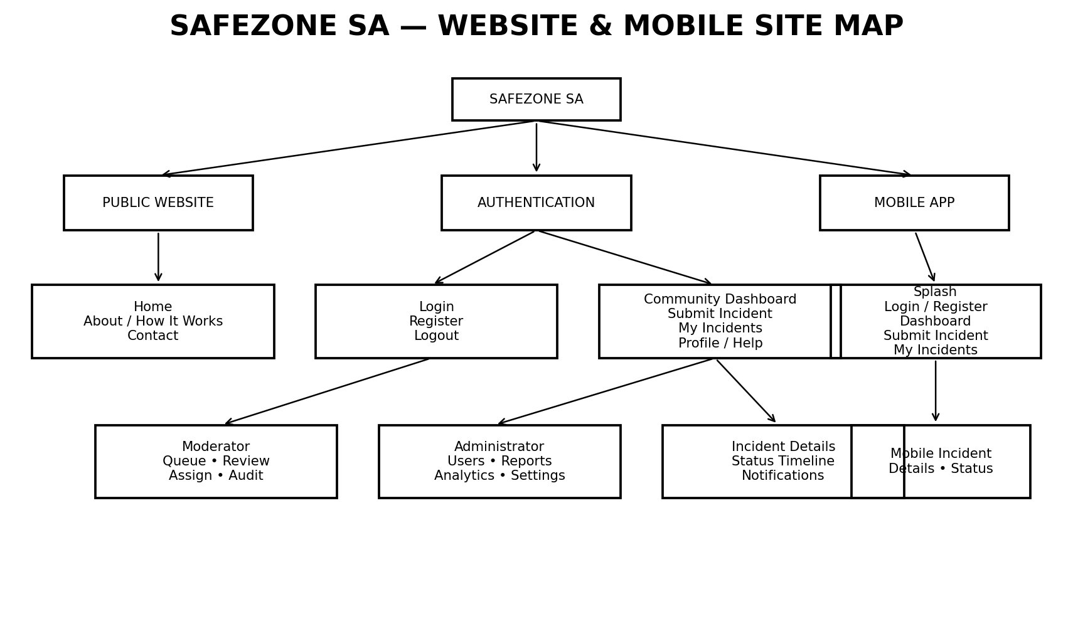

Wireframes
The wireframes translate the requirements and site map into a visual prototype before final implementation. They prioritize clear navigation, incident reporting, status visibility and role-specific functions.

Website Wireframes
Figure 2: Website Wireframes
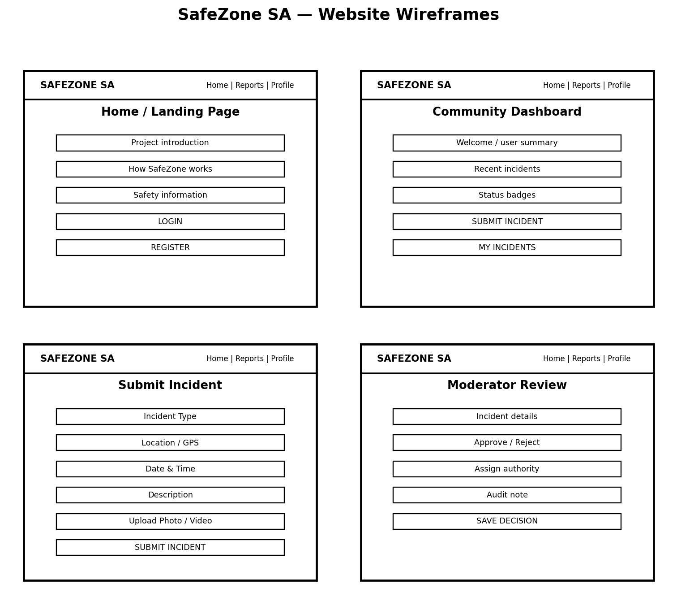

The website wireframes cover the public landing page, community dashboard, and incident submission and moderator review workflow.

Mobile Application Wireframes
Figure 3: Mobile Application Wireframes

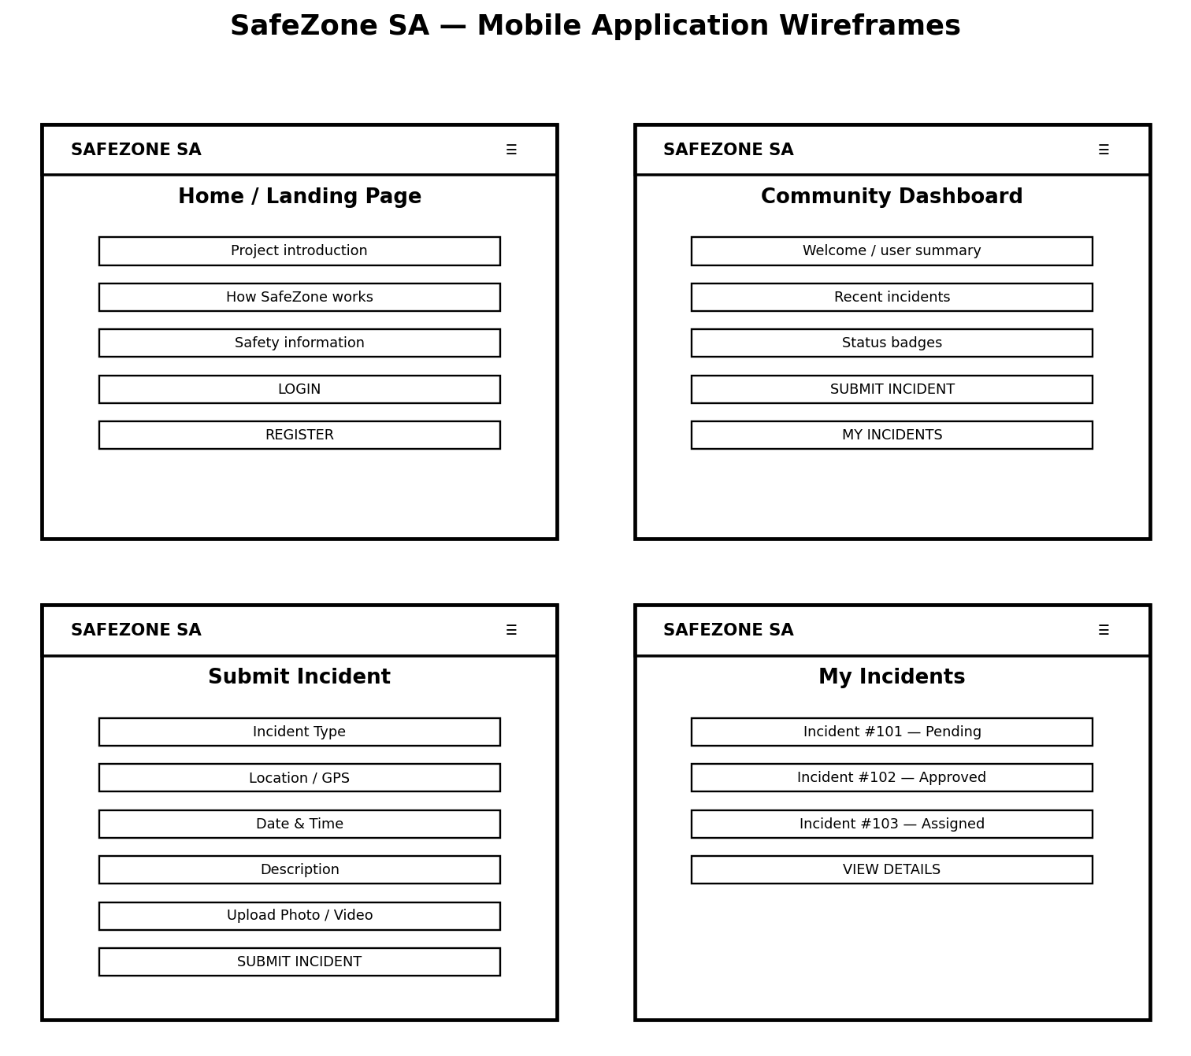
The mobile wireframes cover authentication, the community dashboard, incident submission and incident tracking. The Android application is intended to use the same backend/API and database as the website

