**Name**: Lethabo

**Surname**: Mashinini

**Student number**: ST1018556

**DBAS6211 Assignment1**

**Question 1**

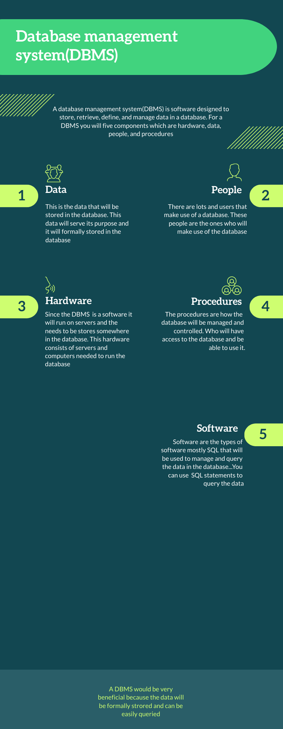

**Question 2**

2.1) I would use a relational database because the data are stored in tables with rows and columns and the relationship between the data is shown via using primary and foreign keys. With a relational database the data will be formally structured with fields for each record. The data will still have its integrity because the data will have foreign and primary keys to identify it. This will allow Thato to properly analyse the database to get accurate results. With the foreign and primary keys Thato can properly query and retrieve the data.

2.2) For videos, pictures and files for course creators I would use a NoSQL database. This database is useful and designed to handle unstructured and semi-structured data and with them you can store large amounts of files. Usually videos, pictures and files are unstructured and do not have schemas. A NoSQL database would be best for this because they do not need a schema and can handle multiple data formats. Videos and pictures are media files that take a lot of storage and NoSQL databases are highly scalable and can handle these large media. The NoSQL databases can store and retrieve data in various formats and would be very helpful for content creators.

**Question 3**

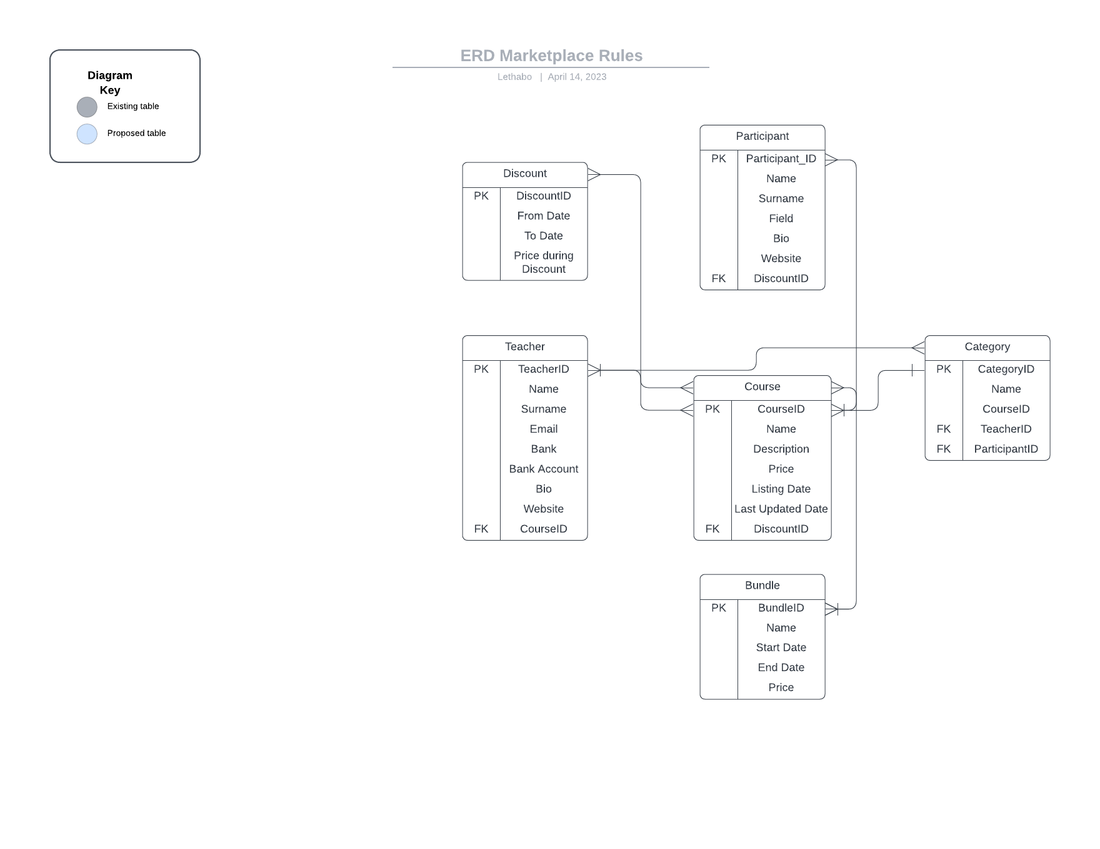

**Question 4**

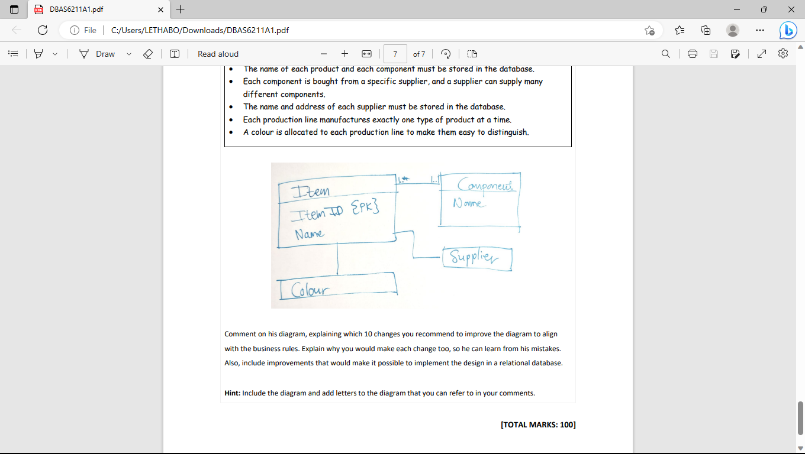

1. The first I would change is supplier. Supplier should be its own entity and have its own attributes such as the name and the address of the supplier.
2. There must be another record for the quantity of the components.
3. The relationship between the component and the item entity should be a one-to-many. This is because one component can be used for many items.
4. There should also be a relationship between the supplier and the component entity. The relationship that should be there is a one-to-many relationship because one supplier can supply multiple components.
5. There should be field for component name in the item entity and it should be a foreign key since a component can be used to make different products.
6. The relationship between the supplier and the item entity must be a one-to-many relationship
7. In the supplier entity he must make a itemID field and make it a foreign key because the supplier can supply a specific item.
8. In the supplier entity the supplier name must be a primary key
9. You must add an itemID field in the colour entity and make it a foreign key
10. Supplier entity and component entity must have a one-to-many relationship

**Bibliography**

Watt, A. and N. Eng. (2014). Database Design – 2nd Edition. Victoria, B.C.: BCcampus. Retrieved from <https://opentextbc.ca/dbdesign01/>.