[Document title]

[Document subtitle]

Vision Keletso Nukeri

[Year]

Question 1

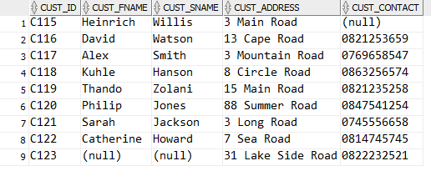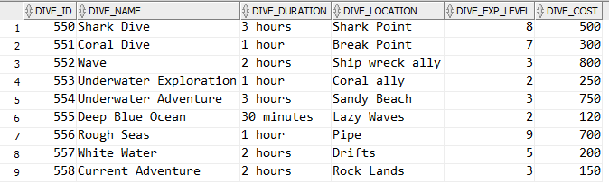

Question 2

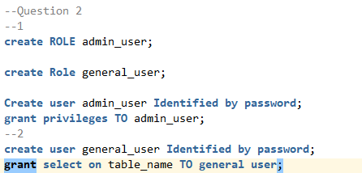

Question3

Question4

Question 5

Question 6

Question 7

Question 8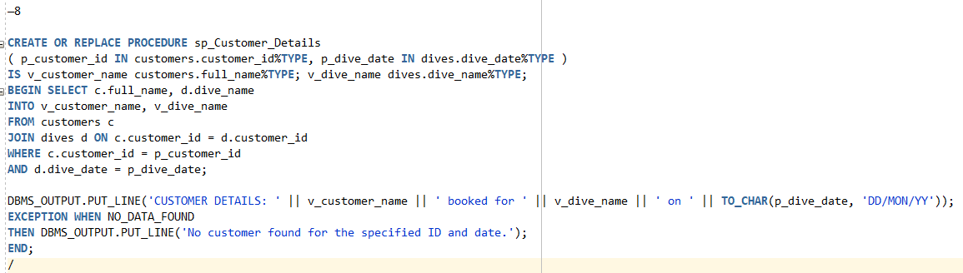

Question 9

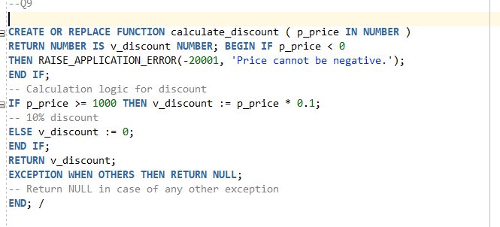

Q10

QUESTION 11



<https://github.com/ST10189387/PracticumExamADDB>