Minimum requirements to run WPF:

+Visual studio 2017+

+2g Ram+

+ .NET FRAMEWORK 6.0+

+PC running atleast windows 7 Professional

Running and using the application

-Locate and open “WpfApp2.sln”



-wait for files to download and rander

-click “ctrl +b” to build the file.

-next click start to start running the application 

-this is the beautiful interface that will pop up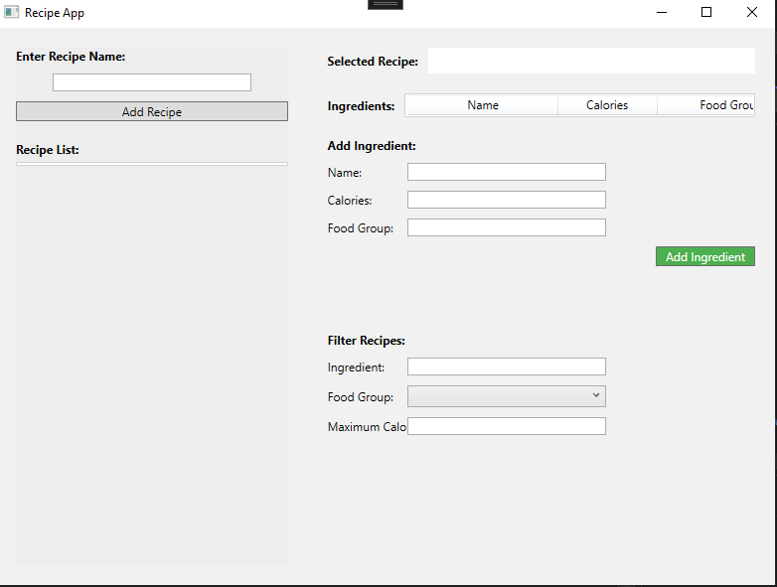

-Enter recipe details starting from the name

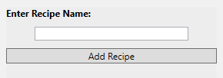

-Click “Add Recipe”

-Recipe List will populate

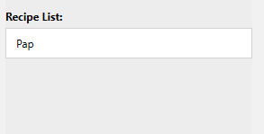

Next step is to add ingredients to the existing Recipe List

-select the recipe you just added

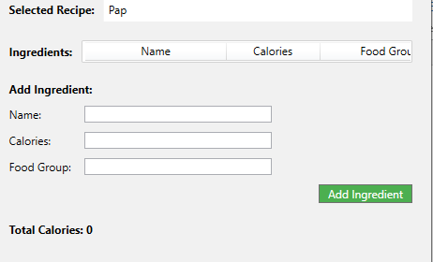

Now add ingredients to that recipe

And click “Add Ingredient”

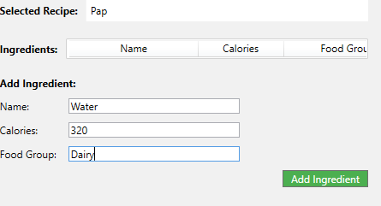

-since the Calories exceed 300

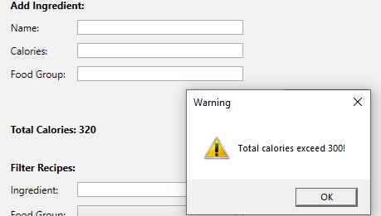

This is what you will see after clicking ok

