Banele Sobantu

ST10242025

PROG6212 POE Part 1

Dr. Mpho Gololo

18 October 2024

GitHub Link:

<https://github.com/ST10242025/PROG6212-POE-PART2.git>

Unit Test:

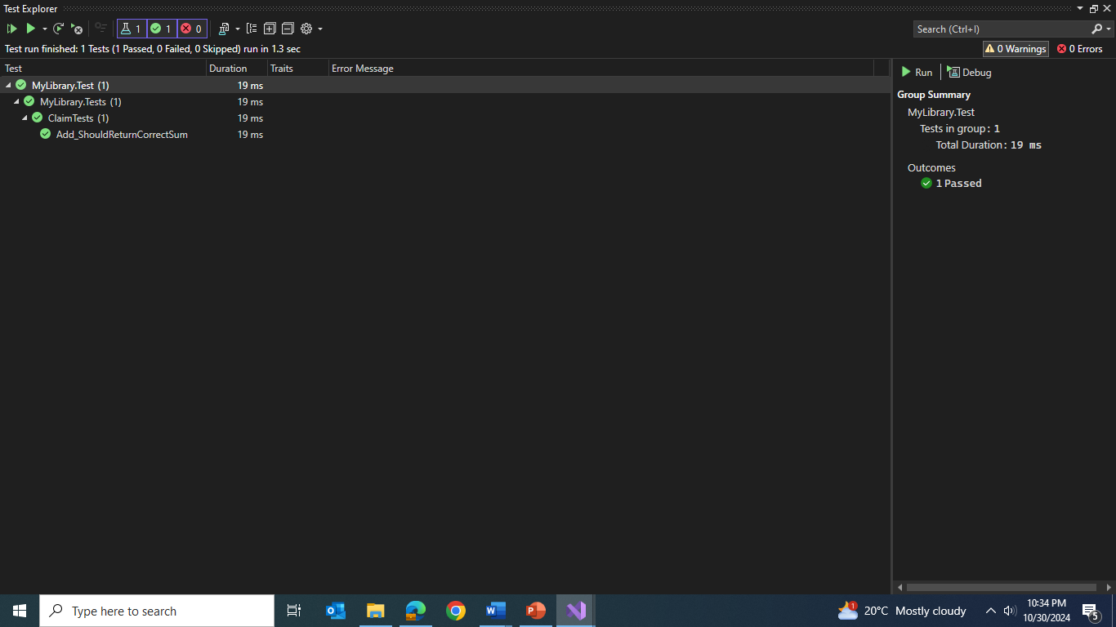

Version control 6 commits:

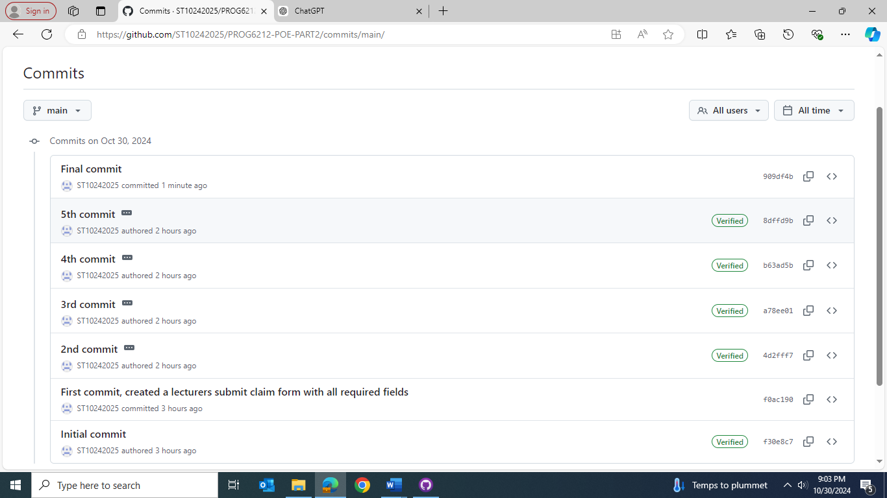

Reference List:

Satzinger, J., Jackson, R. and Burd, S. 2014. System Analysis and Design in a changing world. 7th ed. Massachusetts: Cengage.

W3Schhols. [n.d.]. C# Tutorial, [n.d.]. [Online]. Available at: [C# Tutorial (C Sharp) (w3schools.com)](https://www.w3schools.com/cs/index.php) [Accessed 27May 2024].

Microsoft. [n.d]. Get started wit ASP>NET Core MVC, [n.d]. [Online]. Available at: [Get started with ASP.NET Core MVC | Microsoft Learn](https://learn.microsoft.com/en-us/aspnet/core/tutorials/first-mvc-app/start-mvc?view=aspnetcore-8.0&tabs=visual-studio) [Accessed 1 May 2024].

Microsoft.[n.d]. Compiler Error CS0117, [n.d]. [Online]. Available at: [Compiler Error CS0117 - C# | Microsoft Learn](https://learn.microsoft.com/en-us/dotnet/csharp/misc/cs0117?f1url=%3FappId%3Droslyn%26k%3Dk(CS0117)) [Accessed 04 May 2024].

Microsoft.[n.d]. Role-based authorization in ASP.NET Core, [n.d]. [Online]. Available at: [Role-based authorization in ASP.NET Core | Microsoft Learn](https://learn.microsoft.com/en-us/aspnet/core/security/authorization/roles?view=aspnetcore-8.0)

[Accessed 07 May 2024].

W3Schhols. [n.d.]. HTML, [n.d.]. [Online]. Available at: [HTML Tutorial (w3schools.com)](https://www.w3schools.com/html/) [Accessed 243May 2024].

ASP.NET Core MVC Tutorial – Build a Shop with Admin Area. 2023. YouTube video added by Evan Gudmestad. [Online]. Available at: <https://youtu.be/T9d90fcYJvM?si=9ZJeS_qDzq8UlW_o> [Accessed 25 May 2024].