7/10/2024

ADDB 7311

ASSIGNMENT 2

Sajana Bidesi

ST10249843

# CONTENTS

CONTENTS 1

QUESTION 1 2

CREATING THE TABLES 2

POPULATING THE TABLES 5

QUESTION 2 10

QUESTION 3 11

QUESTION 4 13

QUESTION 5 15

QUESTION 6 17

QUESTION 7 19

QUESTION 7.1 19

QUESTION 7.2 21

QUESTION 7.3 23

QUESTION 8 25

REFERENCES 26

# QUESTION 1

## CREATING THE TABLES

-- CREATE TABLE CUSTOMER

CREATE TABLE CUSTOMER

(

CUSTOMER_ID NUMBER PRIMARY KEY NOT NULL,

FIRST_NAME VARCHAR(50) NOT NULL,

SURNAME VARCHAR(50) NOT NULL,

ADDRESS VARCHAR(100) NOT NULL,

CONTACT_NUMBER VARCHAR(50) NOT NULL,

EMAIL VARCHAR(50) NOT NULL

);

-- CREATE TABLE EMPLOYEE

CREATE TABLE EMPLOYEE

(

EMPLOYEE_ID VARCHAR(50) PRIMARY KEY NOT NULL,

FISRT_NAME VARCHAR(50) NOT NULL,

SURNAME VARCHAR(50) NOT NULL,

CONTACT_NUMBER VARCHAR(50) NOT NULL,

ADDRESS VARCHAR(100) NOT NULL,

EMAIL VARCHAR(50) NOT NULL

);

-- CREATE TABLE DONATOR

CREATE TABLE DONATOR

(

DONATOR_ID NUMBER PRIMARY KEY NOT NULL,

FIRST_NAME VARCHAR(50) NOT NULL,

SURNAME VARCHAR(50) NOT NULL,

CONTACT_NUMBER VARCHAR(50) NOT NULL,

EMAIL VARCHAR(50) NOT NULL

);

-- CREATE TABLE DONATION

CREATE TABLE DONATION

(

DONATION_ID NUMBER PRIMARY KEY NOT NULL,

DONATOR_ID NUMBER NOT NULL,

FOREIGN KEY (DONATOR_ID) REFERENCES DONATOR(DONATOR_ID),

DONATION VARCHAR(100) NOT NULL,

PRICE NUMBER NOT NULL,

DONATION_DATE DATE NOT NULL

);

-- CREATE TABLE DELIVERY

CREATE TABLE DELIVERY

(

DELIVERY_ID NUMBER PRIMARY KEY NOT NULL,

DELIVERY_NOTES VARCHAR(100) NOT NULL,

DISPATCH_DATE DATE NOT NULL,

DELIVERY_DATE DATE NOT NULL

);

-- CREATE TABLE RETURNS

CREATE TABLE RETURNS

(

RETURN_ID NUMBER PRIMARY KEY NOT NULL,

RETURN_DATE DATE NOT NULL,

REASON VARCHAR(100) NOT NULL,

CUSTOMER_ID NUMBER NOT NULL,

FOREIGN KEY (CUSTOMER_ID) REFERENCES CUSTOMER(CUSTOMER_ID),

DONATION_ID NUMBER NOT NULL,

FOREIGN KEY (DONATION_ID) REFERENCES DONATION(DONATION_ID),

EMPLOYEE_ID VARCHAR(50) NOT NULL,

FOREIGN KEY (EMPLOYEE_ID) REFERENCES EMPLOYEE(EMPLOYEE_ID)

);

-- CREATE TABLE INVOICE

CREATE TABLE INVOICE

(

INVOICE_NUM NUMBER PRIMARY KEY NOT NULL,

CUSTOMER_ID NUMBER NOT NULL,

FOREIGN KEY (CUSTOMER_ID) REFERENCES CUSTOMER(CUSTOMER_ID),

INVOICE_DATE DATE NOT NULL,

EMPLOYEE_ID VARCHAR(50) NOT NULL,

FOREIGN KEY (EMPLOYEE_ID) REFERENCES EMPLOYEE(EMPLOYEE_ID),

DONATION_ID NUMBER NOT NULL,

FOREIGN KEY (DONATION_ID) REFERENCES DONATION(DONATION_ID),

DELIVERY_ID NUMBER NOT NULL,

FOREIGN KEY (DELIVERY_ID) REFERENCES DELIVERY(DELIVERY_ID)

);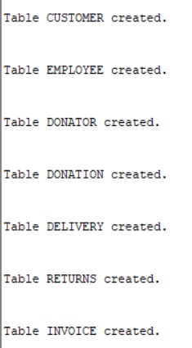

## POPULATING THE TABLES

-- INSERT INTO CUSTOMER

INSERT ALL

INTO CUSTOMER (CUSTOMER_ID, FIRST_NAME, SURNAME, ADDRESS, CONTACT_NUMBER, EMAIL) VALUES (11011, 'Jack', 'Smith', '18 Water Rd', '0877277521', 'jsmith@isat.com')

INTO CUSTOMER (CUSTOMER_ID, FIRST_NAME, SURNAME, ADDRESS, CONTACT_NUMBER, EMAIL) VALUES (11012, 'Pat', 'Hendricks', '22 Water Rd', '0863257857', 'ph@mcom.co.za')

INTO CUSTOMER (CUSTOMER_ID, FIRST_NAME, SURNAME, ADDRESS, CONTACT_NUMBER, EMAIL) VALUES (11013, 'Andre', 'Clark', '101 Summer Lane', '0834567891', 'aclark@mcom.co.za')

INTO CUSTOMER (CUSTOMER_ID, FIRST_NAME, SURNAME, ADDRESS, CONTACT_NUMBER, EMAIL) VALUES (11014, 'Kevin', 'Jones', '55 Mountain Way', '0612547895', 'kj@isat.co.za')

INTO CUSTOMER (CUSTOMER_ID, FIRST_NAME, SURNAME, ADDRESS, CONTACT_NUMBER, EMAIL) VALUES (11015, 'Lucy', 'Williams', '5 Main Rd', '0827238521', 'w@mcal.co.za')

SELECT * FROM dual;

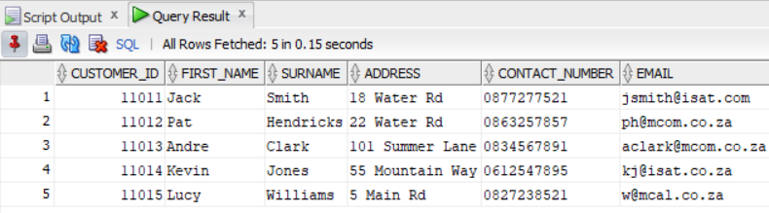SELECT * FROM CUSTOMER;

-- INSERT INTO EMPLOYEE

INSERT ALL

INTO EMPLOYEE (EMPLOYEE_ID, FISRT_NAME, SURNAME, CONTACT_NUMBER, ADDRESS, EMAIL) VALUES ('emp101', 'Jeff', 'Davis', '0877277521', '10 Main Rd', 'jand@isat.com')

INTO EMPLOYEE (EMPLOYEE_ID, FISRT_NAME, SURNAME, CONTACT_NUMBER, ADDRESS, EMAIL) VALUES ('emp102', 'Kevin', 'Marks', '0837377522', '18 Water Rd', 'km@isat.com')

INTO EMPLOYEE (EMPLOYEE_ID, FISRT_NAME, SURNAME, CONTACT_NUMBER, ADDRESS, EMAIL) VALUES ('emp103', 'Adanya', 'Andrews', '0817117523', '21 Circle Lane', 'aa@isat.com')

INTO EMPLOYEE (EMPLOYEE_ID, FISRT_NAME, SURNAME, CONTACT_NUMBER, ADDRESS, EMAIL) VALUES ('emp104', 'Adebayo', 'Dryer', '0797215244', '1 Sea Rd', 'aryer@isat.com')

INTO EMPLOYEE (EMPLOYEE_ID, FISRT_NAME, SURNAME, CONTACT_NUMBER, ADDRESS, EMAIL) VALUES ('emp105', 'Xolani', 'Samson', '0827122255', '12 Main Rd', 'xosam@isat.com')

SELECT * FROM dual;

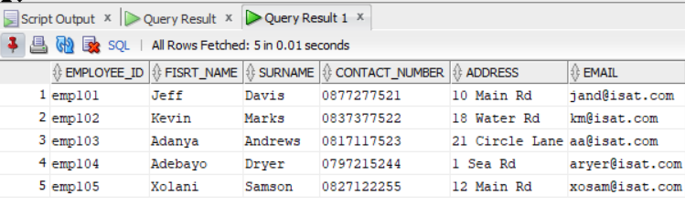SELECT * FROM EMPLOYEE;

-- INSERT INTO DONATOR

INSERT ALL

INTO DONATOR (DONATOR_ID, FIRST_NAME, SURNAME, CONTACT_NUMBER, EMAIL) VALUES (20111, 'Jeff', 'Watson', '0827172250', 'jwatson@ymail.com')

INTO DONATOR (DONATOR_ID, FIRST_NAME, SURNAME, CONTACT_NUMBER, EMAIL) VALUES (20112, 'Stephen', 'Jones', '0837865670', 'joness@ymail.com')

INTO DONATOR (DONATOR_ID, FIRST_NAME, SURNAME, CONTACT_NUMBER, EMAIL) VALUES (20113, 'James', 'Joe', '0878978650', 'jj@isat.com')

INTO DONATOR (DONATOR_ID, FIRST_NAME, SURNAME, CONTACT_NUMBER, EMAIL) VALUES (20114, 'Kelly', 'Ross', '0826575650', 'kross@gsat.com')

INTO DONATOR (DONATOR_ID, FIRST_NAME, SURNAME, CONTACT_NUMBER, EMAIL) VALUES (20115, 'Abraham', 'Clark', '0797656430', 'aclark@ymail.com')

SELECT * FROM dual;

SELECT * FROM DONATOR;

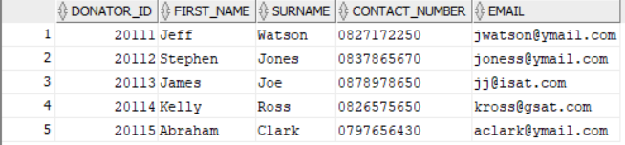

-- INSERT INTO DONATIONS

INSERT ALL

INTO DONATION (DONATION_ID, DONATOR_ID, DONATION, PRICE, DONATION_DATE) VALUES (7111, 20111, 'KIC Fridge', 599, TO_DATE('01-May-2024', 'DD-Mon-YYYY'))

INTO DONATION (DONATION_ID, DONATOR_ID, DONATION, PRICE, DONATION_DATE) VALUES (7112, 20112, 'Samsung 42inch LCD', 1299, TO_DATE('03-May-2024', 'DD-Mon-YYYY'))

INTO DONATION (DONATION_ID, DONATOR_ID, DONATION, PRICE, DONATION_DATE) VALUES (7113, 20113, 'Sharp Microwave', 1599, TO_DATE('03-May-2024', 'DD-Mon-YYYY'))

INTO DONATION (DONATION_ID, DONATOR_ID, DONATION, PRICE, DONATION_DATE) VALUES (7114, 20115, '6 Seat Dining Room Table', 799, TO_DATE('05-May-2024', 'DD-Mon-YYYY'))

INTO DONATION (DONATION_ID, DONATOR_ID, DONATION, PRICE, DONATION_DATE) VALUES (7115, 20114, 'Lazyboy Sofa', 1199, TO_DATE('07-May-2024', 'DD-Mon-YYYY'))

INTO DONATION (DONATION_ID, DONATOR_ID, DONATION, PRICE, DONATION_DATE) VALUES (7116, 20113, 'JVC Surround Sound System', 179, TO_DATE('09-May-2024', 'DD-Mon-YYYY'))

SELECT * FROM dual;

SELECT * FROM DONATION;

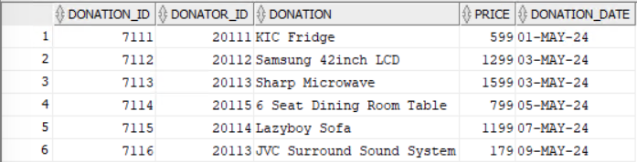

-- INSERT INTO DELIVERY

INSERT ALL

INTO DELIVERY (DELIVERY_ID, DELIVERY_NOTES, DISPATCH_DATE, DELIVERY_DATE) VALUES (511, 'Double packaging requested', TO_DATE('10-May-2024', 'DD-Mon-YYYY'), TO_DATE('15-May-2024', 'DD-Mon-YYYY'))

INTO DELIVERY (DELIVERY_ID, DELIVERY_NOTES, DISPATCH_DATE, DELIVERY_DATE) VALUES (512, 'Delivery to work address', TO_DATE('12-May-2024', 'DD-Mon-YYYY'), TO_DATE('15-May-2024', 'DD-Mon-YYYY'))

INTO DELIVERY (DELIVERY_ID, DELIVERY_NOTES, DISPATCH_DATE, DELIVERY_DATE) VALUES (513, 'Signature required', TO_DATE('12-May-2024', 'DD-Mon-YYYY'), TO_DATE('17-May-2024', 'DD-Mon-YYYY'))

INTO DELIVERY (DELIVERY_ID, DELIVERY_NOTES, DISPATCH_DATE, DELIVERY_DATE) VALUES (514, 'No notes', TO_DATE('12-May-2024', 'DD-Mon-YYYY'), TO_DATE('15-May-2024', 'DD-Mon-YYYY'))

INTO DELIVERY (DELIVERY_ID, DELIVERY_NOTES, DISPATCH_DATE, DELIVERY_DATE) VALUES (515, 'Birthday present wrapping required', TO_DATE('18-May-2024', 'DD-Mon-YYYY'), TO_DATE('19-May-2024', 'DD-Mon-YYYY'))

INTO DELIVERY (DELIVERY_ID, DELIVERY_NOTES, DISPATCH_DATE, DELIVERY_DATE) VALUES (516, 'Delivery to work address', TO_DATE('20-May-2024', 'DD-Mon-YYYY'), TO_DATE('25-May-2024', 'DD-Mon-YYYY'))

SELECT * FROM dual;

SELECT * FROM DELIVERY;

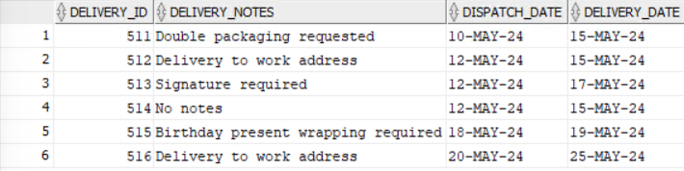

-- INSERT INTO RETURNS

INSERT ALL

INTO RETURNS (RETURN_ID, RETURN_DATE, REASON, CUSTOMER_ID, DONATION_ID, EMPLOYEE_ID) VALUES ('ret001', TO_DATE('25-May-2024', 'DD-Mon-YYYY'), 'Customer not satisfied with product', 11011, 7116, 'emp101')

INTO RETURNS (RETURN_ID, RETURN_DATE, REASON, CUSTOMER_ID, DONATION_ID, EMPLOYEE_ID) VALUES ('ret002', TO_DATE('25-May-2024', 'DD-Mon-YYYY'), 'Product had broken section', 11013, 7114, 'emp103')

SELECT * FROM dual;

SELECT * FROM RETURNS;



INSERT ALL

INTO INVOICE (INVOICE_NUM, CUSTOMER_ID, INVOICE_DATE, EMPLOYEE_ID, DONATION_ID, DELIVERY_ID) VALUES (8111, 11011, TO_DATE('15-May-2024', 'DD-Mon-YYYY'), 'emp103', 7111, 511)

INTO INVOICE (INVOICE_NUM, CUSTOMER_ID, INVOICE_DATE, EMPLOYEE_ID, DONATION_ID, DELIVERY_ID) VALUES (8112, 11013, TO_DATE('15-May-2024', 'DD-Mon-YYYY'), 'emp101', 7114, 512)

INTO INVOICE (INVOICE_NUM, CUSTOMER_ID, INVOICE_DATE, EMPLOYEE_ID, DONATION_ID, DELIVERY_ID) VALUES (8113, 11012, TO_DATE('17-May-2024', 'DD-Mon-YYYY'), 'emp101', 7112, 513)

INTO INVOICE (INVOICE_NUM, CUSTOMER_ID, INVOICE_DATE, EMPLOYEE_ID, DONATION_ID, DELIVERY_ID) VALUES (8114, 11015, TO_DATE('17-May-2024', 'DD-Mon-YYYY'), 'emp102', 7113, 514)

INTO INVOICE (INVOICE_NUM, CUSTOMER_ID, INVOICE_DATE, EMPLOYEE_ID, DONATION_ID, DELIVERY_ID) VALUES (8115, 11011, TO_DATE('17-May-2024', 'DD-Mon-YYYY'), 'emp102', 7115, 515)

INTO INVOICE (INVOICE_NUM, CUSTOMER_ID, INVOICE_DATE, EMPLOYEE_ID, DONATION_ID, DELIVERY_ID) VALUES (8116, 11015, TO_DATE('18-May-2024', 'DD-Mon-YYYY'), 'emp103', 7116, 516)

SELECT * FROM dual;

SELECT * FROM INVOICE;

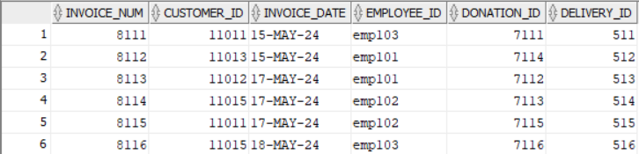

# QUESTION 2

-- QUESTION 2

SELECT

CUST.FIRST_NAME || ',' || CUST.SURNAME AS CUSTOMER_NAME,

EMP.EMPLOYEE_ID,

DEL.DELIVERY_NOTES,

DON.DONATION,

INV.INVOICE_NUM,

INV.INVOICE_DATE

FROM

CUSTOMER CUST

JOIN INVOICE INV ON CUST.CUSTOMER_ID = INV.CUSTOMER_ID

JOIN EMPLOYEE EMP ON INV.EMPLOYEE_ID = EMP.EMPLOYEE_ID

JOIN DONATION DON ON INV.DONATION_ID = DON.DONATION_ID

JOIN DELIVERY DEL ON INV.DELIVERY_ID = DEL.DELIVERY_ID

WHERE

INV.INVOICE_DATE > TO_DATE('16-MAY-2024', 'DD-MON-YYYY')

ORDER BY

DON.DONATION_DATE;

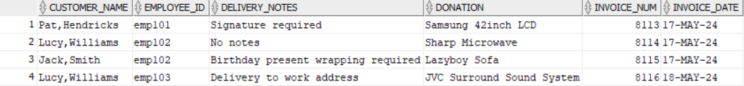

# QUESTION 3

-- QUESTION 3 (The IIE, 2024)

-- CREATE THE SEQUENCE TO INCREMENT THE VALUE FOR THE ID

CREATE SEQUENCE funding_seq

START WITH 1

INCREMENT BY 1

NOCACHE;

-- CREATE THE FUNDING TABLE WITH THE PROVIDED ATTRIBUTES

CREATE TABLE FUNDING (

FUNDING_ID INT PRIMARY KEY,

FUNDER VARCHAR(255) NOT NULL,

FUNDING_AMOUNT NUMBER NOT NULL

);

-- INSERT A RECORT USING THE SEQUENCE

INSERT INTO Funding (FUNDING_ID, FUNDER, FUNDING_AMOUNT)

VALUES (funding_seq.NEXTVAL, 'Sajana Bidesi', 1000);

INSERT INTO Funding (FUNDING_ID, FUNDER, FUNDING_AMOUNT)

VALUES (funding_seq.NEXTVAL, 'Jason Mimosa', 500);

INSERT INTO Funding (FUNDING_ID, FUNDER, FUNDING_AMOUNT)

VALUES (funding_seq.NEXTVAL, 'Evan Michaels', 3500);

SELECT * FROM FUNDING;

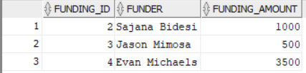

In Oracle databases, a sequence is a database object that generates a sequential series of unique numbers, which can be used primarily for creating primary keys or unique identifiers for rows in a table. When you create a sequence, you define its starting point, the increment value, and other optional parameters like caching and maximum values. Sequences are not tied to any specific table, allowing them to generate unique values across different tables. Each time a sequence is referenced (typically using `NEXTVAL`), it produces the next number in the sequence, ensuring that no two rows receive the same identifier, which helps maintain data integrity and uniqueness within the database. (Oracle, 2019; The IIE, 2024)

# QUESTION 4

-- QUESTION 4

SET SERVEROUTPUT ON;

DECLARE

CURSOR c_donations IS

SELECT

c.FIRST_NAME || ' ' || c.SURNAME AS Customer,

d.DONATION,

d.PRICE,

r.REASON AS "Return Reason"

FROM

CUSTOMER c

JOIN

RETURNS r ON c.CUSTOMER_ID = r.CUSTOMER_ID

JOIN

DONATION d ON r.DONATION_ID = d.DONATION_ID;

BEGIN

FOR rec IN c_donations LOOP

DBMS_OUTPUT.PUT_LINE('Customer: ' || rec.Customer);

DBMS_OUTPUT.PUT_LINE('Donation: ' || rec.DONATION);

DBMS_OUTPUT.PUT_LINE('Price: ' || rec.PRICE);

DBMS_OUTPUT.PUT_LINE('Return Reason: ' || rec."Return Reason");

DBMS_OUTPUT.PUT_LINE('---------------------------');

END LOOP;

END;

/

# QUESTION 5

-- QUESTION 5(The IIE, 2024)

SET SERVEROUTPUT ON;

BEGIN

FOR rec IN (

SELECT

SUBSTR(c.FIRST_NAME, 1, 1) || '.' AS customer_initial,

c.SURNAME AS customer_surname,

SUBSTR(e.FISRT_NAME, 1, 1) || '.' || e.SURNAME AS employee_name,

d.DONATION AS donation,

del.DISPATCH_DATE AS dispatch_date,

del.DELIVERY_DATE AS delivery_date,

(del.DELIVERY_DATE - del.DISPATCH_DATE) AS days_to_deliver

FROM

CUSTOMER c

JOIN

INVOICE i ON c.CUSTOMER_ID = i.CUSTOMER_ID

JOIN

EMPLOYEE e ON i.EMPLOYEE_ID = e.EMPLOYEE_ID

JOIN

DONATION d ON i.DONATION_ID = d.DONATION_ID

JOIN

DELIVERY del ON i.DELIVERY_ID = del.DELIVERY_ID

WHERE

c.CUSTOMER_ID = 11011

) LOOP

DBMS_OUTPUT.PUT_LINE('Customer: ' || rec.customer_initial || ' ' || rec.customer_surname);

DBMS_OUTPUT.PUT_LINE('Employee: ' || rec.employee_name);

DBMS_OUTPUT.PUT_LINE('Donation: ' || rec.donation);

DBMS_OUTPUT.PUT_LINE('Dispatch Date: ' || rec.dispatch_date);

DBMS_OUTPUT.PUT_LINE('Delivery Date: ' || rec.delivery_date);

DBMS_OUTPUT.PUT_LINE('Days to Deliver: ' || rec.days_to_deliver);

DBMS_OUTPUT.PUT_LINE('--------------------------------');

END LOOP;

END;

/

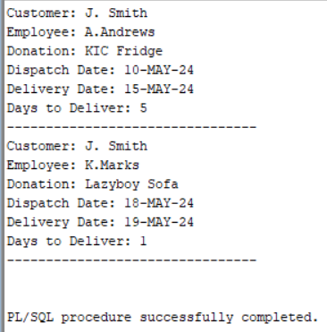

# QUESTION 6

-- QUESTION 6(The IIE, 2024)

SET SERVEROUTPUT ON;

BEGIN

FOR rec IN (

SELECT

c.FIRST_NAME,

c.SURNAME,

SUM(d.PRICE) AS TotalSpent,

CASE

WHEN SUM(d.PRICE) >= 1500 THEN '(***)'

ELSE ''

END AS Rating

FROM CUSTOMER c

JOIN INVOICE i ON c.CUSTOMER_ID = i.CUSTOMER_ID

JOIN DONATION d ON i.DONATION_ID = d.DONATION_ID

WHERE c.FIRST_NAME IN ('Jack', 'Lucy', 'Pat', 'Andre')

GROUP BY c.FIRST_NAME, c.SURNAME

)

LOOP

DBMS_OUTPUT.PUT_LINE('First Name: ' || rec.FIRST_NAME);

DBMS_OUTPUT.PUT_LINE('Surname: ' || rec.SURNAME);

DBMS_OUTPUT.PUT_LINE('Amount: R' || rec.TotalSpent || ' ' || rec.Rating);

DBMS_OUTPUT.PUT_LINE('------------------------');

END LOOP;

END;

/

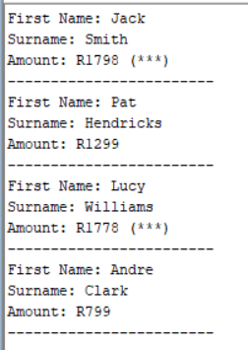

# QUESTION 7

## QUESTION 7.1

-- QUESTION 7.1(Moore et al., 2019)

DECLARE

-- DECLARE VARIABLES USING %TYPE ATTRIBUTE

v_customer_id CUSTOMER.CUSTOMER_ID%TYPE;

v_first_name CUSTOMER.FIRST_NAME%TYPE;

v_surname CUSTOMER.SURNAME%TYPE;

v_address CUSTOMER.ADDRESS%TYPE;

v_contact_number CUSTOMER.CONTACT_NUMBER%TYPE;

v_email CUSTOMER.EMAIL%TYPE;

BEGIN

-- ASSIGN A SAMPLE CUSTOMER ID FOR FETCHING DETAILS

v_customer_id := 11011;

-- FETCH CUSTOMER DETAILS INTO VARIABLES

SELECT FIRST_NAME, SURNAME, ADDRESS, CONTACT_NUMBER, EMAIL

INTO v_first_name, v_surname, v_address, v_contact_number, v_email

FROM CUSTOMER

WHERE CUSTOMER_ID = v_customer_id;

-- OUTPUT CUSTOMER DETAILS

DBMS_OUTPUT.PUT_LINE('Customer ID: ' || v_customer_id);

DBMS_OUTPUT.PUT_LINE('First Name: ' || v_first_name);

DBMS_OUTPUT.PUT_LINE('Surname: ' || v_surname);

DBMS_OUTPUT.PUT_LINE('Address: ' || v_address);

DBMS_OUTPUT.PUT_LINE('Contact Number: ' || v_contact_number);

DBMS_OUTPUT.PUT_LINE('Email: ' || v_email);

EXCEPTION

WHEN NO_DATA_FOUND THEN

DBMS_OUTPUT.PUT_LINE('No customer found with ID: ' || v_customer_id);

WHEN OTHERS THEN

DBMS_OUTPUT.PUT_LINE('An error occurred: ' || SQLERRM);

END;

/

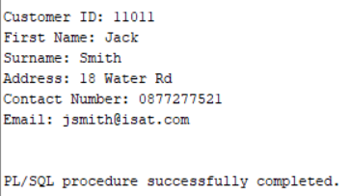

## QUESTION 7.2

-- QUESTION 7.2(L. Jayapalan et al., 2020)

DECLARE

-- DECLARE A RECORD VARIABLE THAT CAN HOLD A ROW FROM THE CUSTOMER TABLE

customer_record CUSTOMER%ROWTYPE;

-- DECLARE A CURSOR TO SELECT ALL CUSTOMERS

CURSOR customer_cursor IS

SELECT * FROM CUSTOMER;

BEGIN

OPEN customer_cursor;

-- LOOP THROUGH EACH ROW RETURNED BY THE CURSOR

LOOP

FETCH customer_cursor INTO customer_record;

-- EXIT THE LOOP WHEN NO MORE ROWS ARE FOUND

EXIT WHEN customer_cursor%NOTFOUND;

-- DISPLAY THE CUSTOMER DETAILS

DBMS_OUTPUT.PUT_LINE('Customer ID: ' || customer_record.CUSTOMER_ID);

DBMS_OUTPUT.PUT_LINE('First Name: ' || customer_record.FIRST_NAME);

DBMS_OUTPUT.PUT_LINE('Surname: ' || customer_record.SURNAME);

DBMS_OUTPUT.PUT_LINE('Address: ' || customer_record.ADDRESS);

DBMS_OUTPUT.PUT_LINE('Contact Number: ' || customer_record.CONTACT_NUMBER);

DBMS_OUTPUT.PUT_LINE('Email: ' || customer_record.EMAIL);

DBMS_OUTPUT.PUT_LINE('-----------------------');

END LOOP;

CLOSE customer_cursor;

END;

/

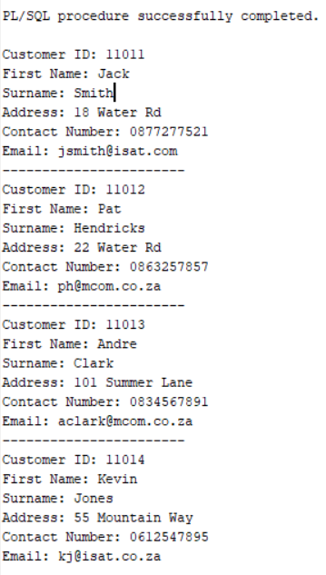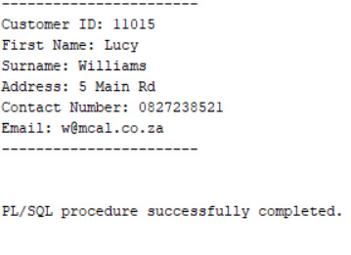

## QUESTION 7.3

-- QUESTION 7.3(TutorialsPoint, n.d.)

SET SERVEROUTPUT ON;

-- PL/SQL block to define a custom exception

-- This block verifies if the donation price surpasses a certain limit

-- If it does, a custom exception is triggered

DECLARE

-- Define an exception for exceeding the allowed donation price

price_limit_exceeded EXCEPTION;

-- Define a variable to store the donation price

v_price NUMBER;

-- Maximum permitted donation price

max_price CONSTANT NUMBER := 2000; -- Example limit set to 1000

BEGIN

-- Fetch the donation price from the DONATION table

SELECT PRICE INTO v_price

FROM DONATION

WHERE DONATION_ID = 7117; -- Assuming donation ID 1 for illustration

-- Verify if the price goes beyond the limit

IF v_price > max_price THEN

-- Trigger the custom exception if the price is above the limit

RAISE price_limit_exceeded;

END IF;

-- If no exception is raised, insert data into the INVOICE table

INSERT INTO INVOICE (INVOICE_NUM, CUSTOMER_ID, INVOICE_DATE, EMPLOYEE_ID, DONATION_ID, DELIVERY_ID)

VALUES (8117, 11011, SYSDATE, 'emp103', 7117, 517);

DBMS_OUTPUT.PUT_LINE('Invoice successfully created.');

EXCEPTION

-- Handle the custom exception if the donation price is too high

WHEN price_limit_exceeded THEN

DBMS_OUTPUT.PUT_LINE('Error: Donation price exceeds the allowed maximum of ' || max_price);

-- Handle any other potential exceptions

WHEN OTHERS THEN

DBMS_OUTPUT.PUT_LINE('Error: ' || SQLERRM);

END;

/

# QUESTION 8

-- QUESTION 8

SELECT

c.FIRST_NAME AS "First Name",

c.SURNAME AS "Surname",

SUM(d.PRICE) AS "Amount",

CASE

WHEN SUM(d.PRICE) >= 1500 THEN '***'

WHEN SUM(d.PRICE) BETWEEN 1000 AND 1400 THEN '**'

ELSE '*'

6

END AS "Rating"

FROM CUSTOMER c

JOIN INVOICE i ON c.CUSTOMER_ID = i.CUSTOMER_ID

JOIN DONATION d ON i.DONATION_ID = d.DONATION_ID

WHERE c.FIRST_NAME IN ('Jack', 'Lucy', 'Pat', 'Andre')

GROUP BY c.FIRST_NAME, c.SURNAME;

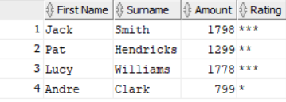

# REFERENCES

L. Jayapalan, Belden, E., Huey, P., Moore, S. and Rich, K. (2020). *%ROWTYPE Attribute*. [online] Oracle Help Center. Available at: https://docs.oracle.com/en/database/oracle/oracle-database/21/lnpls/ROWTYPE-attribute.html.

Moore, S., L. Jayapalan, Huey, P., Belden, E., Rich, K. and Moore, V. (2019). *%TYPE Attribute*. [online] Oracle Help Center. Available at: https://docs.oracle.com/en/database/oracle/oracle-database/19/lnpls/TYPE-attribute.html.

Oracle (2019). *CREATE SEQUENCE*. [online] Oracle Help Center. Available at: https://docs.oracle.com/en/database/oracle/oracle-database/19/sqlrf/CREATE-SEQUENCE.html.

The IIE (2024). *IIE Module Manual ADDB7311/ADDB6311 ADVANCED DATABASES MODULE MANUAL 2024 (First Edition: 2024)*.

TutorialsPoint (n.d.). *PL/SQL - Exceptions - Tutorialspoint*. [online] www.tutorialspoint.com. Available at: https://www.tutorialspoint.com/plsql/plsql_exceptions.htm.