How to run the file: open the source code and run this file.

This will open visual studio and then you can click run at the top of the screen:



The application will run in the command promt:

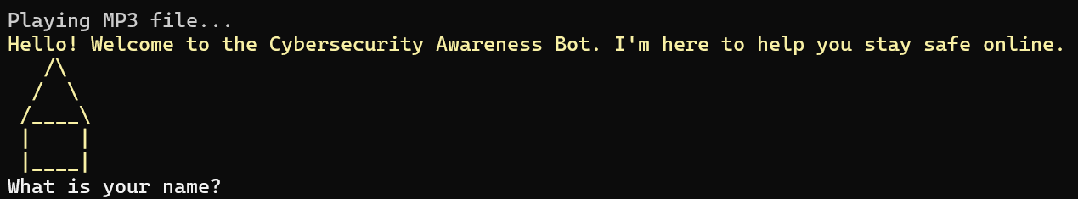

Type in your name then click enter. The application will then ask if you are doing fine, Repond then click enter.

The application will ask ifyou would like to learn about Cyber Security, Respond with ‘1’ then click enter. Then your first question will appear, you can respond with ‘1’ and proceed or you can type in a random letter to trigger a loop exception handler or you can click ‘2’ to disagree. I will display all the possible senarios below:  
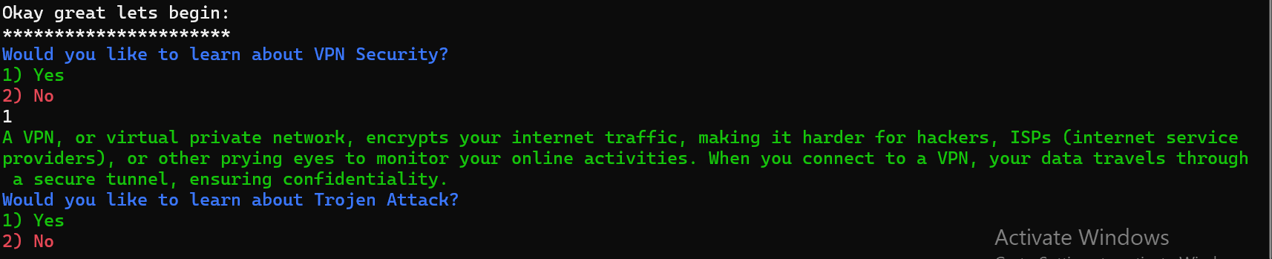

A total of 3 topic display and you are awarded at the end of the application:  
