Title page

ST10261925

SOEN6222

Part 3

Table of Contents
Question 1 3
Question 2 5
Question 3 6

Question 1
This here is for the feedback being addresses for the SRS update:
- I have added a new section detailing the relevance of the artchitecture in industry, I have also added/included the benefits like the easing of testing as well as the scalability.
- I have added to the topic on microservice benefits, resilience and also independent deployment which emphasizes the adaptability of helping hands software (Advantages of microservices and disadvantages to know, 2024).
- I have reviewed all the requirements traceability to make sure that all elements are linked directly to the class diagram and the decisions of the designs.
As for the appendix write up:
According to the feedback given to me about the SRS which stands for software requirements it emphasises the need for better and stronger discussion of the architecture relevance as well as a comprehensive traceability matrix, for this there is a section that was added which explains the advantages of the MVC in the industry, mostly for scalability and modularity. When it comes to the the microservice topic it was expanded to emphasise the characteristics such as the fulat isolation and the ease of the deployment which is directly linked to the projects needs e.g. such as the resource tracking. When it comes to the traceability matric the missing links was corrected to the requirements that were needed with the design decisions.

This here is for the feedback being addressed for the software design document update:
- There is now a detailed motivation for the microservices which also includes a real world application like managing the distributed systems and also enabiling the scalable development for the helping hands software.
- The elements for the class diagram has been updated for the mobile app integration and resource tracking, operations and relationships to make sure the alignment with the current updated SRS
- The UML natation has been refined and it also ensures traceability from the design elements to the requirements

As for the appendix write up:
For the feedback on the design document it required for there to be more detailed explanation for the architecture that was picked as well as the enhancements of the class diagram. For the microservices section it emphasizes the benefits more, such as for the scalability and for fault isolation but it is specifically for managing the distributed resources in helping hands. Foe the class diagram it was updated to include mobile app integration and tracking of resources, with the attributes and operations being defined to reflect these functions. For the UML notation it was fixed and the relations between classes was clarified for there to be consistency. All these changes will allow for the document to be aligned with the project requirements.

Question 2
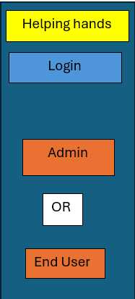
Screenshots

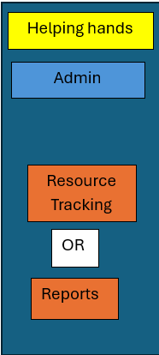
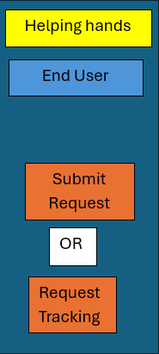

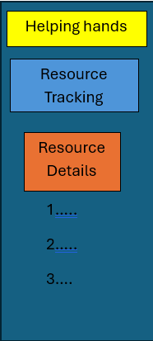
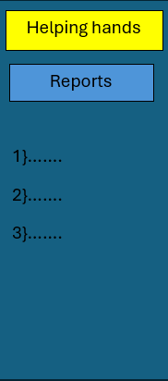
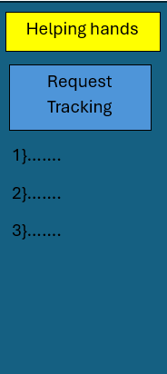
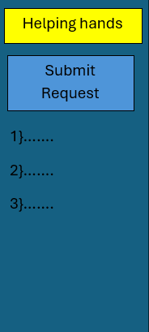

next

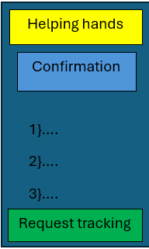

Question 3
For the self reflection paragraph:
working on this project has been a great learning experience. It has taught me how to take feedback seriously and use it to make my work better than it was before. By updating the documents, like the requirements and design, it has showed me how important it is to connect all the pieces of a project so that everything makes sense, works together and runs smoothly.
One of the most difficult parts was fixing the class diagram to add new features such as the tracking of resources and supporting the mobile apps. It was a bit difficult to make sure that everything followed the rules of UML diagrams I made, but to be honet I have learned a lot by practicing it doing it over and over as well as doing research.
When it comes to this this project it has also helped me understand why we use things like microservices and MVC they make it much easier to build systems that can grow and handle changes. I can say that this project has improved my problem solving and planning skills.

References
Advantages of microservices and disadvantages to know. (2024, November 20). Retrieved from ATLASSIAN: https://www.atlassian.com/microservices/cloud-computing/advantages-of-microservices

