Cover Page
ST10261925
SOEN6222
Part 2

Table of Contents
Question 1 3
Question 2 5
References 6

Question 1
When it comes to the Helping Hands Software Solution, I would say that using and implementing the MVC architectural pattern (Model-View-Controller) is ideal. MVC is a well-established pattern that separates the application into three parts/concepts, each with specific responsibilities within the system.
Model
When it comes to the model part/concept, this will handle all the data-based logic as well as the business rules. In the context of Helping Hands, this will include managing the main/core business entities such as donations, volunteer records, beneficiary records, and inventory. This layer ensures data integrity, manages data persistence, and implements business validation rules. For example, when donations are processed, the model contains logic for generating tax receipts, updating donor records, and validating donation amounts. Similarly, for inventory management, it handles stock calculations, resource allocation rules, and threshold alerts (Sommerville, 2024).
To align with the updated requirements, the class diagram has been revised to include elements for mobile app integration and resource tracking. The operations and relationships have been updated to ensure alignment with the SRS and traceability.
View
When it comes to the view part/concept, it is responsible for presenting data/information to users and managing user interface elements. Helping Hands requires different user interfaces for volunteers, beneficiaries, and staff. This layer implements many presentation formats, including:
- Web pages for processing donations.
- Schedules for volunteer placement.
- Mobile-responsive interfaces for on-the-go access.
- Dashboards for inventory management.
The view layer ensures data is presented in a user-friendly and accessible manner without embedding business logic (Sommerville, 2024).
Controller
The controller acts as a middleman between the model and view, processing user input and managing the application flow. It receives user requests, interacts with the model to process data, and determines which view to present to the user. For example, when a staff member assigns a task to a volunteer, the controller verifies the request, updates the allocated models, and ensures the correct views are updated to reflect the changes (Sommerville, 2024).
Motivation for Microservices
There is now a detailed motivation for the microservices, which includes real-world applications like managing distributed systems and enabling scalable development for Helping Hands Software Solution.
Reasons for Choosing MVC
Here are the reasons why this architecture pattern is best suited for Helping Hands Software Solution:
- Scalability:
As the business grows, new features can be added without disrupting existing functionalities. Individual components can be scaled based on demand due to the modular nature of MVC (Sommerville, 2024).
- Future Extensibility:
The planned mobile app can be easily integrated since the controller layer can expose APIs for mobile clients while reusing existing model components (Sommerville, 2024).
- Enhanced Security:
The separation of concerns allows robust security measures to be implemented at different levels. Authorization and user authentication will be effectively managed to protect sensitive beneficiary and donor data (Sommerville, 2024).
- Support for Multiple User Interfaces:
This pattern supports the requirements for various user interfaces, such as those for volunteers and staff (Sommerville, 2024).

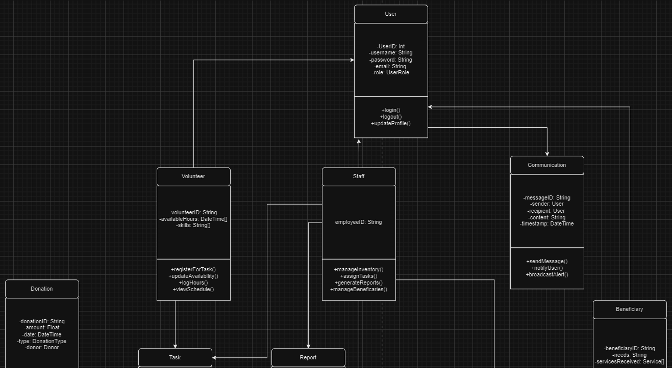
Question 2

Sends/receives

manages
generate
performs
manages
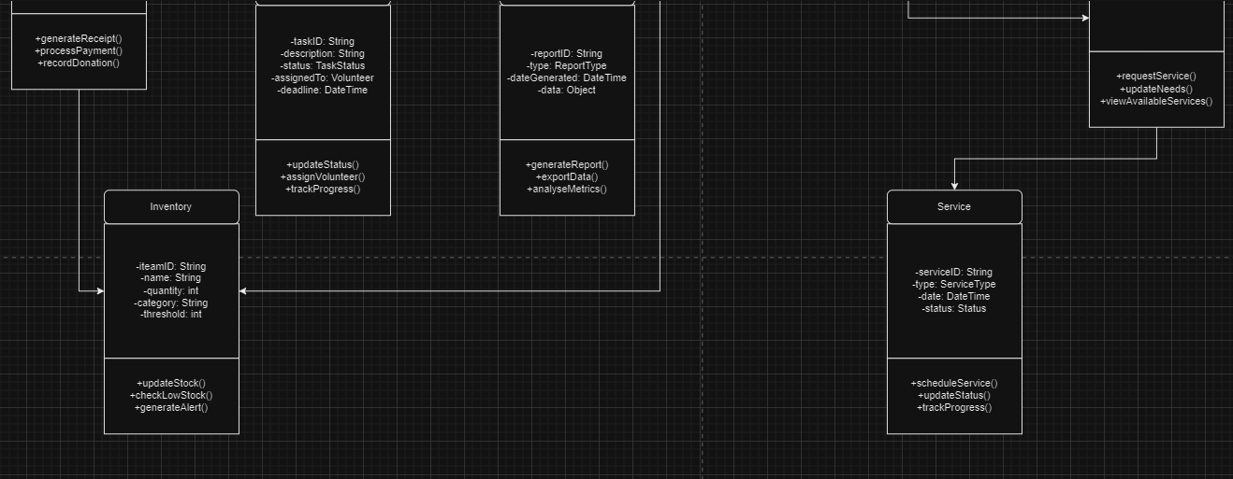

affects
receives

manages

References
Sommerville, I. (2024). Software Engineering (10th ed.). Boston: GLOBAL EDITION.

