**ICE 1   
Screenshots:**

OpenSSL config:

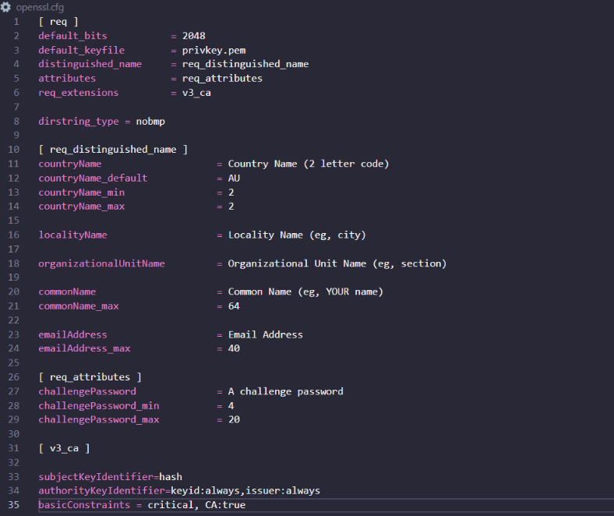

Server:

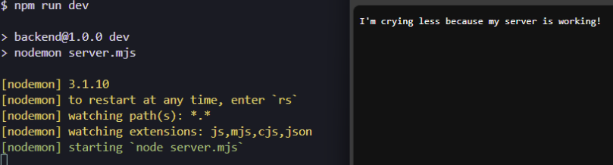

Postman test:

MongoDB:

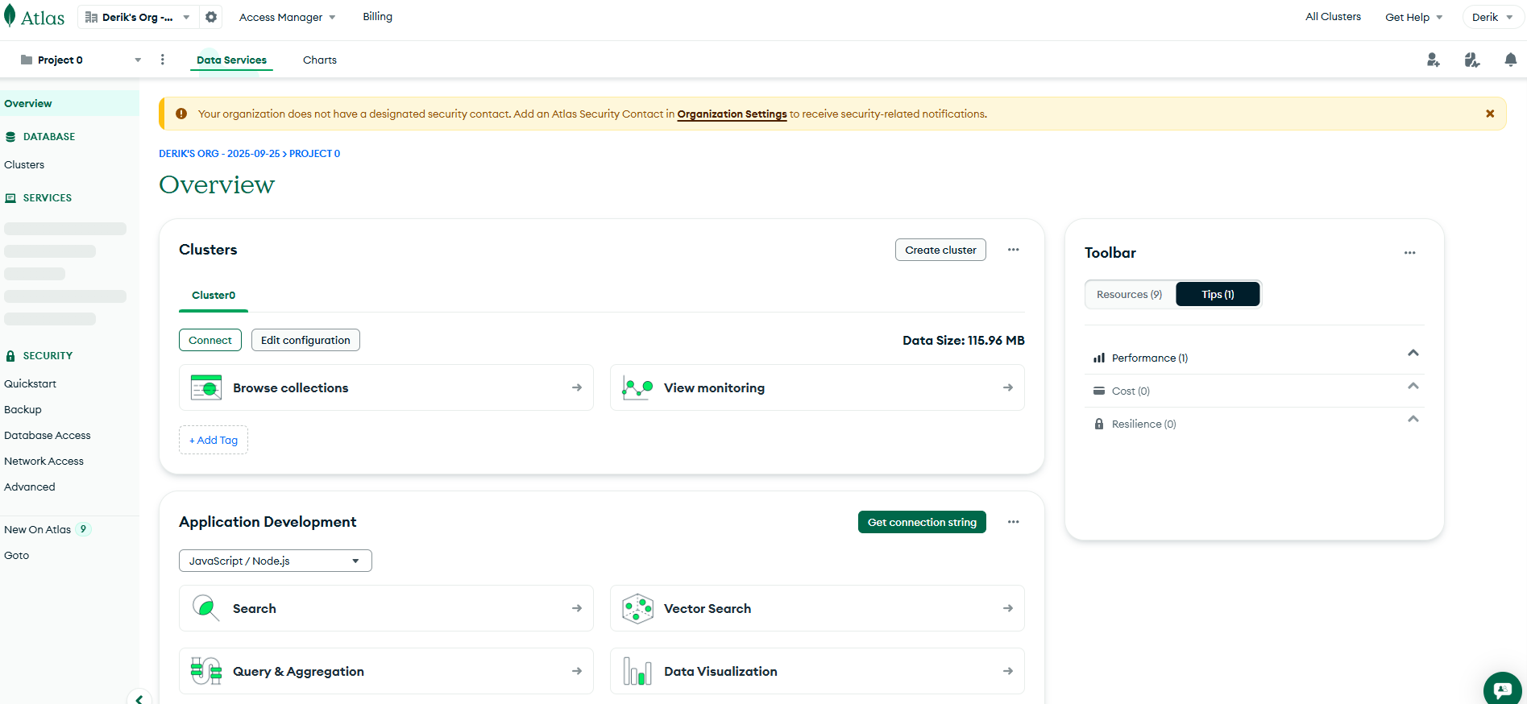

Users:

