Darshan’s POE PART 2 _ PROG

CREATE DATABASE PROG_POE_PART2_ST10278170;

use PROG_POE_PART2_ST10278170

CREATE TABLE Lecturer (

LecturerID INT IDENTITY(1,1) NOT NULL,

LecturerName VARCHAR(55) NOT NULL,

AccPassword VARCHAR(35) NOT NULL,

Role VARCHAR(15) NOT NULL,

CONSTRAINT PK_LecturerName PRIMARY KEY (LecturerName)

);

Insert into Lecturer (LecturerName, AccPassword, Role)

Values ('Darshan', 'Dash26', 'Lecturer'),

('Mohale', 'Data', 'Lecturer')

drop table Lecturer

Select * from Lecturer

CREATE TABLE Programme_Coordinator (

Programme_CoordinatorID INT IDENTITY(1,1) NOT NULL,

PcName VARCHAR(55) NOT NULL,

AccPassword VARCHAR(35) NOT NULL,

Role VARCHAR(55) NOT NULL,

CONSTRAINT PK_Programme_CoordinatorID PRIMARY KEY (Programme_CoordinatorID)

);

Insert into Programme_Coordinator (PcName, AccPassword, Role)

Values ('Marvin', 'Web', ' Program Coordinator')

CREATE TABLE Academic_Manager (

Academic_ManagerID INT IDENTITY(1,1) NOT NULL,

AmName VARCHAR(55) NOT NULL,

AccPassword VARCHAR(35) NOT NULL,

Role VARCHAR(55) NOT NULL,

CONSTRAINT PK_Academic_Manager PRIMARY KEY (Academic_ManagerID)

);

Insert into Academic_Manager (AmName, AccPassword, Role)

Values ('Rejoice', 'IT Tech', 'Academic Manager')

CREATE TABLE Claims (

ClaimId INT IDENTITY(1,1) NOT NULL,

LecturerName VARCHAR(55) NOT NULL,

HoursWorked INT NOT NULL,

HourlyRate INT NOT NULL,

AdditionalNotes VARCHAR(MAX),

Status VARCHAR(15),

);

drop table Claims

Select * from Claims

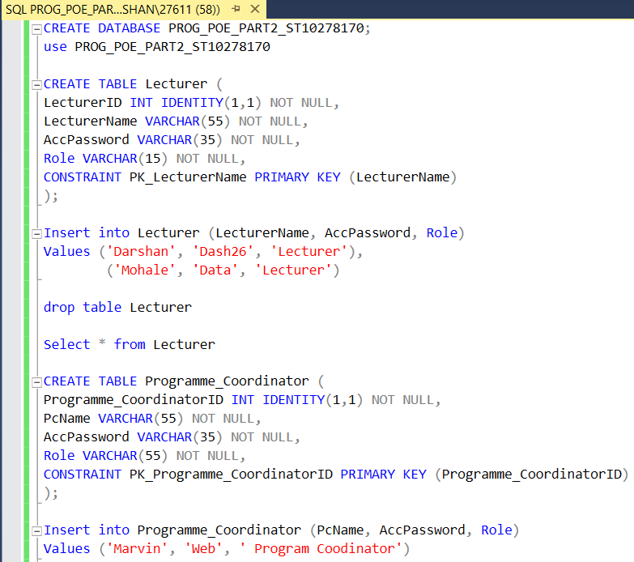**Relationships (UML Table)   
  
A Lecturer** can submit many **Claims**.  
**A Claim** can have many **Supporting Documents**.  
**A programme Co-ordinator** can review many **Claims**.  
**An Academic Manager** approves or can reject many **Claims**.

