**ST10279488**

**CLDV6212**

**Part 2**

URL of deployed application: <https://st10279488-dye6adchbkaabdd7.southafricanorth-01.azurewebsites.net>

GitHub link to wed application source code: <https://github.com/ST10279488/CLDV6212-Part-2.git>

1. Screenshots of function on azure function app and code shared.

* Azure Tables

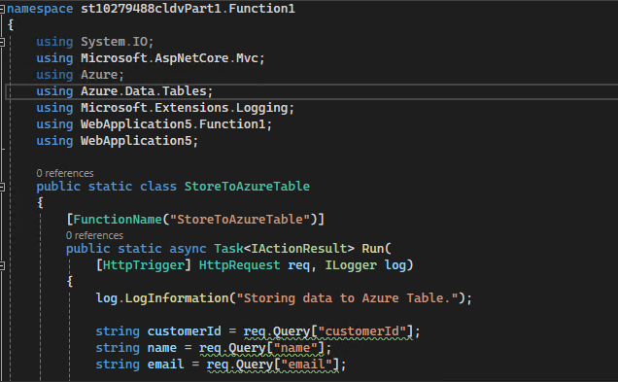

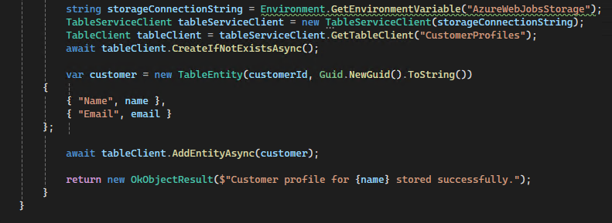

* Azure Blob Storage

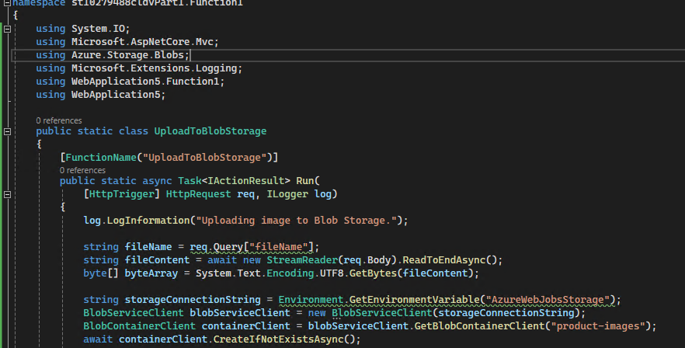

* Azure Queue

* Azure Files



B. Utilising Azure Event Hubs and Azure Event Bus can boost your application's performance, scalability, and responsiveness, all of which will significantly improve the user experience. How to use these two services to enhance the value of your ABC Retail app:

1. Azure Event Hubs: Able to process millions of events per second, Azure Event Hubs is a highly scalable data streaming platform and event ingestion service. Real-time event data, including orders, consumer behaviour, and operational indicators, can be captured and analysed using it. (data semantics, 2024)

Benefits to Customer Experience:

* Real-time Processing: High amounts of event data may be ingested and processed in real-time using Azure Event Hubs. This implies that ABC Retail can keep an eye on user behaviour on the website in real time, including browsing habits, product interactions, and transactions.
* Example: Event Hubs can cause the application to instantly analyse and update product recommendations when a consumer adds an item to their cart. This will improve the user's shopping experience by displaying related or complementary products.
* Customised Recommendations: Event Hubs can process customer interaction data to input into machine learning models for customised promotions and product recommendations, resulting in a more customised shopping experience.
* Example: if a consumer visits the site often and looks at electronics, Event Hubs can set off customised promotions or provide notifications relevant to electronics.
* Handling Peak Loads: During busy seasons like Christmas, when there's a rise in traffic, Event Hubs can handle a huge number of events related to consumer transactions, product views, and stock updates. By doing this, you can make sure that the system doesn't slow down during times of high traffic.
* Example: during sales events, Event Hubs can handle the data from a large number of orders, making sure the order processing system scales to meet demand and preventing order confirmation delays.
* Enhanced Operational Efficiency: Event Hubs improve system synchronisation by broadcasting real-time events from your application, such as price adjustments or inventory changes. This lessens the annoyance that comes with out-of-stock merchandise or inaccurate pricing by guaranteeing that buyers always see accurate, up-to-date information.
* Example: To prevent over purchasing or back-order problems, Event Hubs can set off warnings for customers and operational teams when inventory levels for popular items are low.

2. Azure Event Bus: Reactive event-driven programming in apps is made possible by Azure Event Bus, an event routing solution. It provides scalable, low-latency event delivery and enables real-time service response through event-based communication. (data semantics, 2024)

Benefits to Customer Experience:

* Instant Notifications and Updates: You may utilise Event Bus to let your app tell users right away about critical occurrences like order confirmations, shipping updates, and delivery statuses. This improves the channel of communication between your company and the client.
* Example: an event in Event Bus can be set off when an order is completed and prepared for shipping, promptly informing the buyer via email or SMS.
* Real-time Event-Driven Workflows: Event Bus facilitates event-driven workflows that enhance your application's responsiveness. For example, when customers conduct actions like adding items to their wish list or cart, Event Bus can automatically activate procedures like price watch notifications or stock alerts.
* Example: if a customer adds a product to their wish list, Event Bus instantly notifies them, urging them to finish the transaction when the product's price reduces.
* Seamless Integration Across Systems: Event Bus facilitates easy communication across many systems, such as your CRM, inventory management system, and online application. This guarantees that modifications made to one system will be instantly mirrored in the others, increasing the app's accuracy overall.
* Example: Event Bus can alert other services, like the marketing team or e-commerce platform, when inventory levels change in your system so they can instantly modify their tactics (e.g., take out-of-stock items from promotions).
* Improved Performance and Scalability: Event Bus is perfect for expanding as your application expands because it can process millions of events per second. Customers won't have to deal with delays or inconsistent service, even during times of high traffic.
* Example: Event Bus can quickly handle spikes in activity during busy shopping hours, such as order placements and payment confirmations, resulting in a flawless shopping experience.

(alexanderhagemann, 2024) (Turbo360, 2024)

# References

(2024, 09 25). Retrieved from data semantics: https://datasemantics.co/azure-event-hub-vs-azure-service-bus-a-comparison/#:~:text=Key%20Differences%20Between%20Azure%20Event%20Hub

(2024, 09 25). Retrieved from alexanderhagemann: https://alexanderhagemann.de/understanding-azure-service-bus-and-azure-event-hub/

(2024, 09 25). Retrieved from Turbo360: https://turbo360.com/blog/azure-event-hubs-vs-service-bus#:~:text=Azure%20Event%20Hubs.%20Azure%20Event%20Hubs%20is%20a