HOPE & PAWS ANIMAL SHELTER
PawConnect
User Guide
How to browse, adopt, donate, volunteer and run the shelter with PawConnect
INSY7315 Work Integrated Learning · Task 3
Carson Norman · ST10285120
Version 1.0 · 2 November 2026

Contents

1. Introduction
PawConnect is the online system for Hope & Paws Animal Shelter. It replaces the paper intake cards, the shared spreadsheet and the WhatsApp shift group with one website that the public, volunteers and shelter staff all use.
This guide explains how to use every part of PawConnect, step by step, for each kind of user. It also covers the technical setup for the volunteer who looks after the system, and answers common questions.

1.1 Who this guide is for
You are… | Your role in PawConnect | Read
A member of the public who wants to adopt, donate or sponsor | Adopter (anyone who registers) | Sections 2 and 3
A shelter volunteer or part-time staff member | Volunteer | Sections 2 and 4
The shelter manager or another administrator | Shelter administrator | Sections 2, 4 and 5
The technical volunteer who runs the system | Administrator, plus server access | Sections 6 and 7

1.2 What each role can do
Feature | Public / adopter | Volunteer | Administrator
Browse adoptable animals | ✓ (no login needed) | ✓ | ✓
Register, manage own details, download own data | ✓ | ✓ | ✓
Apply to adopt and track applications | ✓ | – | –
Donate or sponsor an animal | ✓ | ✓ | ✓
Review, approve and reject applications | – | ✓ (own branch) | ✓ (all branches)
Log medical records | – | ✓ | ✓
Sign up for shifts and log hours | – | ✓ | ✓
Manage animals, shifts, users, donations and reports | – | – | ✓

1.3 How to read this guide
- Numbered steps tell you exactly what to click or type, in order.
- Screenshots have numbered red markers. The list under each screenshot explains what each number points to.
- Button and page names are shown in bold, exactly as they appear on screen.
- Boxes marked Tip give shortcuts. Boxes marked Important warn you about something that can't easily be undone.

2. Getting started

2.1 What you need
Item | Requirement
Device | Any computer, tablet or phone. The site adapts to screens from 360 px (small phones) to 1920 px (large monitors).
Browser | One of the two latest versions of Google Chrome, Microsoft Edge or Safari. Firefox also works.
Internet | Any working connection. Pages are small and load quickly on mobile data.
Email address | Needed to register. Confirmations and receipts are sent there.
Phone (optional) | Volunteers who add a mobile number get urgent shift messages by SMS.
Authenticator app | Only for two-step verification: Microsoft Authenticator or Google Authenticator. Required for administrators.

PawConnect also works with JavaScript switched off, and with screen readers and keyboard-only navigation. It was checked against the WCAG 2.1 AA accessibility standard.

2.2 Opening PawConnect
Site | Address | Use it for
Live site | pawconnect-st10285120-fbfcdpfnf5g2h0bk.southafricanorth-01.azurewebsites.net | Real shelter work. Holds real data.
Staging (test) site | pawconnect-st10285120-staging-g0dzbfbtc8atbfcw.southafricanorth-01.azurewebsites.net | Training and trying things out. Holds demo animals and demo accounts, and is reset with demo data.

Tip: New volunteers should practise on the staging site first. Ask the shelter's technical volunteer for the staging demo account details. They are not printed in this guide.

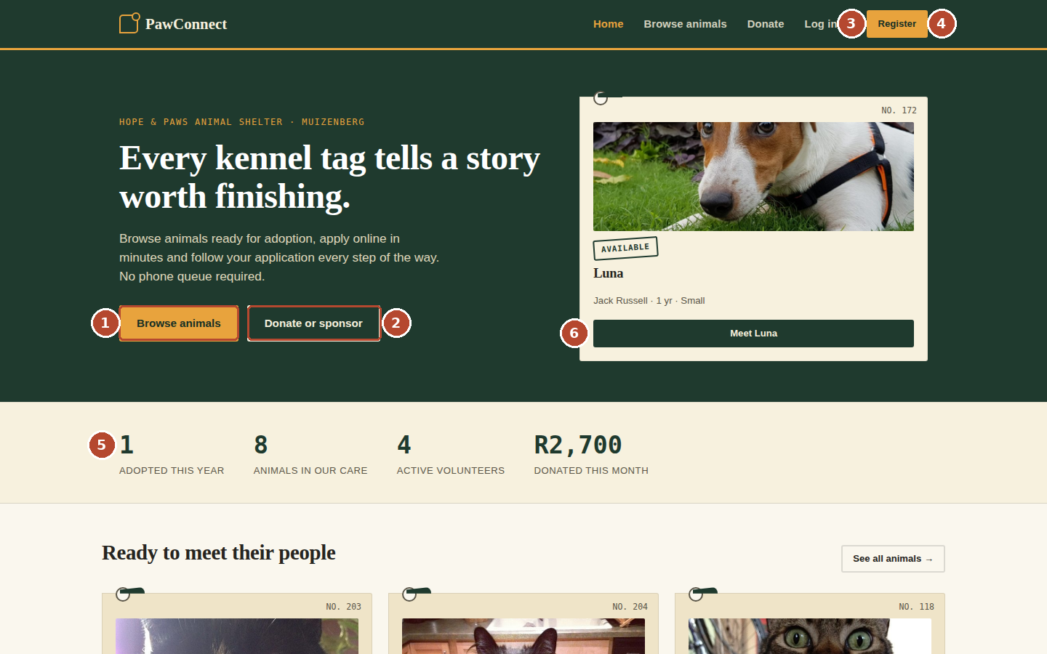
Figure 1: The PawConnect home page
- Browse animals: see every animal looking for a home.
- Donate or sponsor: give a once-off or monthly donation, or sponsor one animal.
- Log in: for people who already have an account.
- Register: create a free account (needed to apply, donate or track an application).
- Live numbers: adoptions this year, animals in care, active volunteers and donations this month.
- The featured animal. Meet opens its profile.

2.3 Creating an account
Anyone can browse animals without an account. You need one to apply to adopt, to donate, and to track an application.
- Click Register at the top right of any page.
- Enter your first name, last name, email address and (optionally) a phone number.
- Choose a password of at least 8 characters with an uppercase letter, a lowercase letter and a number, and type it again to confirm it.
- Read the privacy notice and tick the consent box. PawConnect follows South Africa's Protection of Personal Information Act (POPIA) and can't store your details without your consent.
- Click Create account. You are signed in straight away.
[Screenshot: register.png]
Run tests/screenshots/capture_user_guide.py to capture this annotated screen.
Figure 2: Creating an account
- Your name. It appears on applications and receipts.
- Your email address. You also use it to log in.
- Your password (8+ characters, with upper and lower case and a number).
- POPIA consent. Required before any personal information is stored.
- Create account.

Tip: Everyone who registers on the website becomes an adopter. Volunteer and administrator accounts are created by an administrator (section 5.5).

2.4 Logging in and out
- Click Log in at the top right.
- Enter your email address and password.
- Tick Keep me signed in only on your own device. Otherwise you are signed out after 8 hours without activity.
- Click Log in. Volunteers land on the Volunteer dashboard, administrators on the Shelter dashboard and adopters on the home page.
- To log out, click Log out next to your name at the top right.
[Screenshot: login.png]
Run tests/screenshots/capture_user_guide.py to capture this annotated screen.
Figure 3: Logging in
- Email address.
- Password.
- Keep me signed in (own devices only).
- Log in.

Important: After 5 wrong passwords in a row, the account is locked for 15 minutes to stop people guessing passwords. Wait 15 minutes and try again, or ask an administrator.

2.5 Two-step verification
Two-step verification asks for a 6-digit code from your phone as well as your password. Even if someone learns your password, they can't log in without your phone. Any user can turn it on. Administrators must use it on the live site.

Turning it on
- Install Microsoft Authenticator or Google Authenticator on your phone.
- In PawConnect, open My account (click your name at the top right) and click Manage two-step verification.
- In the authenticator app, choose to add an account, pick Enter a setup key, and type the key shown on the page. If you are using PawConnect on the same phone, tap Open it in your authenticator app instead.
- Type the 6-digit code the app now shows for PawConnect and click Turn on two-step verification.
- PawConnect shows 8 recovery codes. Save them somewhere safe, such as a password manager. Each one lets you log in once if you lose your phone. They are only shown once.
[Screenshot: two-factor.png]
Run tests/screenshots/capture_user_guide.py to capture this annotated screen.
Figure 4: Setting up two-step verification
- The three set-up steps.
- The setup key to type into your authenticator app.
- The 6-digit code from the app.
- Turn on two-step verification.

Logging in with two-step verification
Log in with your email and password as usual. PawConnect then asks for a Verification code. Type the current 6-digit code from your app (codes change every 30 seconds) and click Verify and log in. If you have lost your phone, type one of your recovery codes instead.

2.6 Finding your way around
The dark green bar at the top of every page holds the main links. What you see depends on your role: adopters see Home, Browse animals and Donate. Volunteers also see Volunteer dashboard, and administrators also see Shelter dashboard. On a phone the links fold into the ☰ menu button.
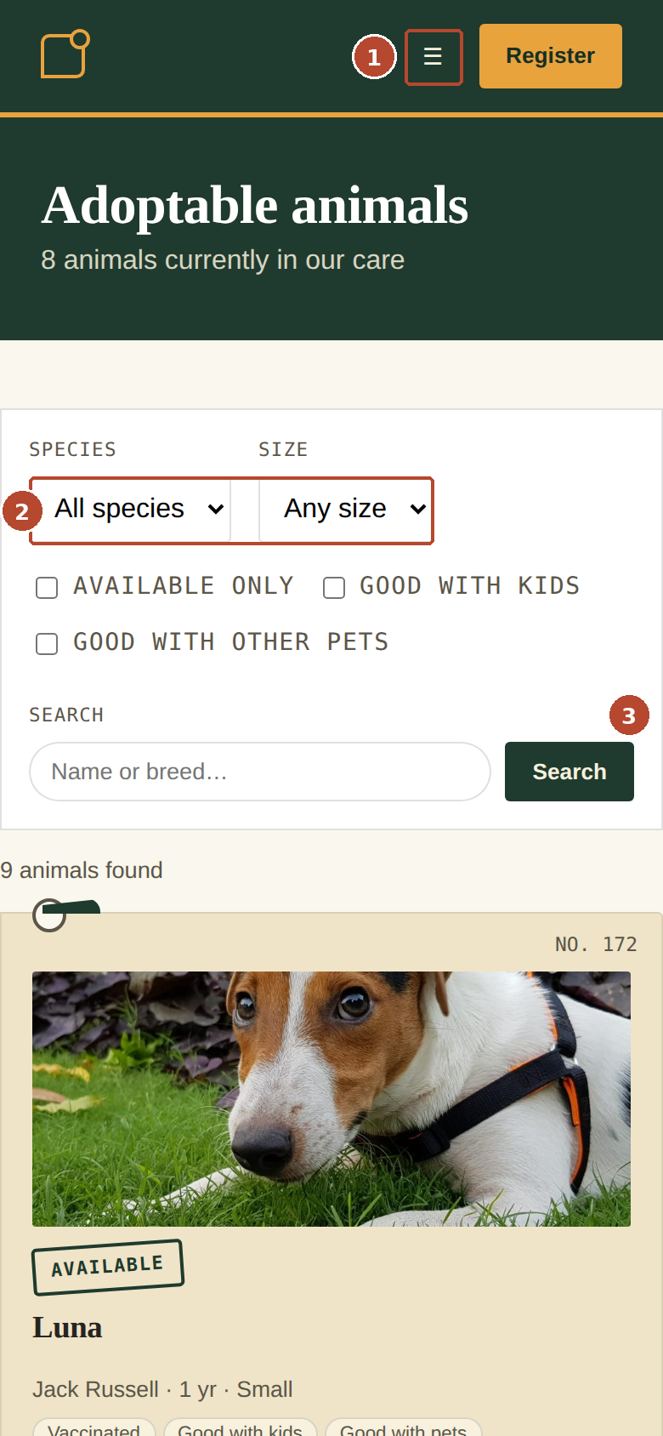
Figure 5: PawConnect on a phone
- The ☰ menu button opens the page links.
- Filters stack one above the other on small screens.
- Search works the same as on a computer.

3. For adopters and the public

3.1 Browsing adoptable animals
- Click Browse animals.
- Narrow the list with the filters: Species (dogs or cats), Size, Available only, Good with kids and Good with other pets.
- Type a name or breed into Search and press Search. With JavaScript on, the list updates as you change the filters.
- Click View profile on an animal to see its photos, story and vaccination status.
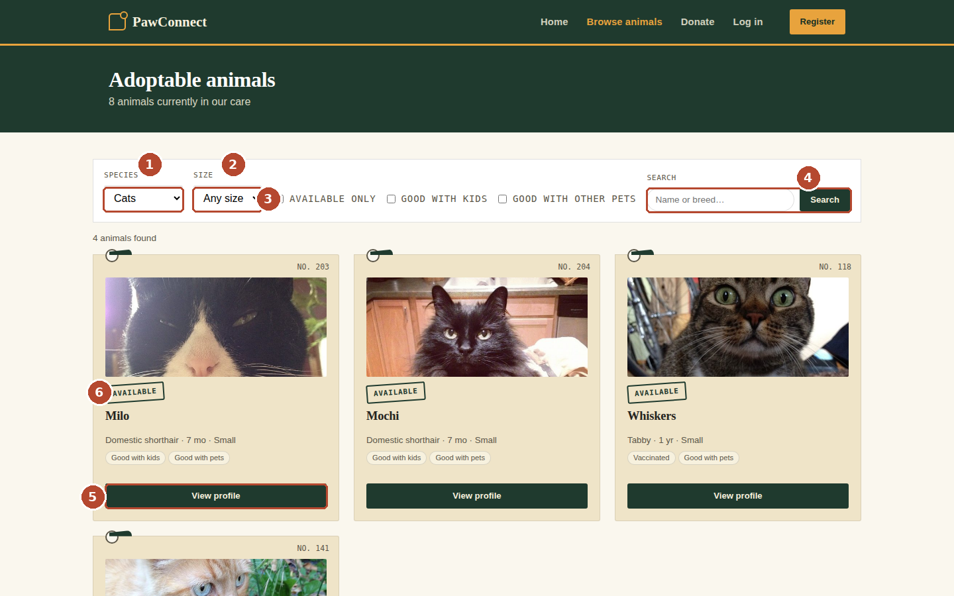
Figure 6: Browsing and filtering animals
- Species filter.
- Size filter.
- Tick boxes: Available only, Good with kids, Good with other pets.
- Search by name or breed.
- View profile opens the animal's page.
- Status stamp: Available, Pending (someone has applied), Adopted or Fostered.

3.2 An animal's profile
The profile shows the animal's photos, age, breed, size, personality, whether it is vaccinated, and whether it is good with children and other pets.
[Screenshot: profile.png]
Run tests/screenshots/capture_user_guide.py to capture this annotated screen.
Figure 7: An animal profile
- Status stamp. Only Available animals can receive applications.
- Apply to adopt starts an application (shown only when the animal is available).
- Sponsor pays toward this animal's care.

3.3 Applying to adopt
The form has three short steps and saves as you type, so you can close the page and come back later without losing anything.
- On an available animal's profile, click Apply to adopt. Log in or register if asked.
- Step 1, About you: check your name, phone and email (filled in from your account), and say why you would like to adopt. Click Next: Your home →.
- Step 2, Your home: choose your home type, whether you own or rent, and any other pets. Add anything else the shelter should know. Click Next: Review →.
- Step 3, Review: check everything and click Submit application. Use ← Back to change an answer.
- You see a confirmation page with your reference number (for example PC-260817-RCKY) and receive a confirmation email.
[Screenshot: apply.png]
Run tests/screenshots/capture_user_guide.py to capture this annotated screen.
Figure 8: Step 1 of the adoption application
- Your contact details, filled in from your account.
- Why you would like to adopt this animal.
- Next: Your home → moves to step 2.

Tip: While your application is open, the animal shows as Pending and nobody else can apply for it. Each person can have one open application per animal.

3.4 Tracking your application
Click My applications in the top bar. Each application shows a progress tracker and its current status:
Status | What it means | What you do
Submitted | The shelter has your application. | Nothing yet. A volunteer will start reviewing it, usually within 2 days.
Under review | A volunteer is checking your application. | Answer the phone or email if the shelter contacts you.
Approved | Your application was accepted. | The shelter arranges a home visit and the adoption fee.
Adopted | The adoption is complete. | Enjoy your new companion!
Rejected | The application was not successful. The reason is shown. | You can apply for another animal.
Withdrawn | You cancelled the application. | –

[Screenshot: my-applications.png]
Run tests/screenshots/capture_user_guide.py to capture this annotated screen.
Figure 9: My applications
- Current status.
- Progress tracker: Submitted → Under review → Approved → Adopted.
- Withdraw cancels an application you no longer want.

3.5 Donating or sponsoring an animal
- Click Donate in the top bar, or Sponsor on an animal's profile.
- Choose One-time or Monthly.
- Pick a suggested amount or type your own (R10 to R100,000).
- Optionally choose an animal under Sponsor a specific animal? and add a message.
- Click Pledge. You get a receipt number straight away, on screen and by email.
- Pay by EFT into the shelter's account shown on the page, using your receipt number as the payment reference.
- When the shelter sees the money arrive, they mark your donation as received and you get an email receipt.
[Screenshot: donate.png]
Run tests/screenshots/capture_user_guide.py to capture this annotated screen.
Figure 10: Making a donation
- One-time or Monthly.
- Suggested amounts, or type your own.
- Optionally sponsor one animal.
- Pledge creates your receipt number.

Tip: Card payments are not available yet. The shelter plans to add PayFast or Yoco later. For now every donation is an EFT, which a staff member confirms.

3.6 Your account and your data
Click your name at the top right to open My account. There you can:
- Change your name and phone number, then click Save changes.
- See every donation you have made and its receipt number.
- Click Download my data (JSON) to get a copy of everything PawConnect holds about you. This is your right under POPIA.
- Turn on two-step verification (section 2.5).
[Screenshot: my-account.png]
Run tests/screenshots/capture_user_guide.py to capture this annotated screen.
Figure 11: My account
- Your details.
- Your donation history.
- Download my data (POPIA).
- Manage two-step verification.

4. For volunteers
Your account is created by the shelter manager, who will give you a temporary password. Log in and change your details under My account. You land on the Volunteer dashboard every time you log in.

4.1 Your dashboard
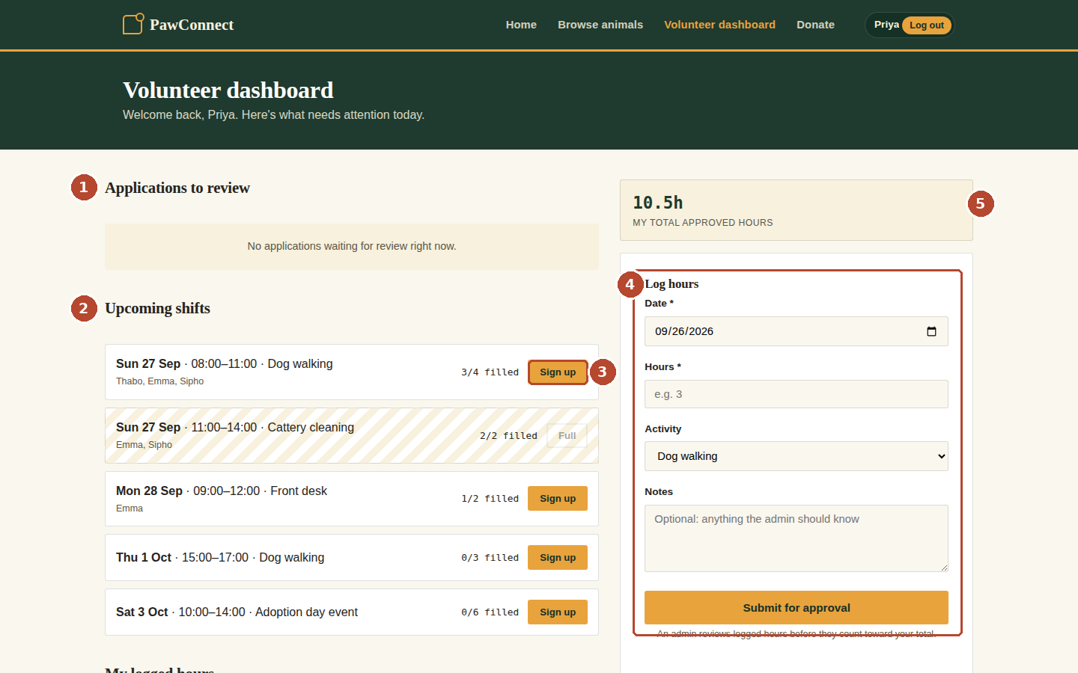
Figure 12: The volunteer dashboard
- Applications to review for your branch.
- Upcoming shifts with how many places are filled.
- Sign up for a shift. The button shows Full when no places are left.
- Log hours after a shift.
- Your total approved volunteer hours.

4.2 Reviewing adoption applications
Applications move through fixed steps, and PawConnect only offers the buttons that are allowed at each stage. A rejected application can never become an adoption.
- On your dashboard, click Review next to an application.
- Read the applicant's answers, then click Start review. The status becomes Under review and the applicant can see that someone is looking at it.
- Contact the applicant if needed. Then either click Approve (you can add a note to the applicant) or enter a Reason and click Reject. The applicant is emailed either way, and a rejected animal becomes available again.
- After approval, do the home visit and type your notes under Home visit notes, then click Record home visit.
- When the adoption fee is paid, enter the amount under Adoption fee received (R) and click Record adoption fee.
- When the animal goes home, click Mark as adopted. This closes the application.
[Screenshot: application-review.png]
Run tests/screenshots/capture_user_guide.py to capture this annotated screen.
Figure 13: Reviewing an application
- History: every status change, who made it and when.
- Next step: only the actions allowed right now.

Important: Mark as adopted only appears after both the home visit and the adoption fee have been recorded.

4.3 Signing up for shifts
- Find a shift under Upcoming shifts on your dashboard.
- Click Sign up. You get a confirmation by SMS (if you have a mobile number on your account) or email.
- To drop out, click Cancel on the shift. Please do this early so someone else can take the place.
PawConnect stops double bookings automatically. You can't sign up for a full shift, sign up twice, or sign up for two shifts that overlap in time, even if two people click at the same moment.

4.4 Logging your hours
- Under Log hours, choose the Date, enter the number of Hours and pick the Activity (Dog walking, Cattery cleaning, Front desk, Events & fundraising, Transport or General).
- Optionally add Notes for the administrator.
- Click Submit for approval. The hours show as Pending under My logged hours until an administrator approves them. Only approved hours count toward your total.

4.5 Logging a medical record
Volunteers record every vet visit, vaccination and treatment, so the animal's full health history is in one place and the visiting vet can see it.
- Open the animal's profile (from Browse animals).
- Scroll to Medical history. Earlier records are shown on the left.
- In Log a medical record, choose the Type (Vaccination, Treatment, Checkup, Sterilisation or Other).
- Fill in What was done?, the Date, the Next due date if there is one, the Vet and any Details.
- Click Save record. It appears in the history immediately. If it is a vaccination, the animal's public profile shows it as vaccinated.
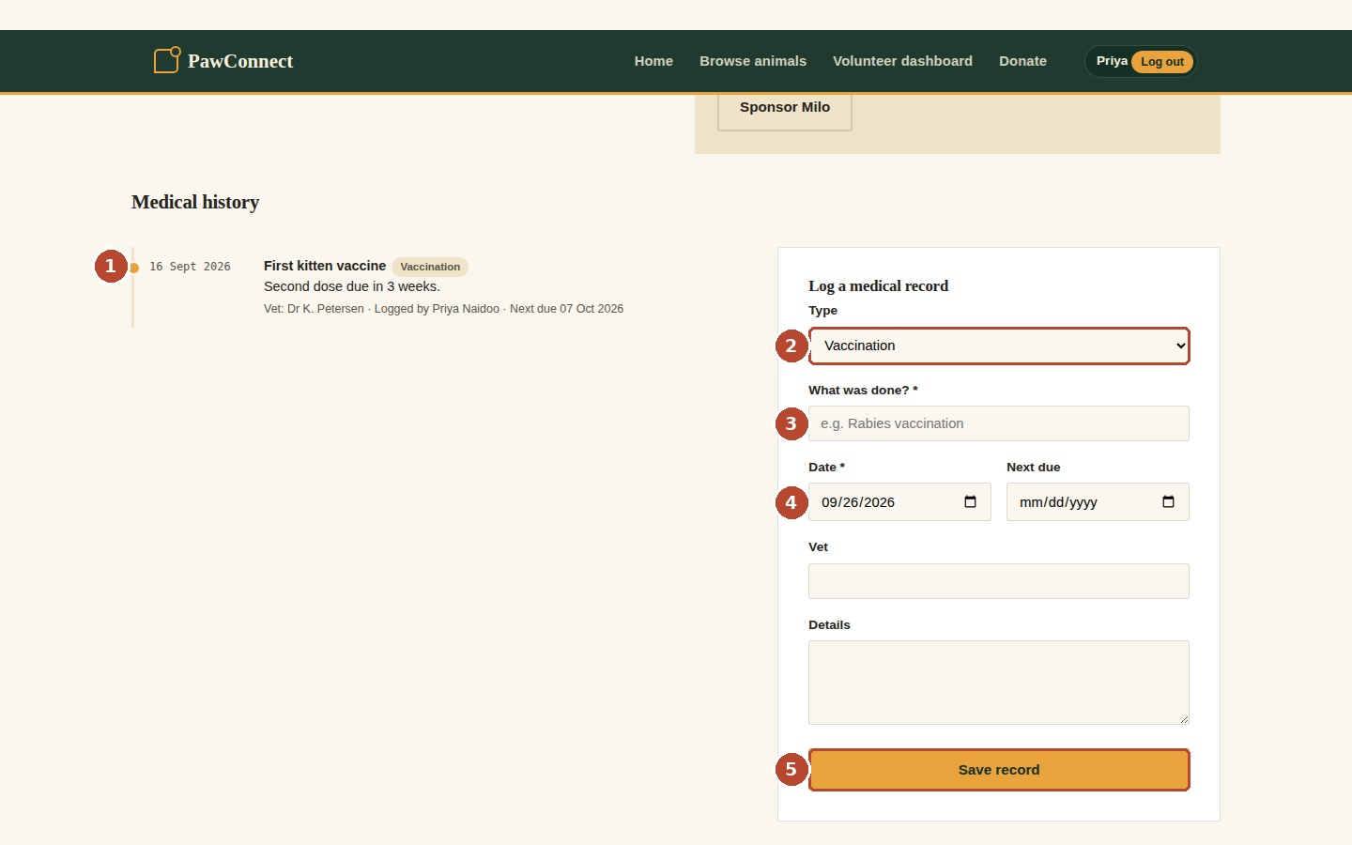
Figure 14: Logging a medical record
- The animal's medical history, newest first.
- Record Type.
- What was done? (required).
- Date (required) and Next due.
- Save record.

Tip: Medical history is only visible to volunteers and administrators. The public only sees whether the animal is vaccinated.

5. For shelter administrators
Administrators can do everything volunteers can, for every branch, and also manage animals, shifts, users, donations and reports. All admin pages are reached through the tabs under the Shelter dashboard heading.
Important: On the live site you must turn on two-step verification (section 2.5) before you can open the Shelter dashboard. PawConnect takes you to the set-up page the first time.

5.1 The shelter dashboard
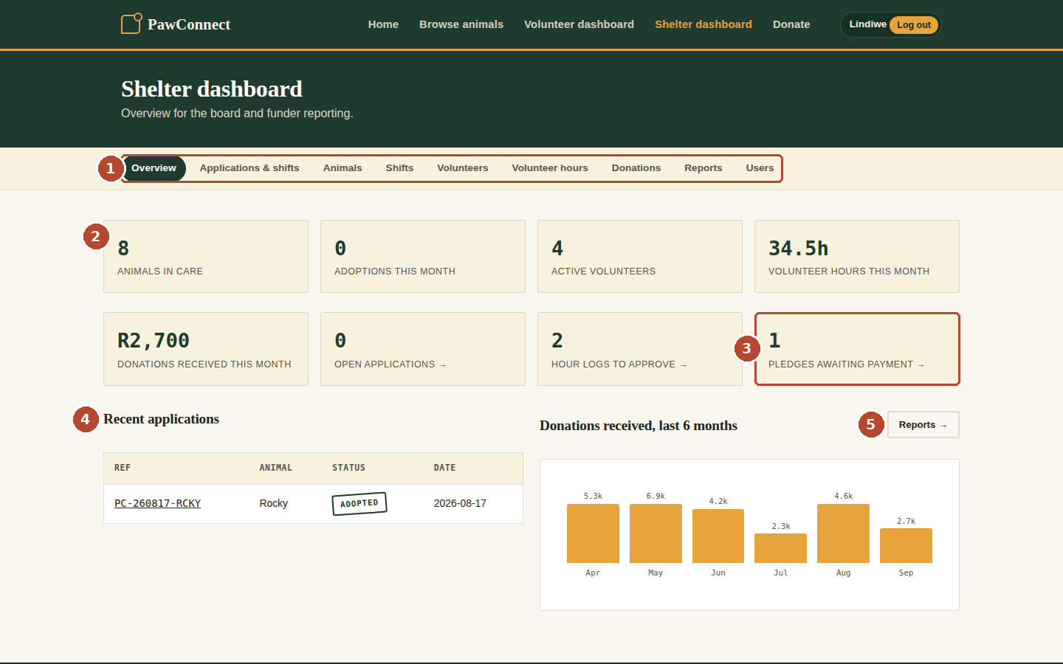
Figure 15: The shelter dashboard
- Admin tabs: Overview, Applications & shifts, Animals, Shifts, Volunteers, Volunteer hours, Donations, Reports, Users.
- Key numbers: animals in care, adoptions and volunteer hours this month, donations received.
- Work queues. Click a card such as Pledges awaiting payment → to go straight to that list.
- Recent applications. Click a reference to review it.
- Reports → opens the funder report.

5.2 Managing animals

Recording a new arrival
- Open the Animals tab.
- Fill in Record a new arrival: name, species, breed, age, size, kennel number, whether it is good with kids and other pets, and a short bio.
- Click Add animal. It appears on the public Browse animals page straight away with the status Available.

Changing status, details and photos
- To change status quickly, pick the new status in the animal's row and click Save. Statuses are Available, Pending, Adopted and Fostered.
- Click Edit to change any detail, then Save details.
- Under Photos, choose a JPEG, PNG or WebP image (2 MB or smaller, up to 6 per animal) and click Upload. Click Remove to delete a photo.
[Screenshot: admin-animals.png]
Run tests/screenshots/capture_user_guide.py to capture this annotated screen.
Figure 16: Managing animals
- Status Save for one animal.
- Edit an animal's details and photos.
- Record a new arrival.
- Add animal.

[Screenshot: admin-edit-animal.png]
Run tests/screenshots/capture_user_guide.py to capture this annotated screen.
Figure 17: Editing an animal
- Save details.
- Change Status.
- Current Photos.
- Upload a new photo.

Tip: Two animals can't share a kennel number. PawConnect tells you if the number is already in use.

5.3 Publishing volunteer shifts
- Open the Shifts tab.
- Under Create a shift, enter the Date, Start and End times (South African time), the Role and how many Places are available. Add Notes if needed.
- Click Create shift. Volunteers see it on their dashboards immediately.
[Screenshot: admin-shifts.png]
Run tests/screenshots/capture_user_guide.py to capture this annotated screen.
Figure 18: Publishing shifts
- Upcoming shifts with who has signed up.
- Create a shift.
- Create shift.

5.4 Volunteers and their hours
The Volunteers tab lists every volunteer with their activity, contact details, join date, approved hours and pending logs. Sort it by name, hours or join date.
[Screenshot: admin-volunteers.png]
Run tests/screenshots/capture_user_guide.py to capture this annotated screen.
Figure 19: The volunteer directory
- Volunteer list.
- Add volunteer (opens Users, section 5.5).

The Volunteer hours tab is where logged hours are approved:
- Optionally filter by volunteer or status and click Filter.
- Check each pending entry and click Approve or Reject.
- The chart Approved hours by volunteer updates. Only approved hours count in reports.
[Screenshot: admin-hours.png]
Run tests/screenshots/capture_user_guide.py to capture this annotated screen.
Figure 20: Approving volunteer hours
- Filter the list.
- Approve (or Reject) an entry.
- Approved hours per volunteer.

5.5 Users and access

Adding a staff member or volunteer
- Open the Users tab.
- Under Add a staff member or volunteer, fill in their name, email, phone, Role and (for volunteers) their usual Volunteer activity.
- Choose a Temporary password and give it to them in person or by phone, not by email.
- Click Create account. Ask them to log in and change their details.

Changing roles and deactivating accounts
- Click Make volunteer / Make administrator or Remove… in a user's row to change their roles.
- Click Deactivate when someone leaves. They are signed out within 5 minutes and can't log in again. Their history (applications, hours, records) is kept. Click Reactivate to undo.
[Screenshot: admin-users.png]
Run tests/screenshots/capture_user_guide.py to capture this annotated screen.
Figure 21: Users and access
- Grant or remove a role.
- Deactivate an account.
- Add a staff member or volunteer.
- Create account.

5.6 Confirming donations
- Open the Donations tab. Pledges awaiting payment lists donations people have pledged but not yet paid.
- Check the bank statement for an EFT with the matching Receipt / EFT ref.
- Click Mark received. The donor is emailed their receipt automatically and the amount counts in reports.
- If a pledge will never be paid, click Cancel.
[Screenshot: admin-donations.png]
Run tests/screenshots/capture_user_guide.py to capture this annotated screen.
Figure 22: Confirming donations
- Mark received once the EFT clears.
- Donations received in the last 30 days.
- Full report & export →.

5.7 Funder reports and CSV export
- Open the Reports tab.
- Choose the From and To dates and click Run report. The report takes well under 10 seconds for any range.
- Read the totals: donations received, adoptions completed, applications submitted and approved volunteer hours, plus donations by type and the average time to a decision.
- Click Export donations (CSV) to download the donations in that range. The file opens in Excel or Google Sheets, ready for funding applications.
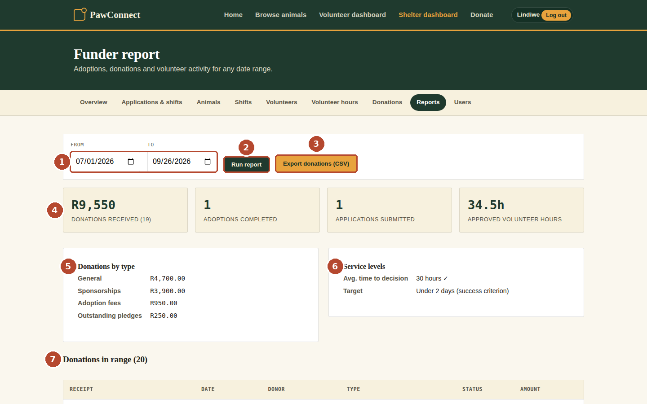
Figure 23: The funder report
- From and To dates.
- Run report.
- Export donations (CSV).
- Headline totals for the range.
- Donations split by type: general, sponsorship and adoption fees, plus outstanding pledges.
- Service levels: average time from application to decision, against the 2-day target.

5.8 Reviewing applications as an administrator
Administrators review applications exactly as volunteers do (section 4.2), but can see and decide applications for every branch. Open them from Recent applications on the dashboard or the Applications & shifts tab.

6. Setup and technical requirements
This section is for the technical volunteer who looks after PawConnect. Day-to-day users can skip it. The full technical documentation is in the project's GitHub repository (README.md and the docs folder).

6.1 How PawConnect is hosted
Part | Service | Notes
Web application | Azure App Service (Linux, .NET 8), South Africa North | HTTPS only, TLS 1.2+, health check on /health, running version on /version.
Database | Azure Database for PostgreSQL Flexible Server | Daily backups kept for 7 days, with point-in-time restore.
Secrets | Azure Key Vault | Connection strings and passwords. Read by the app's managed identity, never stored in code.
Monitoring | Application Insights | Alerts if errors pass 2% or responses slow beyond 1 second.
Email | Any SMTP service (e.g. Azure Communication Services) | Confirmations, approvals and receipts.
SMS | Twilio | Optional. Urgent shift messages, with email as the fallback.
Code and releases | GitHub and GitHub Actions | Tests, security scans and deployments run automatically.

6.2 Running PawConnect on your own computer
You need: the .NET 8 SDK, Docker Desktop (for PostgreSQL) and Git.
- Clone the repository: git clone https://github.com/ST10285120/st10285120.INSY7315.Part2.PAWCONNECT
- Start the database: docker compose up -d db
- Start the app: dotnet run --project src/PawConnect.Web. Database tables are created and demo data is loaded automatically.
- Open http://localhost:5231 and log in with a demo account (listed in README.md).
- To run the automated tests: dotnet test
Tip: No Docker? Install PostgreSQL 16, create a pawconnect database and user, and update ConnectionStrings:PawConnect in appsettings.Development.json.

6.3 Configuration settings
Settings are set in Azure under App Service → Configuration (use a double underscore __ in place of :). Secrets should point at Key Vault.
Setting | Purpose
ConnectionStrings:PawConnect | PostgreSQL connection string (Key Vault).
Seed:AdminEmail / Seed:AdminPassword | Creates the first administrator on an empty database (Key Vault for the password).
Seed:DemoData / Seed:DemoPassword | Loads demo animals and accounts. Staging only, never production.
Notifications:Email:SmtpHost, UserName, Password, FromAddress | Email sending. Without a host, emails are only written to the log.
Notifications:Sms:Enabled, Provider, AccountSid, AuthToken, FromNumber | SMS through Twilio (Provider = Twilio). Keep staging on Log.
Security:RequireAdminTwoFactor | Forces administrators to use two-step verification. On by default in production.

6.4 The first administrator on the live site
- Put the manager's email in Seed:AdminEmail and a strong temporary password in Key Vault for Seed:AdminPassword.
- Restart the app. The administrator account is created on start-up.
- The manager logs in, sets up two-step verification (section 2.5), and then creates everyone else's accounts from Users.

6.5 Releasing a new version
- Changes are made on a feature/… branch and merged into develop through a pull request. GitHub Actions builds the app, runs every test, checks code coverage (at least 70%), scans for vulnerable packages and runs the accessibility audit.
- Merging into develop deploys automatically to the staging site and runs a smoke test.
- Merging develop into main waits for manual approval, then deploys to the live site and checks it is healthy. If the check fails, the deploy log prints what the site is answering, to help find the cause.

6.6 Backups and recovery
Azure backs up the database every day and keeps backups for 7 days. To restore, open the PostgreSQL server in the Azure portal, choose Restore, pick a point in time and restore to a new server, then point ConnectionStrings:PawConnect at it. Practise this once a quarter on staging.

7. Troubleshooting and FAQ
Problem or question | What to do
I forgot my password. | PawConnect does not have a self-service reset yet (it is planned). Contact the shelter manager, who will ask the technical volunteer to reset it for you.
It says my account is locked. | After 5 wrong passwords the account locks for 15 minutes. Wait, then try again carefully.
It says my account has been deactivated. | An administrator switched your account off. Contact the shelter if this is a mistake.
My authenticator code is not accepted. | Codes change every 30 seconds, so use the current one. Check that your phone's clock is set automatically. If it still fails, use a recovery code.
I lost my phone and my recovery codes. | Contact the technical volunteer. After checking who you are, they can switch two-step verification off for your account so you can set it up again on a new phone.
The Apply to adopt button is missing. | The animal is Pending, Adopted or Fostered, so it can't take new applications right now. Try another animal, or check back later.
I closed the application form by accident. | Open it again from the same animal. Your answers were saved as you typed.
I didn't get a confirmation email. | Check your spam folder and that your email address under My account is correct. Your application or receipt is still saved and visible in PawConnect.
I can't sign up for a shift. | The shift is full, you are already on it, or it overlaps with another shift you signed up for.
My logged hours don't show in my total. | Hours count only once an administrator approves them. Pending hours are shown under My logged hours.
My donation still shows as pledged. | It changes to received once the shelter sees your EFT. Use your receipt number as the payment reference so it can be matched.
A photo won't upload. | Use JPEG, PNG or WebP, 2 MB or smaller. Each animal can have up to 6 photos.
As an admin, I'm sent to the two-step verification page. | Administrators must use two-step verification on the live site. Set it up (section 2.5) and you'll go straight in.
The site is slow to load the first time. | If the site is on Azure's free plan it sleeps when idle. The first visit wakes it, which takes about 20 seconds.
The page says “Something went wrong”. | Try again in a minute. If it keeps happening, note the time and what you clicked, and tell the technical volunteer. Every error is logged.
Does PawConnect work on my phone? | Yes. Every page works on phones and tablets, in the browser. No app is needed.
Who can see my personal information? | Only shelter staff who need it for your application or donation. It is never sold or shared. Download it any time from My account.

Getting help
- Day-to-day questions: ask the shelter's volunteer super user, who has been trained on every part of PawConnect.
- Technical problems: contact the technical volunteer. Include the time, the page address and what you clicked.
- Account problems: contact the shelter manager, who can unlock, reactivate or re-create accounts.

Appendix A: Quick reference
I want to… | Go to | Click
Find an animal | Browse animals | Filters, then View profile
Adopt | Animal profile | Apply to adopt
Check my application | My applications | –
Donate or sponsor | Donate | Pledge
Download my data | My account | Download my data (JSON)
Review an application | Volunteer dashboard | Review → Start review → Approve / Reject
Sign up for a shift | Volunteer dashboard | Sign up
Log hours | Volunteer dashboard | Submit for approval
Log a vet visit | Animal profile | Save record
Add a new animal | Shelter dashboard → Animals | Add animal
Publish a shift | Shelter dashboard → Shifts | Create shift
Approve hours | Shelter dashboard → Volunteer hours | Approve
Add a volunteer | Shelter dashboard → Users | Create account
Confirm an EFT | Shelter dashboard → Donations | Mark received
Report to funders | Shelter dashboard → Reports | Run report, Export donations (CSV)

