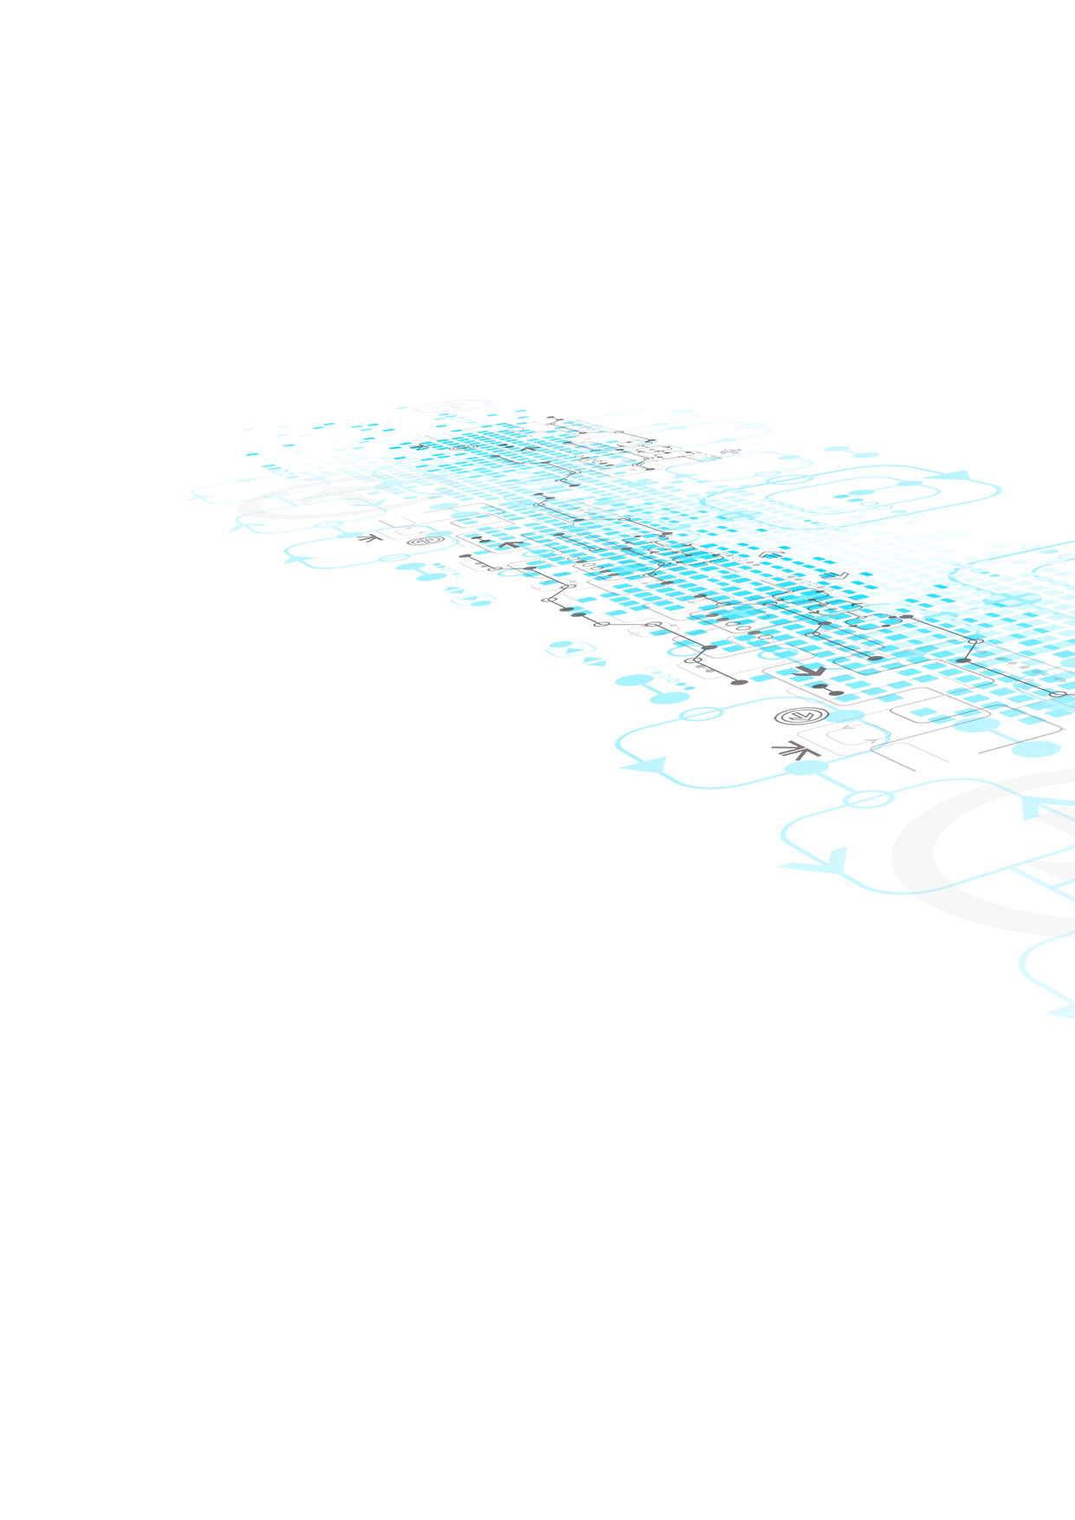

Part 2

ST10286777

PROG6212

Table of Contents

Implementation of feedback 3

Lecturer Feedback: 3

How I implemented the recommendations 3

Application Screenshots: 4

Home Page: 4

About Page: 4

Submit Claims Page: 5

Review/ Process Claim view : 5

Lecturer view of previous claims: 5

Claim details view: 6

Delete Claim view: 6

Edit Claim view: 6

Login view: 6

Register view: 7

Important Note: 7

Code Attributions: 8

Implementation of feedback

## Lecturer Feedback:

In the submit claim, you allow for the lecturer to input their hourly rate, how is this being validated & verified? Can the lecturer input any hourly rate? While you cover lecturer and claim management, the UI should also include user-friendly interface for HR staff to manage lecturer data, review claims, and process payments. Required to model the complete application build.

## How I implemented the recommendations

Given the feedback that I received I needed to improve the way the lecturer submitted the claim by ensuring that the Programme Coordinator and Academic Manager has a proper way of verifying the claim made by the lecturer. Therefore, the lecturer must now enter extra notes and submit a document to verify the legitimacy of the claim they made.

Application Screenshots:

## Home Page:

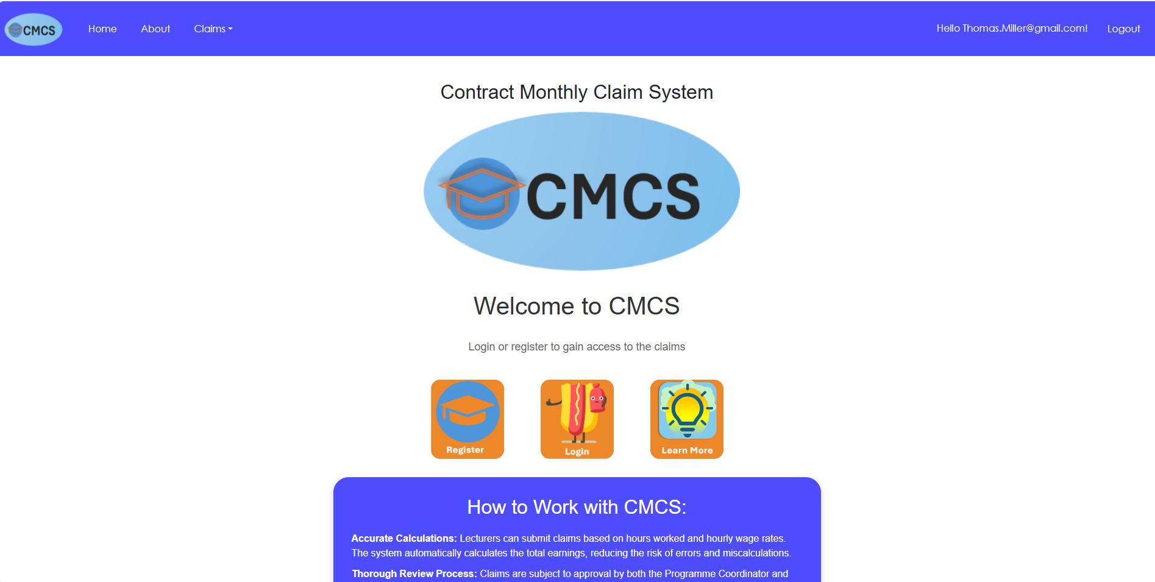

## About Page:

## Submit Claims Page:

## Review/ Process Claim view :

## Lecturer view of previous claims:

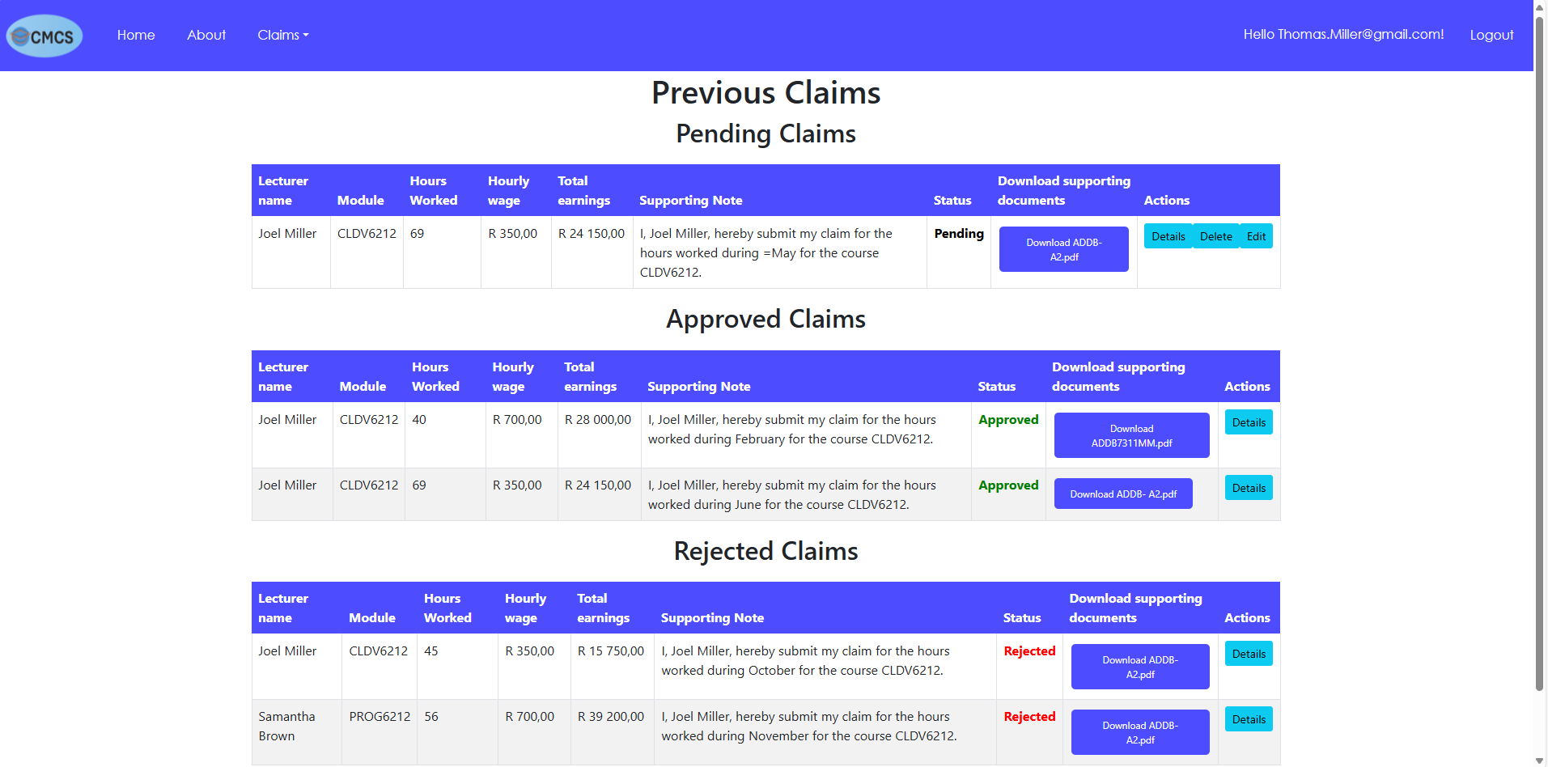

## Claim details view:

## Delete Claim view:

## Edit Claim view:

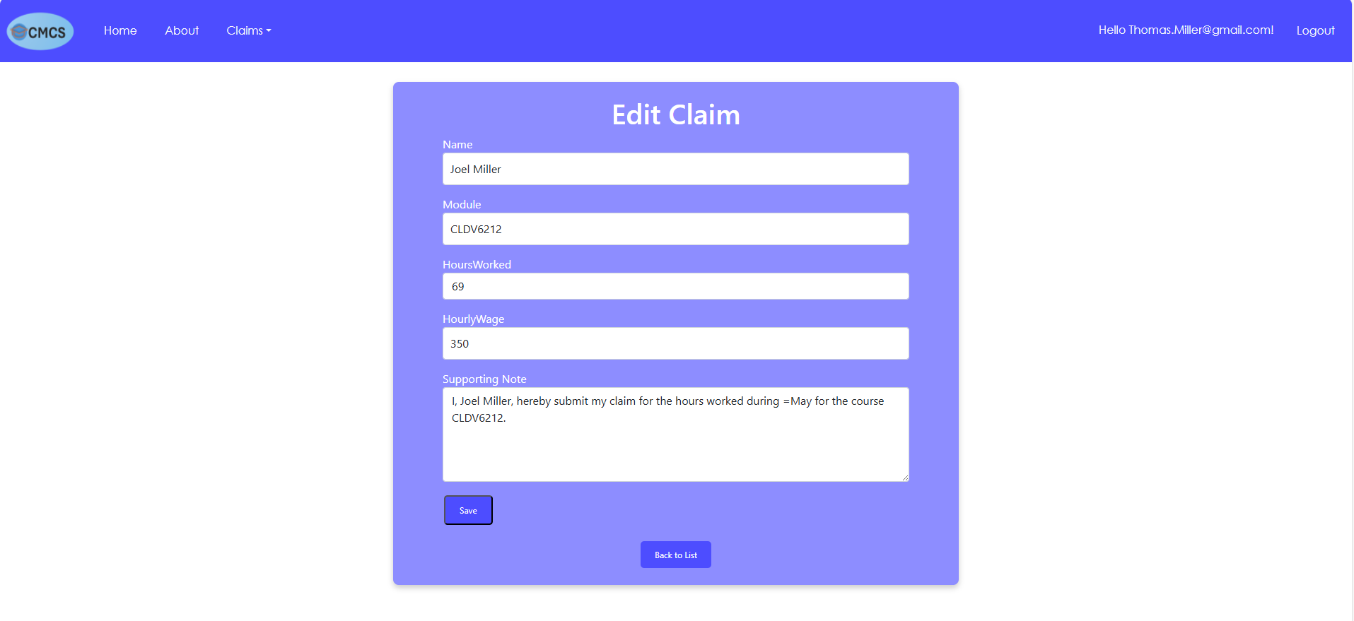

## Login view:

## Register view:

Important Note:

To test the different roles when registering an account the role of the user is set by entering the correct position. Eg. Position= Lecturer => Role= Lecturer.

Code Attributions:

// Code attribution: Redirect Action example was gained from Stack Overflow.

// https://stackoverflow.com/questions/2677072/asp-net-mvc-what-is-the-correct-way-to-redirect-to-pages-actions-in-mvc

// Author: Jimmy : https://stackoverflow.com/users/166658/jimmy

//Edited by: Luke Girvin <https://stackoverflow.com/users/133/luke-girvin>

// Code attribution: Upload files example was gained from Microsoft Learn.

// <https://learn.microsoft.com/en-us/aspnet/core/mvc/models/file-> uploads?view=aspnetcore-8.0

// Authors: tdykstra, guardrex, tgondar, ryan-carbon, Rick-Anderson ect,

//Code attribution: User Role example was used to create roles from youtube video: ASP.NET User Roles - Create and Assign Roles for AUTHORIZATION!

//https://www.youtube.com/watch?v=Y6DCP-yH-9Q

//Channel: tutorialsEU - C# <https://www.youtube.com/@tutorialsEUC>