Aiden Reddy – ST10290935

Dheyan Ramballi – ST10248202

Ananta Reddy – ST10143151

Shreya Dhawrajh – ST10249644

**Research into Apps for Personal Budgeting**

# Introduction

Financial stability depends on personal financial management, and budgeting applications assist users in tracking spending, establishing objectives, and effectively saving money. Mobile applications have completely changed financial planning in the current digital era by providing simple access to data in real time, spending insights, and automated tracking. GoodBudget, YNAB (You Need a Budget), and Mint are three personal budgeting applications that are currently available for the Android operating system and will be the subjects of this study. To determine the ideal features for a complete budgeting tool, the research compares the features, strengths, and weaknesses of each app.

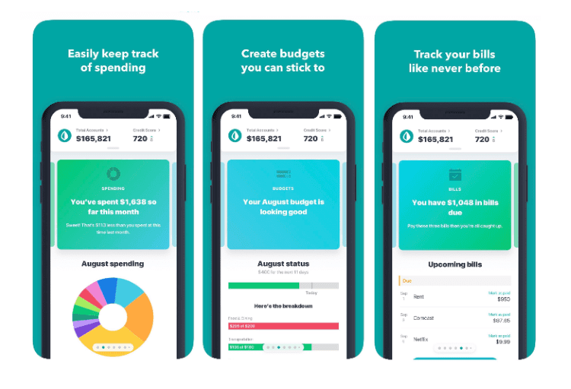**Mint**

# a. Overview

One of the most well-liked and feature-rich apps for managing personal finances is Mint. It provides consumers with a comprehensive financial tracking system and was created by Intuit. The software gives users real-time financial health insights by automatically syncing with bank accounts, credit cards, and even investment accounts. By automatically classifying transactions, Mint assists users in visualizing their spending patterns across many categories, including utilities, groceries, rent, and entertainment (Mint, 2024).

Mint is a great option for both novice and professional budgeters due to its user-friendly and accessible design. The software gives users a complete picture of their financial status by offering credit score tracking, bill reminders, and spending trends. Mint is a more comprehensive financial solution than some budgeting applications that only concentrate on expenditure because it incorporates functions like debt management and investment tracking (Mint, 2024).

**b. Strengths and Weaknesses**

Strengths:

* Numerous money management and budgeting software are available for free usage (Savology, 2020).
* Transactions are automatically categorized for simple expense tracking (Savology, 2020).
* Monitoring credit scores keep consumers informed about their financial situation (Savology, 2020).
* Missed payments and late fines are avoided with bill notifications and reminders (Savology, 2020).
* Links to several financial organizations, including loan and investment accounts (Savology, 2020).
* Offers tailored financial advice and insights according on expenditure trends (Savology, 2020).

Weaknesses:

* Shows potentially distracting commercials and special offers (Savology, 2020).
* Restricted ability to customize for more complex budgeting requirements (Savology, 2020).
* Some users complain about bank account syncing problems, which might occasionally result in errors (Savology, 2020).
* Lacks the capabilities of specialized investing apps for financial planning and investment management (Savology, 2020).
* Manual modifications may be necessary because the automatic categorization is not always precise (Savology, 2020).

## Innovative Features

Users may keep track of their spending without having to manually enter data thanks to automated transaction classification (Savology, 2020).

Financial alerts and credit score tracking: Informs consumers about possible financial hazards and the state of their credit (Savology, 2020).

Personalized budgeting advice: Offers suggestions for improved financial practices based on past spending data (Savology, 2020).

Users may examine their net worth and financial progress in one location thanks to integration with loan and investment accounts (Savology, 2020).

Subscription tracking: Assists consumers in keeping track of ongoing costs including software subscriptions, gym memberships, and streaming services (Savology, 2020).

# GoodBudget

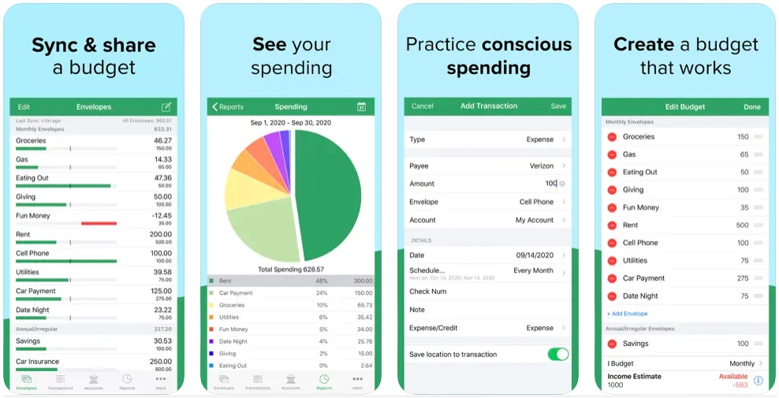

## a. Overview

With the use of the digital envelope-based budgeting program GoodBudget, users may divide their money across various spending categories, including utilities, groceries, rent, and entertainment (Goodbudget, 2019). The classic cash-stuffing approach, which involves putting actual cash into envelopes with labels to keep track of spending, is the foundation of this budgeting system. GoodBudget is perfect for people who prefer a hands-on approach to budgeting because it requires users to manually enter their income and expenses, in contrast to many contemporary budgeting apps that automatically sync with bank accounts. Cross-device synchronization is one of its primary benefits, facilitating easy financial planning collaboration between couples and families. This ensures transparency in the management of home finances by enabling numerous people to access and amend the budget in real time (Goodbudget, 2019).

## **b. Strengths and Weaknesses**

Strengths:

- The envelope system reduces overspending by offering a methodical and disciplined approach to money management (By, n.d.).

- Effective home budgeting is made possible by multi-device synchronization, which facilitates smooth coordination between partners or family members (By, n.d.).

- For customers who do not wish to pay for premium services, the app provides a free version that includes all the necessary budgeting tools (By, n.d.).

- Users can clearly understand their financial habits thanks to the graphic representation of their spending patterns and savings goals (By, n.d.).

- By allocating money to various envelopes before it is spent, users may make plans in advance and promote prudent financial practices (By, n.d.).

Weaknesses:

- Users must manually enter transactions because the software does not support automatic bank syncing, which can be laborious and error prone (By, n.d.).

- Users must purchase the premium version to access more sophisticated features like infinite envelopes and extra synchronizing possibilities, while the free version offers restricted functionality (By, n.d.).

- For users seeking thorough financial planning, it is less appropriate because it lacks sophisticated financial analysis, investment tracking, and asset management options (By, n.d.).

- The manual entry method might be time-consuming and ineffective for users who choose automated alternatives (By, n.d.).

## Innovative Features

A digital envelope budgeting system that makes tracking spending simple by simulating the conventional cash budgeting approach (Uptodown Technologies SL, 2024).

For managing shared money in families, multi-user synchronization is very helpful as it enables many people to track costs in real time (Uptodown Technologies SL, 2024).

Users can examine past financial behaviour and make well-informed budgeting decisions by using the app's previous spending trends and records (Uptodown Technologies SL, 2024).

Provides a debt-tracking tool to assist customers in allocating money for debt repayment while preserving their overall financial security (Uptodown Technologies SL, 2024).

Tools for tracking expenses classify spending to give a thorough picture of financial patterns and habits (Uptodown Technologies SL, 2024).

**YNAB (You Need a Budget)**

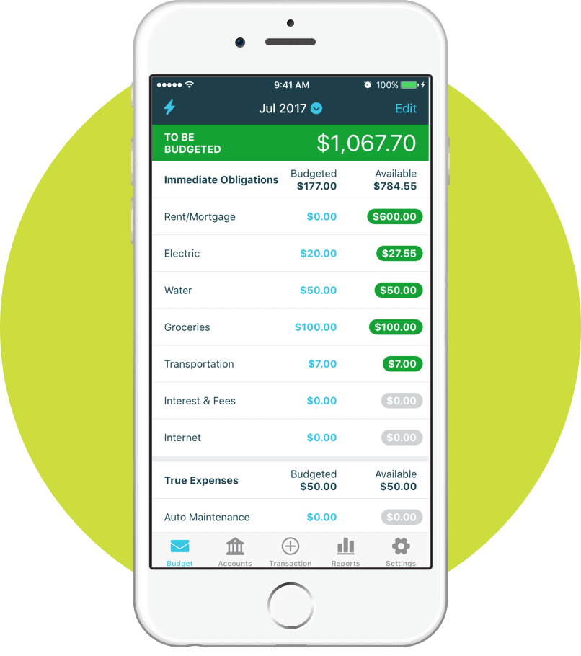

# a. Overview

The zero-based budgeting approach is the foundation of YNAB, or You Need a Budget, a potent financial management program. This technique helps people take charge of their spending by guaranteeing that every dollar has a specific purpose. By asking users to divide their income before making purchases, YNAB promotes proactive financial planning in contrast to typical budgeting methods that keep track of previous expenditures (www.ynab.com, n.d.). Its capacity to automatically import and classify transactions from connected bank accounts, greatly minimizing manual labour, is one of its main advantages. Additionally, YNAB offers comprehensive training materials and financial counselling to help consumers become better money managers. YNAB, which places a high priority on financial transparency, assists users in ending the cycle of paycheck to paycheck, effectively paying off debt, and accumulating long-term savings (www.ynab.com, n.d.).

**b. Strengths and Weaknesses**

Strengths:

- By eliminating the need for manual transaction entry, automated bank syncing guarantees current financial tracking (Bottorff, 2025).

- The zero-based budgeting method makes sure that every dollar is tracked and encourages thoughtful, strategic expenditure (Bottorff, 2025).

- Users can enhance their budgeting and money management abilities with the use of extensive financial coaching and educational materials (Bottorff, 2025).

- The software helps users plan for emergencies and major expenditures by providing tools for tracking and establishing savings goals (Bottorff, 2025).

- Strong financial reports and visual data analytics are available to users, offering them insights into their financial well-being (Bottorff, 2025).

- Debt-tracking systems facilitate the effective elimination of debt by assisting users in creating structured payback schedules (Bottorff, 2025).

Weaknesses:

- After the trial period, the software requires a paid membership, which might not be appropriate for consumers on a tight budget (Bottorff, 2025).

- For beginners who are not accustomed with zero-based budgeting, the learning curve can be challenging and takes time to become proficient (Bottorff, 2025).

- Lacks integrated bill payment capabilities, thus users must manage payments independently (Bottorff, 2025).

- YNAB is less complete for total financial management because it does not provide credit score tracking, in contrast to several of its rivals (Bottorff, 2025).

- Despite its abundance of features, the UI can be too complicated for customers who would rather use a more straightforward budgeting application (Bottorff, 2025).

## Innovative Features

A solid basis in zero-based budgeting that motivates customers to allocate each dollar for a specific purpose, guaranteeing proactive money management (www.ynab.com, n.d.).

Tools for defining goals that let users’ budget for important purchases, vacations, and emergency cash, among other savings milestones (www.ynab.com, n.d.).

Charts and graphs are examples of data visualization tools that assist users in examining their spending patterns and long-term financial trends (www.ynab.com, n.d.).

A forecasting tool that assists users in projecting future costs and modifying their spending plan appropriately (www.ynab.com, n.d.).

Effective debt payout strategy architecture is made possible by debt-repayment planning tools (www.ynab.com, n.d.).

Users receive continuing education through financial workshops and tutorials, which improve their understanding and proficiency in budgeting (www.ynab.com, n.d.).

## Infographic

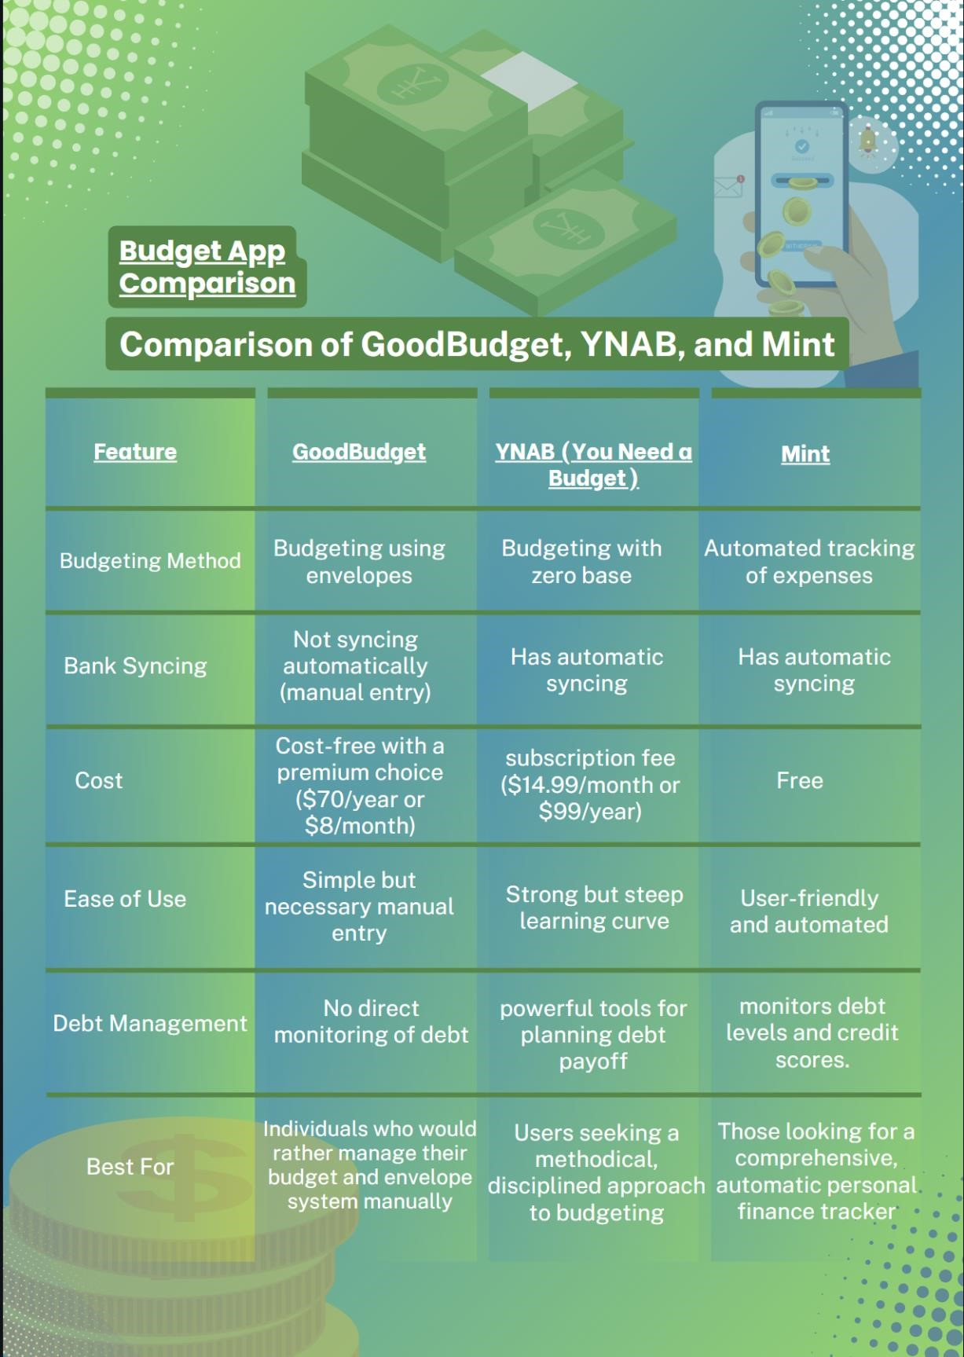

### 4. Implement the Greatest Features of All Three Apps in Your Own App

These are the top features that are to be included in the new budgeting app, according to the comparison of GoodBudget, YNAB, and Mint:

# Mint Automated Bank Syncing

Bank transaction syncing enables real-time expense tracking and minimizes human entry. In addition to providing manual modifications, this feature ought to automatically classify transactions (Mint, 2024).

# Savings Plans & Goal Monitoring (YNAB)

It should be possible for users to establish savings objectives for various purposes, like debt repayment, vacations, and emergency funds (www.ynab.com, n.d.).

**GoodBudget (and YNAB) is available for free.**

Basic budgeting capabilities are available in a free edition, while more sophisticated tools like forecasting, detailed reports, and automation require a premium subscription (Goodbudget, 2019).

# Tools for Debt Management (Mint)

It should incorporate automatic interest and payment plan computations together with debt payoff tracking (Mint, 2024).

**Synchronization Across Devices (GoodBudget)** multi-device access should be supported by the app so that couples or families may work together to manage joint funds (Goodbudget, 2019).

# Conclusion

Apps for personal budgeting are essential for assisting people and families in efficiently managing their money. Each of GoodBudget, YNAB, and Mint has special advantages suited to various financial planning requirements. YNAB enforces zero-based budgeting with robust goal monitoring, GoodBudget gives an organized envelope budgeting system, and Mint provides an automated, user-friendly method with credit tracking and spending classification.

New budgeting software can provide a thorough financial planning experience by integrating the finest features from these three apps, striking a balance between automation, sophisticated analytics, and manual management. The app will be more efficient and user-friendly if it includes features like goal monitoring, debt management, automatic bank syncing, and clear financial information.

In the end, a good budgeting tool should enable users to take charge of their money, make wise spending choices, and easily reach their financial objectives.

## Reference List

Bottorff, C. 2025. *I’ve been using YNAB for more than a decade. Here are the biggest pros and cons of this cult favorite budgeting platform*. [online] Fortune. Available at: [<https://fortune.com/article/ynab-pros-and-cons/](https://fortune.com/article/ynab-pros-and-cons/) > [Accessed 4 March 2025].

By (n.d.). *Goodbudget Review: A Digital Envelope Budgeting System- Experian - Experian*. [online] www.experian.com. Available at:< <https://www.experian.com/blogs/ask-experian/goodbudget-budgeting-app-review/>> [Accessed 2 March 2025].

|  |  |  |
| --- | --- | --- |
| Canva.2020. | *Canva* | . [online] Available at: |
| [<https://www.canva.com/design/DAGgkN5z8rQ/peEHo9kto8uLg0FTVXNpFg/edit](https://www.canva.com/design/DAGgkN5z8rQ/peEHo9kto8uLg0FTVXNpFg/edit) > [Accessed 19 March 2025]. | | |

Canva,2019.Sea Green and Green Minimalistic Style Digital Payment App Logo.[Online].Available at: < <https://www.canva.com/design/DAGg1guZ6OI/qtS7zuIuD0__A5TuUgXyBQ/edit> > [Accessed 19 March 2025].

Goodbudget. 2019. *Home*. [online] Available at: [<https://goodbudget.com/](https://goodbudget.com/) > [Accessed 4 March 2025].

iOSHacker, 2023. *Best personal expense tracker apps for iPhone in 2025*. [electronic print]. Available at: <<https://ioshacker.com/apps/best-personal-expense-tracker-apps-for-iphone>> [Accessed 4 March 2025].

THE LONDON MOTHER, 2020. *5 of the best budget apps to help you spend wisely when shopping*. [electronic print]. Available at: <<https://www.thelondonmother.net/budget-apps/>> [Accessed 4 March 2025].

The Smart Wallet, 2021. *Mint review 2021: Fresh money budgeting*. [electronic print]. Available at: <<https://thesmartwallet.com/mint-budget-app-review/?articleid=22637>> [Accessed 4 March 2025].

Mint. 2024. *Budget Tracker & Planner | Free Online Money Management | Mint*. [online] mint.intuit.com. Available at:< [https://mint.intuit.com/>](https://mint.intuit.com/) [Accessed 4 March 2025].

Savology. 2020. *YNAB vs Mint: Which Budgeting Tool is Better?* [online] Available at: [<https://savology.com/ynab-vs-mint>](https://savology.com/ynab-vs-mint) [Accessed 4 March 2025].

Uptodown Technologies SL 2024. *Goodbudget: Best Budgeting App for Android*. [online] Uptodown. Available at: [<https://goodbudget.en.uptodown.com/android](https://goodbudget.en.uptodown.com/android) > [Accessed 4 March 2025].

www.ynab.com. (n.d.). *The Ultimate Get Started Guide | YNAB*. [online] Available at:

[<https://www.ynab.com/guide/the-ultimate-get-started-guide.](https://www.ynab.com/guide/the-ultimate-get-started-guide)> [Accessed 4 March 2025].