1. **User interface design, including a mockup for each screen, a description of the purpose of the screen, and a diagram showing how the user navigates between the various screens (Wireframes).**
2. **Conclusion**
3. **Referencing**

**Introduction  
  
CashFlow is an intuitive and user-friendly budgeting application that aims to make managing budgets and expenses more enjoyable. Where CashFlow deviates from conventional budget tracking apps lies within our unique budgeting software that manages to incorporate a user dashboard that has implemented interactive elements, and built-in AI driven assistance that will track you spending and advice you on more efficient and effective ways to use your money by promoting wiser spending habits. Our application has a host of customizable and quality of life features that just make sense such as, our customizable categories that enable you to make and set a specific budget that suites your preference, we also offer smart reminder that will inform you if your budget is at risk of exceeding its limits and a built-in receipt scanner that allows you to scan and store you receipts in our application. CashFlow guarantees that consumers may effectively manage their accounts at any time and from any location thanks to its safe and optimized design.**

**OVERVIEW**

**App Name: CashFlow**

**Initial Icon Design:**



Our application icon is an embolden “C” and it aims to incorporate the meaning and understanding behind wise spending and budgeting while making it engaging. We have made use of a calming and motivating colour scheme of hues of orange which will help represent the prospects of financial stability and growth.

**Description of Innovative Features:**

CashFlow is a personal finance tracker that is designed to make activities such as expense logging a smooth experience. While this app focuses on all the important numbers, it is able to stand out from other budgeting apps due to its addition of gamification features. By doing this, the process of budgeting isn’t boring, but is made to be enjoyable and motivates users to better their financial habits.

**Key Innovative Features that we plan to add:**

* Gamification & Rewards - Earn badges and achievements for logging expenses consistently, staying within budget, and decreasing the amount spent in a high-spending category.
* AI-Powered Insights: Get specific suggestions on reducing expenses and optimizing spending patterns according to your existing statistics.
* Customizable Expense Categories - Expense categories can be customized (during creation or through editing) in order for them to work well with your current financial lifestyle and spending habits.
* Receipt Scanner - This would allow users to take a photo of their recipes with their phones that would then allow the receipt/expense details to be extracted and stored.
* Budget Dashboard - This dashboard would allow users to track their financial situation through interactive charts as well as relevant progress indicators.
* Smart notifications and alerts - The users will be notified when they are approaching their budget limits or if they are missing an expense entry.

**User Management**

**Registration of users and authentication**

* Users must have the ability to register by using a username, email and password.
* The hashing of passwords must be incorporated in order to improve security.
* An option that allows the user to recover their password should be incorporated.
* The system should allow for a login session that is persistent

**Multi device access and compatibility**

* An online database must be used in order to store all user data.
* Users should have the ability to access their data by being able log in on multiple devices.

**Expense tracking**

**Expense Categories**

* The user must be able to add, edit and/or delete their own expenses.
* The categories provided should be focused on expense management in order to improve useability.
* The various categories should follow a distinct colour coded approach in order to improve user navigation and visualization.

**Adding an Expense**

* A user should be able to log an expense by filling in the following fields:
  + Amount spent.
  + Date of expense.
  + Description.
  + Category.
  + Receipt attachment in the form of an image.

**Viewing an Expense**

* Users should be able to view all their **logged expenses** in the form of a list with the relevant filters provided:
  + **Filter by category -** this will allow the user to search a targeted category.
  + **Filter by date range -** this will allow the user to search by a targeted date (week, month, custom period)
  + **Arrange by amount -** this will allow the user to arrange by a targeted amount (ascending/descending)
  + **Arrange by date -** this will allow the user to arrange by date order (newest to oldest, vice versa)
* Clicking an expense should open/access the details of the selected expense, it will be displayed as such:
  + **Expense details** (amount, date, description, category, and/or receipt photo).

**Budget management**

**Monthly Budget management & Category Limits**

* Users must be able to set:
  + A total budget for the month.
  + Category-specific budgets/limits.
* The app should allocate for real time budget tracking in order to determine the remaining budget for the month.
* A **Visual alert** (color-coded warnings) should notify users when:
  + **50% of a category or category-specific budget/limit is reached** (this would be represented with a yellow warning).
  + **80%+ of a category or category-specific budget/limit is reached** (this would be represented with a red warning).

**Budget status Dashboard**

* This dashboard should show a summary of what has currently been spent:
  + The total amount spent in the current month.
  + Remaining budget for the month.
  + Breakdown of expenses per category (using a bar/pie chart).
  + Categories with excessive spending (highlighted as yellow/red).

**Storage of data and backups**

**Local Database**

* Expense data should be saved to a local SQLite, RoomDB or similar offline Android database platform.
* The database should be well optimized in order to implement and accommodate filtering as well as quick searches.

**Online Database**

* User data must be stored in a **cloud database** (e.g., Firebase, Azure, etc.).
* Users should be able to export their data by downloading it.

**Visualization of data**

**Trends based on spending habits**

* Users must be able to view a **graph of daily spending** over a **selected period**.
* The graph should:
  + Show the users daily spending trends.
  + Users should be able to **view the graph based on a select category**.

**Weekly/Monthly Reports**

* An automated report indicating the users spending should be sent at the end of each weed/month.
* Reports should include:
  + **Comparison of total spending against the budget.**
  + **Top 3 spending categories**.
  + Possible ways to save money.

**Gamification**

**Rewards, Badges and achievements**

* Users should earn **badges & awards** for:
  + Staying within their monthly budget.
  + Being consistent with expense logging.
  + Decreasing the amount spent in a category that is high-spending.
* Any badges obtained should be displayed on the profile of the user.

**Streaks & Challenges**

* Users should see a **streak counter** in order to know how many days they have been logging expenses for, this would help boost the user’s interaction with the application.

**Reminders and notifications**

**Smart Reminders**

* Users should receive **push notifications** for:
  + Reminder to log weekly expenses.
  + Budget alerts.
  + Savings reminders.

**Application performance and security**

**Security Measures**

* Secure authentication.
* Data encryption.
* Auto logout after inactivity.
* MFA

**App Optimization**

* The app should be lightweight & fast, optimized for mobile devices.
* Database queries should be optimized to ensure fast searches & filtering.

Figma Link: <https://www.figma.com/design/VC6yY0C5AfklI5wTns9UtF/PROG7313-Wireframes?node-id=0-1&t=p5OVEQIKV1OrJkec-1>

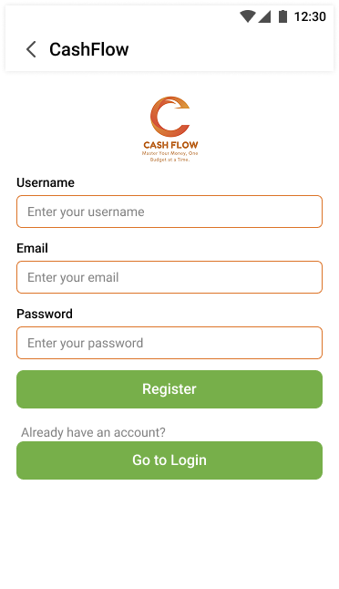**Login and Registration**

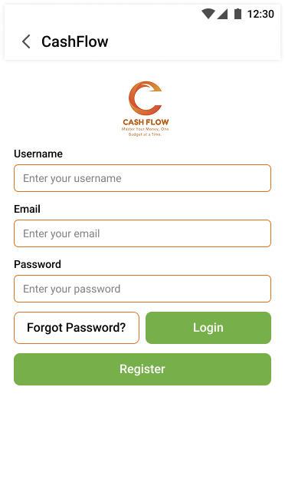

* The Login Screen (left) will first greet the user when opening the app. The user can enter their information (Username, Email, Password) if they have an existing account. They can then press the ‘Login’ button and will be redirected to the main menu if the login was successful. The ‘Forgot Password?’ button can be clicked if the user forgot their password, which would send them an email regarding the steps to reset it. If the user does not have an account, they can click the ‘Register’ button to navigate to the ‘Registration screen’.
* The Registration Screen (right) will allow users who do not have an account to create one by entering the information needed (Username, Email, Password). They will then click the ‘Register’ button to create their account and will be redirected to the main menu. If a user who has an account mistakenly navigated to this screen, they may click the ‘Go to Login’ button to return to the login screen.

Main Menu

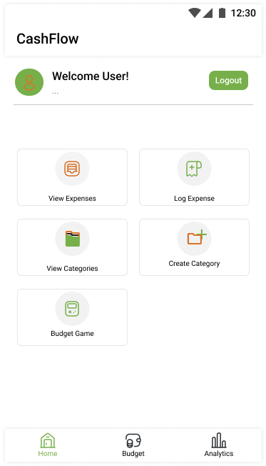

* A logged in user will be greeted with the main menu screen. The ‘View Expenses’ button will redirect the user to the ‘Expenses’ screen. The ‘Log Expense’ button will redirect the user to the ‘Log Expense' screen. The ‘View Categories’ button will redirect the user to the ‘Categories’ screen. The ‘Create Category’ button will redirect the user to the ‘Create Category’ screen. The ‘Budget Game’ button will redirect the user to the ‘Game Dashboard' screen. The navigation bar at the bottom of the screen has three buttons. The ‘Home’ button is to redirect the user to this current screen (Main Menu). The ‘Budget’ button redirects the user to the ‘Budget Dashboard’ screen. The ‘Analytics’ button redirects the user to the ‘Analytics Insights Screen.’ If the user is on one of these screens, the corresponding button will be highlighted on the navigation bar. There is a ‘Logout’ button at the top right of the screen, which will logout the user and redirect them to the login screen.

Expenses Screen

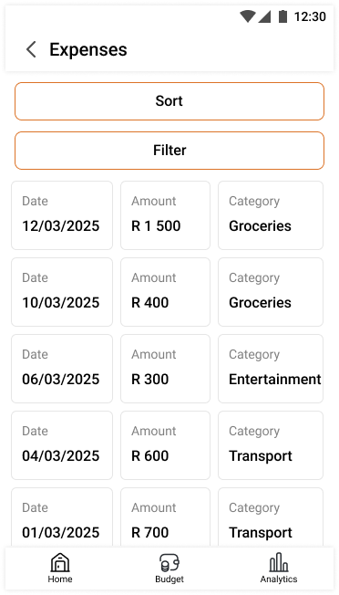

* This screen will show all the expenses and their relevant information (Date, Amount, Category) that have been logged by the user in a list format that can be scrolled through. There is a left-facing arrow at the top left of the screen, which this the ‘back’ button for taking the user to the previous screen. Clicking on an expense will open the ‘Selected Expense’ screen. At the top of the screen, there is a ‘Sort’ and ‘Filter’ button, which when clicked, will redirect the user to their respective screens for applying a filter or sorting the expenses.

Sort Screen

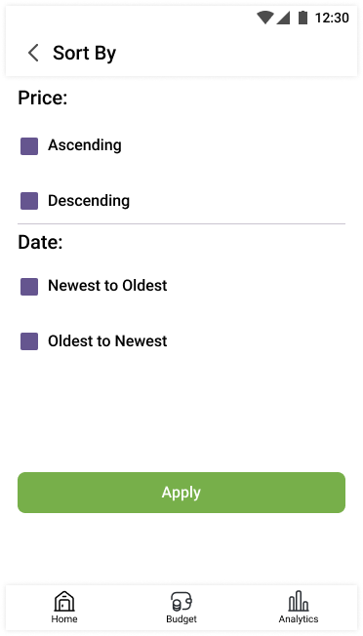

* This screen allows the user to sort the expenses by price (Ascending or Descending) or date (New to Old or Old to New). There are checkboxes for the user to click for selecting how they want to sort the data. When the user has decided on a sorting option, they may click the ‘Apply’ button to then be redirected to the ‘Expenses’ screen with the chosen sorting option applied to the expenses list.

Filter Screen

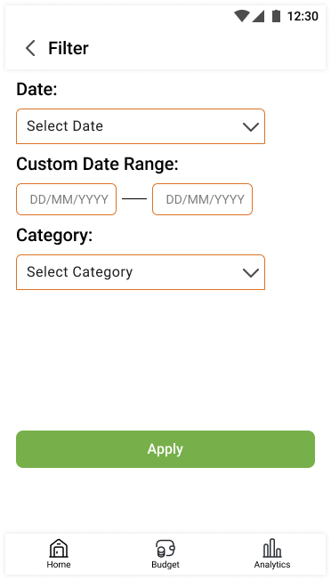

* This screen allows users to filter the expenses shown by specific criteria such as date (Past Day, Past Week, Past Month, Past Year, Custom) through a dropdown menu. If ‘Custom’ is chosen, the user will be allowed to type the custom date range that they want to filter the expenses by. There is also a dropdown menu for filtering expenses by a specific category. They may click the ‘Apply’ button to then be redirected to the ‘Expenses’ screen with the chosen filtering options applied to the expenses list.

Selected Expense Screen

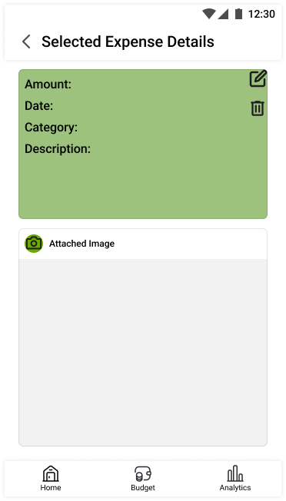

* This screen will be opened when an expense in the expense list is clicked. It shows a more detailed view of all the information for the specific expense that has been clicked on (Expense description and the attached image can only be viewed on this screen). On the expense information card, there is an ‘Edit’ button (the pen icon) and a ‘Delete’ button (the bin icon). Clicking the edit button redirect the user to the ‘Edit Expense’ screen. Clicking the delete button will open a pop-up warning asking if you want to delete the expense. Clicking ‘delete’ on the pop-up will completely delete the expense.

Edit Expense Screen

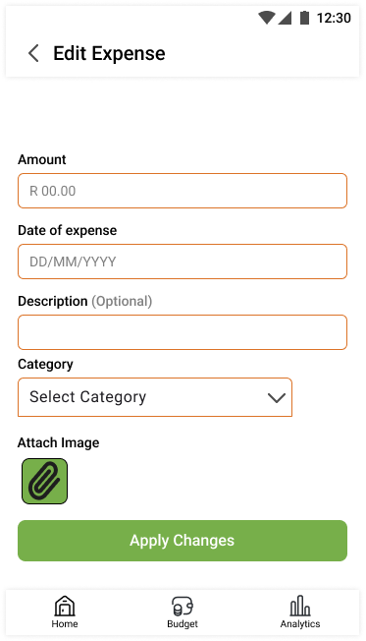

* The user can edit the category, description and the attached image (to change the image to another) of the expense. It has fields for all the expense information. After the changes have been made, the user can click the ‘Apply Changes’ button to be redirected the selected expense screen where the information will be updated.

Log Expense Screen

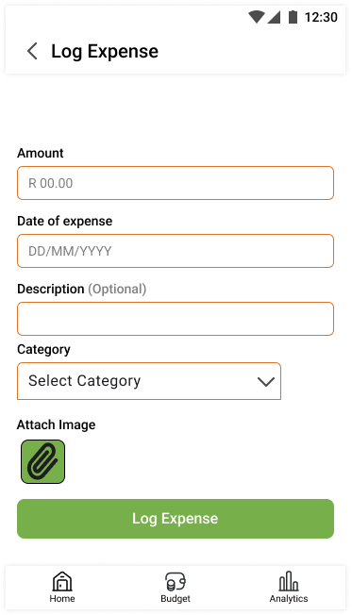

* This screen can be navigated to by clicking the ‘Log Expense’ button on the main menu. It includes fields and buttons for the user to enter all the necessary information for an expense (Amount, Date, Description (optional), Category, Image). The category isn’t typed but is selected from the dropdown menu. The paperclip icon is the button to attach an image related to the expense (receipt). Clicking the ‘Log Expense’ button when all the information is added will create the expense and add it to the expense list.

View Categories Screen

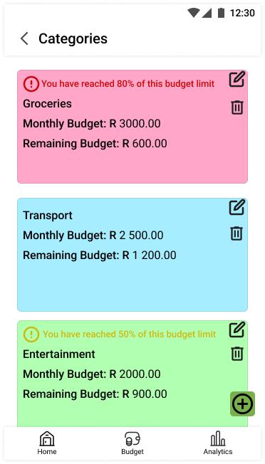

* This screen can be navigated to by clicking the ‘View Categories’ button on the main menu. Each existing category will be displayed on this screen with the relevant information (Category name, monthly budget, remaining budget). There is a ‘Delete’ button (the bin icon), which when clicked, will open a pop-up warning asking if you want to delete the category. Clicking ‘delete’ on the pop-up will completely delete the category. There is an ‘Edit’ button (the pen icon), which will redirect the user to the ‘Edit Category’ screen. Exclamation mark icons will appear on a category to warn the user if 50% (yellow warning) or 80% (red warning) of the category total budget has been reached. At the bottom right of the screen, there is a plus icon, which will redirect the user to the ‘Create Category’ screen.

Edit Category Screen

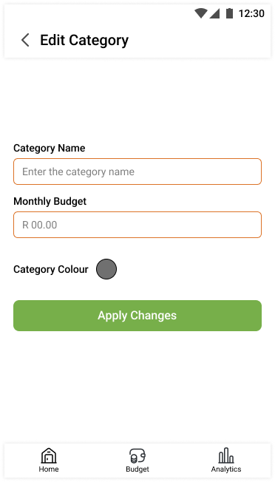

* This screen includes fields to allow the user to edit the category name, total monthly budget, and the category colour (A colour picker pop-up will appear). Clicking the ‘Apply Changes’ button will redirect the user to the ‘View Categories’ screen with the category information updated.

Category Create Screen

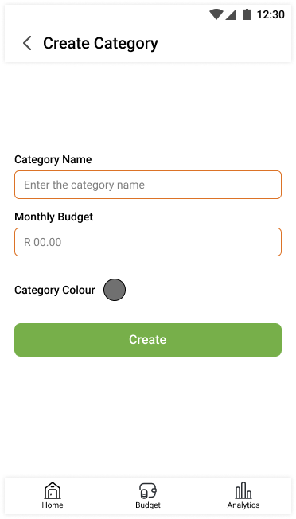

* This screen can be navigated to through the main menu by clicking the ‘Create Category’ button or clicking the previously mentioned plus icon on the ‘View Categories’ screen. It includes fields to enter the category name, its total monthly budget (which needs to fit within the overall total budget), and a category colour (A colour picker pop-up will appear). Clicking the ‘Create’ button when all the information is added will create the category and add it to the categories list.

Budget Game Screen

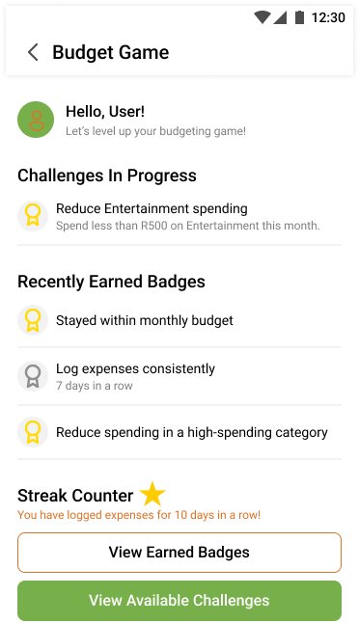

* This screen can be navigated to through the ‘Budget Game’ button on the main menu. This screen is the main screen for accessing the gamification features of the app. It displays the challenges in progress that has been chosen by the user, the recently earned badges from challenges, and it displays the current streak of daily expenses logged. There is the ‘View Earned Badges’ button, which redirects the user to the ‘Earned Badges’ screen. The ‘View Available Challenges’ button redirects the user to the ‘Available Challenges’ screen.

Earned Badges Screen

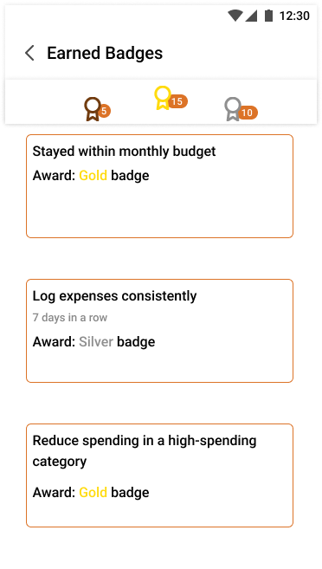

* This screen displays a list all the completed challenges and their rewards. There is a top bar, which displays each type of medal (Bronze, Silver, Gold) and the amount of each medal the user has obtained.

Challenges Screen

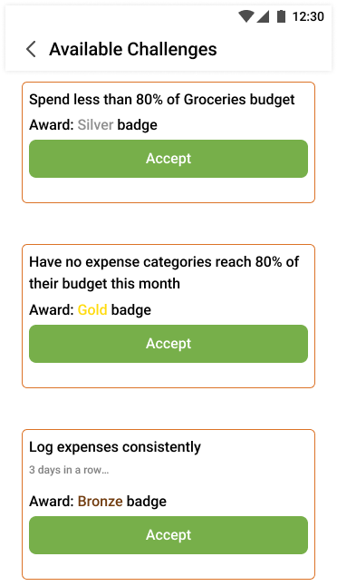

* This screen displays all the available challenges (and their corresponding badges/awards) for the user to accept. There is an ‘Accept’ button that when clicked, will add the challenge to the list of challenges in progress.

Budget Dashboard Screen

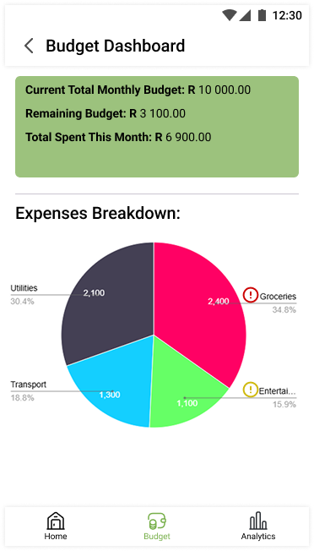

* This screen can be navigated to by clicking the ‘Budget’ button on the bottom navigation bar. This screen displays the current total monthly budget, the remaining budget, and the total spent within the current month. There is a pie chart displayed, which is a breakdown of the money spent for the month between each category (showing the actual amount spent for each category and the percentage of each category represents). Categories with excessive spending will have a yellow warning (for 50% of category budget reached) and a red warning (for 80% of category budget reached).

Analytics Screen

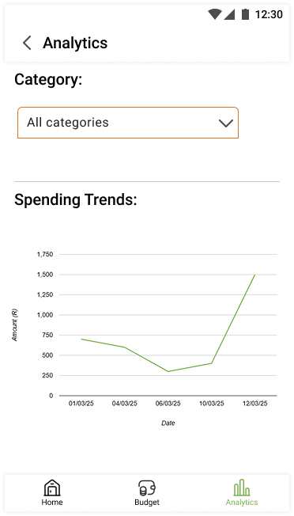

* This screen can be navigated to by clicking the ‘Analytics’ button on the bottom-right of the bottom navigation bar. This screen has a graph that displays daily expenses over a selected period. There is a dropdown menu for the user to display the graph for category-specific expenses. This is used to visualize daily spending and trends.

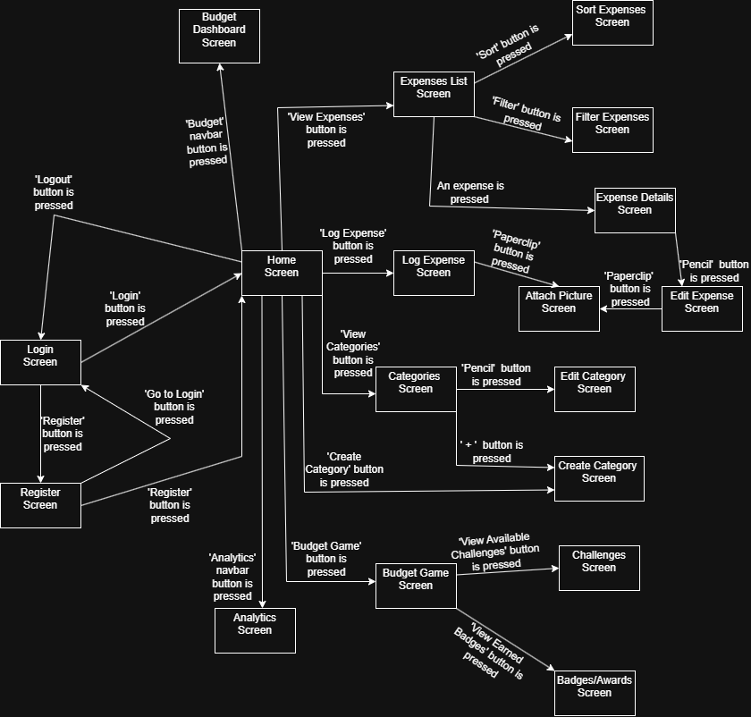**Navigation Diagram**

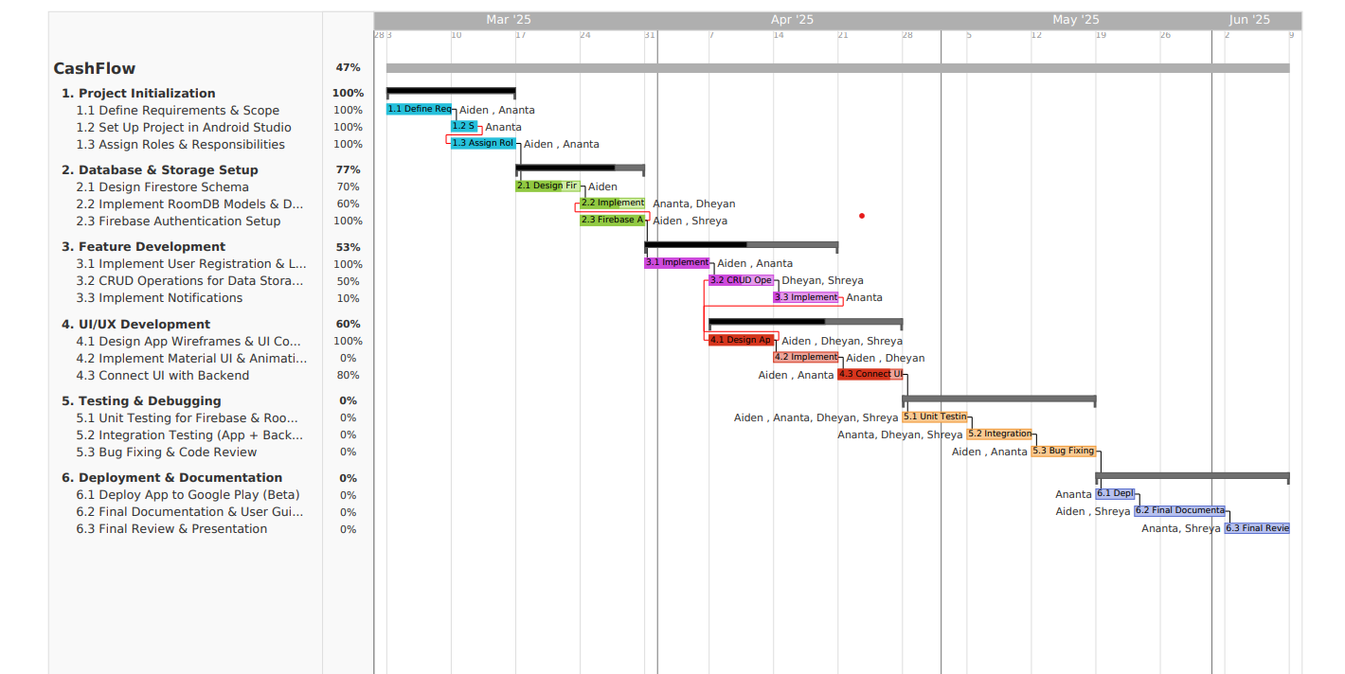

In conclusion an effective and user-friendly budgeting application is a powerful tool that should appeal to individuals that want to improve or better their financial habits. In our research document we identified and selected 3 of the best budgeting applications that stood out from the rest with regards to the features they offered, for instance YNAB enforces zero- based budgeting that focused on goal monitoring, GoodBudget has an organized envelope budgeting system and Mint provides an automated, user-friendly method with credit tracking and spending classification. By using these applications as a guide, we aim to develop CashFlow into an all-encompassing budgeting application that will be more efficient and user-friendly all while providing efficient and effective debt management, bank syncing and clear finical information tracking.

References

Canva,2019.*Sea Green and Green Minimalistic Style Digital Payment App Logo*.[Online].Available at: < <https://www.canva.com/design/DAGg1guZ6OI/qtS7zuIuD0__A5TuUgXyBQ/edit> > [Accessed 19 March 2025].

Canva,2020.Canava.[Online].Available at: < <https://www.canva.com/design/DAGgkN5z8rQ/peEHo9kto8uLg0FTVXNpFg/edit> > [Accessed 19 March 2025].

Draw.io, 2025. Draw.io - Flowchart Maker and Online Diagram Software. [Online]. Available at: < <https://app.diagrams.net/>> [Accessed 19 March 2025].

Figma, 2025.Free Online Wireframe Kit – Figma.[Online].Available at: <[Recents and Sharing – Figma](https://www.figma.com/files/team/1414618446783494002/recents-and-sharing?fuid=1414618444660900785)> [Accessed 5 March 2025].

Teamgantt, 2025.Website Design Plan – Gantt | TeamGantt.[Online].Available at: <[TeamGantt: The Easiest FREE Gantt Chart Maker Online](https://www.teamgantt.com/) >[Accessed 16 March 2025].