**ST10304660**

**Lebone Paballo Mnisi**

**Test**

**Information Systems 1b**

Question 1

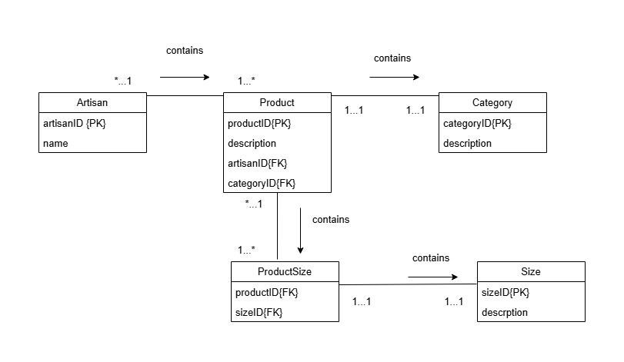

Question 2

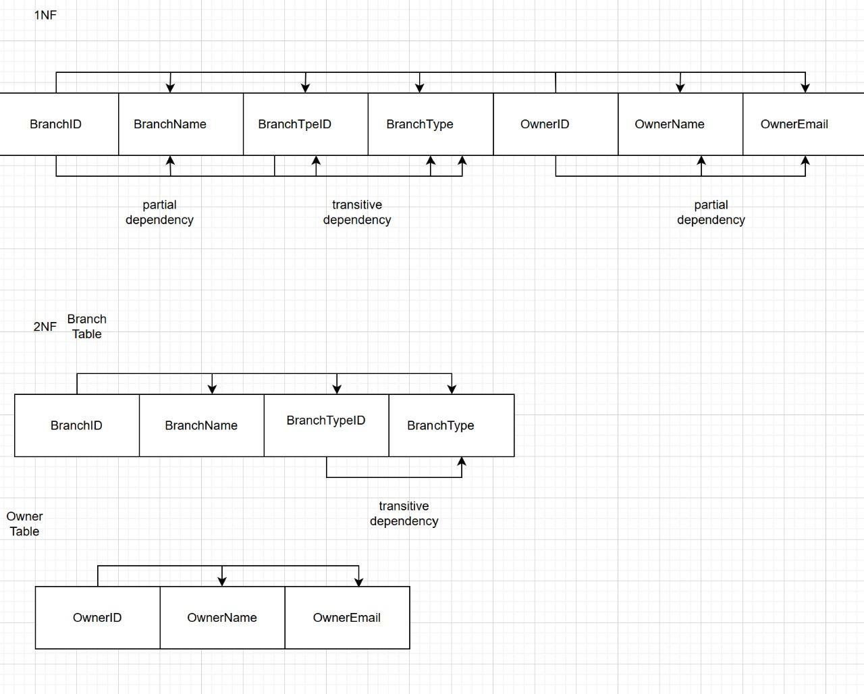

Question 3

Sql file attached