THARIMPEPE FEEDING SCHEME
FEEDING SCHEME MANAGEMENT SYSTEM
System Requirements Document

Prepared by:  Olebogeng Phawe  ST10345327 | Module:  XISD5319 – Work Integrated Learning  Task 2a – Requirement Analysis
Client:  Tharimpepe Feeding Scheme  Mafikeng, North West, South Africa | Date:  April 2026  Version: 1.0

XISD5319 | Task 2 | Requirements Analysis | Confidential

1. Requirement Analysis

1.1 Problem Domain
Tharimpepe Feeding Scheme is a community-based non-profit organisation (NPO) located in Mafikeng, North West, South Africa. The organisation provides daily meals to underprivileged children and vulnerable community members, operating through donations, volunteer support, and community partnerships.
Currently, all operational tasks are managed manually using paper-based systems and informal communication channels. This creates several critical problems for the organisation:
- Beneficiary registration is done on paper, making it difficult to track who receives meals, how often, and whether records are up to date.
- Attendance is recorded manually with no central repository, leading to inaccurate headcounts and food wastage.
- Food stock and donation tracking is done informally, making it difficult to plan meals or demonstrate impact to donors.
- Volunteer schedules are communicated via phone/WhatsApp, causing confusion, no-shows, and uneven workloads.
- Reporting to donors and community partners requires manual compilation, which is time-consuming and error-prone.

1.2 Solution Domain
The proposed solution is a web-based Feeding Scheme Management System (FSMS). Built on a three-layer MVC architecture using PHP, MySQL and Bootstrap, it will replace all manual processes with a secure, centralised digital platform providing:
- Beneficiary Registration & Management: Digital registration with searchable records.
- Attendance Tracking: Daily digital attendance recording per feeding session.
- Food Stock & Donation Tracking: Real-time inventory management and donation logging.
- Volunteer Scheduling: Online volunteer registration and schedule management.
- Reporting & Analytics: Automated generation of reports for donors and stakeholders.
- Secure Authentication: Role-based access control for Administrators and Volunteers.

1.3 Active Actors
The following active actors interact directly with the Feeding Scheme Management System:

Active Actor | Description | System Interaction
Organisation Manager (Admin) | Oversees all operations, approves records, generates reports | Full system access: manage beneficiaries, reports, volunteers, stock
Volunteer | Assists with meal preparation and distribution | Record attendance, view schedules, update assigned tasks
Beneficiary Representative | Guardian registering community member for meals | Submit registration form, view status
Donor | Individuals or organisations contributing food or funds | View donation records, submit donation details

1.4 Functions (Use Cases)
The following table lists all use cases of the Feeding Scheme Management System (Satzinger, Jackson and Burd, 2014):

# | Function / Use Case | Active Actor
1 | Login to the system | Admin, Volunteer
2 | Logout of the system | Admin, Volunteer
3 | Register a new beneficiary | Admin
4 | View / search beneficiary list | Admin
5 | Update beneficiary details | Admin
6 | Deactivate a beneficiary | Admin
7 | Record daily attendance | Admin, Volunteer
8 | View attendance report | Admin
9 | Add food stock / donation | Admin
10 | View current stock levels | Admin, Volunteer
11 | Update stock levels | Admin
12 | Record a donation | Admin
13 | View donation history | Admin
14 | Register a volunteer | Admin
15 | View volunteer schedule | Admin, Volunteer
16 | Assign volunteer to session | Admin
17 | Generate attendance report | Admin
18 | Generate stock report | Admin
19 | Generate donation report | Admin
20 | Generate impact report | Admin

1.5 Passive Actors
Passive actors are the systems/subsystems acted upon by active actors:

Passive Actor / System | Description
Beneficiary Management Subsystem | Stores and manages all beneficiary registration and profile data
Attendance Tracking Subsystem | Records and retrieves daily attendance data per beneficiary and session
Food Inventory Subsystem | Manages stock levels, food item records, and low-stock alerts
Donation Management Subsystem | Logs donations (food and financial), links to donor records
Volunteer Management Subsystem | Stores volunteer profiles, assigned sessions, and availability data
Reporting Subsystem | Generates reports from aggregated system data for admin use
Authentication Subsystem | Manages user login, session tokens, and role-based access control
Database (MySQL) | Central persistent data store for all system entities and records

1.6 Use Case Diagram
The following use case diagram illustrates all interactions between active actors (Admin, Volunteer, Donor) and the system use cases, enclosed within the system boundary box:

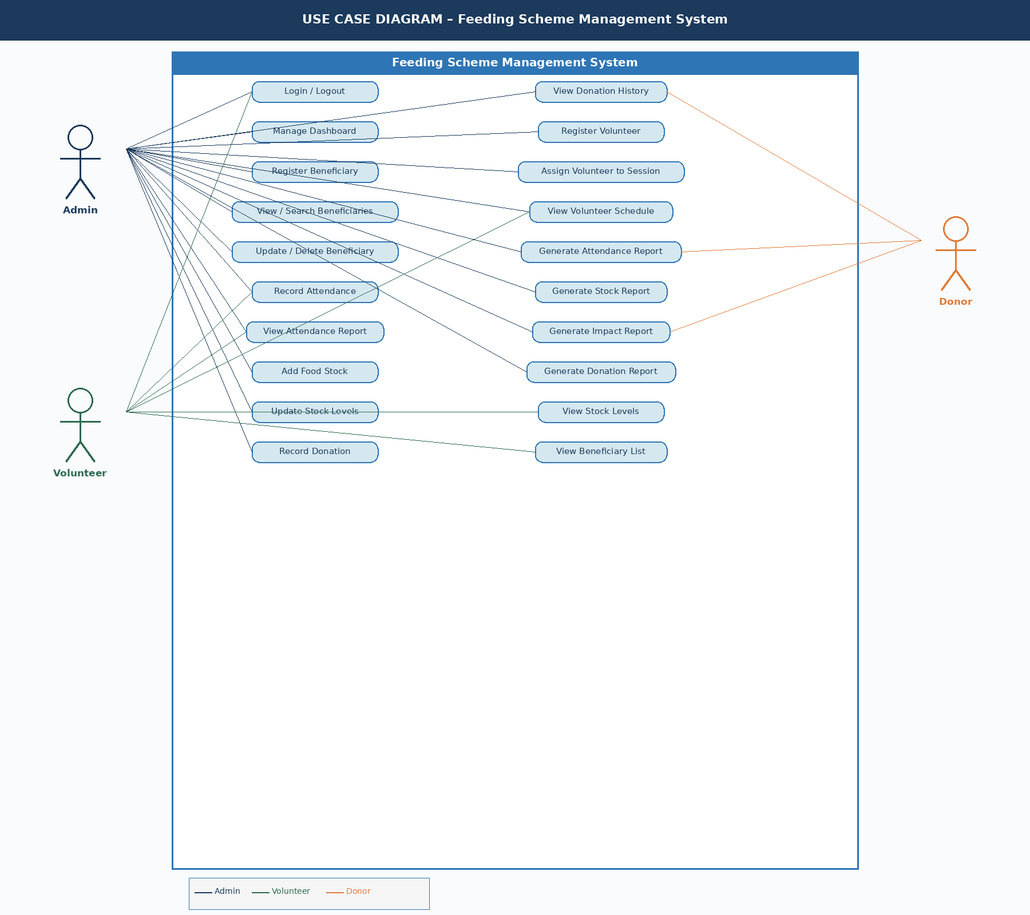
Figure 1: Use Case Diagram – Feeding Scheme Management System

2. Logical System Model

The logical system model maps each system function to its GUI inputs, outputs, system processes, and the corresponding entity relationship (database) table.

GUI Input | GUI Output | System Process | ER Table
Login credentials | Dashboard / Error message | Authenticate user | Users
Beneficiary details (name, DOB, address, guardian) | Beneficiary record confirmation | Register new beneficiary | Beneficiaries
Search keyword / ID | Beneficiary profile | Search/view beneficiary | Beneficiaries
Updated beneficiary fields | Updated record confirmation | Update beneficiary details | Beneficiaries
Session date, beneficiary list | Attendance confirmation | Record daily attendance | Attendance
No input | Attendance report (by date/period) | View/generate attendance report | Attendance
Food item name, quantity, expiry, supplier | Stock record confirmation | Add stock / donation item | FoodStock, Donations
No input | Current stock levels list | View food stock | FoodStock
Updated stock quantities | Updated stock confirmation | Update stock levels | FoodStock
Donation details (donor, amount/item, date) | Donation record confirmation | Record donation | Donations
No input | Donation history list | View donation records | Donations
Volunteer details (name, contact, availability) | Volunteer record confirmation | Register volunteer | Volunteers
Session date, volunteer ID | Schedule confirmation | Assign volunteer to session | VolunteerSessions
No input | Volunteer schedule list | View volunteer schedules | VolunteerSessions
Report type, date range | Generated report (PDF/screen) | Generate report | All tables

2.1 Input Specifications
Input Field | Data Type | Validation Rules | Required
Beneficiary First Name | String (max 50) | Letters only, no numbers | Yes
Beneficiary Last Name | String (max 50) | Letters only, no numbers | Yes
Date of Birth | Date (DD/MM/YYYY) | Must be a valid past date | Yes
Gender | Enum (Male/Female/Other) | Must select one option | Yes
Guardian Name | String (max 100) | Letters only | No
Contact Number | String (10 digits) | Numeric, 10 digits, SA format | Yes
Physical Address | String (max 200) | Free text | Yes
Attendance Date | Date | Cannot be future date | Yes
Beneficiary Present (Y/N) | Boolean | Must be True or False | Yes
Food Item Name | String (max 100) | Free text | Yes
Quantity | Decimal | Must be greater than 0 | Yes
Unit of Measure | Enum (kg/litres/units) | Must select one | Yes
Donation Type | Enum (Food/Cash/Other) | Must select one | Yes
Donor Name / Organisation | String (max 100) | Free text | Yes
Volunteer Name | String (max 100) | Letters only | Yes
Username | String (max 50) | Alphanumeric | Yes
Password | String (min 8 chars) | At least 1 uppercase, 1 number | Yes

2.2 Output Specifications
Output | Format | Audience | Frequency
Beneficiary Registration Confirmation | On-screen message | Admin | On demand
Beneficiary List | Paginated table (screen) | Admin | On demand
Daily Attendance Record | On-screen confirmation + stored record | Admin, Volunteer | Daily
Attendance Report (by date/period) | Table / downloadable PDF | Admin, Donors | Weekly/Monthly
Current Stock Levels | Dashboard table | Admin, Volunteer | On demand
Low Stock Alert | On-screen notification | Admin | Automatic
Donation History Report | Table / downloadable PDF | Admin, Donors | On demand
Volunteer Schedule | Calendar view / table | Admin, Volunteer | On demand
Impact Report (meals served, beneficiaries) | Summary dashboard + PDF | Admin, Donors | Monthly
Login / Access Error Message | On-screen alert | All users | On event

2.3 System Processes
Process ID | Process Name | Description
P01 | User Authentication | Validates credentials against Users table; creates a session token; enforces role-based access.
P02 | Beneficiary Registration | Validates and stores new beneficiary data in the Beneficiaries table; generates a unique Beneficiary ID.
P03 | Beneficiary Search & Retrieval | Queries the Beneficiaries table by name, ID, or address and returns matching records.
P04 | Attendance Recording | Logs presence/absence of each beneficiary per feeding session; links to session date and Volunteer ID.
P05 | Attendance Report Generation | Aggregates Attendance table records by date range; calculates total meals served and average attendance.
P06 | Food Stock Management | Updates FoodStock table on addition or consumption; triggers low-stock alert when quantity falls below threshold.
P07 | Donation Recording | Stores donation details in the Donations table; links donation to a donor and optionally to a stock item.
P08 | Volunteer Registration & Scheduling | Creates volunteer record; assigns volunteer to sessions via the VolunteerSessions linking table.
P09 | Report Generation | Aggregates data across tables to produce formatted reports for admin or donor audience.
P10 | Data Validation | Cross-cutting process: validates all input fields before database write operations.

3. Entity Relationship Tables

The following tables define the entities and their attributes in the Feeding Scheme Management System database.

3.1 Users Table
Field Name | Data Type | Constraints | Description
UserID | INT | PK, AUTO INCREMENT, NOT NULL | Unique identifier for each user
Username | VARCHAR(50) | UNIQUE, NOT NULL | Login username
PasswordHash | VARCHAR(255) | NOT NULL | Bcrypt-hashed password
FullName | VARCHAR(100) | NOT NULL | Full name of the user
Email | VARCHAR(100) | UNIQUE, NOT NULL | User email address
Role | ENUM('Admin','Volunteer') | NOT NULL, DEFAULT 'Volunteer' | Role determines system access level
IsActive | BOOLEAN | NOT NULL, DEFAULT TRUE | Whether the account is active
CreatedAt | DATETIME | NOT NULL, DEFAULT NOW() | Account creation timestamp

3.2 Beneficiaries Table
Field Name | Data Type | Constraints | Description
BeneficiaryID | INT | PK, AUTO INCREMENT, NOT NULL | Unique beneficiary identifier
FirstName | VARCHAR(50) | NOT NULL | Beneficiary first name
LastName | VARCHAR(50) | NOT NULL | Beneficiary last name
DateOfBirth | DATE | NOT NULL | Date of birth
Gender | ENUM('Male','Female','Other') | NOT NULL | Gender of beneficiary
GuardianName | VARCHAR(100) | NULL | Name of guardian (if minor)
ContactNumber | VARCHAR(15) | NOT NULL | Contact phone number
Address | VARCHAR(200) | NOT NULL | Physical address
RegistrationDate | DATE | NOT NULL, DEFAULT CURDATE() | Date of registration
IsActive | BOOLEAN | NOT NULL, DEFAULT TRUE | Whether beneficiary is currently active
RegisteredBy | INT | FK -> Users(UserID) | Admin who registered this beneficiary

3.3 Attendance Table
Field Name | Data Type | Constraints | Description
AttendanceID | INT | PK, AUTO INCREMENT, NOT NULL | Unique attendance record ID
BeneficiaryID | INT | FK -> Beneficiaries(BeneficiaryID), NOT NULL | Beneficiary who attended
SessionDate | DATE | NOT NULL | Date of the feeding session
IsPresent | BOOLEAN | NOT NULL | TRUE = present, FALSE = absent
RecordedBy | INT | FK -> Users(UserID) | User who recorded attendance
Notes | TEXT | NULL | Optional notes (e.g. illness, late arrival)

3.4 FoodStock Table
Field Name | Data Type | Constraints | Description
StockID | INT | PK, AUTO INCREMENT, NOT NULL | Unique stock item ID
ItemName | VARCHAR(100) | NOT NULL | Name of the food item
Category | VARCHAR(50) | NOT NULL | Category (Grain, Protein, Vegetable, etc.)
Quantity | DECIMAL(10,2) | NOT NULL, DEFAULT 0 | Current quantity available
UnitOfMeasure | ENUM('kg','litres','units') | NOT NULL | Unit of measure for quantity
MinimumThreshold | DECIMAL(10,2) | NOT NULL, DEFAULT 5 | Minimum quantity before alert triggered
ExpiryDate | DATE | NULL | Expiry date of batch
UpdatedBy | INT | FK -> Users(UserID) | User who last updated this record

3.5 Donations Table
Field Name | Data Type | Constraints | Description
DonationID | INT | PK, AUTO INCREMENT, NOT NULL | Unique donation ID
DonorName | VARCHAR(100) | NOT NULL | Name of donor or organisation
DonationType | ENUM('Food','Cash','Other') | NOT NULL | Type of donation
ItemDescription | VARCHAR(200) | NULL | Description of food donated (if food)
Quantity | DECIMAL(10,2) | NULL | Quantity donated (if food)
AmountRand | DECIMAL(10,2) | NULL | Amount in Rands (if cash)
DonationDate | DATE | NOT NULL, DEFAULT CURDATE() | Date donation was received
LinkedStockID | INT | FK -> FoodStock(StockID), NULL | Food stock item updated by this donation
RecordedBy | INT | FK -> Users(UserID) | Admin who recorded this donation

3.6 Volunteers Table
Field Name | Data Type | Constraints | Description
VolunteerID | INT | PK, AUTO INCREMENT, NOT NULL | Unique volunteer ID
UserID | INT | FK -> Users(UserID), NULL | Linked system user account (if applicable)
FullName | VARCHAR(100) | NOT NULL | Full name of volunteer
ContactNumber | VARCHAR(15) | NOT NULL | Contact phone number
Email | VARCHAR(100) | NULL | Email address
Availability | TEXT | NULL | Notes on availability
IsActive | BOOLEAN | NOT NULL, DEFAULT TRUE | Whether volunteer is currently active
RegisteredDate | DATE | NOT NULL, DEFAULT CURDATE() | Date volunteer was registered

3.7 VolunteerSessions Table
Field Name | Data Type | Constraints | Description
SessionID | INT | PK, AUTO INCREMENT, NOT NULL | Unique session record ID
VolunteerID | INT | FK -> Volunteers(VolunteerID), NOT NULL | Volunteer assigned to session
SessionDate | DATE | NOT NULL | Date of the feeding session
Role | VARCHAR(100) | NULL | Volunteer role for this session (e.g. Food Prep)
AttendedSession | BOOLEAN | NULL, DEFAULT NULL | Whether volunteer attended (confirmed after session)

3.8 Entity Relationship Diagram (ERD)
The following ERD illustrates all seven entities and their relationships (Primary Keys, Foreign Keys, and cardinality) for the Feeding Scheme Management System database:

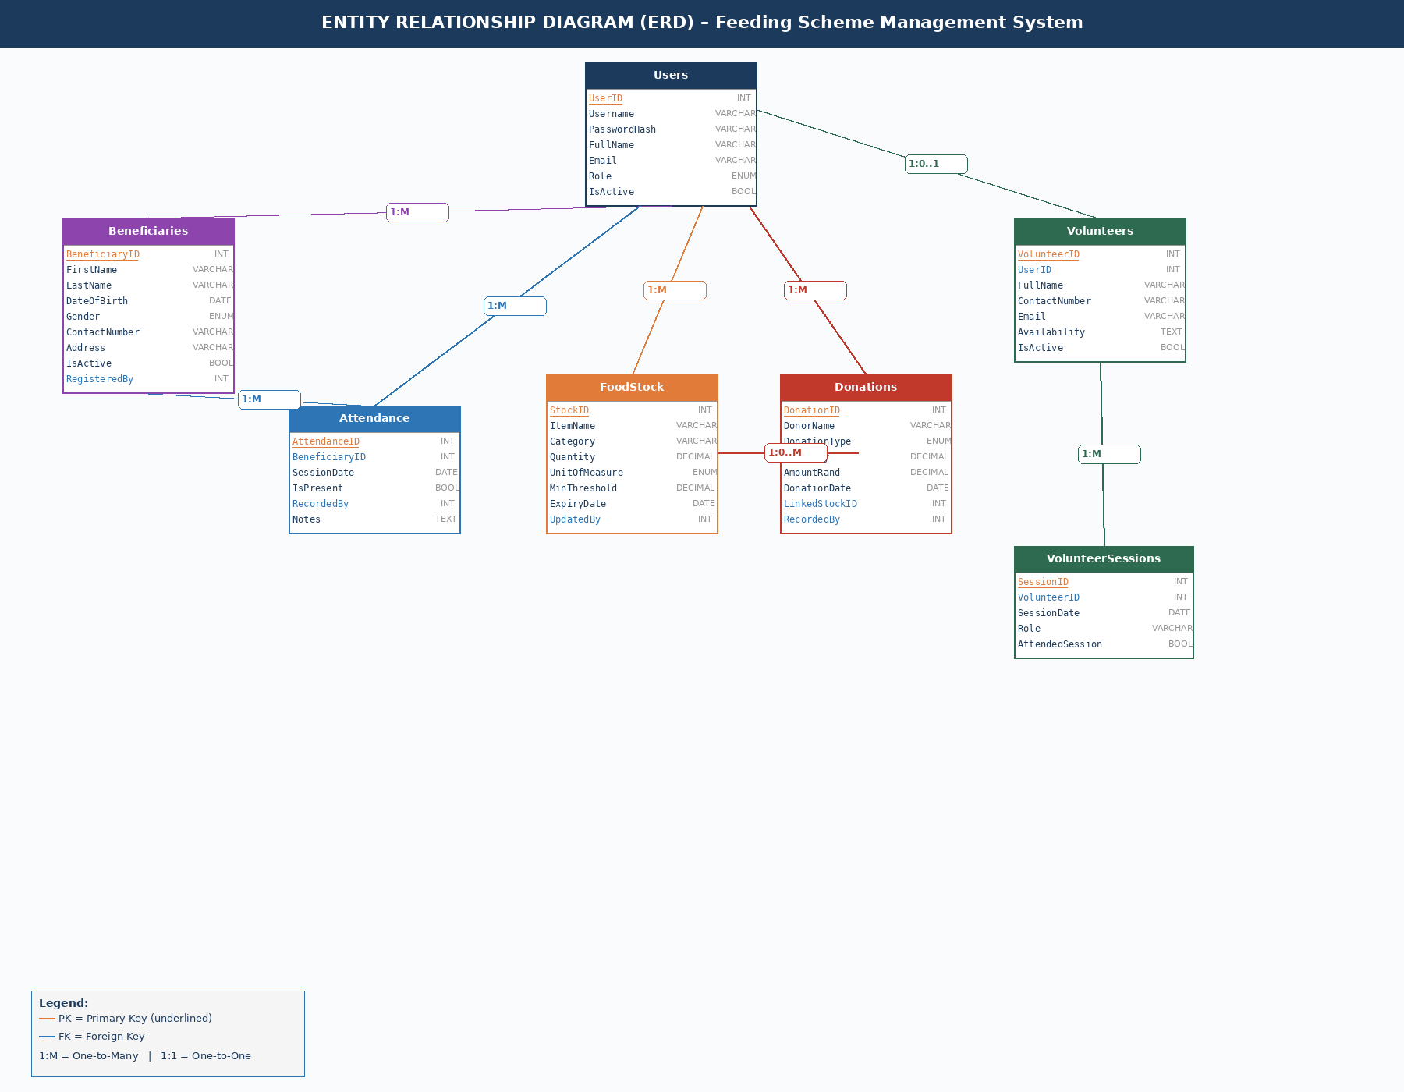
Figure 2: Entity Relationship Diagram (ERD) – Feeding Scheme Management System

3.9 Business Rules & Entity Relationships
Entity | Related Entity | Relationship | Business Rule
User (Admin) | Beneficiary | One-to-Many | One admin can register many beneficiaries. Each beneficiary is registered by one admin.
Beneficiary | Attendance | One-to-Many | One beneficiary can have many attendance records. Each record belongs to one beneficiary.
User | Attendance | One-to-Many | One user can record many attendance entries. Each entry is recorded by one user.
FoodStock | Donation | One-to-Many (opt) | One stock item can be linked to many donations. A donation may or may not update a stock item.
Volunteer | VolunteerSession | One-to-Many | One volunteer can be assigned to many sessions.
User | Volunteer | One-to-One (opt) | A volunteer may optionally have a system user account.

4. Class Diagram

The following UML Class Diagram shows all system classes with their attributes, methods, and relationships. Inheritance arrows indicate that Admin and Volunteer are subclasses of the User base class.

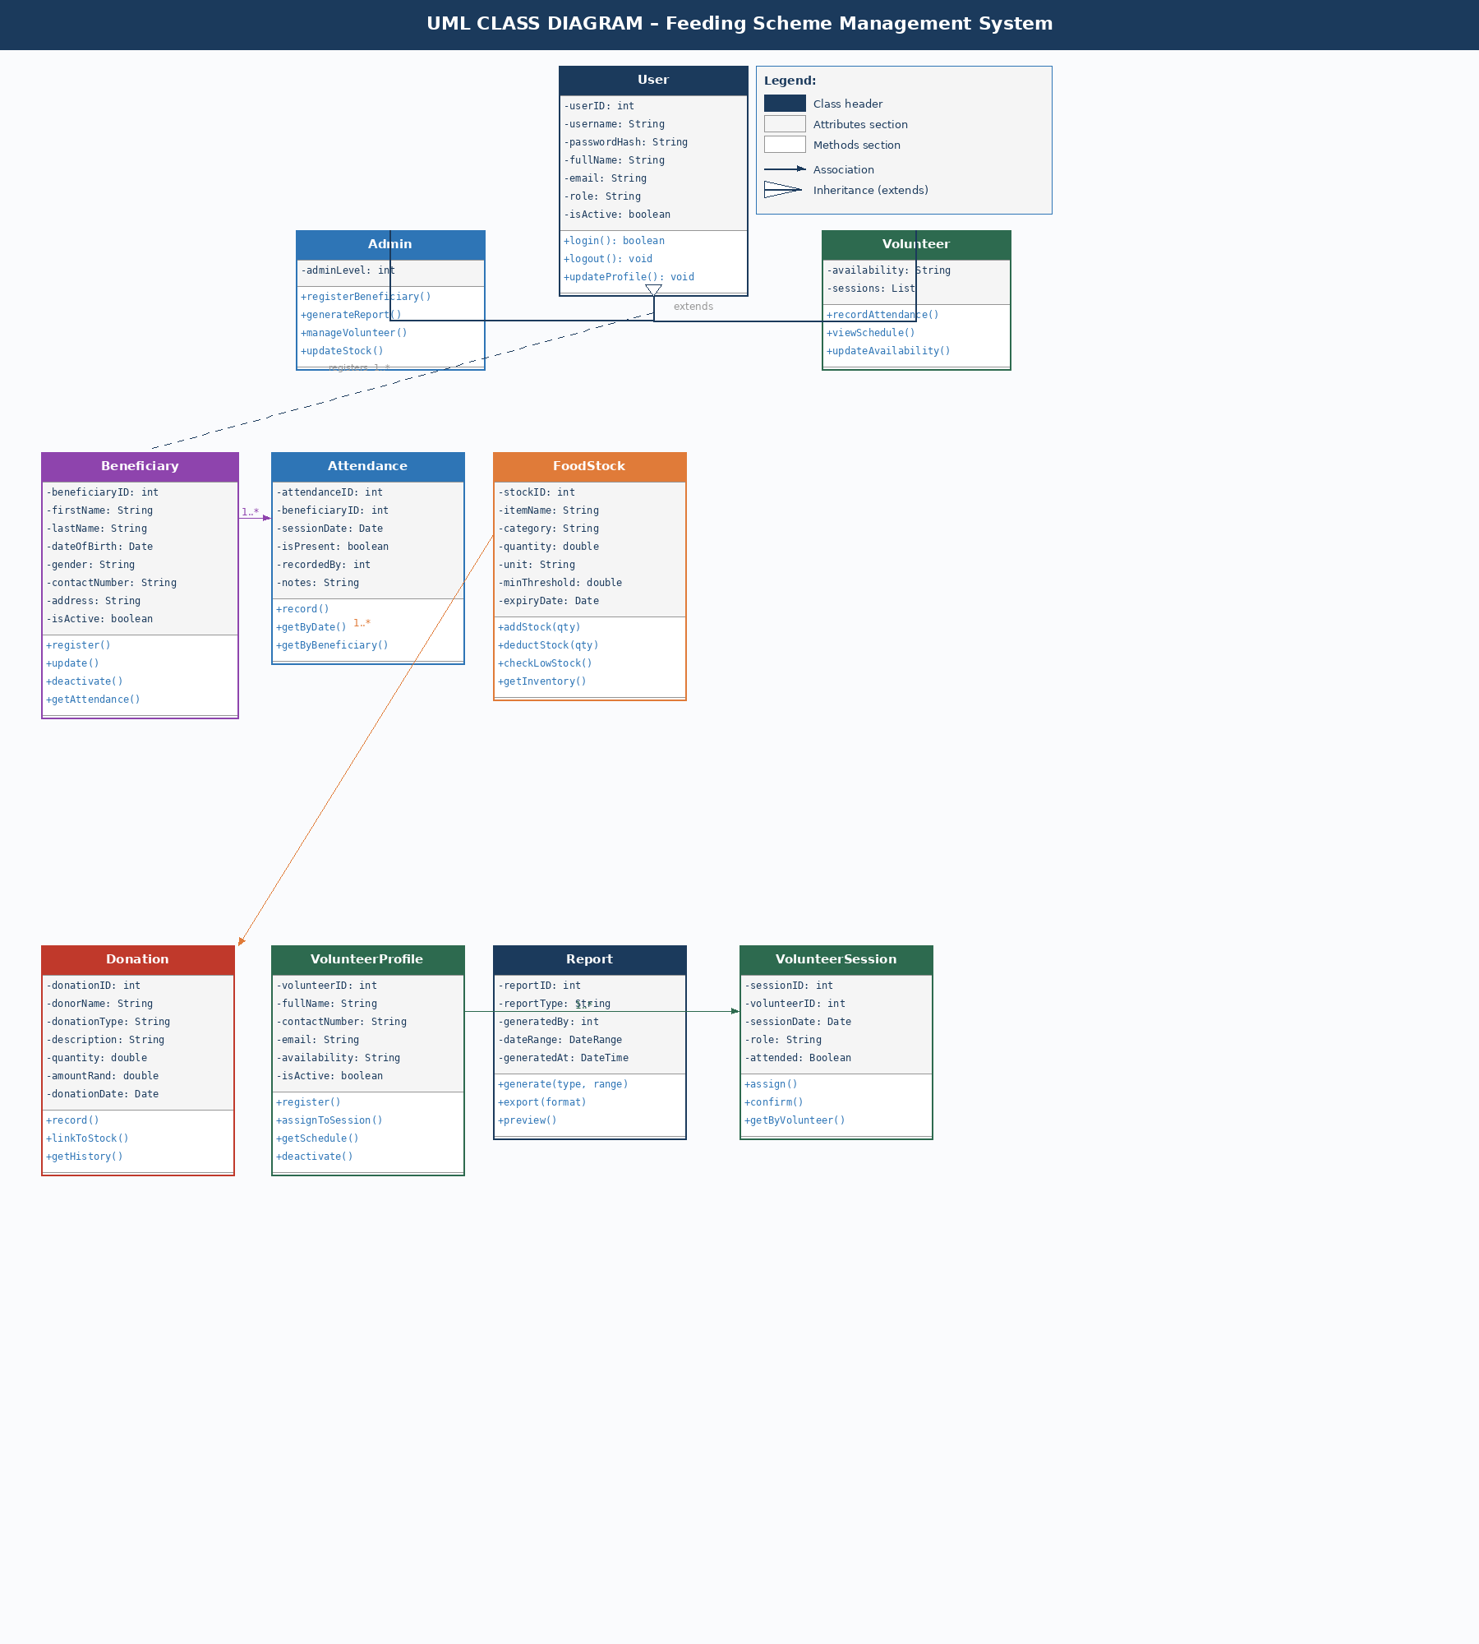
Figure 3: UML Class Diagram – Feeding Scheme Management System

4.1 Class Descriptions
Class | Key Attributes | Key Methods | Relationships
User | userID, username, passwordHash, role | login(), logout(), updateProfile() | Parent of Admin and Volunteer
Admin (extends User) | adminLevel | registerBeneficiary(), generateReport() | Manages Beneficiary, FoodStock, Donation
Volunteer (extends User) | availability, sessions | recordAttendance(), viewSchedule() | Linked to VolunteerSession
Beneficiary | beneficiaryID, firstName, dateOfBirth, address | register(), update(), deactivate() | Has many Attendance records
Attendance | attendanceID, sessionDate, isPresent | record(), getByDate(), getByBeneficiary() | Belongs to Beneficiary
FoodStock | stockID, quantity, minThreshold | addStock(), deductStock(), checkLowStock() | Linked to Donation
Donation | donationID, donorName, amountRand | record(), linkToStock() | May link to FoodStock
VolunteerProfile | volunteerID, fullName, availability | register(), assignToSession() | Has many VolunteerSessions
Report | reportType, dateRange | generate(), export() | Aggregates data from all classes

5. Functional & Non-Functional Requirements

5.1 Functional Requirements
- FR01: The system must allow admin users to register new beneficiaries with all required personal details.
- FR02: The system must allow admin and volunteer users to record daily attendance per feeding session.
- FR03: The system must track food stock levels and alert the admin when any item falls below the minimum threshold.
- FR04: The system must allow admin users to record food and cash donations and link them to stock items where applicable.
- FR05: The system must allow admin users to register volunteers and assign them to feeding sessions.
- FR06: The system must generate attendance, stock, donation, and impact reports for admin use.
- FR07: The system must enforce role-based access control – Admins have full access; Volunteers have limited access.
- FR08: The system must allow admin users to search for beneficiaries, volunteers, and donations using keywords.
- FR09: The system must allow admin users to update or deactivate beneficiary and volunteer records.
- FR10: The system must display a dashboard summary (total beneficiaries, meals served, stock levels) on login.

5.2 Non-Functional Requirements
- NFR01 – Usability: The interface must be simple and intuitive for users with limited digital literacy.
- NFR02 – Availability: The system must be available 24/7 with maximum 1% planned downtime.
- NFR03 – Security: All passwords must be hashed. All data transmission must use HTTPS/SSL.
- NFR04 – Performance: Page load times must not exceed 3 seconds under normal conditions.
- NFR05 – Reliability: The system must support offline data entry for attendance when internet is unavailable.
- NFR06 – Maintainability: The codebase must follow MVC architecture to facilitate future enhancements.
- NFR07 – Scalability: The system must support up to 500 beneficiaries and 50 users without degradation.
- NFR08 – Compatibility: The system must function correctly on Chrome, Firefox, and Edge browsers.

6. References

- Satzinger, J.W., Jackson, R.B. and Burd, S.D. (2014) Systems Analysis and Design in a Changing World. 7th edn. Cengage Learning.
- Dennis, A., Wixom, B.H. and Roth, R.M. (2015) Systems Analysis and Design. 6th edn. Wiley.
- Oracle (2025) MySQL 8.0 Reference Manual. Available at: https://dev.mysql.com/doc (Accessed: April 2026).
- Padi, C. (2025) Feed My People NGO – Community Outreach Programme Documentation. Internal document.
- Arola, M. (2022) Hardware Requirements for Web Development. Nashville Software School.
- Daly, R. (2019) The Pros and Cons of Switching to Free and Open-Source Tools. CultureHive.

