THARIMPEPE FEEDING SCHEME
FEEDING SCHEME MANAGEMENT SYSTEM
System Design Document

Prepared by:  Olebogeng Phawe  ST10345327 | Module:  XISD5319 – Work Integrated Learning  Task 2b – System Design
Client:  Tharimpepe Feeding Scheme | Date:  April 2026 | Version 1.0

XISD5319 | Task 2 | System Design | Confidential

1. Introduction

1.1 Purpose
This System Design Document describes the architectural and detailed design of the Feeding Scheme Management System (FSMS) developed for Tharimpepe Feeding Scheme. It translates requirements into a concrete technical blueprint covering logical architecture, high-level and low-level design, user interaction design, database design, ERD, UI mockups, and report design.

1.2 System Overview
The FSMS is a web-based application that digitalises and streamlines the operations of Tharimpepe Feeding Scheme in Mafikeng, North West, South Africa. It manages beneficiary registration, daily attendance tracking, food stock and donation management, volunteer scheduling, and automated reporting.

1.3 Technology Stack

Layer | Technology | Purpose
Frontend (View) | HTML5, CSS3, JavaScript, Bootstrap 5 | User interface – responsive, accessible web pages
Backend (Domain) | PHP 8 (MVC Pattern) | Business logic, routing, session management
Database (Data) | MySQL 8.0 via XAMPP | Persistent data storage for all system entities
Web Server | Apache (via XAMPP) | Serve PHP application locally or on hosting platform
Version Control | Git / GitHub | Source code management and team collaboration
IDE | Visual Studio Code | Development environment (free, cross-platform)
Hosting | AWS Free Tier / cPanel | Cloud deployment of the web application

2. Logical Architectural Design

The FSMS follows a Three-Layer Architecture (View, Domain, Data) that separates concerns for maintainability, scalability, and testability.

2.1 High-Level Architecture Diagram
The diagram below shows all components within each layer and communication pathways between them:

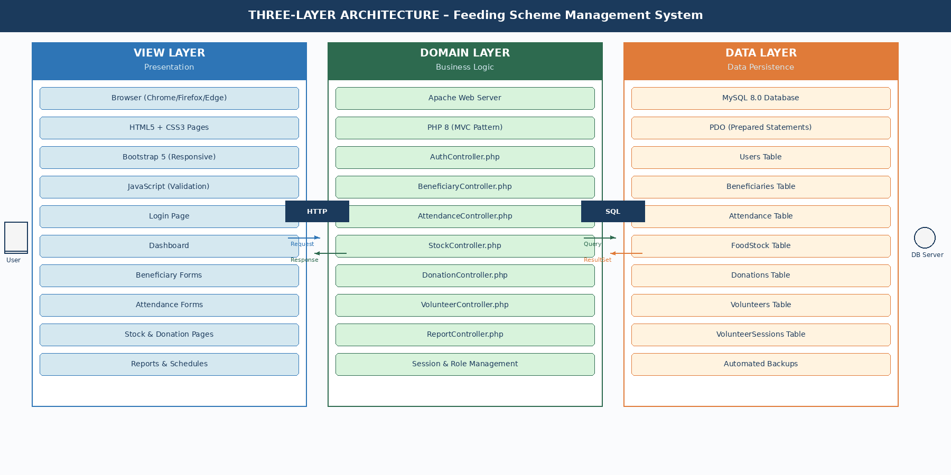
Figure 1: Three-Layer Architecture Diagram – Feeding Scheme Management System
Layer Descriptions
View Layer: HTML/CSS/JavaScript pages using Bootstrap 5 for responsive, accessible design. Communicates with the domain layer via HTTP GET/POST requests.
Domain Layer: PHP 8 MVC controllers handle business logic, session management, authentication, and input validation before querying or updating the database.
Data Layer: MySQL 8.0 accessed via PDO prepared statements to prevent SQL injection. Seven relational tables store all system data persistently.

2.2 Low-Level Design
2.2.1 MVC Folder Structure
Folder / File | Purpose
/app/controllers/ | PHP controller classes (AuthController, BeneficiaryController, AttendanceController, etc.)
/app/models/ | PHP model classes (User.php, Beneficiary.php, Attendance.php, FoodStock.php, etc.)
/app/views/ | HTML/PHP template files for each page (login.php, dashboard.php, beneficiaries.php, etc.)
/config/ | Database connection config (db.php), environment settings
/public/ | Entry point index.php + publicly accessible CSS, JS, image assets
/sql/ | Database schema files (schema.sql, seed_data.sql)
.htaccess | Apache URL rewrite rules for clean RESTful-style URLs

2.2.2 MVC Request-Response Flow
The diagram below shows the complete seven-step request-response cycle from browser action through controller and model to database and back:

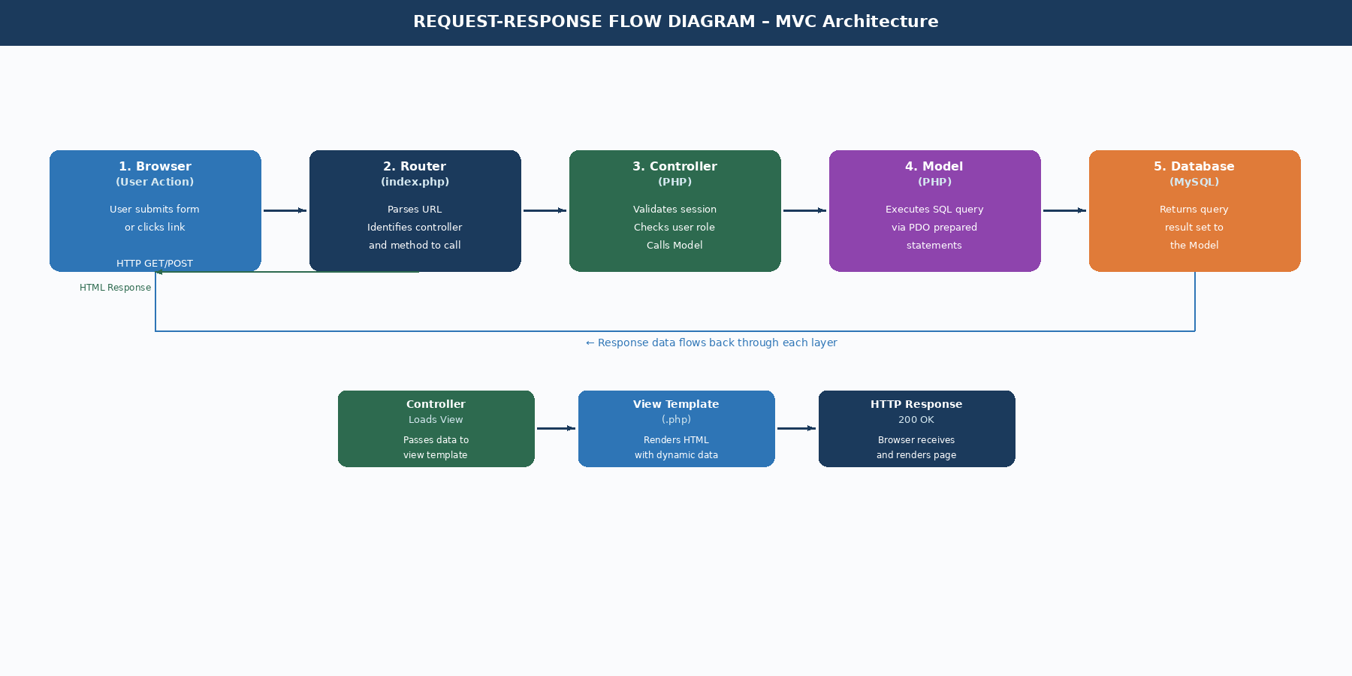
Figure 2: MVC Request-Response Flow Diagram
Step | Component | Action
1 | Browser | User submits form or clicks link; browser sends HTTP GET/POST request to the server.
2 | index.php (Router) | Front controller parses URL to determine which controller and method to invoke.
3 | Controller | Validates session/role; calls appropriate Model method(s) with input data.
4 | Model | Executes prepared SQL query against MySQL database; returns result as PHP array.
5 | Controller | Receives model result; formats data; loads appropriate view template.
6 | View | PHP template renders HTML with dynamic data embedded; HTTP response sent to browser.
7 | Browser | Browser renders HTML page to the user.

3. User Interaction Design

3.1 Input Interactions
Screen/Form | Input Fields | Validation | Action on Submit
Login Form | Username, Password | Both required; password min 8 chars | Authenticate user; redirect to dashboard or show error
Register Beneficiary | First Name, Last Name, DOB, Gender, Guardian, Contact, Address | All required except Guardian; DOB must be past date | Save to Beneficiaries table; show success message
Edit Beneficiary | Same fields (pre-filled) | Same as register; at least one field changed | Update Beneficiaries record; redirect to list
Record Attendance | Session Date, Present/Absent per beneficiary | Session date required; at least one beneficiary | Save attendance records; redirect to list
Add Food Stock | Item Name, Category, Quantity, Unit, Min Threshold, Expiry | Quantity > 0; Expiry must be future date | Insert or update FoodStock; show updated inventory
Record Donation | Donor Name, Type, Description, Quantity/Amount, Date | Donor Name, Type, Date required; Amount > 0 if Cash | Insert Donations record; optionally update FoodStock
Register Volunteer | Full Name, Contact, Email, Availability | Full Name and Contact required; valid email format | Insert Volunteers record; show confirmation
Assign Volunteer | Volunteer (dropdown), Session Date, Role | All required | Insert VolunteerSessions record; show schedule
Generate Report | Report Type, Start Date, End Date | Dates required; Start before End | Query database; render report on screen

3.2 Request Interactions (URL Routing)
URL Route | Method | Controller::Method | Description
/login | GET/POST | AuthController::login() | GET: show form. POST: authenticate user.
/logout | GET | AuthController::logout() | Destroy session; redirect to login.
/dashboard | GET | DashboardController::index() | Show dashboard with summary stats.
/beneficiaries | GET | BeneficiaryController::index() | List all active beneficiaries.
/beneficiaries/add | GET/POST | BeneficiaryController::add() | GET: show form. POST: save beneficiary.
/beneficiaries/edit/{id} | GET/POST | BeneficiaryController::edit() | GET: show form. POST: update record.
/attendance/record | GET/POST | AttendanceController::record() | GET: show form. POST: save attendance.
/stock | GET | StockController::index() | View food stock levels.
/stock/add | GET/POST | StockController::add() | GET: show form. POST: save stock.
/donations/add | GET/POST | DonationController::add() | GET: show form. POST: save donation.
/volunteers/add | GET/POST | VolunteerController::add() | GET: show form. POST: save volunteer.
/volunteers/assign | GET/POST | VolunteerController::assign() | GET: show form. POST: assign session.
/reports/generate | POST | ReportController::generate() | Generate and display selected report.

3.3 System Workflows
3.3.1 Beneficiary Registration Workflow
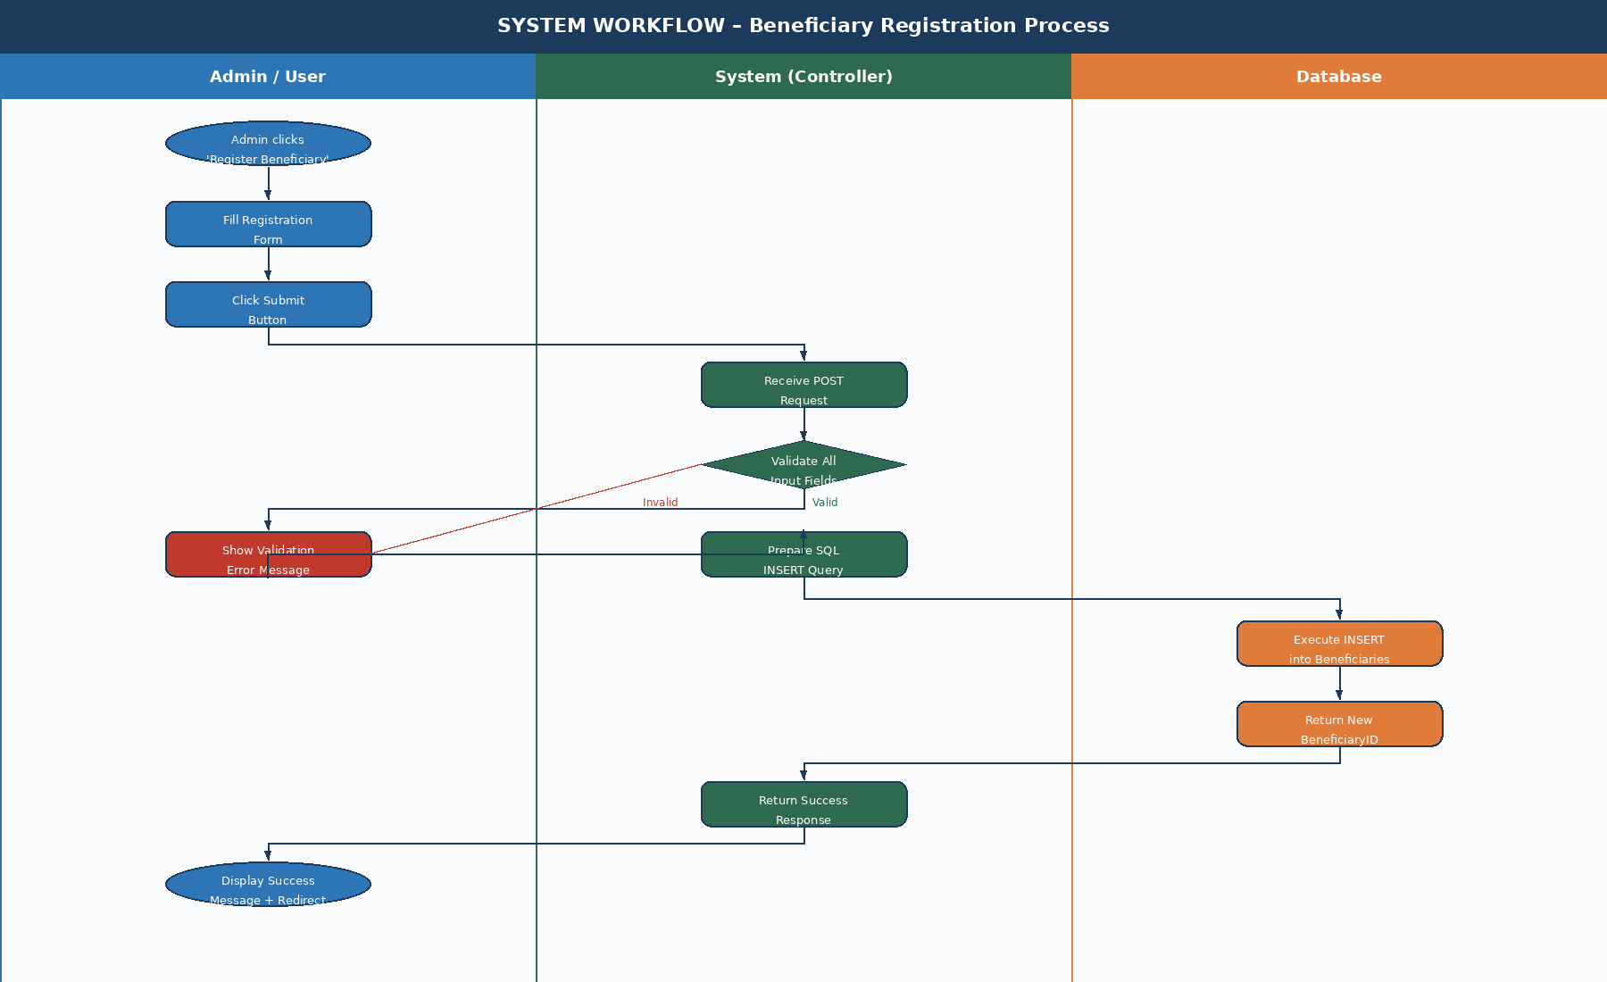
Figure 3: Beneficiary Registration Workflow (Swimlane Diagram)
3.3.2 Daily Attendance Recording Workflow
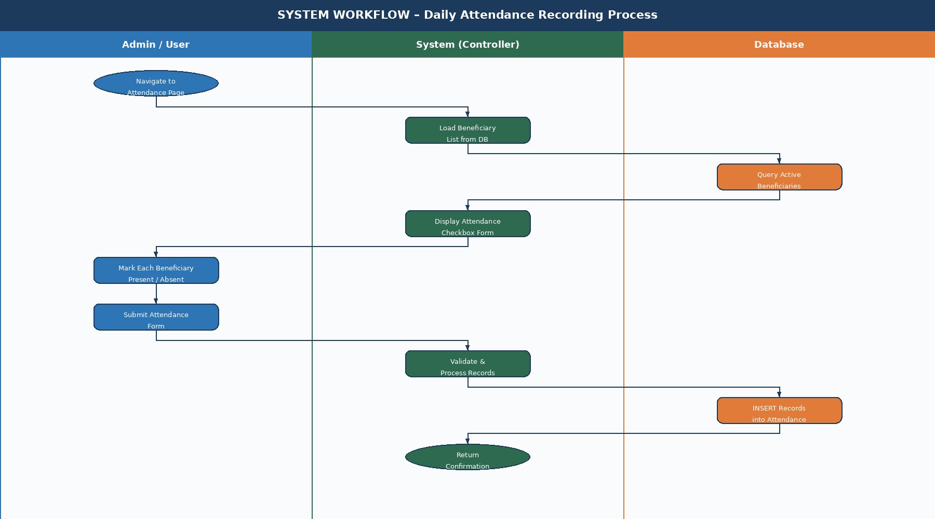
Figure 4: Daily Attendance Recording Workflow (Swimlane Diagram)

4. Database Design

The database is a relational MySQL 8.0 database consisting of seven tables. All tables use InnoDB engine with utf8mb4 character set.

4.1 ERD Design
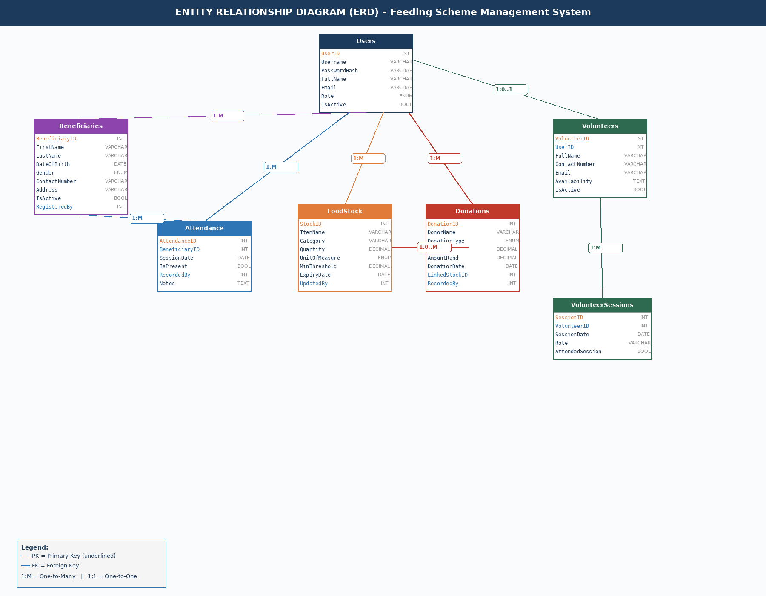
Figure 5: Entity Relationship Diagram (ERD) – MySQL Database Schema

4.2 Database Tables (SQL)

4.2.1 Users
CREATE TABLE Users (
UserID INT AUTO_INCREMENT PRIMARY KEY,
Username VARCHAR(50) NOT NULL UNIQUE,
PasswordHash VARCHAR(255) NOT NULL,
FullName VARCHAR(100) NOT NULL,
Email VARCHAR(100) NOT NULL UNIQUE,
Role ENUM('Admin','Volunteer') NOT NULL DEFAULT 'Volunteer',
IsActive BOOLEAN NOT NULL DEFAULT TRUE,
CreatedAt DATETIME NOT NULL DEFAULT NOW()
) ENGINE=InnoDB DEFAULT CHARSET=utf8mb4;

4.2.2 Beneficiaries
CREATE TABLE Beneficiaries (
BeneficiaryID INT AUTO_INCREMENT PRIMARY KEY,
FirstName VARCHAR(50) NOT NULL,
LastName VARCHAR(50) NOT NULL,
DateOfBirth DATE NOT NULL,
Gender ENUM('Male','Female','Other') NOT NULL,
GuardianName VARCHAR(100) NULL,
ContactNumber VARCHAR(15) NOT NULL,
Address VARCHAR(200) NOT NULL,
RegistrationDate DATE NOT NULL DEFAULT (CURDATE()),
IsActive BOOLEAN NOT NULL DEFAULT TRUE,
RegisteredBy INT NOT NULL,
FOREIGN KEY (RegisteredBy) REFERENCES Users(UserID)
) ENGINE=InnoDB DEFAULT CHARSET=utf8mb4;

4.2.3 Attendance
CREATE TABLE Attendance (
AttendanceID INT AUTO_INCREMENT PRIMARY KEY,
BeneficiaryID INT NOT NULL,
SessionDate DATE NOT NULL,
IsPresent BOOLEAN NOT NULL,
RecordedBy INT NOT NULL,
Notes TEXT NULL,
FOREIGN KEY (BeneficiaryID) REFERENCES Beneficiaries(BeneficiaryID),
FOREIGN KEY (RecordedBy) REFERENCES Users(UserID),
UNIQUE KEY unique_att (BeneficiaryID, SessionDate)
) ENGINE=InnoDB DEFAULT CHARSET=utf8mb4;

4.2.4 FoodStock
CREATE TABLE FoodStock (
StockID INT AUTO_INCREMENT PRIMARY KEY,
ItemName VARCHAR(100) NOT NULL,
Category VARCHAR(50) NOT NULL,
Quantity DECIMAL(10,2) NOT NULL DEFAULT 0,
UnitOfMeasure ENUM('kg','litres','units') NOT NULL,
MinimumThreshold DECIMAL(10,2) NOT NULL DEFAULT 5,
ExpiryDate DATE NULL,
LastUpdated DATETIME NOT NULL DEFAULT NOW(),
UpdatedBy INT NOT NULL,
FOREIGN KEY (UpdatedBy) REFERENCES Users(UserID)
) ENGINE=InnoDB DEFAULT CHARSET=utf8mb4;

4.2.5 Donations + Volunteers + VolunteerSessions
CREATE TABLE Donations (
DonationID INT AUTO_INCREMENT PRIMARY KEY,
DonorName VARCHAR(100) NOT NULL,
DonationType ENUM('Food','Cash','Other') NOT NULL,
Description VARCHAR(200) NULL,
Quantity DECIMAL(10,2) NULL,
AmountRand DECIMAL(10,2) NULL,
DonationDate DATE NOT NULL DEFAULT (CURDATE()),
LinkedStockID INT NULL,
RecordedBy INT NOT NULL,
FOREIGN KEY (LinkedStockID) REFERENCES FoodStock(StockID),
FOREIGN KEY (RecordedBy) REFERENCES Users(UserID)
) ENGINE=InnoDB DEFAULT CHARSET=utf8mb4;

CREATE TABLE Volunteers (
VolunteerID INT AUTO_INCREMENT PRIMARY KEY,
UserID INT NULL,
FullName VARCHAR(100) NOT NULL,
ContactNumber VARCHAR(15) NOT NULL,
Email VARCHAR(100) NULL,
Availability TEXT NULL,
IsActive BOOLEAN NOT NULL DEFAULT TRUE,
RegisteredDate DATE NOT NULL DEFAULT (CURDATE()),
FOREIGN KEY (UserID) REFERENCES Users(UserID)
) ENGINE=InnoDB DEFAULT CHARSET=utf8mb4;

CREATE TABLE VolunteerSessions (
SessionID INT AUTO_INCREMENT PRIMARY KEY,
VolunteerID INT NOT NULL,
SessionDate DATE NOT NULL,
Role VARCHAR(100) NULL,
AttendedSession BOOLEAN NULL DEFAULT NULL,
FOREIGN KEY (VolunteerID) REFERENCES Volunteers(VolunteerID)
) ENGINE=InnoDB DEFAULT CHARSET=utf8mb4;

5. User Interface Mockups (Wireframes)

The following high-fidelity wireframes illustrate the complete visual design and layout of all key screens in the Feeding Scheme Management System. Each mockup reflects the Bootstrap 5 responsive design, consistent navigation sidebar, role-based access, and the colour scheme aligned with Tharimpepe Feeding Scheme branding.
All screens share a consistent layout: a dark sidebar navigation (left), a topbar with breadcrumbs (top), and a main content area (right). The colour scheme uses deep navy (#1B3A5C) for branding elements, with green/red status indicators following standard UX conventions.

5.1 Login Page
The login page is the entry point for all users. It features a split-screen layout with branding on the left and a clean authentication form on the right. Access is restricted to registered system users only.

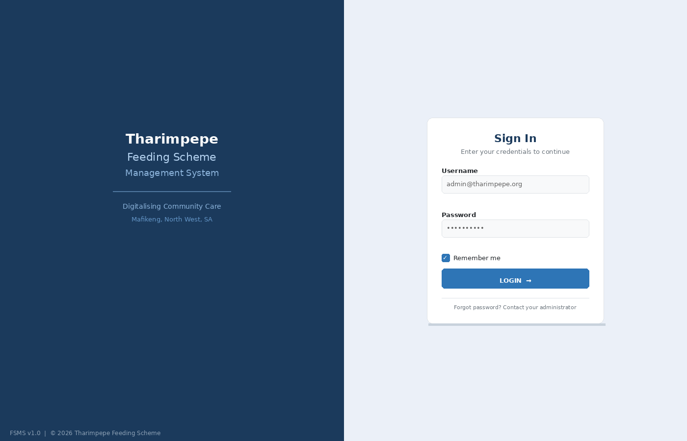
Figure 6: Login Page Mockup

5.2 Admin Dashboard
The dashboard provides an at-a-glance summary of key system metrics: total beneficiaries, meals served today, active volunteers, and stock alerts. It includes a weekly attendance bar chart, food stock progress bars, and a recent activity feed.

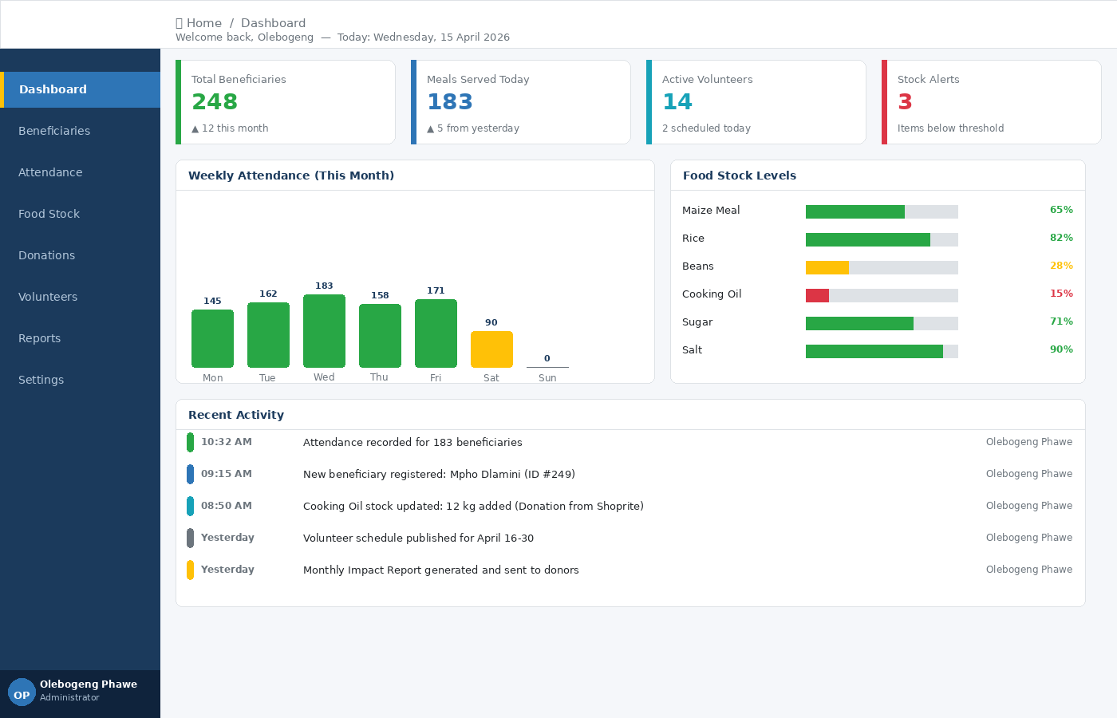
Figure 7: Admin Dashboard Mockup

5.3 Beneficiary List
The beneficiary list displays all registered beneficiaries in a paginated table with search and filter functionality. Each row shows the beneficiary ID, name, date of birth, gender, contact number, registration date, and active status badge. Edit and delete action buttons appear per row.

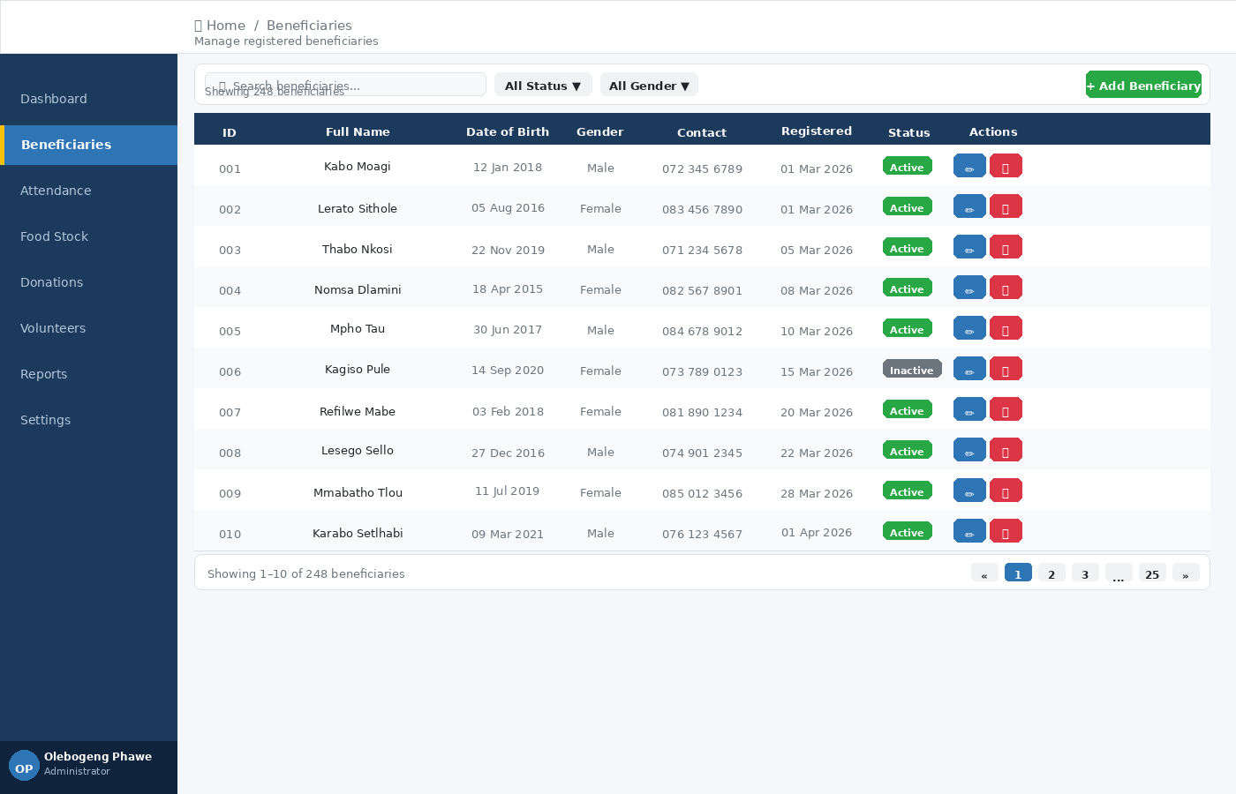
Figure 8: Beneficiary List Mockup

5.4 Register New Beneficiary Form
The registration form collects all required personal details for a new beneficiary: name, date of birth, gender, guardian (optional), contact number, address, medical conditions, and dietary needs. Required fields are marked with an asterisk (*). The form validates all inputs before submission.

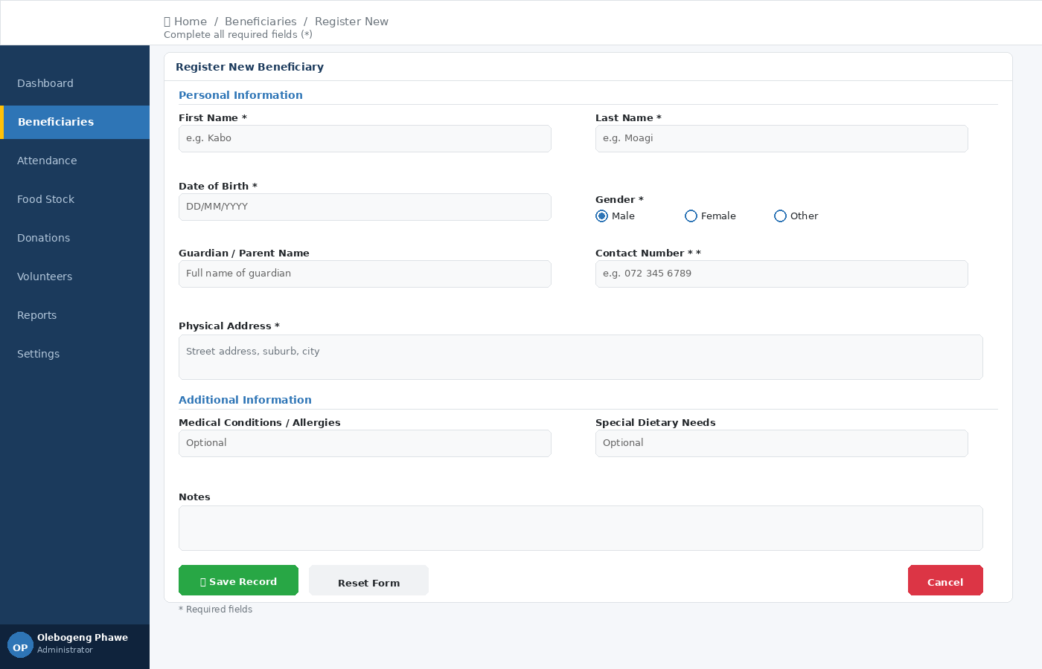
Figure 9: Register Beneficiary Form Mockup

5.5 Record Daily Attendance
The attendance screen loads the full beneficiary list for a selected session date. Each beneficiary has toggle buttons for Present/Absent. The screen shows a live count of present, absent, and total beneficiaries. Quick-action buttons allow marking all present or all absent at once. Notes can be added per beneficiary.

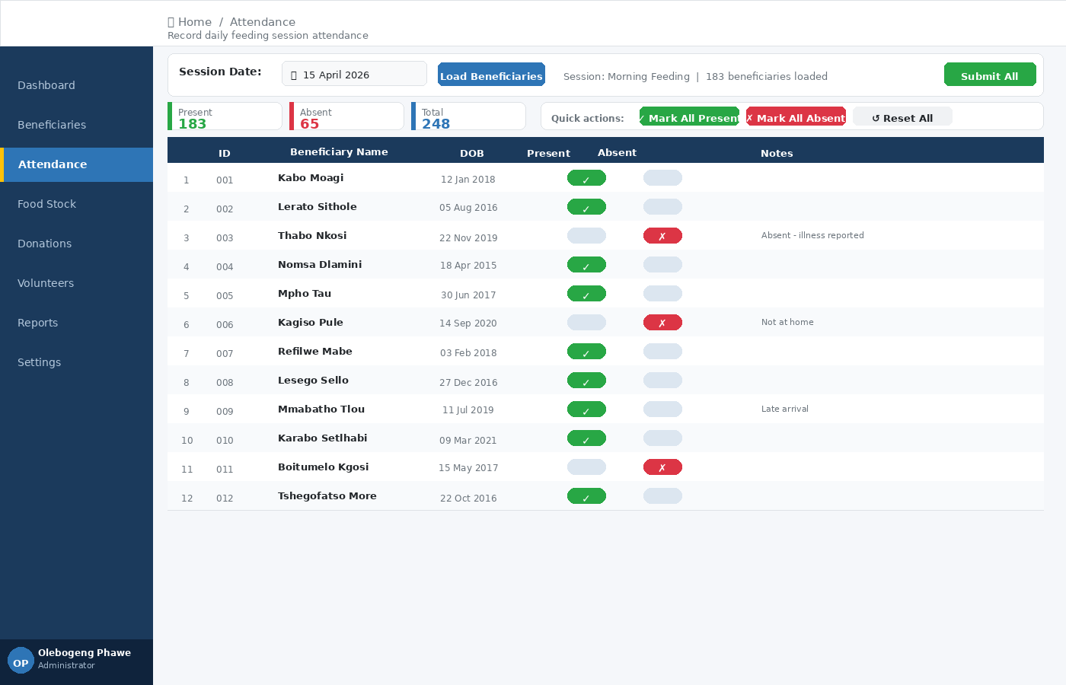
Figure 10: Record Daily Attendance Mockup

5.6 Food Stock Management
The food stock screen shows current inventory levels in a table with colour-coded status indicators. Items below minimum threshold are highlighted in red with a LOW STOCK badge and a warning banner at the top. Each row includes edit and update-quantity action buttons.

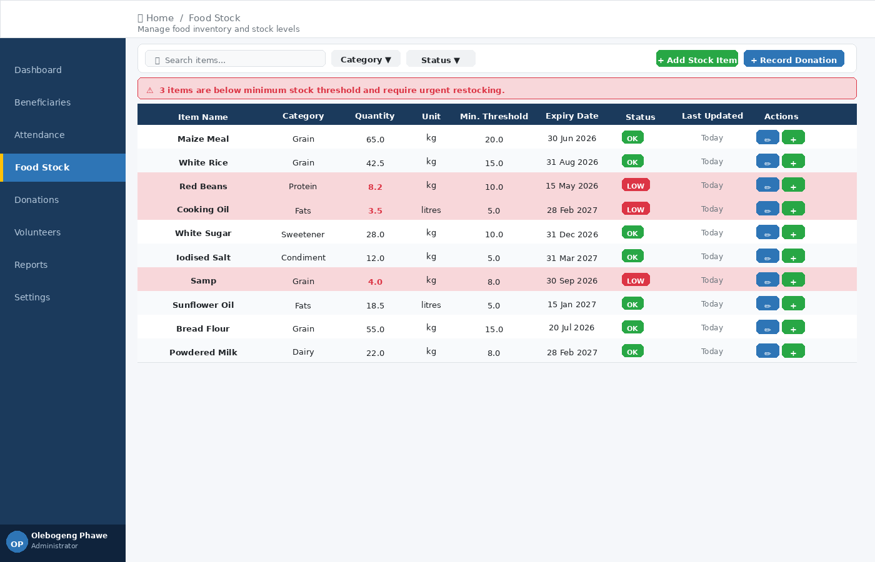
Figure 11: Food Stock Management Mockup

5.7 Volunteer Schedule
The volunteer schedule is presented as a weekly calendar view showing which volunteers are assigned to each day's feeding session. Each assigned slot displays the time and role. Tabs allow switching between the volunteer list, schedule, assignment form, and registration form.

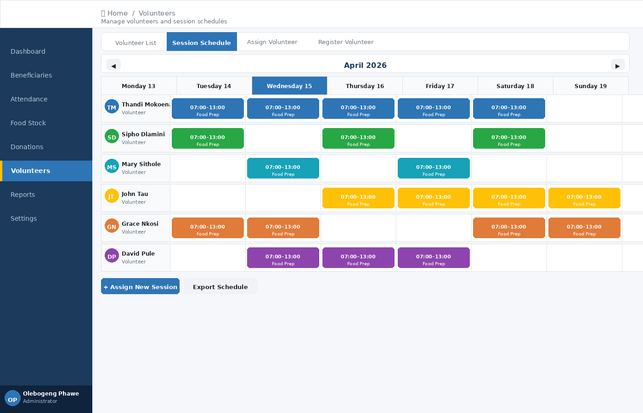
Figure 12: Volunteer Schedule Mockup

5.8 Reports Page
The reports page allows the admin to select a report type, specify a date range and output format (PDF, Excel, or on-screen), and generate the report. A live preview panel shows a formatted summary on the right. Export buttons allow downloading as PDF, Excel, or printing.

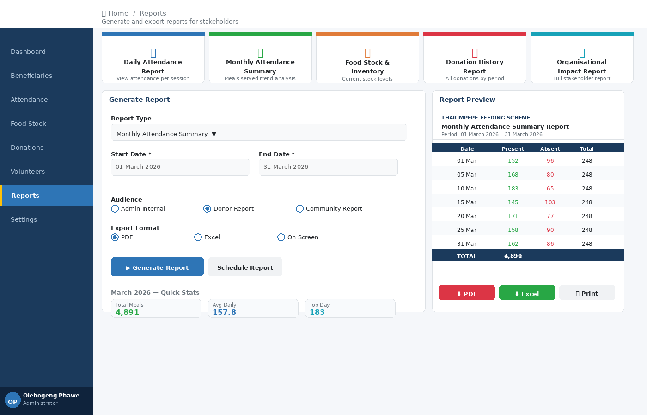
Figure 13: Reports Generation Mockup

6. Report Design

The FSMS generates five reports. All display on-screen and are available for PDF/Excel export.

6.1 Daily Attendance Report
Field | Details
Purpose | Shows beneficiary attendance/absence for a specific feeding session date
Parameters | Session Date (required)
Data Source | Attendance JOIN Beneficiaries WHERE SessionDate = [date]
Output Fields | Beneficiary ID, Full Name, DOB, Gender, Present (Yes/No), Notes
Summary | Total Present: [n] | Total Absent: [n] | Total: [n]
Format | Table on screen; PDF export
Access | Admin, Volunteer

6.2 Monthly Attendance Summary
Field | Details
Purpose | Summarises meals served and attendance rates per month for donor reporting
Parameters | Start Date, End Date
Data Source | Attendance GROUP BY SessionDate, COUNT(IsPresent = TRUE)
Output Fields | Date, Total Present, Sessions, Average Attendance (%)
Summary | Total Meals: [n] | Avg Daily Attendance: [n]
Format | Table + bar chart; PDF export
Access | Admin only

6.3 Food Stock & Inventory Report
Field | Details
Purpose | Shows current stock levels, highlighting items below minimum threshold
Parameters | None; optional Category filter
Output Fields | Item, Category, Quantity, Unit, Min Threshold, Expiry, Status (OK/LOW)
Highlight | LOW STOCK rows shown in red
Format | Table; PDF export
Access | Admin, Volunteer (view)

6.4 Donation History Report
Field | Details
Purpose | Lists all donations received within a date range
Parameters | Start Date, End Date; optional Type filter
Output Fields | Donation ID, Donor, Type, Description, Qty/Amount, Date, Recorded By
Summary | Total Food: [n] | Total Cash: R[amount]
Format | Table; PDF export
Access | Admin only

6.5 Organisational Impact Report
Field | Details
Purpose | High-level summary report for donors and stakeholders
Parameters | Period (Month / Quarter / Custom range)
Output Fields | Total Beneficiaries, Meals Served, Volunteers, Donations Received, Stock Status
Format | Summary dashboard + PDF for sharing with donors
Access | Admin only

7. Appendix

7.1 UML Class Diagram
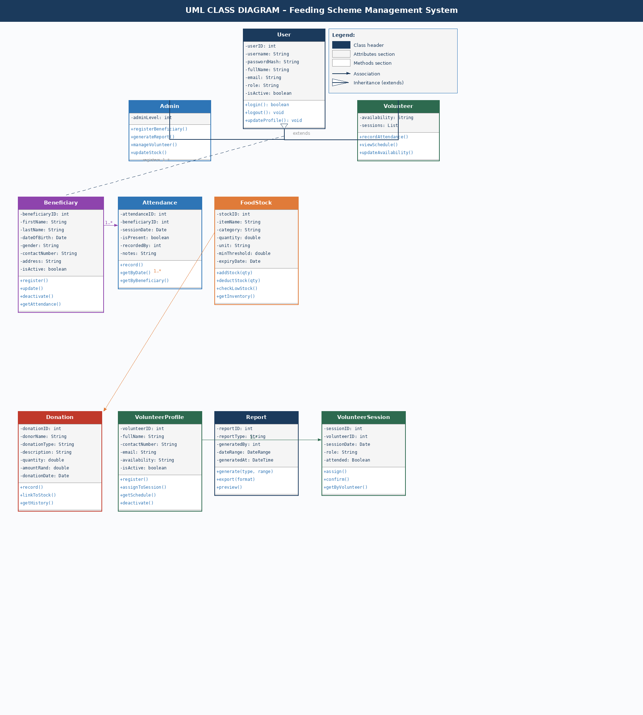
Figure 14: UML Class Diagram – Feeding Scheme Management System

7.2 Use Case Diagram
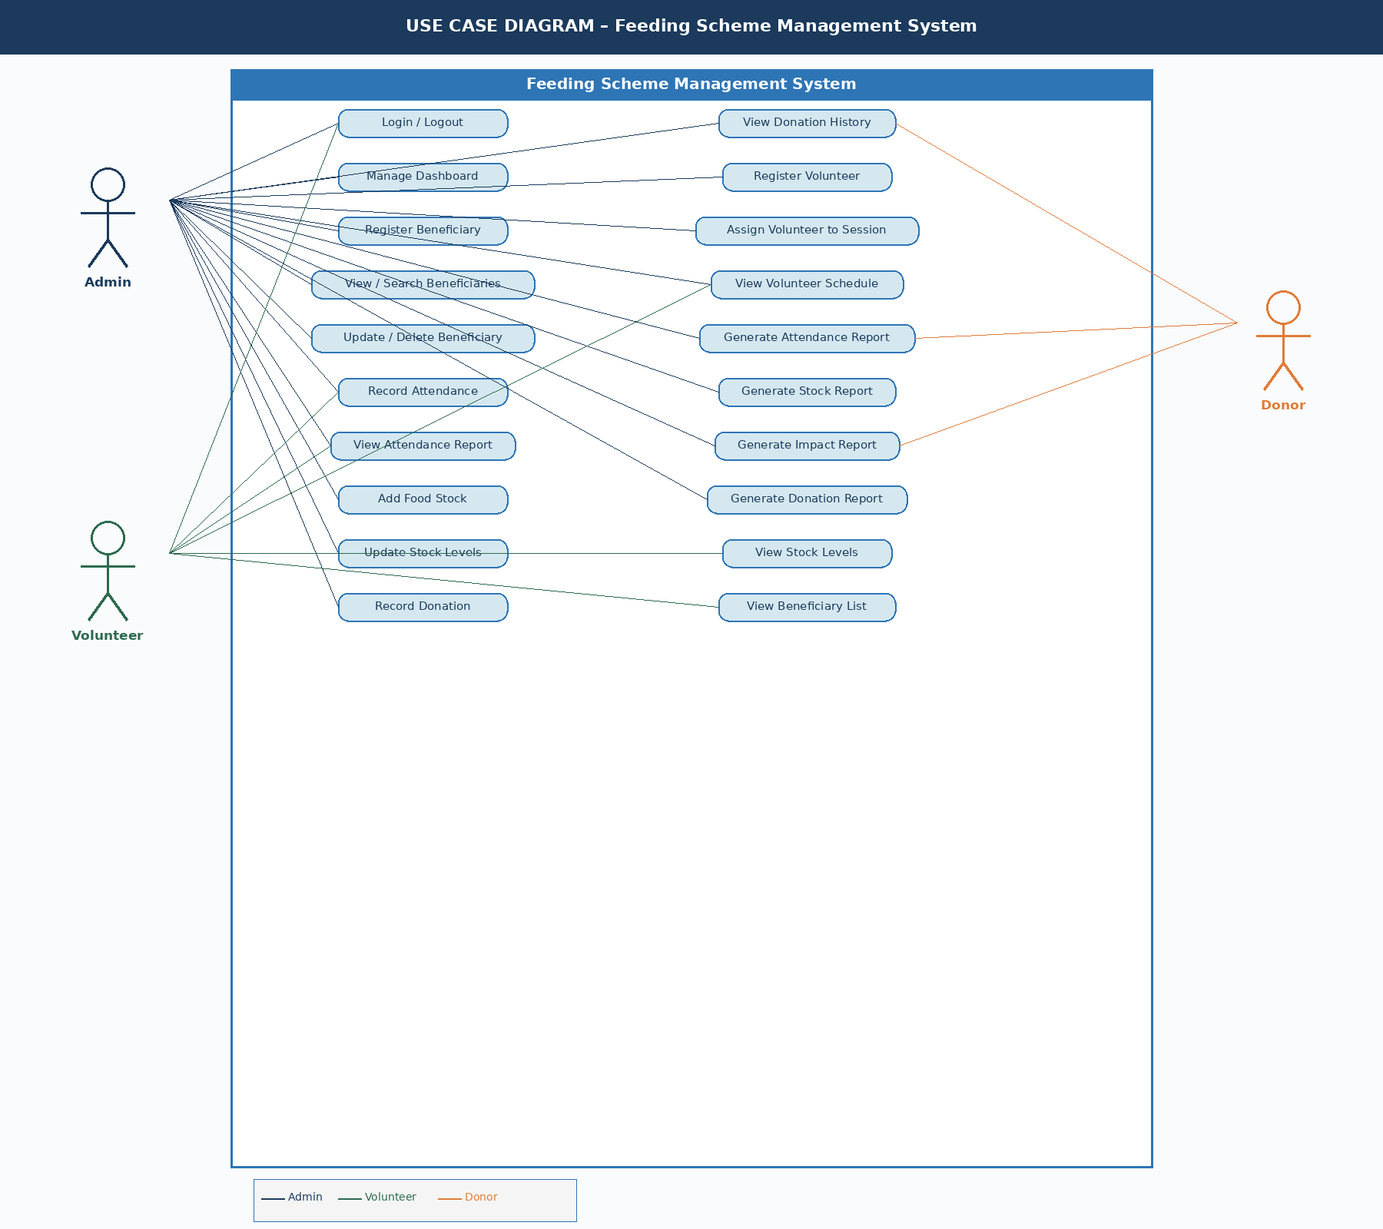
Figure 15: Use Case Diagram – Feeding Scheme Management System

8. References

- Dennis, A., Wixom, B.H. and Roth, R.M. (2015) Systems Analysis and Design. 6th edn. Wiley.
- Weierick, S. (2013) Three-Layer Architecture for Web Applications. IEEE Software Engineering.
- Oracle (2025) MySQL 8.0 Reference Manual. Available at: https://dev.mysql.com/doc (Accessed: April 2026).
- PHP Group (2025) PHP PDO Documentation. Available at: https://php.net/manual/en/pdo.prepared-statements.php (Accessed: April 2026).
- Bootstrap (2024) Bootstrap 5 Documentation. Available at: https://getbootstrap.com/docs/5.0 (Accessed: April 2026).
- Satzinger, J.W., Jackson, R.B. and Burd, S.D. (2014) Systems Analysis and Design in a Changing World. 7th edn. Cengage Learning.
- Daly, R. (2019) The Pros and Cons of Switching to Free and Open-Source Tools. CultureHive.
- Nielsen, J. (1994) Usability Engineering. Morgan Kaufmann Publishers Inc.

