**OPEN SOURCE CODING PART 1**

BAREFILE LEPHONDO ST10311574

NKOSINATHI MABENA ST10344257

LESEGO LETSAPA ST10351970

OPSC6311

Introduction

Many individuals face quite a lot of struggles when it comes to managing their own finances and most of them are exposed to overspending, they also face challenges with tracking their own expenses and setting budget goals.

The purpose of this research is to analyze three existing personal budgeting apps we went with Wallet (by budgetbakers), Goodbudget and YNAB (You need a budget). This is done to understand the strengths, weaknesses and innovative features that the apps may carry. This will assist in identifying features that will be used into our own budgeting app.

A. GOODBUDGET

Overview of the app

It focuses more on planning for finances than tracking past transactions. The app uses an envelope budgeting system in which users can allocate their monthly income into different spending categories (envelopes). This helps users plan their spending in advance.

Home Screen

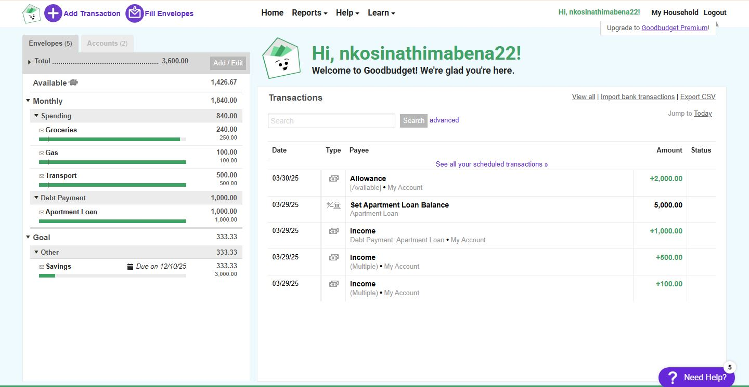

The home screen shows the different budget categories (envelopes) as well as the remaining balances. Users can quickly see where their money is allocated.

Reports and Insights

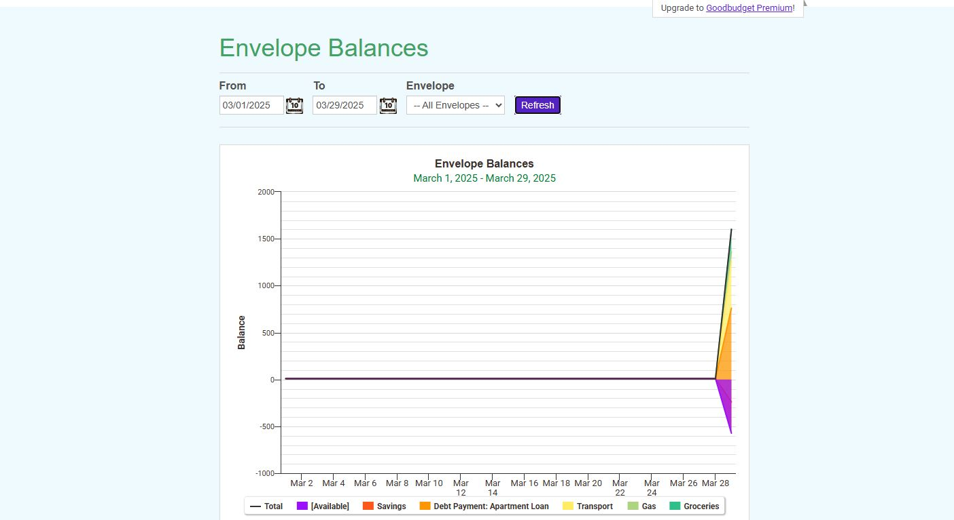

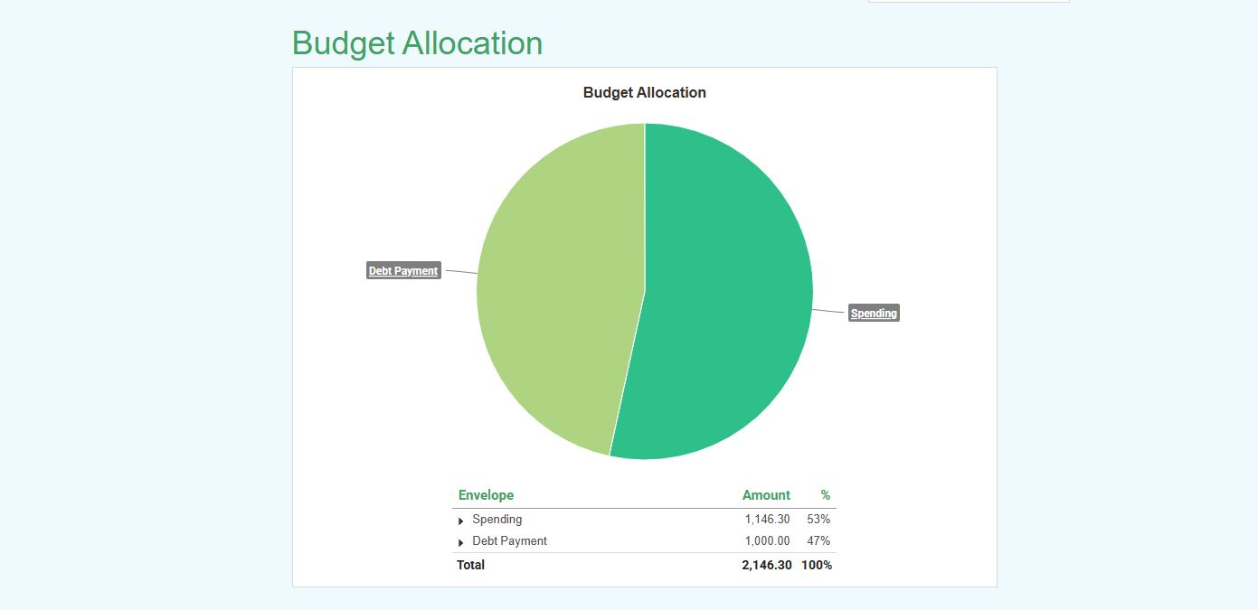

Pie charts show the budget allocation, it shows both amounts of debt payments and spending. This helps users with analyzing their expenses and they keep track on the percentage increase of both.

Budget Setup Screen

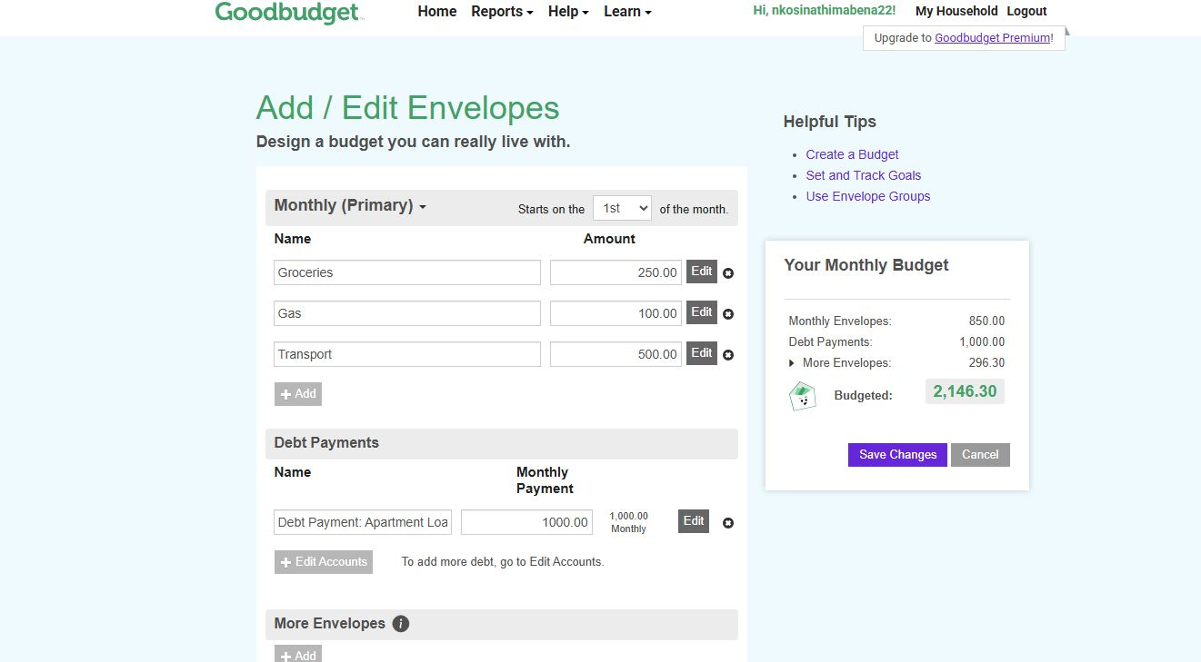

This is where users can modify their current envelopes or add a new one. By categorizing expenses this helps users plan better for their spending in the month.

Strengths

Goodbudget is great for families as it can be shared among multiple users.

It can be accessed from anywhere (it is available online, and as a mobile app) so it is better convenience for users and budget data is updated in real-time on all platforms.

The envelope system makes it easy to use and it is also an effective way to manage finances.

Weaknesses

The free version of Goodbudget has limited features so users might be forced to upgrade to the premium version, this will be costly.

Goodbudget does not offer investment tracking

Innovative features

* Digital Envelope Budgeting (This feature helps users plan their spending by allocating money to different envelopes before they can even spend it)
* Multi-Device Access (This feature helps users sync their budget data across all devices, real-time updates take place)
* Customizable Envelopes (Users are able to edit their categories)
* Reports and Forums
* Debt Payoff Tracking (This feature helps with allocating money to allow debts to be paid)

1. WALLET (budgetbakers)

Overview of the app

Designed to help users take control of their finances. Wallet helps keep track of expenses and manage their budgets while planning for the future, this happenings by connecting to their financial accounts then Wallet goes ahead and provides insights on how the users are spending their money.

Dashboard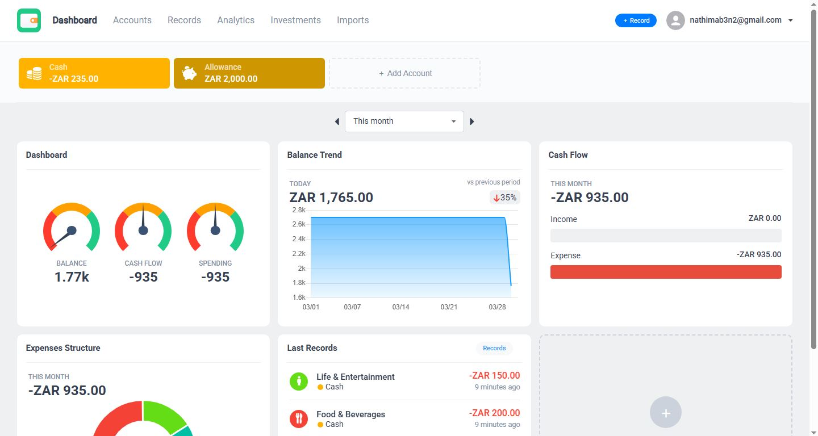

The Dashboard shows the current balance in the users account, cash flow, the spending and a graph that represents the balance trend.

Reports and Graphs

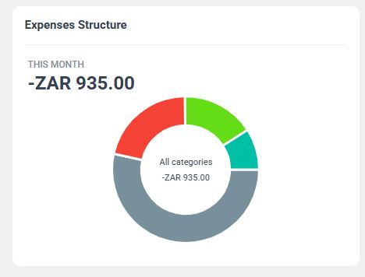

The expense structure is a screen that helps users keep track of their spending patterns. Users are able to see a clear view of their expenses across all categories which is about R935. This helps users with staying in their budget.

Income and Expense Report

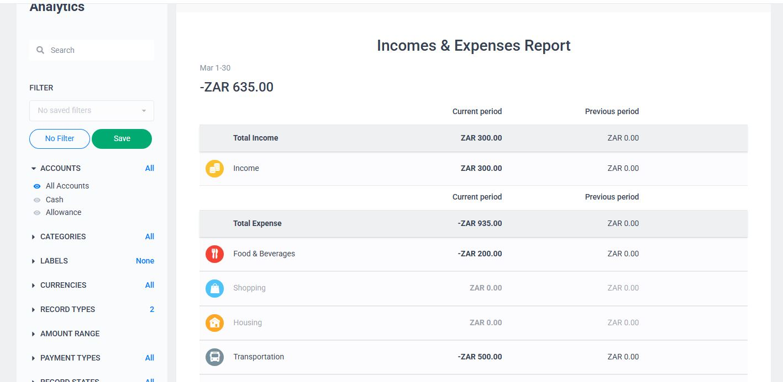

This shows users if they are staying within their budget or over spending. That allows users to look at past and present spending habits and with that they can make better budgeting decisions.

Strengths

There is no need for users are to enter their transactions manually, Wallet allows bank syncing which automatically enters the users’ transactions.

Weaknesses

Wallet contains a lot of advanced features but some of them require a paid subscription to gain access.

Bank syncing depends on the banks in certain regions so not all banks may be included.

Innovative features

* Automatic Bank Syncing (connects with bank accounts to allow transaction to be automatically tracked)
* Multi-Currency Support (multiple currencies are available)
* Shared Wallets (joint accounts)

1. YNAB (You need a budget)

Overview of the app

Is a zero-based budgeting app. The YNAB method gives every dollar a job. YNAB allocates income into specific categories (envelopes) and this happens before users can spend their income. All this helps users to break the paycheck cycle.

Dashboard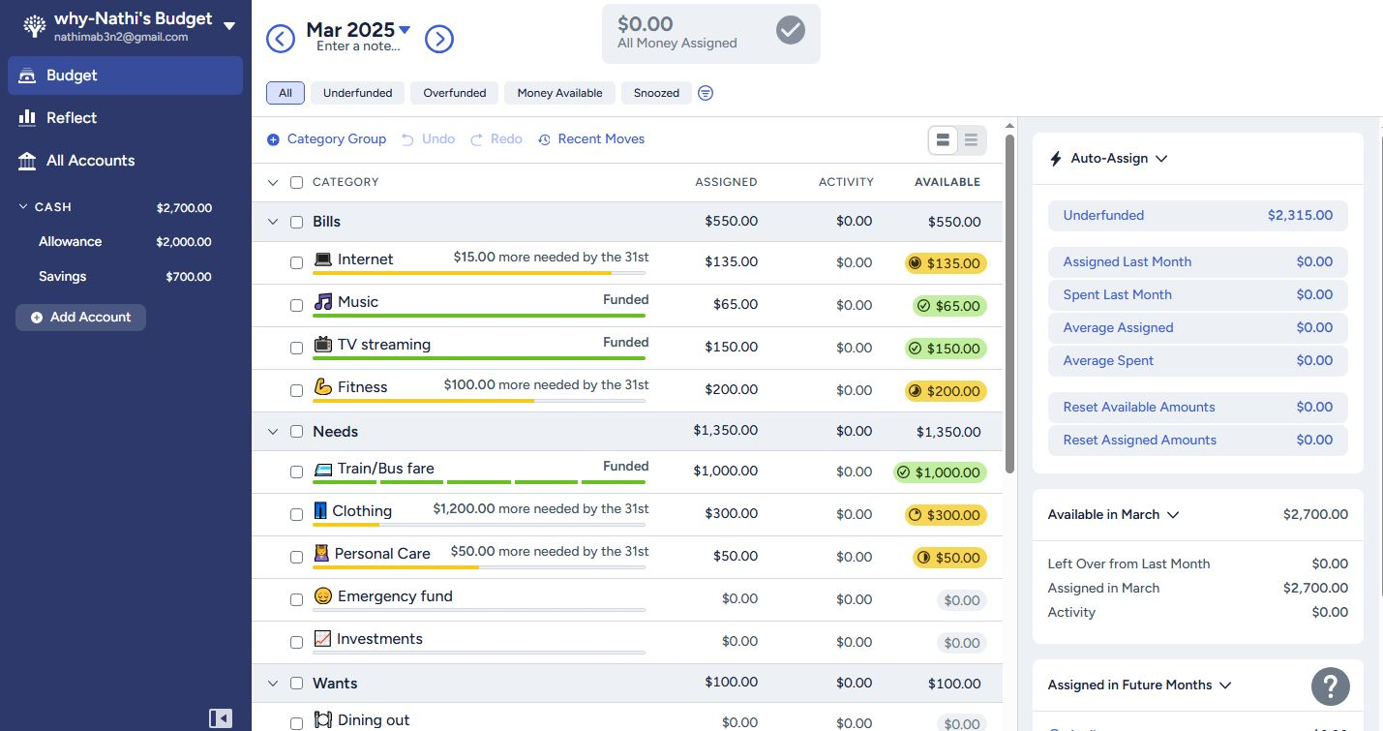

These are the assigned budgets for the different categories (Bills, Needs, Wants). On the Dashboard YNAB highlights remaining balances, money that’s needed to reach a goal and gives warnings if users overspend in the categories.

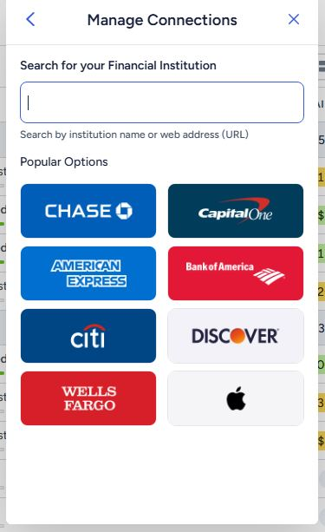

Bank Syncing

Users can sync with their bank accounts for transactions to be automatically entered or they can enter those details manually.

Spending Reports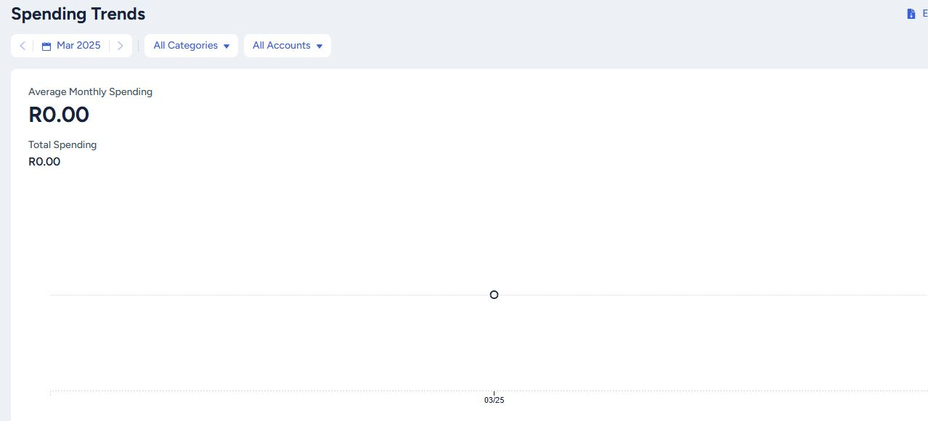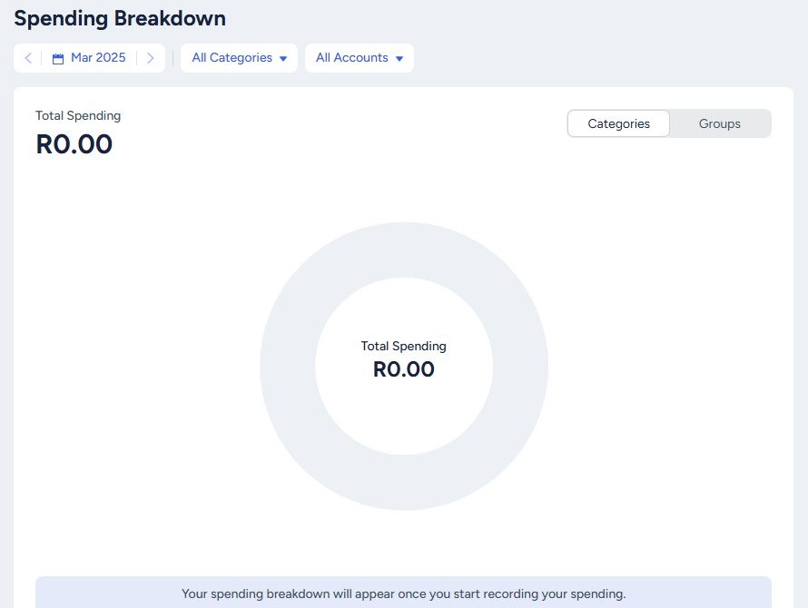

The spending trends report will be generated once the users spend their income, this happens automatically. Users will learn on planning ahead based on past expenses.

Strengths

YNAB is able to sync your Bank and that automates transaction tracking

YNAB encourages all their users to save and plan for future expenses

Weaknesses

New users will need to take time to learn how to use YNAB

It is subscription-based offers a free trail that runs for 34 days before YNAB forces you to upgrade

Innovative features

* Age Of Money Tracker (This feature shows how long money stays in the account this happens before even spending the money)
* Zero-Based Budgeting (all money needs to be allocated first into categories before spending)
* Goal-Based Budgeting (saving goals)

4.

Envelope Budgeting (Goodbudget)

Zero-Based Budgeting (YNAB)

Goal-Based Budgeting (YNAB)

Shared Budget (Goodbudget and Wallet)

Visual Infographic

|  |  |  |  |
| --- | --- | --- | --- |
| Feature | Goodbudget | Wallet | YNAB |
| Budgeting Method | Envelope-based | Expense tracking | Zero-based budgeting |
| User Authentication | Yes | Yes | Yes |
| Goal Setting | No dedicated goals | Yes | Yes (strong goals) |
| Data Storage | Cloud-based | Cloud or Local | Cloud-based |
| Paid Subscription | Free and it has paid plans | Free and it has paid plans | Free-trial but it lasts for 34 days so it is subscription-based |
| Custom Categories (Envelopes) | Yes | Yes | Yes |
| Graphs and Insights | Limited | The visual reports are advanced | The financial reports are detailed |

In conclusion after analyzing the three personal budgeting apps, we saw strengths and innovative features, the stand feature was the YNAB’s zero-based budgeting and also, it’s goal tracking, we believe that will enhance and create a user-friendly personal budgeting app but also teach users to be discipline when it comes to money management.

REFERENCING LIST

<https://www.nerdwallet.com/article/finance/best-budget-apps>

<https://morganfranklinfoundation.org/financial-tools-the-pros-cons-of-goodbudget/>

<https://www.usertesting.com/blog/innovative-features-for-product-pages>