

# PROG7313 POE: Planning and Design Document

**Compiled by:**

Ethan Moodley (ST10351721),

Nikhil Ratanjee (ST10357451),

Tariq Sallie (ST10248762)

# Table of Contents

Contents

PROG7313 POE: Planning and Design Document 1

Table of Contents 2

(1) Introduction 3

(2) Overview 3

(3) App Requirements 5

(4) UI design 7

(5) Project Plan (Gantt Chart) 11

(6) Conclusion 12

(7) Reference list 13

# (1) Introduction

Managing personal finances can be overwhelming, especially when trying to track expenses, set budgets, and save for future goals.

Our innovative budgeting app aims to simplify this process by offering a simple and understandable financial management solution that not only helps users track their spending but also makes budgeting engaging through gamification features. By integrating expense tracking, collaborative budgeting, and financial insights, our app allows users to make smarter financial decisions while staying motivated through rewards and challenges.

# (2) Overview

**Name:** Pocket Paladin

**Icon Design:**

**Description of our Budget App:**

Pocket Paladin is a personal budgeting app designed to help individuals and families take control of their finances.

What sets this application apart from others is its combination of unique features from multiple personal budgeting apps, offering a comprehensive and engaging approach to money management. Our target audience consists of middle to low-income users who are looking for effective ways to save money while maintaining control over their expenses.

With features such as goal tracking, budget alerts, data visualization, and gamification elements like ranking systems, rewards, and challenges, Pocket Paladin transforms budgeting into an interactive and motivating experience.

**Innovative Features, that we have added to our app:**

1. **Collaboration system** – Our app should allow for multiply users to merge their budgets. So that a husband and wife can share a budget, and access it from each of their apps.
2. **Goal Tracking** – The user should be able to set goals (goal to save R10 000 by September), and the app must track their goals and reward them on good progress.
3. **Budget Alerts** – The app must send notifications, to alert the user on various budget updates, good and bad.
4. **Data Visualization** – The app must be able to convert budget stats into graphs and diagrams.
5. **Identifies unnecessary expenses** – Our budget app must outline the user’s unnecessary expenses, from month to month, and suggest changes on how they spend their money.

# (3) App Requirements

**Functional Requirements:**

1. The system shall allow the users to register, log in, and manage accounts securely and easily.
2. The system shall allow users to create, edit, and delete categories for their expenses. For example, the user can create a category for their take-out food and monitor how much they spend.
3. The system shall allow users to add, edit, and delete expense entries, including amount, date, description, and category. The entered expense will be used to perform budget calculations.
4. The system shall allow users to attach receipt photos to expense entries. These photos need to be accessible to the user even after a couple months.
5. The system shall allow users to set a monthly budget and category-specific spending limits. This is to help the user easily monitor their expenses
6. The system shall allow users to view and filter expense history by date range, additionally if a receipt was uploaded, it needs to be accessible.
7. The system shall allow users to track the total amount spent for each category, this must also be able to filter by date. This will let the users know which is their most and least expensive ‘expense category’.
8. The system shall provide graphs to visualize spending trends, this must be done daily and should also be able to be filtered by date. The user can use these graphs to easily understand their budget and how it works.
9. The system shall store data locally and to an online Database for multi-device access. This will make sure out user data is safely stored.
10. The system shall identify unnecessary expenses and suggest strategies to avoid them.
11. The system shall allow users to share budgets with others for example, spouses, family members, colleagues or friends.
12. The system shall send budget alerts for spending updates and warnings. These alerts can warn or congratulate the user on their spending.
13. The system shall implement a ranking system to score users based on budgeting performance. Having a competitive feature in our app could motivate users to improve their budget scores.
14. The system shall reward users with trophies and achievements for milestones and challenges. Gaining rewards will make the user feel accomplished and motivate them to gain more rewards.
15. The system shall include sound effects, tips, and challenges to enhance engagement. We could possibly train the user on budgeting strategies, with the use of well-placed sound ques.
16. The system shall track streaks to encourage daily app usage.
17. The system shall allow users to earn coins for budgeting actions, redeemable for in-app benefits, like extra app backgrounds and colours.
18. The system shall allow users to set financial goals. For example, they could set a goal to Save R10,000 by September, and track the goals progress.
19. The system shall provide visual insights and data visualization for better budgeting. Having good visual effects could enhance the user’s engagement with our app.

**Gamification features that we will be using:**

1. **Ranking System** - Rank the users on the app by the budget score (will have to calculate)
2. **Sound effects** - have sound effects for when the user completes tasks or earns a reward/trophies
3. **Trophies** - reward trophies for reaching milestones and completing Challenges
4. **Tips/Hints** - the app can give the user hints on how to use the app and better ways to budget.
5. **Challenges** - have the app set challenges for the user to complete; these challenges can help train good budgeting tactics
6. **Streaks** – the app could have streaks that incentivize the user to use the application every day.
7. **Unlockable features** – The app could reward the user points for doing certain tasks, these points can be used to unlock customizable options for the app or more.

**Non-functional Requirements**

1. The system shall provide security features, including two-factor authentication for user protection. (Functionality)
2. The system shall have a user-friendly UI, making navigation and interaction easy. (Usability)
3. The system shall handle high user traffic efficiently, ensuring smooth performance. (Reliability)
4. The system shall be scalable, allowing users to manage multiple bank accounts without performance issues. (Performance)
5. The system shall support multiple platforms (e.g., mobile, tablet, and web) to ensure accessibility across different devices. (Supportability)

# (4) UI design

**Login & Register:**

Above is the login and Register Screens:

* The login screen allows for the user to login to the Pocket Paladin application.
* The Register screen allows for the user to Register using email and Password, with the password needing to be confirmed.

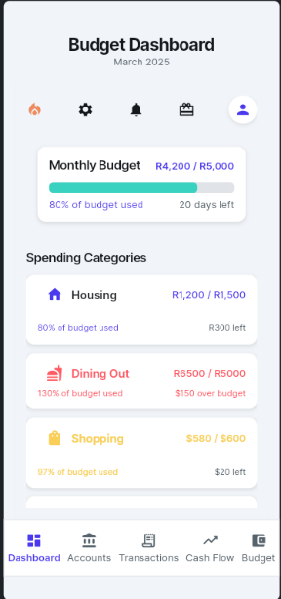**Dashboard:**

The purpose of this screen is to act as the main hub for the user. It allows them to access multiple different screens and quick access certain features through it. Additionally, it shows important stats related to the budget, with the use of graphs.

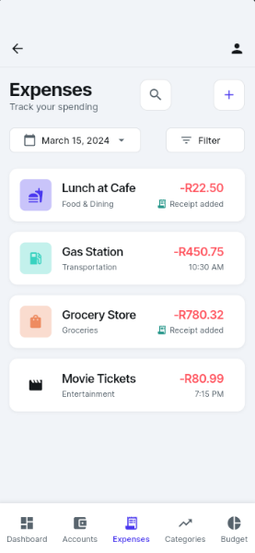**Expense Management:**

The expense management screens allow the user to:

* Add their expenses to the application which will aid them in tracking their monthly expenditure.
* View their expense for each category
* Track the expenses filtering by date and category

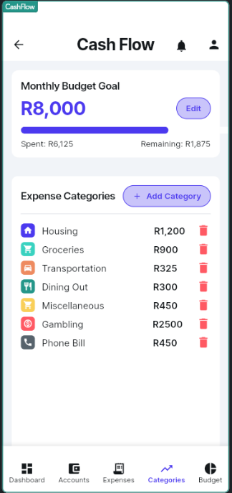**Category Management:**

This screen helps users manage their income and expenses by allowing them to make specific categories for their expenses. The screen clearly indicates the different categories that are present as well as allowing the user to add more categories through the indicated Add Category button. Above these categories is the monthly budget goal that indicates the current budget set by the user, the display also shows how much was spent in the category.

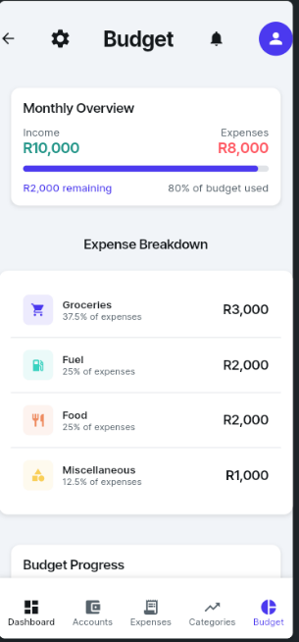**Budget Management:**

This screen allows the user to generate a budget, the app will use the user’s income and expenses for calculating the budget. The app will also teach the user on budgeting strategies.

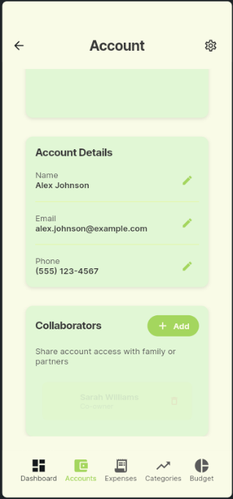**Settings:**

The Settings screens do the following:

* Allows the user to select what notifications they would like to receive as well as what they are willing to let the application have access to.
* Edit their personal information. Such as payment options, editing their profile picture and details, select country.
* Add members to collaborate in a budgeting group

**Navigation Diagram:**

Login/Register

Dashboard

Expense Management

Category management

Budget Management

Settings

**Below are brief descriptions detailing what is on the various UI screens, for the navigation diagram:**

1. **Login & Registration:** Users sign in or create an account.
2. **Dashboard:**
   1. Displays an overview of spending, budget, and alerts.
   2. The dashboard also has accessed the Trophy Cabinet, which does the following:
      1. View Trophies & Rewards
      2. Check Rank, Streaks & Challenges
      3. Earn Coins & Unlock Features
3. **Expense Management**:
   1. Add, Edit, Delete Expenses
   2. Attach Receipt Photos
   3. View Spending Trends (with Graphs & Data Visualization)
   4. Filter by Date & Category
   5. Identify Unnecessary Expenses
4. **Category Management:**
   1. Create, Edit, Delete Categories
   2. Set and Monitor Financial Goals
5. **Budget Management:**
   1. Set Monthly Budget
   2. Set Category-Specific Limits
   3. Share Budgets with Others
6. **Settings:**
   1. Account Management
   2. Security (enable Two-Factor Authentication, etc.)
   3. Notifications

# (5) Project Plan (Gantt Chart)

**Our Project TimeLine:**

**Gantt Chart:**

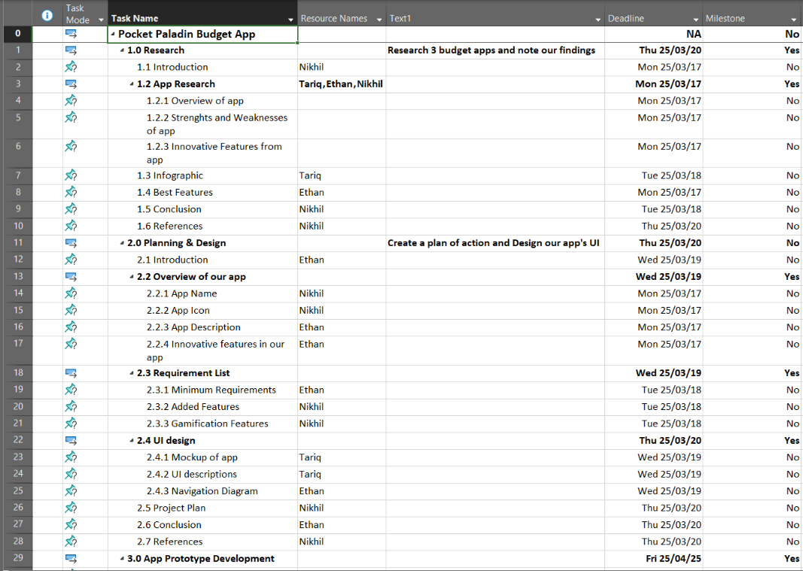

# (6) Conclusion

Our budgeting app is attempting to redefines financial management by combining budgeting strategies, collaboration, and gamification into one seamless experience. With features like expense tracking, goal setting and with the gamification features we have added; users can develop better financial habits while staying engaged and motivated.

Whether you’re an individual looking to track your daily spending or a family working towards shared financial goals, our app provides the tools you need to succeed. Take control of your finances today and make budgeting more rewarding than ever!

# (7) Reference list

FlutterFlow, 2025. *MobileBudgetingApp*.[Online].Available at: <https://www.flutterflow.io/?gad_source=1&gclid=Cj0KCQjw1um-BhDtARIsABjU5x5y0zxHT2pNcmf_vq-PonTkXdBtTKA_OGjwJlUNHdmJFPHe_dXbY4MaAmR4EALw_wcB>. [Accessed 19th March 2025]