Student Number:St10358665

Student Name : Mudzweda Mupfi

Module Code : HCIN6222

Due Date: 21 : October 2024

Lecture Name: Guy Toko

Part : 2

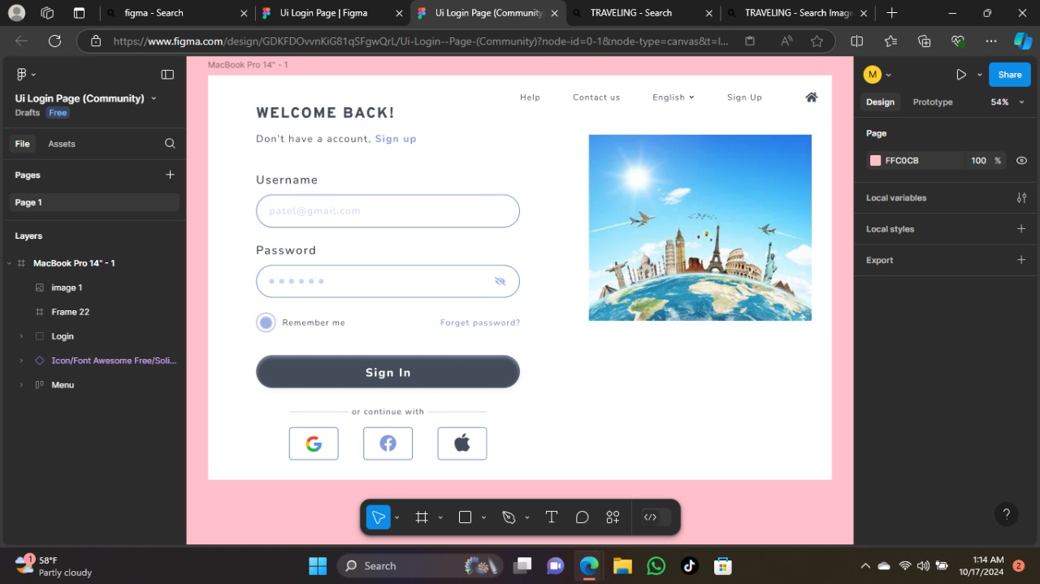

This is the sign up page which will prompt the user to sign up if they don’t have an account yet

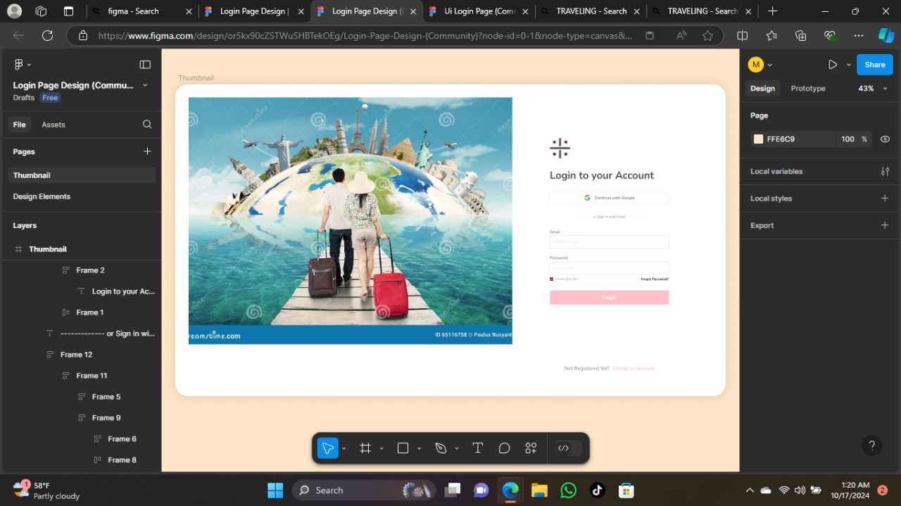

Then after signing up is then that the user will log in so that they can start looking and the packages.

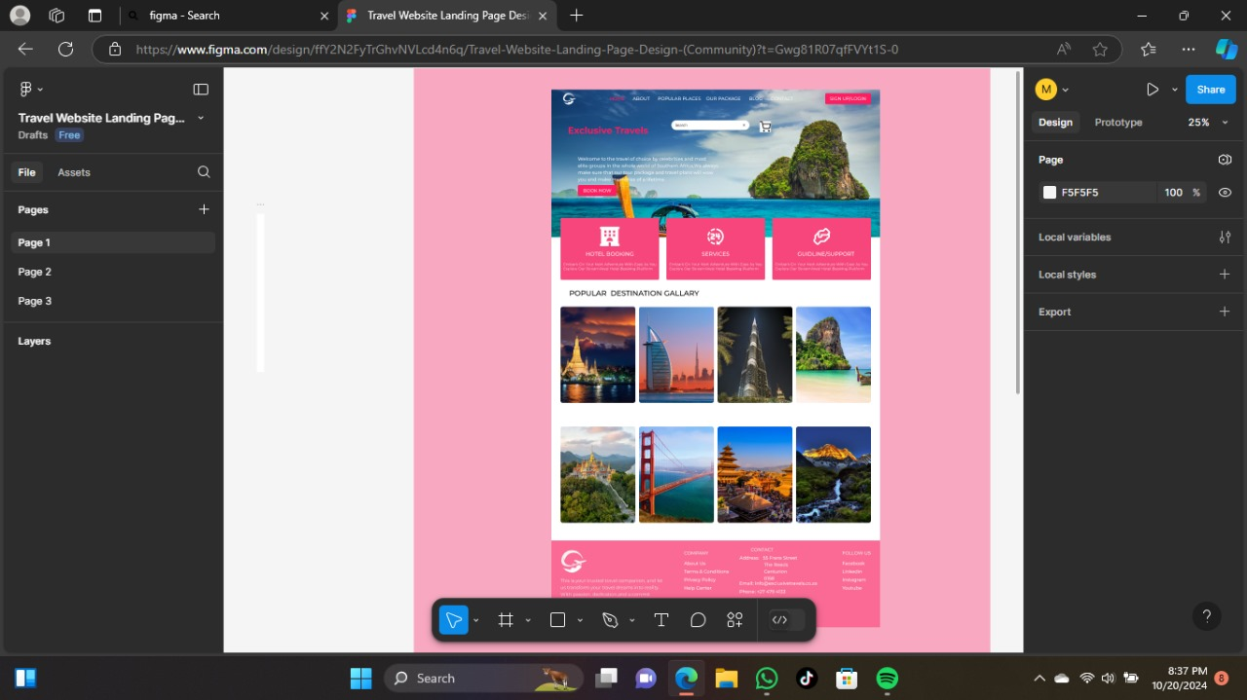

This is the home page which it shows the gallery of some of the places they can choose from so they can have nice experience with exclusive travels.It is also user friendly the search bar is not hidden so that the user can search whatever they want to search.It is also colorfull and attractive and eye catchy.

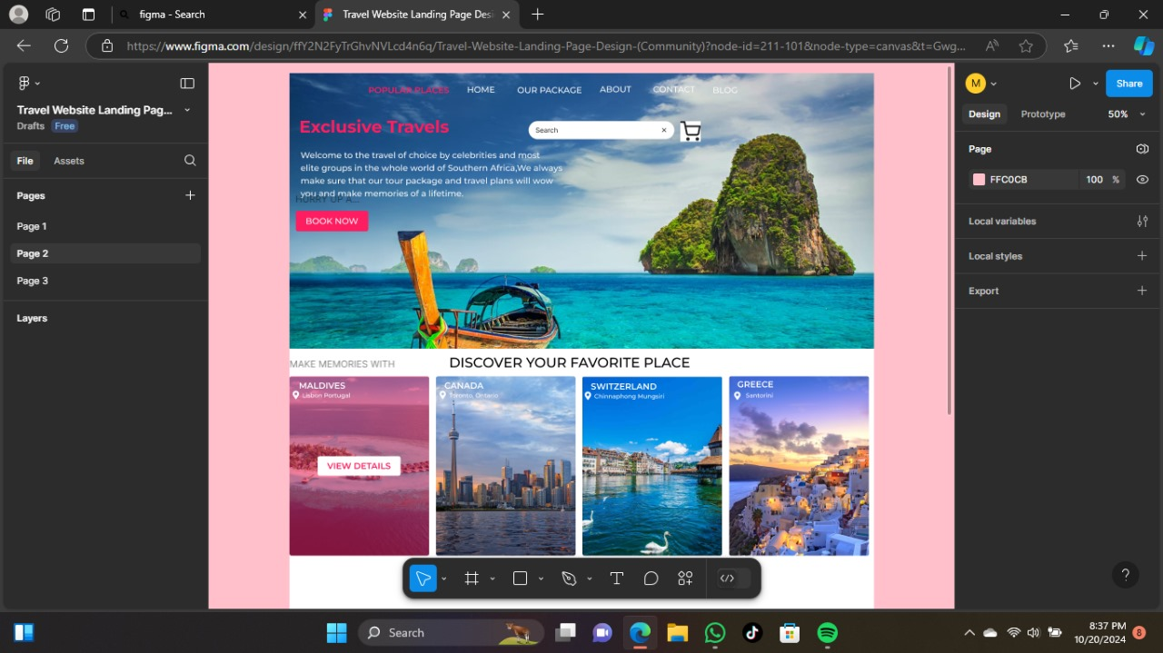

This is also a page where if the user have never traveled before they get to check out some of the places which has been visited already.

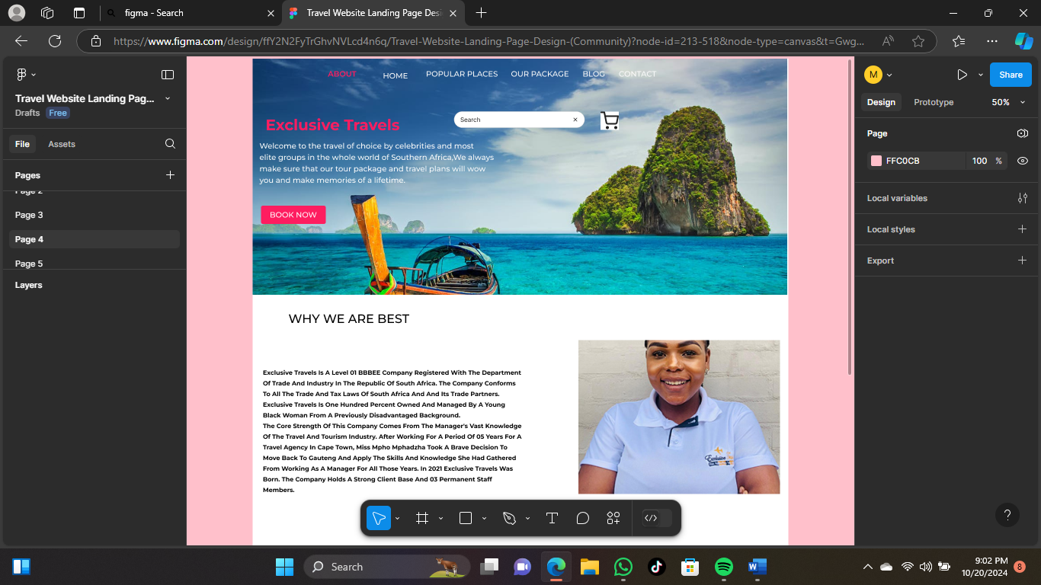

This is the about page where the user get to read more about the company’s background.

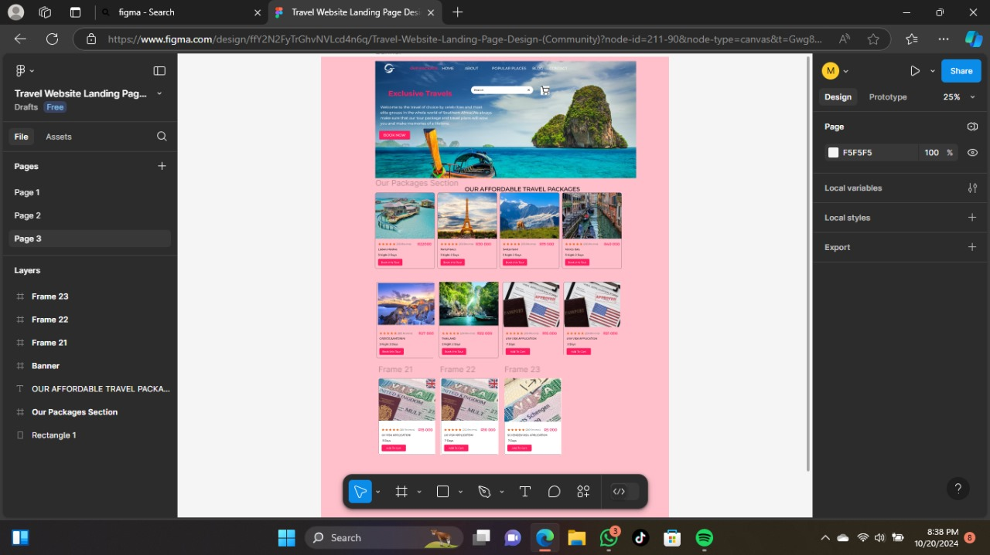

So this is the package page where the user get to see the prices of the trips and the visas .It helps them to choose exactly what they want as well as the price of the thing the want .

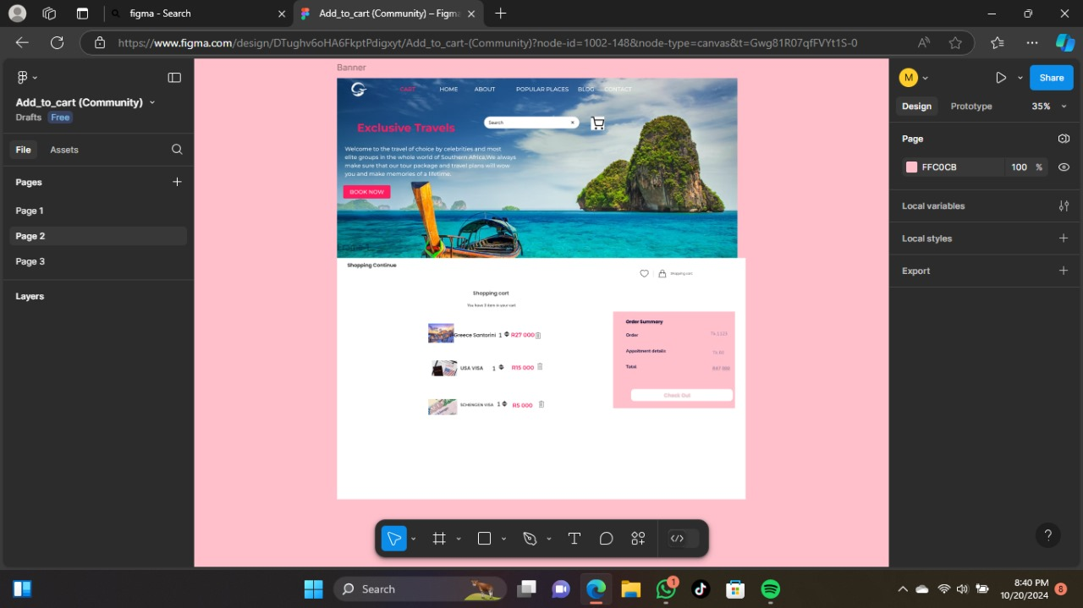

After choosing the package of they’re choice they will add it to the cart which will be preparing them for checkout.

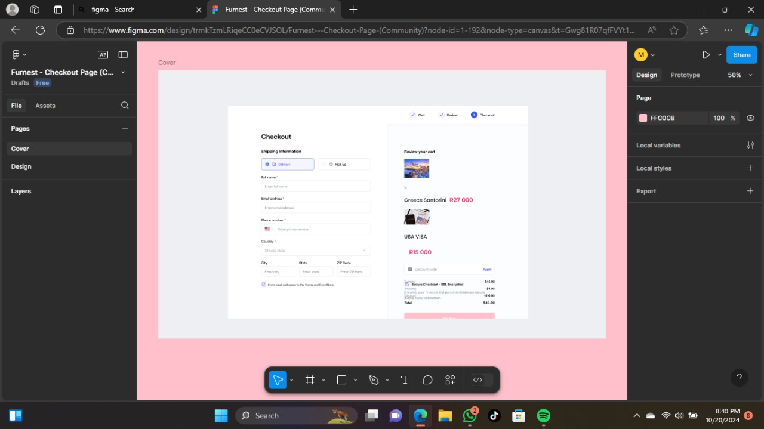

And this is the checkout page which the user pays for the package the choose to confirm they’re booking for the drip or the visa so that they cant start processing they’re order.

**Citations:**

**https://www.figma.com/proto/ffY2N2FyTrGhvNVLcd4n6q/Travel-Website-Landing-Page-Design-(Community)?node-id=213-518&t=Gwg81R07qfFVYt1S-1**

[1] https://exclusivetravels.co.za

https://www.figma.com/proto/trmkTzmLRiqeCC0eCVJSOL/Furnest---Checkout-Page-(Community)?node-id=1-192&t=Gwg81R07qfFVYt1S-1