CLDV7112 PRACTICUM
AgriStream IoT
Building a Real-Time Processing System on Microsoft Azure

Student number | ST10405518
Student name | Musawenkosi Bhebhe
Module | CLDV7112 Cloud Development
Assessment | Practicum
Date | 6 November 2026

Table of Contents
Abstract 2
1. Introduction and architecture 2
1.1 Architecture overview 2
1.2 Data flows 3
1.3 Design decisions 3
2. Implementation of Azure services 4
2.1 Task (a): Azure App Service 4
2.2 Task (b): Azure SQL Database (user management) 4
2.3 Task (c): Azure Blob and Table Storage 5
2.4 Task (d): Serverless data pipeline 6
3. Testing, monitoring and scaling 8
3.1 Task (e): Load testing 8
3.2 Task (f): Monitoring 9
3.3 Task (g): Auto-scaling 10
3.4 Limitations and evidence 11
4. Theory questions 12
4.1 Disaster recovery and redundancy 12
4.2 Stateless versus stateful architecture 13
4.3 Serverless triggers and bindings 14
5. Conclusion 14
Reference list 15

Abstract
AgriStream IoT is a serverless, queue-decoupled pipeline on Microsoft Azure that absorbs bursty sensor and drone traffic without losing data. This report documents its implementation, testing and design rationale. The system uses Azure App Service, Azure SQL Database, Blob, Table and Queue Storage, and four Azure Functions. Manual scale-out to two instances was demonstrated under load. Application Insights and rule-based autoscale could not be enabled because of subscription restrictions, and the evidence for this is presented in Section 3.4.
Keywords: Azure, serverless, Azure Functions, stateless architecture, queue-based load levelling, scalability

Submission item | Link
Deployed web application | https://st10405518-web.azurewebsites.net
Function App | https://st10405518-func.azurewebsites.net
Source code repository | https://github.com/ST10405518/CLDV7112_Practicum.git
Demo login | Create a Farmer account through Register, or use the seeded Admin account supplied separately.

1. Introduction and architecture
AgriStream IoT monitors large commercial farms. Soil sensors send telemetry continuously, while drones upload high-resolution imagery in bursts. The system must absorb these surges without losing data, so every heavy operation is separated from the web tier by storage and queues.

1.1 Architecture overview
Layer | Azure service | Role
Presentation | Azure App Service (ASP.NET Core MVC) | Hosts the management web application. It is stateless, so it can scale out (manually on the Basic tier).
Identity and registry | Azure SQL Database | Stores users, roles and the master device registry.
Unstructured data | Azure Blob Storage | Holds drone images in the container drone-images.
NoSQL data | Azure Table Storage | Holds the Telemetry and ImageAudit tables.
Messaging | Azure Storage Queue | Buffers irrigation commands in irrigation-commands.
Compute | Azure Functions (four functions) | Blob, HTTP GET, HTTP POST and Queue triggers.
Observability | Azure Monitor metrics | Plan CPU and memory metrics, function invocations. Application Insights is wired in code but blocked by the subscription (Section 3.4).

1.2 Data flows
- Image upload: the MVC application uploads to Blob Storage, which triggers DroneImageUploaded. The function writes an audit row to the ImageAudit table.
- Dashboard: the MVC application calls GetTelemetry (HTTP GET). The function reads the newest rows for the field from the Telemetry table.
- Irrigation: the MVC application calls TriggerIrrigation (HTTP POST). The function validates the request and enqueues a command. ProcessIrrigationCommand dequeues it and sets the device status to Irrigating in Azure SQL.

1.3 Design decisions
Queue between the POST function and SQL. The web request returns immediately with HTTP 202, and bursts of commands wait in the queue instead of overloading the database. A failing message is retried up to five times (maxDequeueCount) before the runtime moves it to a poison queue, which is the default behaviour for Storage Queue triggers (Microsoft, n.d.b). No command is therefore lost silently.
Table Storage keys. The Table service indexes entities only by PartitionKey and RowKey, returns them in ascending key order, and recommends choosing a RowKey that matches the most common sort order (Microsoft, n.d.e). Telemetry is partitioned by FieldId with a reverse-timestamp RowKey, so the newest readings come first and the GET function needs only one inexpensive partition query.
Output bindings. Table and Queue output bindings replace hand-written client code in two functions, which keeps them short and easier to test. Bindings are optional and declarative, and avoid hard-coding access to other services (Microsoft, n.d.a).
Statelessness. Authentication uses a cookie and there is no in-memory session, so any App Service instance can serve any request. This follows the stateless-process principle of the twelve-factor methodology, which warns that later requests are likely to reach a different process (Wiggins, 2017). Section 4.2 develops the argument.
Password storage. Passwords are stored as salted PBKDF2 hashes (100,000 iterations, SHA-256), and self-registration cannot create Admin accounts. OWASP requires a unique random salt per password and currently recommends a work factor of at least 600,000 for PBKDF2 with HMAC-SHA-256 (OWASP Foundation, n.d.). The iteration count used here is therefore below current guidance and should be raised before production use.

2. Implementation of Azure services

2.1 Task (a): Azure App Service
The MVC application (AgriStream.Web, .NET 9) is published to an Azure App Service on Linux, using the Basic (B1) tier. This is the only tier family that the college subscription policy allows, and it supports manual scale-out only (Section 3.3). The SQL connection string, storage connection string and function key are held as application settings, so no secrets appear in source control.

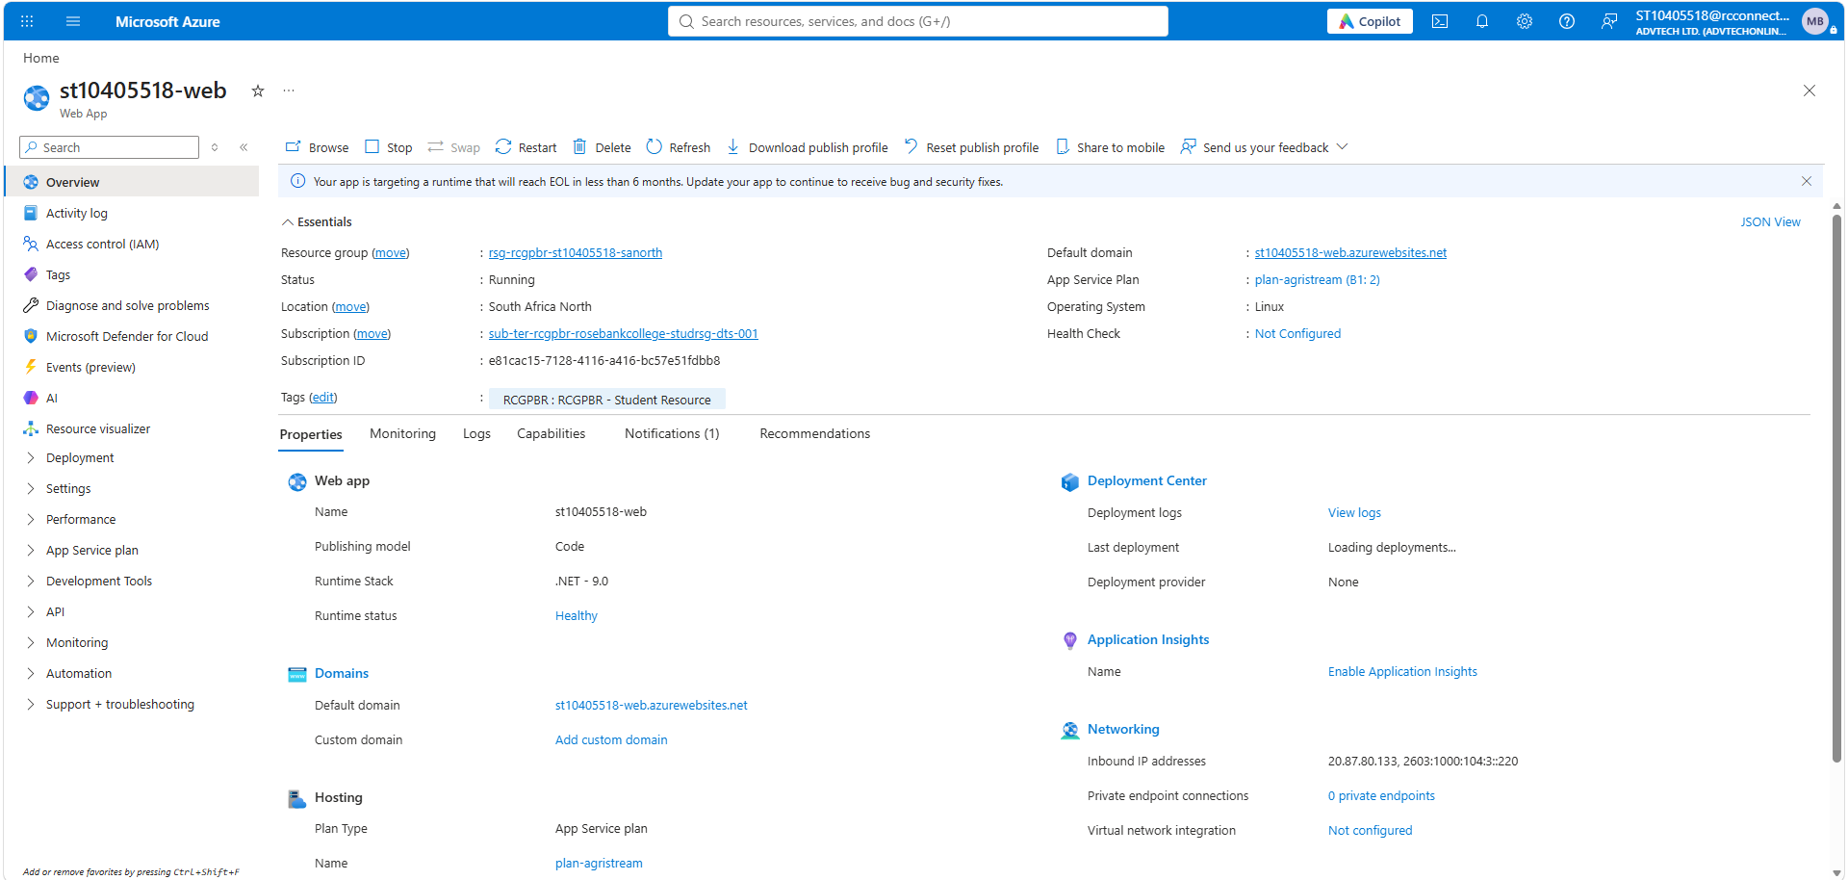
Figure 1Figure 1: App Service overview page showing the URL, the status Running and the App Service plan
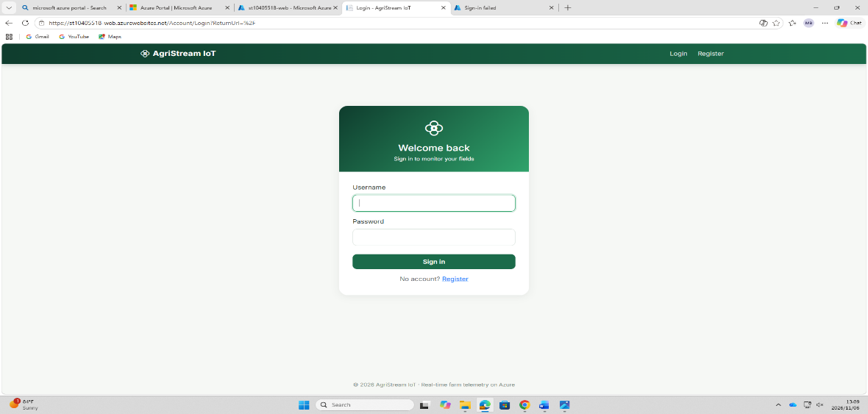
Figure 2: The deployed website in the browser (login page) with the azurewebsites.net URL visible

2.2 Task (b): Azure SQL Database (user management)
Entity Framework creates two tables on first run. Users stores the username, a password hash and a role (Farmer, Agronomist or Admin). Devices is the master registry that the queue function updates.
public class AppUser
{
public int Id { get; set; }
[Required, StringLength(50)] public string Username { get; set; } = "";
[Required] public string PasswordHash { get; set; } = ""; // salt:hash (PBKDF2)
[Required, StringLength(20)] public string Role { get; set; } = Roles.Farmer;
}
Role-based access is enforced with [Authorize(Roles = ...)] on controller actions. Farmers and Admins may trigger irrigation, only Admins may generate simulated sensor data, and all roles may view the dashboard.

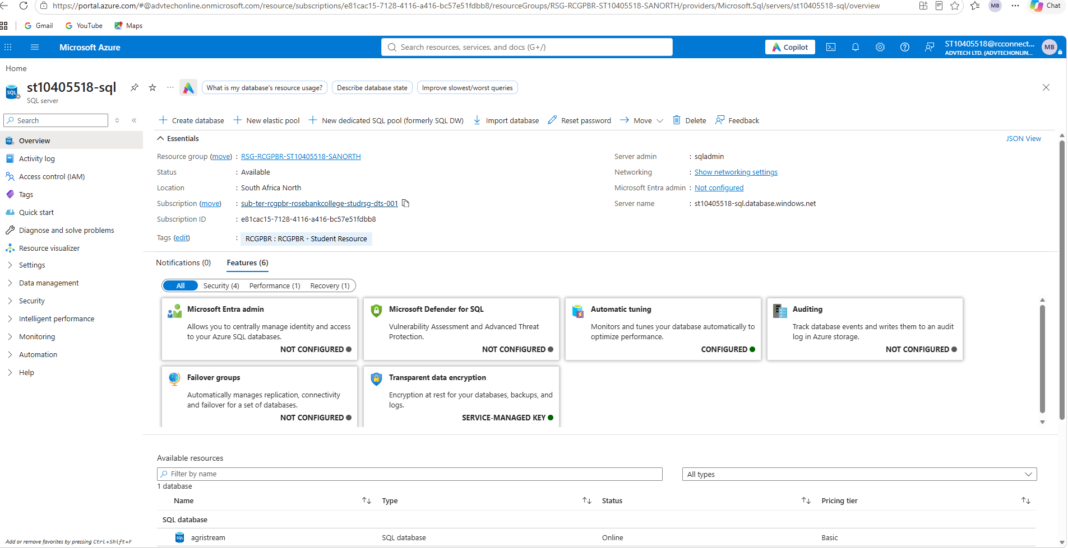
Figure 3: Azure SQL Database overview and the server firewall rule allowing Azure services
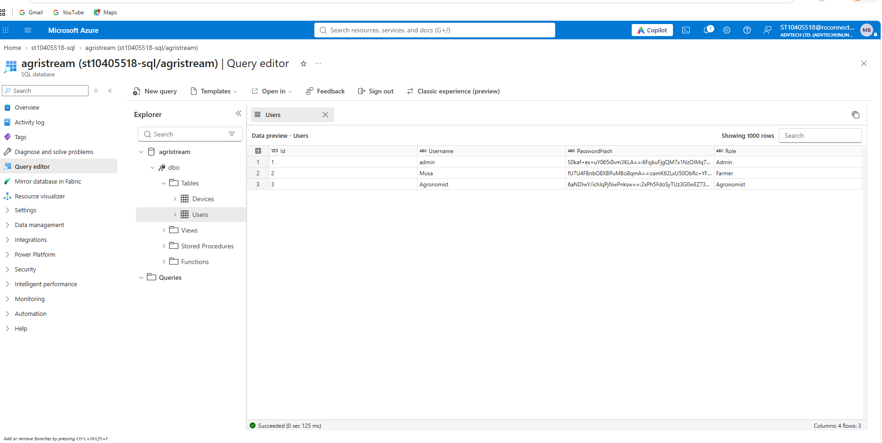
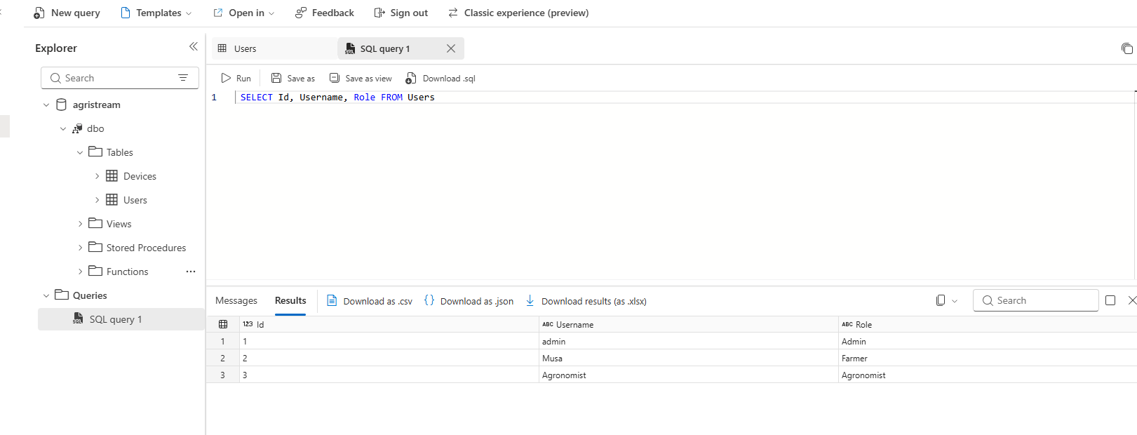
Figure 4: Query editor result of SELECT Id, Username, Role FROM Users (hash column hidden)

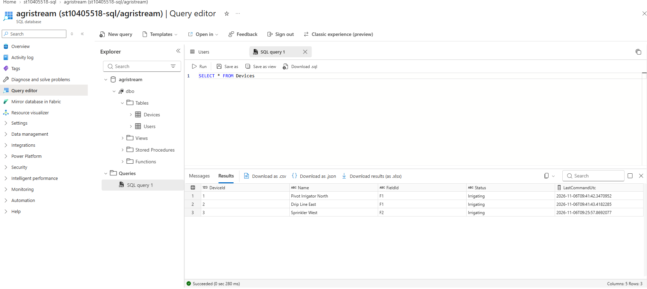
Figure 5: Query editor result of SELECT * FROM Devices showing device status

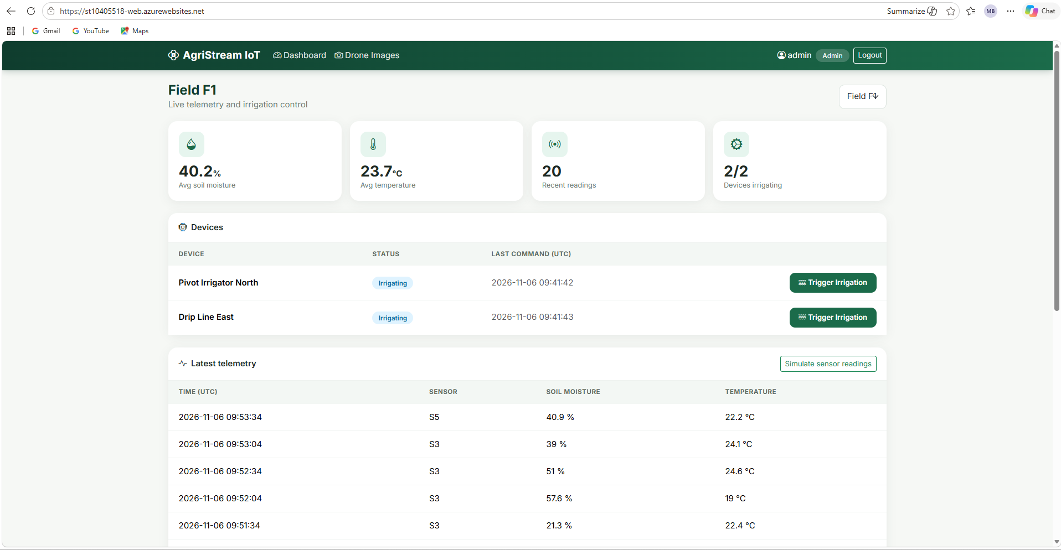
Figure 6: MVC login page and the dashboard after a successful login, showing the MVC-to-SQL connection

2.3 Task ©: Azure Blob and Table Storage
One storage account provides the Blob service (container drone-images), the Table service (Telemetry and ImageAudit) and the Queue service (irrigation-commands). Images are uploaded through the Drone Images page, which accepts only JPEG and PNG files.
Public async Task UploadImageAsync(IformFile file)
{
var blobName = $”{DateTime.UtcNow:yyyyMMddHHmmss}-{Path.GetFileName(file.FileName)}”;
await using var stream = file.OpenReadStream();
await _images.GetBlobClient(blobName).UploadAsync(stream,
new BlobHttpHeaders { ContentType = file.ContentType });
}

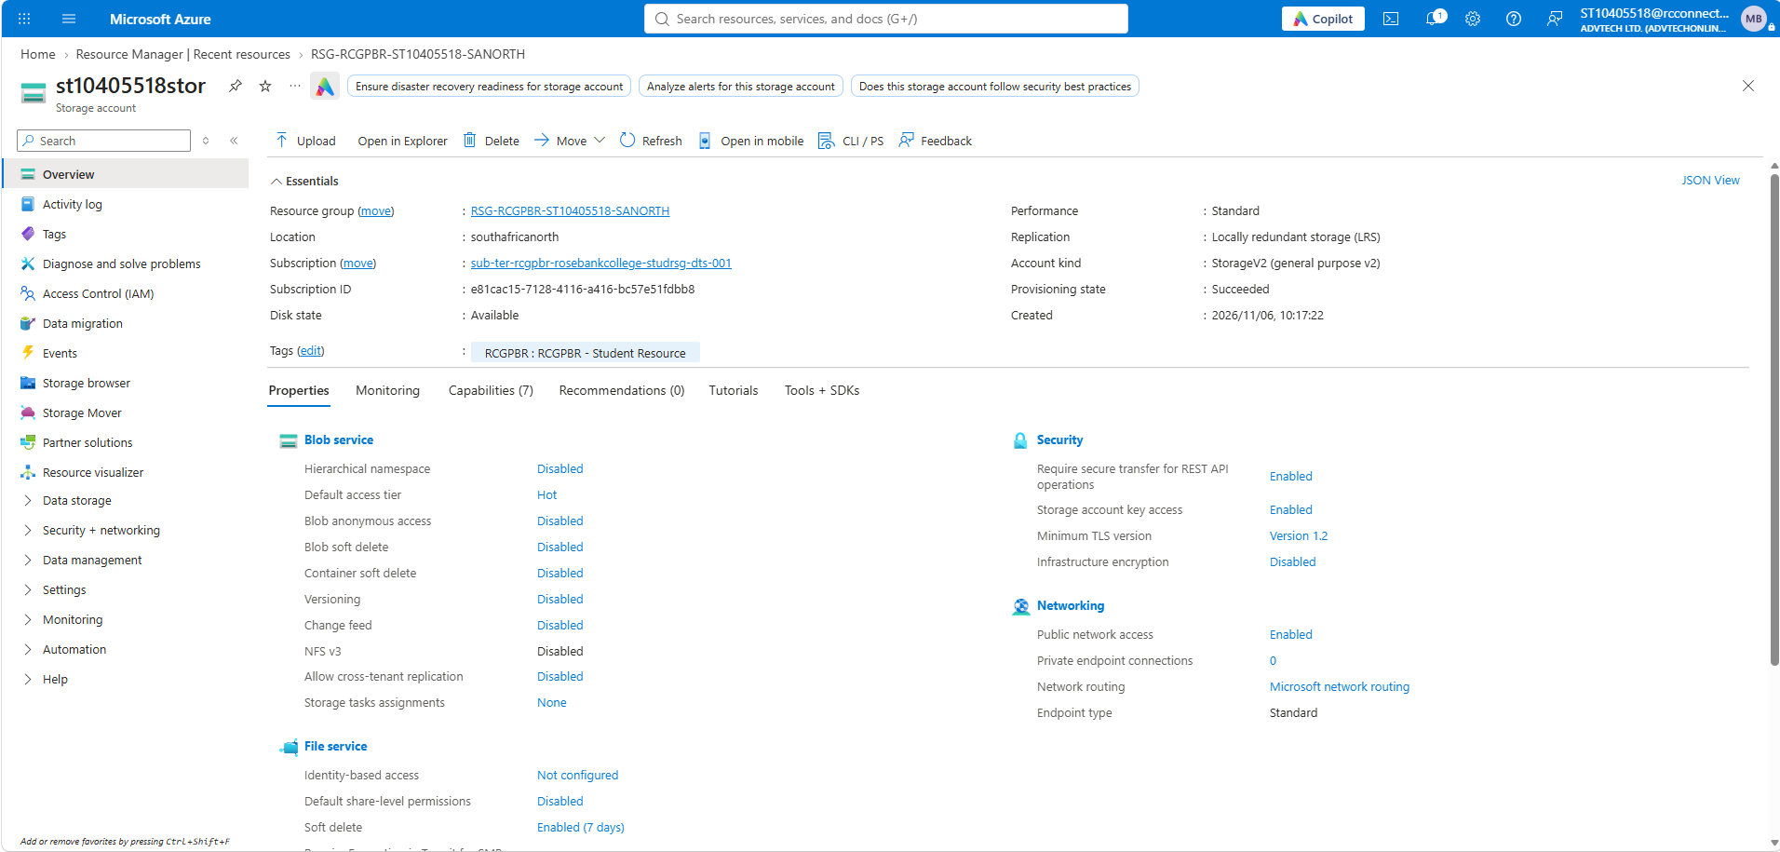
Figure 7: Storage account overview with the Blob container drone-images containing uploaded images

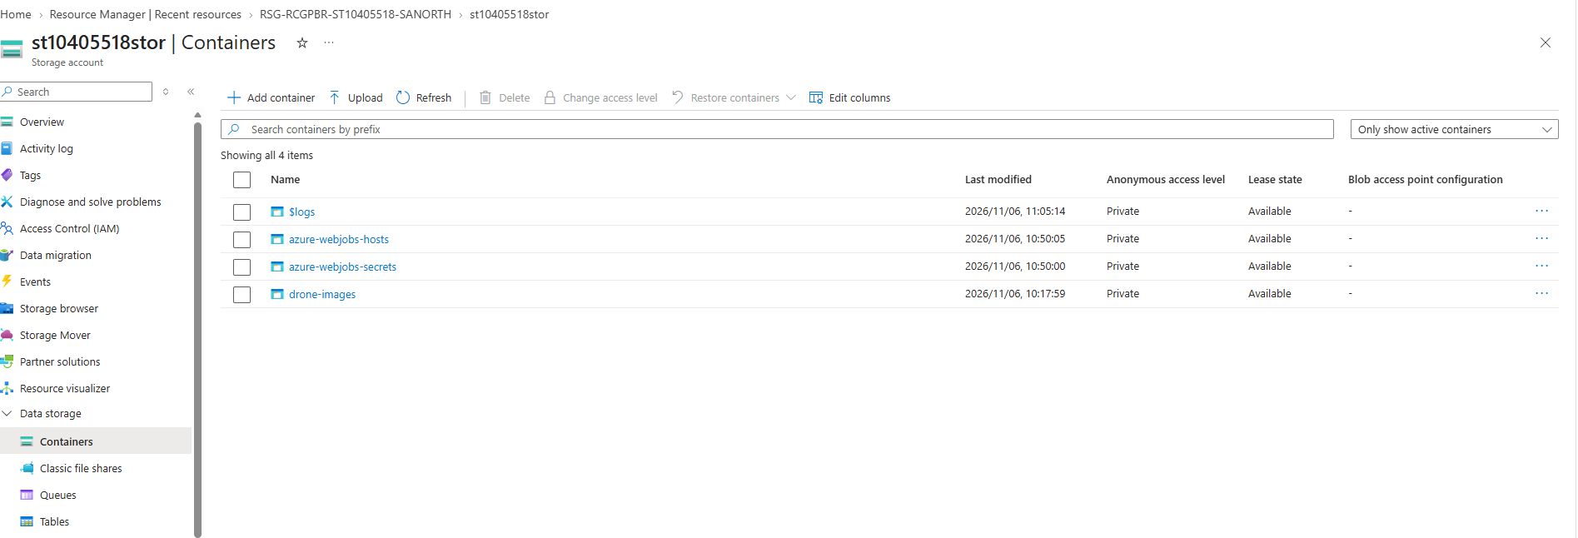

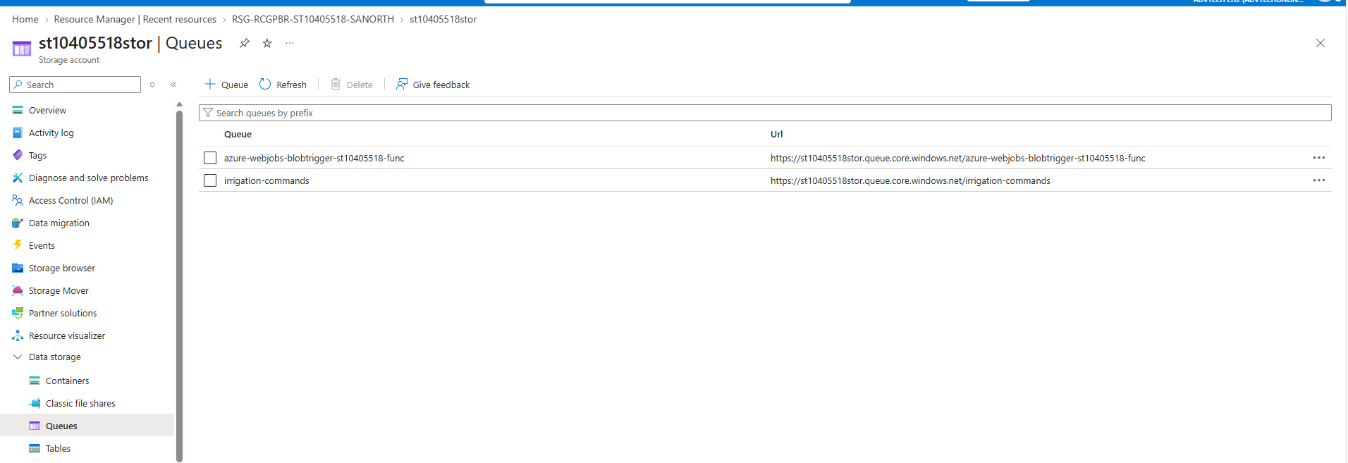
Figure 8: Storage browser showing the Telemetry table
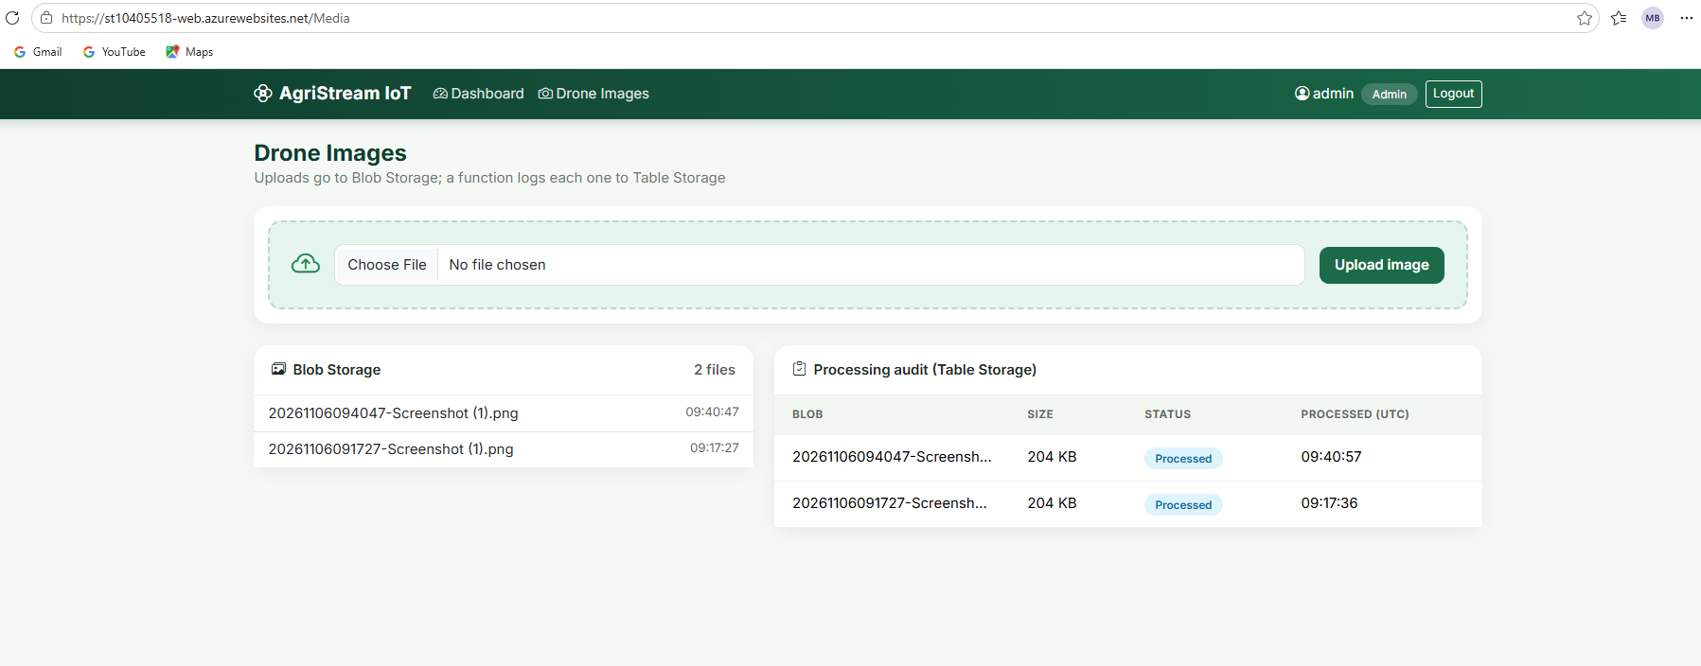
Figure 9: Drone Images page in the web application after an upload

2.4 Task (d): Serverless data pipeline
Four Azure Functions implement the pipeline. Each function has exactly one trigger, and input or output bindings are optional (Microsoft, n.d.a).
# | Function | Trigger | Binding | Purpose
1 | DroneImageUploaded | Blob | Table output (ImageAudit) | Logs upload details and writes an audit entry.
2 | GetTelemetry | HTTP GET | Reads the Telemetry table | Returns the latest readings for a field.
3 | TriggerIrrigation | HTTP POST | Queue output | Validates and enqueues an irrigation command.
4 | ProcessIrrigationCommand | Queue | Writes to Azure SQL | Updates the device status in the registry.

Function 1 uses a blob trigger with a table output binding.
[Function(“DroneImageUploaded”)]
[TableOutput(“ImageAudit”, Connection = “StorageConnection”)]
public TableEntity Run(
[BlobTrigger(“drone-images/{name}”, Connection = “StorageConnection”)] byte[] content,
string name)
{
_logger.LogInformation(“Drone image uploaded: {Name} ({Size} bytes)”, name, content.Length);
return new TableEntity(“ImageAudit”, $”{DateTime.UtcNow.Ticks:D19}-{Guid.NewGuid():N}”)
{
{ “BlobName”, name }, { “SizeBytes”, content.Length },
{ “Status”, “Processed” }, { “ProcessedUtc”, DateTime.UtcNow }
};
}
Function 2 is an HTTP GET function that returns the newest readings for a field.
[Function(“GetTelemetry”)]
public async Task<IactionResult> Run(
[HttpTrigger(AuthorizationLevel.Function, “get”, Route = “telemetry”)] HttpRequest req)
{
var fieldId = req.Query[“fieldId”].ToString();
if (string.IsNullOrWhiteSpace(fieldId))
return new BadRequestObjectResult(“fieldId query parameter is required.”);
// … query Telemetry table where PartitionKey == fieldId, newest first
}
Function 3 is an HTTP POST function that places an irrigation command on the queue.
[Function(“TriggerIrrigation”)]
public async Task<Result> Run(
[HttpTrigger(AuthorizationLevel.Function, “post”, Route = “irrigation”)] HttpRequest req)
{
// validate DeviceId and DurationMinutes, then:
return new Result { QueueMessage = JsonSerializer.Serialize(cmd), Response = new AcceptedResult() };
}
Function 4 is a queue-triggered function that updates the device registry in Azure SQL.
[Function(“ProcessIrrigationCommand”)]
public async Task Run(
[QueueTrigger(“irrigation-commands”, Connection = “StorageConnection”)] string message)
{
var cmd = JsonSerializer.Deserialize<IrrigationCommand>(message, …);
// UPDATE Devices SET Status = ‘Irrigating’, LastCommandUtc = SYSUTCDATETIME() WHERE DeviceId = @id
}

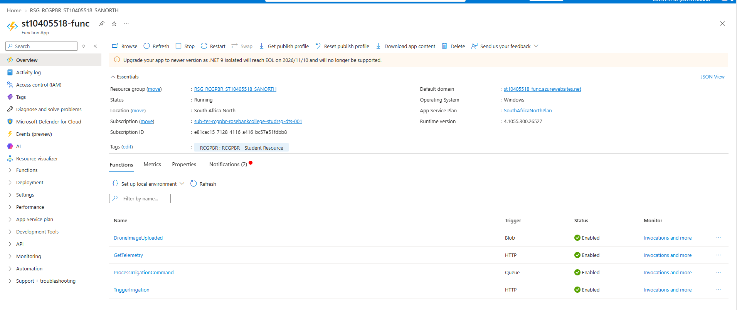
Figure 10: Function App overview listing all four functions

3. Testing, monitoring and scaling
Azure App Service can be scaled up (a larger tier) or scaled out (more instances), and scale-out can be set manually or by autoscale rules (Microsoft, n.d.f). This section reports what was tested and what the subscription allowed.

3.1 Task (e): Load testing
Load was generated with LoadTest/loadtest.ps1. The script starts many concurrent users that call the CPU-bound endpoint /Home/Stress?ms=300 for a fixed duration, and then reports successful requests, failures and requ/ests per second.
.\loadtest.ps1 -BaseUrl https://st10405518-web.azurewebsites.net -Users 50 -Seconds 300
Record the results below after running the test.
Metric | 1 instance | 2 instances (manual scale-out)
Concurrent users | [ ] | [ ]
Requests per second | [ ] | [ ]
Average response time (ms) | [ ] | [ ]
Failed requests | [ ] | [ ]
Instance count | 1 | [ ]
Peak CPU (%) | [ ] | [ ]

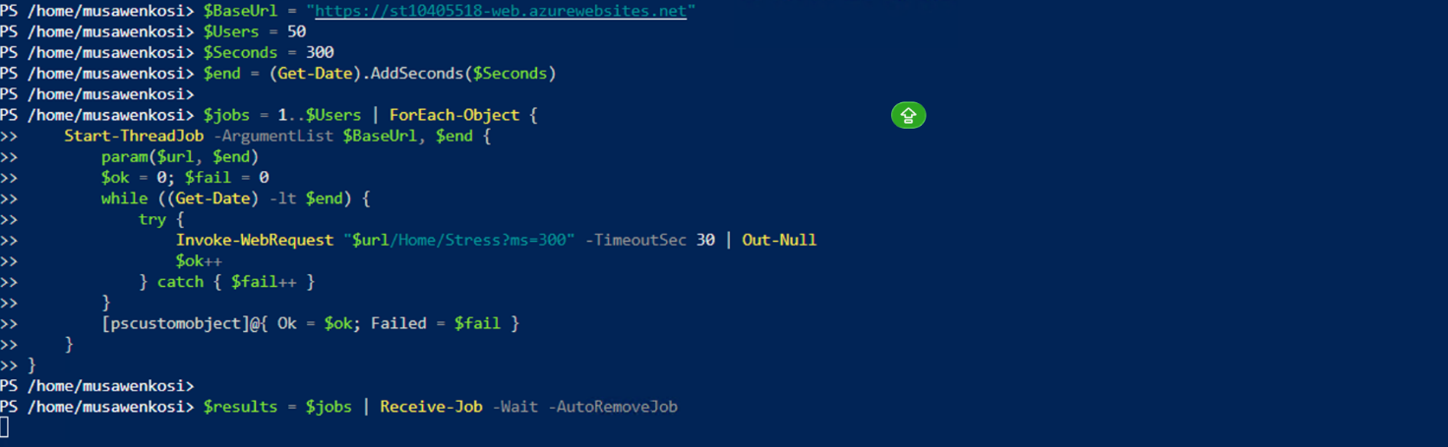
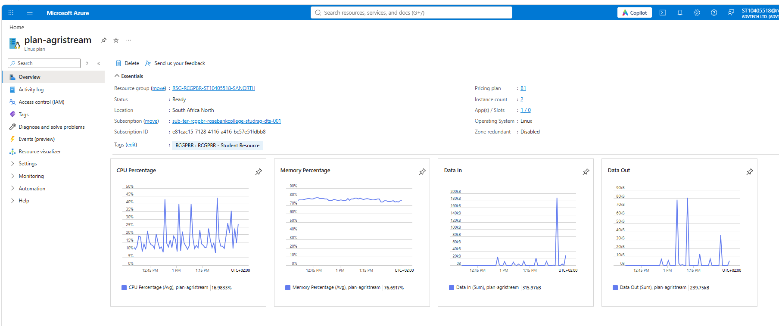
Figure 11: PowerShell output of loadtest.ps1 showing total requests, failures and requests per second

3.2 Task (f): Monitoring
Limitation. An Application Insights resource could not be created, so Live Metrics and the Performance blade are unavailable. The Azure subscription is not registered for the Microsoft.Insights resource provider, and the student account has no rights to register it. Section 3.4 gives the cause and the evidence.
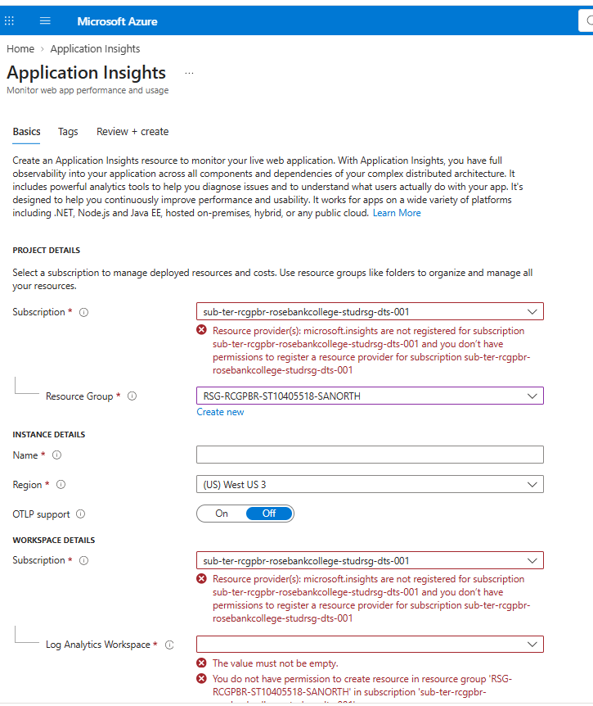
Figure 12: Proof of limitation: the Missing Subscription Registration error when creating Application Insights

3.3 Task (g): Auto-scaling
Limitation. Rule-based auto scale could not be enabled. Two independent restrictions apply, and both are outside my control

Autoscale settings are stored as Microsoft.Insights/autoscaleSettings, so the unregistered Microsoft.Insights provider makes az monitor autoscale create fail with MissingSubscriptionRegistration.
- Autoscale needs a Standard (S1) or higher plan. A college Azure Policy denies every SKU except Basic and Shared, so upgrading from B1 to S1 is rejected with RequestDisallowedByPolicy.
Intended design. Scale out by one instance when average CPU exceeds 60% for five minutes, with a five-minute cooldown, a minimum of one and a maximum of three instances. Scale in by one instance when CPU falls below 30%. The commands below show how this would be configured once the restrictions are lifted.
az monitor autoscale create -g <rg> --resource plan-agristream --resource-type Microsoft.Web/serverfarms --min-count 1 --max-count 3 --count 1 -n autoscale-agristream
az monitor autoscale rule create -g <rg> --autoscale-name autoscale-agristream --scale out 1 --condition "CpuPercentage > 60 avg 5m"
az monitor autoscale rule create -g <rg> --autoscale-name autoscale-agristream --scale in 1 --condition "CpuPercentage < 30 avg 5m"

3.4 Limitations and evidence
Two required tasks could not be completed in full because of restrictions set by the college on the student subscription. They are not configuration mistakes. The errors come from the subscription registration state and from an Azure Policy, as the evidence below shows.
Requirement | Blocker | Evidence | Alternative used
Application Insights (task f) | The subscription is not registered for the Microsoft.Insights resource provider, and registration by the student fails. | az provider show returns NotRegistered. Creating the resource returns MissingSubscriptionRegistration. | Application instrumented in code and ready to switch on. Azure Monitor plan metrics and the log stream were used.
Autoscale rules (task g), reason 1 | Autoscale needs Microsoft.Insights, which is not registered. | az monitor autoscale create returns MissingSubscriptionRegistration. | Intended rules and commands documented.
Autoscale rules (task g), reason 2 | An Azure Policy denies any plan other than Basic and Shared, while autoscale rules need Standard or higher. | az appservice plan update --sku S1 returns RequestDisallowedByPolicy under the policy "App Service Plan should use a SKU that supports Basic and Shared", assigned at the subscription and at the Rosebank student management group. | Manual scale-out to two instances on the B1 plan during the load test.

4. Theory questions

4.1 Disaster recovery and redundancy
Azure Storage always keeps multiple copies of data, and the redundancy option decides where those copies live (Microsoft, n.d.c).
Aspect | LRS (locally redundant) | GRS (geo-redundant)
Copies | Three copies within a single data centre in the primary region. | Three copies in the primary region (LRS), plus a further three copies replicated asynchronously to a paired secondary region.
Durability over a year | At least 99.999999999% (11 nines). | At least 99.99999999999999% (16 nines).
Protects against | Disk, server and rack failures. | The same failures, plus loss of a whole data centre or region.
Does not protect against | An event that affects the whole data centre, such as fire or flood. | Accidental deletion or corruption, which replicates to the secondary copy.
Failover | None. | Failover to the secondary region is possible.
Cost | The lowest of the redundancy options. | Higher than LRS, because of the extra copies and replication.

The durability figures and the replication model are taken from Microsoft (n.d.c). Microsoft describes LRS as the lowest-cost option with the least durability, suited to data that can easily be reconstructed if it is lost (Microsoft, n.d.d).
Critical historical crop harvest records: GRS (or RA-GRS where read access to the secondary region is required). These records cannot be recreated if they are lost. They support yield analysis, insurance claims and planning across seasons. The higher cost is small compared with the cost of losing years of history, and regional protection supports disaster-recovery requirements.
Temporary sensor logs: LRS. This data is high in volume, short lived and replaceable, because the sensors keep producing new readings. Paying for geo-replication on large volumes of transient data adds cost without matching value, and LRS still protects against hardware failure. If a retention policy deletes the data after days or weeks, the lower durability is an acceptable trade-off.
In AgriStream a single storage account holds both telemetry and images. For production, harvest archives should move to a GRS account while the telemetry account stays on LRS.

4.2 Stateless versus stateful architecture
A stateless service keeps no client-specific data between requests. Every request carries, or can fetch from shared storage, everything needed to process it. The twelve-factor methodology states the same rule: nothing held in memory or on local disk should be assumed available to a later request, because a different process will probably serve it (Wiggins, 2017).
Why it matters for horizontal scaling. When load grows, Azure adds instances behind a load balancer, and any instance may receive any request. If an instance holds unique state, a request is correct only when it reaches that same instance. Stateless instances are interchangeable, so they can be added, removed, restarted or replaced during scale-in, updates or failures without losing user data. Scale-out itself is an increase in the number of instances running the application (Microsoft, n.d.f).
Negative effects of local session data or local files.
- Sticky sessions are required. Users must be pinned to the instance that holds their session, which creates uneven load. One instance can be saturated while new instances sit idle, so scale-out does not help.
- Sessions are lost. When an instance is scaled in, restarted or recycled, its in-memory sessions disappear and users are logged out or lose work.
- Data becomes inconsistent. A file uploaded to instance A is missing on instance B, so users see broken images or errors depending on which instance answers.
- Data is lost and reliability falls. Local disk is temporary and not shared, so a failed instance takes its data with it.
- Scale-out is slow. A new instance starts empty and cannot share the work of existing state, so the extra capacity is not usable immediately.
How AgriStream stays stateless. Login identity is kept in an encrypted cookie rather than in server memory. Images go to Blob Storage rather than the web server disk. Telemetry and audit data go to Table Storage, commands go through a Storage Queue, and user and device data live in Azure SQL. Any App Service instance or function host can therefore handle any request, which is why the plan could be scaled out under load.

4.3 Serverless triggers and bindings
A trigger defines how a function is invoked, and every function must have exactly one. Bindings are optional declarative connections to other services, and a function may have several input or output bindings. Bindings avoid hard-coding access to those services (Microsoft, n.d.a).
 | Triggers | Input and output bindings
Definition | The event that causes a function to run. A function has exactly one trigger, which can pass the event data in as a parameter. | A declarative connection to another Azure resource. Input bindings read data into the function and output bindings write data out of it. A function can have none, one or many.
Purpose | To start execution in response to an event such as a new blob, an HTTP request, a queue message or a timer. | To read from or write to services without connection and SDK boilerplate, which keeps the function code short and focused.
AgriStream: blob function | BlobTrigger on drone-images/{name} starts DroneImageUploaded when an image is uploaded. | TableOutput("ImageAudit") writes the audit row from the returned TableEntity.
AgriStream: HTTP functions | HttpTrigger (GET) starts GetTelemetry when the dashboard opens. HttpTrigger (POST) starts TriggerIrrigation when a user clicks Trigger Irrigation. | The POST function places the irrigation command on the irrigation-commands queue through a queue output binding.
AgriStream: queue function | QueueTrigger on irrigation-commands starts ProcessIrrigationCommand for each queued message. | No binding is used for the SQL update. The function uses SqlClient directly, because Azure SQL is not accessed through a binding in this project.

In short, triggers answer “what starts the function?” and bindings answer “what data does it read or write while it runs?”.

5. Conclusion
AgriStream IoT implements a decoupled pipeline in which each heavy operation is separated from the web tier. The App Service handles interactive traffic and was scaled out manually to two instances during the load test. Blob and Table Storage hold the unstructured and non-relational data. Four Azure Functions ingest, route and process events, and a Storage Queue absorbs bursts of irrigation commands, with retries and a poison queue so that no command is lost silently.
Two requirements were only partly met. Application Insights and rule-based autoscale could not be enabled because the subscription lacks the Microsoft.Insights registration and an Azure Policy blocks plans above Basic. Monitoring therefore relied on Azure Monitor platform metrics, and autoscale is documented as a design with ready-to-run commands (Section 3.3).
Three improvements are recommended before production use: raise the PBKDF2 work factor to the current OWASP guidance, separate harvest archives into a GRS storage account, and enable Application Insights and autoscale once the subscription restrictions are lifted.

Reference list
Microsoft (n.d.a) Azure Functions triggers and bindings concepts. Available at: https://learn.microsoft.com/en-us/azure/azure-functions/functions-triggers-bindings (Accessed: 6 November 2026).
Microsoft (n.d.b) Azure Queue storage trigger and bindings for Azure Functions overview. Available at: https://docs.azure.cn/en-us/azure-functions/functions-bindings-storage-queue (Accessed: 6 November 2026).
Microsoft (n.d.c) Azure Storage redundancy. Available at: https://learn.microsoft.com/azure/storage/common/storage-redundancy (Accessed: 6 November 2026).
Microsoft (n.d.d) Design for data redundancy. Available at: https://learn.microsoft.com/en-us/training/modules/design-data-storage-solution-for-non-relational-data/4-design-for-data-redundancy (Accessed: 6 November 2026).
Microsoft (n.d.e) Design for querying. Available at: https://learn.microsoft.com/azure/storage/tables/table-storage-design-for-query (Accessed: 6 November 2026).
Microsoft (n.d.f) Scale up and scale out Azure App Service. Available at: https://learn.microsoft.com/en-us/training/modules/configure-app-service-plans/4-scale-up-scale-out (Accessed: 6 November 2026).
OWASP Foundation (n.d.) Password Storage Cheat Sheet. Available at: https://cheatsheetseries.owasp.org/cheatsheets/Password_Storage_Cheat_Sheet.html (Accessed: 6 November 2026).
Wiggins, A. (2017) ‘VI. Processes’, in The Twelve-Factor App. Available at: https://12factor.net/processes (Accessed: 6 November 2026).

