Smart X telemetry dashboard engagement
PROG7312 POE Part 1 | Research report

1 Purpose and research context
This report considers five engagement strategies for a simulated IoT gateway serving hydroponic farms, utility meters and actuators. It selects interactive telemetry investigation to help developers identify abnormal readings and missing transmissions. The design draws on journal research into sensor anomalies, visual analytics and dashboard usability.

2 Five strategies considered
1. Live trends with anomaly markers. Show timestamped readings, threshold lines and unusual points so developers can examine spikes in context (Janetzko et al., 2014).
2. Filtering and device drill-down. Narrow a large registry to a category or identifier, then open deployment details and raw packets (Yigitbasioglu and Velcu, 2012).
3. Freshness indicators and actionable alerts. Display last reception time alongside the expected interval to distinguish missing transmissions from valid sensor values; this is a Smart-X application of sensor-specific anomaly reasoning (DeMedeiros, Hendawi and Alvarez, 2023).
4. Guided registration and immediate validation. Provide category choices, clear error messages and deployment checks to support learnability and task completion (Almasi et al., 2023).
5. Interactive troubleshooting practice. Let developers inject faults and test recovery in a simulation. This proposed application of task-focused interaction makes feedback visible; engagement improvements require evaluation (Almasi et al., 2023).
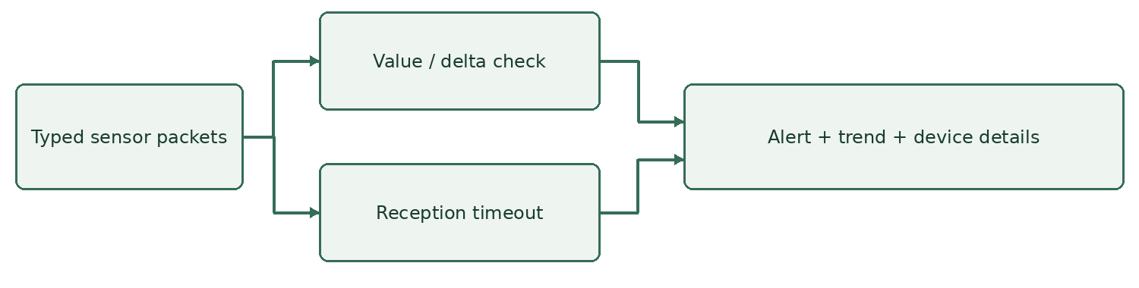
Figure 1. Proposed Smart-X investigation flow (author’s diagram).

3 Chosen strategy and justification
Smart-X should use an interactive telemetry investigation dashboard that combines recent trends, explicit anomaly markers and device freshness indicators. Its purpose is to help developers move from noticing a problem to inspecting evidence and testing recovery. Janetzko et al. (2014) connect anomaly detection with visual analysis of power consumption. This provides a directly relevant foundation for Smart-X utility meters, while the same investigation pattern can support hydroponic moisture sensors and irrigation actuators.
The proposed interface presents one selected sensor alongside an active alert queue. Users filter devices by identifier or category, then inspect timestamped readings. Soil moisture appears as percentages, power as watts, and valve states as open or closed. Separate scales prevent misleading comparisons between unrelated quantities. Yigitbasioglu and Velcu (2012) identify drill-down and presentation flexibility as useful dashboard features. Applying those principles here means retaining a simple overview while making raw packets and deployment details available when troubleshooting requires precision.
For spike detection, Smart-X highlights values outside a demonstration operating range or values that change sharply between consecutive samples. For example, a power reading above 5,000 watts or a change exceeding 1,000 watts raises an alert. The graph places highlighted points against surrounding readings and a threshold line. Developers can therefore distinguish a sudden excursion from sustained elevated consumption. These thresholds are prototype assumptions, not universal electrical limits. They should eventually be configured for each device and installation.
Disconnect detection requires different evidence. A sensor is marked disconnected when the gateway receives no packet for more than three expected reporting intervals. The interface displays the last reception age and timeout, avoiding the misleading impression that an old reading describes current conditions. A closed valve remains a valid boolean reading; silence is a communication problem. DeMedeiros, Hendawi and Alvarez (2023) review anomaly detection across IoT and sensor networks, supporting attention to the particular characteristics of sensor data rather than treating every unusual observation identically.
Engagement comes from practical investigation controls. Users can inject a spike, pause a simulated sensor, inspect its configuration attachment, and send a normal sample to observe recovery. This creates an understandable feedback loop without rewarding operators for dismissing alerts. Text labels accompany colour, and contextual guidance suggests checking power, connectivity or calibration. Almasi et al. (2023) identify learnability, task suitability and situational awareness as dashboard evaluation criteria. Their healthcare-focused evidence informs interface design here; it does not establish measured improvements for IoT developers.
The strategy also has limitations. Fixed rules can generate false positives, and two-second polling may miss a brief alert between refreshes. The bounded history preserves recent investigation context but cannot replace durable incident records. Evaluation should compare this interface with a raw-data view using seeded spikes and disconnects. Record detection time, diagnostic accuracy, recovery completion and user-rated usability. Until that evaluation occurs, reduced troubleshooting effort remains an intended benefit rather than a demonstrated result. This distinction keeps the research justification aligned with the implemented prototype and avoids unsupported claims about retention gains. Operators should also document suspected causes before modifying device settings.

4 References
Almasi, S., Bahaadinbeigy, K., Ahmadi, H., Sohrabei, S. and Rabiei, R. (2023) ‘Usability evaluation of dashboards: A systematic literature review of tools’, BioMed Research International, 2023, article 9990933. https://doi.org/10.1155/2023/9990933.
DeMedeiros, K., Hendawi, A. and Alvarez, M. (2023) ‘A survey of AI-based anomaly detection in IoT and sensor networks’, Sensors, 23(3), article 1352. https://doi.org/10.3390/s23031352.
Janetzko, H., Stoffel, F., Mittelstädt, S. and Keim, D.A. (2014) ‘Anomaly detection for visual analytics of power consumption data’, Computers & Graphics, 38, pp. 27–37. https://doi.org/10.1016/j.cag.2013.10.006.
Yigitbasioglu, O.M. and Velcu, O. (2012) ‘A review of dashboards in performance management: Implications for design and research’, International Journal of Accounting Information Systems, 13(1), pp. 41–59. https://doi.org/10.1016/j.accinf.2011.08.002.
Online sources accessed 13 September 2026.

