Liam Dylon Swile

This Document is the Written Report on the changes made for the POE Final Part based on the Lecturer’s Feedback for POE Part 2
POE Feedback Document
ST10438679

Table of Contents
Important Notes 2
Feedback Changes 3
AI Usage Disclosure 5

Important Notes
GitHub Link (within Branch PROG6212_POE_Final_Part) : https://github.com/VCCT-PROG6212-2025-G4/ST10438679_PROG6212_POE_Part_1.git
YouTube Link: https://youtu.be/2eQNJYsmzCc

PowerPoint Presentation and this document (both Word and PDF formats) should be present within the GitHub Repository under the Branch PROG6212_POE_Final_Part.
Please note that should any folder be within the repository appear with a stripped outline (excluded from Project) to right-click and include in Project as this shouldn’t be happening (some peers reported this happening, fixes were but should it happen again Please just right-click and click Include in Project.
Please note that a simple update-database in the Package Manager Console should implement the Database to the Project.
Login Information:
HR Thomas Williams
Email = "twill@gmail.com"
Password = "ThowillMas361"
HR Madeline Smith
Email = "mad@gmail.com”
Password = "SmithEline953"
Lecturer John Doe
Email = "doe@gmail.com"
Password = "JoeDohn145"
Programme Coordinator Sam Sampson
Email = "samson@gmail.com"
Password = "SSson528"
Academic Manager Alvin Avin
Email = "AA@gmail.com"
Password = "vinny216"

Feedback Changes

The Lecturer’s Feedback as an Image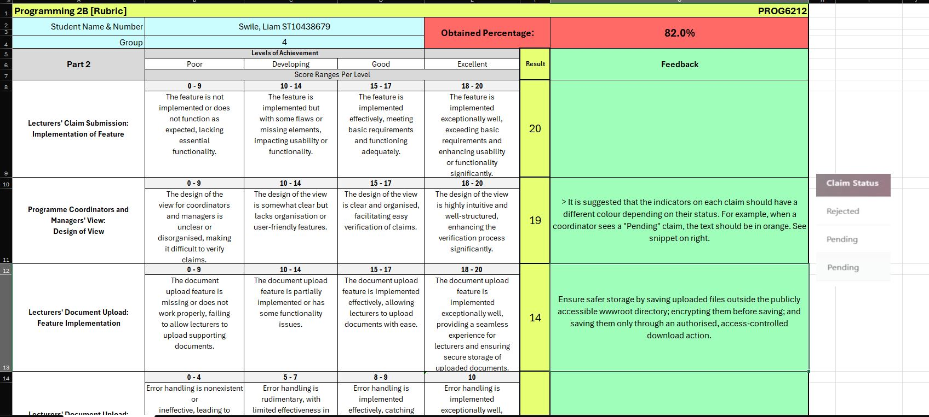
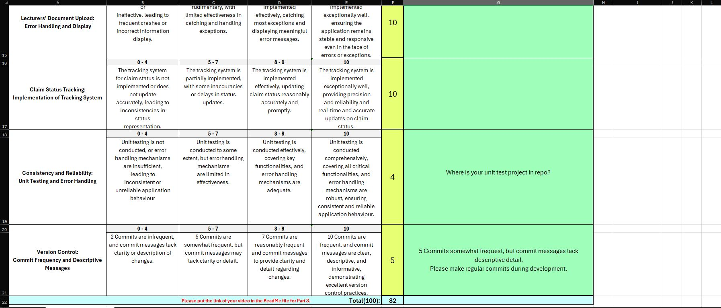

Changes made to the Program:
- Colour Coordination was added to all views involving the Claim Status to add more readability and present Clear Information.
- The storage folder was moved to a Document folder within the App_Data folder which is within the Project PROG6212_POE (as seen in the image below) and securing methods were added to prevent unauthorized access to files.
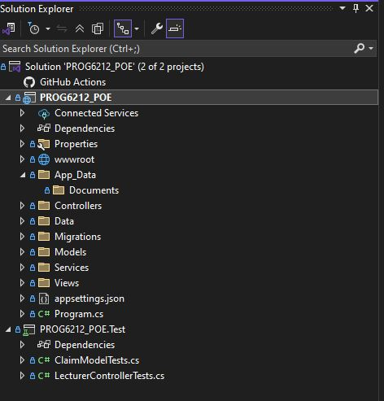

- Unit Tests were checked and have been believed to fixed in properly included in the GitHub Repository (tested by fellow Students).
- All commits made for Part 3 have been more descriptive in their messages and explanatory in the changes.

AI Usage Disclosure

Section: GUI/UI elements
AI Tool: Claude AI
Intention: The intention was to fast-track creation of GUI and UI elements to match the rest of the views in a timelier manner as well as generate some code that took the previous code as base and changed elements to what was required.
Date: 19 November 2025
Link: https://claude.ai/share/e21a06eb-c01c-47c3-84f6-e32eb702a338

