CLOUD DEvelopment b poe Final part
ST10438679

Liam Swile
CLDV6212

Table of Contents
Important Notes 2
Screenshots 3
Technology Choices Report 5
Motivation of Azure Services 6
Alternative Azure Technologies 8
References 9
Disclosure of AI Usage in my Assessment 10

Important Notes

GitHub Link (within branch Part_3_Final_POE) : https://github.com/VCCT-CLDV6212-2025-G4/CLDV6212_POE.git
YouTube Link (showcase of Application): https://youtu.be/wpI3cz68bWg
YouTube Link (showcase of Azure Services): https://youtu.be/51V5zoElSwY
Web App Link: https://st10438679.azurewebsites.net/

Login Information:
Admin User #1:
Email: michael@charge.com
Password: Password123!
Admin User #2:
Email: tobyfirst@mate.com
Password: first!45
Customer User #1:
Email: Ntom@gmail.com
Password: NilesTommy67
Customer User #2:
Email: YuHungray@gmail.com
Password: HYrayman24
Customer User #3:
Email: MstandsForM@gmail.com
Password: MMaail215

Screenshots
SQL Database Deployment
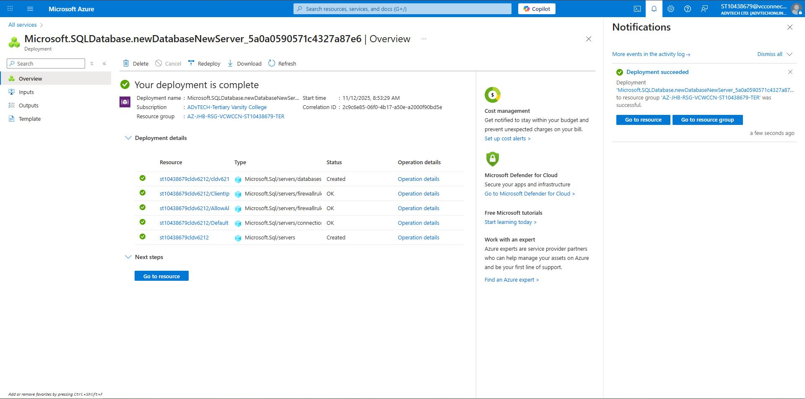
Web App Deployment
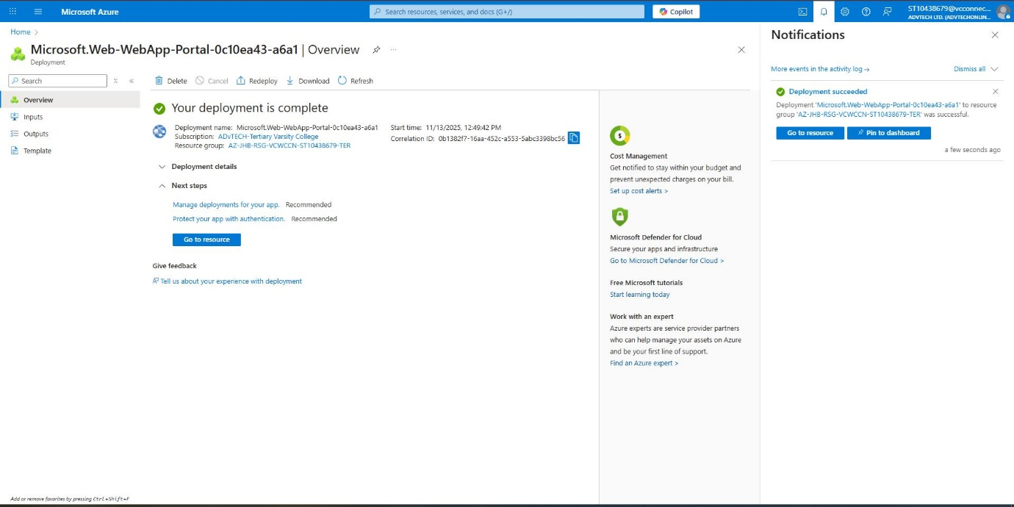

Page when Admin has successfully Logged In
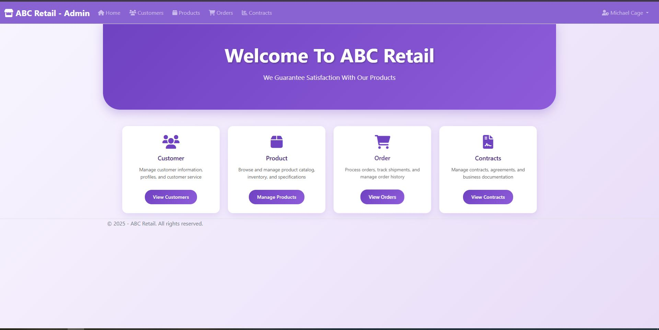
Page when Customer has successfully Logged In
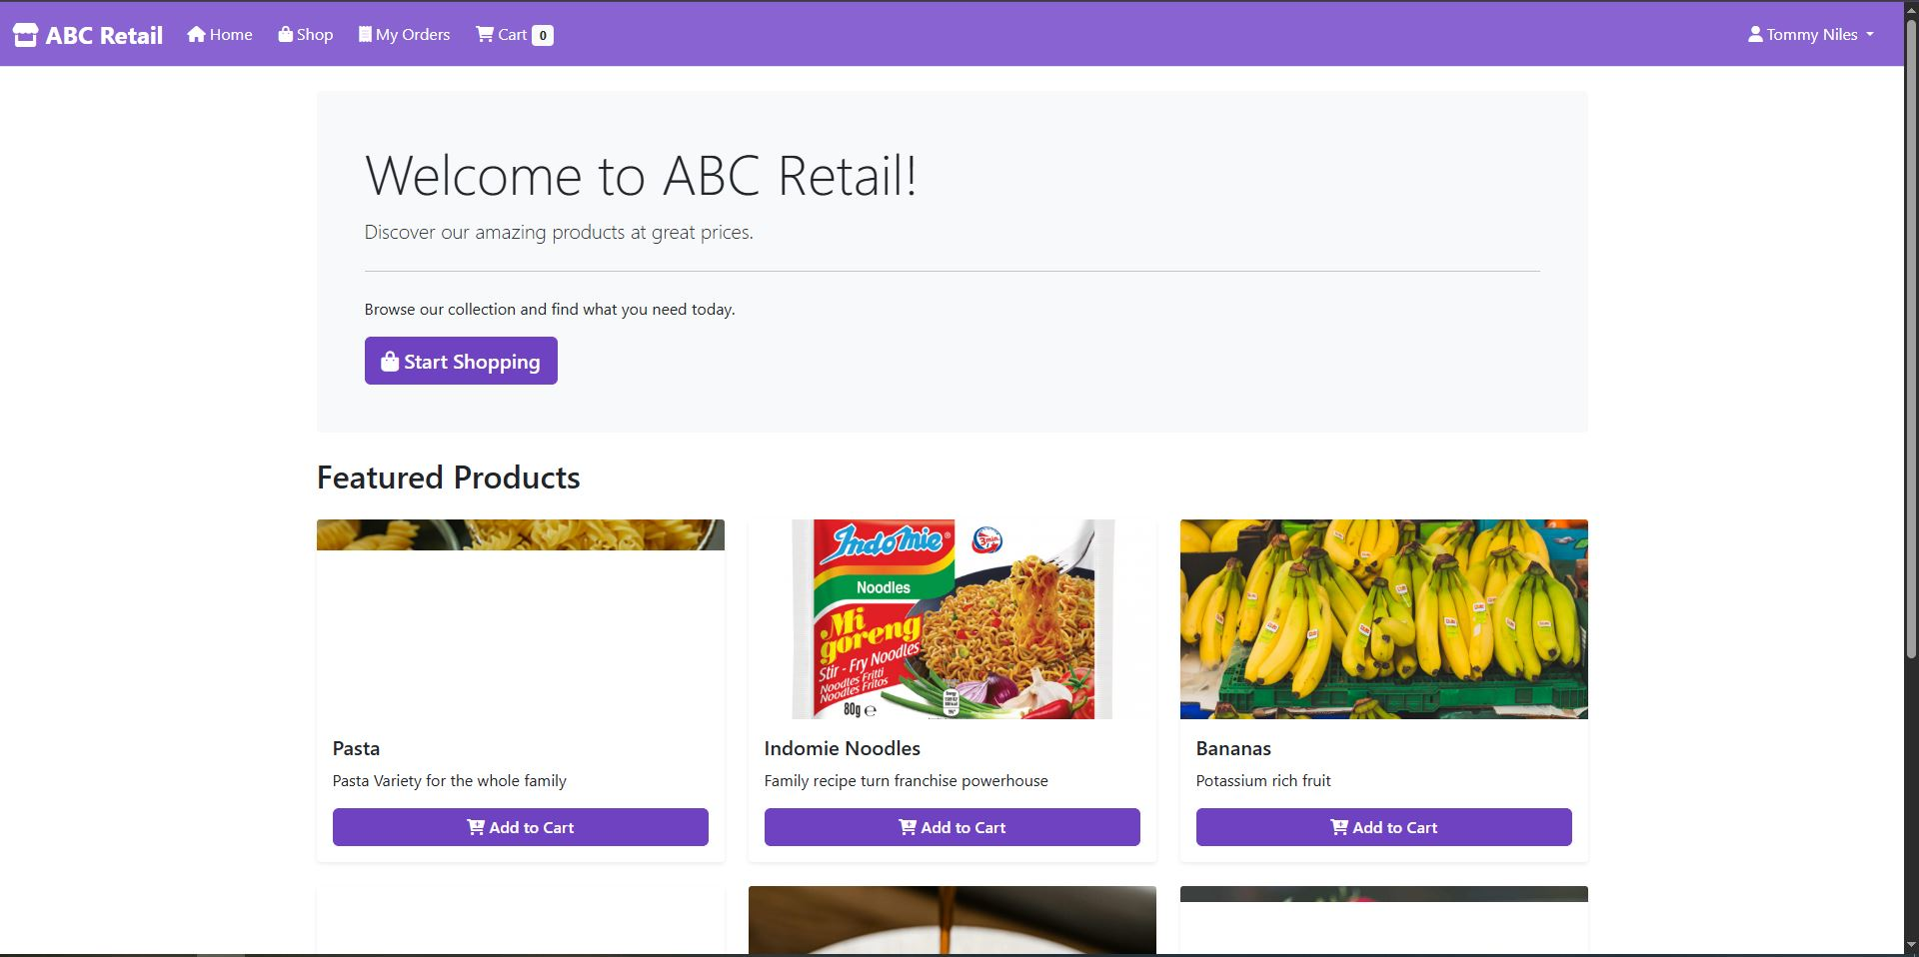

Technology Choices Report
Report on Azure Services
Component | Explanation of Services | Technology Choices | Hosting Models
Azure Web App | “Azure App Service is a platform that lets you run web applications, mobile back ends, and RESTful APIs without worrying about managing the underlying infrastructure” according to (Microsoft, 2025) | Compute | Platform-as-a-Service (PaaS) according to (Wickramasinghe, 2023)
Azure Storage Account | Azure Storage Service is Cloud storage solution with availability, security, durability and scalability built in mind (Microsoft, 2025). This service provides tables, queues, file shares and blob storage capabilities. | Storage | Infrastructure-as-a-Service (IaaS) according to (Wickramasinghe, 2023)
Azure SQL Database | Azure SQL Database is full PaaS database engine which boast 99.99% availability and high performance (Microsoft, 2025). | Database | Platform as a Service (PaaS) according to (Wickramasinghe, 2023)
Azure Functions | “Azure Functions is a serverless solution that allows you to build robust apps while using less code, and with less infrastructure and lower costs” (Microsoft, 2025) | Compute | Platform as a Service (PaaS) according to (Wickramasinghe, 2023)

Motivation of Azure Services

Azure App Service, responsible for Azure Web App, is an azure platform service that allows easy creation and deployment of web applications as well as APIs (Wickramasinghe, 2023) and the best thing about them is the interconnection between Azure and .Net architecture. With Azure App Service ASP .Net as well as Visual Studio all have ease of access and easy collaboration with these tools. Let’s go over the specific requirement for this project as it pertains to Azure Web App:
- This Project required the ability to host MVC web application over the internet to allow for global access and thanks to Azure App Service this was accomplished with ease thanks to the integration of Azure services with Visual Studio, C# and ASP .NET.
Azure Storage are an azure service that allows for storing of data in many forms like files, multimedia files and data entries (Microsoft, 2025) and the main motivation for this tool is that many form factor that allows for a plethora data storage types to be held within Azure. So, let’s go over them as it pertains to Azure Storage:
- This Project required the storage of data entries like a customer and their details as well as a product with all its details so to accommodate that Azure Storage was used as it allowed table storage which fit well with the nature of these data entries.
- This Project also required the storage of multimedia files like a product image as well as a promotional video to go along with the product and Blob storage seemed like the best option to go. Azure Storage was great as it allowed for not only table storage but with blob storage capabilities and it allowed for these files to stored within a single service instance which helps with convenience, simplicity and measure of cost.
Azure SQL Database is a great SQL database engine which gives a platform to store database entries in the cloud for safekeeping and distribution. The main motivation for this service is the need to have a database and the ability to read those data entered to much data within the web application. So, let’s go over specific requirements as it pertains to Azure SQL Database:
- This Project requires the storage of database entries within a SQL database and Azure SQL Database is optimal as there is collaboration with Azure and Visual Studio making it quite easy to implement SQL solutions to the Project.
- This Project also required the reading of SQL Database entries and with the collaboration present with Visual Studio and Azure SQL Database it can implemented with ease hence the reason for the service.
Azure Functions is programming solution that allows for a serverless platform solution to coding for an application (Microsoft, 2025). The main motivation for this service is the simplification of coding solutions for an application so that the project can be more seamless and efficient. Let’s go over the specific requirement for this project as it pertains to Azure Functions:
- This Project needs to hold many complex code functions so having Azure Functions allow for simplified program application that can be more seamless in its functions.
- Another thing this project needs is complex functions like a queue reader like Azure Function and Visual Studio’s queue trigger which allows for the complex function to be performed.

Alternative Azure Technologies

For this Project one specific requirement is the ability to host a website for this project’s web application and an alternative azure technology for achieving this is Azure Static Web App. Azure Static Web App is a service capable of automatically deploying full stack web applications via a code repository (Microsoft, 2024). Azure Static Web Apps are great for static content and well-integrated with the rest of Azure service there is also integration with GitHub which boast coding capabilities. The researcher believes Azure Static Web App is worthy alternative to Azure App Service as it still allows for web hosting and Azure other services integration to host an exceptional website.
This project other specific requirement is storage of data like tables and blobs so an alternative to Azure Storage would be Azure Data Lake Storage and though there is system sharing between the two they are different service with different strengths and weaknesses. Azure Data Lake Storage, according to (Microsoft, 2024) “is a set of capabilities dedicated to big data analytics, built on Azure Blob Storage”. This service is very viable to cover the capabilities of Azure Storage for this project application.
According to (Microsoft, 2025) “Azure Logic Apps is a cloud platform where you can create and run automated workflows in, across, and outside the software ecosystems in your enterprise or organization. This platform greatly reduces or removes the need to write code when your workflows must connect and work with resources from different components, such as services, systems, apps, and data sources”. Taking what Microsoft says we can see this as alternative to Azure functions to allow for automation of code and simplification of a program.
The Project requirement is a database and one of the few Azure alternatives is Azure Cosmos DB which is full managed serverless database that supports multiple database interfaces (Wickramasinghe, 2023). According to (Microsoft, 2025) Azure Cosmos DB offers high responsibility and always online availability which allows them to respond quickly and to large changes. Cosmos DB still possess the database engine capabilities and may be a more powerful alternative which still allows it to be a great alternative.

References
Microsoft, 2024. Introduction to Azure Data Lake Storage. [Online]
Available at: https://learn.microsoft.com/en-us/azure/storage/blobs/data-lake-storage-introduction
[Accessed 14 November 2025].
Microsoft, 2024. What is Azure Static Web Apps?. [Online]
Available at: https://learn.microsoft.com/en-us/azure/static-web-apps/overview
[Accessed 14 November 2025].
Microsoft, 2025. App Service documentation. [Online]
Available at: https://learn.microsoft.com/en-us/azure/app-service/
[Accessed 13 November 2025].
Microsoft, 2025. Azure Cosmos DB - Database for the AI Era. [Online]
Available at: https://learn.microsoft.com/en-us/azure/cosmos-db/introduction
[Accessed 14 November 2025].
Microsoft, 2025. Introduction to Azure Storage. [Online]
Available at: https://learn.microsoft.com/en-us/azure/storage/common/storage-introduction?toc=%2Fazure%2Fstorage%2Fblobs%2Ftoc.json
[Accessed 14 November 2025].
Microsoft, 2025. What is Azure Functions?. [Online]
Available at: https://learn.microsoft.com/en-us/azure/azure-functions/functions-overview
[Accessed 14 November 2025].
Microsoft, 2025. What is Azure Logic Apps?. [Online]
Available at: https://learn.microsoft.com/en-us/azure/logic-apps/logic-apps-overview
[Accessed 14 Novmeber 2025].
Microsoft, 2025. What is Azure SQL Database?. [Online]
Available at: https://learn.microsoft.com/en-us/azure/azure-sql/database/sql-database-paas-overview?view=azuresql
[Accessed 14 November 2025].
Wickramasinghe, S., 2023. Azure Services: The Complete Guide. [Online]
Available at: https://www.splunk.com/en_us/blog/learn/microsoft-azure-services.html#:~:text=Microsoft%20Azure%20is%20a%20comprehensive%20cloud%20computing,Active%20Directory%20for%20identity%20and%20access%20management.
[Accessed 14 November 2025].

Disclosure of AI Usage in my Assessment

Section: Alternative Azure Technologies
AI tool: ChatGPT
Intention: To help generate ideas of which azure alternative technologies there could be to replace the azure technologies used.
Date: 14 Nov. 25
Link: https://chatgpt.com/share/6917561c-e2f0-800f-8572-630906f18cd1

