THE INDEPENDENT INSTITUTE OF EDUCATION | IIE ROSEBANK COLLEGE
iTHRIFT CLOTHES
South African pre-loved branded fashion: website and Android application

XISD6329 Work Integrated Learning 3B
Task 2: Mobile application development, website update and DevOps implementation
Item | Detail
Module | XISD6329 Work Integrated Learning 3B
Assessment | Task 2: Working prototype (50% of the module)
Group | 11 (Eleven)
Group members | Vukosi Rikhotso (ST10439408)  Theo Golele (ST10439863)
Qualification | Diploma in Information Technology in Software Development
Institution | IIE Rosebank College, Pretoria
Client | iTHRIFT Clothes, Pretoria
Repository | https://github.com/ST10439408-VRIKHOTSO/iTHRIFT
Application version | 1.2.0 (build 3)
Date | October 2026

Table of Contents
1. Introduction 5
1.1 Purpose of this document 5
1.2 The solution, in brief 5
1.3 Project links 5
1.4 How the prototype was developed 6
1.5 Acting on the Task 1 feedback 6
2. Team accountability and collaboration 7
2.1 Deliverables and ownership 7
2.2 How accountability was enforced 7
3. DevOps implementation 8
3.1 Planning on Azure Boards 8
3.2 Source control and branching 9
3.3 Continuous integration with GitHub Actions 10
3.4 Release and deployment 11
3.5 Monitoring and logging 12
4. The Android application 12
4.1 Architecture 13
4.2 Program modules and project structure 13
4.3 The graphical user interface 14
Dark theme 14
4.4 Input controls and validation 16
4.5 Settings 17
4.6 Shopping features 18
5. Authentication, roles and security 20
5.1 Registration and sign-in 20
5.2 Password encryption 20
5.3 Single sign-on 21
Configuration, and why the button can be hidden 22
5.4 Roles and server-side access control 23
6. Database design 24
6.1 Database management system 24
6.2 Tables and relationships 24
6.3 Recording how an account signs in 25
6.4 Seed data 26
7. The shared REST API 29
8. Website updates 30
9. Automated testing 35
9.1 Kotlin unit tests 36
9.2 API unit tests 36
9.3 End-to-end smoke test 37
9.4 Results 37
10. Verification and validation 39
11. Help system and user documentation 42
12. Demonstration video 43
12.1 What the walk-through covers 43
13. Release notes 44
14. Preparation for Google Play publication 46
14.1 Draft store listing 46
15. Use of AI tools 46
16. Requirement checklist 47
16.1 Against the marking rubric 47
16.2 Against the module manual, Section 9.2 48
References 49

List of Figures
Figure 1: Azure DevOps Kanban board for iTHRIFT on 2 October 2026, with the assignee on every card (three screenshots joined so that the whole Done column is visible) 9
Figure 2: GitHub Actions run history for the repository: every push runs both workflows, and every run has passed 11
Figure 3: The Android application workflow: the Kotlin unit tests and the debug build both succeed on a clean runner 11
Figure 4: Android, Shop tab: the catalogue grid (left), a product with a size chosen (centre) and the cart (right) 15
Figure 5: Android, checkout: delivery method and address (left), a promo code applied and priced by the server (centre) and the order confirmation (right) 15
Figure 6: Android, Orders tab: the order list (left), an order that can still be cancelled (centre) and a delivered order with Return this item (right) 16
Figure 7: Android, Settings: account details (left), password and appearance (centre), notifications, connection and reset (right) 18
Figure 8: Android, shopping features: the Sale filter with the old prices crossed out (left), the wishlist (centre) and the address book (right) 19
Figure 9: Android, single sign-on: the Google account chooser opened by Continue with Google (left), and Settings after signing in with Google, where no password section is offered (right) 23
Figure 10: Google Cloud console, Credentials: the two OAuth clients registered for iTHRIFT on 1 October 2026, one for the Android app and one for the server 23
Figure 11: Rows in every table after npm run init-db; each meets the ten-record minimum 27
Figure 12: The Customer table: passwords are held only as a per-account salt and an scrypt hash 28
Figure 13: The Product table, first fifteen of 63 rows, with brand and category as foreign keys 28
Figure 14: Orders joined to Payment: twenty-two orders across all four statuses and three payment methods 28
Figure 15: Stock held per size: the sizes of each product add up to its stock 29
Figure 16: The PromoCode table: percentage and fixed codes, minimum spends and one expired code 29
Figure 17: ReturnRequest joined to the order line it belongs to, covering every return status 29
Figure 18: Website, Shop: the catalogue with category filters, condition grades and the Sale link 31
Figure 19: Website, Product detail: the size picker, stock in the chosen size, Save to wishlist and reviews 32
Figure 20: Website, order detail: tracking, delivery details and a return being requested 32
Figure 21: Website, Sale: sale prices with the old price crossed out and the percentage off 33
Figure 22: Website, Checkout: delivery method, address, promo code and the total quoted by the server 33
Figure 23: Website, Admin console: dashboard with revenue by brand and category 34
Figure 24: Website, Admin console: the order queue that staff work through 34
Figure 25: Website, Admin console: the Returns section, where staff approve, reject and refund 35
Figure 26: API unit tests: 22 passed, 0 failed (2 October 2026) 38
Figure 27: End-to-end smoke test: 131 passed, 0 failed (2 October 2026) 39
Figure 28: The API request log from the 25 September run, showing refused requests logged as failures 39
Figure 29: Manual checks on the phone: the stock limit in case 5 (left), an expired promo code in case 18 (centre) and a wrong server address in case 8 (right) 41
Figure 30: Manual checks on the phone: a blank first name in case 10 (left) and a three-digit postal code in case 11 (right) 42
Figure 31: Manual check on the phone: the Shop screen after the device was rotated in case 16 42
Figure 32: Android, Account tab: the way through to the wishlist, addresses, returns, Settings and Help (left), and the in-app Help screen (right) 43

1. Introduction

1.1 Purpose of this document
Task 1 produced the updated project plan, the site maps and the wireframes for the iTHRIFT Clothes solution. Task 2 is where that plan became a working product. This document records what Group 11 built, how it was tested, and where each requirement in Section 9.2 of the module manual has been met. It is the written companion to the code in the repository, to the pipeline that builds it, and to the demonstration video.
The scope of Task 2 is the working prototype: a native Android application that runs on a physical handset, the updated website, the shared REST API and relational database that both clients use, and the DevOps lifecycle that builds, tests and releases them. The final report, the peer and self evaluations and the presentation belong to Task 3 and are not repeated here.
Everything described in this document is in the repository and can be run. Where a claim is better shown by a screenshot from the running system than by a description, an amber box marks it.

1.2 The solution, in brief
iTHRIFT Clothes buys, grades and resells pre-loved branded clothing in South Africa. Before this project the business ran on WhatsApp and Instagram, with stock held in one person’s memory and orders tracked in chat threads. The solution replaces that with two connected sales channels and one administrative console:
- a native Android application for customers, who browse, search, buy and track orders on a phone;
- an updated website carrying both the customer storefront and the staff and administrator console;
- one REST API and one relational database that both clients share, so a business rule is written once and enforced everywhere.
The architecture is the three-tier design carried forward from Task 1. The presentation tier now has two occupants, the application tier is a JSON REST API, and the data tier is a Third Normal Form relational schema. Neither client is trusted: cart totals, stock locking at checkout, order status transitions and role permissions are all enforced on the server. Hiding a control in a client is a convenience, never a control.
The shape of the system
Website (HTML5/CSS3/JS) Android app (Kotlin)
| |
+-------- HTTPS / JSON -------+
|
REST API: Node.js + Express (server/)
auth . roles . cart totals . stock locking
order status rules . reporting
|
parameterised SQL
|
SQLite (prototype) / MySQL 8 (production)

1.3 Project links
These give the marker direct access to the repository, the pipeline and the running evidence. They are gathered here and repeated in the sections they belong to.
Resource | Link
GitHub repository | https://github.com/ST10439408-VRIKHOTSO/iTHRIFT
GitHub Actions (all pipeline runs) | https://github.com/ST10439408-VRIKHOTSO/iTHRIFT/actions
README (setup, demo accounts, release notes) | https://github.com/ST10439408-VRIKHOTSO/iTHRIFT/blob/main/README.md
User guide | https://github.com/ST10439408-VRIKHOTSO/iTHRIFT/blob/main/docs/user-guide.md
Azure DevOps board | https://dev.azure.com/ST10439408/iTHRIFT/_boards/board/t/iTHRIFT%20Team/Issues
Demonstration video (unlisted YouTube) | PASTE YOUR UNLISTED YOUTUBE LINK HERE
Table 1: Where to find each part of the submission
BEFORE YOU SUBMIT
One link above is still a placeholder: the demonstration video. Paste it in, and put the video link in the README as well.
Open every link in a private browser window first. The lecturer must be able to reach the repository, the Actions history and the video without signing in as you. The Azure DevOps project is private and the lecturer has been invited to it, so confirm with them that the board link opens.

1.4 How the prototype was developed
Development followed the pacer in the module manual and the guidance given in the weekly collaboration sessions. Implementation began once the Task 1 design was signed off, with the lecturer confirming the two-channel scope and the API-first sequence. Building the API first was the decision that shaped everything after it: with the contract fixed, the website and the application could be worked on in parallel without either developer waiting on the other.
The two members talked about the task every day rather than holding scheduled meetings. The split of the work was agreed on a WhatsApp call on 18 September 2026, the day the Task 1 feedback was received; the meeting log is in Section 2.2. Any change to the agreed API contract was made in the shared repository, where the automated tests exercise every route, so that both developers were always building against the same agreement.

1.5 Acting on the Task 1 feedback
Task 1 scored 91 out of 100. The lecturer’s marks showed where the remaining nine were lost, and each of those points was addressed before any Task 2 evidence was captured, so the screenshots in this document show the corrected system. The table sets out what was changed for each criterion.
Task 1 criterion | Mark | What we changed for Task 2
Cover page, contents, list of figures | 9 / 10 | This document now carries a list of figures as well as a table of contents, and every screenshot is numbered and captioned so the marker can find it from either list.
Update project plan | 9 / 10 | The plan is carried forward rather than restated. Section 3 reports what each DevOps phase actually looked like in practice, and Section 2.1 records who owned each deliverable.
File and folder structure | 8 / 10 | Renamed the 37 product images that used underscores (adidas_eqt.jpg is now adidas-eqt.jpg) and updated the seed script to match. Renamed both task documents to lowercase, hyphenated names with no spaces or commas, for example xisd6329-task1-group11-project-plan.docx. New evidence images follow the same rule.
HTML page code | 17 / 20 | Validated the static pages and the rendered output of every website route with html-validate, using its recommended and WCAG rule sets. Fixed the 38 table header cells that had no scope attribute and the 6 buttons with no type attribute, and pinned the icon library to a fixed version instead of @latest, so a third-party release can no longer change the site without us. Every page now validates with no errors.
Web page content | 13 / 15 | Edited the storefront copy so that sentences are no longer joined with dashes, which read as unfinished on a small screen. Eight phrases were rewritten, including the catalogue heading, the product button and the checkout note. Emoji icons were also removed from the navigation, buttons and form labels on both the website and the mobile web app, so every label is plain text.
Client needs, site map, wireframes, GitHub | 10, 10, 10, 5 | Full marks, so these were kept. The Android screens and the updated website follow the Task 1 wireframes.
Table 2: How each point of the Task 1 feedback was acted on
The file-naming point deserved the most attention, because it lost the most marks and because it is the easiest to regress on: a single photograph saved from a phone with a default name brings it back. Renaming the images meant changing the seed script in the same commit, since the database stores each product’s image file name, and the end-to-end suite was run again afterwards to confirm that every product still loads its photograph.

2. Team accountability and collaboration
Task 2 is a group deliverable and each member is accountable for the items allocated to them. Ownership here means the named member is responsible for finishing the deliverable and making it work; the supporting member can still contribute. The allocation carries over from Task 1 and reflects who actually built what.

2.1 Deliverables and ownership
Deliverable | Owner | Support
REST API endpoints and business rules | Vukosi Rikhotso | Theo Golele
Database schema, seed data and constraints | Vukosi Rikhotso | None
Authentication, roles and single sign-on | Vukosi Rikhotso | Theo Golele
Android UI: Cart, Checkout, Orders, Account | Vukosi Rikhotso | Theo Golele
Android UI: Shop, Search, Product detail | Theo Golele | Vukosi Rikhotso
Settings and Help screens | Vukosi Rikhotso | Theo Golele
Website markup, styling and client logic | Theo Golele | Vukosi Rikhotso
Unit tests and GitHub Actions workflows | Vukosi Rikhotso | Theo Golele
Help system and user documentation | Theo Golele | Vukosi Rikhotso
Demonstration video and release notes | Theo Golele | Vukosi Rikhotso
Signed release build and Play Store assets | Vukosi Rikhotso | Theo Golele
Table 3: Deliverables and who owned each one

2.2 How accountability was enforced
Accountability rested on named ownership and on the pipeline rather than on trust. Each deliverable in the table above has one owner, the commit history on GitHub records what was changed and when, and a change only counts as done once the GitHub Actions run for it is green, so that done was not a matter of opinion. The Azure DevOps board in Section 3.1 shows the same work packages with their assignees and their current state.
Because the group has only two members, every deliverable also names a supporting member who can take it over. That is the mitigation for the highest-rated risk in the Task 1 risk register: in a group this small, one person being unavailable for a fortnight is not a delay, it is a failure, unless somebody else already knows the code.
Date | Meeting | What came out of it
18 September 2026 | Task 1 feedback received | The group received the mark and feedback for Task 1 (91 out of 100). The points raised are answered in Section 1.5.
18 September 2026 | WhatsApp call, both members | The Task 2 work was split between the two members, as set out in the deliverables table above.
Table 4: Meeting log for Task 2
Beyond these two entries, day-to-day contact was informal: the two members spoke about the task every day, and those conversations are not listed one by one.

3. DevOps implementation
The module asks for the full DevOps lifecycle rather than a single hand-over at the end. The team used GitHub to hold the code, GitHub Actions to build and test every change automatically, and an Azure DevOps board to record the work packages and who owns each one. The eight phases below are the ones set out in the Task 1 plan; this section is what each one actually looked like in practice.
Phase | Tool | What happens
Plan | Azure Boards (Kanban) | Each Task 2 work package is an issue on the board with one assignee, in To Do, Doing or Done.
Code | GitHub, VS Code, Android Studio | One repository holds the website, the API and the app. Small commits go to the main branch, each with a message that says what changed.
Build | GitHub Actions, Gradle, npm | Two workflows run on every push: one assembles the Android debug build, one installs and starts the API.
Test | JUnit, node:test, smoke test | 203 automated checks. A red run is fixed before any further work is pushed.
Release | Tag-triggered workflow | A v* tag produces a signed APK and App Bundle plus the release notes for that version.
Deploy | Play Console / host | The APK is installed on a physical handset for the demonstration and prepared for the Play Store.
Operate | Seeded demo environment | A seeded database and known demo accounts keep the walk-through repeatable.
Monitor | Server logging, Logcat | Per-request logging on the API and network-boundary logging in the app; anything found is fixed and covered by a test.
Table 5: The eight DevOps phases as applied to the iTHRIFT prototype

3.1 Planning on Azure Boards
The work for this task is recorded on a Kanban board in an Azure DevOps project named iTHRIFT, which uses the Basic process with the columns To Do, Doing and Done. Each work package is one issue with a single assignee. On 2 October 2026 the board held seventeen issues: thirteen in Done, two in Doing (this report and the manual testing on the phone) and two in To Do (the demonstration video and the Play Store listing).
The board was set up on 2 October 2026, late in the task, and the issues were entered then to record work that was already complete or under way. Before that date the day-to-day record of progress was the commit history on GitHub and the pipeline runs in Section 3.3. The board therefore shows the state of the work and who owns each part, but it is not a day-by-day history of the task, and the dates on its items show that. Keeping the board current from the first day is the main process improvement the group carries into the final task.
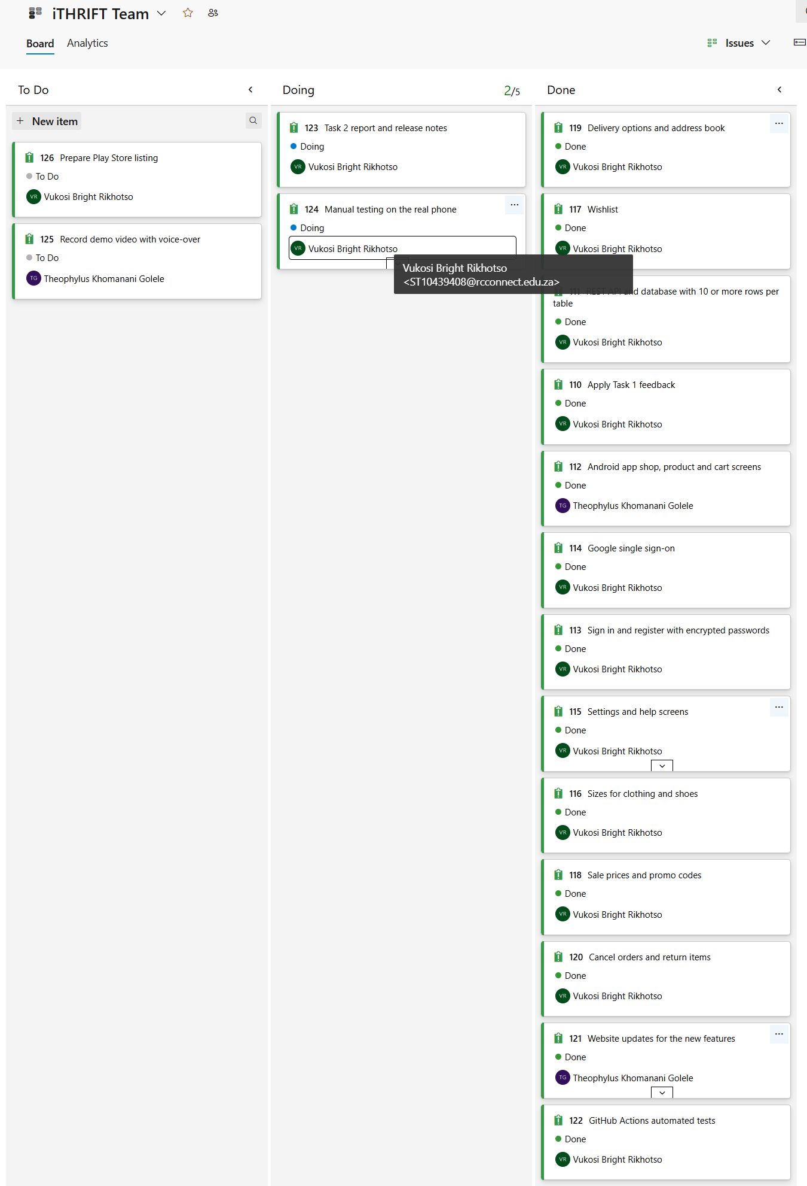
Figure 1: Azure DevOps Kanban board for iTHRIFT on 2 October 2026, with the assignee on every card (three screenshots joined so that the whole Done column is visible)
The board is at https://dev.azure.com/ST10439408/iTHRIFT/_boards/board/t/iTHRIFT%20Team/Issues

3.2 Source control and branching
All three products live in one GitHub repository, which is why a change to a shared contract, such as an API route or a JSON field name, can be made in a single commit rather than in three that have to land together. The group commits to the main branch in small steps, each with a message that says what changed, and every push runs both build workflows, so a change that breaks something shows as a red run within minutes and is fixed before more work is added. The Task 1 plan described feature branches and reviewed pull requests. In practice only one side branch was used (rebrand-ithrift-accessibility), and the commit history shows the rest of the work going straight to main. With two members and every push tested automatically this was workable, but it meant there was no formal review step before a change landed, which the group acknowledges as a limitation. The repository was initialised with a README and a .gitignore, and code is committed and pushed as it is written rather than in one large drop at the end. In line with the module rule, nothing is distributed as a ZIP file.
A typical change
# a typical change, made on main
git add -A
git commit -m "Add Kotlin and API unit tests"
git push origin main
# the push starts both workflows on GitHub Actions
# a red run is fixed before the next change is pushed

3.3 Continuous integration with GitHub Actions
Three workflows live in .github/workflows/. Two of them run on every push and every pull request to main; the third runs only on a release tag, because releasing is a decision and not a side effect of committing.
Workflow | Trigger | What it does
android.yml | push, PR | Sets up JDK 17, runs the 50 Kotlin unit tests, assembles the debug build, uploads the APK as an artefact.
api-and-website.yml | push, PR | Sets up Node 24, runs the 22 API unit tests, seeds the database, starts the server, runs the 131-check smoke test.
release.yml | tag v* | Runs the tests, restores the keystore from a repository secret, assembles a signed APK and App Bundle, then deletes the keystore from the runner.
Table 6: The three GitHub Actions workflows
The ordering inside each workflow is deliberate. The unit suites need no server and no emulator and finish in seconds, so they run first: if a business rule is broken there is no point spending a minute booting the API to find out.
.github/workflows/android.yml (extract)
jobs:
build:
name: Run unit tests and assemble the debug build
runs-on: ubuntu-latest
steps:
- uses: actions/checkout@v4
- uses: actions/setup-java@v4
with:
distribution: temurin
java-version: '17'
- uses: gradle/actions/setup-gradle@v4
- run: chmod +x gradlew
- name: Run the unit tests
run: ./gradlew testDebugUnitTest --no-daemon --stacktrace
- name: Assemble the debug build
run: ./gradlew assembleDebug --no-daemon --stacktrace
- name: Upload the debug package
uses: actions/upload-artifact@v4
with:
name: ithrift-debug-apk
path: app/build/outputs/apk/debug/*.apk
if-no-files-found: error

The two screenshots below were taken by the group on 1 October 2026. By the end of that day each workflow had run seven times, once for every push to main, and every run passed, including the push that added the shopping features described in Section 4.6 (commit 2801b1e).
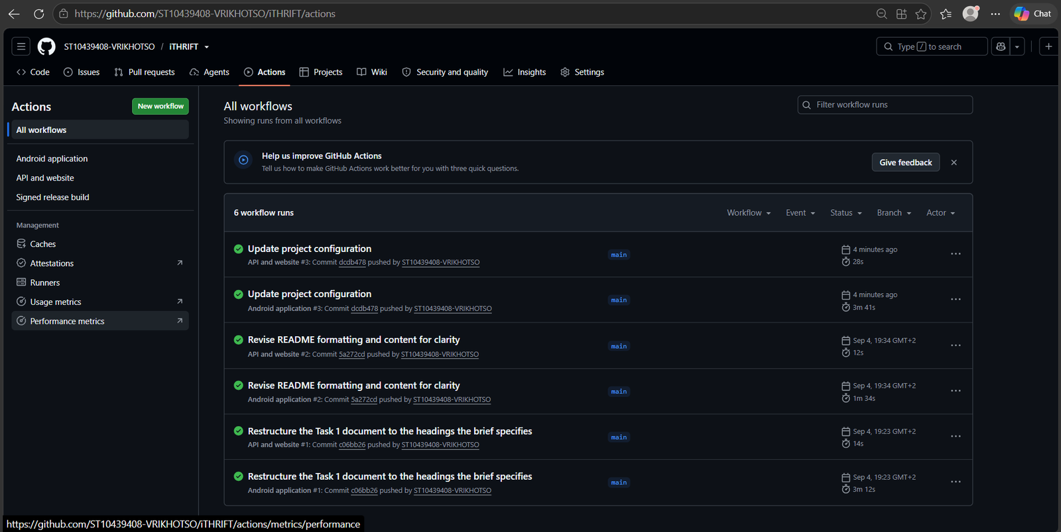
Figure 2: GitHub Actions run history for the repository: every push runs both workflows, and every run has passed
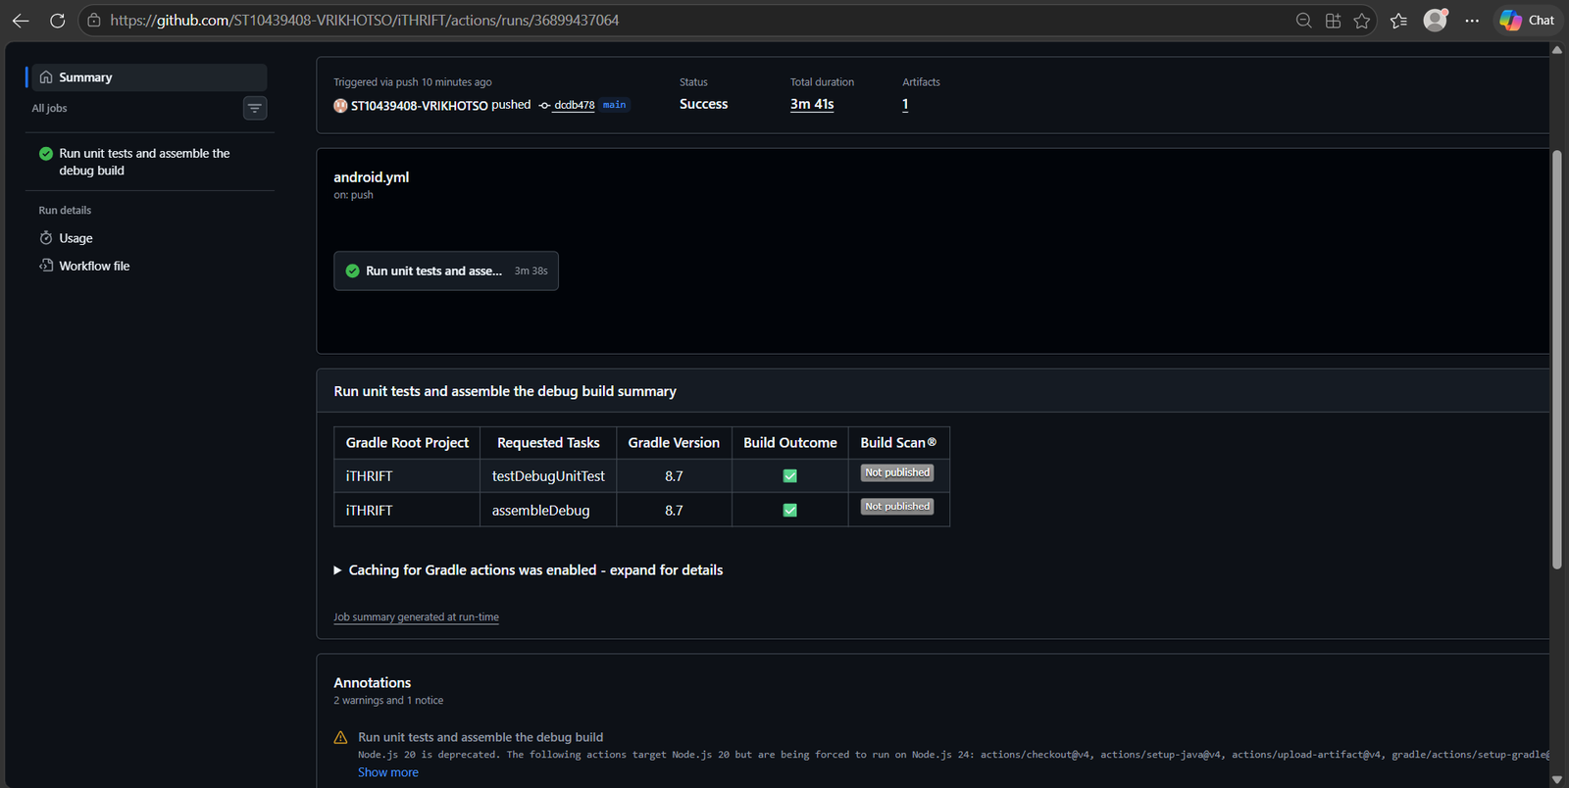
Figure 3: The Android application workflow: the Kotlin unit tests and the debug build both succeed on a clean runner

3.4 Release and deployment
Any build that clears integration is a candidate release, so releasing is a decision rather than a scramble. Tagging a commit triggers release.yml, which runs the tests again, because a tag is not a reason to skip them but the reason to be surest, and then assembles a signed APK and App Bundle.
The keystore is never committed. It is held base64-encoded in a repository secret, restored to the runner’s temporary directory for the build, and deleted afterwards in a step that runs even if the build failed. This matters more than it might appear: anyone holding that file can publish an update to the Play Store under the group’s name, and unlike a password it cannot be rotated once an app is live.

3.5 Monitoring and logging
The API writes one line per request, when the response finishes so that the status code and the duration are known. Failures go to stderr rather than stdout, so a CI log or a log viewer can be filtered down to just the problems. Nothing from the request body is logged, because that is where passwords and ID tokens travel.
server/index.js: request logging
app.use('/api', (req, res, next) => {
const startedAt = process.hrtime.bigint();

res.on('finish', () => {
const ms = Number(process.hrtime.bigint() - startedAt) / 1e6;
const who = req.user ? `${req.user.type}#${req.user.id}` : 'anonymous';
const line = `[api] ${req.method} ${req.originalUrl} -> ${res.statusCode} (${ms.toFixed(1)}ms) [${who}]`;
if (res.statusCode >= 400) console.error(line);
else console.log(line);
});

next();
});

What that produces while the smoke test runs
[api] POST /api/auth/login -> 200 (86.4ms) [anonymous]
[api] GET /api/auth/profile -> 403 (1.1ms) [staff#2]
[api] PUT /api/auth/profile -> 400 (0.9ms) [customer#1]
[api] POST /api/orders -> 201 (18.7ms) [customer#13]
[api] PUT /api/admin/users/13/status -> 200 (14.0ms) [admin#1]

On the client, OkHttp’s logging interceptor records the start and end of every network call, and the Settings, Account and Help screens log the decisions a person would want explained after the fact: a theme change, a saved profile, a rejected sign-in. Logging is included deliberately: the module asks for evidence that the team understands its own code, and a log line at each boundary is what makes a failure explainable rather than mysterious.

4. The Android application
The application is written in Kotlin and targets mid-range Android handsets, which are what most South African customers carry. It runs on a physical phone rather than only on an emulator, which is what the demonstration video shows.
Setting | Value | Why
Language | Kotlin | The supported language for Android; null-safety removes a whole class of crash.
minSdk | 24 (Android 7.0) | Reaches older handsets that are still common second-hand, which is the same market the shop sells into.
targetSdk / compileSdk | 35 | Current platform behaviour and the Play Store requirement.
View layer | View binding | Compile-time-checked view references; no findViewById, no cast errors at runtime.
Networking | Retrofit 2 + OkHttp + Gson | A typed interface over the same REST API the website calls.
Concurrency | Kotlin coroutines | Network calls off the main thread without callback nesting.
Images | Coil (with SVG support) | Loads product images straight from the API, including generated SVG placeholders.
Sign-in | Credential Manager + Google ID | The supported single sign-on route; GoogleSignInClient is deprecated.
Table 7: The application’s technical configuration and the reason for each choice

4.1 Architecture
The app uses a single-activity design. One activity hosts a fragment container and a bottom navigation bar with five tabs; every other screen opens on top of the current tab through the fragment back stack, so the system back button behaves as a person expects without any custom handling.
Screen state is held in the fragment and network access goes through a shared, typed API client rather than through a per-screen ViewModel. This is worth stating plainly, because it is a departure from the Model-View-ViewModel pattern that Google’s architecture guide recommends. The reason is that the logic worth extracting from a screen in this app is not state management, since the screens are thin and each one loads a list and renders it, but validation, parsing and formatting, and those have been extracted into framework-free objects that the unit tests exercise directly. The cost of the decision is honest: rotating the device re-fetches rather than restoring from memory. Introducing ViewModels is the first refactor to make if the screens grow.
Layer | Responsibility | Example types
Activity | Hosts the fragment container, the toolbar and the bottom navigation | MainActivity
Fragment | Renders state, captures input, holds no business rules | ShopFragment, SettingsFragment, AccountFragment
Data / API client | HTTP calls, session token, typed results | ApiClient, ApiService, safeApiCall
Session and settings | The signed-in token and the device preferences | SessionManager, AppSettings
Utilities | Validation, URL parsing, formatting; framework-free and unit-tested | Validators, ApiUrl, formatMoney
Table 8: Layers of the Android application and their responsibilities

4.2 Program modules and project structure
The code is organised by feature, so a screen and the classes that support it sit together. This is what a marker will see in the repository.
app/src/main/java/com/codecouture/ithrift/
MainActivity.kt single-activity shell: toolbar, container, bottom nav
IThriftApplication.kt applies the saved theme before the first screen draws
data/
ApiClient.kt builds Retrofit/OkHttp against the configured server
ApiService.kt the typed REST interface
ApiResult.kt safeApiCall(): every failure becomes a message
Models.kt the JSON shapes the API returns
SessionManager.kt the signed-in token and user
AppSettings.kt theme, notifications, server address
GoogleSignIn.kt Credential Manager -> a Google ID token
LookupCache.kt brands and categories, fetched once
ui/
BaseFragment.kt shared helpers every screen uses
shop/ search/ product/ cart/ checkout/ orders/
account/ AccountFragment, SettingsFragment, HelpFragment
util/
Validators.kt every input rule, in one tested place
ApiUrl.kt server address -> a URL Retrofit accepts
Extensions.kt money, dates, star ratings, status colours

4.3 The graphical user interface
The five bottom-navigation tabs, Shop, Search, Cart, Orders and Account, are the only top-level destinations, so a customer is never more than two taps from the catalogue. The Cart tab carries a badge with the number of items in it.
The catalogue uses a two-column grid. One column wastes the screen and three make the photographs too small to judge condition, and condition is the deciding factor when buying second-hand clothing: a shopper is looking for the mark that the description mentions. Every product tile therefore leads with the photograph and carries the condition grade on it.

Dark theme
The app follows the phone’s light and dark setting, and the customer can override it in Settings. This was implemented by redefining the colour palette in res/values-night/colors.xml rather than by touching any layout. Every layout already referred to the palette by name, so one file gives the whole app a dark theme and no screen can be left behind on a colour somebody hard-coded.
The dark values are not a straight inversion of the light ones. Pure white text on pure black glares and smears on an OLED panel, so the background is a very dark grey and the text is a warm off-white, and the status colours are lightened to hold their contrast against the darker ground. The theme is applied in Application.onCreate rather than in the activity, so the app opens in the right theme instead of flashing light and then going dark.
The screenshots below were taken on a Samsung Galaxy A71 on 1 October 2026, with the app pointed at the API running on a laptop on the same network. The phone is set to dark mode, so they show the dark theme. Each figure reads left to right in the order a customer meets the screens.
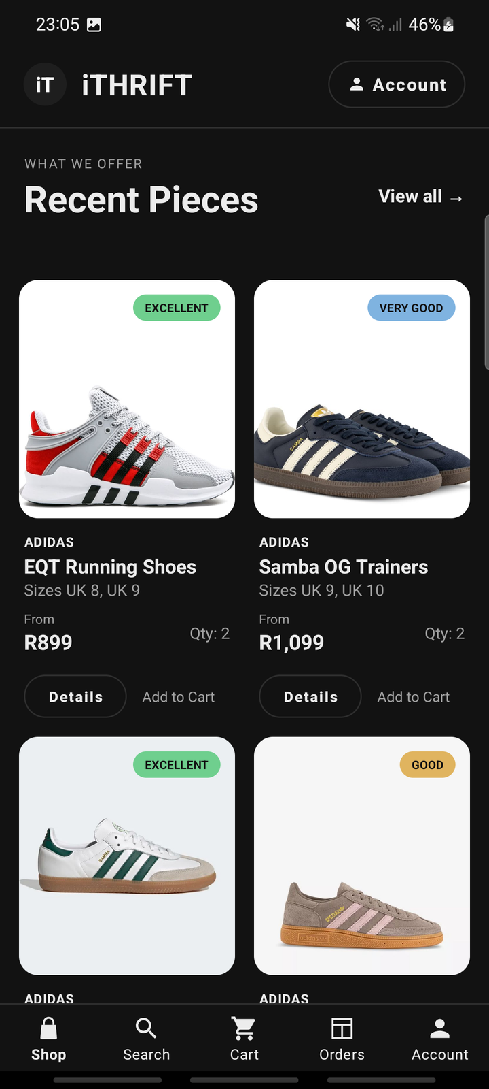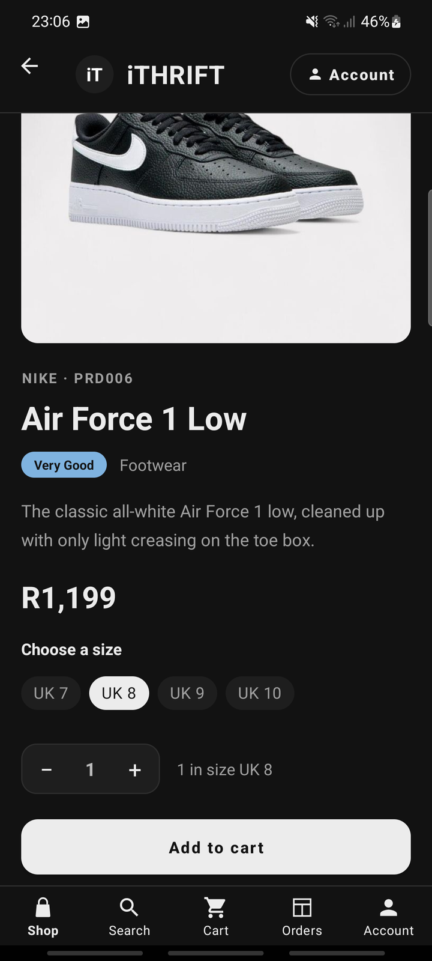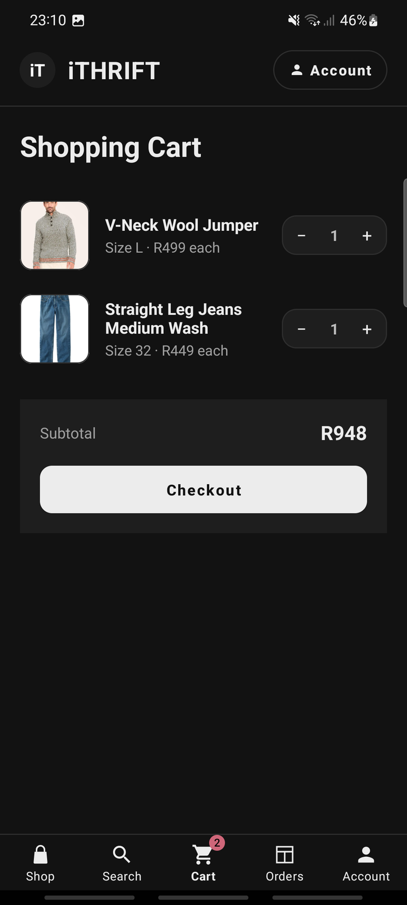
Figure 4: Android, Shop tab: the catalogue grid (left), a product with a size chosen (centre) and the cart (right)
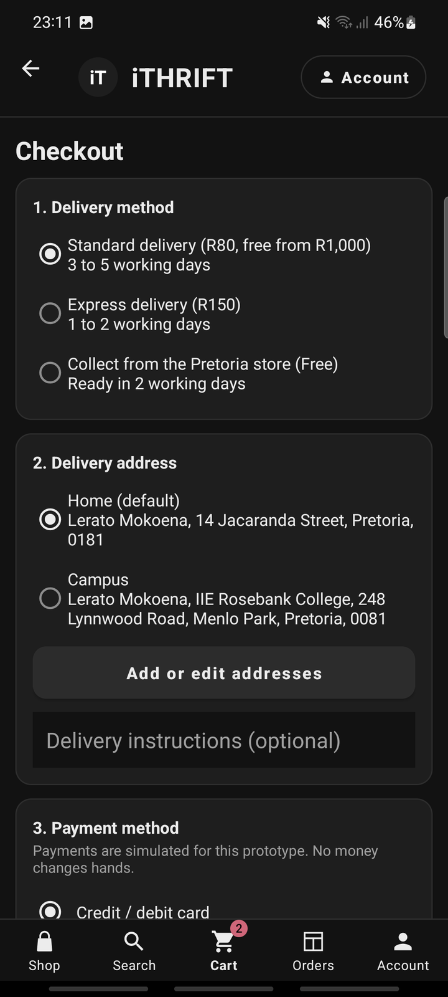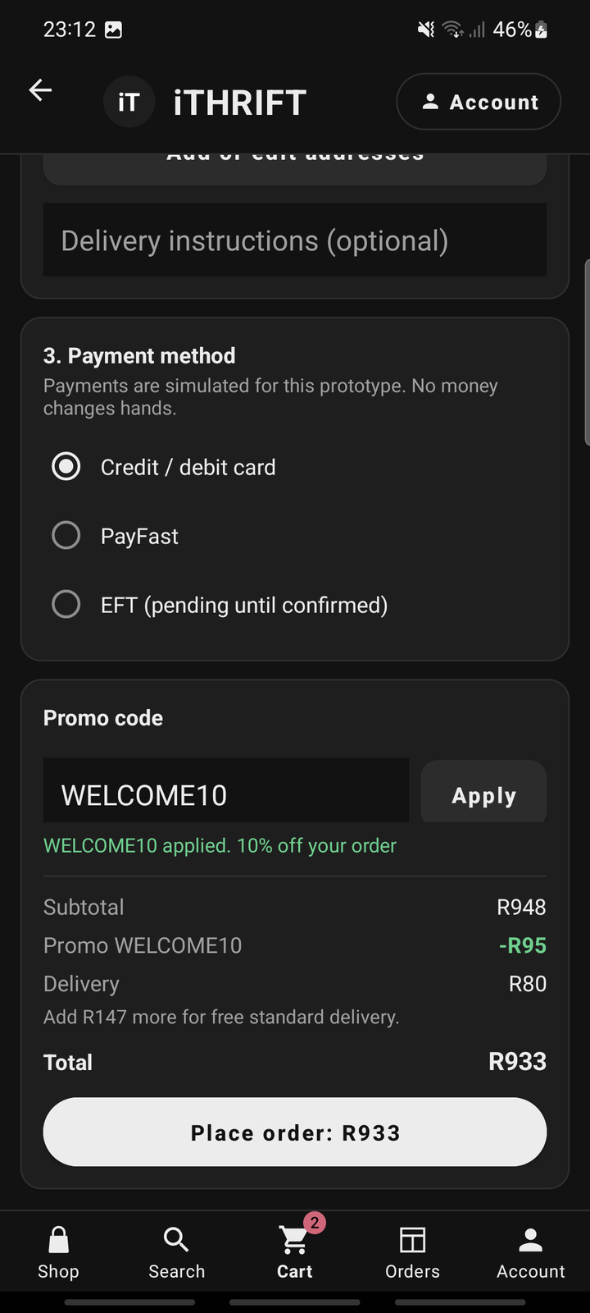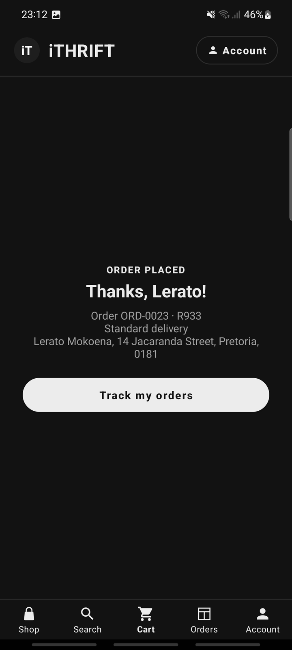
Figure 5: Android, checkout: delivery method and address (left), a promo code applied and priced by the server (centre) and the order confirmation (right)
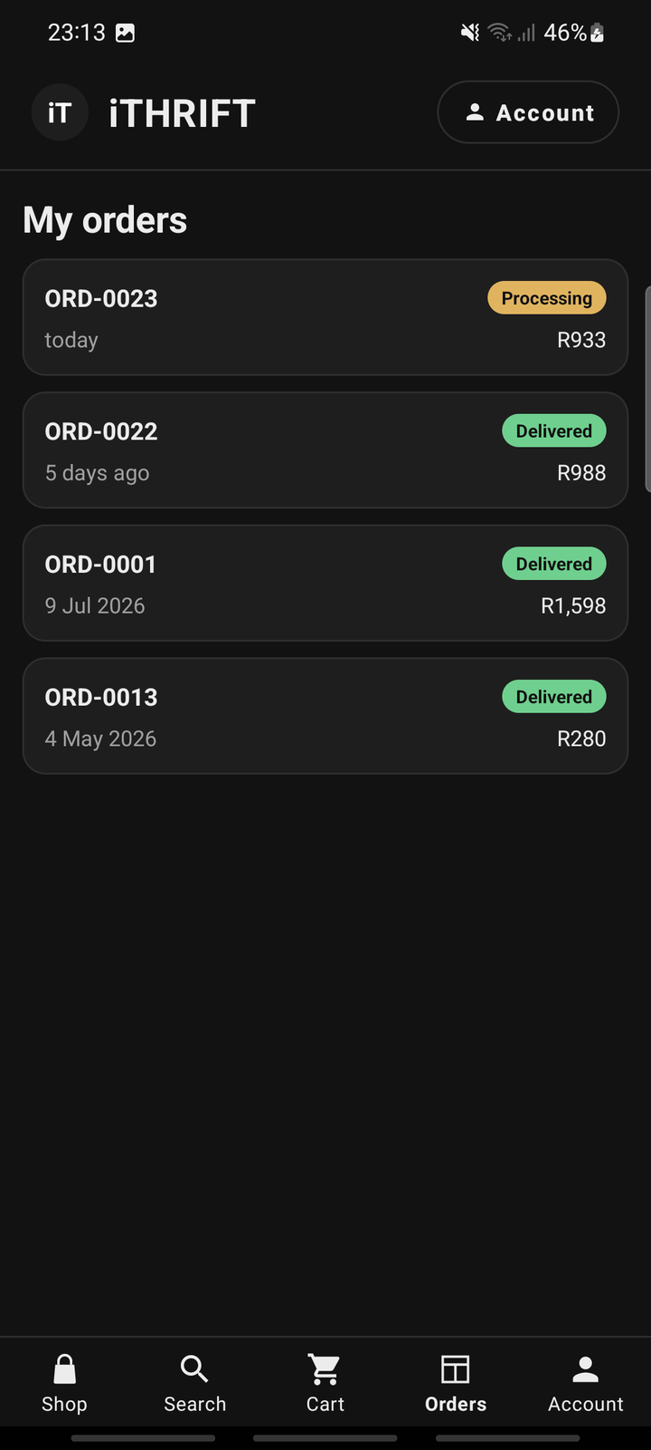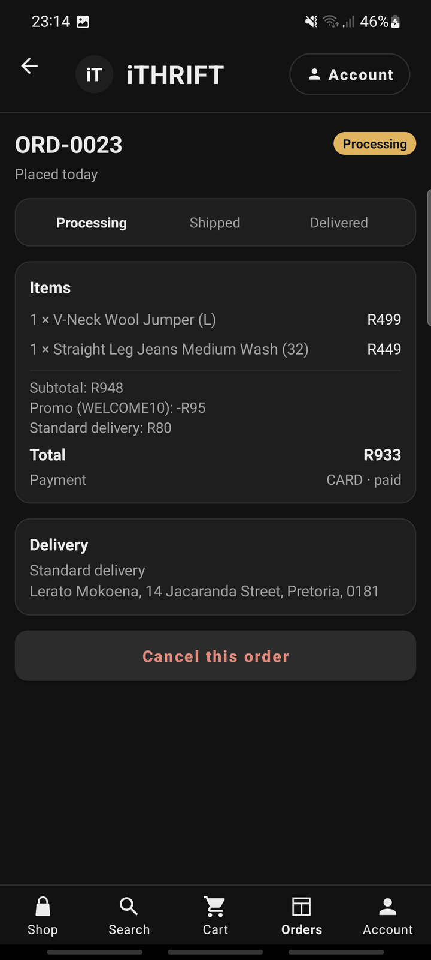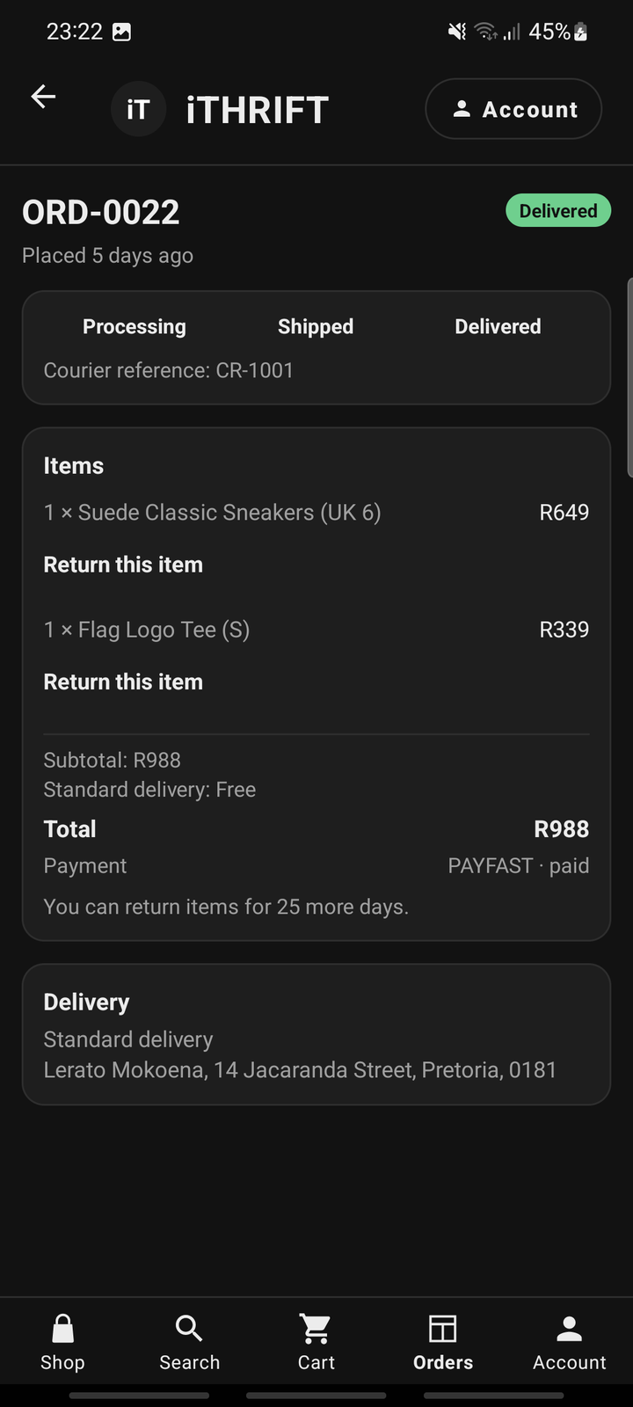
Figure 6: Android, Orders tab: the order list (left), an order that can still be cancelled (centre) and a delivered order with Return this item (right)

4.4 Input controls and validation
Every input control is validated before it does any work, and the app is built so that a bad input produces a helpful message rather than a crash. The rules live in one object, Validators, rather than being written inline in each screen, so "what counts as a valid password" is answered in exactly one place, and that place matches the server’s own rule. When the two disagree, the customer is told their password is fine and then rejected by the API, which is the most frustrating kind of error there is.
Validators deliberately touches no Android type. That is what lets the unit tests run on a plain JVM in seconds on the CI runner, with no emulator. Every function returns null when the value is acceptable, or the message to show against the field when it is not.
app/src/main/java/com/codecouture/ithrift/util/Validators.kt (extract)
object Validators {

/** Mirrors isPasswordStrong() in server/utils/password.js. Keep the two in step. */
fun password(value: String): String? = when {
value.isEmpty() -> "Enter a password."
value.length < 8 -> "Password must be at least 8 characters long."
!value.any { it.isUpperCase() } -> "Password must include an uppercase letter."
!value.any { it.isDigit() } -> "Password must include a number."
else -> null
}

fun quantity(value: String, inStock: Int): String? {
val number = value.trim().toIntOrNull()
?: return "Enter a quantity as a whole number."
return when {
number < 1 -> "Order at least one."
inStock <= 0 -> "That item is out of stock."
number > inStock -> "Only $inStock in stock."
else -> null
}
}
}

Network calls cannot crash a screen either. Every call goes through safeApiCall, which turns a network failure, a non-2xx response and a missing body all into a displayable message. Nothing above that layer ever sees an exception, which is why an unreachable server shows a retry message instead of closing the app.
app/src/main/java/com/codecouture/ithrift/data/ApiResult.kt (extract)
sealed class ApiOutcome<out T> {
data class Success<T>(val data: T) : ApiOutcome<T>()
data class Failure(val message: String) : ApiOutcome<Nothing>()
}

suspend fun <T> safeApiCall(block: suspend () -> Response<T>): ApiOutcome<T> {
return try {
val response = block()
if (response.isSuccessful) {
val body = response.body()
if (body != null) ApiOutcome.Success(body)
else ApiOutcome.Failure("Empty response from server.")
} else {
ApiOutcome.Failure(parseErrorBody(response.errorBody()))
}
} catch (e: IOException) {
ApiOutcome.Failure("Couldn't reach the server. Check the server address " +
"in Account, and make sure npm start is running.")
} catch (e: Exception) {
ApiOutcome.Failure(e.message ?: "Something went wrong.")
}
}

parseErrorBody reads the API’s own { "error": "..." } body, so the message the customer sees is the one the server wrote: "Only 2 of this item is in stock." rather than "HTTP 409". Eight unit tests cover this one function, because every error message in the app passes through it.

4.5 Settings
The Account tab leads to a Settings screen, which is where the module’s requirement that "the user must be able to change their settings in the app" is met. The sections are grouped by what the setting belongs to, because that is how a customer thinks about it.
Section | What the customer can change | Where it is stored
Your details | First and last name, phone number, delivery address, city, postal code | The account, through PUT /api/auth/profile
Password | The account password; the current one is required first | The account, through POST /api/auth/change-password
Appearance | Light, dark, or follow the system setting | This phone (SharedPreferences)
Notifications | Order updates; new arrivals and sales | This phone (SharedPreferences)
Connection | The server address, with a Test connection button | This phone (SharedPreferences)
Reset | Clear cached data; sign out | Nothing is stored
Table 9: The settings screen, and where each setting is kept
The split between the two storage locations is the point of the design rather than an implementation detail. A delivery address kept in SharedPreferences would mean a customer who changed it on the website still saw the old one on the phone; an appearance setting kept in the database would follow them onto a friend’s phone. Account settings go to the database through the API, and device settings stay on the device.
Three smaller decisions are worth recording:
- The Password section is removed entirely for an account created through single sign-on. The API reports canChangePassword, and offering the section and then rejecting it would be a dead end.
- Test connection calls the API and says plainly what came back. Almost every "it isn’t working" turns out to be the wrong server address, and this turns a mystery into a sentence.
- Clear cached data does not sign the customer out. Clearing a cache and losing a session are different things, and a button that does both surprises people.
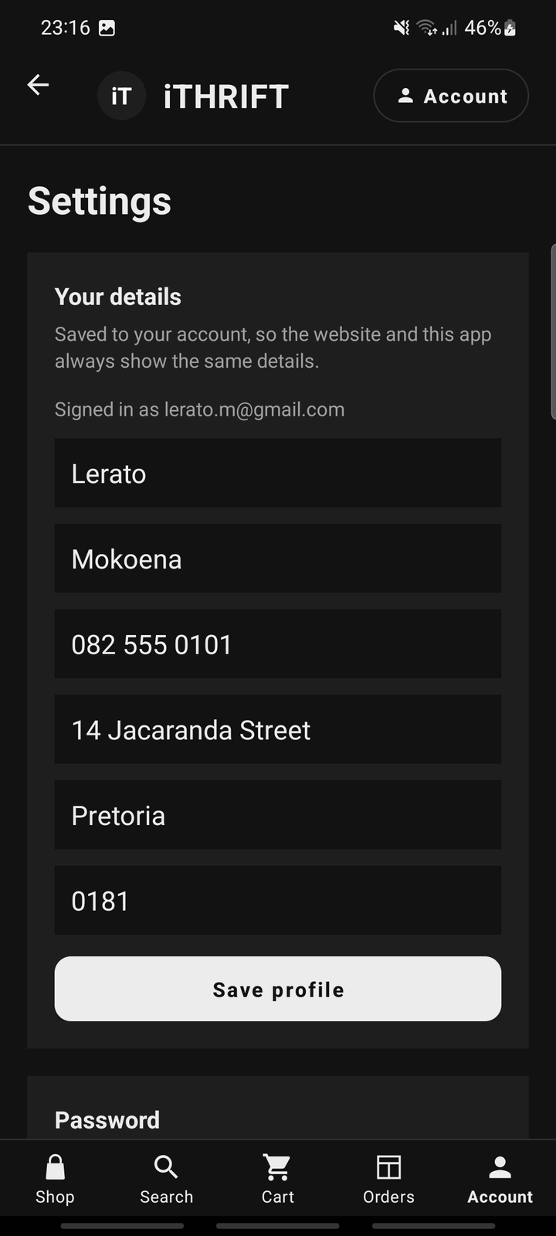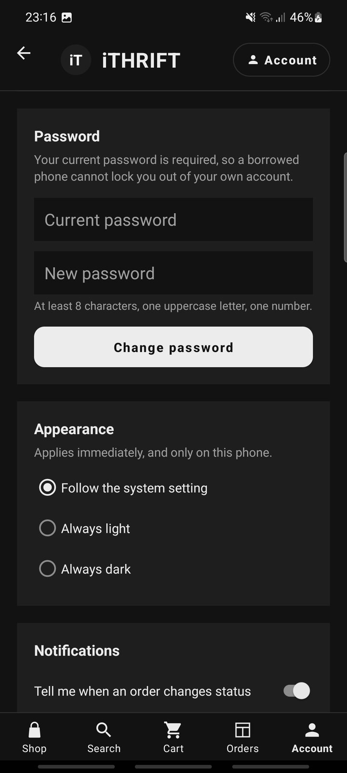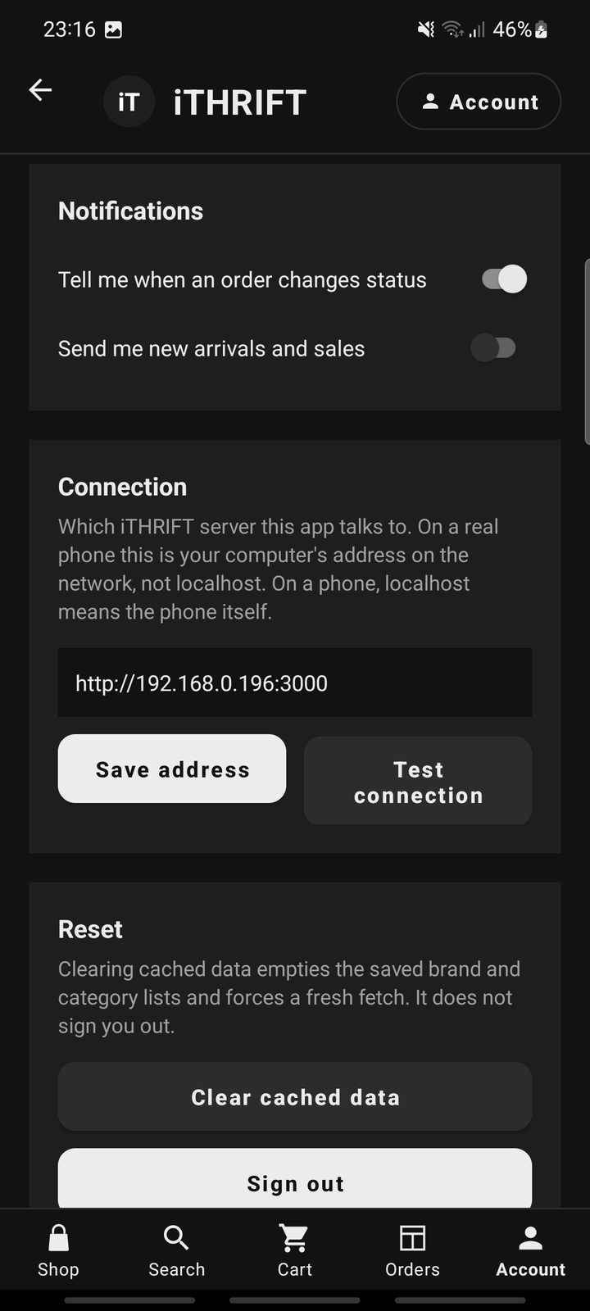
Figure 7: Android, Settings: account details (left), password and appearance (centre), notifications, connection and reset (right)

4.6 Shopping features
After the first Task 2 build was running on the phone, five groups of shopping features were added, each one on the phone and on the website against the same API. They are the features a customer expects of a clothing shop, and in every case the rule was written on the server and not in a screen.
Feature | What the customer can do | Where the rule is enforced
Sizes | Pick a size on the product screen. Only sizes in stock are offered: shoes UK 3 to UK 10, tops and dresses XS to XXL, trousers and jeans waist 28 to 44 | The ProductSize table. The cart and the checkout refuse a size that is not in stock
Wishlist | Save a piece from the product screen, then move it to the cart or remove it | The WishlistItem table, so the list is the same on the phone and on the website
Sale prices and promo codes | See the old price crossed out and the percentage off, filter the catalogue to sale items, and apply a code at checkout | Product.OriginalPrice and the PromoCode table, priced by server/utils/pricing.js
Delivery and addresses | Keep an address book with a default address, and choose standard delivery, express delivery or collection | The Address table and POST /api/orders/quote
Cancelling and returns | Cancel an order that is still processing, and return a delivered item within 30 days | The order status rules in the API, and the ReturnRequest table
Table 10: The shopping features, and where each rule is enforced
The total is never worked out on the phone. Every change at checkout, whether a different delivery method or a promo code, asks the API for a quote, and the screen shows what comes back. The figure on the Place order button is therefore the figure the order is placed for. Standard delivery costs R80 and is free once the goods, after any discount, come to R1,000 or more. Express delivery costs R150, and collection from the Pretoria store is free. A code that is unknown, expired or below its minimum spend is refused with a message that says why, and the wording of that message comes from the server, so the website and the app can never explain the same refusal differently.
Stock is held per size. The sizes of a piece always add up to its stock, and the seed script fails if they do not. Most pieces are one of a kind, so a size chip that is shown is a size that can be bought, and the quantity stepper stops at the number left in that size.
Cancelling an order puts each piece back on sale in the size it was bought in, and marks a paid order as refunded. A return is requested for one order line at a time with one of five reasons. Staff move it from Requested to Approved and then to Refunded in the console on the website, and a refunded piece goes back into stock.
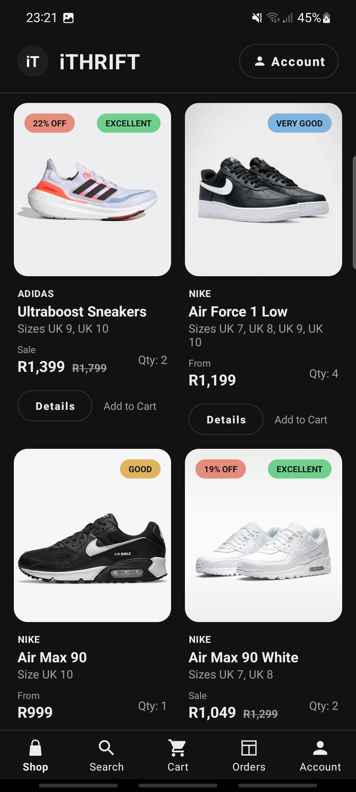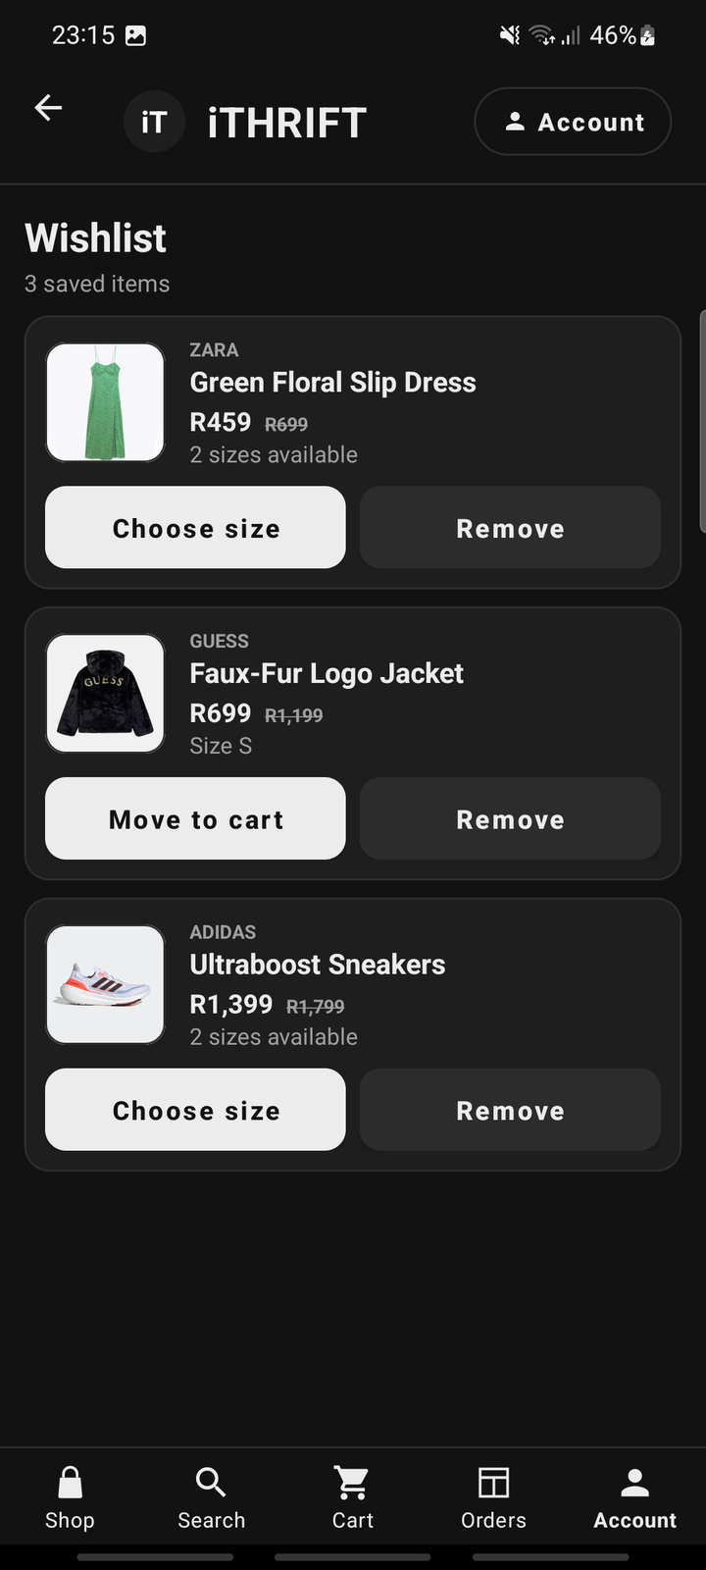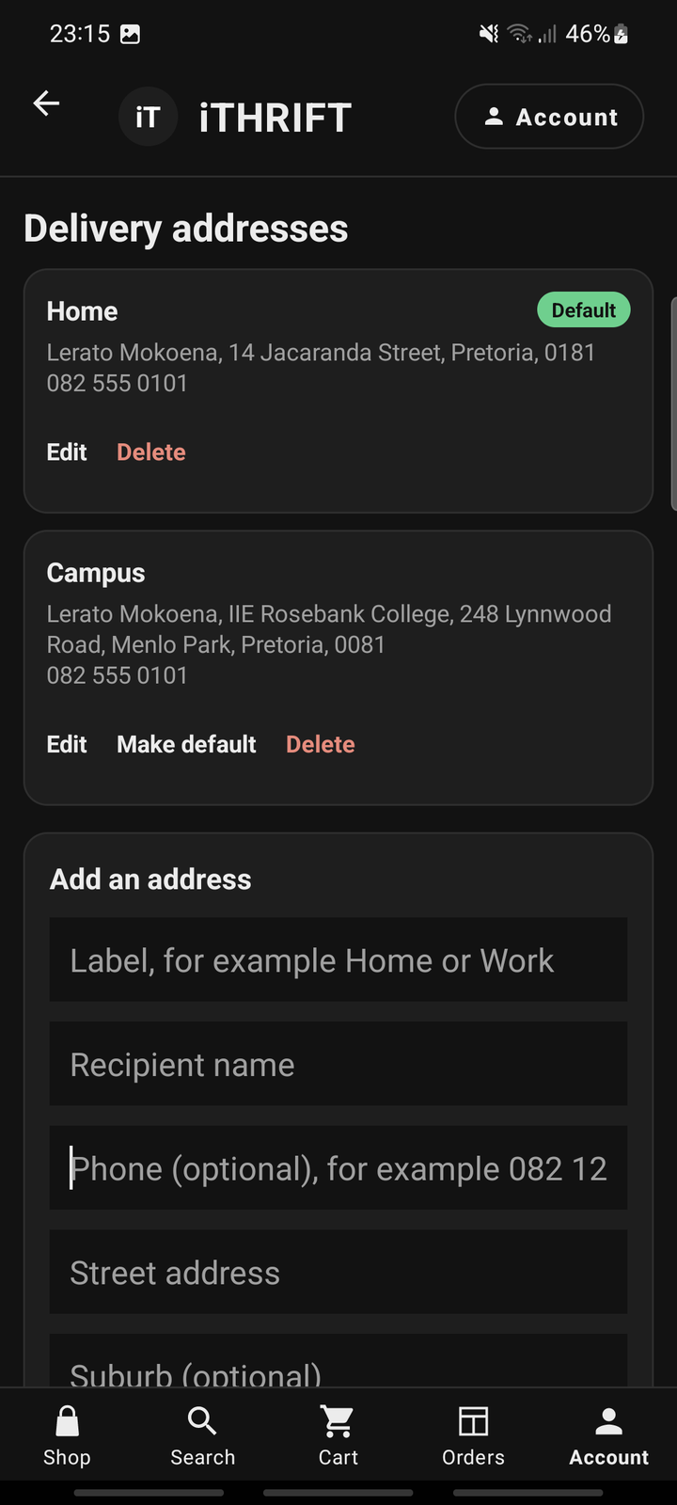
Figure 8: Android, shopping features: the Sale filter with the old prices crossed out (left), the wishlist (centre) and the address book (right)

5. Authentication, roles and security

5.1 Registration and sign-in
A customer can register and sign in from the Account tab. Registration validates the name, the email address and the password, creates the account through the API and signs the customer straight in. On success the API returns a bearer token, which the client stores and attaches to every request that follows, so the account behaves identically on the app and on the website.
There are three routes into a session, register, sign in and Google sign-in, and all three end in the same place: an API-issued token in SessionManager. Nothing above that point needs to know which route was taken, which is what keeps the rest of the app free of "was this a Google user?" checks.
Sign-in failures return the same message whether the email address or the password was wrong. That is deliberate: distinguishing them would turn the sign-in form into a way of discovering which email addresses have accounts.

5.2 Password encryption
Passwords are protected in transit and at rest, as the module requires. Traffic runs over HTTPS in production, so credentials are encrypted in transit. At rest, passwords are never stored: what is stored is a salted hash, computed on the server with scrypt, which is a deliberately slow, memory-hard key-derivation function. Slowness is the feature: it is what makes guessing a stolen hash expensive rather than instant.
Decision | What was done | Why
Algorithm | scrypt (Node’s built-in node:crypto) | Memory-hard and deliberately slow, so a stolen database is expensive to attack. No third-party dependency.
Salt | 16 random bytes per account | Two customers who choose the same password get different hashes, so cracking one does not crack both.
Key length | 64 bytes | Long enough that collisions are not a practical concern.
Comparison | crypto.timingSafeEqual | A normal comparison returns faster on a near-miss, which leaks the password one character at a time.
Where it runs | On the server, never the client | A client can be repackaged; whatever it computes can be forged.
Table 11: How passwords are stored, and the reasoning behind each choice
server/utils/password.js
const crypto = require('node:crypto');
const KEY_LEN = 64;

function hashPassword(password) {
const salt = crypto.randomBytes(16).toString('hex');
const hash = crypto.scryptSync(password, salt, KEY_LEN).toString('hex');
return { hash, salt };
}

function verifyPassword(password, salt, expectedHashHex) {
const candidate = crypto.scryptSync(password, salt, KEY_LEN);
const expected = Buffer.from(expectedHashHex, 'hex');
if (candidate.length !== expected.length) return false;
// Constant-time: a normal === returns early on the first differing byte.
return crypto.timingSafeEqual(candidate, expected);
}

Five unit tests cover this file directly. They assert that a hash never contains the plain text, that the same password hashes differently for two accounts, that a wrong password and a wrong salt both fail, and that the policy accepts strong passwords and rejects short, lowercase-only and digit-less ones.

5.3 Single sign-on
Single sign-on with Google is offered so that a customer can use an identity they already have rather than inventing another password on a phone keyboard. It is implemented end to end and, more importantly, implemented in the only way that is actually safe.
The app’s entire job in single sign-on is to ask Android for a Google ID token and hand it to the API. It deliberately does not decide who the customer is, because it cannot: anything the app worked out locally could be forged by anyone who repackaged it. The API verifies the token with Google and only then issues a session of its own.
Step | Where | What happens
1 | Android app | Credential Manager shows the Google account chooser and returns a signed ID token.
2 | Android app | The token is POSTed to /api/auth/sso. The app never inspects it.
3 | API | The token is verified with Google: signature, issuer, audience, expiry, and that the email address is verified.
4 | API | The customer is matched on the provider’s subject, or created if they are new.
5 | API | An iTHRIFT session token is issued, the same kind a password sign-in produces.
Table 12: The single sign-on flow, and which side does each part
Four checks in that verification are each there for a specific reason:
- The audience is checked against our own client id. A validly signed Google token issued to somebody else’s application must not be accepted here.
- The email address must be marked verified. Otherwise anyone could sign up to Google with someone else’s address, never prove they own it, and claim the matching iTHRIFT account.
- Matching is on the provider’s subject, which is Google’s immutable user id, rather than on the email address, because a person can change the address on their Google account.
- If the address already belongs to a password account, the sign-in is refused rather than linked. Linking automatically would let anyone who could create a Google account on that address walk into the existing one.
The check with Google is given ten seconds, and the API tells apart two failures that need different advice: Google being unreachable from the server, and Google rejecting the token. That distinction was added after testing on the group's own phone on 2 October 2026. The first version gave each connection attempt a quarter of a second, which was too impatient for the connection in use, and every Google sign-in failed with one generic message. The server log now names the cause, and four unit tests hold the behaviour in place.
server/routes/auth.js: the SSO route (extract)
router.post('/sso', async (req, res) => {
const { idToken } = req.body || {};

let identity;
try {
identity = await verifyGoogleIdToken(idToken);
} catch (err) {
console.warn('[auth] single sign-on rejected:', err.message);
return res.status(401).json({ error: err.message });
}

const db = getDb();
// Match on the provider subject: it never changes, an email address can.
let customer = db.prepare('SELECT * FROM Customer WHERE ProviderSubject = ?')
.get(identity.subject);

if (!customer) {
const byEmail = db.prepare('SELECT * FROM Customer WHERE Email = ?')
.get(identity.email);
if (byEmail && byEmail.AuthProvider === 'password') {
return res.status(409).json({ error:
'An account with that email already exists. Sign in with your email and password instead.' });
}
customer = byEmail;
}
// ... create the customer and their cart if still not found, then:
const user = { type: 'customer', id: customer.CustomerID,
name: `${customer.FirstName} ${customer.LastName}` };
res.json({ token: createSession(user), user });
});

Configuration, and why the button can be hidden
Single sign-on needs an OAuth web client id from a Google Cloud project. Neither the client id nor anything derived from it is committed: the app reads it from local.properties, which is git-ignored, and the server reads it from the GOOGLE_CLIENT_ID environment variable. A checkout on a clean machine, or on the CI runner, still builds. It simply builds without single sign-on.
When it is not configured, the app hides the button rather than offering one that fails. It checks two things: whether this build has a client id at all, and whether the server it is pointed at reports single sign-on as enabled (GET /api/auth/sso/status). A button that always fails is worse than no button. Equally, an unconfigured server refuses every token rather than accepting any, because a server that trusted tokens minted for any application at all would be worse than one with no SSO.
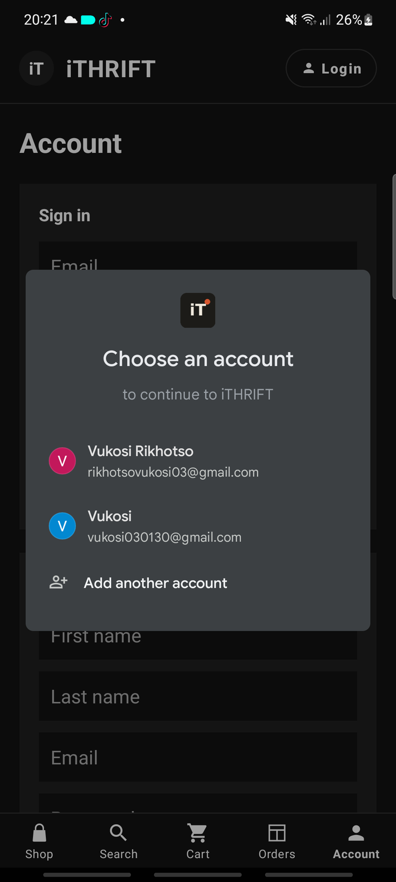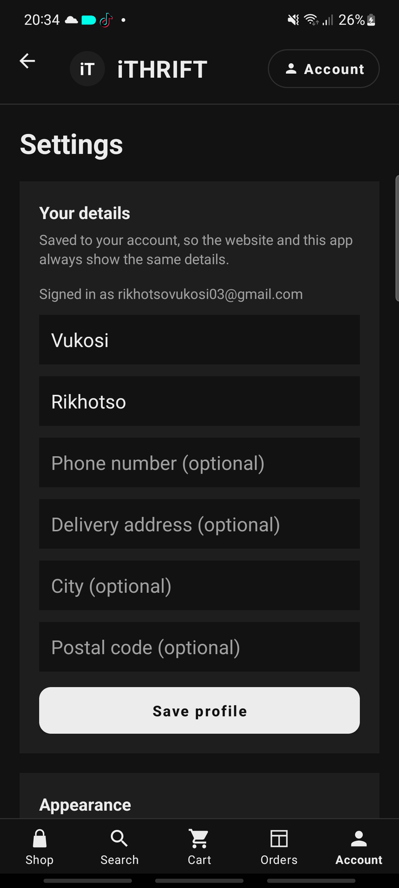
Figure 9: Android, single sign-on: the Google account chooser opened by Continue with Google (left), and Settings after signing in with Google, where no password section is offered (right)
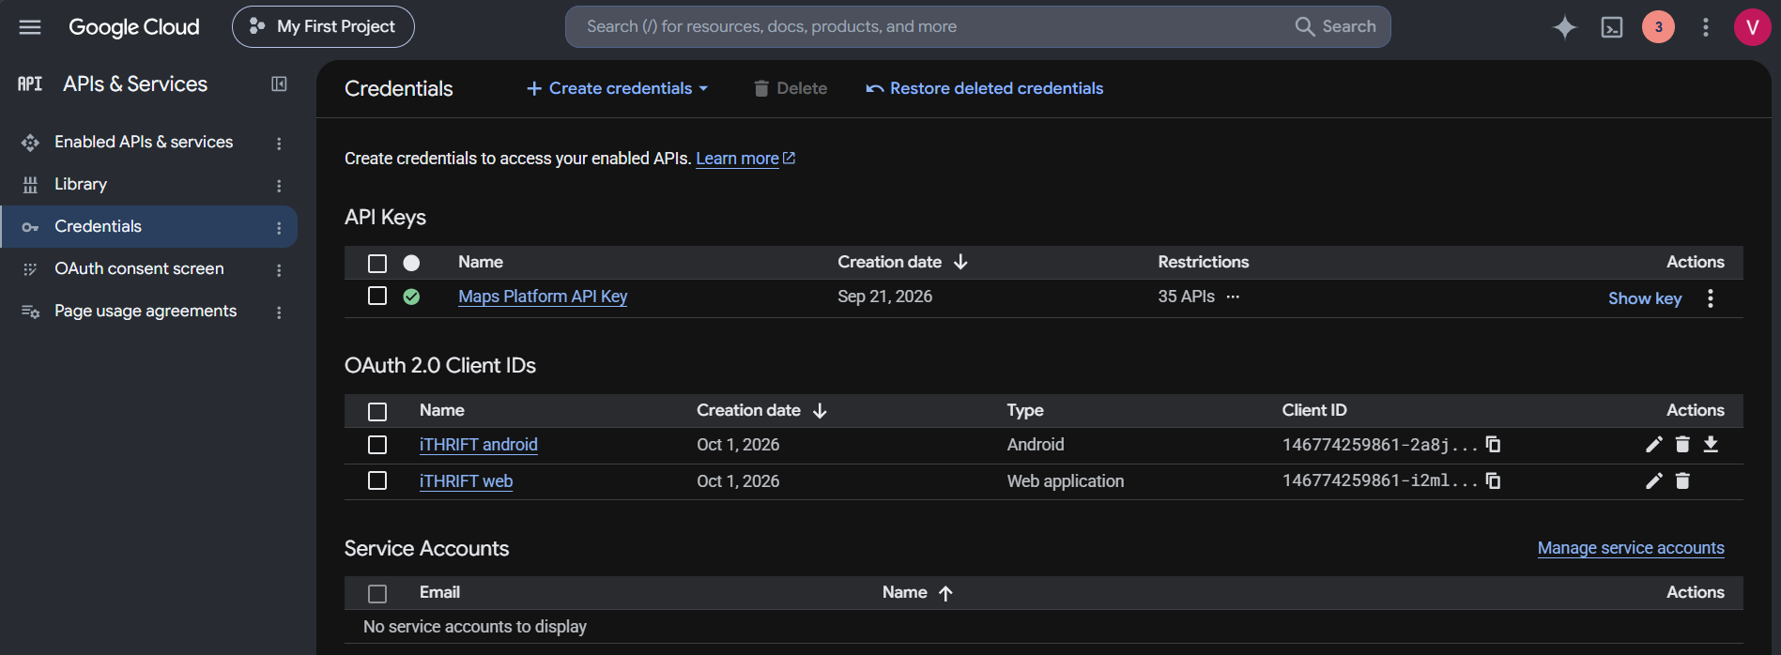
Figure 10: Google Cloud console, Credentials: the two OAuth clients registered for iTHRIFT on 1 October 2026, one for the Android app and one for the server
The identity provider is Google. Google holds the account and its password; iTHRIFT never sees either. What the Google Cloud project holds is the registration of the two clients in the figure above: the Android client, which ties sign-in to this app and its signing key, and the web client, whose id the server uses to check that a token was issued for iTHRIFT and for nobody else. What iTHRIFT stores for a Google customer is one row in the Customer table with the name and email address that Google returned, the provider (google) and the identifier Google gives the account, and no password, which is why Settings offers such an account no password section.

5.4 Roles and server-side access control
There are three roles: customer, staff and administrator. The Android application contains no administrative screens at all, and a staff account that signs in is told to use the website. Every request is checked on the server.
This is the difference between a convenience and a control. Hiding a menu item stops an honest person from clicking something they should not; the role check on the API is what stops a dishonest one from typing the address by hand. Both exist here, and only the second is relied on.
server/middleware/auth.js: the role check
function requireRole(...types) {
return (req, res, next) => {
if (!req.user) return res.status(401)
.json({ error: 'Sign in is required for this action.' });
if (!types.includes(req.user.type)) {
return res.status(403).json({ error: 'You do not have permission to do that.' });
}
next();
};
}

// applied per route, e.g.:
router.get('/profile', requireAuth, requireRole('customer'), ...);
router.put('/orders/:id/status', requireRole('staff', 'admin'), ...);

The profile and settings routes take the customer id from the session and never from the request body. That is what stops a customer editing somebody else’s details by changing a number on the phone. Fourteen of the 131 end-to-end checks exist purely to confirm that each role is refused what it should be refused.

6. Database design

6.1 Database management system
The design specifies MySQL 8, and the production schema is in the repository at database/mysql-schema.sql. The prototype runs on SQLite through Node’s built-in node:sqlite module, so that the whole system starts with one command and no database server to install, which matters when the marker has to run it.
The table structure, the keys and the Third Normal Form design are identical across the two. One difference is recorded honestly: SQLite treats ORDER as a reserved word, so that table is named Orders, and the MySQL schema keeps the same name for consistency between them.

6.2 Tables and relationships
Sixteen tables, in Third Normal Form. Eleven were carried forward from the XISD5319 system design and extended in Task 2 to record how an account authenticates. Five were added for the shopping features in Section 4.6: sizes, addresses, the wishlist, promo codes and returns.
Table | Purpose | Key relationships
Brand | Brand names, held once | PK BrandID
Category | Category names, held once | PK CategoryID
Product | Catalogue items: condition, price, sale price, total stock | FK BrandID, CategoryID
ProductSize | The stock of one product in one size | FK ProductID; unique (ProductID, Size)
Customer | Customer accounts, credentials and profile address | PK CustomerID
Address | A saved delivery address; one default per customer | FK CustomerID
Admin | Staff and administrator accounts | PK AdminID
Cart | One open cart per customer | FK CustomerID (unique)
CartItem | A line in a cart, for one size | FK CartID, ProductID
WishlistItem | A piece a customer saved for later | FK CustomerID, ProductID (unique pair)
PromoCode | A discount code: percentage or fixed, with a minimum spend | PK PromoCodeID; Code unique
Orders | A placed order: status, delivery method, discount and total | FK CustomerID
OrderItem | A line in an order, with the size and the price paid | FK OrderID, ProductID
Payment | One payment per order | FK OrderID (unique)
ReturnRequest | A return asked for on one order line | FK OrderItemID (unique), CustomerID
Review | A star rating and comment on a product | FK ProductID, CustomerID
Table 13: The sixteen tables and their relationships (Third Normal Form)
Two design points are worth drawing out. Brand and Category are separate tables rather than text columns on Product, which is what makes the filter chips a lookup rather than a scan of every row, and what stops "Adidas" and "adidas" existing side by side. OrderItem stores UnitPrice rather than reading it from Product, because the price a customer paid is a historical fact: repricing an item must not silently rewrite what an old order was worth.
The five newer tables follow the same reasoning. ProductSize holds stock per size, so that Product.StockQty is always the sum of its sizes and a size can sell out on its own. OrderItem and CartItem record the size, because "one pair of trainers" is not enough to pick the right box. An order stores its subtotal, discount, delivery fee and delivery address as they were when it was placed, for the same reason it stores the unit price: later changes to a promo code or an address must not rewrite an old order. ReturnRequest is unique on OrderItemID, which is what makes "an item can only be returned once" a rule of the database and not only of the API.

6.3 Recording how an account signs in
Task 2 added single sign-on, and the Customer table had to change to record it. The password columns became nullable, because a customer who signs in through Google never chooses a password on this system, and two columns were added: AuthProvider, and ProviderSubject holding the provider’s own immutable user id.
Making the password columns nullable creates an obvious hole, because a row could now exist with no credentials of any kind, so the table carries a constraint that closes it. A password account must have a hash and a salt; an SSO account must have a provider subject. The database refuses anything else, which means the rule holds even if a future route forgets to check.
server/init-db.js: the Customer table
CREATE TABLE Customer (
CustomerID INTEGER PRIMARY KEY AUTOINCREMENT,
FirstName TEXT NOT NULL,
LastName TEXT NOT NULL,
Email TEXT NOT NULL UNIQUE,
PasswordHash TEXT,
PasswordSalt TEXT,
AuthProvider TEXT NOT NULL DEFAULT 'password'
CHECK (AuthProvider IN ('password','google')),
ProviderSubject TEXT UNIQUE,
Phone TEXT,
AddressLine TEXT,
City TEXT,
PostalCode TEXT,
Status TEXT NOT NULL DEFAULT 'active'
CHECK (Status IN ('active','suspended')),
CreatedAt TEXT NOT NULL DEFAULT (datetime('now')),
-- A password account must carry a hash; an SSO account must carry a subject.
CHECK (
(AuthProvider = 'password' AND PasswordHash IS NOT NULL
AND PasswordSalt IS NOT NULL)
OR
(AuthProvider = 'google' AND ProviderSubject IS NOT NULL)
)
);

6.4 Seed data
The module requires at least ten records in every table. Every table meets that, and the seed script counts the rows and exits with an error rather than finishing quietly if any table falls short. A seed script that silently under-fills a table is worse than one that fails, because the gap is only discovered during the demonstration.
Table | Rows | Table | Rows
Brand | 15 | CartItem | 12
Category | 12 | WishlistItem | 14
Product | 63 | PromoCode | 11
ProductSize | 130 | Orders | 22
Customer | 12 | OrderItem | 33
Address | 15 | Payment | 22
Admin | 10 | ReturnRequest | 10
Cart | 12 | Review | 15
Table 14: Rows seeded per table; every one meets the ten-record minimum
The data is shaped to make the system demonstrable, not merely to reach ten. The twenty-two orders are spread across all four statuses and all three payment methods, and are dated from five months ago to yesterday, because the order queue, the status filter and the "last 30 days" figures on the dashboard are only worth looking at if there is something in every state. Two of the delivered orders are recent and have no return yet, so the demonstration accounts can request one inside the 30-day window. Seven customers have items left in an open cart, as real shops always do. Twelve pieces are on sale, the ten seeded returns cover every status, and one of the eleven promo codes is expired so that the refusal can be shown. The fifteen reviews are not all five stars: a catalogue where every rating is perfect tells a shopper nothing, and the low ratings are the honest ones for second-hand stock, because the complaint is almost always that a piece was more worn than the photographs suggested, which is exactly what the condition grade exists to prevent.
The names, addresses and phone numbers are invented. No real customer’s details appear anywhere in the repository.
The seed script checks itself
const MINIMUM_ROWS = 10;
const tables = ['Brand', 'Category', 'Product', 'ProductSize', 'Customer', 'Address',
'Admin', 'Cart', 'CartItem', 'WishlistItem', 'PromoCode', 'Orders',
'OrderItem', 'Payment', 'ReturnRequest', 'Review'];

for (const table of tables) {
const { total } = db.prepare(`SELECT COUNT(*) AS total FROM ${table}`).get();
counts[table] = total;
if (total < MINIMUM_ROWS) shortfall.push(`${table} (${total})`);
}

if (shortfall.length > 0) {
console.error(`\nThese tables hold fewer than ${MINIMUM_ROWS} rows: ${shortfall.join(', ')}.`);
process.exit(1);
}

npm run init-db
Creating schema...
Seeding brands and categories...
Seeding products...
Seeding customers...
Seeding addresses...
Seeding promo codes...
Seeding staff and administrator accounts...
Seeding orders, payments and reviews...
Seeding open carts...
Seeding wishlists...
Seeding returns...
Seeding reviews...
Database created at ...\data\ithrift.db
Seed summary: 15 Brand, 12 Category, 63 Product, 130 ProductSize, 12 Customer,
15 Address, 10 Admin, 12 Cart, 12 CartItem, 14 WishlistItem,
11 PromoCode, 22 Orders, 33 OrderItem, 22 Payment,
10 ReturnRequest, 15 Review.

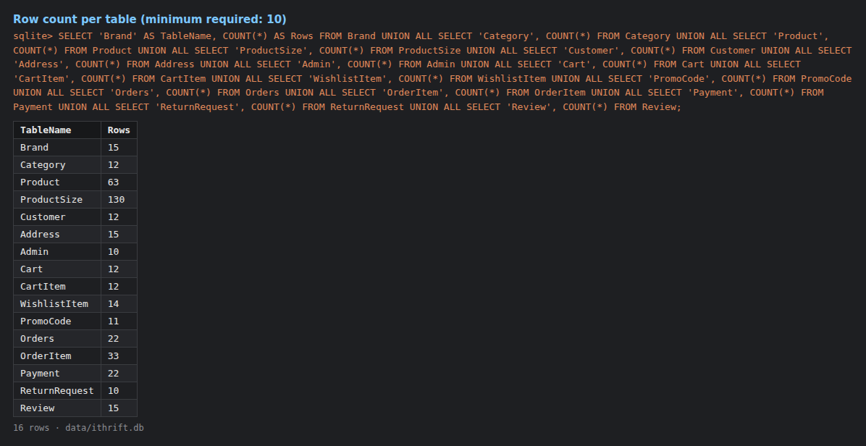
Figure 11: Rows in every table after npm run init-db; each meets the ten-record minimum

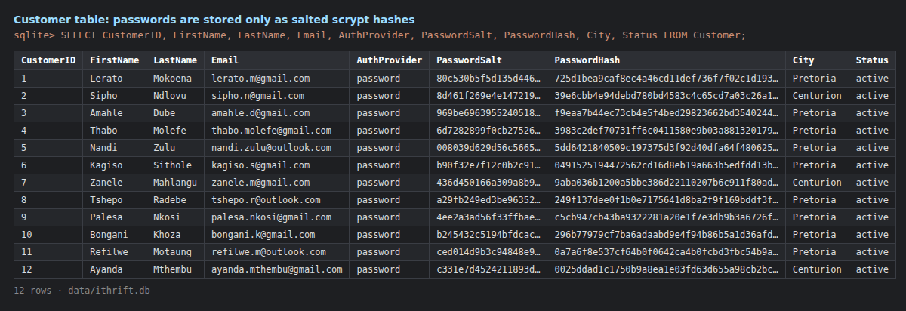
Figure 12: The Customer table: passwords are held only as a per-account salt and an scrypt hash

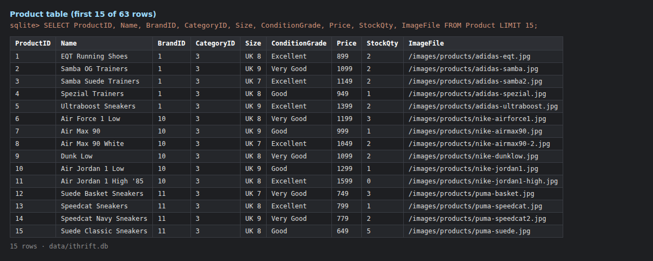
Figure 13: The Product table, first fifteen of 63 rows, with brand and category as foreign keys

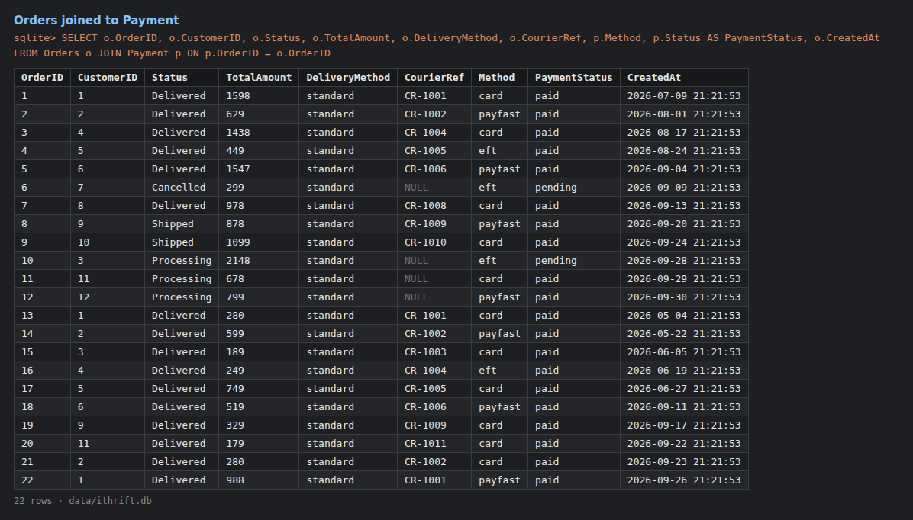
Figure 14: Orders joined to Payment: twenty-two orders across all four statuses and three payment methods
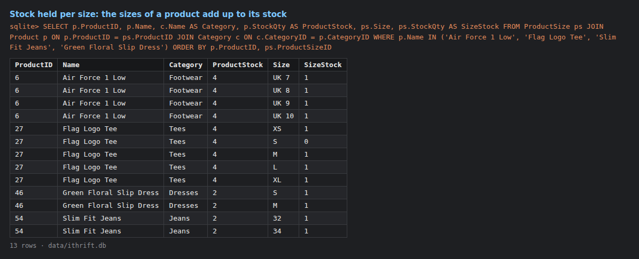
Figure 15: Stock held per size: the sizes of each product add up to its stock
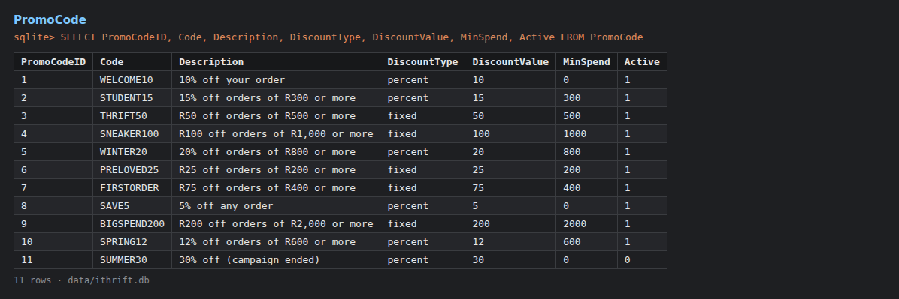
Figure 16: The PromoCode table: percentage and fixed codes, minimum spends and one expired code
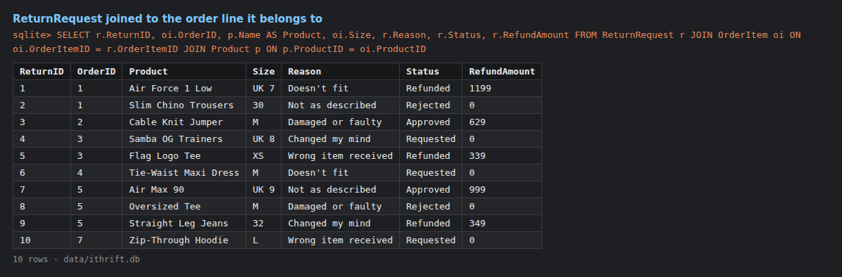
Figure 17: ReturnRequest joined to the order line it belongs to, covering every return status

7. The shared REST API
The API is the single application tier for both clients. It exposes JSON over HTTP, enforces every business rule, and is the only tier that can reach the database. The app and the website consume exactly the same routes, which is what makes "one database, two clients" true rather than merely claimed.
Method and path | Purpose | Access
POST /api/auth/register | Create a customer account | Public
POST /api/auth/login | Sign in; returns a bearer token | Public
POST /api/auth/sso | Sign in with a Google ID token | Public
GET /api/auth/sso/status | Whether SSO is configured on this server | Public
GET /api/auth/profile | The signed-in customer’s own details | Customer
PUT /api/auth/profile | Update those details | Customer
POST /api/auth/change-password | Change the password | Customer
GET /api/products | Catalogue, with search and filters | Public
GET /api/products/:id | Product detail | Public
GET /api/cart | The current cart | Customer
POST /api/cart/items | Add to the cart | Customer
POST /api/orders | Check out: lock stock and place the order | Customer
GET /api/orders | The customer’s orders (all orders, for staff) | Customer / Staff
PUT /api/orders/:id/status | Advance an order’s status | Staff / Admin
GET /api/orders/options | Delivery methods, the free-delivery threshold and return reasons | Public
POST /api/orders/quote | Price the cart for a delivery method and a promo code | Customer
PUT /api/orders/:id/cancel | Cancel an order that is still processing; restock it | Customer
POST /api/orders/:id/returns | Ask to return one line of a delivered order | Customer
GET /api/returns | Returns: the customer's own, or all of them for staff | Customer / Staff
PUT /api/returns/:id | Approve, reject or refund a return | Staff / Admin
GET, POST, DELETE /api/wishlist | The pieces a customer has saved | Customer
GET, POST, PUT, DELETE /api/addresses | The address book and its default address | Customer
GET /api/admin/users | Customer accounts | Admin
GET /api/admin/reports/sales | Sales reporting | Staff / Admin
Table 15: The main REST API routes shared by both clients (the auth block and the shopping routes were added in Task 2)
The most important rule in the whole system is checkout. The order total is recalculated on the server from the current product prices, and the stock is locked in the same database transaction. That is what stops two customers buying the same one-off item, and it is why the client’s idea of the total is ignored entirely: a client that could set its own total could set it to one rand.

8. Website updates
The website was updated to consume the new REST API and to match the Task 1 wireframes. The storefront (catalogue, search, product detail, cart, checkout and order tracking) and the staff and administrator console (dashboard, listings, inventory, order queue, customers and reports) now run through the same shared API as the application rather than through server-rendered pages.
The administrator-only Customers section is rendered for administrators alone, and the server refuses the request from any other role even if the address is typed by hand. There is also an installable Progressive Web App build of the storefront at /mobile, which is the fallback for anyone who cannot install the Android application.
The shopping features in Section 4.6 are on the website as well: a size picker on the product page, a Sale link and sale prices, a wishlist, an address book, a checkout with delivery methods, a promo code and the server's quote, order cancelling and returns. The staff console gained a Returns section, where a return is approved, rejected or refunded. The figures below are of the website running from the repository on 1 October 2026.
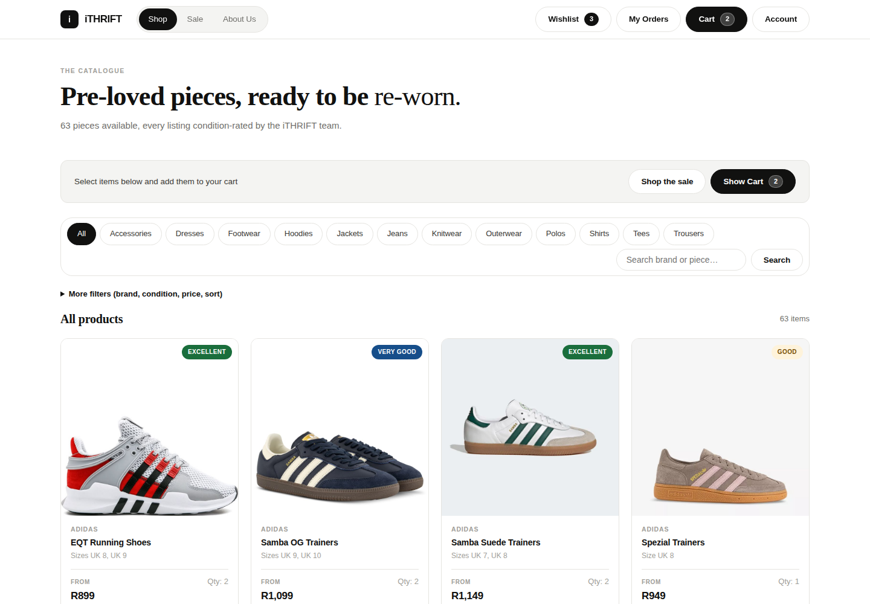
Figure 18: Website, Shop: the catalogue with category filters, condition grades and the Sale link

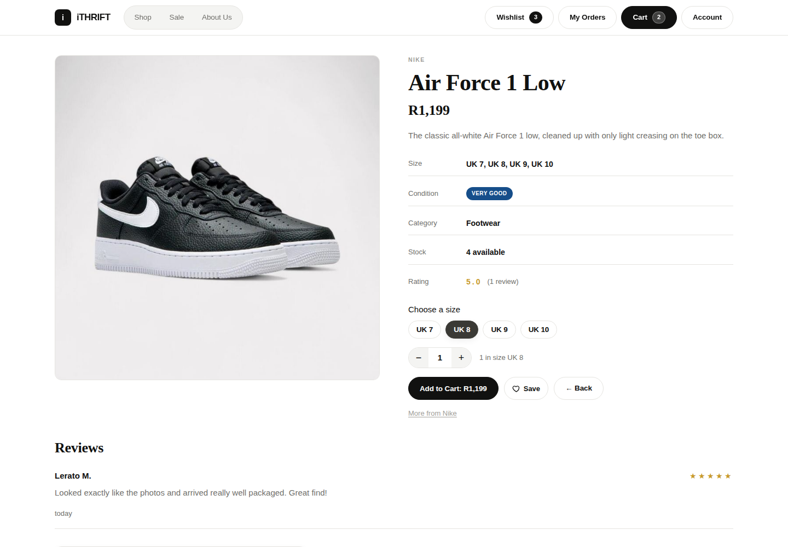
Figure 19: Website, Product detail: the size picker, stock in the chosen size, Save to wishlist and reviews

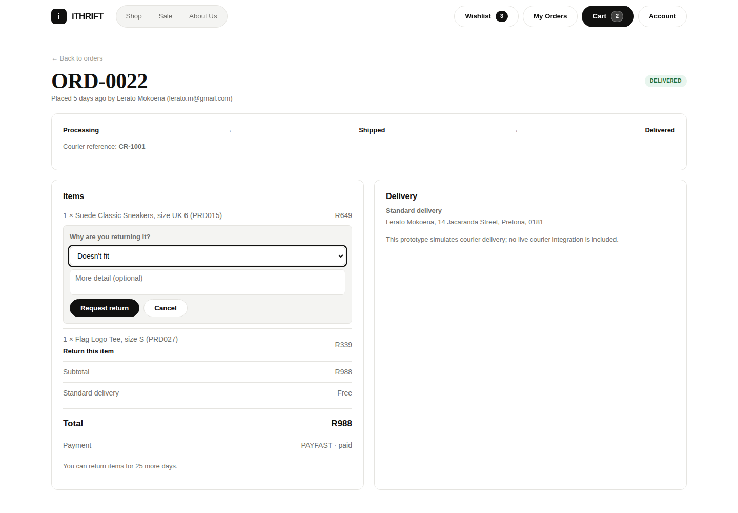
Figure 20: Website, order detail: tracking, delivery details and a return being requested
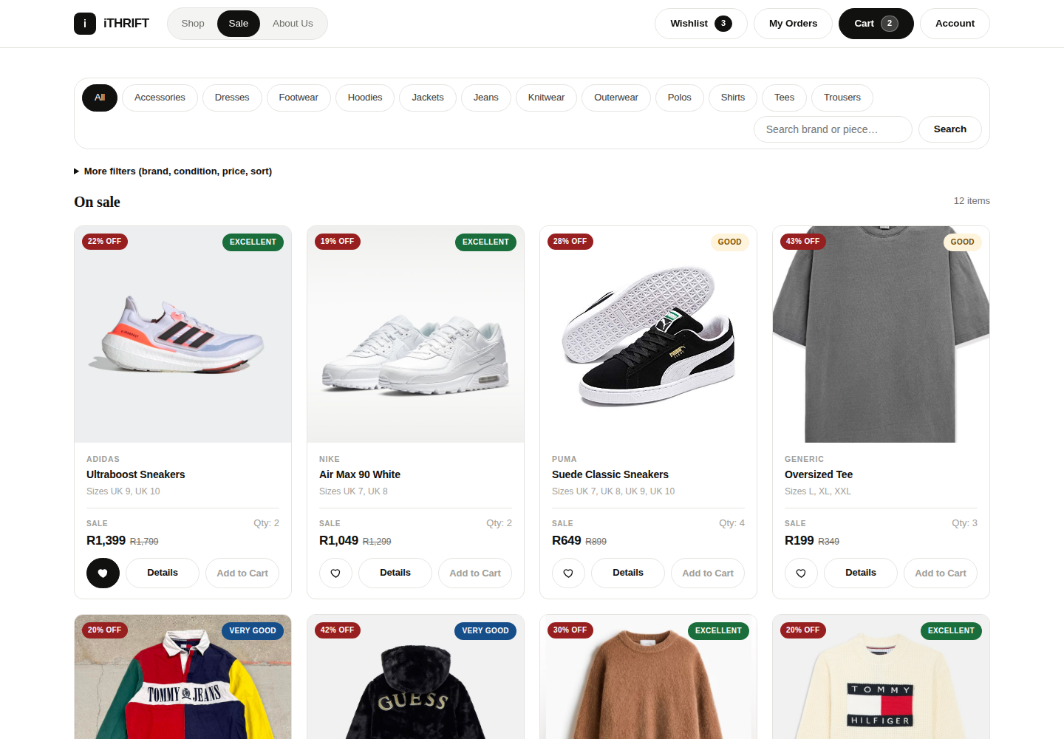
Figure 21: Website, Sale: sale prices with the old price crossed out and the percentage off
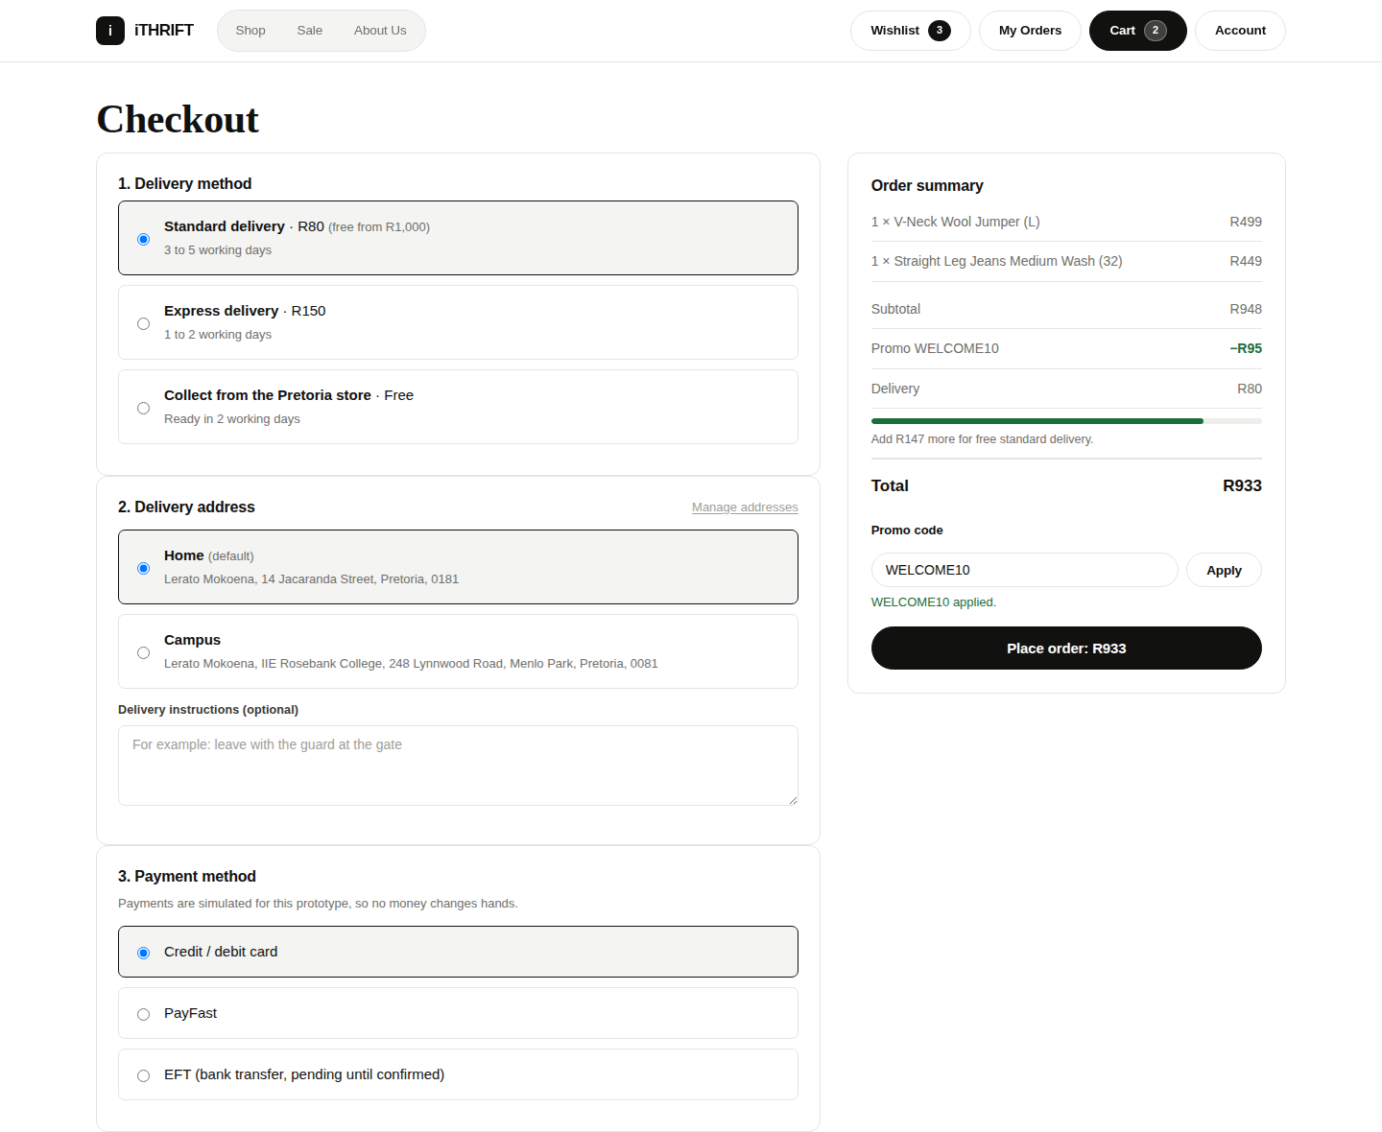
Figure 22: Website, Checkout: delivery method, address, promo code and the total quoted by the server

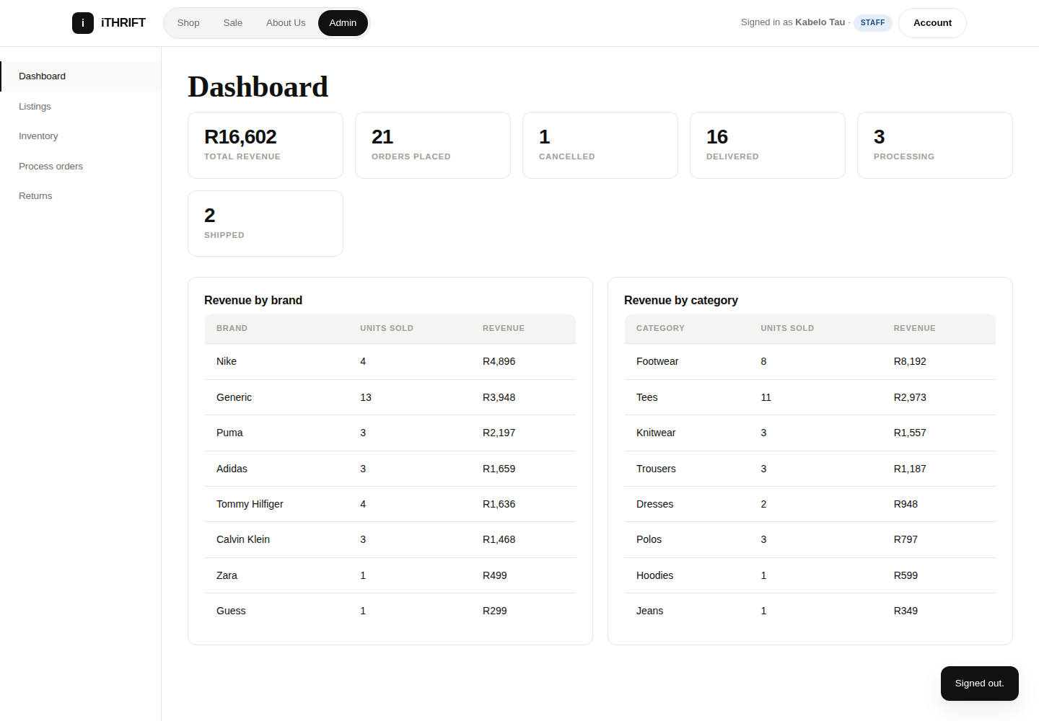
Figure 23: Website, Admin console: dashboard with revenue by brand and category

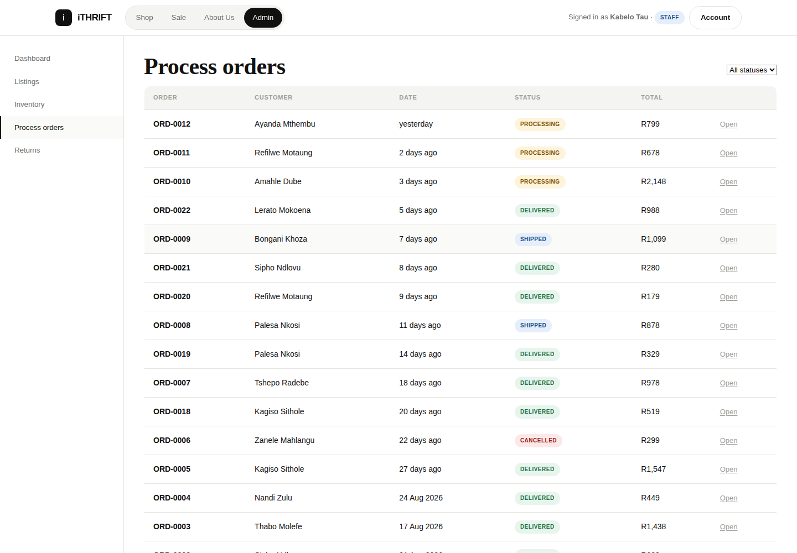
Figure 24: Website, Admin console: the order queue that staff work through
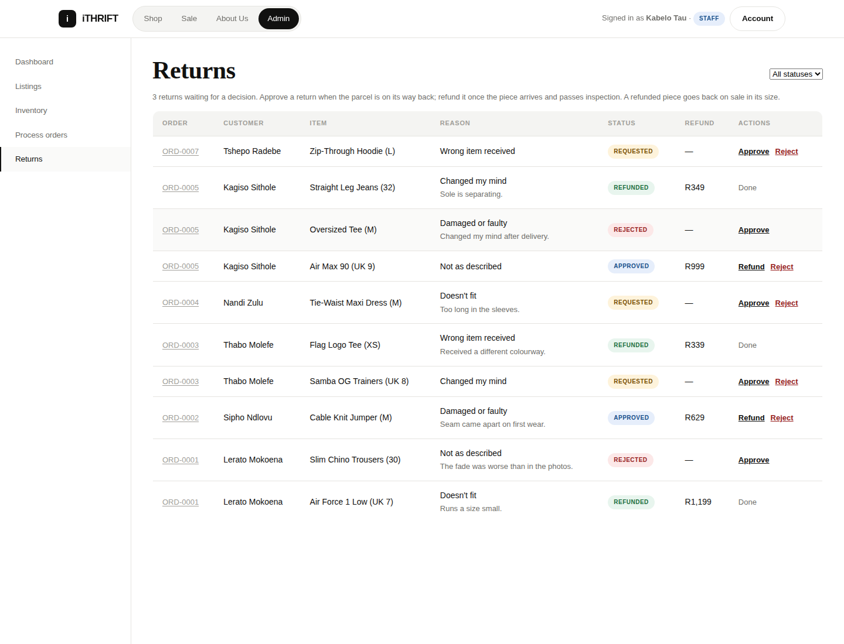
Figure 25: Website, Admin console: the Returns section, where staff approve, reject and refund

9. Automated testing
There are 203 automated checks in three suites, and all three run through GitHub Actions so that a change is tested on the pipeline and not only on one developer’s machine. The module asks for exactly this: proof that the code works somewhere other than the computer it was written on.
Suite | Checks | Runs with | What it covers
Kotlin unit tests  app/src/test/ | 50 | ./gradlew  testDebugUnitTest | Input validation, server-address parsing, money and date formatting, network error handling, the theme setting
API unit tests  test/unit-tests.js | 22 | npm run test:unit | Password hashing and verification, the password policy, SSO configuration and token verification, cart arithmetic, delivery fees and promo codes
End-to-end smoke test  test/smoke-test.js | 131 | npm test | The whole API surface, against a running server and a seeded database
Table 16: The three test suites
The division is deliberate. A unit test needs no server, no database and no network, so it runs in seconds and points straight at the function that broke. An end-to-end test proves the parts work together but, when it fails, only tells you that a request returned the wrong status. Having both means a failure is usually diagnosed by reading the test name.

9.1 Kotlin unit tests
This suite is new in Task 2, and it closed a real hole. The Android workflow already ran ./gradlew testDebugUnitTest, but app/src/test/ did not exist, so the step passed on every run without testing anything at all. A green tick that means nothing is worse than a red one.
Test class | Tests | What it pins down
ValidatorsTest | 19 | Every input rule: email, password policy, required fields, quantity against stock, postal code, phone number
SafeApiCallTest | 8 | That no network failure can reach a screen as an exception, and that a cancelled call stops the screen that made it
FormattingTest | 10 | Rand formatting, star ratings, relative dates
ApiUrlTest | 8 | Server-address parsing: missing scheme, trailing slashes, whitespace, blank
ThemeModeTest | 5 | That the appearance setting survives storage and upgrades
Table 17: The 50 Kotlin unit tests
Two of these are worth explaining, because they guard against bugs that would only appear on a customer’s phone.
FormattingTest: money must not follow the phone’s locale
@Test
fun `thousands are grouped with a comma regardless of the phone's locale`() {
val original = Locale.getDefault()
try {
// A locale whose own convention is a space or a full stop.
Locale.setDefault(Locale.FRANCE)
assertEquals("R1,620", formatMoney(1620.0))
assertEquals("R12,500", formatMoney(12500.0))
} finally {
Locale.setDefault(original)
}
}

On a phone set to Afrikaans or French the default grouping separator is a space or a full stop, and "R1.620" reads as one rand sixty-two to half the people who see it. Pinning the output means a well-meaning change to the locale fails a test instead of quietly mispricing the catalogue.
ThemeModeTest: the setting must survive an upgrade
@Test
fun `the stored values are the exact strings written to preferences`() {
// Pinned literally: changing one of these would orphan the preference
// already saved on every installed copy of the app.
assertEquals("system", AppSettings.ThemeMode.SYSTEM.stored)
assertEquals("light", AppSettings.ThemeMode.LIGHT.stored)
assertEquals("dark", AppSettings.ThemeMode.DARK.stored)
}

The theme is stored as a string rather than as an enum ordinal, and this test is what keeps it that way. Storing an ordinal would mean that inserting a fourth theme into the middle of the enum silently re-interprets everyone’s saved preference as a different one, which is a bug that only surfaces on an upgrade, on a customer’s phone, where nobody is watching.

9.2 API unit tests
Twenty-two checks on the API’s pure logic, using node:test, which is built into Node and needs no framework. Five of them cover password storage, which is the rule with the highest cost of failure in the system. Nine cover checkout pricing: the delivery fees, the free-delivery threshold, and promo codes that are expired, below their minimum spend or larger than the order. Four cover the check on a Google sign-in: a token Google confirms, a token it rejects, Google being unreachable, and a genuine token issued to another application.
test/unit-tests.js (extract)
test('the same password hashes differently for two accounts', () => {
// Without a per-account salt, two customers who picked the same password
// would share a hash, and cracking one would crack both.
const a = hashPassword('Password1');
const b = hashPassword('Password1');
assert.notEqual(a.salt, b.salt);
assert.notEqual(a.hash, b.hash);
});

test('the correct password verifies and a wrong one does not', () => {
const { hash, salt } = hashPassword('Password1');
assert.equal(verifyPassword('Password1', salt, hash), true);
assert.equal(verifyPassword('password1', salt, hash), false,
'verification must be case sensitive');
});

9.3 End-to-end smoke test
One hundred and thirty-one checks drive the running server exactly as a client would: register, sign in, browse, filter, search, add to a cart, check out, track an order, review a product, and try each of those as the wrong role. It grew from 51 checks in Task 1 to 70 in the first Task 2 build, with the new checks covering single sign-on, the profile routes and password changes, and then to 131 when the shopping features were added: sizes, the address book, delivery fees, promo codes, cancelling, returns and the wishlist.
The single sign-on checks are worth describing, because what they test is not the happy path. A successful Google sign-in needs a real ID token, which only a person tapping the button on a handset can produce, and that is what the demonstration video is for. What is testable here, and what actually protects the system, is the refusal.
test/smoke-test.js: single sign-on
const forged = await call('/api/auth/sso', { method: 'POST',
body: { idToken: 'not.a.real.token' } });
check('SSO refuses a token it has not verified with Google', forged.status === 401);

const empty = await call('/api/auth/sso', { method: 'POST', body: {} });
check('SSO refuses a request with no token at all', empty.status === 401);

One more check is worth pointing out, because it is the kind of thing that is easy to get wrong and impossible to see by looking at a screen:
The profile route must never leak the hash
check('Profile never returns the password hash',
!JSON.stringify(profile.data).toLowerCase().includes('passwordhash'));

9.4 Results
All three suites pass. The two API suites were re-run on 2 October 2026 against a freshly seeded database, after the shopping features in Section 4.6 were added, and both passed in full. The Kotlin figures are from the GitHub Actions run for the same code; that workflow re-runs the suite on every push, which is the evidence that it passes on a clean machine rather than only on ours. The pipeline screenshots are in Section 3.3.
Suite | Result
Kotlin unit tests | 50 passed, 0 failed
API unit tests | 22 passed, 0 failed
End-to-end smoke test | 131 passed, 0 failed, 131 total checks
Debug build | BUILD SUCCESSFUL. app-debug.apk, about 8 MB
Table 18: Test and build results

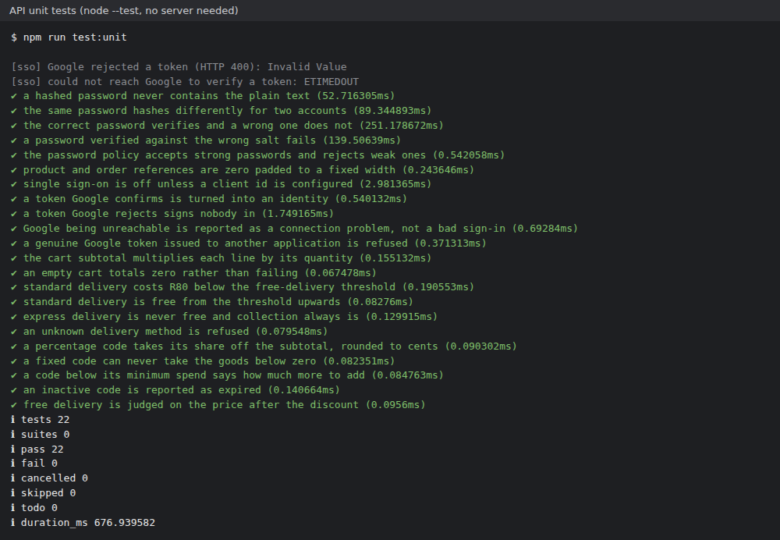
Figure 26: API unit tests: 22 passed, 0 failed (2 October 2026)

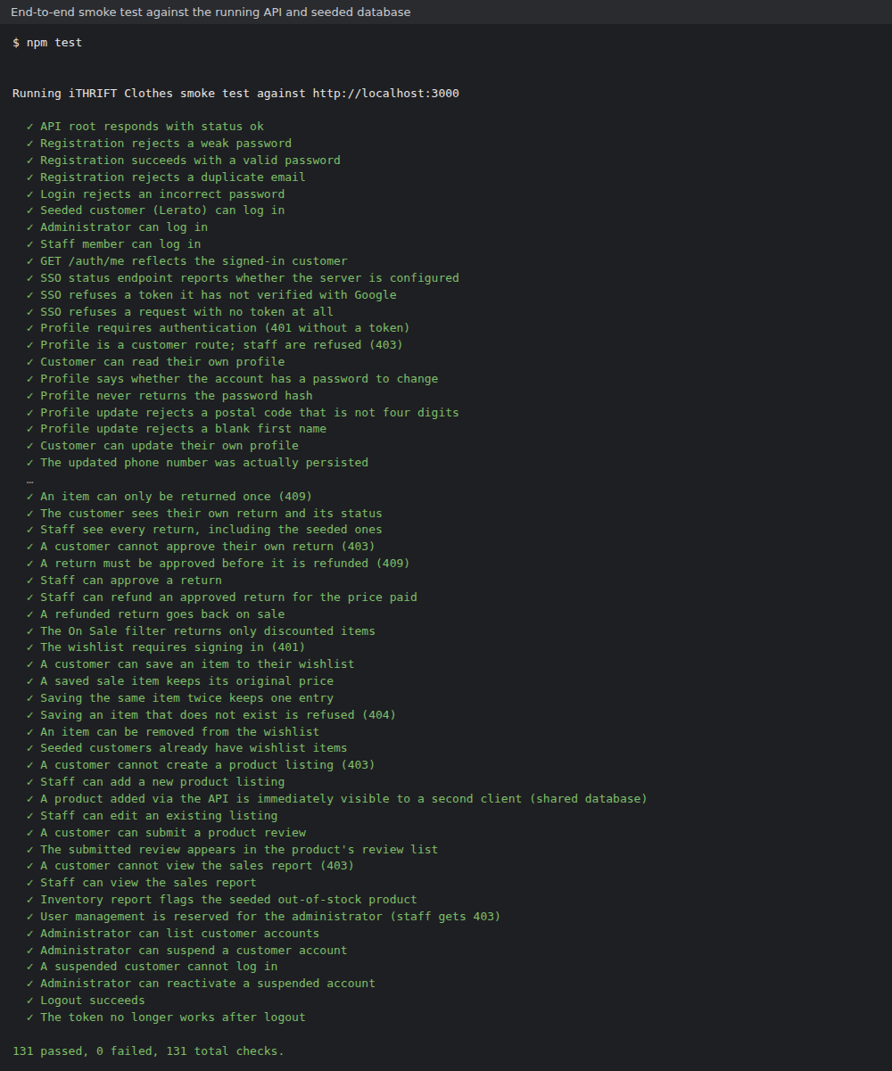
Figure 27: End-to-end smoke test: 131 passed, 0 failed (2 October 2026)

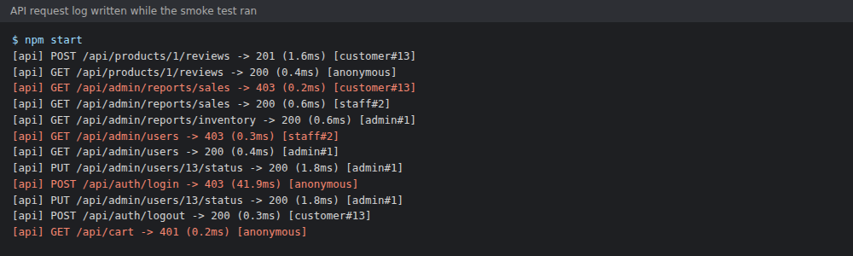
Figure 28: The API request log from the 25 September run, showing refused requests logged as failures

10. Verification and validation
Beyond the automated suites, the group ran a manual pass focused on invalid input and error handling, because the module requires that a bad input never crashes the application. The table below is the test log. Each case names the automated check that covers it, where one exists, because a manual test that finds a bug should become an automated test or it will be found again.
Ten of the cases were run by hand on 2 October 2026 on a Samsung Galaxy A71 running version 1.2.0 (build 3), and all ten passed. The last column records what was seen. The other cases were not run by hand: most rely on the automated check named beside them, which passes, and cases 4, 14 and 22 have no automated check and are still to be run.
# | Test case | Expected result | Covered by | Outcome on the phone, 2 October 2026
1 | Register with a malformed email address | Inline message, no account created | ValidatorsTest, smoke test | Not run by hand; the automated check passes
2 | Register with a weak password | Inline message naming the rule that failed | ValidatorsTest, unit tests | Not run by hand; the automated check passes
3 | Sign in with the wrong password | Generic "incorrect email or password" | Smoke test | Not run by hand; the automated check passes
4 | Sign in to a Google account with a password | Told to use the Google button instead | Manual | Still to be run by hand
5 | Add more items than are in stock | Blocked with "Only n in stock." | ValidatorsTest, smoke test | Pass. "Only 1 of size UK 8 is in stock."
6 | Two customers buy the last item | Only the first succeeds | Smoke test | Not run by hand; the automated check passes
7 | Check out with no network | Message with advice, no crash | SafeApiCallTest | Not run by hand; the automated check passes
8 | Point the app at a wrong server address | Test connection reports the failure plainly | ApiUrlTest, manual | Pass. "Couldn't reach the server", no crash
9 | Type a server address with no scheme | Accepted; http:// is added | ApiUrlTest | Pass. Connected, 15 brands returned
10 | Save a profile with a blank first name | Rejected on both client and server | Smoke test | Pass. "First name is required."
11 | Save a three-digit postal code | Rejected on both client and server | ValidatorsTest, smoke test | Pass. "A South African postal code is four digits."
12 | Change password with the wrong current one | Refused (401) | Smoke test | Not run by hand; the automated check passes
13 | Open an admin route as a customer | Refused by the server (403) | Smoke test | Not run by hand; the automated check passes
14 | Sign in as staff on the phone | Told the app is for customer accounts | Manual | Still to be run by hand
15 | Switch to dark mode on every screen | No unreadable text; setting survives a restart | Manual, ThemeModeTest | Pass on the screens checked in both themes; restart not re-checked
16 | Rotate the device on each screen | No crash; the screen reloads its data | Manual | Pass on the Shop screen
17 | Add a piece to the cart without choosing a size | "Choose a size first."; nothing is added | Smoke test | Pass. "Choose a size first."
18 | Apply a promo code that is unknown, expired or under its minimum spend | Refused with the reason; the total does not change | Smoke test, unit tests | Pass for an expired code: "SUMMER30 has expired."
19 | Save a delivery address with a two-digit postal code | Rejected on both client and server | Smoke test | Pass. "A South African postal code has four digits."
20 | Cancel an order that has already shipped | Refused (409); the button is no longer offered | Smoke test | Not run by hand; the automated check passes
21 | Ask to return the same item twice | Refused (409) | Smoke test | Not run by hand; the automated check passes
22 | Use the app after the server has been restarted | "Sign in is required" message, no crash; signing in again continues | Manual | Still to be run by hand
23 | Sign in with Google while the server cannot reach Google | Message saying the server could not reach Google; password sign-in still works | Unit tests, manual | Not run by hand; the automated check passes
Table 19: The manual verification log
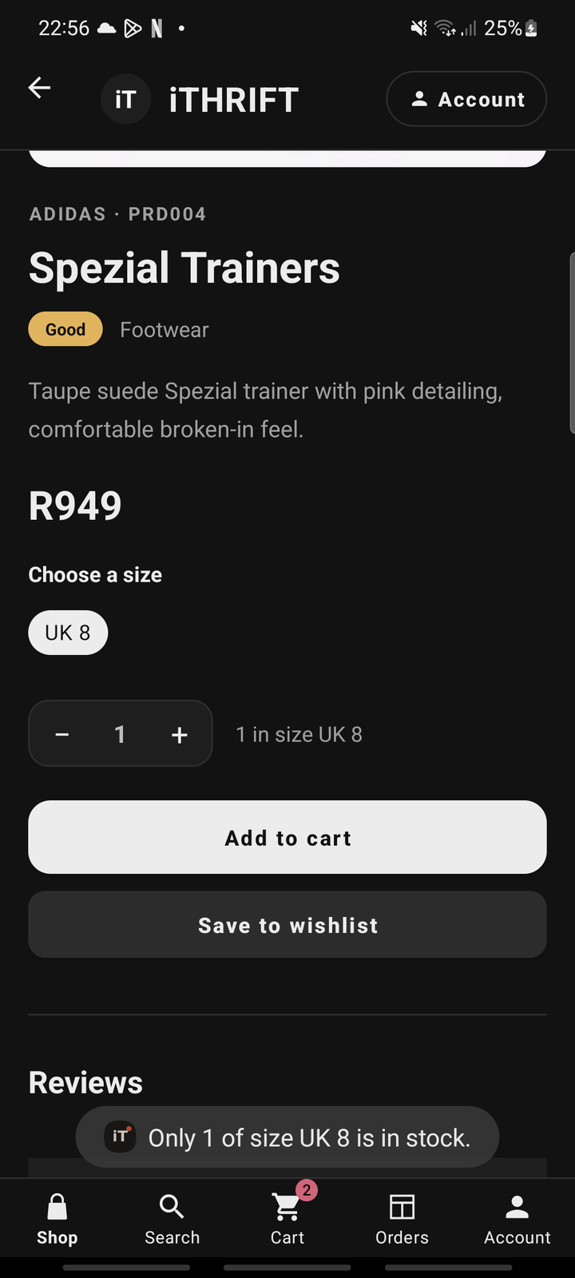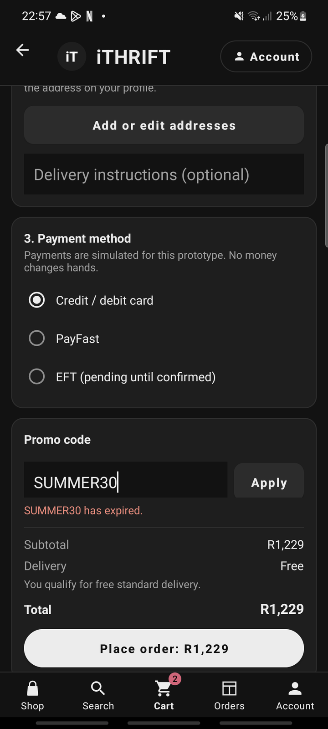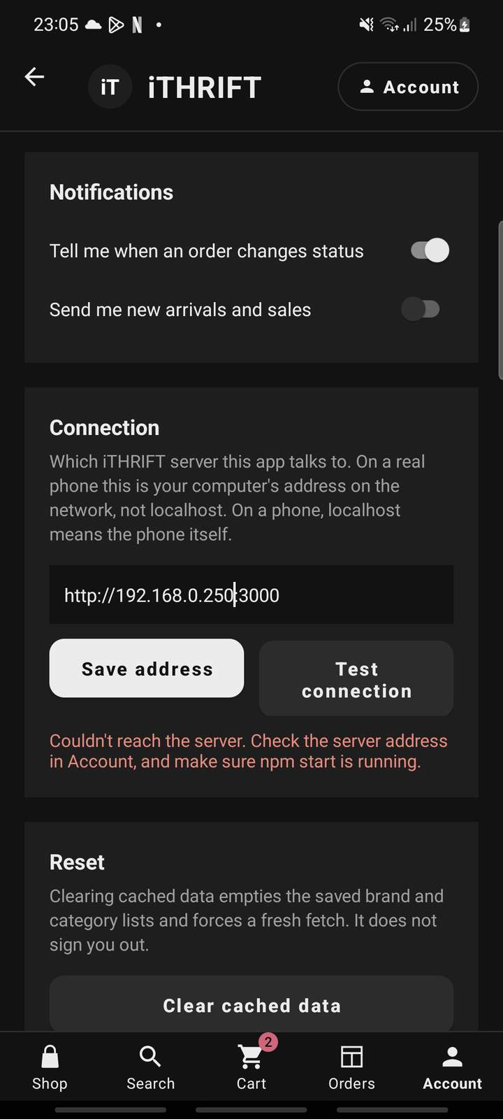
Figure 29: Manual checks on the phone: the stock limit in case 5 (left), an expired promo code in case 18 (centre) and a wrong server address in case 8 (right)
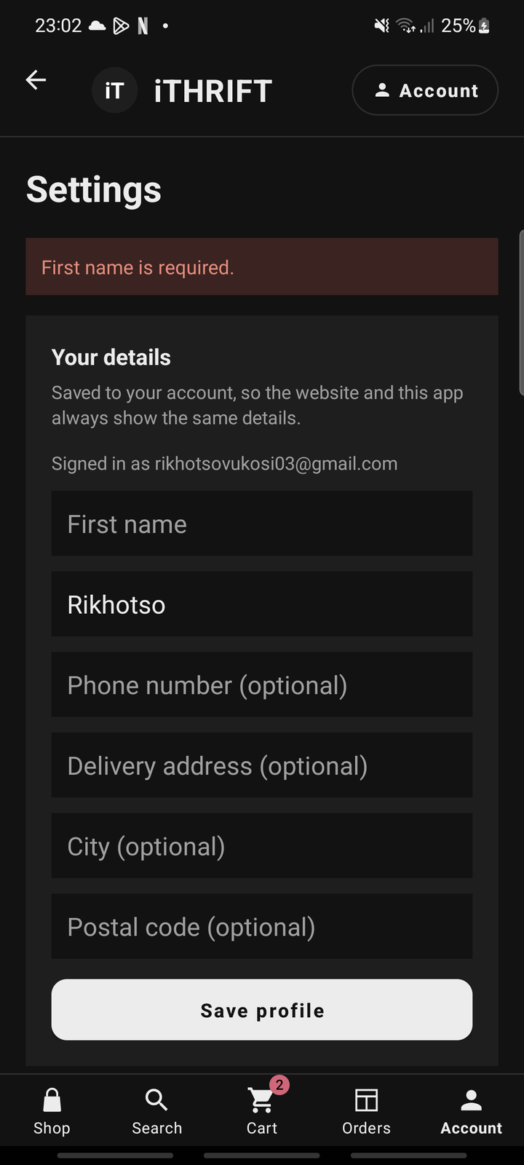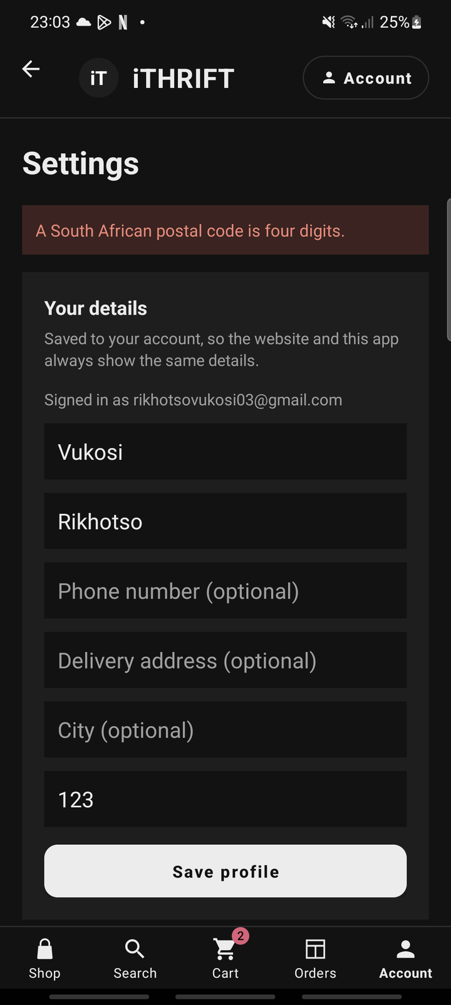
Figure 30: Manual checks on the phone: a blank first name in case 10 (left) and a three-digit postal code in case 11 (right)
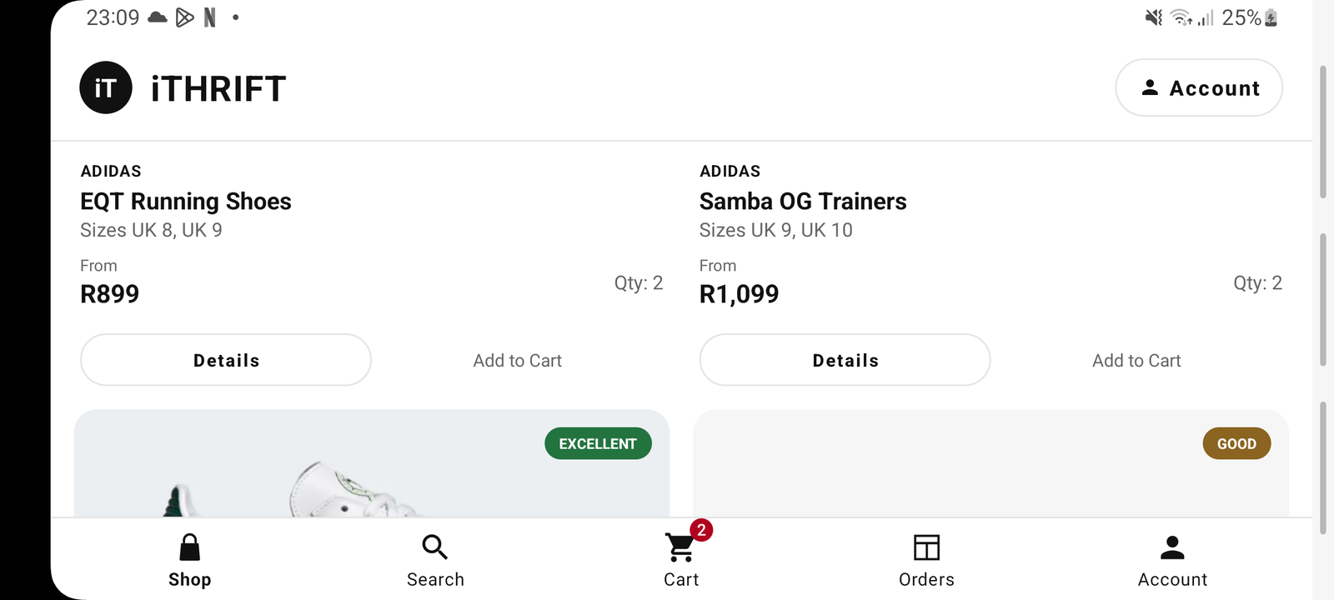
Figure 31: Manual check on the phone: the Shop screen after the device was rotated in case 16

11. Help system and user documentation
The module requires user support in two forms, and both are in the repository.
Deliverable | Where | What is in it
In-app help | Account → Help | Fourteen task-based topics, plus a support panel and a diagnostics panel
User guide | docs/user-guide.md | Installing, connecting, buying, tracking, settings, troubleshooting, staff console, and instructions for the marker
README | README.md | Setup, demo accounts, SSO configuration, testing, project structure, release notes
Table 20: The three pieces of user documentation
The help topics are written as tasks a customer is trying to finish, such as "Track an order", "Buy something" or "Switch to dark mode", rather than as a tour of the screens. Someone who is stuck does not know what we called the screen they need, so indexing the help by our screen names would only help a person who did not need help.
The Help screen ends with a panel showing the app version, the server address it is currently using and who is signed in. That is there for support rather than for decoration: almost every report of "it isn’t working" turns out to be the wrong server address, and this saves walking somebody through three screens to read it out.
The in-app help and docs/user-guide.md carry the same content deliberately, and both files say so, so that changing one without the other is an obvious omission rather than an invisible one.
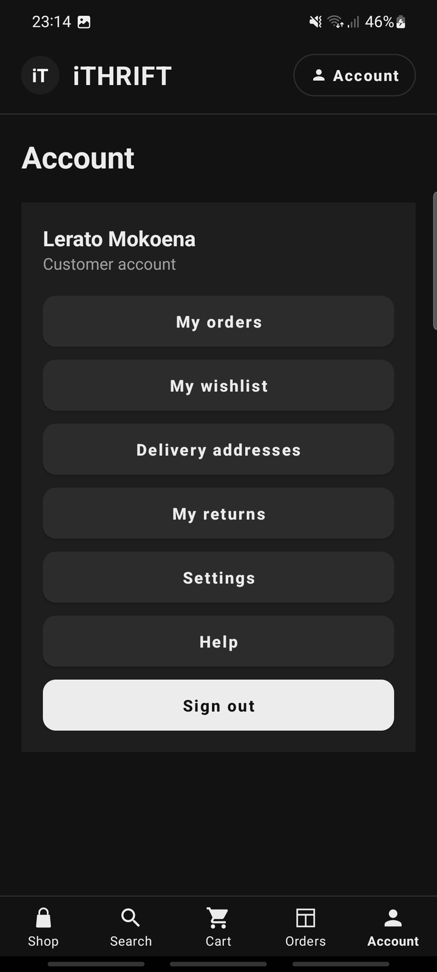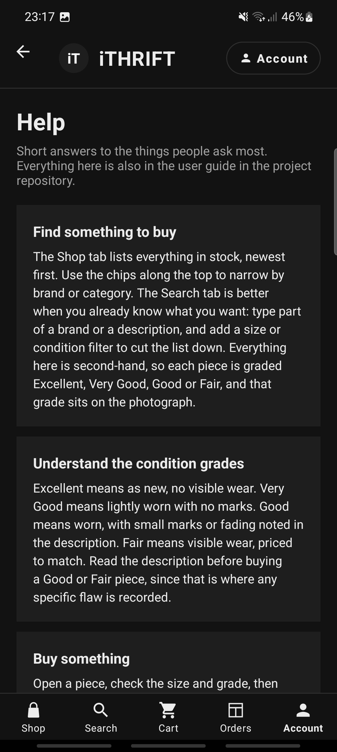
Figure 32: Android, Account tab: the way through to the wishlist, addresses, returns, Settings and Help (left), and the in-app Help screen (right)

12. Demonstration video
The demonstration video is 3 minutes 46 seconds long and has two parts. The first is a screen recording made on a physical Android handset, a Samsung phone, not an emulator. The second is a screen recording of the laptop that runs the server. A voice-over explains what is being shown; it is a computer-generated voice reading a script, as set out in Section 15. The video is to be uploaded to YouTube as unlisted, and the link will appear in the README as well as here.
The module sets three conditions on this video, and all three should be visibly satisfied: a real phone, a voice-over, and evidence of the data held in the online authentication service, in the API and in the database. The last of these is the one most often missed: it means showing the stored records, not only the screens that were built from them.

12.1 What the walk-through covers
Time | Segment | What is shown
0:00 | The phone | The app is opened from the home screen of the handset
0:06 | Home | The landing page of the app
0:22 | Account | The sign-in and create-account form; an empty form is refused with a message
0:43 | Single sign-on | Continue with Google, the account chooser, and the signed-in state
0:52 | Browse | The catalogue, the Sale filter and the category filters
1:22 | Product detail | Condition, price and sizes; sold-out pieces marked out of stock
1:35 | Buy | A size is chosen, the piece is added to the cart, and the cart is edited
1:48 | Checkout | Delivery method, the address book, payment method, and the total quoted by the server
2:14 | Order | The order is placed; the order detail with its tracker and cancel option; My orders
2:36 | Account | The wishlist and the account menu
2:45 | Authentication service | The Google Cloud console, with the two OAuth clients registered for iTHRIFT
2:59 | The API | GET /api/products in a browser, returning every product as JSON
3:11 | The server | The server window, logging each request with its result and who made it
3:18 | The database | The Customer table with salted password hashes, the Google customer with no password stored, and the newest orders, including the two placed from the phone
3:34 | The website | The staff console on Process orders, showing the same orders
Table 21: Running order of the demonstration video
The video does not show every feature. Settings, dark mode, search, promo codes, cancelling an order and returns are evidenced by the phone screenshots in Sections 4 and 10. The database segment is a still screenshot of the stored rows rather than moving footage.
EVIDENCE TO INSERT
Paste the unlisted YouTube link here, and into the README.
Check before submitting: recorded on a real phone; voice-over throughout; shows data in the authentication service, the API and the database.

13. Release notes
Version 1.2.0 (build 3) is the current Task 2 prototype. It adds the shopping features to version 1.1.0 (build 2), which was the first Task 2 build. The same notes are kept in the README, which is where the module asks for them.
Area | What changed since version 1.1.0
Sizes | Every piece is stocked by size, and only sizes in stock can be chosen. The cart, the order and the stock count all work per size.
Wishlist | Save a piece for later, move it to the cart or remove it. The list is held on the server, so it is the same on the phone and on the website.
Sale prices and promo codes | Sale prices with the old price crossed out, a Sale filter in both clients, and promo codes at checkout with a percentage or fixed discount and an optional minimum spend.
Delivery and addresses | An address book with a default address. Standard, express and collection delivery, with the total quoted by the server in one place for both clients.
Cancelling and returns | A customer can cancel an order that is still processing, and return a delivered item within 30 days. Staff approve, reject and refund returns in a new section of the console.
Fixes | The Shop and Search tabs no longer crash when a screen closes while it is loading. Dark-mode colours corrected so every block has readable text. The website keeps its side margin on every page. The app signs out cleanly when the server no longer recognises its session. Google sign-in no longer fails on a slow connection.
Testing | The end-to-end suite grew from 70 checks to 131, the API unit tests from 9 to 22 and the Kotlin unit tests from 49 to 50.
Database | Five new tables: ProductSize, Address, WishlistItem, PromoCode and ReturnRequest, each seeded with at least ten rows.
Table 22: Release notes for version 1.2.0 (build 3)
The innovative features in this version are the per-size stock model, the single server-side quote that both clients display, and returns that put a refunded piece back on sale in its size. Version 1.1.0, the first Task 2 build, made the changes below.
Area | What changed since the Task 1 baseline
Single sign-on | Added end to end. Credential Manager on the phone, POST /api/auth/sso on the server, with the Google ID token verified for issuer, audience, expiry and a verified email address before any session is issued. Neither the app nor the repository holds the client id.
Account security | The Customer table now records how an account authenticates, with a constraint enforcing that a password account has a hash and an SSO account has a provider subject. Signing in with Google on an address that already has a password account is refused rather than linked. Customers can change their password from the app.
Settings | A new settings screen: profile, password, appearance, notifications, connection and reset. Dark theme, applied before the first screen is drawn. The server address moved here and gained a Test connection button.
Help and documentation | A new in-app Help screen with eight task-based topics and a diagnostics panel, and a new written user guide at docs/user-guide.md.
Testing | 49 Kotlin unit tests added. Before this the Android CI job ran against an empty source set and passed without testing anything. 9 API unit tests added. The end-to-end suite grew from 51 checks to 70.
Release pipeline | A tag-triggered workflow producing a signed APK and App Bundle, with the keystore held as a repository secret and deleted from the runner afterwards.
Database | Every table now holds at least ten rows and the seed script fails rather than under-filling one. Twelve customers, ten staff accounts, twelve orders across all four statuses, twelve open carts, fifteen reviews. Four categories split out: Polos, Shirts, Hoodies, Jackets.
Logging | Per-request server logging of method, path, status, duration and who was signed in, with failures sent to stderr so they can be filtered out of a CI log.
Validation | Input rules collected into one tested place matching the server’s own, so a customer is no longer told a password is fine and then rejected by the API.
Table 23: Release notes for version 1.1.0 (build 2)
Of these, the four that a marker should look at first are single sign-on, the settings screen, the help system and the Kotlin unit tests, because each of them is a rubric line that Task 1 did not address at all.

14. Preparation for Google Play publication
The application is prepared for publication. The release workflow produces a signed APK and an Android App Bundle from a keystore that is never committed, which is the part of publication that has to be got right first: the signing key cannot be rotated once an app is live, so an app signed with a key that leaked, or lost, cannot be updated at all.
Requirement | State
Signed release artefact | Produced by .github/workflows/release.yml on a v* tag
Keystore kept out of the repository | Held base64 in a repository secret; restored to the runner and deleted afterwards
Application id | com.codecouture.ithrift
Version | 1.2.0 (versionCode 3)
Target API level | 35
App Bundle (.aab) for the Play Console | Produced alongside the APK
Store listing text and graphics | Listing text drafted in Section 14.1; feature graphic and phone screenshots still to capture
Play Console upload | TO BE COMPLETED
Table 24: Publication readiness
EVIDENCE TO INSERT
A screenshot of the signed APK or App Bundle produced by the release workflow.
A screenshot of the app in the Google Play Console, uploaded and, if applicable, published.
Play Store screenshots at the sizes the Console requires.

14.1 Draft store listing
App name (30 characters max): iTHRIFT: Pre-loved Fashion
Short description (80 characters max): Buy condition-graded, pre-loved branded clothing in South Africa.
Full description: iTHRIFT sells pre-loved branded clothing, footwear and accessories that our team has checked and graded before listing. Every piece carries an honest condition grade, Excellent, Very Good or Good, so you know what you are buying before it arrives. Browse by category and brand, search for the piece you want, and check out in a few taps. Track your order from Processing to Shipped to Delivered, with the courier reference in the app. Sign in with your email or with Google, switch between light and dark themes, and manage your delivery details in Settings. Prices are in rand and delivery is within South Africa.
Category and details: Shopping. Content rating: Everyone. Contact: the group’s student email addresses.

15. Use of AI tools
The group used Claude, a large language model made by Anthropic, through the Claude app during Task 2 (Anthropic, 2026). It was used as a pair programmer and an editor, not as a substitute for understanding the code, and this section sets out where.
Code. Claude produced first drafts of the new Settings and Help screens, the Google single sign-on flow on both the phone and the server, the Validators object, and most of the Kotlin and API unit tests. It also helped diagnose Gradle and Android Studio set-up errors on Windows. In October it also drafted the shopping features in Section 4.6 on the server, the website and the app, together with their tests. Each draft was read, run and changed where it did not fit: for example, the rule that a Google sign-in on an address that already has a password account is refused rather than linked was a decision the group made after discussing the security trade-off.
Documentation. Claude drafted the structure and much of the wording of this document, the README and the user guide from the group’s notes and the code in the repository. The group edited the drafts for accuracy against what was actually built.
Evidence and checking. Claude ran the API unit tests and the end-to-end smoke test in a sandbox, captured the website, database and test-output figures in Sections 6, 8 and 9, and validated the HTML of every page. The phone screenshots in Sections 4 and 11 and the pipeline screenshots in Section 3.3 were taken by the group on their own phone and laptop. The screenshots are of the real system running from this repository; none is a mock-up.
How the output was checked. Nothing was accepted on trust. Every rule described in this document is covered by an automated test that runs in GitHub Actions, and a suggestion that could not be explained by the member committing it was not committed. Where Claude and the tests disagreed, the tests won.
The demonstration video. The group recorded the phone screen and the laptop screen themselves, on 2 and 7 October 2026. Claude wrote the narration from those recordings and produced the voice-over with a text-to-speech model (Kokoro), so the voice in the video is computer generated and is not a group member speaking. Claude also joined the recordings and the voice into one file. The database segment is a still screenshot, taken by the group on the laptop, of a small read-only viewer script that Claude wrote; the other segments are moving footage.
What it was not used for. The peer and self evaluations are the group’s own work. The group created the Azure DevOps board, entered the issues and assigned them; Claude suggested the titles of the issues from the work in the repository.
CHECK BEFORE SUBMITTING
This account was drafted for the group. Read it against what each of you actually did, correct anything that is not accurate, and add anything that is missing. It must stay under 500 words.

16. Requirement checklist
Every requirement in Section 9.2 of the module manual, and every criterion on the Task 2 marking rubric, mapped to where it is met.

16.1 Against the marking rubric
Rubric criterion | Marks | Where it is met
The app runs on a mobile device | 10 | §4, §12: builds to app-debug.apk (about 8 MB); demonstrated on a handset in the video
Feature: sign in | 10 | §5.1, §5.3: email and password, plus Google single sign-on
Feature: settings menu | 10 | §4.5: profile, password, appearance, notifications, connection, reset
Creation and use of the API | 10 | §7: the shared REST API, used by both clients
Integration of the API in the app | 10 | §4.1, §4.4: Retrofit client, typed results, every screen
Database structure and table design | 15 | §6: 16 tables in 3NF, constraints, ≥10 rows in every table
User interface | 10 | §4.3, §4.6: five tabs, two-column grid, light and dark themes, shopping features
User documentation | 10 | §11: in-app Help, docs/user-guide.md, README
GitHub, README and automated testing | 10 | §3, §9: three workflows, 203 automated checks, no ZIP files
Demonstration video | 10 | §12: real handset, voice-over, shows the stored data
Table 25: The Task 2 marking rubric, mapped to this document

16.2 Against the module manual, Section 9.2
Requirement | Where it is met | Done
Mobile app developed on GitHub | §4, repository link in §1.3 | Yes
Website updated | §8 | Yes
Full DevOps lifecycle | §3 | Yes
Azure DevOps used throughout implementation | §3.1 | Partly: board set up on 2 October 2026
Runs on a phone, not an emulator | §12 | Recorded; YouTube link to be added
GUI, input controls and program modules coded | §4.2 to §4.4 | Yes
Database tables designed in a DBMS | §6.1 to §6.3 | Yes
At least ten records per table | §6.4 | Yes
System verified and tested | §9, §10 | Yes
Help system and user documentation | §11 | Yes
Register and log in | §5.1 | Yes
Password encrypted | §5.2 | Yes
Single sign-on | §5.3 | Yes
User can change their settings | §4.5 | Yes
UI handles invalid input without crashing | §4.4, §10 | Yes
Automated testing through GitHub Actions | §3.3, §9 | Yes
Video: real phone, voice-over, shows auth/API/DB data | §12 | Recorded; YouTube link to be added
Cover page and table of contents | This document | Yes
GitHub links in the document; no ZIP files | §1.3 | Yes
Release notes since the prototype | §13 | Yes
Prepared for Google Play publication | §14 | Partly; listing drafted, upload to do
Write-up on the use of AI tools | §15 | Drafted; check it
Table 26: Section 9.2 requirements, mapped to this document
The items not yet ticked need something only the group can supply: the link to the uploaded demonstration video, the Play Console upload, and a final check of the account of AI use. Everything else is in the repository and can be verified by running it.

References
Anthropic. 2026. Claude [Large language model]. Available at: https://claude.ai [Accessed 25 September 2026].
Google. 2025. Guide to app architecture. [Online]. Available at: https://developer.android.com/topic/architecture [Accessed 6 September 2026].
Google. 2025. Sign in your user with Credential Manager. [Online]. Available at: https://developer.android.com/identity/sign-in/credential-manager-siwg [Accessed 6 September 2026].
Google. 2025. Authenticate with a backend server. [Online]. Available at: https://developers.google.com/identity/gsi/web/guides/verify-google-id-token [Accessed 6 September 2026].
Google. 2025. Material Design 3: Navigation bar. [Online]. Available at: https://m3.material.io/components/navigation-bar/overview [Accessed 6 September 2026].
Google. 2025. Sign your app. [Online]. Available at: https://developer.android.com/studio/publish/app-signing [Accessed 6 September 2026].
GitHub. 2025. GitHub Actions documentation. [Online]. Available at: https://docs.github.com/en/actions [Accessed 6 September 2026].
GitHub Marketplace. 2025. Automated build Android app with GitHub Action. [Online]. Available at: https://github.com/marketplace/actions/automated-build-android-app-with-github-action [Accessed 3 November 2025].
Microsoft. 2025. Azure Boards documentation. [Online]. Available at: https://learn.microsoft.com/en-us/azure/devops/boards [Accessed 6 September 2026].
Microsoft. 2025. What is DevOps? [Online]. Available at: https://learn.microsoft.com/en-us/devops/what-is-devops [Accessed 6 September 2026].
Node.js. 2025. Crypto: scrypt. [Online]. Available at: https://nodejs.org/api/crypto.html [Accessed 6 September 2026].
OWASP. 2021. Password storage cheat sheet. [Online]. Available at: https://cheatsheetseries.owasp.org/cheatsheets/Password_Storage_Cheat_Sheet.html [Accessed 6 September 2026].
The Independent Institute of Education. 2026. Module manual XISD6329: Work Integrated Learning 3B. Johannesburg: The Independent Institute of Education.

