INSY7213 Output Evidence
Oracle SQL / PL/SQL Screenshots
The following screenshots provide output evidence for the completed INSY7213 database questions. Setup evidence is shown first, followed by Questions 1–8.

Database Setup Evidence
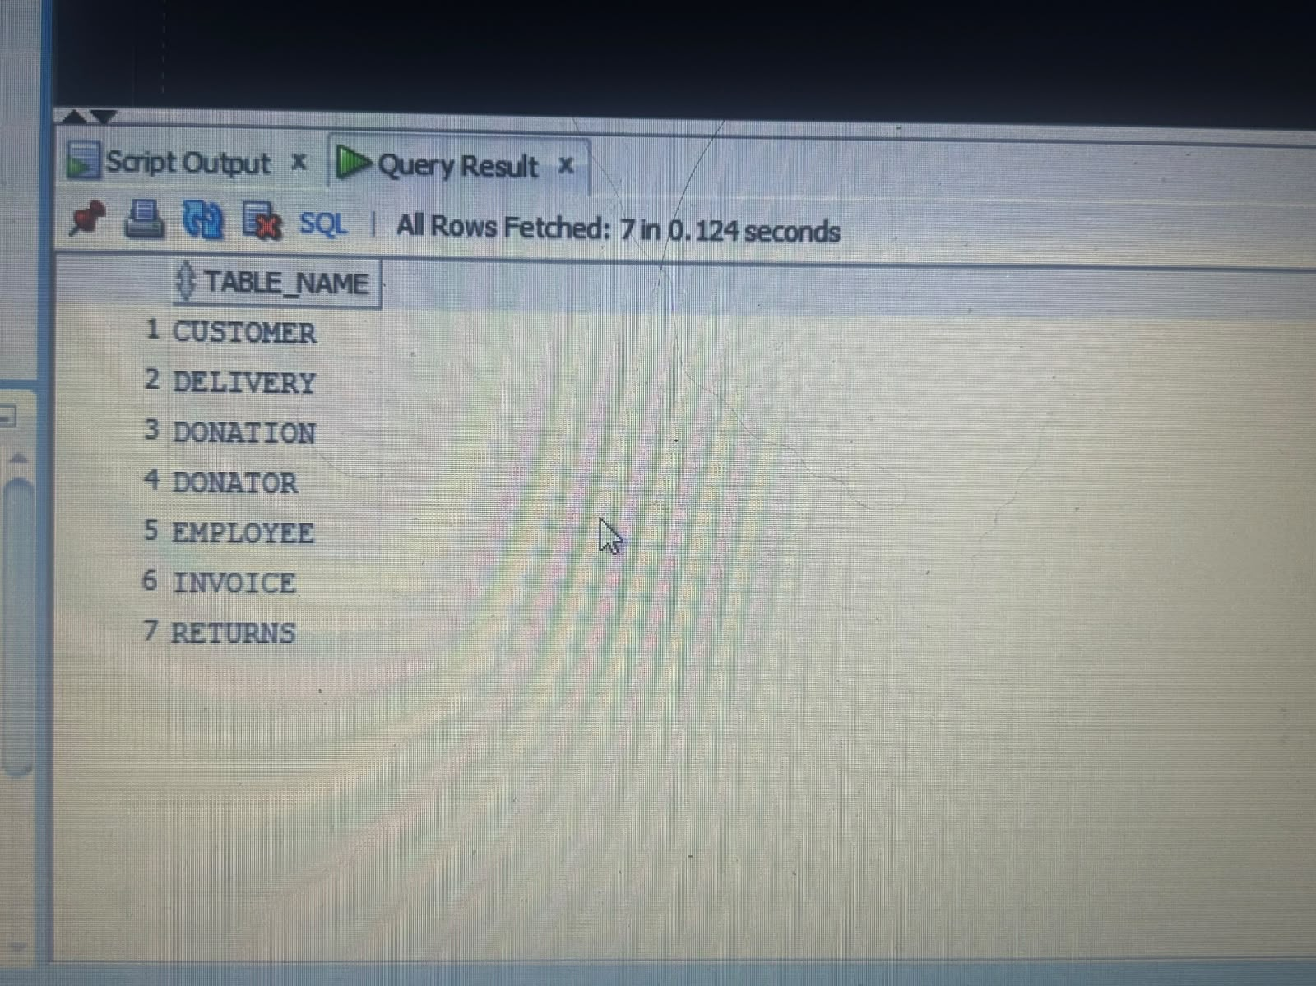
Database setup evidence – tables created.

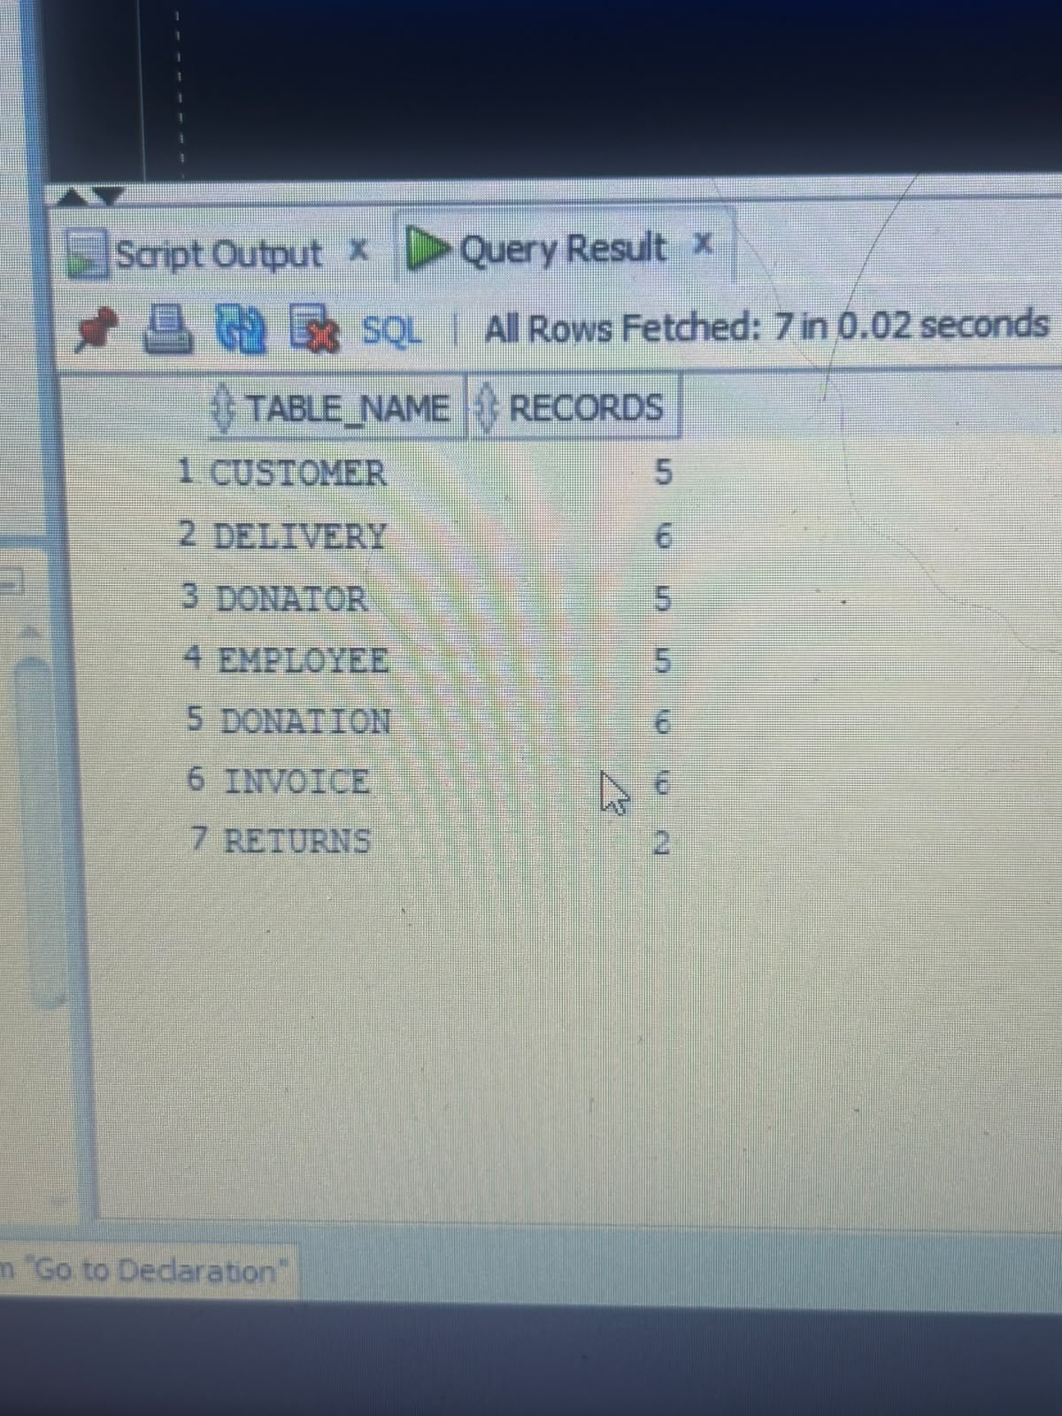
Database setup evidence – table/record count output.

Question 1
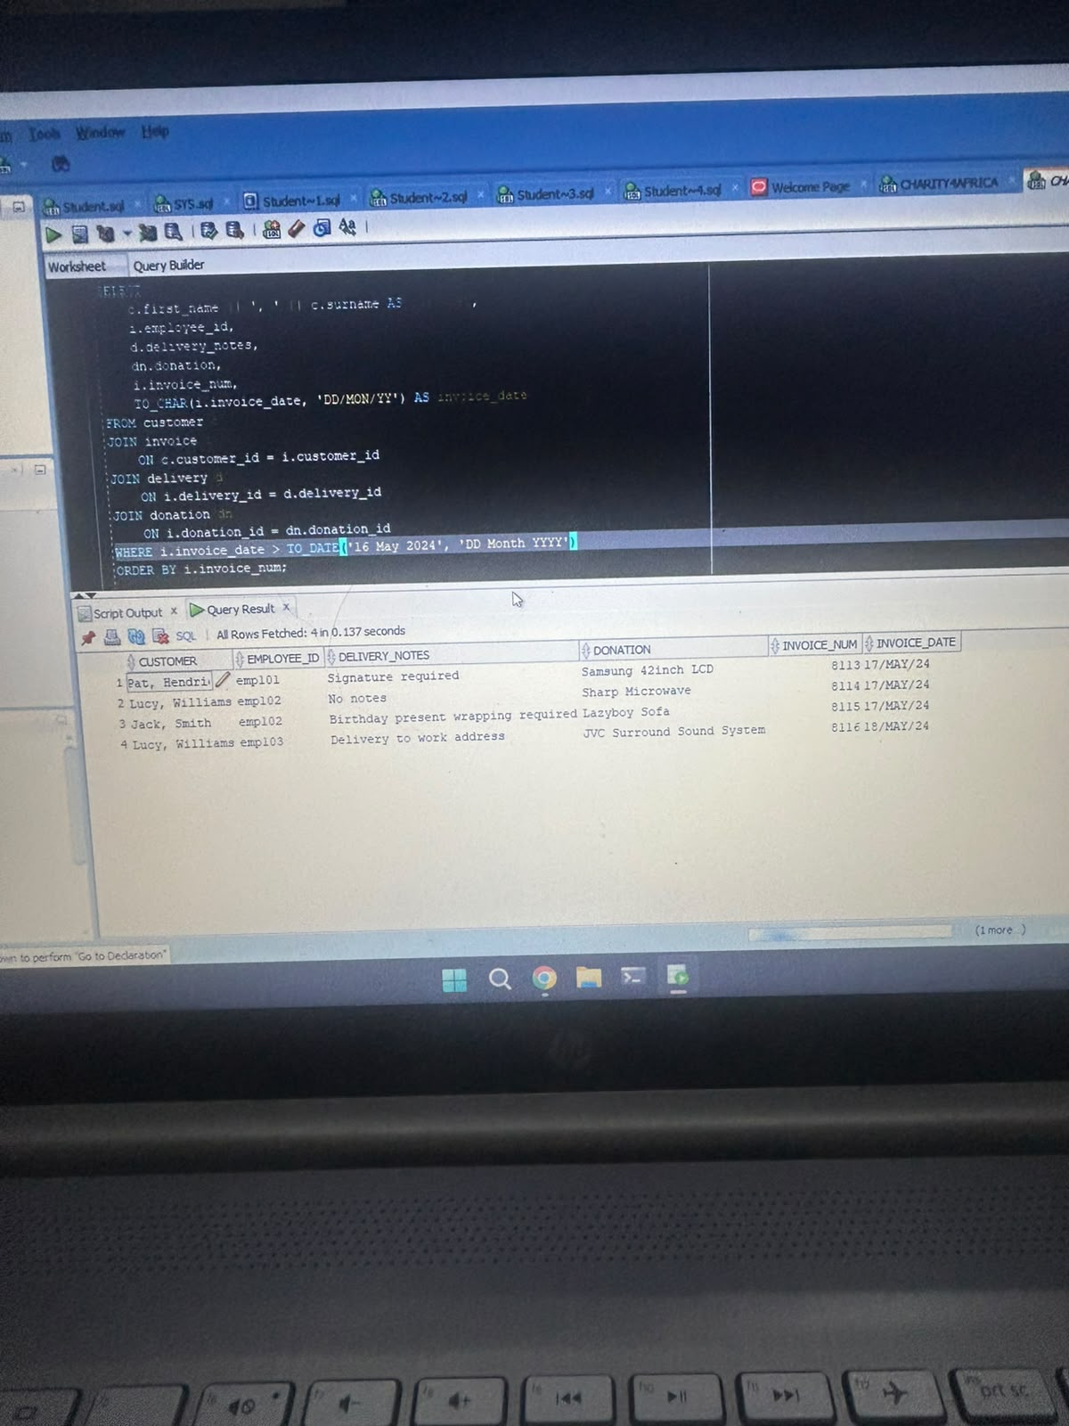
Question 1 output – invoice/customer/donation query.

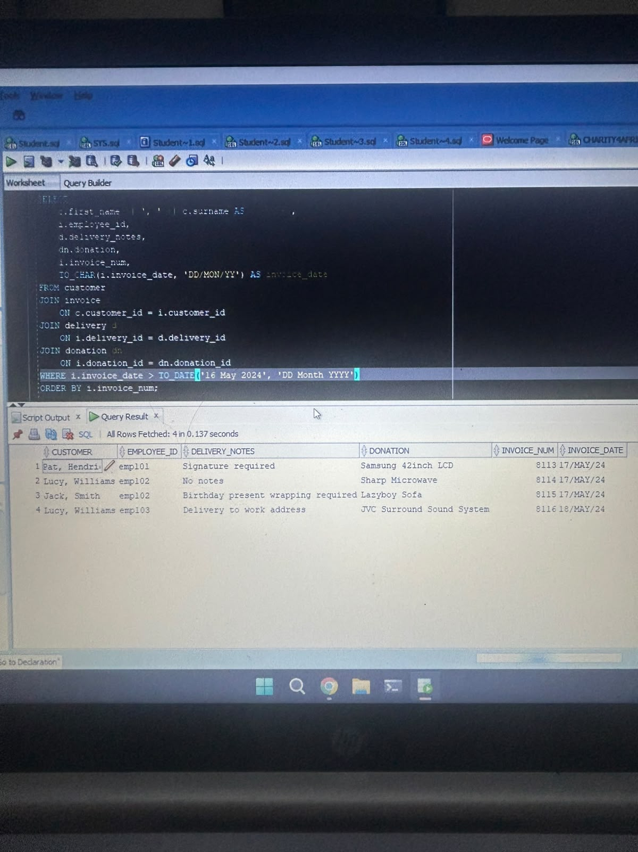
Question 1 supporting output.

Question 2
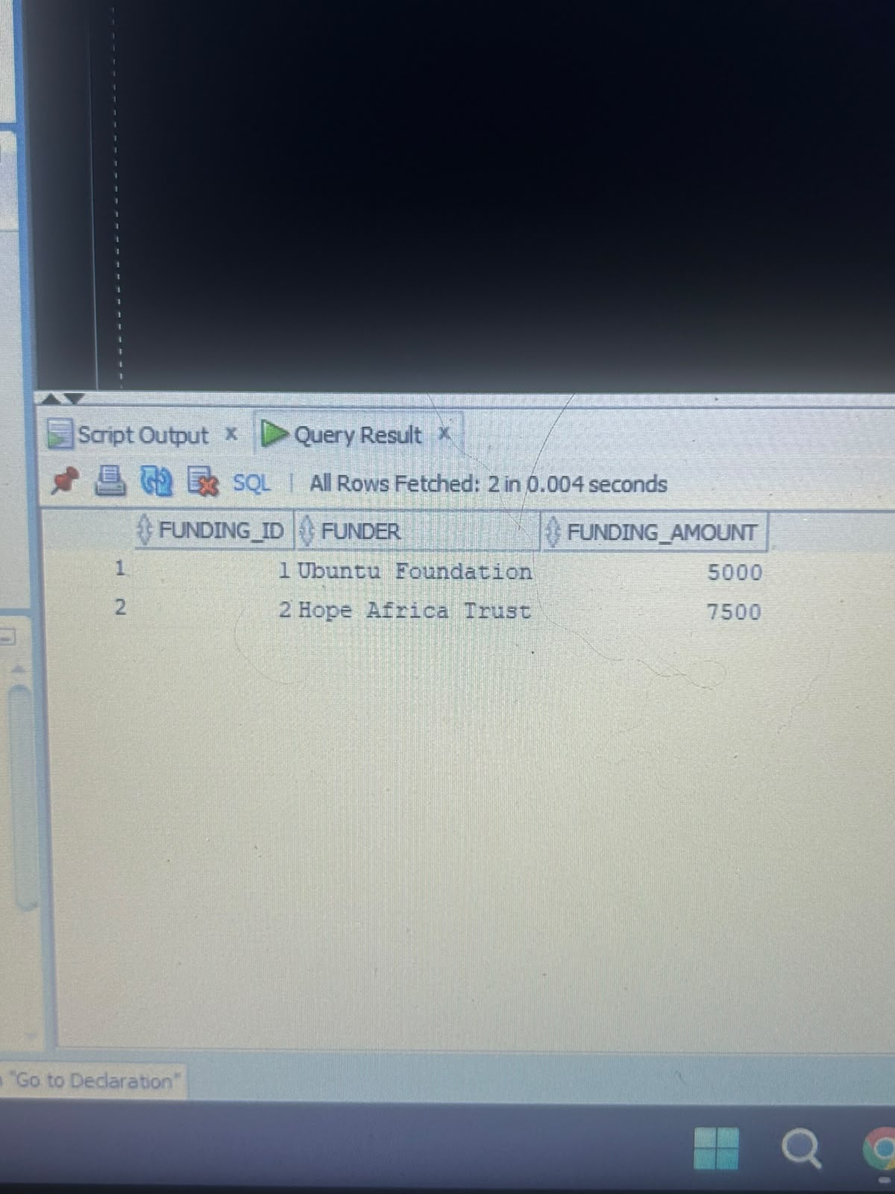
Question 2 output – funding/donation results.

Question 3
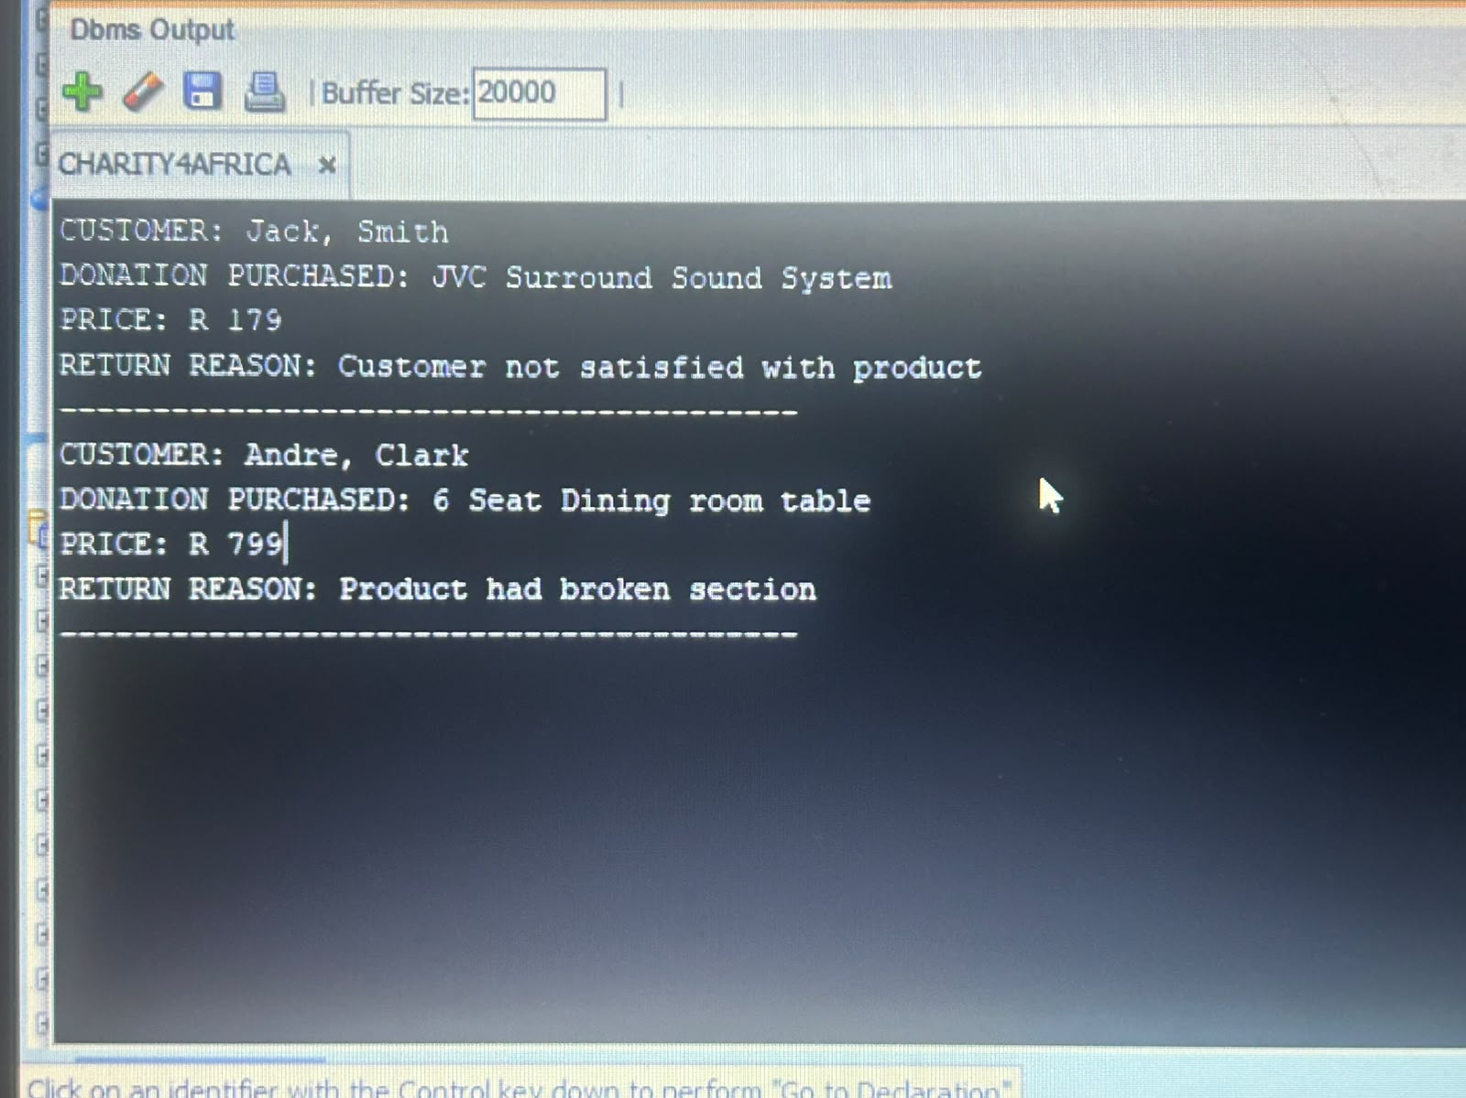
Question 3 output – PL/SQL returns output.

Question 4
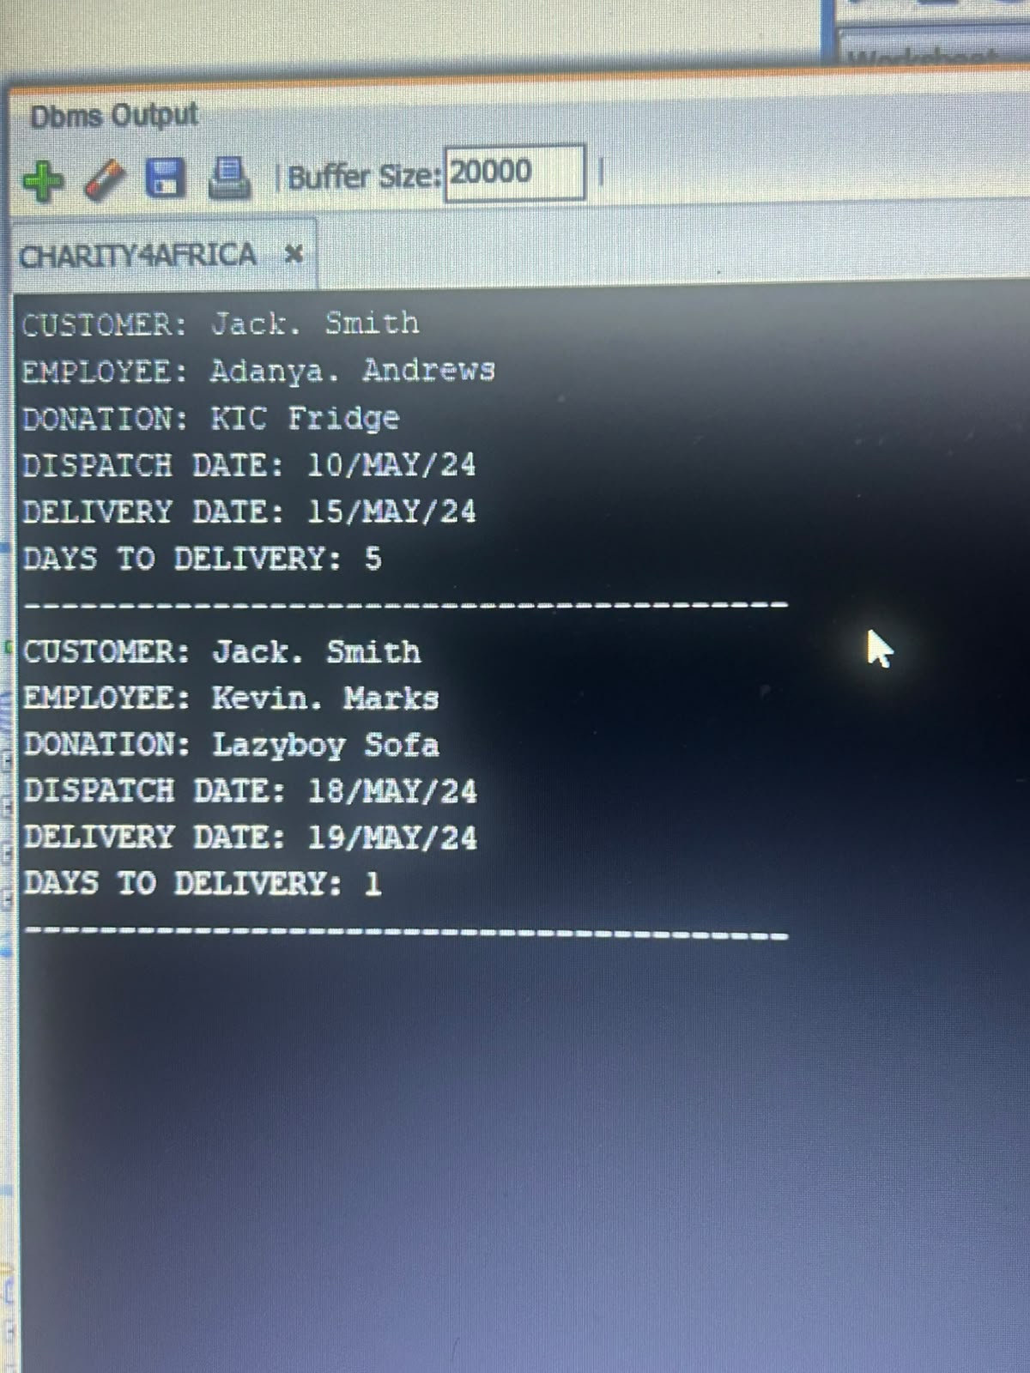
Question 4 output – PL/SQL days-to-delivery calculation.

Question 5
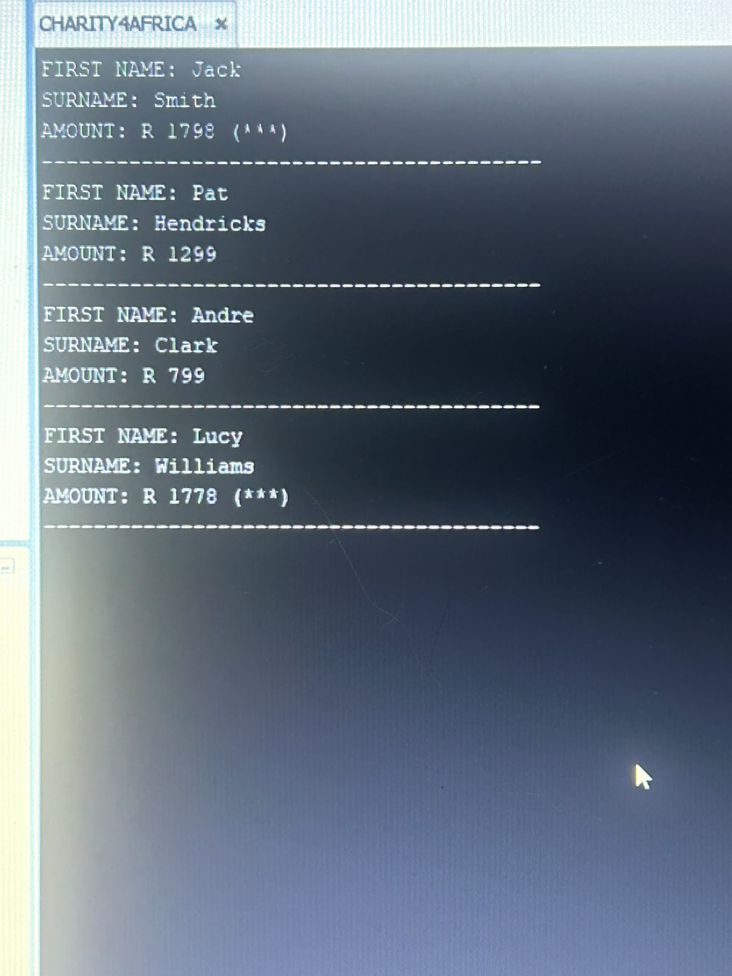
Question 5 output – customer amount/rating.

Question 6
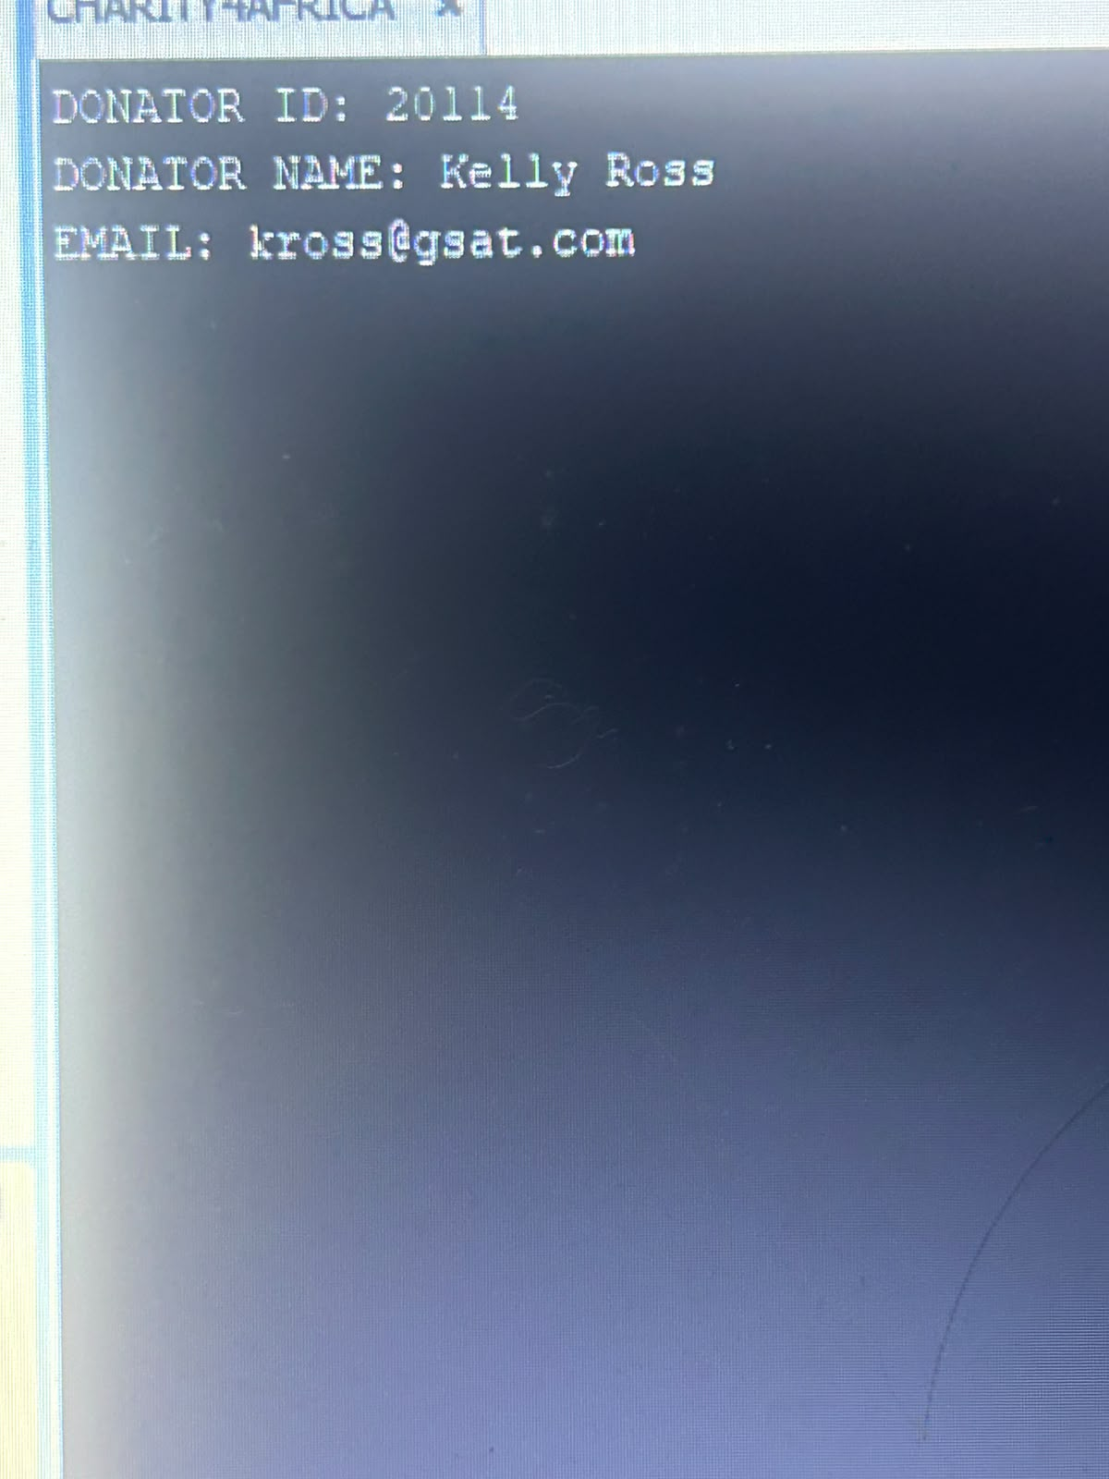
Question 6 output – donator details.

Question 7
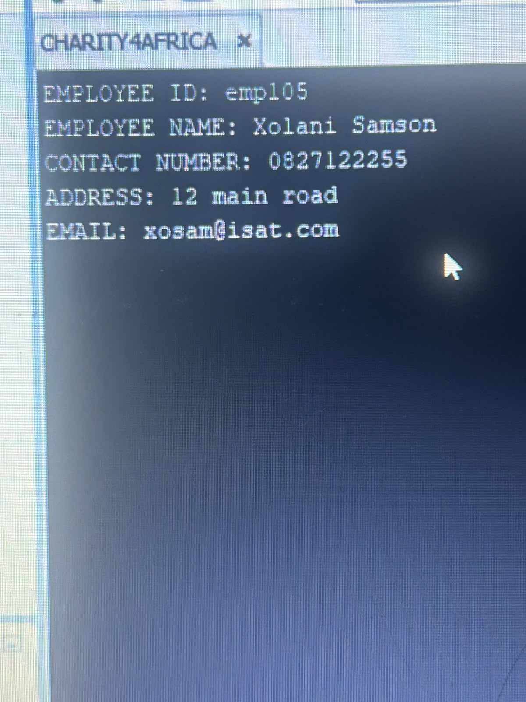
Question 7 output – employee details.

Question 8
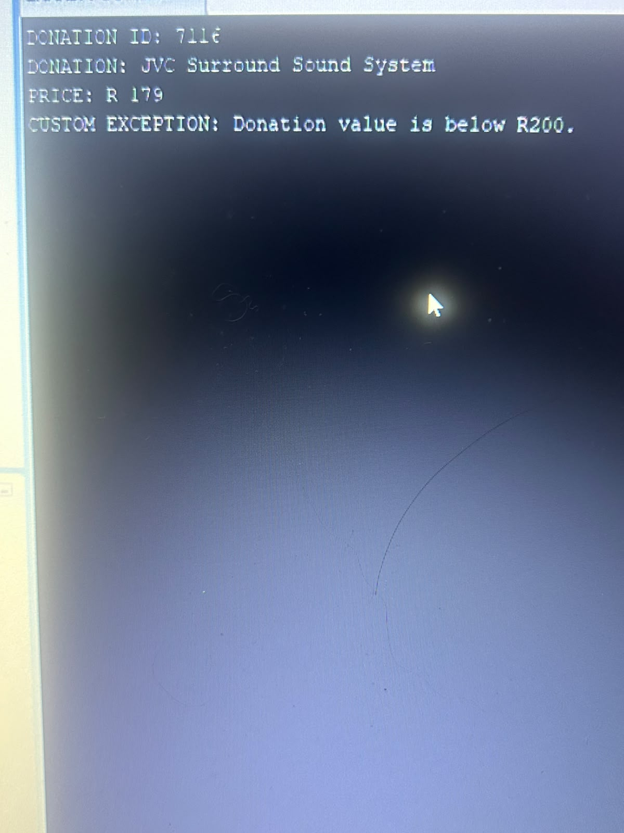
Question 8 output – custom exception for donation below R200.

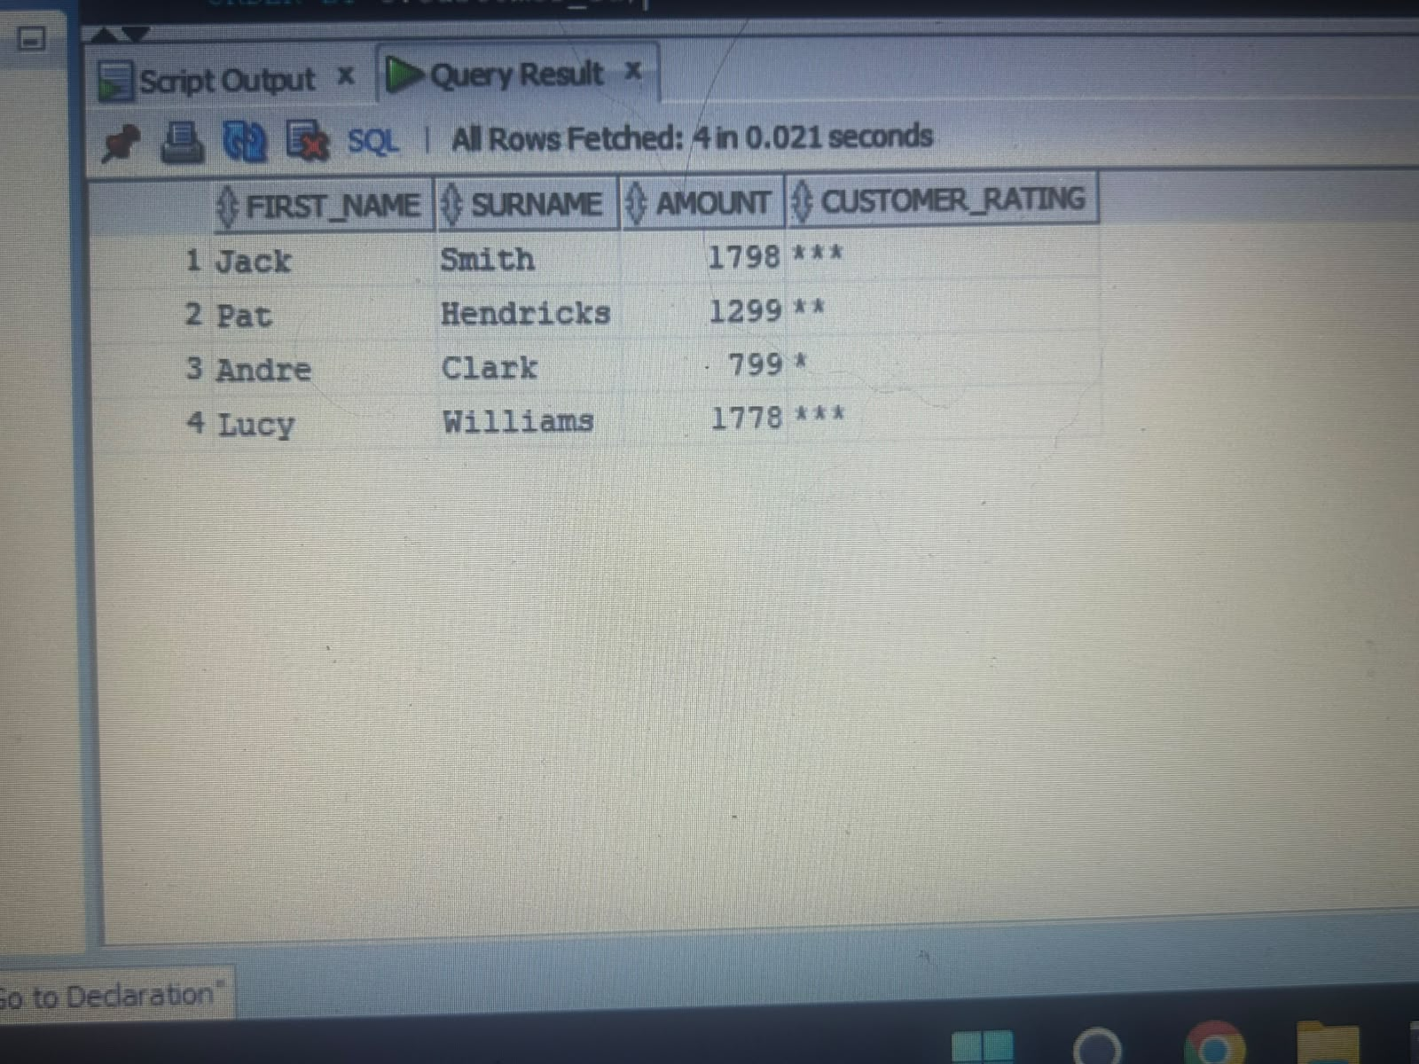
Question 8 supporting output – customer/rating query.

