SWL DETAILED


Vehicle Workflow & Operations Management System

TASK 1 — PROTOTYPE DOCUMENTATION
INSY7315 — Work-Integrated Learning

Team Name: Quantum Coder
Team Members:
Blake Derek Godfrey | ST10435415
Syed Muhammad Hamza Kazmi | ST10443021
Connor Albertyn | ST10437293
Luke Hopewell | ST10301519
Muzammil Cassim | ST10259792

Client: SWL Detailed (Pty) Ltd
Unit 26, Scientia Technopark, 2 Meiring Naude Road, Pretoria, 0181

Academic Year: 2026

1. Prototype Overview

1.1 Purpose and Scope
The prototype accounts for 25% of the grade for Task 1 and serves to visually represent and illustrate how the SWL Detailed Vehicle Workflow & Operations Management System will be functioning when it will be developed. There is no need for any backend logic or programming at this point as only layout and navigation design are required for all four system roles (Manager/Admin, Reception/Administrator, Detailer/Worker, Client/Customer).
Prototype is different from the document attached to it since it serves its specific purpose while the document is there to provide stakeholders with all the information about the project in the form of textual description of the system requirements, data models and workflows (Figma, 2024). This is in line with UX standards which recommend making use of prototypes to validate all the design decisions made and identify usability problems before even writing a single line of production code (Nielsen Norman Group, 2019).
For this project, the prototype must:
- Show the essential screens identified for each of the four user roles.
- Connect those screens with real clickthrough navigation instead of just showing a list of screens.
- Delineate the flow of information between screens using realistic dummy data (client names, vehicle registrations, job statuses, and life cycle stages).
- Cover the entire job life cycle, from Booked all the way to Collected, and include the new features added based on client feedback (bookings, check-in/checkout, the Quality Control gate, Manager pre-sign-off, battery reminders, invoicing, PPF checkups, and customer satisfaction sign-off).
- Be responsive for desktop and mobile/tablet form factors and match the actual usage for each role.
The scope intentionally omits a functional backend, database, or authentication. Dummy buttons and dummy forms are included so that someone reviewing the prototype can trace the full operational scenario, such as the movement of a vehicle from booking through intake, servicing, quality control, and collection.

1.2 Prototype Tool (Figma)
For the prototype creation, it was decided to use Figma. Figma is an online software development and prototyping service that provides designers with the possibility to design interfaces and connect them into interactive and clickable flows without coding (Figma, 2024). Screens ("frames") relate to the help of hot spots and connections forming a navigable flow, which resembles user navigation in a finished product (Figma Help Center, 2024).
The following are some of the key reasons for the selection of Figma for this prototype:
- No-code interactivity – The frames can be wired up to create click, hover, and scroll events. This is enough for showing navigation and data flow without having any backend coding done (Figma, 2024).
- Collaboration in real-time – Multiple people can work, comment on and review the same file at the same time. It matches well with the team nature of this WIL project.
- Responsive preview built in – Figma’s prototyping tool can show the same design in different screen sizes, allowing it to easily demonstrate the desktop version and mobile/tablet version of each screen from a single file (Figma, 2024).
- Presentation mode – Any person who has view access can run the prototype in presentation mode. So, the link can be shared with markers or other stakeholders without needing any Figma account or any software installation (Figma Help Center, 2024).
The link of the completed prototype can be found in section 9 of this document (and/or the ARC submission comment). It can be accessed in Presentation mode in the web browser to run the entire 14-step flow shown in section 9.4.

1.3 Device Views Covered
The four users’ roles use the system in their respective environments through different devices in actual operational situations; therefore, the prototype addresses both the desktop and mobile/tablet breakpoints in accordance with each role’s working environment:
Role | Primary device modelled | Rationale
Client/Customer | Tablet/iPad | Used at the reception desk during vehicle intake and at collection for the satisfaction sign-off.
Reception/Administrator | Desktop (with tablet fallback) | Front-counter role handling bookings, check-in, invoicing, and battery reminders.
Manager/Admin | Desktop | Oversight role requiring dashboards, reporting, and QC review across all jobs.
Detailer/Worker | Mobile (phone-first, tablet secondary) | Workshop-floor role logging procedures, timers, product usage, and photos on the move.
In this case, responsive design is an adaptation of layout, spacing, and navigation to the screen size and mode of interaction, without necessitating separate builds for each device (MDN Web Docs, 2024). This is significant in the case of the prototype because while the manager's dashboard would require higher information density on a desktop screen, the detailer's job screen needs to be operable with a single hand on a phone in a workshop setting (Figma, 2024). The reason why the two screen formats have been developed for each of the screens mentioned in Section 9.3 of the brief is thus because both formats of each screen have been created in the Figma file for the purpose of viewing them in the context of the device frames.

Screens for User Roles

2. Client / Customer Screens (iPad / Tablet)
Each screen below is designed as an individual Figma frame, linked to the next via a hotspot so the full role journey can be played back in Presentation view. Layout, field order, and navigation follow standard usability conventions for the given pattern (form, dashboard, gallery, etc.) so that the flow feels familiar rather than arbitrary (Nielsen Norman Group, 2024a).

2.1 Welcome / Start Intake Screen
The entry point for the tablet-based intake kiosk. It presents the SWL Detailed branding, a short welcome message, and a single primary "Start Intake" call-to-action, keeping the first screen, a customer sees free of clutter or competing choices.
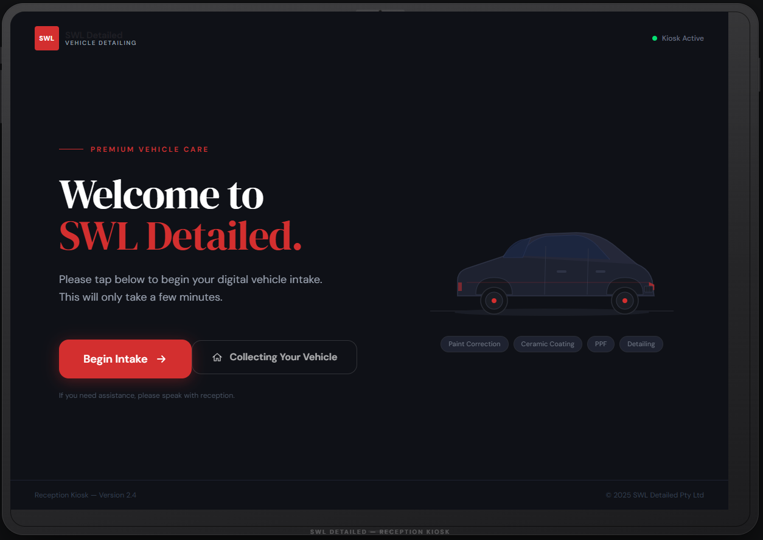
Figure P-1: Client - Welcome / Start Intake Screen (iPad)

2.2 Customer Details Form
Capture the customer's name, contact number, and email using a single-column field layout with clear labels above each input. A single-column layout reduces the risk of users skipping fields or misreading which label belongs to which input, which is one of the most consistent findings in form-usability research (Nielsen Norman Group, 2024a).
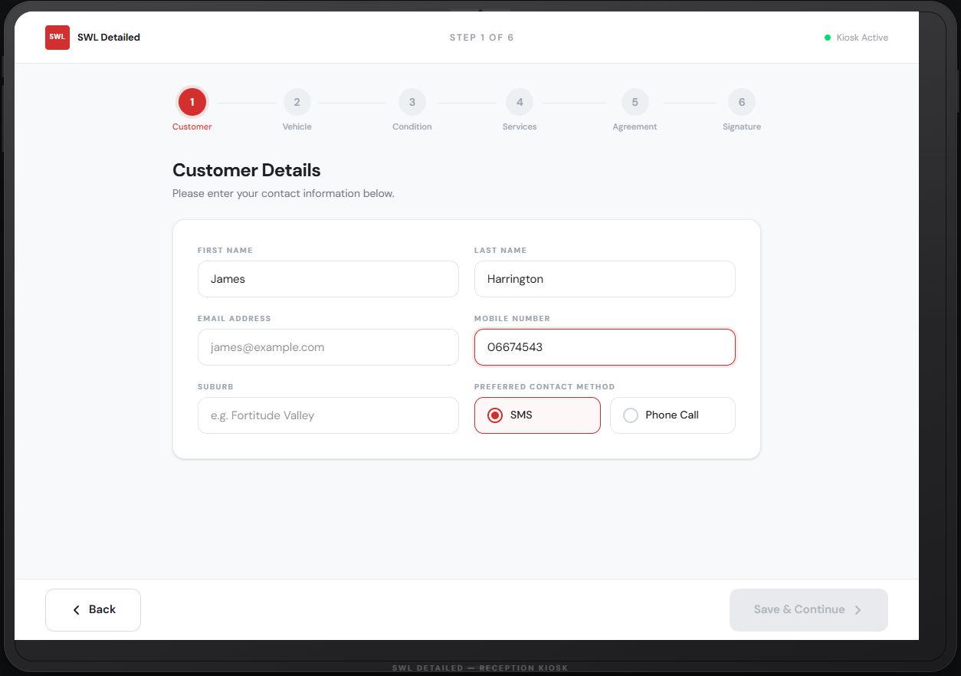
Figure P-2: Client - Customer Details Form (iPad)

2.3 Vehicle Details Form
Collects registration number, make, model, year, and colour. Dropdowns are used for making and year to reduce typing and input error, while registration and model remain free-text fields with placeholder examples to guide formatting.
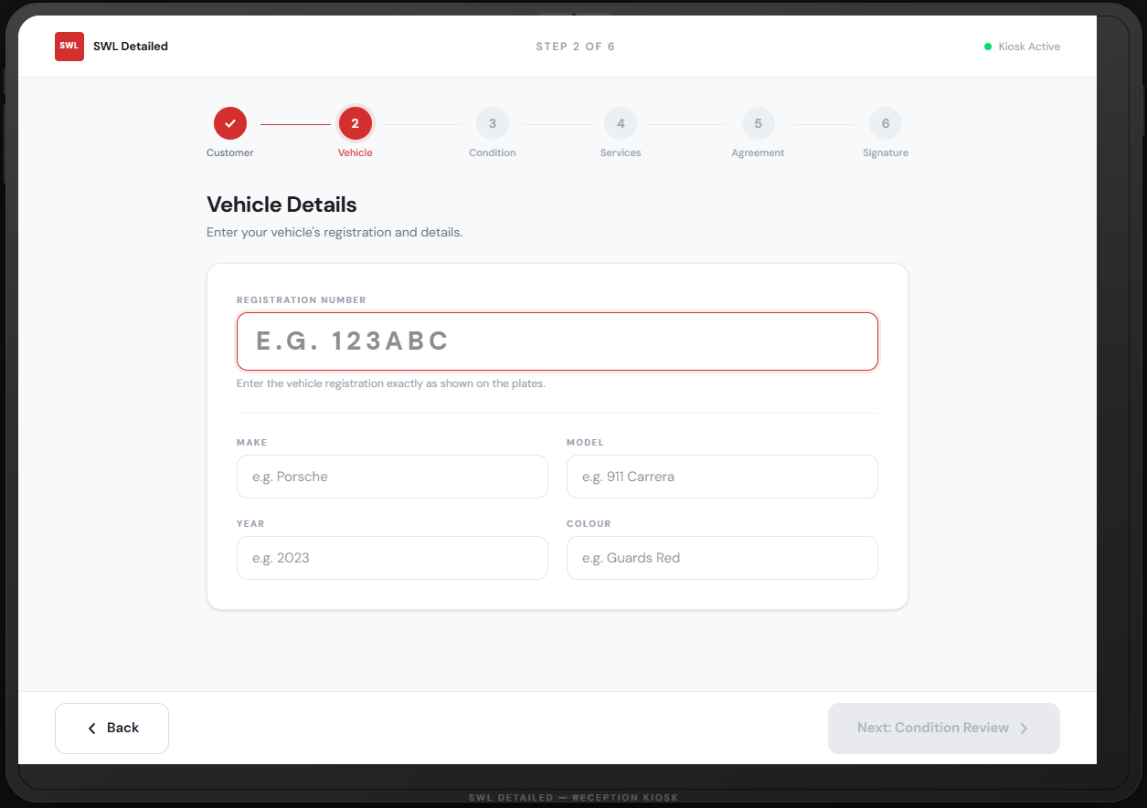
Figure P-3: Client -Vehicle Details Form (iPad)

2.4 Vehicle Condition & Damage Notes Screen
Allows the customer (or reception, on the customer's behalf) to review existing damage and add notes before service begins. Dummy "before" photos and pre-filled sample notes are used here to demonstrate how existing condition is captured and displayed prior to any work starting.
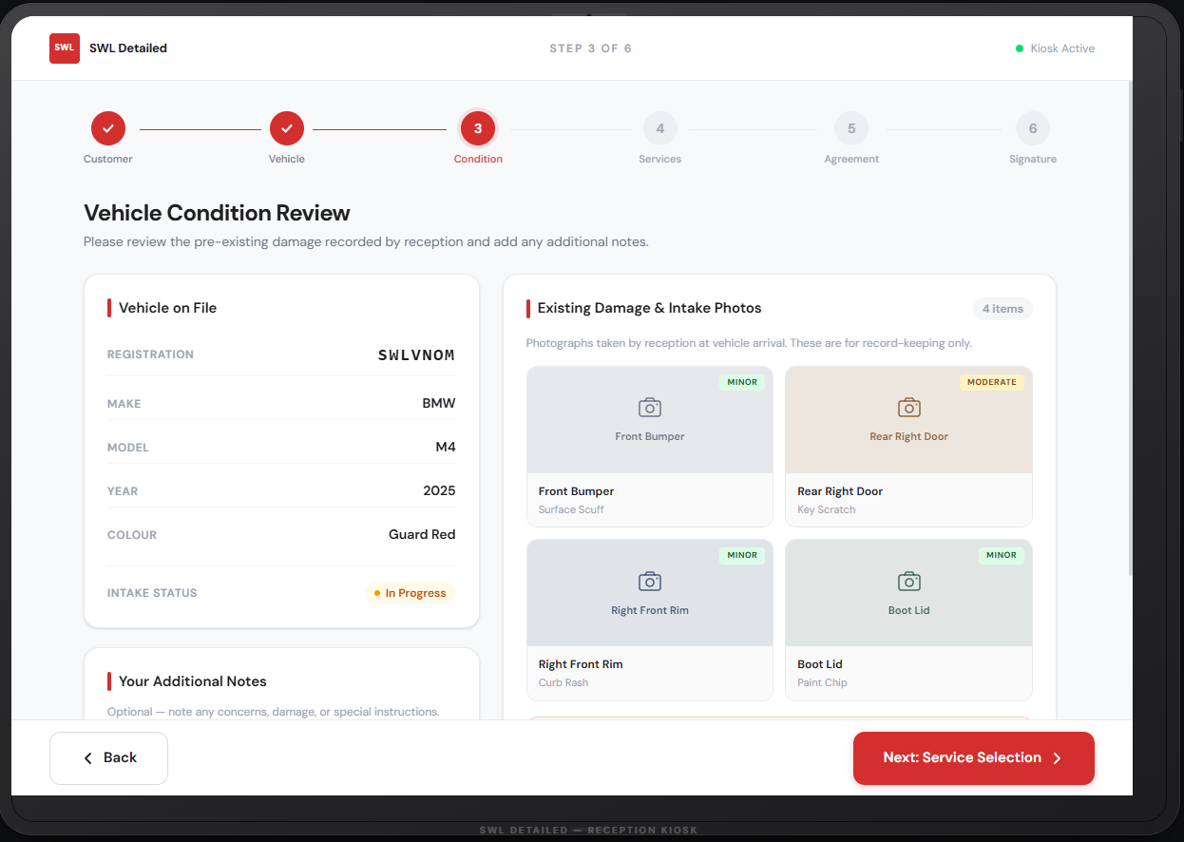
Figure P-4a: Client - Vehicle Condition & Damage Notes (iPad)
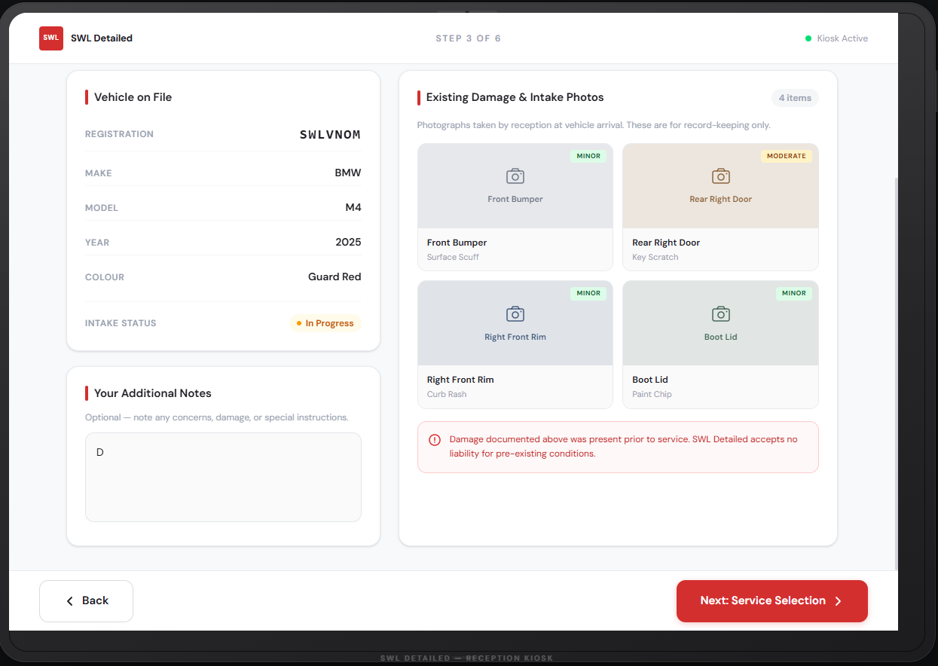
Figure P-4b: Client - Vehicle Condition & Damage Notes (iPad)

2.5 Service Selection Screen
Presents the available services (e.g. PPF, ceramic coating, paint correction) as selectable cards rather than a plain checklist, so the customer can see a short description and price indication for each before choosing.
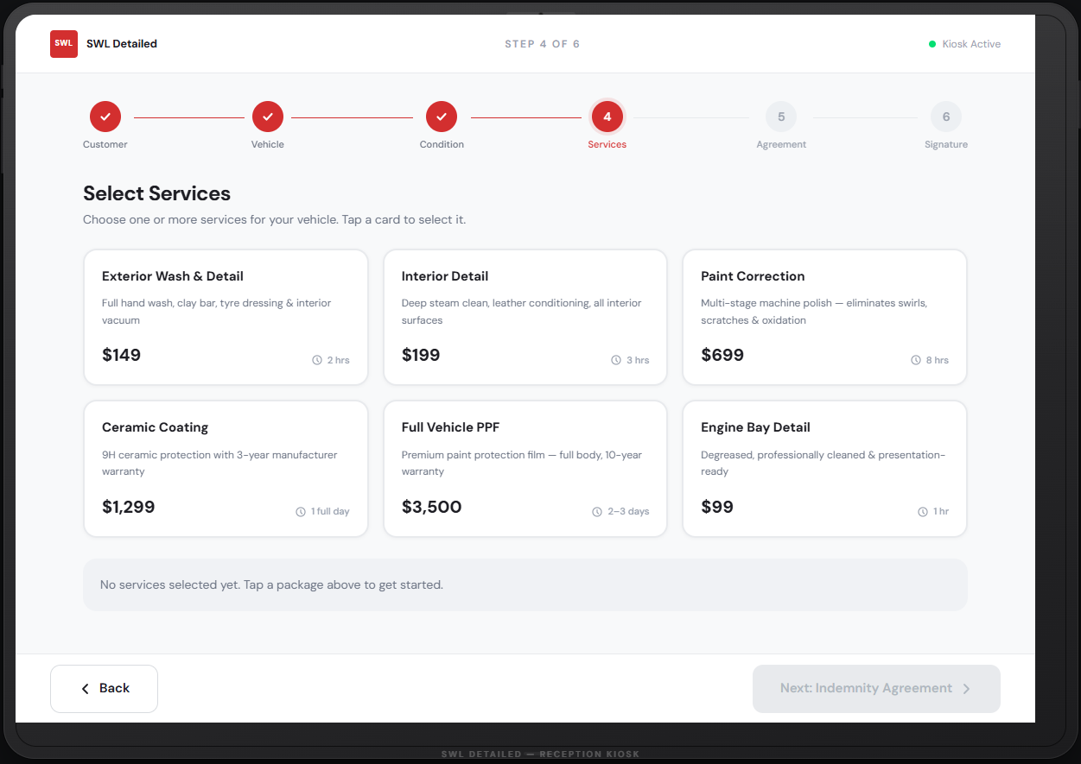
Figure P-5a: Client - Service Selection Screen (iPad
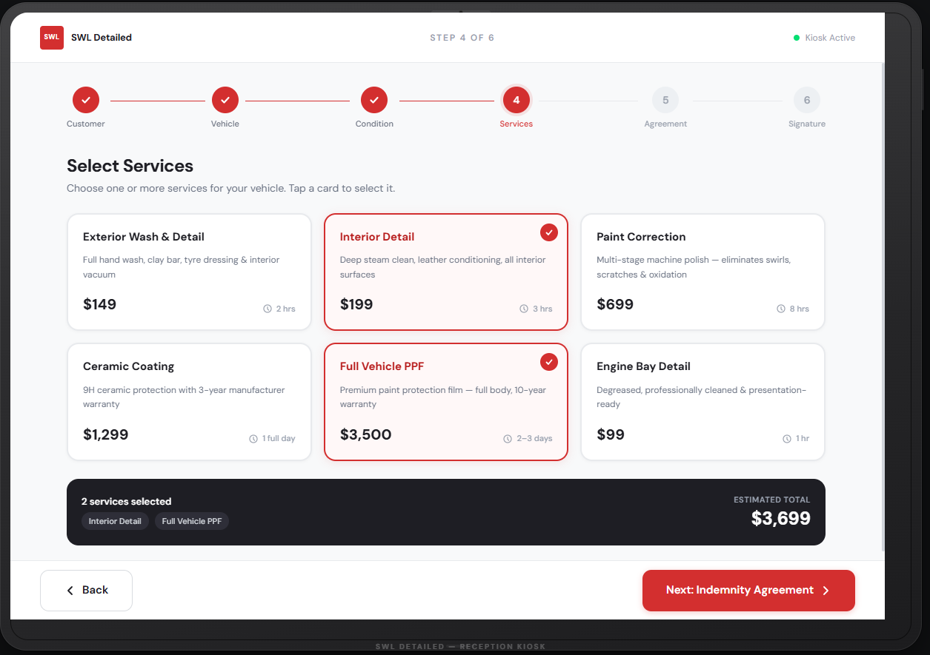
Figure P-5b: Client - Service Selection Screen (iPad

2.6 Indemnity Form (Read-Only View)
Displays the full indemnity text in a scrollable, read-only panel. The design requires the user to scroll to the bottom of the terms before the "Continue" button becomes active, a common pattern for ensuring informed consent is at least visually acknowledged before signature.
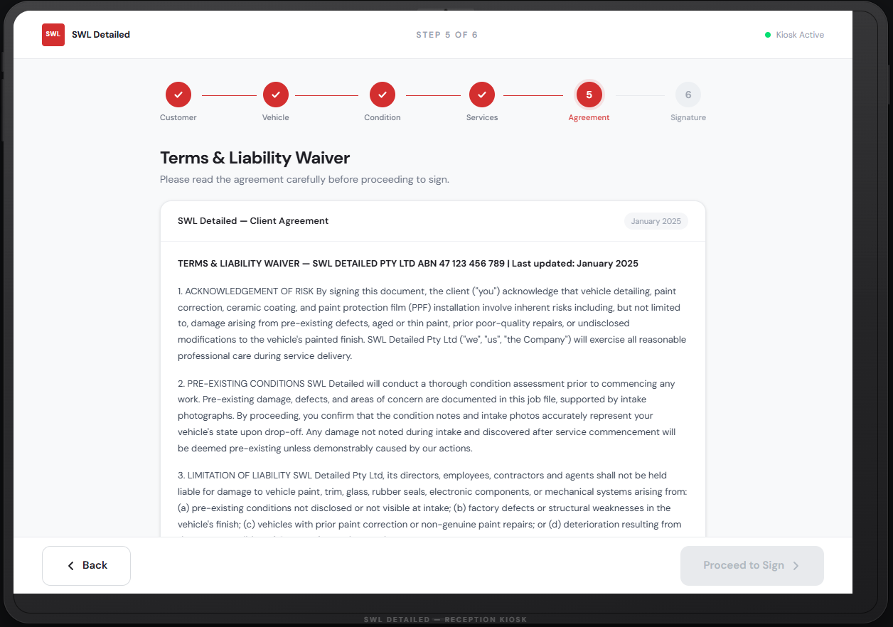
Figure P-6a: Client - Indemnity Form Read Screen (iPad)
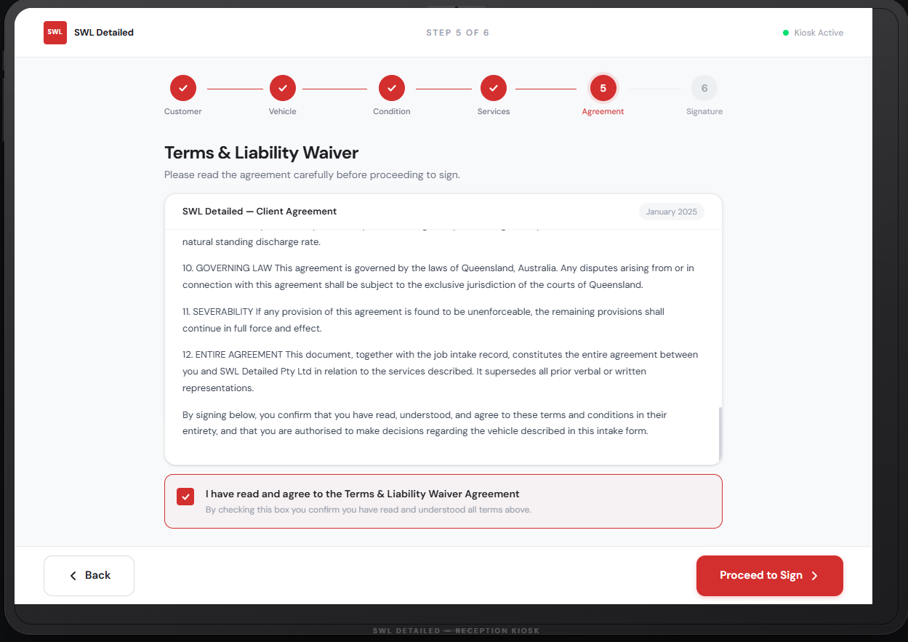
Figure P-6b: Client - Indemnity Form Read Screen (iPad)

2.7 Digital Signature Screen
Provides a signature capture pad where the customer signs with a finger or stylus, alongside a timestamp and the customer's typed name for confirmation. In South Africa, an electronic signature of this kind is legally recognised for most private agreements under the Electronic Communications and Transactions Act, provided it demonstrates clear intent to sign and is reliably associated with the document (Republic of South Africa, 2002).
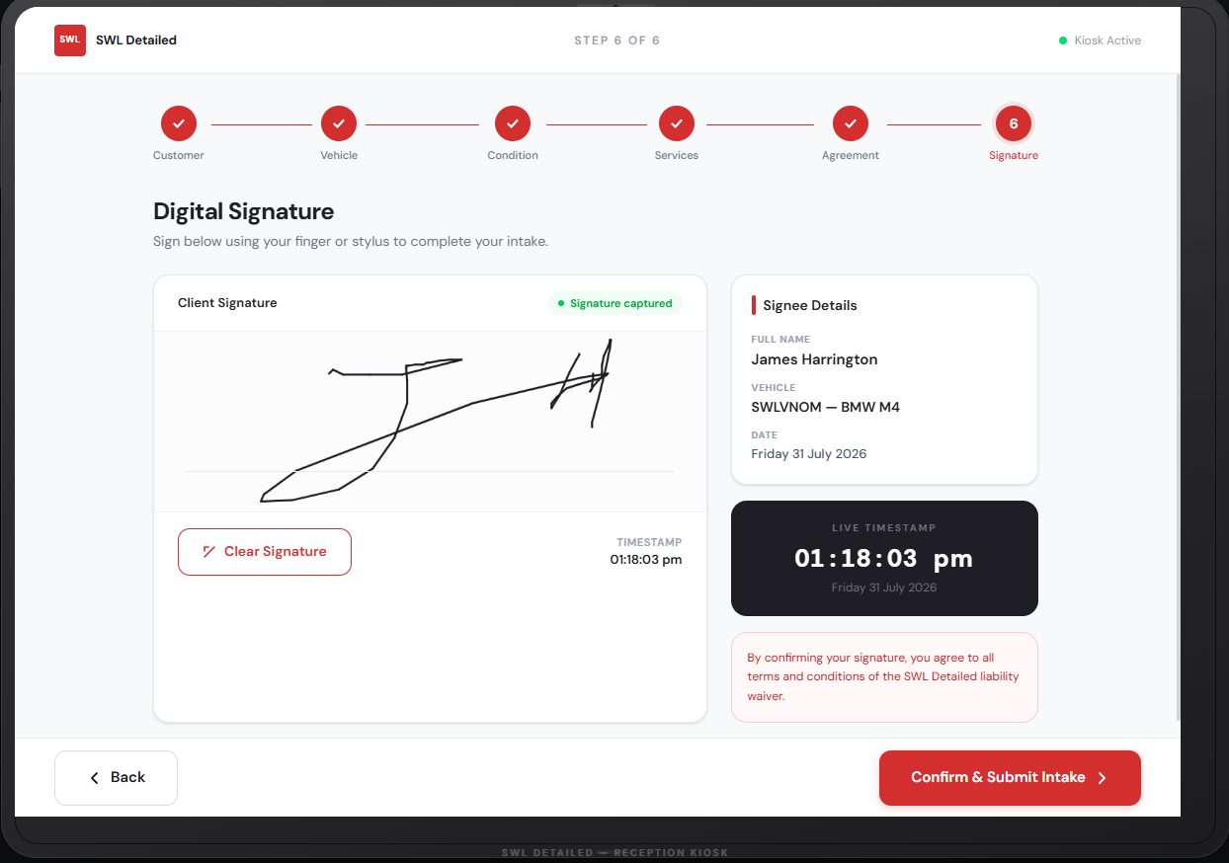
Figure P-7: Client - Digital Signature Screen (iPad)

2.8 Intake Submitted Confirmation Screen
A simple confirmation screen showing a success icon, a summary of the job reference number, and next steps, giving the customer clear closure on the intake process before handing the tablet back to reception.
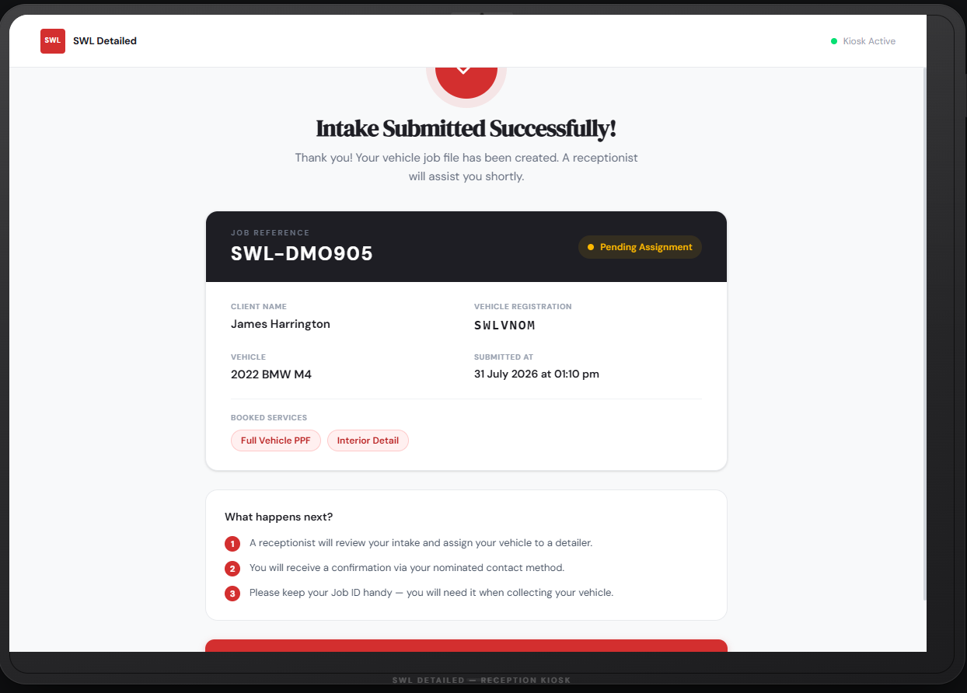
Figure P-8a: Client - Intake Submitted Confirmation (iPad)
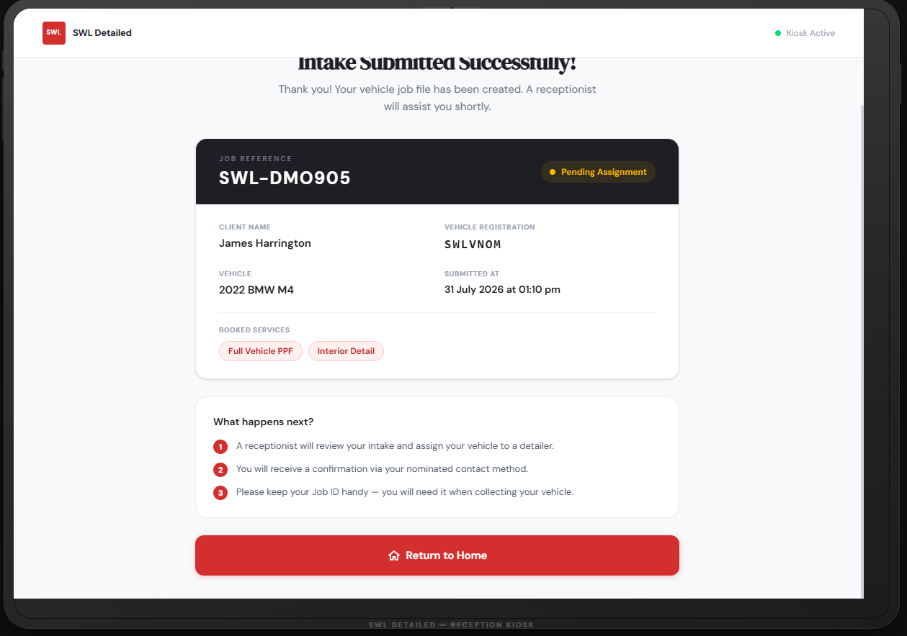
Figure P-8b: Client - Intake Submitted Confirmation (iPad)

2.9 Collection Notification & Customer Satisfaction Sign-Off (captured at pickup)
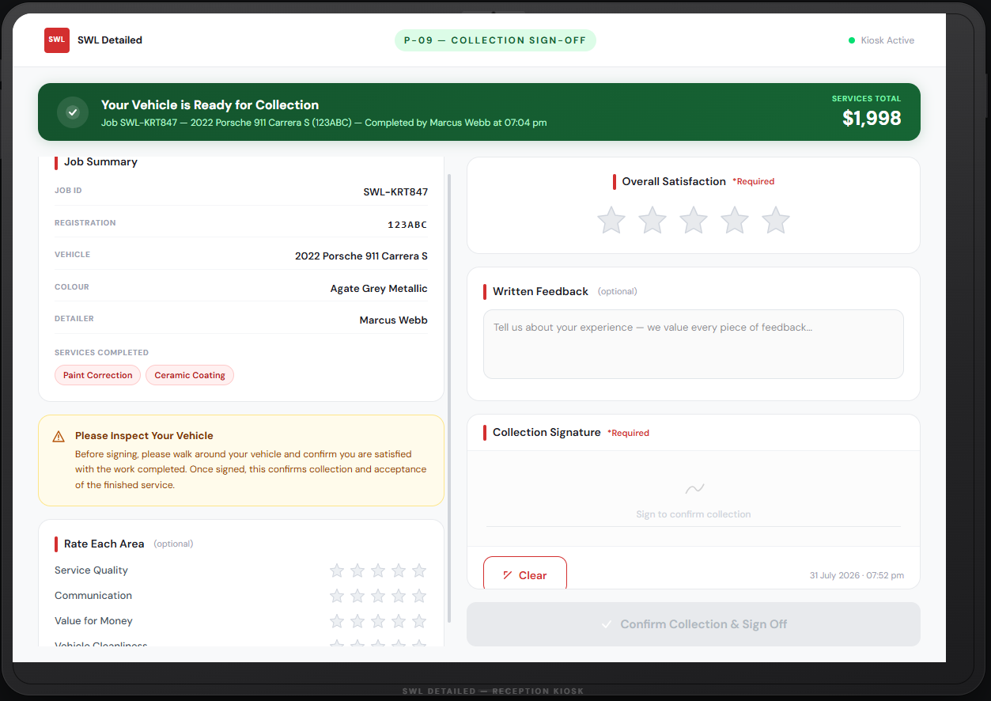
Figure P-09a: Collection Notification & Customer Satisfaction Sign-Off (captured at pickup)
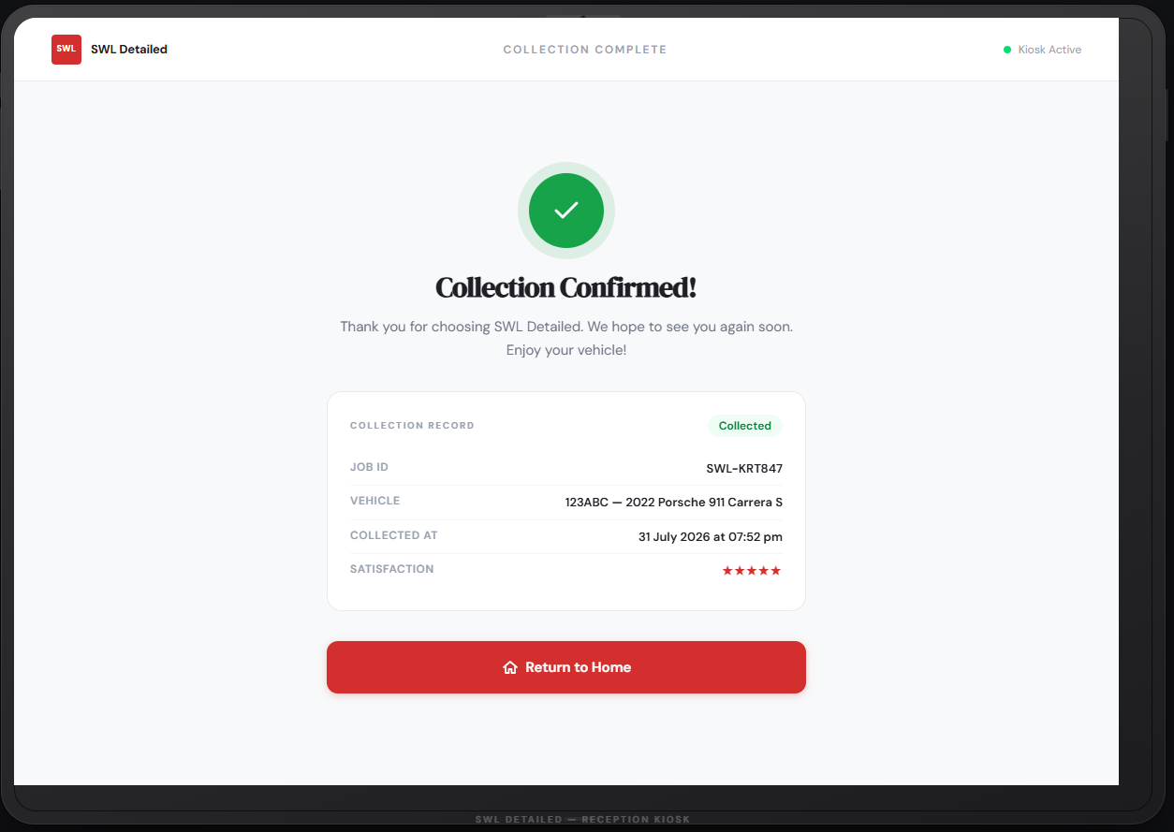
Figure P-09a: Collection Notification & Customer Satisfaction Sign-Off (captured at pickup)

2.2 Manager / Administrator Screens (Desktop)
2.2.1 Manager Login Screen
A standard desktop login form with username/email and password fields, plus a "Forgot password" link, styled consistently with the rest of the manager-facing screens.
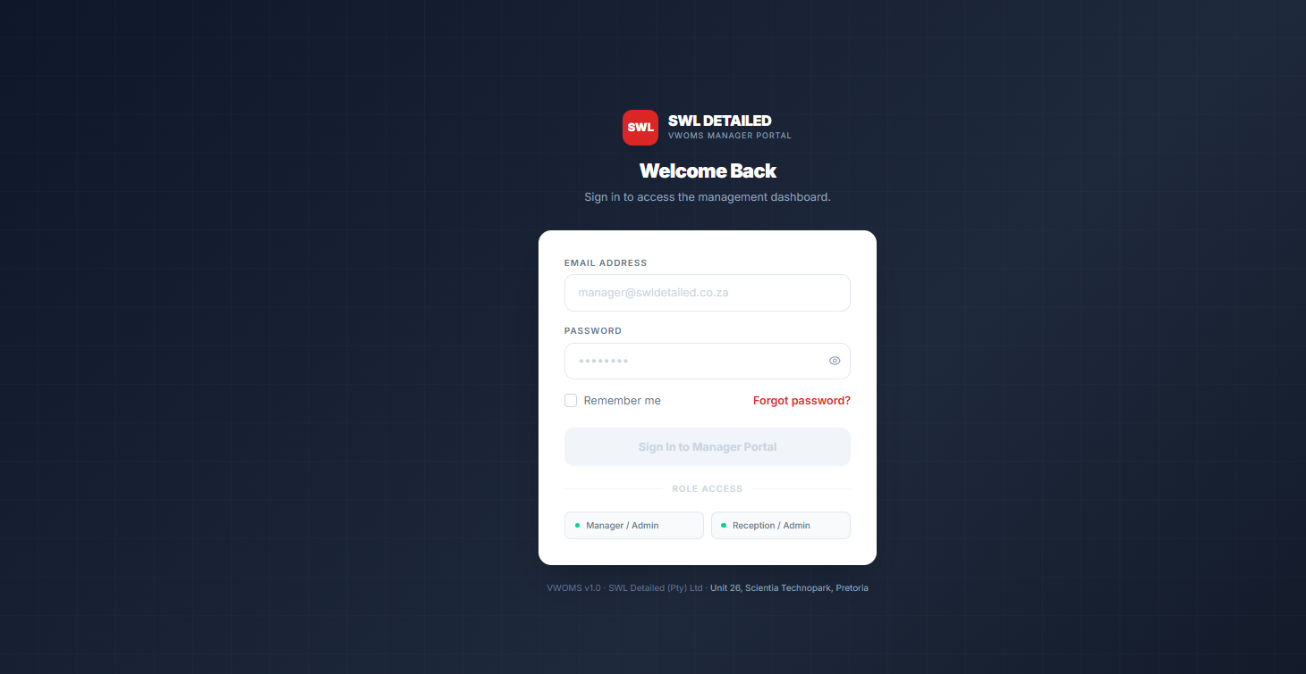
Figure P-10: Manager Login Screen
2.2.2 Admin Dashboard (Stats Overview)
Surfaces job counts by lifecycle stage, active jobs, and key alerts at the top of the screen, since users scan dashboards in a predictable top-left-first pattern and tend to disengage when more than a handful of competing elements are shown above the fold (Nielsen, 2024). The most time-sensitive information (e.g. jobs awaiting QC) is therefore placed in the upper-left region of the layout.
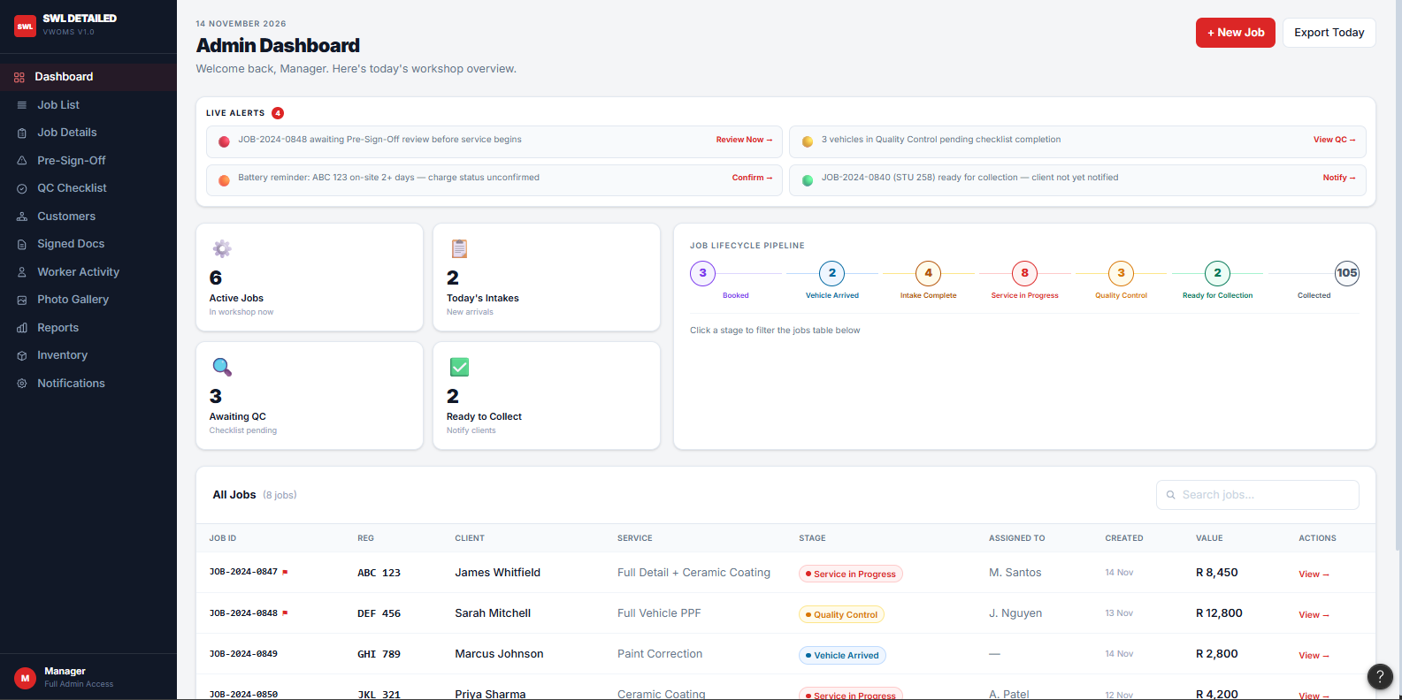
Figure P-11a: Admin Dashboard — Jobs by Lifecycle Stage
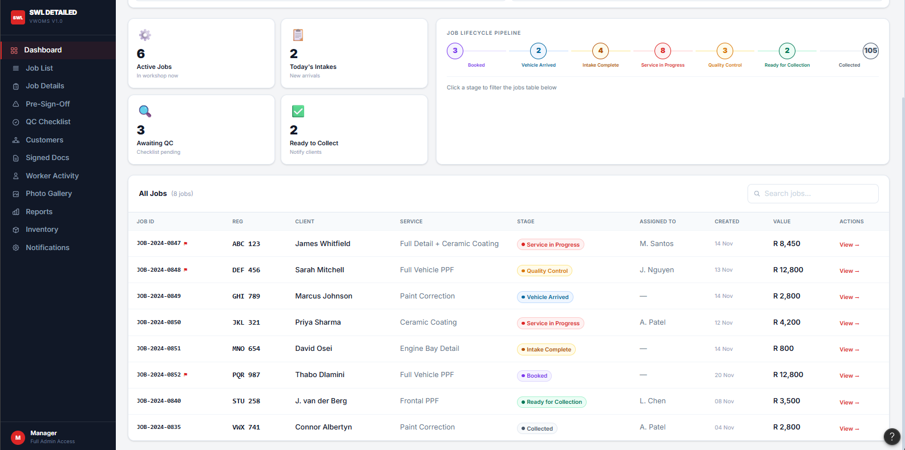
Figure P-11b: Admin Dashboard — Jobs by Lifecycle Stage
2.2.3 Customer List Page
A searchable, sortable table of all customers with columns for name, contact details, and number of vehicles on record, supporting quick look up by name or registration.
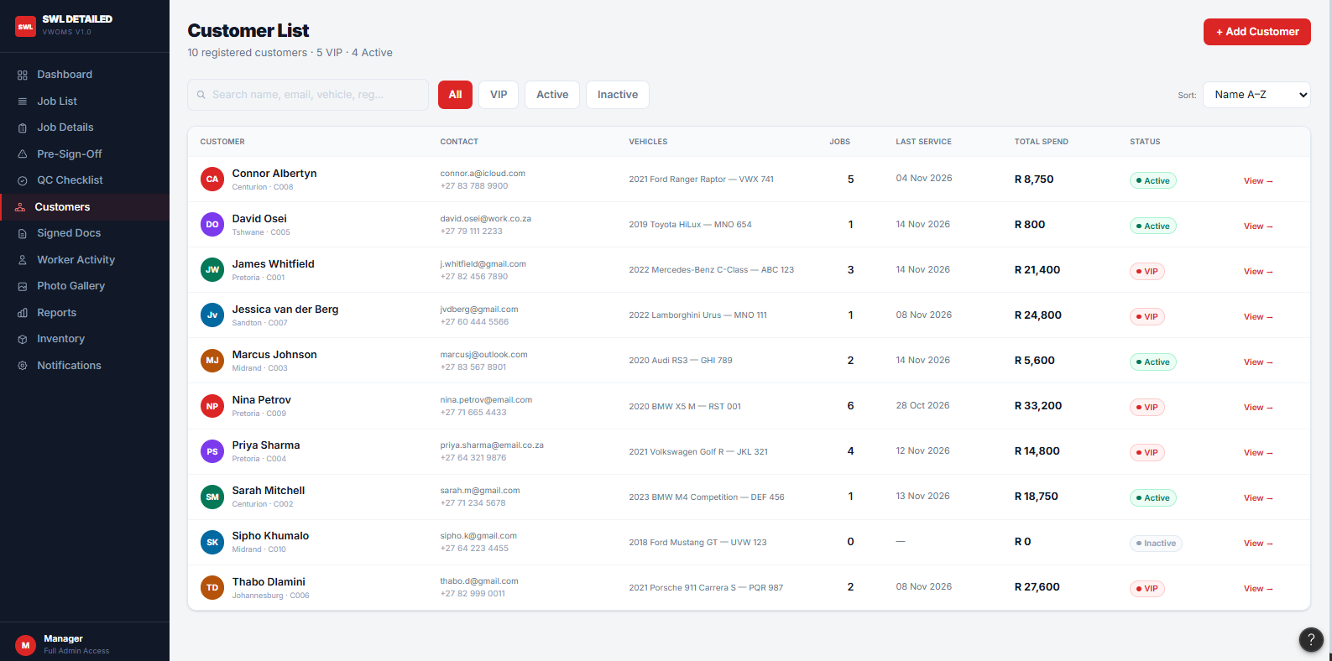
Figure P-12: Customer List Page Manager Desktop

2.2.4 Vehicle / Job List Page
Lists all vehicles/jobs with filters for date, assigned Detailer, and lifecycle stage, mirroring the stage names used throughout the system (Booked, Vehicle Arrived, Intake Complete, Service in Progress, Quality Control, Ready for Collection, Collected) for consistency.
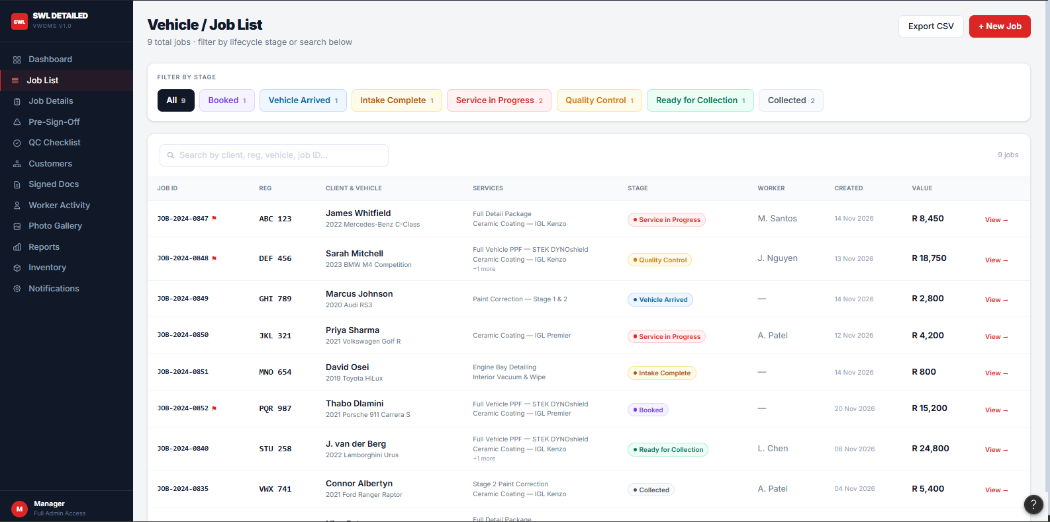
Figure P-13: Vehicle / Job List Page Manager Desktop
2.2.5 Job Details Page
A single consolidated view of one job: customer and vehicle details, selected services, current stage, assigned Detailer, timestamps, and linked documents, acting as the "hub" screen that most other manager screens link back to.
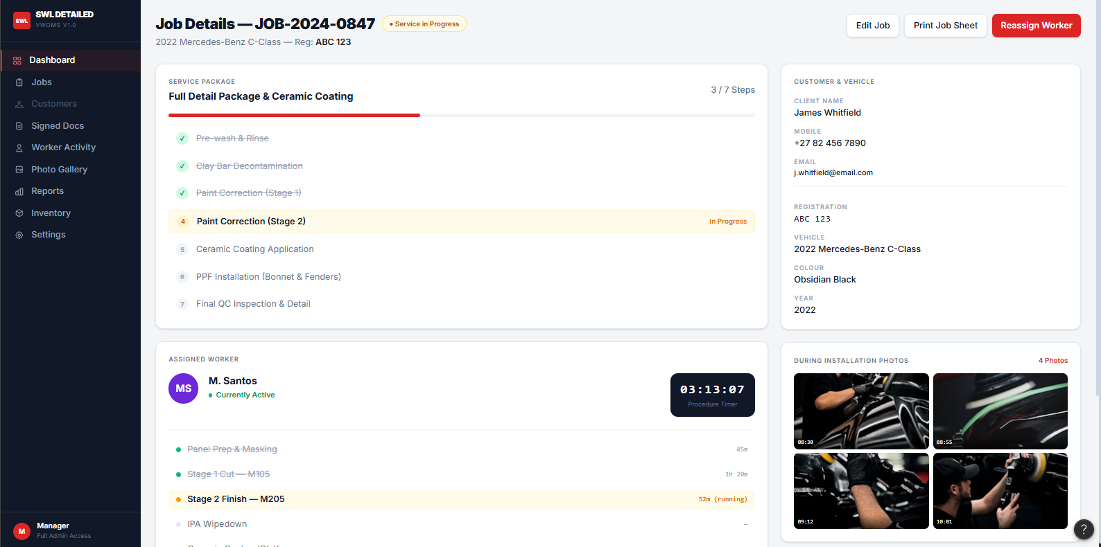
Figure P-14a: Job Details Page Manager Desktop
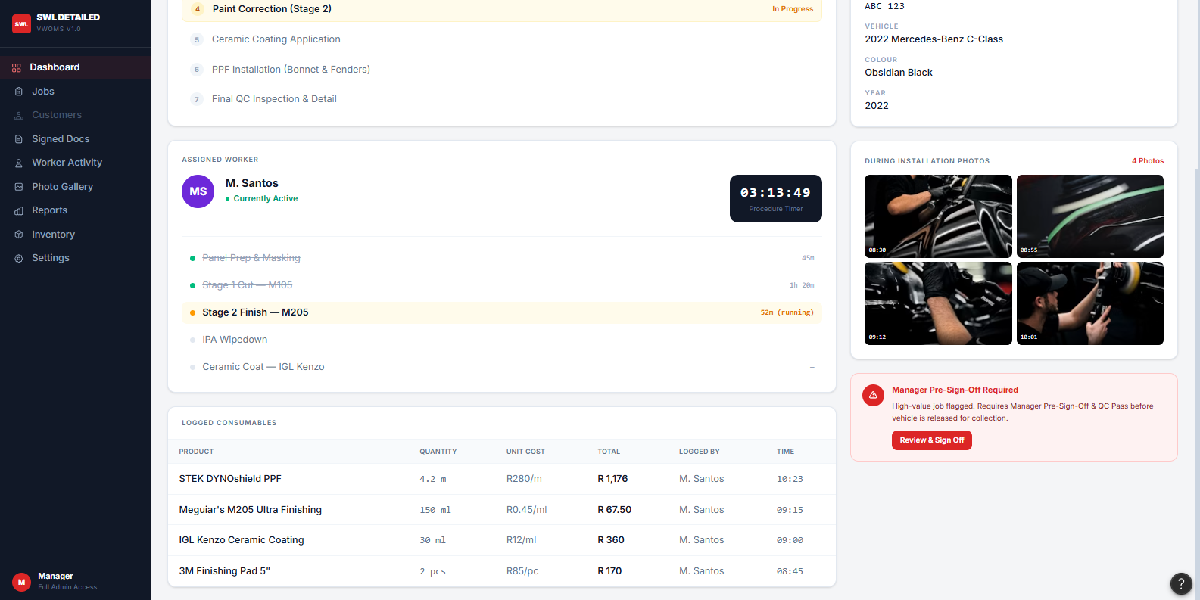
Figure P-14a: Job Details Page Manager Desktop
2.2.6 Pre-Sign-Off Review Screen (large/high-value jobs)
Flags jobs above a value threshold or of a sensitive type (e.g. full-vehicle PPF) for manager review before work proceeds, showing job value, service scope, and a sign-off button, so higher-risk jobs get an extra checkpoint before the Detailer begins.
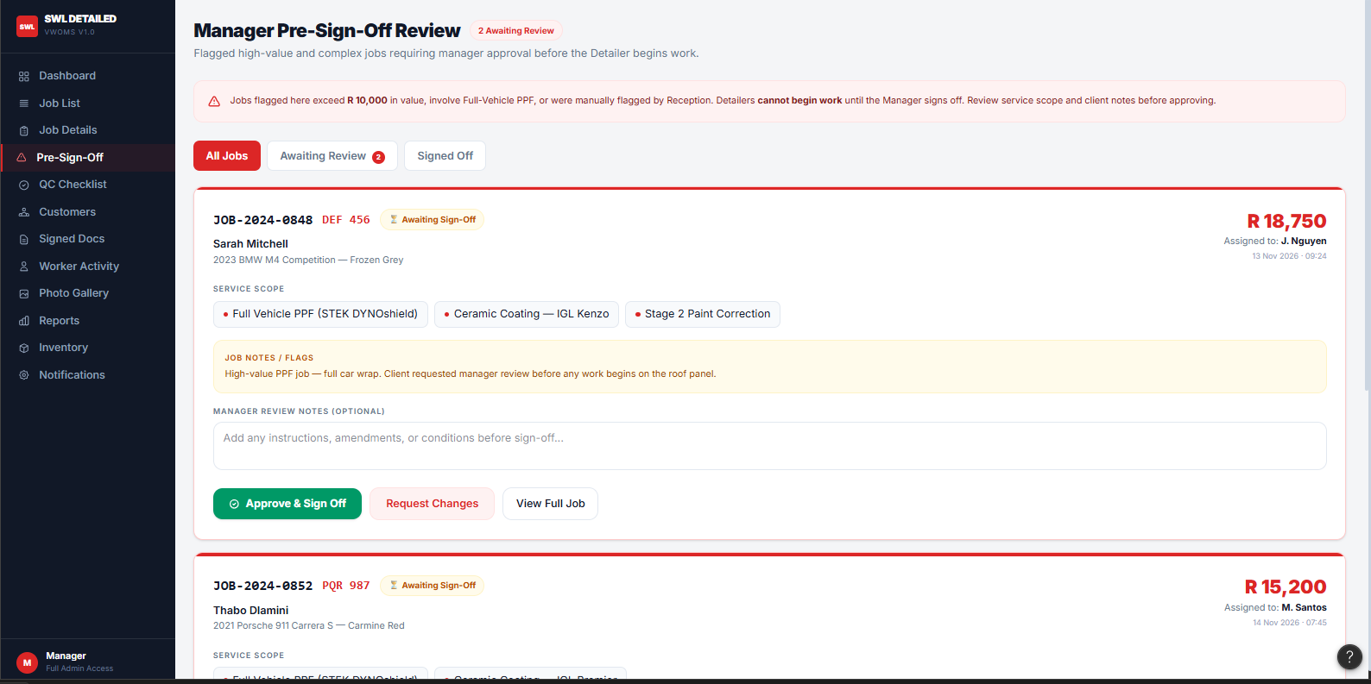
Figure P-14a: Pre-Sign-Off Review Screen Manager Desktop
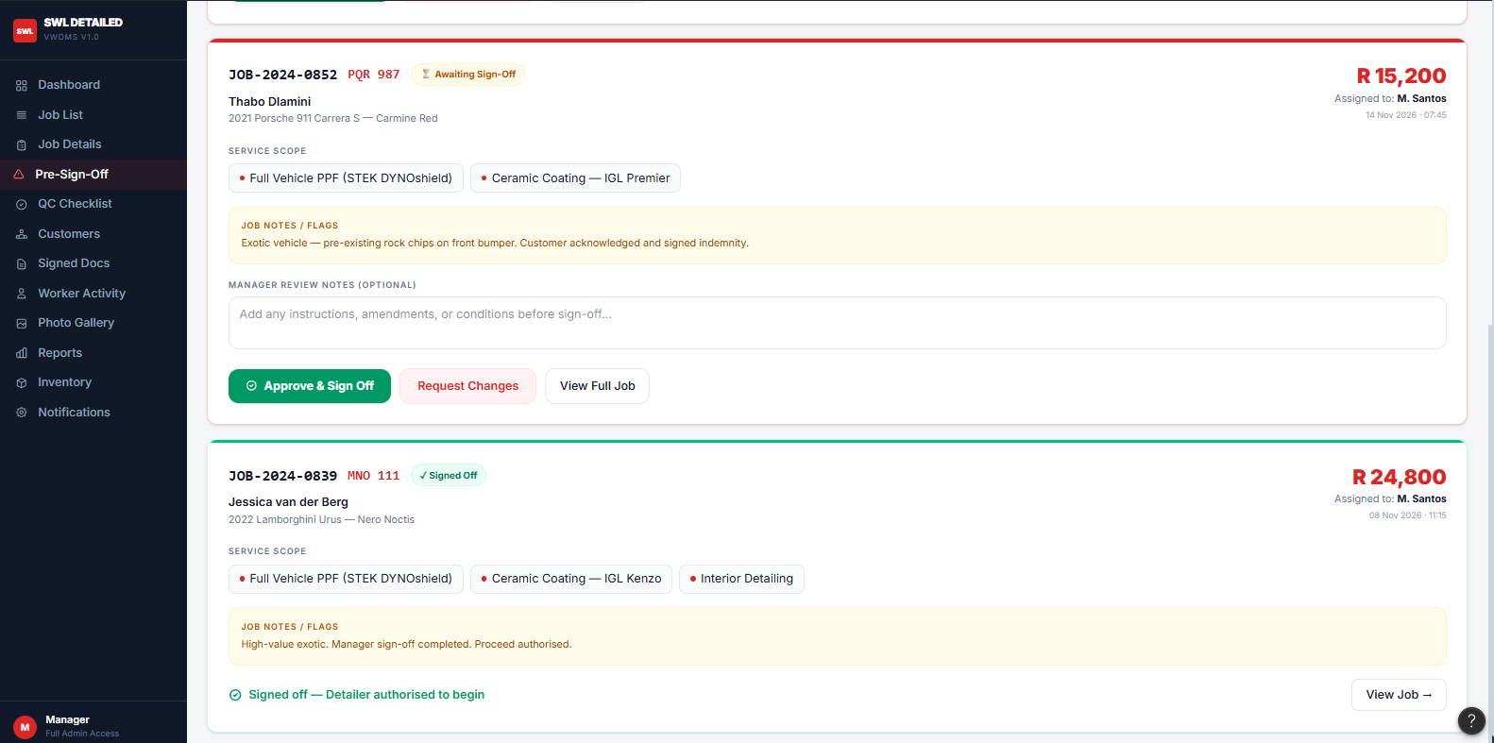
Figure P-14b: Pre-Sign-Off Review Screen Manager Desktop
2.2.7 Signed Documents Page
A searchable repository of signed indemnity forms and other completed documents, filterable by vehicle registration or customer name, giving the manager quick access to compliance records.
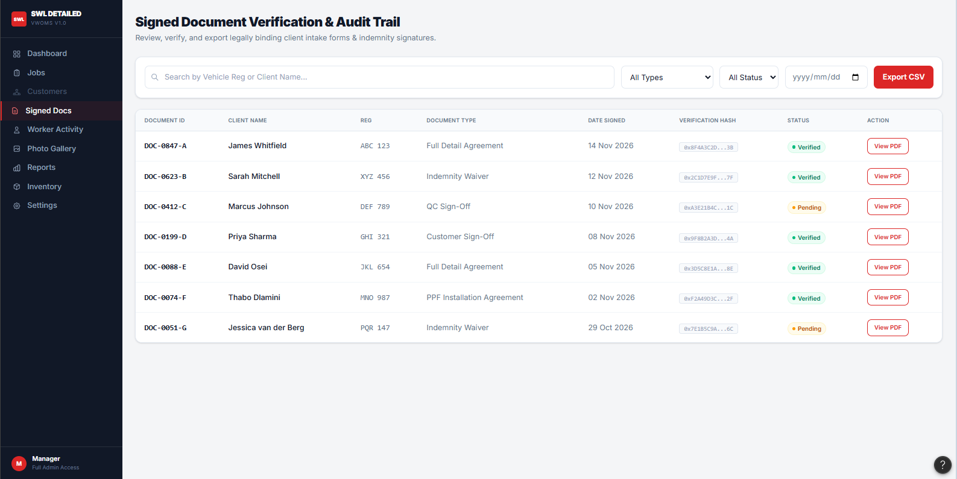
Figure P-15: Signed Documents Page Manager Desktop

2.2.8 Worker Activity Page
Shows each Detailer's active and completed jobs, time spent per procedure, and productivity indicators by service category, supporting oversight of workload distribution.
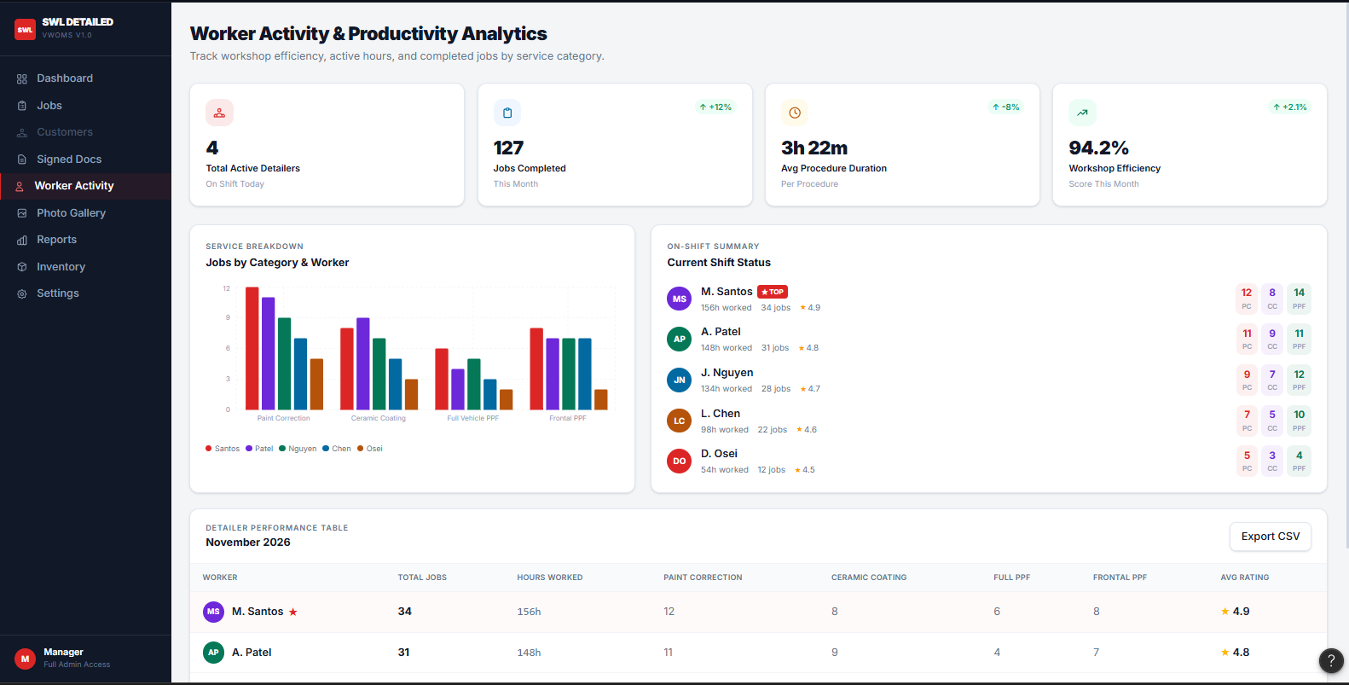
Figure P-16: Worker Activity & Productivity Page Manager Desktop
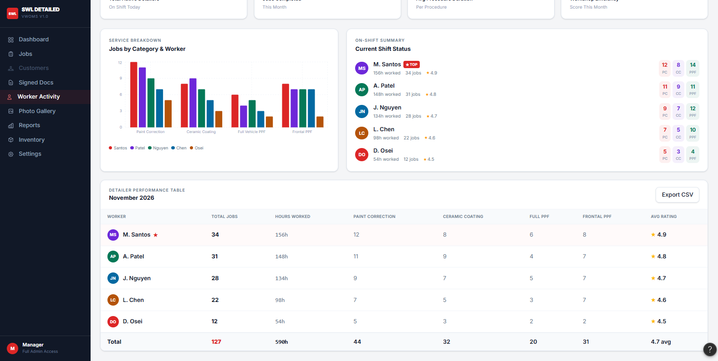
Figure P-16: Worker Activity & Productivity Page Manager Desktop

2.2.9 Product Usage Page
Aggregates product/material usage logged by Detailers per job and per period, useful for stock and cost tracking.
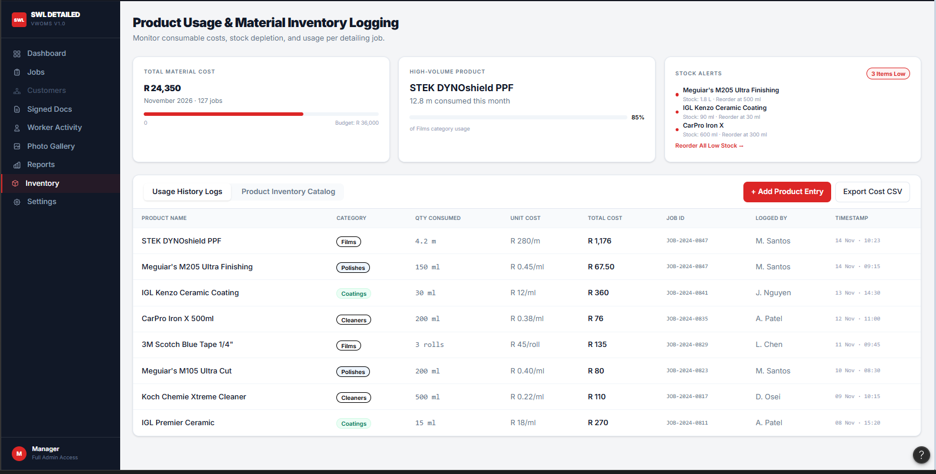
Figure P-17: Product Usage Page Manager Desktop
2.2.10 Photo Gallery
Displays intake and progress photos grouped by vehicle and category, using a grid/thumbnail layout so a large volume of images remains scannable rather than overwhelming.
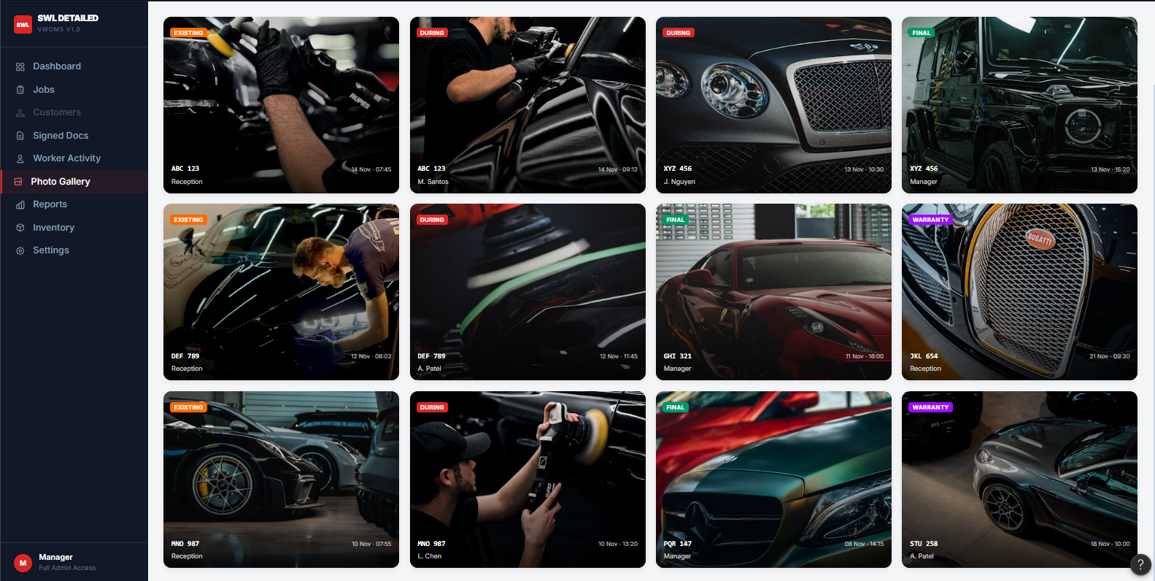
Figure P-18: Photo Gallery — Four Categories Manager Desktop

2.2.11 Reports Page (service-category breakdown)
Presents summary reporting — job volumes, revenue, and worker productivity — broken down by service category, using simple charts and tables rather than dense data grids, consistent with the principle that dashboards should minimise cognitive load rather than maximise the amount of data shown at once (Nielsen Norman Group, 2024b).
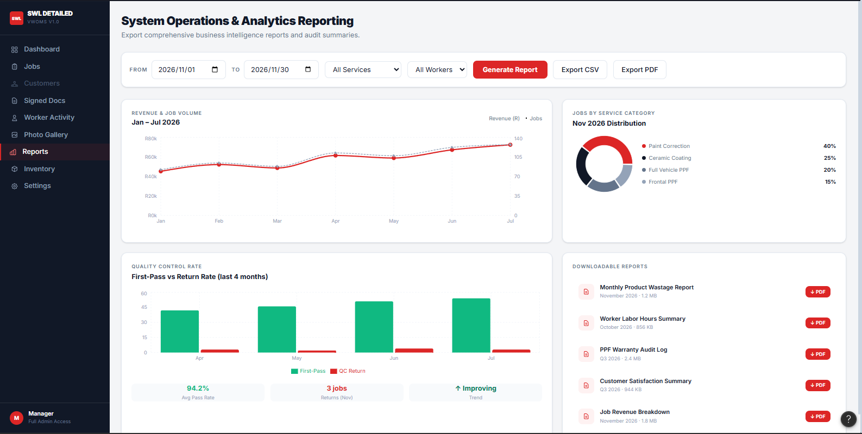
Figure P-19: Reports Page Manager Desktop

2.2.12 Notification Template Settings Page
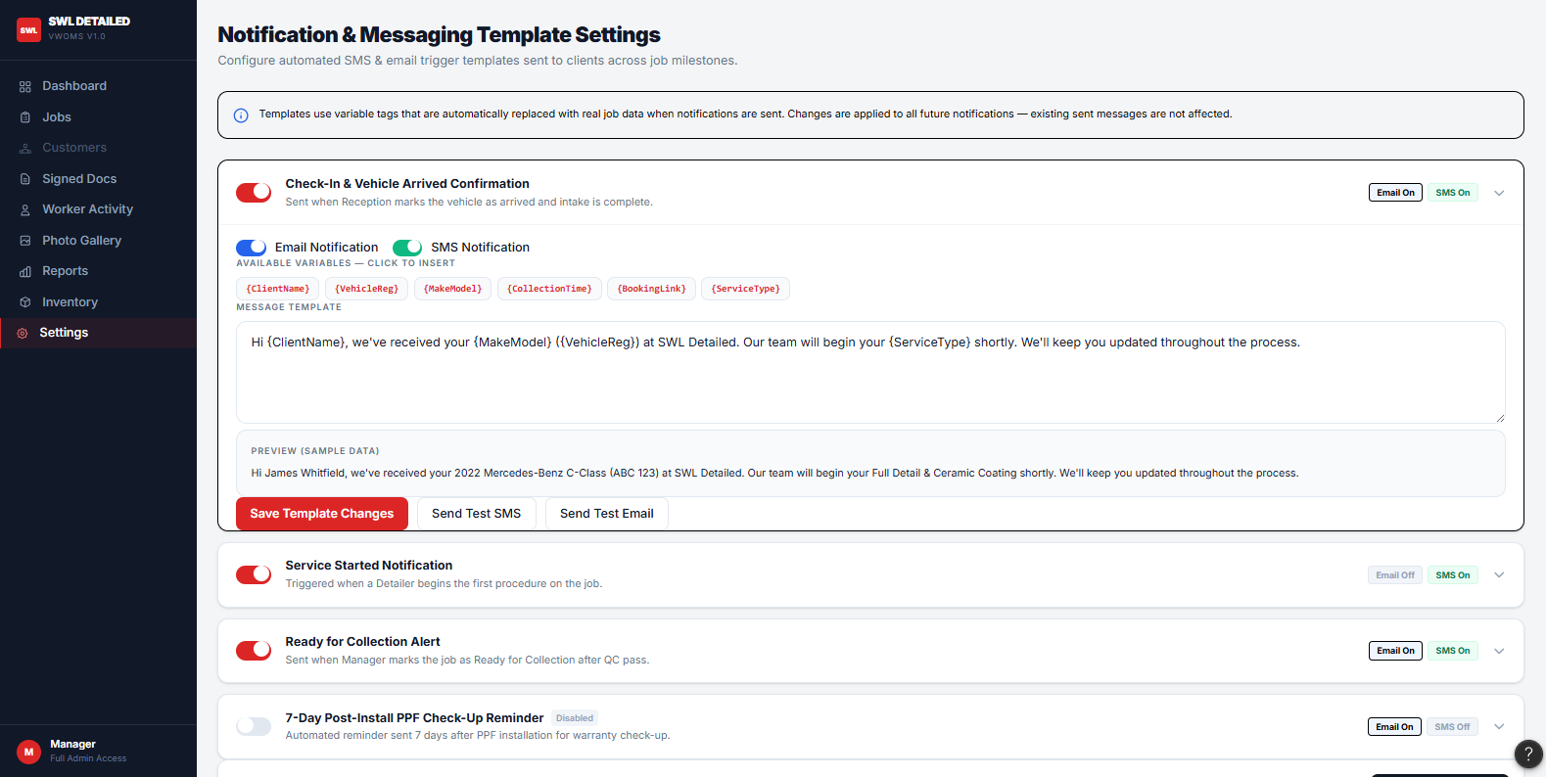
Figure P-20a: Notification Template Settings Manager Desktop

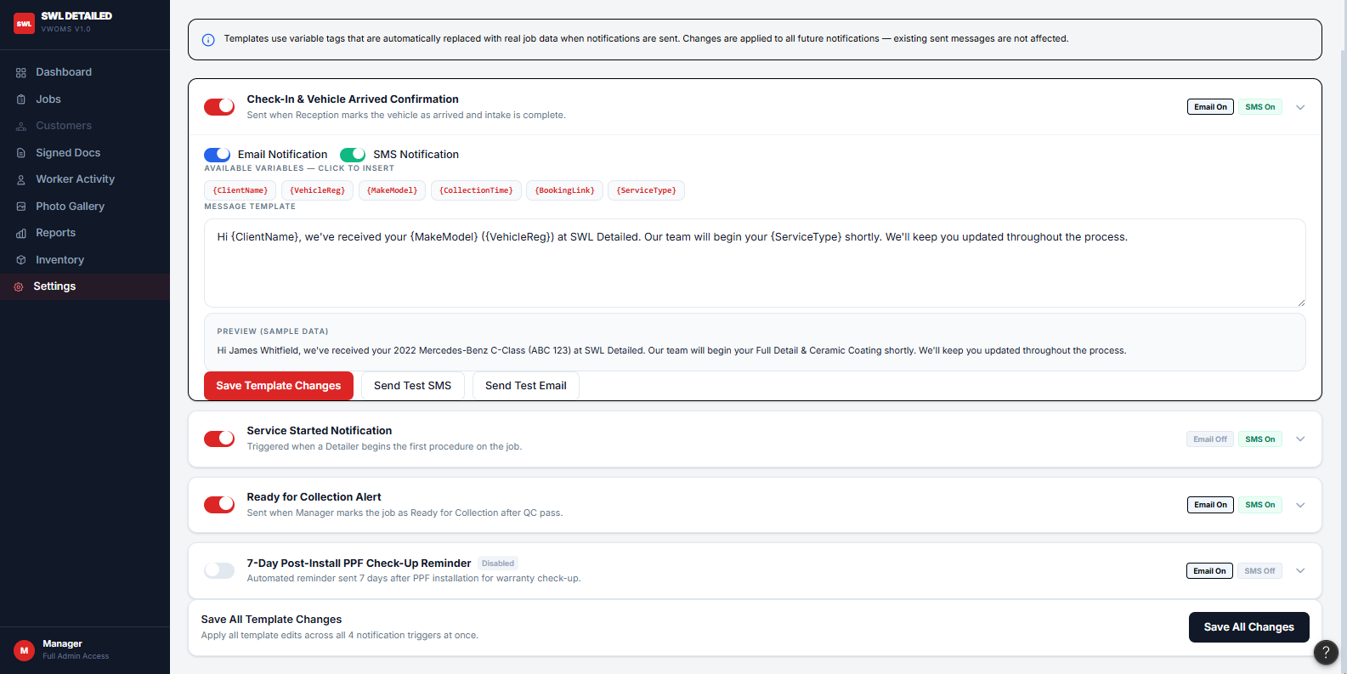
Figure P-20b: Notification Template Settings Manager Desktop
2.2.13 QC Checklist Screen — Pass / Fail Manager Desktop
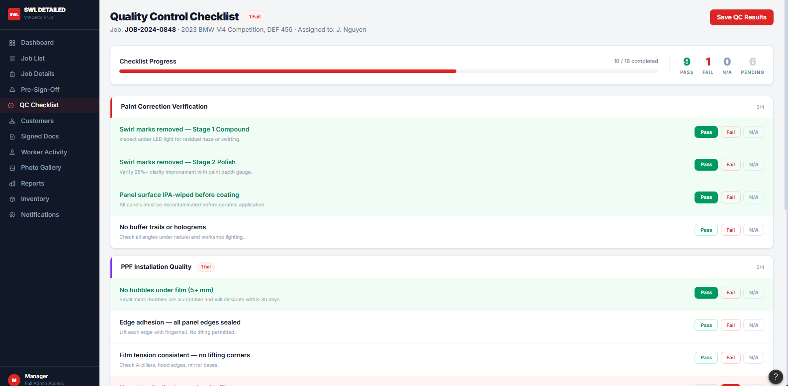
Figure P-21: QC Checklist Screen - Pass / Fail Manager Desktop

2.3 Detailer / Worker Screens (Mobile — Primary | Tablet — Secondary)
2.3.1 Worker Login Screen
A simplified PIN-entry login optimised for one-handed use on a phone in a workshop environment, avoiding a full username/password form that would be slower to use with gloved or wet hands.
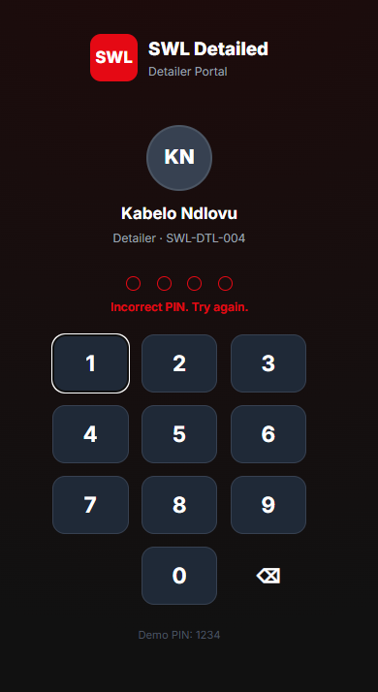
Figure P-22: Worker Login — PIN Entry Detailer Mobile
2.3.2 Assigned Jobs List
A scrollable list of jobs assigned to the logged-in Detailer, with the current stage and vehicle registration visible briefly without needing to open each job.
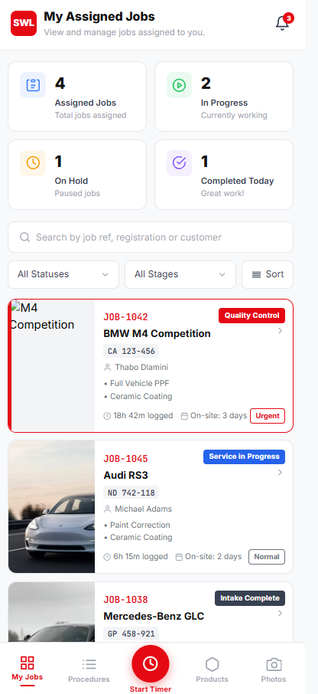
Figure P-23: Assigned Jobs List Detailer Mobile

2.3.3 Job Details View
Shows vehicle details, selected services, and any notes left by the customer or manager, condensed for a single-column mobile layout.
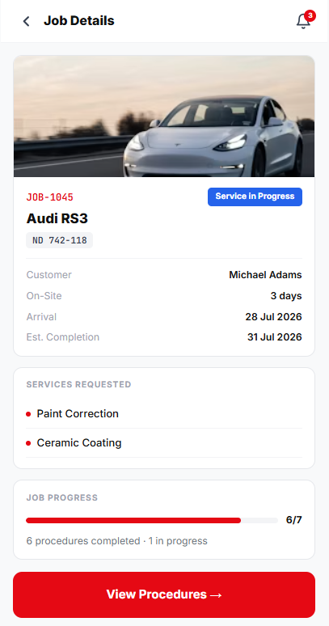
Figure P-23: Job Details View Detailer Mobile

2.3.4 Procedure List Screen
Lists each procedure required for the job with a status toggle (not started / in progress / done), giving the Detailer a clear checklist to work through.
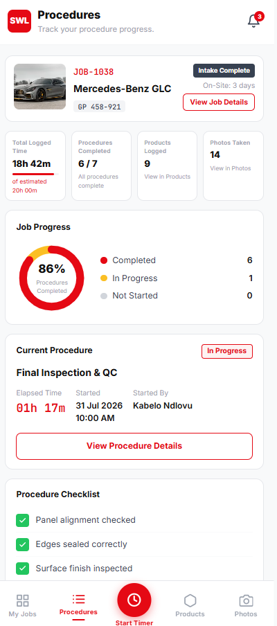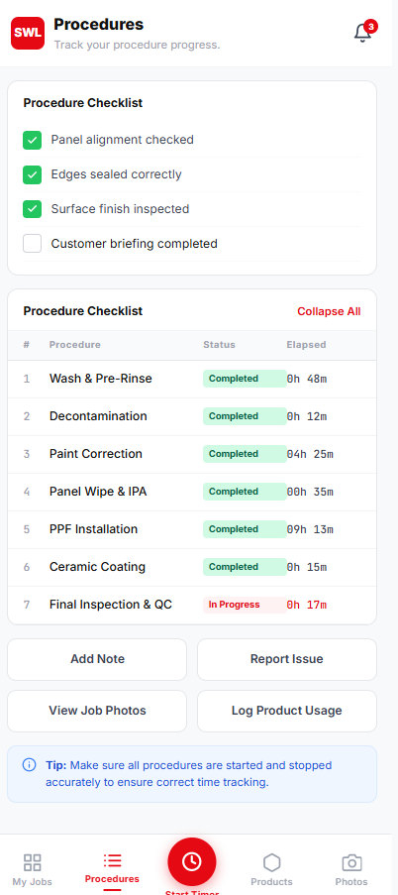
Figure P-24a and P-24b: Procedure List Screen Detailer Mobile

2.3.5 Start / Stop Timer Screen
A large, thumb-friendly start/stop control for timing each procedure, since mobile interfaces used in physically active contexts benefit from oversized touch targets rather than small precision controls.
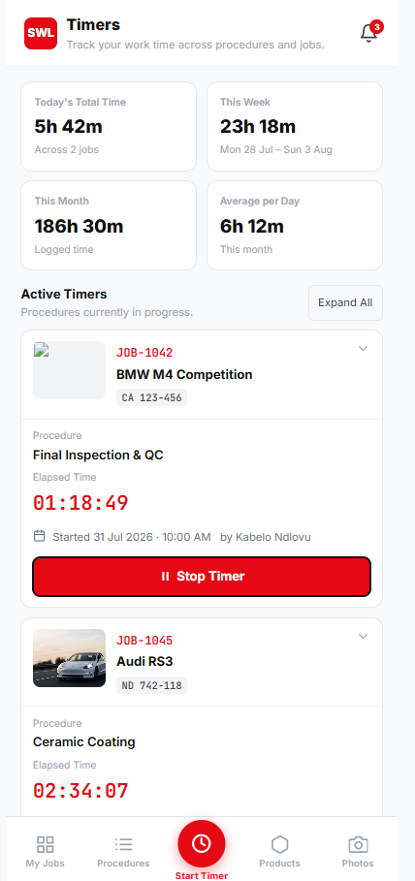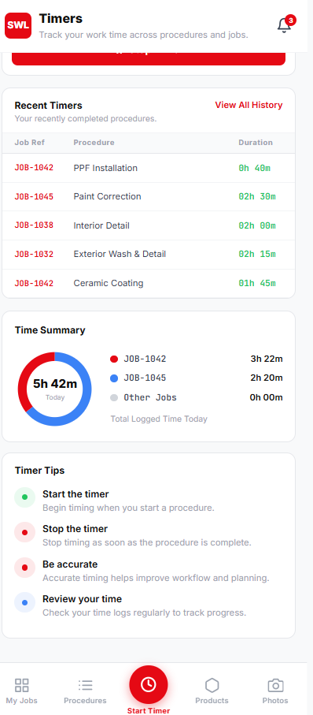
Figure P-25a and P-25b: Start / Stop Timer Screen Detailer Mobile

2.3.6 Product Usage Logging Screen
A quick-entry form for recording which products and quantities were used on the current procedure, using steppers/dropdowns rather than free typing to keep entry fast on a phone.
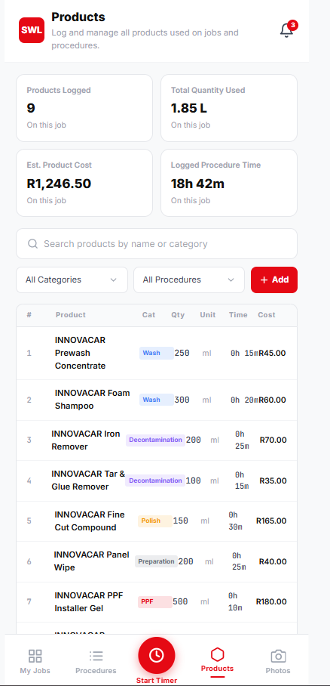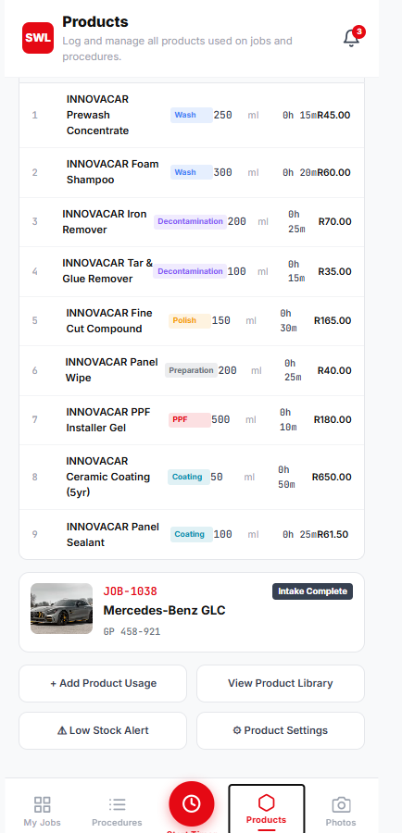
Figure P-26a and P-26b: Product Usage Logging Screen Detailer Mobile

2.3.7 Damage Photo Capture & Upload Screen
Allows the Detailer to capture and attach photos directly from the device camera, tagged to the relevant job and category, demonstrating the flow of image data from capture to the manager's Photo Gallery screen.
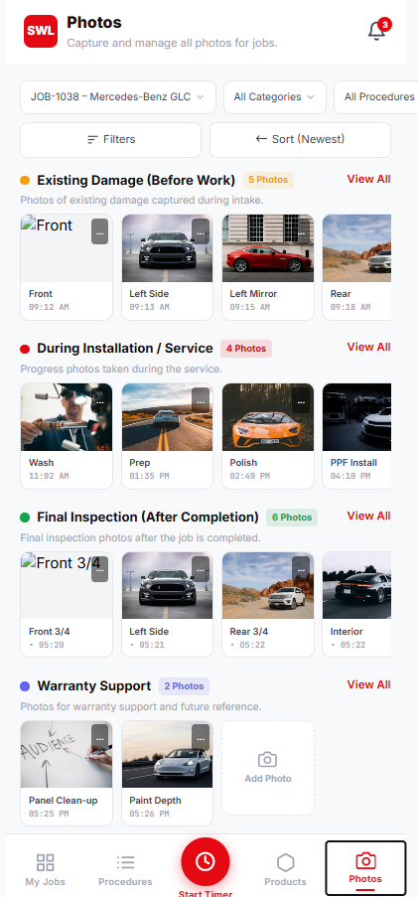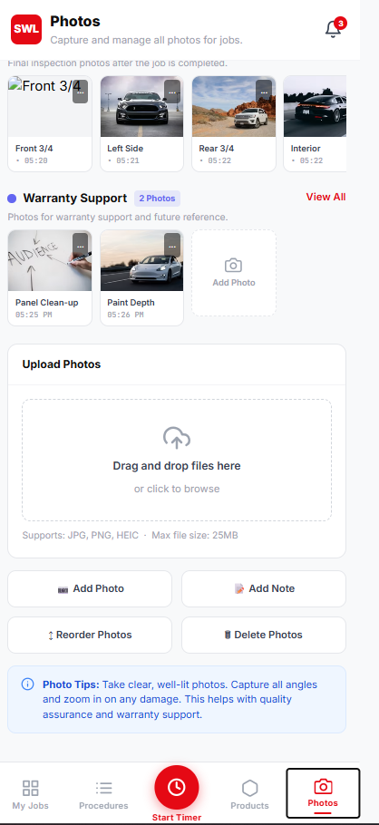
Figure P-27a and P-27b: Photo Capture — During Installation Detailer Mobile

2.3.8 Procedure Completed Confirmation Screen
A brief confirmation shown after marking a procedure done, returning the Detailer to the Procedure List, and once all procedures are complete, prompting the transition of the job into Quality Control.
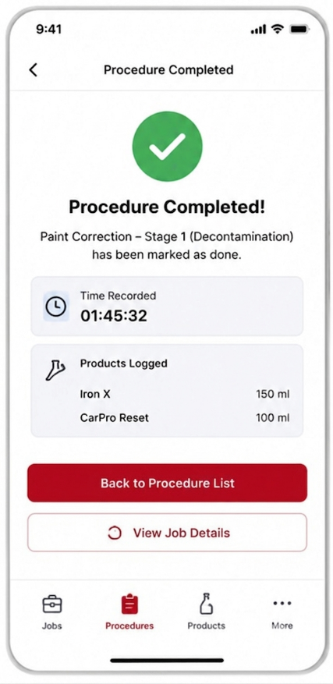
Figure P-28: Procedure Completed Confirmation Screen
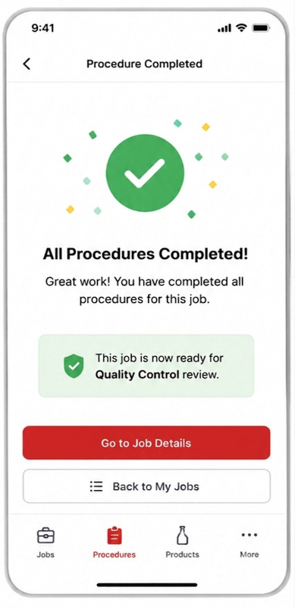
Figure P-29: All Procedure Completed Confirmation Screen
2.3.9 Notifications Screen
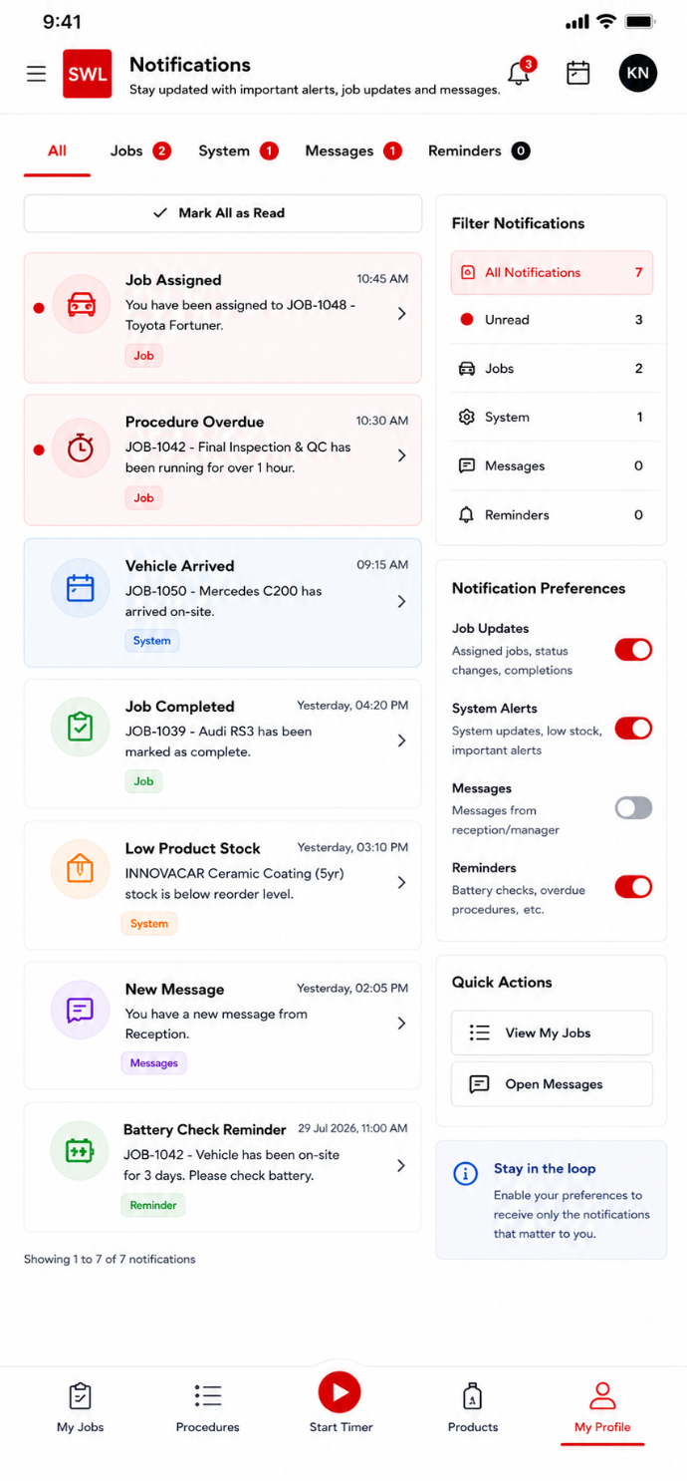
Figure P-30: Notification Screen

2.3.10 Profile and Settings Screen
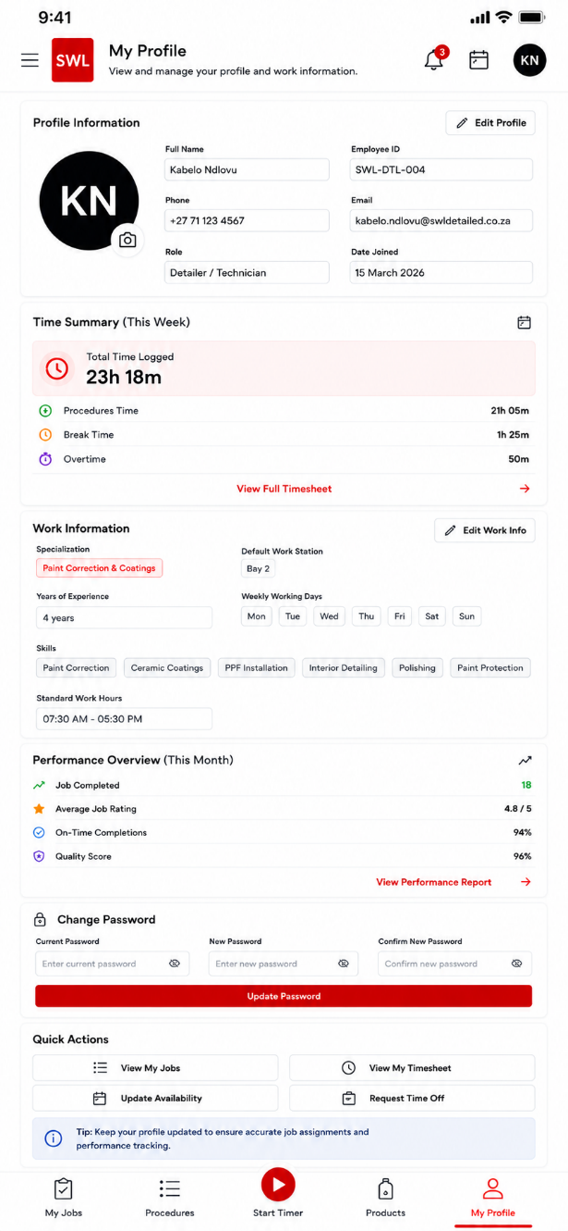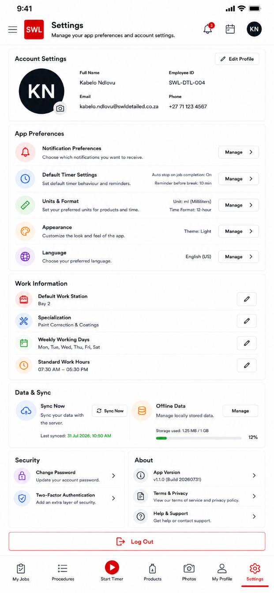
Figure P-31 and P-32: Profile and Settings Screen

Secondary View Screens
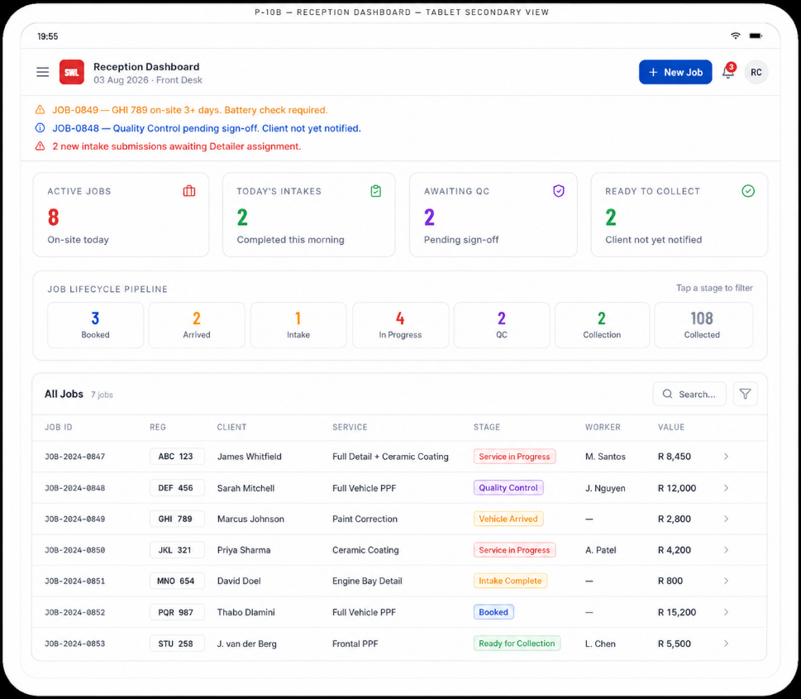
Figure P-33: Reception Dashboard (Tablet — Secondary View)
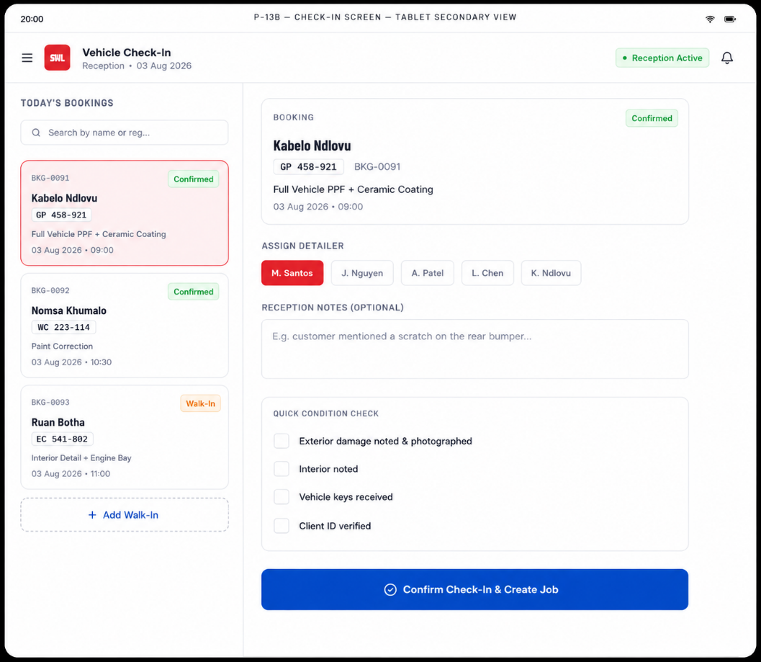
Figure P-34: Check-In Screen (Tablet — Secondary View)

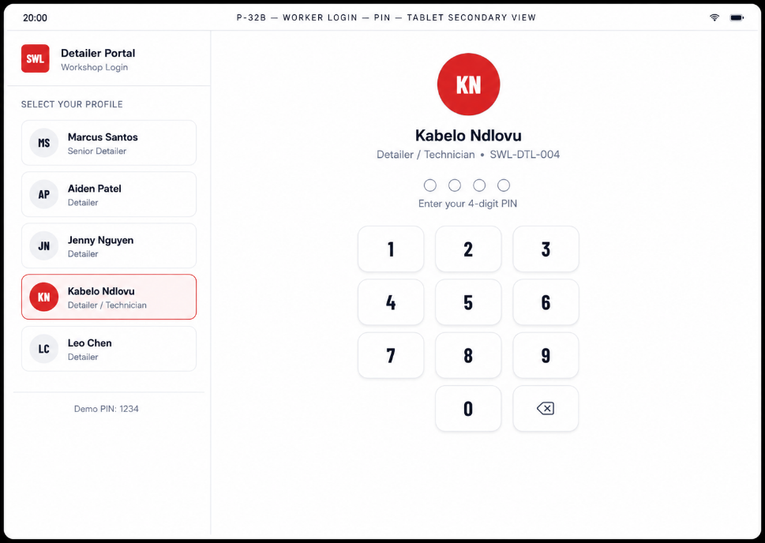
Figure P-35: Worker Login — PIN Entry (Tablet — Secondary View)
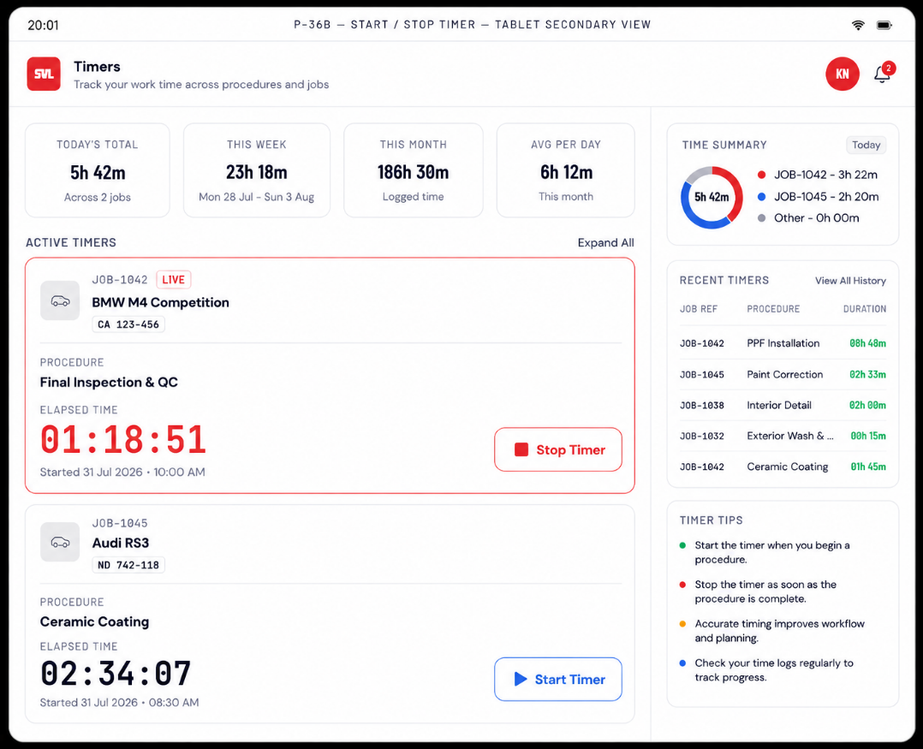
Figure P-36: Start / Stop Timer Screen (Tablet — Secondary View)

3. End-to-End 14-Step Prototype Flow Demonstration
The 14-step end-to-end flow that has been shown in the VWOMS Figma prototype shows the movement of a vehicle through all phases of its operational life cycle in the SWL Detailed, starting with booking of the vehicle in Reception until vehicle collection, and any post-collection process (if required) (SWL Detailed, 2026). This flow has been designed with the help of a series of connected frames in Figma, which are navigable in the presentation mode even without knowing anything about the system through the dummy data provided in the prototype (Figma Help Center, 2024).
This flow is purposefully cross-role, which means that it moves across the four different user interfaces – Reception (desktop), Client (tablet), Manager (desktop), and Detailer (mobile) – in the exact order as the job flows between these roles in the workshop (Nielsen Norman Group, 2024a). The cross-role approach has purposefully been taken for the prototype design because it will allow the stakeholders to see not only what the screens look like in their isolated form, but also how data and job status move between roles on each handoff point (Preece, Rogers and Sharp, 2019).

3.1 Step 1 — Receptionist Creates a Booking (Reception — Desktop)
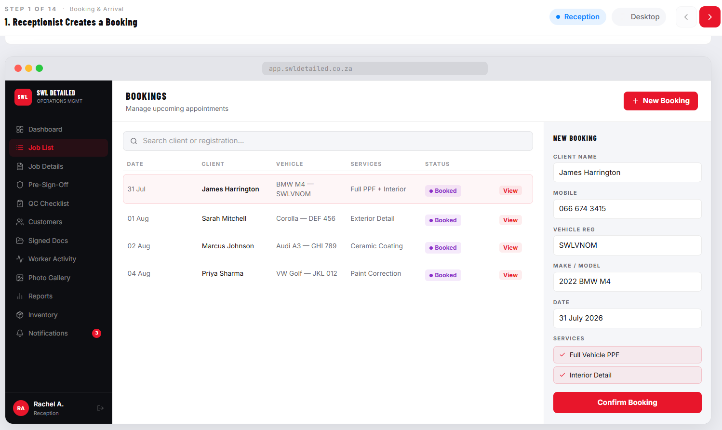
Figure P-37: Booking Screen (Reception, Desktop). Dummy booking: James Harrington | SWLVNOM | Full Vehicle PPF + Interior Detail | 31 July 2026 | 09:00.

3.2 Step 2 — Client Arrives; Receptionist Checks in Vehicle — Booking Becomes a Job (Reception — Desktop)
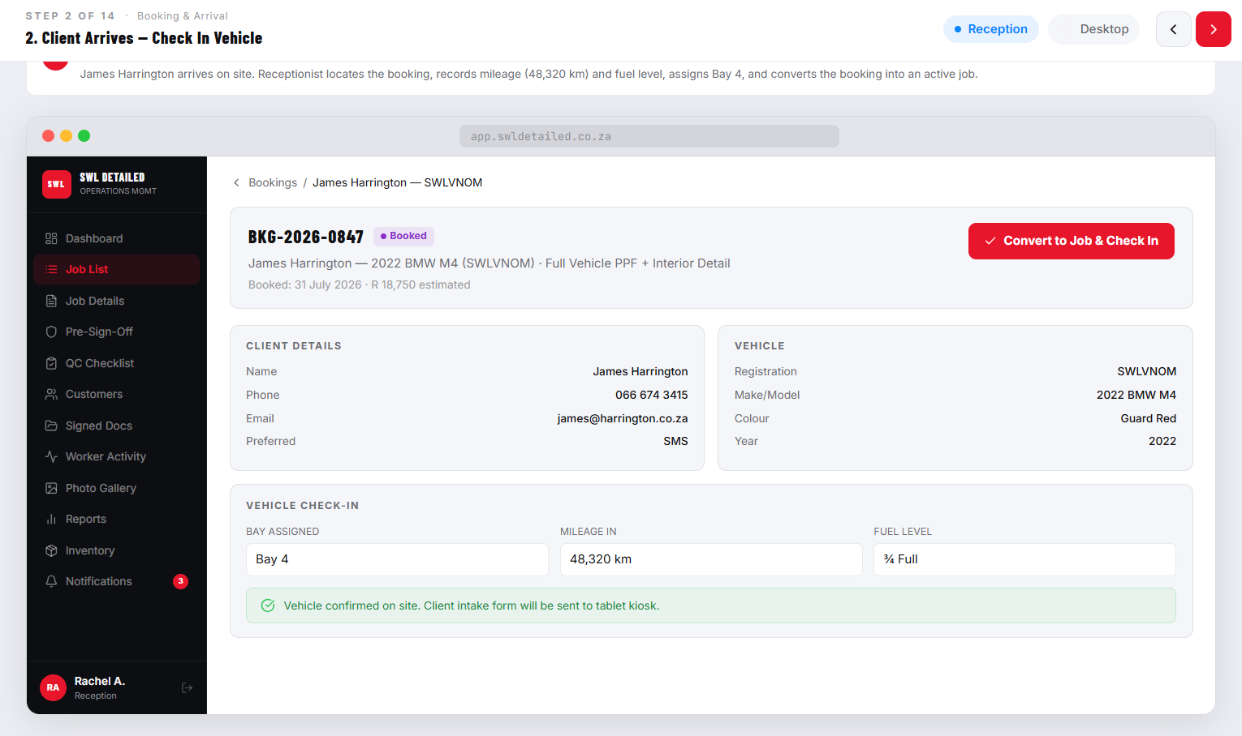
Figure P-38: Check-In Screen (Reception, Desktop). Dummy job created: SWL-DMO905 | James Harrington | SWLVNOM | BMW M4 | Stage: Vehicle Arrived.

3.3 Step 3 — Client Completes Intake Form & Condition Review (Client — Tablet)
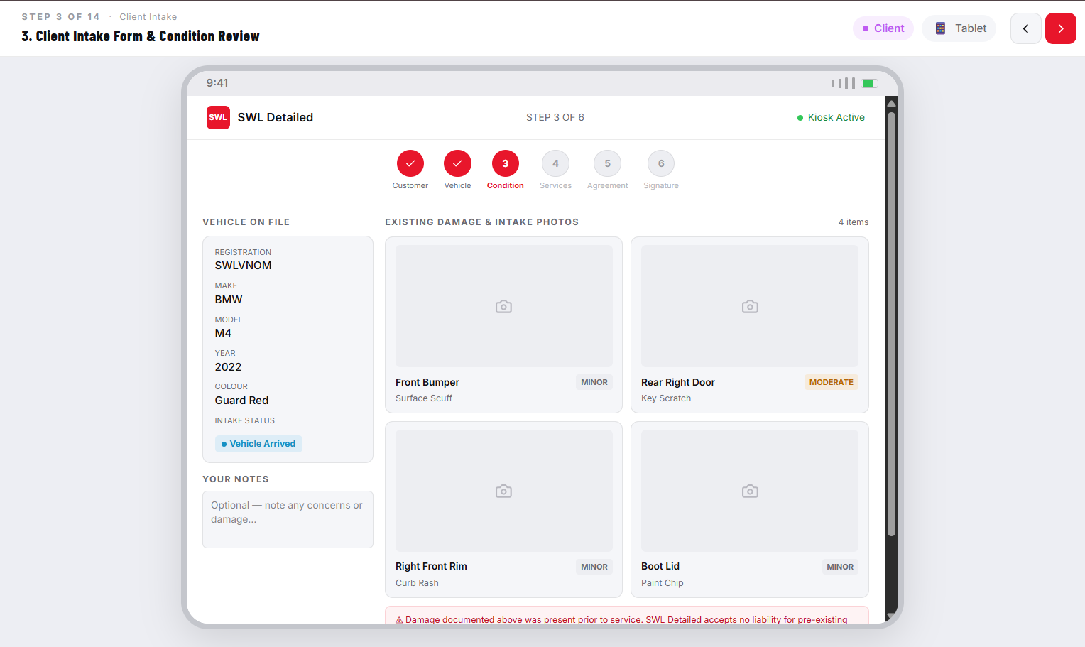
Figure P-39: Screens P-01 through P-05b — Client Intake Flow (Tablet). Dummy data: James Harrington | SWLVNOM | BMW M4 2025 Guard Red | Services: Full Vehicle PPF + Interior Detail | Estimated Total: R 3,699.

3.4 Step 4 — Client Signs Indemnity Form (Client — Tablet) 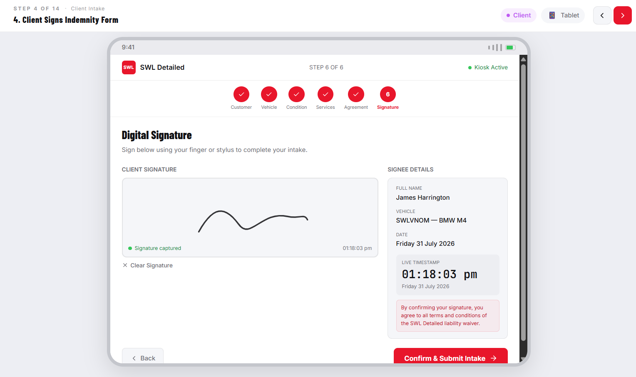
Figure P-39: Screens P-06a, P-06b, P-07, P-08a, P-08b — Indemnity & Signature Flow (Client, Tablet). Dummy signee: James Harrington | SWLVNOM | Signed: 31 July 2026 01:18:03 pm. Job Reference: SWL-DMO905.

3.5 Step 5 — Receptionist Assigns Job to a Detailer (Reception — Desktop) 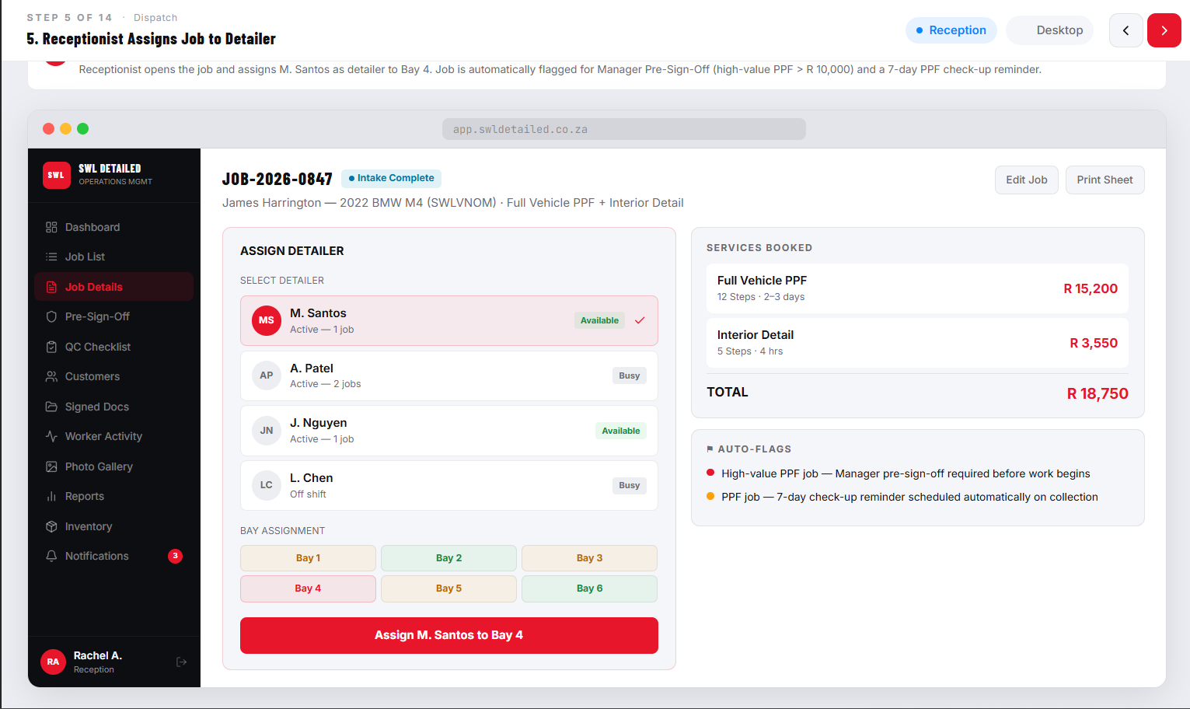
Figure P-40: Screen P-14 — Job Assignment Screen (Reception, Desktop). Dummy assignment: JOB-SWL-DMO905 assigned to M. Santos.

3.6 Step 6 — Manager Views New Job on Dashboard (Manager — Desktop) 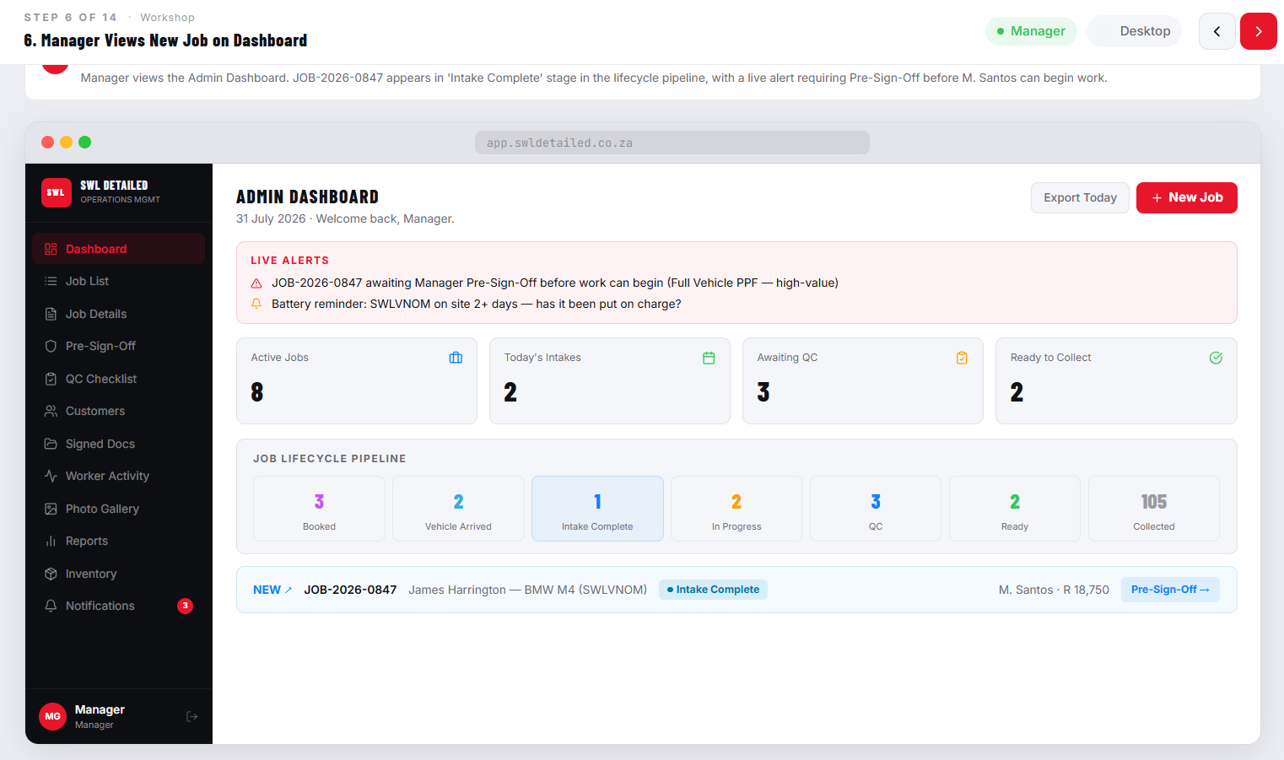
Figure P-41: Screens P-11a, P-11b — Admin Dashboard (Manager, Desktop). Dummy job visible: JOB-2024-0847 | ABC 123 | James Whitfield | Full Detail Package + Ceramic Coating | Service in Progress | M. Santos | R 8,450.

3.7 Step 7 — Detailer Starts Procedures & Timers, Logs Products, Captures "During Installation" Photos (Detailer — Mobile) 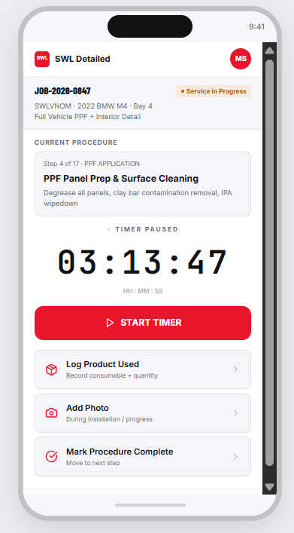
Figure P-42: Screens P-22 through P-27b — Detailer Flow (Mobile). Dummy Detailer: Kabelo Ndlovu (SWL-DTL-004). Active job: JOB-1038 | Mercedes-Benz GLC | GP 458-921. Products logged: INNOVACAR Prewash Concentrate 250ml, INNOVACAR Foam Shampoo 300ml, INNOVACAR Iron Remover 200ml.

3.8 Step 8 — Detailer Marks All Procedures Done — Job Moves to Quality Control (Detailer — Mobile) 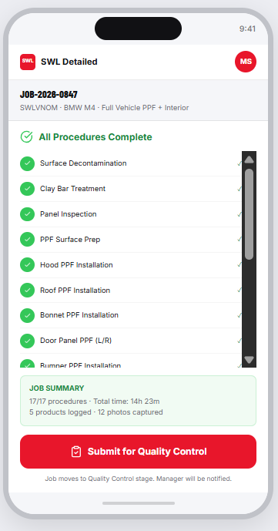
Figure P-43: Screens P-28 and P-29 — Procedure Completed & All-Procedures-Done Confirmation (Detailer, Mobile). Job JOB-1038 transitions: Service in Progress → Quality Control.

3.9 Step 9 — Manager Runs QC Checklist (Pass/Fail); Pre-Sign-Off Completed for Flagged/High-Value Jobs (Manager — Desktop) 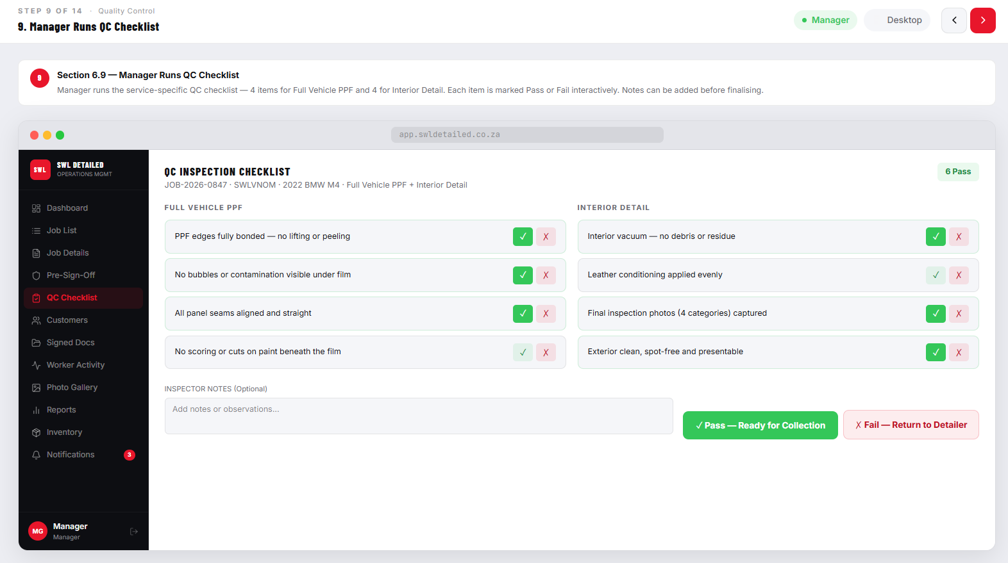
Figure P-44: Screen P-21 — QC Checklist (Manager, Desktop); Screens P-14a/P-14b — Pre-Sign-Off Review (Manager, Desktop). Dummy job: JOB-2024-0848 | DEF 456 | Sarah Mitchell | 2023 BMW M4 Competition | R 18,750 | Awaiting Sign-Off.

3.10 Step 10 — Manager Marks Job "Ready for Collection" — Client Notified (Manager — Desktop) 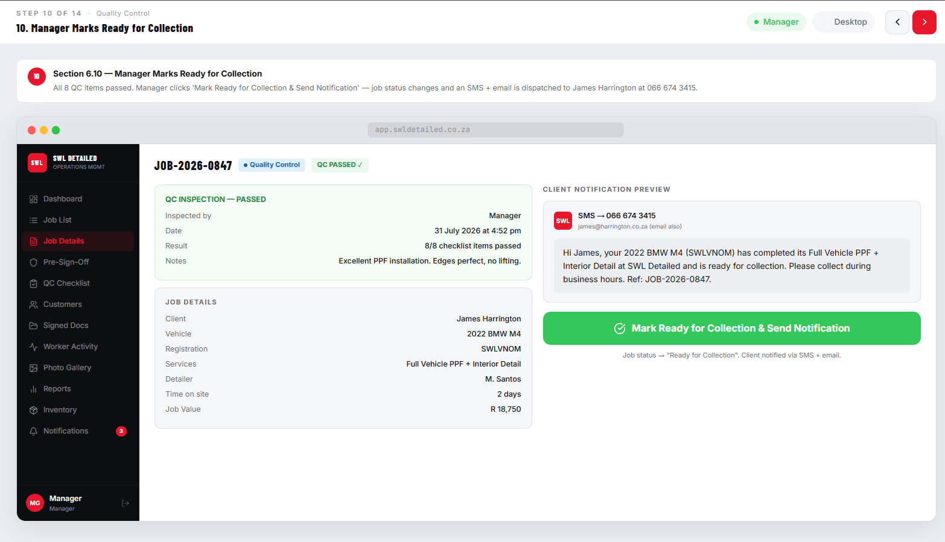
Figure P-45: Screen P-20a, P-20b — Notification Template Settings (Manager, Desktop). Notification sent: "Ready for Collection Alert" — Email On, SMS On. Job transitions: Quality Control → Ready for Collection.

3.11 Step 11 — Receptionist Creates Invoice, Records Payment (Reception — Desktop) 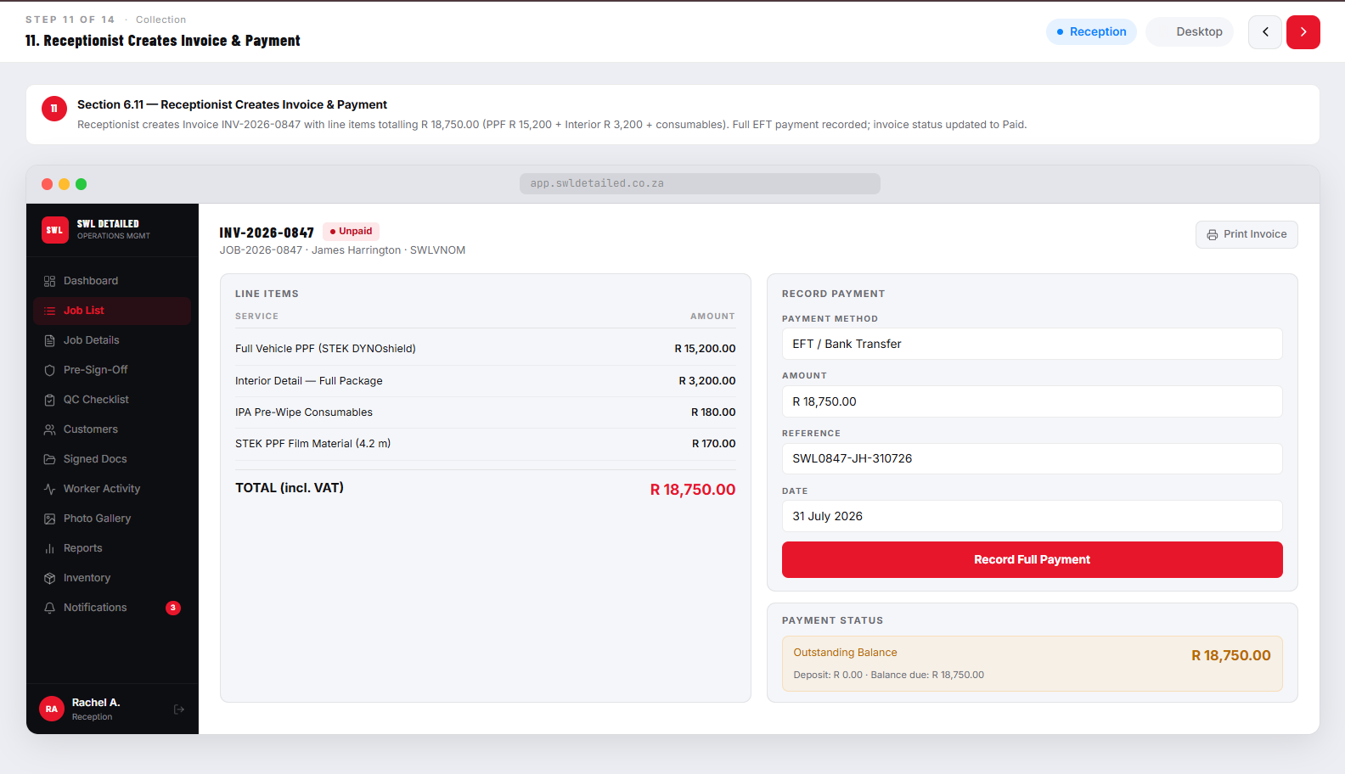
Figure P-46: Screen P-16 — Invoice Screen (Reception, Desktop). Dummy invoice: JOB-SWL-DMO905 | Full Vehicle PPF R 3,500 + Interior Detail R 199 | Total R 3,699 | Status: Paid.

3.12 Step 12 — Client Collects Vehicle; Satisfaction Sign-Off Captured (Client / Reception) 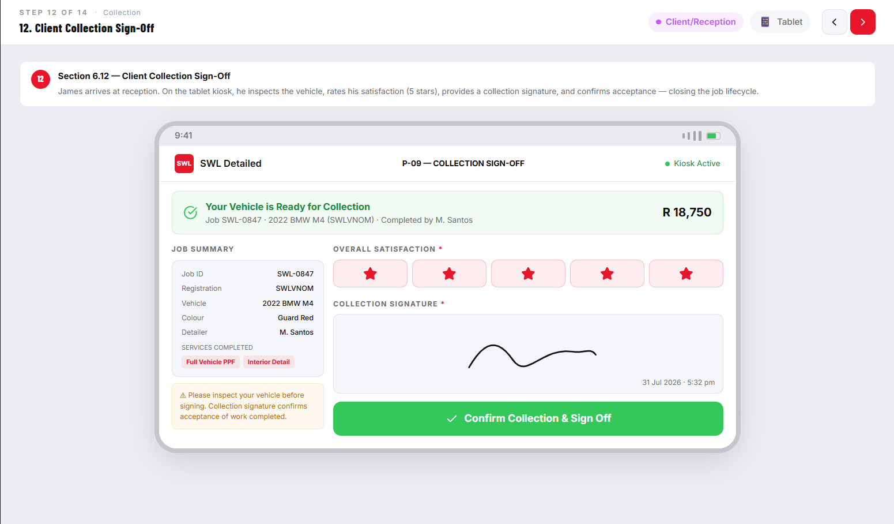
Figure P-47: Screens P-09a and P-09b — Collection Notification & Customer Satisfaction Sign-Off (Client, Tablet). Dummy: Job SWL-KRT847 | 123ABC | 2022 Porsche 911 Carrera S | Collected: 31 July 2026 07:52 pm | Rating: 5 stars.

3.13 Step 13 — (PPF Jobs Only) Receptionist Schedules 7-Day PPF Check-Up (Reception — Desktop) 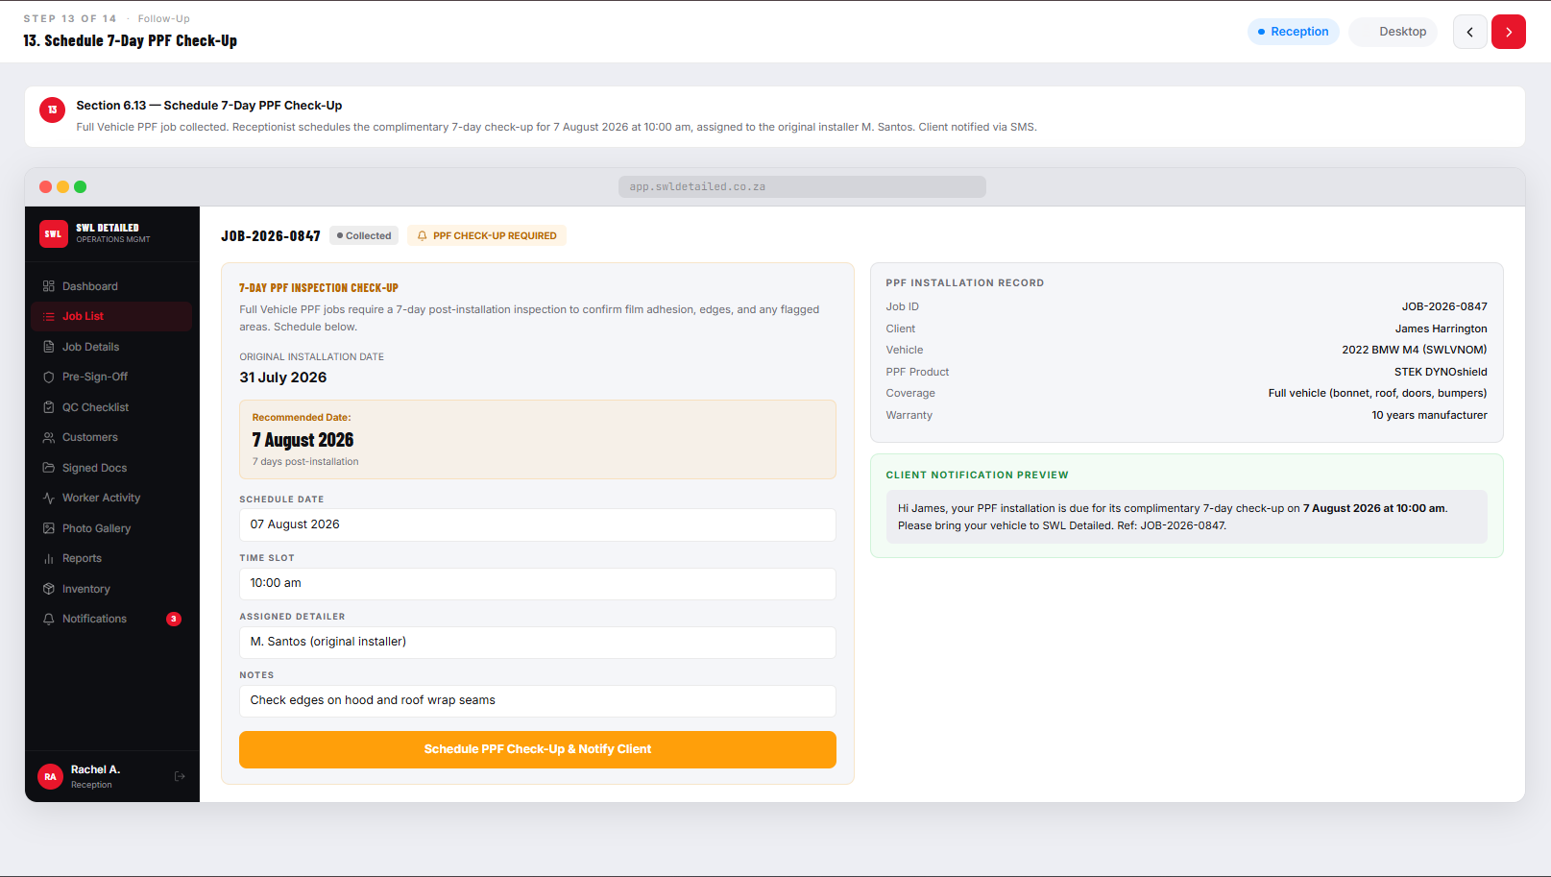
Figure P-48: Screen P-18 — PPF Check-Up Scheduling Screen (Reception, Desktop). Dummy: JOB-SWL-DMO905 PPF installed 31 July 2026. Check-up scheduled: 07 August 2026 at 10:00 AM.

3.14 Step 14 — Receptionist Confirms Battery Reminder Response for Any Vehicle On-Site 2+ Days (Reception — Desktop)
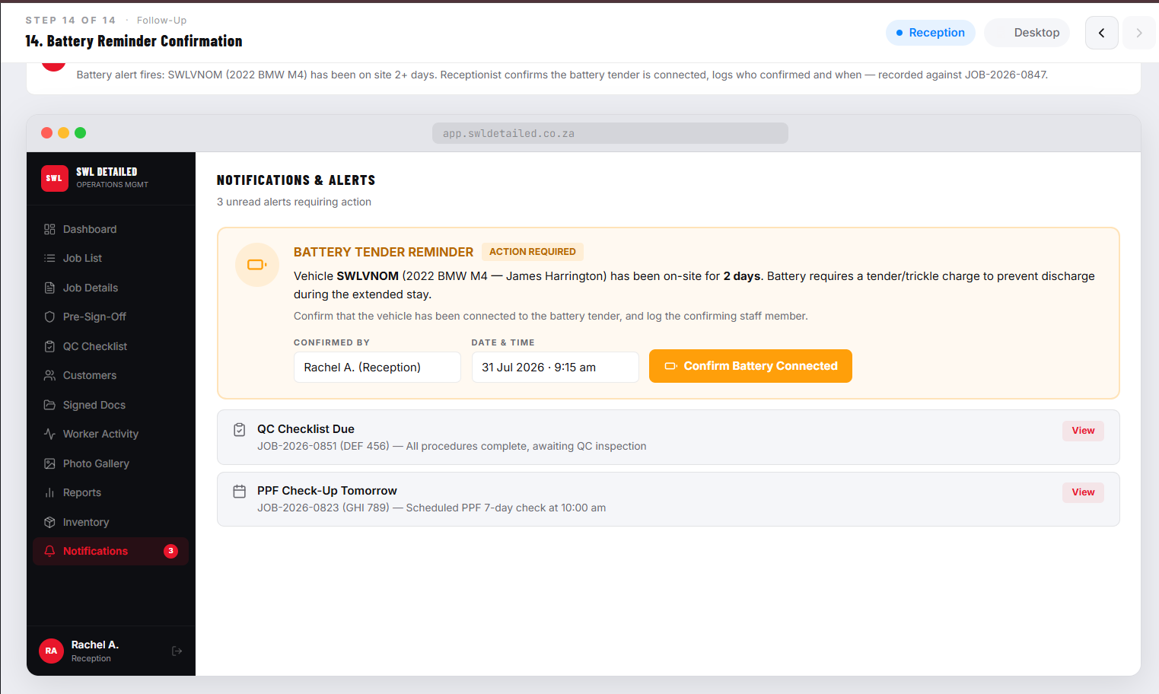
Figure P-49: Screen P-15 — Battery Reminder Panel (Reception, Desktop). Dummy: JOB-1042 | CA 123-456 | BMW M4 Competition | On-site: 3 days | Status: Urgent — battery check required.

4. Job Lifecycle State Visualisation
The VWOMS jobs lifecycle consists of the set of distinct and uniquely named states that every vehicle job goes through from the very creation of the booking to the point where the vehicle is collected by the customer (SWL Detailed, 2026). Formalizing the process into a distinct state machine instead of just an informal progression of states described in words is one of the key system design principles, guaranteeing that each and every player in the workflow will know exactly the current status of the job at any moment without having to communicate it manually (Dennis, Wixom and Tegarden, 2021). This process can be seen in the Admin Dashboard pipeline, Vehicle/Job List stage filter, Detailer job stage badge, and Reception Dashboard pipeline bar (SWL Detailed, 2026).

4.1 Lifecycle Stages
The Volkswagen Job Life Cycle for the VWOMS comprises seven different stages that occur sequentially during the process of operation, with each stage depicting a unique operation landmark during the process of the vehicle going through the SWL Detailed workshop (SWL Detailed, 2026). These stages are detailed below along with the person who drives the job into that stage.
Stage | Description | Triggered By | System Action
1. Booked | A booking has been created by Reception for a future date. The vehicle has not yet arrived. | Reception | Booking record created. Appears in upcoming bookings list on Reception Dashboard.
2. Vehicle Arrived | Client has arrived. Receptionist has completed check-in and confirmed vehicle condition. | Reception (Check-In) | Booking converted to Job. Job ID assigned. Intake damage photos linked. Battery timer started.
3. Intake Complete | Client has completed all intake wizard steps and signed the indemnity form on the tablet. | Client (via Tablet Kiosk) | Signed indemnity linked to job. Intake form record created. Job appears on Reception assignment queue.
4. Service in Progress | Job has been assigned to a Detailer. Detailer has started at least one procedure timer. | Detailer (first timer start) | Live timer data begins accumulating. Job appears in Manager dashboard "In Progress" count. Products logged in real time.
5. Quality Control | All Detailer procedures are marked done. Job has moved to the QC inspection stage. | Detailer (all-procedures-done confirmation) | QC alert surfaced on Manager dashboard. QC Checklist activated for the job. Pre-sign-off required if job is flagged.
6. Ready for Collection | QC has passed (all checklist items passed; pre-sign-off approved where required). Client notified. | Manager (QC approval + Ready for Collection action) | Automated client notification sent (email/WhatsApp). Invoice prepared by Reception. Vehicle moved to collection bay.
7. Collected | Client has collected the vehicle and signed the satisfaction sign-off on the tablet. | Client / Reception (Collection Sign-Off) | Satisfaction rating and collection signature linked to job. Job status set to terminal "Collected" state. PPF check-up scheduled if applicable.
Table 1: VWOMS Job Lifecycle Stage Definitions (Quantum Coder, 2026).
Lifecycle is displayed in the prototype using a horizontal pipeline bar on the Admin Dashboard (Screens P-11a and P-11b) and Reception Dashboard (Screen P-11/P-33) which illustrates the number of jobs at different stages (SWL Detailed, 2026). By clicking on any of the stages in the pipeline, the All-Jobs table is filtered to display only the jobs at that stage allowing the manager or receptionist to concentrate on the most important operational tasks without having to go through the entire list (Laudon and Laudon, 2022). The stage badges are color-coded throughout all screens: blue for Booked, amber for Vehicle Arrived, teal for Intake Complete, orange for Service in Progress, purple for Quality Control, green for Ready for Collection, and grey for Collected, making the status immediately recognizable without even reading it (Nielsen Norman Group, 2024a).
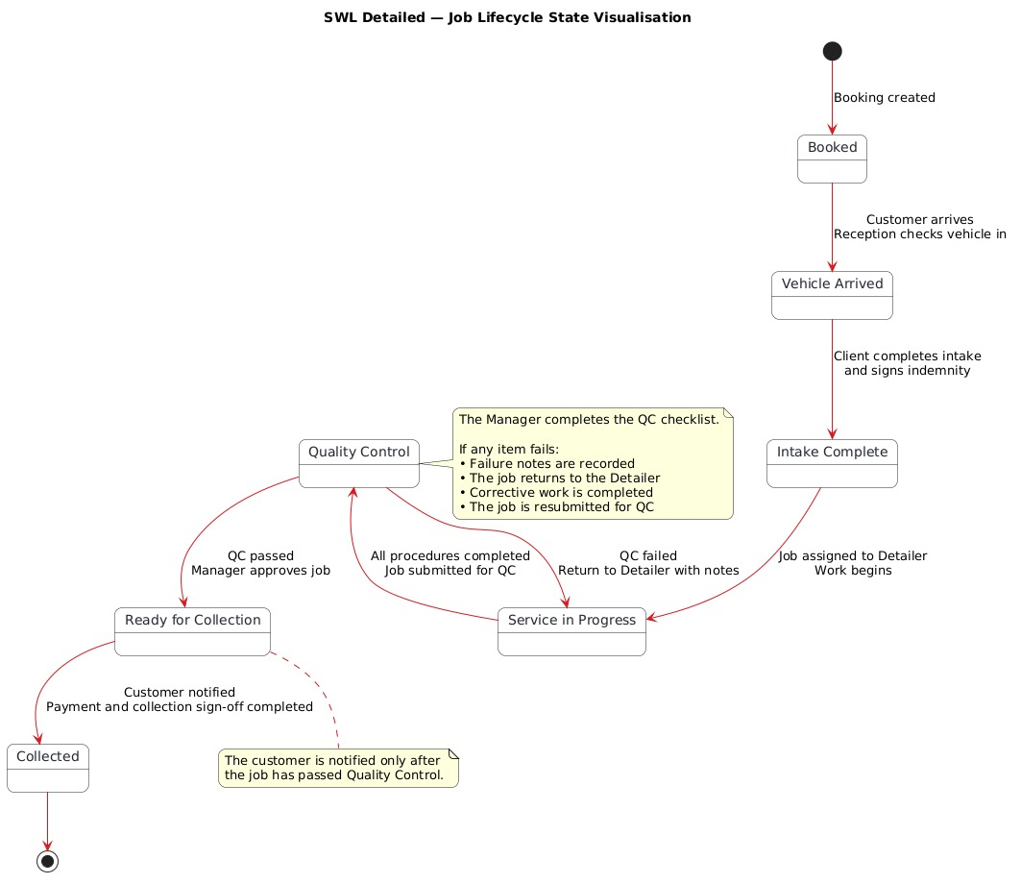
Figure P-50: Job Cycle VNOM

7.2 QC Fail Loop — Job Returned to Detailer with Notes
The Quality Control phase comprises a failure loop process which gives the Manager the opportunity to reject a job back to the Detailer in case one or several items of the Quality Control checklist do not satisfy the minimum standards (SWL Detailed, 2026). The failure loop is essential to operations because it ensures that the quality problems are officially noted, reported and corrected prior to releasing the car to the customer (SWL Detailed, 2026).
Once the Manager fails one or more QC checklist items, the “Save QC Results” function will lead to the following system behaviour: The job status changes from "Quality Control" back to "Service in Progress — QC Return"; The Detailer’s Assigned Jobs screen will update to show the returned job, indicated with a red QC return badge; The notes on QC fail that are made by the Manager are added to the job and will be shown in the Detailer’s Job Details screen in a “QC Notes” box; And the number of QC will decrease, while the number of Services in Progress will increase for the Manager on the Admin Dashboard (SWL Detailed, 2026). The Detailer will see the returned job prominently highlighted at the top of their jobs list along with detailed notes on what should be fixed to pass QC (SWL Detailed, 2026).
Once the Detailer completes the remediation process, he or she flags the relevant procedures as done and sends the All-Procedures-Done Confirmation, taking the job back to “Quality Control” where the Manager (SWL Detailed, 2026) carries out another round of inspection. The iteration can continue in such a fashion until all the QC criteria are met, so that no vehicle exits the garage unless it conforms to the established quality standard (SWL Detailed, 2026). The entire cycle of passes and failures during quality control process is recorded in the job documentation and is available for review by the Manager on the Job Details and Signed Documents pages (OWASP, 2021).

8. Responsive Design Evidence
"Responsive Design refers to design approaches for designing interfaces which are capable of altering the arrangement, spacing, typography and navigation based on the size of device and type of input used by the device without building a separate version for every device class" (MDN Web Docs, 2024). About the VWOMS prototype, responsive design is not just a matter of aesthetics, but a matter of practicality: the four user roles use different devices and in completely different physical settings and it is necessary that the interface of each role is designed accordingly (SWL Detailed, 2026). A manager who reviews job data using a desktop computer needs a high density layout consisting of data tables and document panes; a Detailer who logs product usage in workshop bay needs a minimalist interface with large targets to use with one hand while wearing gloves (Preece, Rogers and Sharp, 2019).
The Figma prototype is an example of the responsive design approach through device-specific frames developed according to the real screen resolution of each particular device targeted by each role: a desktop viewport of 1440 px for Manager and Reception screens, an iPad Pro viewport of 1024 × 1366 px for Client screens, and an iPhone 14 viewport of 390 × 844 px for Detailer screens (Figma, 2024). If a role has a secondary device as well, additional frames are provided according to the dimensions of this device (SWL Detailed, 2026). All device frames are available in the Figma prototype along with their primary-device analogs, both marked as such.

8.1 Desktop Views — Manager & Reception
The Manager and Reception interfaces have been developed with full screen, desktop design in mind, with minimal viewport widths of 1280 pixels being used in addition to layouts optimized for 1440 pixels (SWL Detailed, 2026). The two role interfaces use a sidebar navigation on the left-hand side with the role logo, navigation links displayed in icon and label form, along with the avatar of the logged in user at the bottom (SWL Detailed, 2026). The sidebar navigation is in accordance with design conventions used for information-heavy management dashboards (Nielsen Norman Group, 2024b).
The Admin Dashboard of the Manager (P-11a and P-11b screens) occupies the full horizontal width of the viewport displaying the lifecycle pipeline bar, KPI metric cards, and All Jobs data table together without horizontal scrolling (SWL Detailed, 2026). Data tables occupy the full width of the content area with proportional sizes of columns based on the amount of data – small columns for Job ID and registration fields and larger ones for client name and service description – and enable column sorting and keyword searching (Laudon and Laudon, 2022). The Worker Activity page (P-16 screen) uses a two-panel design with a service breakdown bar chart on the left side and on-shift summary on the right one, and a full-width Detailer performance table below; all the data is arranged to fully utilise the horizontal desktop space that would be otherwise impossible on smaller devices (Nielsen Norman Group, 2024b). Pages that include a lot of documents, e.g., Signed Documents (P-15 screen) and Job Details (P-14a and P-14b screens), use two-column layout with navigation and summary of the document on the left and its content on the right (Nielsen Norman Group, 2024a).

8.2 Tablet / iPad Views — Client Intake Flow & Reception Secondary Screens
Client / Customer interface can be used only on the iPad tablet device available at the SWL Detailed reception desk, where all screens have 1024 × 1366px format in portrait mode (SWL Detailed, 2026). For the intake wizard, centred card layout is used, where all content of the form is in the central third part of the screen, while there is enough space on the sides. Such a design is convenient for tablet touch screens, as it allows to keep all interactive elements in a thumb’s reach, without need to extend the hand on the entire width of the screen (Preece, Rogers and Sharp, 2019). The minimum height of form fields is 48px with visible labels. Navigation buttons are "Next" and "Back". The first one is in the bottom-right corner, while the second is in the bottom-left one, as it should be according to the left-to-right reading order (Nielsen Norman Group, 2024a).
The secondary views of Screens P-33 and P-34 for the Reception role illustrate how the Reception Dashboard and Check-In screens change when the receptionist uses a tablet device instead of a computer, for instance, in peak booking time when the computer desk is in use (SWL Detailed, 2026). Specifically, in the tablet view, the left-side navigation menu becomes a hamburger menu icon to make extra space, the pipeline bar becomes vertical instead of being horizontal, and the number of columns displayed in the All-Jobs table gets reduced, with the rest of the data shown horizontally by scrolling (MDN Web Docs, 2024). The Check-In tablet screen (Screen P-34) uses a split-two-panel layout, with the left panel showing a bookings list of the current day in a card with scroll, and the right panel displaying the chosen booking and the check-in form (SWL Detailed, 2026).

8.3 Mobile Smartphone Views — Detailer Primary Screens
Detailer/Worker Interface is designed specifically for mobile phone usage, where all the basic screens have been created with a 390 × 844px screen size, which is equal to that of iPhone 14 and similar Android devices (SWL Detailed, 2026). The main constraint for the design of Detailer screens is that all the important actions such as starting the timer, marking completion of the procedure, registering the product, and taking photos are possible by tapping on one big touch target without having the Detailer remove protective gloves, change his hand or go through the menus (SWL Detailed, 2026). This constraint is a direct result of the feedback that was provided by SWL Detailed employees during the requirements elicitation process since they found out that previous attempts to use the web interface in the workshops failed due to its small size and complexity (SWL Detailed, 2026).
All Detailer screens have a bottom navigation bar featuring five persistent icons: My Jobs, Procedures, Start Timer, Products, and Photos that are available on all screens and allow for instant switching of functionalities without the need to press back or hamburger button (Nielsen Norman Group, 2024a). All touch targets in all Detailer screens are at least 44 × 44 points in size and the main action buttons (Start Timer, Stop Timer, Mark Done, Add Photo) are much bigger – at least 56 × 56 points – to ensure operability when wearing gloves and to decrease the error rate in a dynamic physical environment (Apple, 2024). The colour palette includes a dark background (#1A1A1A), white text, and red accents used for the main actions, which offers good visibility in various light conditions including sunlight (Preece, Rogers and Sharp, 2019).

8.4 Tablet Secondary Views — Detailer Fallback Screens
The Detailer’s main tool is the smartphone; however, according to the brief, the use of tablet/iPad as a secondary device should also be provided as a fall-back option when a larger display becomes available (SWL Detailed, 2026). Examples of the Detailer secondary tablet views (Screens P-35 & P-36) show how Detailer’s interface looks on a larger screen while following the minimalistic and large target approach. In particular, in the PIN login screen (Screen P-35), the use of a tablet brings the addition of a Profile Selection Panel to the left, which allows different Detailers who use the same workshop tablet to choose the appropriate profile prior to logging into the app by entering a PIN code instead of a username (Nielsen Norman Group, 2024a).
In the case of the Start/Stop Timer screen in the secondary view of the tablet (Screen P-36), the additional horizontal screen space allows showing the active timers on one side and a history of recently used timers, including a time summary per week, on the other side, which would have to be viewed separately in the mobile version of the app because of the limitations of the mobile screen (SWL Detailed, 2026). Such a side-by-side representation makes it possible to minimize the number of taps to access related information about the timers currently being used and the ones recently used, which is especially important for a Detailer working on a multi-day job who wants to check if the previous days’ time record is correct before continuing work in the new session (Preece, Rogers and Sharp, 2019). Other Detailer screens in tablet view will feature only one column but with bigger fonts and touch targets.

9. Screen Connectivity & Navigation Maps
Connectivity maps for screens, also known as user flow maps or navigation maps, outline the various paths that a user may take throughout the application by representing screens as nodes and navigational actions (like taps on buttons or clicks on links) as edges from one screen to the other (Preece, Rogers and Sharp, 2019). In Figma, the connectivity of screens is done using hotspots. Hotspots refer to clickable areas within a frame in Figma prototypes which navigate to another frame on clicking in Presentation Mode of the prototype (Figma Help Center, 2024). The connectivity maps presented in this section represent the actual hotspot wiring within the Figma prototype of VWOMS.

9.1 Client Flow Navigation Map

Device: Tablet (iPad)
Client flow consists of a linear wizard with only some branching in place to walk through the intake procedure with a new user who does not have any prior knowledge of the system (SWL Detailed, 2026). Navigation is mostly one-way; there is a main button "Next/Continue," which moves the wizard forward, as well as a "Back" button, which takes the user back to the previous stage, except for the Service Selection screen, where users can select/deselect several services (Nielsen Norman Group, 2024a).
From Screen | Action | To Screen
P-01 Welcome | Tap "Begin Intake" |  | P-02 Customer Details Form
P-02 Customer Details | Tap "Save & Continue" |  | P-03 Vehicle Details Form
P-03 Vehicle Details | Tap "Next: Condition Review" |  | P-04 Vehicle Condition & Damage Notes
P-04 Condition Review | Tap "Next: Service Selection" |  | P-05 Service Selection
P-05 Service Selection | Tap "Next: Indemnity Agreement" |  | P-06 Indemnity Form (Read-Only)
P-06 Indemnity Form | Scroll to bottom + tick checkbox + tap "Proceed to Sign" |  | P-07 Digital Signature Screen
P-07 Digital Signature | Sign + tap "Confirm & Submit Intake" |  | P-08 Intake Submitted Confirmation
P-08 Confirmation | Tap "Return to Home" |  | P-01 Welcome (kiosk reset)
[Any step] Back arrow | Tap "< Back" |  | Previous wizard step
[Collection] P-09a Sign-Off | Sign + tap "Confirm Collection & Sign Off" |  | P-09b Collection Confirmed
P-09b Collection Confirmed | Tap "Return to Home" |  | P-01 Welcome (kiosk reset)
Table 2: Client Flow Navigation Map (Quantum Coder, 2026).

9.2 Reception Flow Navigation Map

Primary Device: Desktop | Secondary Device: Tablet
Reception flow follows the hub and spoke model, whereby the Reception Dashboard (Screen P-11) acts as the central point from where all reception-related functionalities can be accessed, and to where the receptionist goes back after performing each one of those tasks (Nielsen Norman Group, 2024b). The hub and spoke model is the best choice for the reception function because the receptionist moves back and forth doing tasks such as booking management, check-ins, invoices, and battery reminders during the course of his/her workday, and therefore he/she needs a central screen that shows everything relevant at a glance (Nielsen Norman Group, 2024a).
From Screen | Action | To Screen
P-10 Reception Login | Successful login | P-11 Reception Dashboard
P-11 Reception Dashboard | Tap "+ New Job" or "Booking" | P-12 Booking Screen
P-12 Booking Screen | Save booking / Back | P-11 Reception Dashboard
P-11 Reception Dashboard | Tap "Check-In" or select arriving booking | P-13 Check-In Screen
P-13 Check-In Screen | Tap "Confirm Check-In & Create Job" | P-14 Job Assignment Screen
P-14 Job Assignment | Assign Detailer + confirm | P-11 Reception Dashboard (job now active)
P-11 Reception Dashboard | Tap battery alert / Battery Reminder | P-15 Battery Reminder Panel
P-15 Battery Reminder | Confirm battery check / Back | P-11 Reception Dashboard
P-11 Reception Dashboard | Tap "Create Invoice" on Ready-for-Collection job | P-16 Invoice Screen
P-16 Invoice Screen | Record payment + confirm | P-17 Collection Confirmation Screen
P-17 Collection Confirmation | Confirm collection / Back | P-11 Reception Dashboard
P-17 Collection Confirmation | (PPF jobs) Tap "Schedule PPF Check-Up" | P-18 PPF Check-Up Scheduling Screen
P-18 PPF Check-Up Scheduling | Save check-up / Back | P-11 Reception Dashboard
P-33 Reception Dashboard (Tablet) | Same navigation as Desktop — sidebar collapsed to hamburger | All Reception screens (tablet layout)
P-34 Check-In Screen (Tablet) | Same as P-13 but two-panel layout | P-14 Job Assignment (tablet)
Table 3: Reception Flow Navigation Map (Quantum Coder, 2026).

9.3 Manager Flow Navigation Map

Primary Device: Desktop
In the Manager flow, the left-side menu with named links to sections is used, giving the Manager a chance to go straight to any one of them - Dashboard, Job List, Job Detail, Pre-Sign-Off, Quality Control Checklist, Customers, Signed Documents, Worker activity, Photo Gallery, Reports, Inventory, Notifications - without going back to the dashboard after every single action (SWL Detailed, 2026). The Admin Dashboard, apart from that, includes contextual quick-action links in the Live Alerts section and all the jobs’ rows in the table (for example, "Review Now →", "Confirm →", "Notify →") which give direct access to the corresponding action page for a particular job (Laudon and Laudon, 2022).
From Screen | Action | To Screen
P-10 Manager Login | Successful login | P-11a Admin Dashboard
P-11a/b Admin Dashboard | Click any pipeline stage count | P-13 Vehicle/Job List (filtered by stage)
P-11a/b Admin Dashboard | Click "Review Now" on Pre-Sign-Off alert | P-14a/b Pre-Sign-Off Review Screen
P-11a/b Admin Dashboard | Click "Confirm" on battery alert | P-11 Dashboard (alert dismissed)
P-11a/b Admin Dashboard | Click "View QC" on QC alert | P-21 QC Checklist Screen
P-14a Pre-Sign-Off | Tap "Approve & Sign Off" | P-11 Dashboard (job cleared) or P-21 QC Checklist
P-14a Pre-Sign-Off | Tap "Request Changes" | P-11 Dashboard (job returned to Detailer)
P-21 QC Checklist | All Pass — tap "Save QC Results" | P-11 Dashboard (job advances to Ready for Collection)
P-21 QC Checklist | Any Fail — tap "Save QC Results" | P-11 Dashboard (job returned to Detailer)
P-11 Dashboard | Click "Notify →" on Ready-for-Collection job | P-20a/b Notification Template Settings
P-13 Vehicle/Job List | Click any Job ID row | P-14a/b Job Details Page
P-12 Customer List | Click any customer row | Customer detail view
Sidebar nav | Click "Signed Docs" | P-15 Signed Documents Page
Sidebar nav | Click "Worker Activity" | P-16 Worker Activity & Productivity Page
Sidebar nav | Click "Photo Gallery" | P-18 Photo Gallery
Sidebar nav | Click "Reports" | P-19 Reports Page
Sidebar nav | Click "Notifications" | P-20a/b Notification Template Settings
Table 4: Manager Flow Navigation Map (Quantum Coder, 2026).

9.4 Detailer Flow Navigation Map

Primary Device: Mobile Smartphone | Secondary Device: Tablet
In the Manager flow, the left-side menu with named links to sections is used, giving the Manager a chance to go straight to any one of them - Dashboard, Job List, Job Detail, Pre-Sign-Off, Quality Control Checklist, Customers, Signed Documents, Worker activity, Photo Gallery, Reports, Inventory, Notifications - without going back to the dashboard after every single action (SWL Detailed, 2026). The Admin Dashboard, apart from that, includes contextual quick-action links in the Live Alerts section and all the jobs’ rows in the table (for example, "Review Now →", "Confirm →", "Notify →") which give direct access to the corresponding action page for a particular job (Laudon and Laudon, 2022).
From Screen | Action | To Screen
P-22 Worker Login (Mobile) | Enter correct PIN | P-23 Assigned Jobs List
P-23 Assigned Jobs List | Tap any job card | P-23 Job Details View
P-23 Job Details View | Tap "View Procedures →" | P-24a Procedure List Screen
P-24a Procedure List | Tap a procedure row | P-24b Procedure Detail / Start Timer prompt
P-24a/b Procedure List | Tap bottom nav "Start Timer" | P-25a Start/Stop Timer Screen
P-25a Timer (active) | Tap "Stop Timer" | P-25a Timer (stopped) → back to P-24
P-24a Procedure List | Tap bottom nav "Products" | P-26a Product Usage Logging Screen
P-26a Products | Tap "+ Add" and complete entry | P-26b Updated product list view
P-24a Procedure List | Tap bottom nav "Photos" | P-27a Photo Capture Screen
P-27a Photos | Capture / upload photo | P-27b Updated photo gallery view
P-24a Procedure List | All procedures done — tap "Mark All Done" | P-28 Procedure Completed Confirmation
P-28 Procedure Completed | Tap "Back to Procedure List" | P-24a Procedure List
P-24a All done | System detects all complete | P-29 All-Procedures-Done Confirmation
P-29 All Done | Tap "Go to Job Details" | P-23 Job Details View (status: QC)
P-29 All Done | Tap "Back to My Jobs" | P-23 Assigned Jobs List
P-30 Notifications | Accessible via bell icon on any screen | P-30 Notifications Screen
P-31/P-32 Profile/Settings | Accessible via profile icon on any screen | P-31 Profile / P-32 Settings Screen
P-35 Worker Login (Tablet) | Select profile + enter PIN | Assigned Jobs List (tablet layout)
P-36 Timer (Tablet) | Same as P-25a — wider layout with history panel | Same destinations as P-25a
Table 5: Detailer Flow Navigation Map (Quantum Coder, 2026).

9.5 Cross-Role Handoff Points
The cross-role handovers in VWOMS are the points within its workflow at which the act carried out by one role leads directly to a change in what the other role sees on the interface (Dennis, Wixom and Tegarden, 2021). The cross-role handovers are the most important points in terms of system operations since they are those points when the baton is passed from one member to the next. Moreover, they were the main point in the previous system using verbal communication or WhatsApp where delays and misunderstandings were common (SWL Detailed, 2026). The inclusion of cross-role handovers helps show the entire process of information flow in the system rather than just the screens in isolation (Preece, Rogers and Sharp, 2019).
Step | Triggering Role | Triggering Action | Receiving Role | Effect on Receiving Role's Interface
2 → 3 | Reception | Confirms vehicle check-in — Job Created | Client | Tablet kiosk is activated for client intake wizard (P-01 Welcome screen).
3 → 5 | Client | Submits intake form + signs indemnity | Reception | Job appears on Reception Dashboard assignment queue with "Intake Complete" badge. Intake form and signed indemnity linked to job.
5 → 6 | Reception | Assigns job to a Detailer | Manager + Detailer | Manager: Job appears in Admin Dashboard All Jobs table. Detailer: New job appears at top of Assigned Jobs list (P-23).
7 → 8 | Detailer | Marks all procedures done | Manager | Manager: QC alert surfaced in Live Alerts panel on Admin Dashboard. Job stage badge updates to "Quality Control" in pipeline.
9 → 7 (fail loop) | Manager | Saves QC results with failed items | Detailer | Detailer: Job reappears in Assigned Jobs list with QC return badge. QC notes displayed in Job Details view.
9 → 10 | Manager | Approves QC + marks Ready for Collection | Client + Reception | Client: Automated notification sent (email/WhatsApp). Reception: Job appears in "Ready to Collect" pipeline column.
11 → 12 | Reception | Creates invoice + records payment | Client | Client: Tablet kiosk presents Collection Sign-Off screen (P-09a).
12 → 13 | Client | Signs collection satisfaction sign-off | Reception | Reception: Job status finalised as "Collected". PPF check-up scheduling prompt triggered for applicable jobs.
Table 6: Cross-Role Handoff Points (Quantum Coder, 2026).

10. Prototype Submission Checklist
The checklist presented below indicates the fulfilment of all requirements stated in the VWOMS Task 1 Prototype Brief Revision (SWL Detailed, 2026) and INSY7315 rubric (The Independent Institute of Education, 2026) within the submitted Figma prototype. Every point from the checklist will be verified according to frames of the prototype provided in Sections 2 to 9 of this paper.

10.1 All Four Role Screen Sets Included
The prototype includes screen sets for all four user roles defined in the updated VWOMS brief: Client / Customer (screens P-01 through P-09b), Reception / Administrator (screens P-10 through P-18, P-33 and P-34), Manager / Administrator (screens P-19 through P-21), and Detailer / Worker (screens P-22 through P-36) (SWL Detailed, 2026). The Reception / Administrator role is a new addition relative to the original three-role brief and has been fully implemented with all nine primary screens specified in the updated brief, including the Booking screen, Check-In screen, Job Assignment screen, Battery Reminder Panel, Invoice screen, Collection Confirmation screen, and PPF Check-Up Scheduling screen (SWL Detailed, 2026). All role screen sets are clearly labelled in the Figma file with role name and device type headers, enabling reviewers to locate any specific screen without prior knowledge of the file structure.
Status: COMPLETE — All four role screen sets included. Reception role fully implemented as per updated brief.

10.2 All Screens Numbered and Labelled
Each of the screens in the prototype is given a number using the “P-” prefix numbering scheme adopted in the Table of Contents (P-01, P-04a, P-04b, P-11a, P-11b), and each screen is named according to its purpose and functionality (SWL Detailed, 2026). In case of having two versions of the same screen presented in the prototype (form screen in its blank version and filled-out version; or the same screen with variations A and B of dummy data), both screens are numbered with the same P number and an alphabetical suffix indicating the version (P-04a and P-04b) because they are not different screens but two versions of the same screen (Figma, 2024). Figure captions used in this document correspond to the frame labels in the Figma file one-to-one.
Status: COMPLETE — All frames numbered P-01 through P-36 with alphabetical suffixes where applicable. Total unique screens: 36 primary + secondary views. Captions match Figma frame labels.

10.3 All 14 Flow Steps Linked and Interactive in Figma
The 14-step process, as illustrated in Section 6, is completely prototyped as an interactive prototype with a link between frames via hotspots in Figma (Figma Help Center, 2024). Each and every button, tab, navigation item, and other action elements, which are a part of the 14-step process, have a hotspot connected to the right destination frame, meaning that the reviewer can go through the whole process starting from Step 1, which is "Receptionist Creates a Booking," and ending at Step 14, which is "Battery Reminder Confirmed" without running into a dead-end or a disconnected frame in Presentation mode (SWL Detailed, 2026). Navigation elements, which are the same across screens for one role, like the bottom navigation bar on Detailer screens and the left sidebar on Manager and Reception screens, are implemented as components with hotspots (Figma, 2024).
Apart from the main process of 14 steps, the prototype also includes additional interactions such as the Quality Check fail process (Step 9 → Step 7 → Step 8 → Step 9), the Pre-Sign-Off Approve/Request changes process (Step 9), and the Collection Sign-Off process (Step 12) so that the evaluators can test out these essential branch processes (SWL Detailed, 2026).
Status: COMPLETE — All 14 steps hotspot-linked and navigable in Presentation mode. QC fail loop, Pre-Sign-Off branching, and collection sign-off flow implemented as secondary interactions.

10.4 Dummy Data Applied Throughout
Dummy data is used in all frames of prototypes to ensure that users can track the movement of data through the screens without having to see any blank or dummy fields (SWL Detailed, 2026). Below is the data set used in all prototypes, which will ensure that the same data is seen on the right screens by all roles (Figma, 2024).
Data Category | Dummy Values Used
Client Name | James Harrington, Sarah Mitchell, Marcus Johnson, Priya Sharma, Jessica van der Berg
Vehicle Registrations | SWLVNOM, ABC 123, DEF 456, GRE 789, JKL 321, RNO 654, PQR 987, STU 258, VWX 741
Vehicle Makes / Models | BMW M4 Competition, Porsche 911 Carrera S, Lamborghini Urus, Audi RS3, Toyota Fortuner, Mercedes-Benz GLC
Job IDs | SWL-DMO905, JOB-1038, JOB-1042, JOB-1045, JOB-2024-0847, JOB-2024-0848, JOB-2024-0851
Job Lifecycle Stages | Booked, Vehicle Arrived, Intake Complete, Service in Progress, Quality Control, Ready for Collection, Collected
Detailer Names | M. Santos, A. Patel, J. Nguyen, L. Chen, K. Ndlovu, D. Osei, Kabelo Ndlovu
Service Packages | Full Vehicle PPF, Interior Detail, Paint Correction, Ceramic Coating, Full Detail Package, Engine Bay Detail, Frontal PPF
Job Values | R 800, R 2,800, R 3,500, R 3,699, R 4,200, R 8,450, R 12,800, R 15,200, R 18,750, R 24,800
Products | INNOVACAR Prewash Concentrate, INNOVACAR Foam Shampoo, INNOVACAR Iron Remover, STEK DYNOshield PPF, IGL Kenzo Ceramic Coating, Meguiar's M205 Ultra Finishing
Timestamps | 31 July 2026 (primary demo date); 03 Aug 2026 (Reception secondary view)
Table 7: Dummy Data Set Applied Throughout the Prototype (Quantum Coder, 2026).
Status: COMPLETE — Consistent dummy data applied across all 36 screens. Same client names, vehicle registrations, job IDs, and job values appear in corresponding screens across all role flows.
10.5 Desktop, Tablet, and Mobile Views All Present
Device-specific frames have been created for all the three types of devices: desktops, tablets/iPads, and mobile phones. Each frame has been designed to match the actual pixel dimensions of the target device (SWL Detailed, 2026). Frames for desktops (Manager and Reception primary) have been designed at 1440 × 900 px. Frames for tablets (Client primary; Reception secondary; Detailer secondary) have been designed at 1024 × 1366 px. Frames for mobiles (Detailer primary) have been designed at 390 × 844 px (Figma, 2024). All three types of devices are featured in the Figma file with the type of the device and its role indicated for ease of comparison among different devices in the same file (SWL Detailed, 2026).
Status: COMPLETE — Desktop (1440px), Tablet (1024px), and Mobile (390px) frames all present. Device frames labelled by role and device type. Secondary views provided for Reception (tablet) and Detailer (tablet).

19. Appendices

Annexure A — Declaration of Authenticity
Whereas we, below, members of the Quantum Coder team, do solemnly affirm that the work contained in this assignment for INSY7315 Work-Integrated Learning Task 1, is our work and work alone and that all sources referred to have been referenced using the IIE Harvard referencing format. This assignment has not been submitted anywhere else for any other module/qualification. Assistance provided has been acknowledged.
Team Member 1:
Name: Blake Derek Godfrey Student Number: ST10435415
Signature: 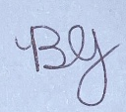Date: 05/08/2026

Team Member 2:
Name: Syed Muhammad Hamza Kazmi Student Number: ST10443021
Signature: 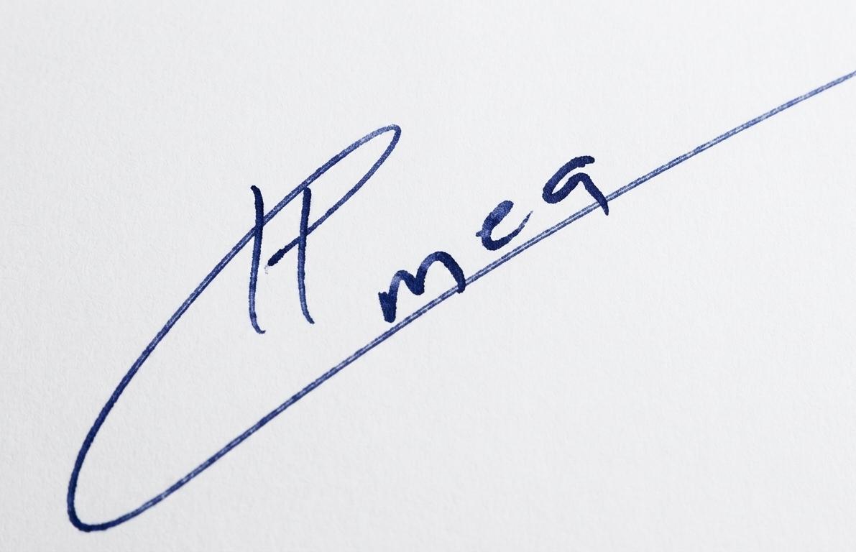Date: 05/08/2026

Team Member 3:
Name: Connor Albertyn Student Number: ST10437293
Signature:  Date: 05/08/2026

Team Member 4:
Name: Luke Hopewell Student Number: ST10301519
Signature: Date: 05/08/2026

Team Member 5:
Name: Muzammil Cassim Student Number: ST10259792
Signature: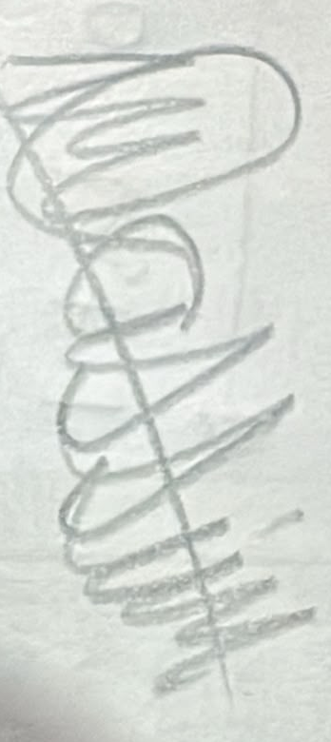 Date: 05/08/2026

Reference List
- Apple. 2024. Human Interface Guidelines — Layout. Available at: https://developer.apple.com/design/human-interface-guidelines/layout [Accessed: 31 July 2026].
- Dennis, A., Wixom, B.H. and Tegarden, D. 2021. Systems Analysis and Design: An Object-Oriented Approach with UML. 6th ed. Hoboken: John Wiley & Sons.
- Figma. 2024. What is prototyping in design? [Online]. Available at: https://www.figma.com/resource-library/what-is-prototyping/ [Accessed: 31 July 2026].
- Figma Help Center. 2024. Guide to prototyping in Figma. [Online]. Available at: https://help.figma.com/hc/en-us/articles/360040314193-Guide-to-prototyping-in-Figma [Accessed: 31 July 2026].
- Laudon, K.C. and Laudon, J.P. 2022. Management Information Systems: Managing the Digital Firm. 16th ed. Hoboken: Pearson.
- MDN Web Docs. 2024. Responsive web design (RWD). [Online]. Available at: https://developer.mozilla.org/en-US/docs/Glossary/Responsive_web_design [Accessed: 31 July 2026].
- Nielsen Norman Group. 2019. Usability testing 101. [Online]. Available at: https://www.nngroup.com/articles/usability-testing-101/ [Accessed: 31 July 2026].
- Nielsen Norman Group. 2024a. Form design — usability guidelines. [Online]. Available at: https://www.nngroup.com/articles/web-form-design/ [Accessed: 31 July 2026].
- Nielsen Norman Group. 2024b. Dashboard design — best practices. [Online]. Available at: https://www.nngroup.com/articles/dashboard-design/ [Accessed: 31 July 2026].
- OWASP. 2021. OWASP Top Ten 2021. [Online]. Available at: https://owasp.org/www-project-top-ten/ [Accessed: 31 July 2026].
- Preece, J., Rogers, Y. and Sharp, H. 2019. Interaction Design: Beyond Human-Computer Interaction. 5th ed. Hoboken: John Wiley & Sons.
- Quantum Coder. 2026. VWOMS Task 1 Prototype Documentation — Internal Draft. Emeris Pretoria: Unpublished.
- Republic of South Africa. 2002. Electronic Communications and Transactions Act 25 of 2002. Pretoria: Government Printer.
- Sommerville, I. 2016. Software Engineering. 10th ed. Harlow: Pearson Education Limited.
- SWL Detailed. 2026. Requirements elicitation session and non-disclosure agreement. Unpublished internal communication. Pretoria: SWL Detailed (Pty) Ltd.
- The Independent Institute of Education. 2026. INSY7315: Work-Integrated Learning — Module Guide. Sandton: The IIE.

