p

PROG 7313
POE PART 1 – PLANNING AND DESIGN DOCUMENT

Group:
Bertha Wolvaardt (st10397382)
Cameron Lee Griffin (st10443441)
Christopher John Leonard Janse van Rensburg (st10434337)
Luan Gulamhussene da Silva (st10444978)
Regardt Estian Malan (st10434247)

Introduction
This document outlines how the research findings, system requirements and user interface design are integrated to create a functional, intuitive an easy-to-use personal finance app that is ready for the programming and build phase to commence. The wireframes and project plan also ensure that usability and intuitive interaction remain central in Cash Chaos’s design. The wireframes included in this document take their inspiration from the findings of the research document, which emphasizes the importance of a clean and simple interface that avoids unnecessary complexity while incorporating motivational features. Specifically, the design integrated gamification elements like “Daily Streak” and “Your Challenges”, this encourages the user to enjoy engaging with the app on a daily basis whilst improving their personal financial planning skills.
This document also outlines the system requirements and core functionalities that the Cash Chaos app must support, these include to name a few, the creation of expense categories and logging expenses. The research infographic comparing Cashew, You Need A Budget, and The Budgeting App has influenced the design by inspiring the wireframes to focus on simplicity, accessibility, and motivational design. Furthermore, the detailed requirements list, wireframes and project plan form a strong foundation and roadmap for programming and the build phase which is to follow next.
Finally, the inclusion of data visualization tools, such as the inclusion of donut chart that the amounts spent on each category in relation to one another, helps the user to better understand their spending habits and identify spending patterns, so that they can curb unnecessary spending, reach savings goals and take control of their personal finance.

Overview of the App

Cash Chaos allows the user to create expense categories and record expenses according to these, expense spending can then be tracked over time to isolate trends as well as visualized as donut charts to see spending distribution across different categories. The fact that expense categories and spending limits per category are customizable gives the user the power to organize their spending according to their own priorities.
A core functionality of the app is the user authentication system, once authenticated the user must set a monthly budget goal which corresponds to their overall spending limit, usually for a month but can be customized. The system will warn the user when category spending limits are being approached or exceeded. The Wallets screen is used for viewing account balances, the Budget Goals screen is used for setting and monitoring monthly spending limits, and the Expenses per Category Screen provides a breakdown of actual incurred expenses for each category.

The user interface has been designed around the idea of having a high energy effect. We have chosen comic book styling inspired fonts and bright primary colors to promote excitement and keep the user engaged.


Figure 1: Cash Chaos Logo.
Gamification features such as Daily Streak and Your Challenges motivate users to log their expenses and to become cognizant of their day-to-day financial situation. In addition, innovative features such as a bill-splitting tool and included to assist users in managing shared expenses.
The Cash Chaos app integrates elements such has financial tracking, visual analytics and motivational design seamlessly without exposing the user to cognitive overload. This overview touches on subsequent sections in this document, which will elaborate in detail on the needed system requirements, wireframes and project plan that will lay the foundation for the programming, development and implementation phases of the Cash Chaos app.

Detailed List of Requirements for the App
1. User Registration and Login
The app will allow users to register by creating a unique username and password combination. The user’s data is securely stored.
2. Expense Categories
The app will allow the user to create expense categories. The app will allow the user to edit or delete expense categories.
3. Adding Expense Entries
The app will allow the user to record expenses, by adding expense entries. Expense entries will contain the following details, amount spent, ????currency
4. Optional Attachment of Photo or Image Upload
The app will
5. Monthly Budget Goals
The app must allow the user to set a monthly budget goal amount. The app must compare this monthly budget amount with a tally of the actual expenses as inputted and captured by the user. The app must give daily feedback to user on whether the user is still within their target monthly budget goal amount.
6. Category Budget Limits
The app must allow the user to set spending limit goal amounts for expense categories. The app must give feedback and warn the user should they closely approach or exceed their set spending limit for any given expense category. An example expense category can be groceries or rent.
7. View List of Expenses
The app will
8. Summaries of Spending per Category
The app will
9. Visualization and Graphs of Expenses
The app will
10. Progress Dashboard
The app will
11. Storage of user data in a Local Database
12. Gamification
13. Online Database Storage (multiple devices)
14. Own feature
15. Own feature

User Interface Design (15 marks)
mockup for each screen
description of the purpose of the screen
diagram showing how users navigate between various screens

Navigation Diagram

Project Plan (5 marks)
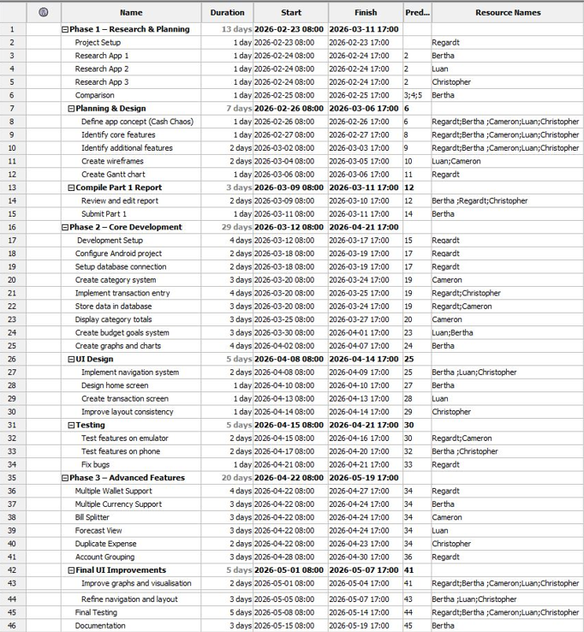
Figure 2: Project Plan.
Gantt chart
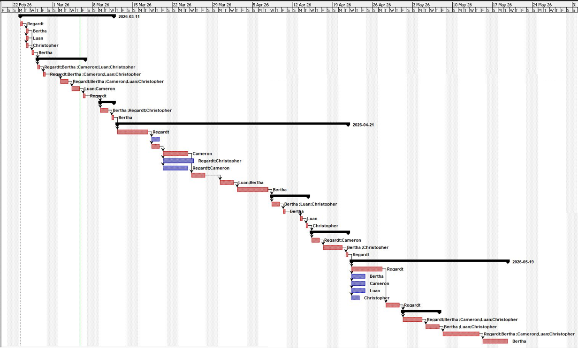

Conclusion
The Cash Chaos app is innovative as it incorporated unique features form the research phase namely bill splitter and multi currency wallet.

References
Wolvaardt, B., 2026. Cash Chaos Budget App Logo. [Personal Drawing] Pretoria: Unpublished.

Software Used:
Adobe Free Logo Maker
Project Libre (Project Plan and Gannt Chart
Visily (WireFrames)

