p

PROG 7313
POE PART 1 – PLANNING AND DESIGN DOCUMENT
17 March 2026

da Silva, Luan Gulamhussene (ST10444978)
Griffin, Cameron Lee (ST10443441)
Janse van Rensburg, Christopher John Leonard (ST10434337)
Malan, Regardt Estian (ST10434247)
Wolvaardt, Bertha (ST10397382)

1. Introduction
The following detailed design document outlines the vision and development plan for the Cash Chaos personal finance app. The document provides a detailed requirements list with additional innovative features as well as mockups for the user interface and three navigation diagrams. The mockups and navigation diagrams ensure that usability and intuitive interaction remain central in Cash Chaos’s design. The mockups take their inspiration from the findings of the research document, which emphasizes the importance of a clean and simple interface design. Additionally, the design integrates gamification elements such as Daily Streak and Your Challenges, this makes the app fun to engage with on a daily basis. The project plan embodies the blueprint for all the development phases to be completed within the timeframe; the building phase will commence next.

2. Overview of the App
Cash Chaos allows the user to create transaction categories and record transactions. Using this transaction data, spending and income can then be tracked over time to isolate trends. Donut charts help the user visualize spending distribution across different categories. The fact that transaction categories and spending limits per category are customizable gives the user the power to organize their spending according to their own priorities.
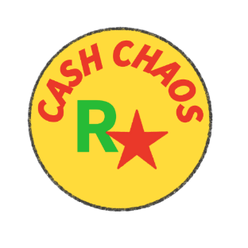
A core functionality of the app is the user authentication system. This ensures that he user’s data is stored and remains private and secure. Once authenticated the user must set a monthly budget goal, which corresponds to their overall spending limit. The system will warn the user when category spending limits are being approached or exceeded. The Wallets screen is used for viewing account balances. The Budget Goals screen is used for setting and monitoring monthly spending limits. The Expenses per Category Screen provides a breakdown of actual incurred expenses for each category.

Figure 1: Cash Chaos Logo.
The user interface has been designed around the idea of having a high energy aesthetic. Comic book inspired fonts and bright primary colors will be used to promote excitement and keep the user engaged.
Gamification features such as Daily Streak and Your Challenges motivate users to log their transactions and to become cognisant of their day-to-day financial situation. In addition, innovative features such as goal grouping, the bill-splitting tool and multi-currency support are included to assist users by providing various useful personal finance tools.
The Cash Chaos app integrates elements such has financial tracking, visual analytics and motivational design seamlessly without exposing the user to cognitive overload. The following, will elaborate in detail on the needed system requirements, mockups and project plan that will lay the foundation for the creation of the Cash Chaos app.

3. Detailed List of Requirements for the App
1. User Registration and Login
The app will allow users to register by using a unique email and password combination. On subsequent uses of the app, users will be required to enter the details they registered with. The users’ accounts must be uniquely connected with their data using this identity. The users’ data must be securely stored and encrypted inside an online database.

2. Transaction Categories
The app will allow the user to create transaction categories. The app will allow the user to Create, Edit or Delete transaction categories. The user will be able to allocate transactions to categories as they see fit.

3. Adding Transaction Entries
The app will allow the user to record transactions, by adding transaction entries. Transaction entries will contain the following details: Amount, Date, the Type (Income or Expense), Description, an Optional Image for receipts etc. and an optional To Whom entry for transactions between users. Transaction entries will be stored in an online database.

4. Optional Attachment of Photo or Image Upload
The app will allow the user to attach an image to the Transactions. The image can be sources from the device camera or document upload. Images/documents will be stored in an online database.

5. Monthly Budget Goals
The app must allow the user to set a monthly budget goal amount. The app must compare this monthly budget amount with a total of the actual transactions as allocated by the user. The app must give daily feedback to users on whether or not they are still within their target monthly budget. This will be done by backend calculations and notifications.

6. Category Budget Limits
The app must allow the user to set a spending limit for expense categories. The app must give feedback and warn the user should they closely approach or exceed their set spending limit for any given expense category. The user must be alerted with warning notifications.

7. View List of transactions
The app will give list of Transactions grouped by category and sorted by date within a user defined time period. The filtered information will be displayed for inspection and will be available to download as a report.

8. Summaries of Spending per Category
The app will show the Spending habits of the user based on category and expenditure per day, week or month. It will be displayed as a donut chart on the Dashboard screen.

9. Visualization and Graphs of Expenses
The app will use graphs to show the expenses of categories in order to allow them to be compared to one another with ease. The app will use graphs such as donut and time series graphs to the progress of Savings Goals at a glance.

10. Progress Dashboard
The app will show progress bars under all the savings goals to visually see how much has been saved towards a goal in a centralized screen.
11. Storage of user data in a Local Database
The app will in the early stages of deployment will make use of local database to store the data associated with the application. The data will later be migrated to an online database.

12. Gamification
The app will have elements under gamification such as “Daily Streaks” and “Achievements” for reaching goals. These will be viewable on the profile screen and users will receive a notification when they are about to lose their streak or have completed an achievement.

13. Online Database Storage (multiple devices)
The app will for in final stages of deployment the database will be moved to an online service like FireBaseDB which will allow users to access their accounts from any device with the app and allow for other features like Milestone sharing and tab Splitting.

14. Goal Grouping
The user will be able to group goals under a parent or overall goal e.g. User wants to goal on vacation and is budgeting fuel, accommodation, food, and activities all under the overall goal of “Vacation”, the user will then be able to easily see their budget for the vacation at a glance.

15. Split Bill
The user will be able to load other users into a bill and decide how it should be split; there will be an option to add a tip to the bill. The users If registered with the app will receive a notification and be able to add the transaction to their account.

16. Multi-Currency Support
The app will be able to support the use of multiple currencies that the user can select such as: Rand (R), Dollar ($), and Euro (£).

17. Forecasting
The app will be able to use past transactions to attempt to predict a forecasted income and expenditure chart for the next month based on averages and recurring transactions.

4. User Interface Design
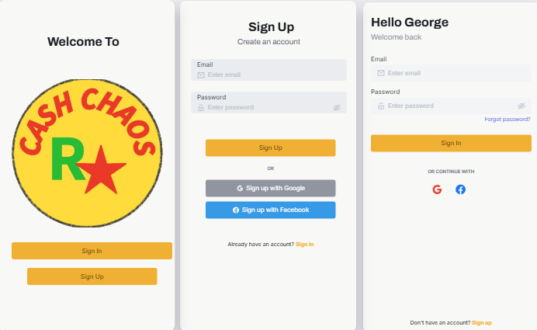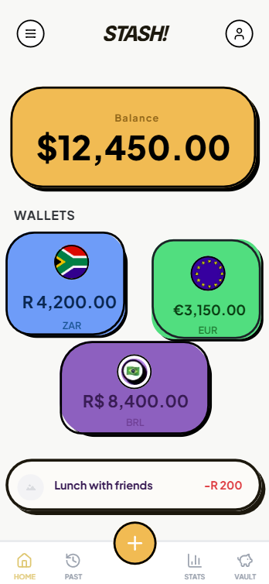

Figure 2: Login/Sign up process with Landing Page, sign up page and Wallet screen.
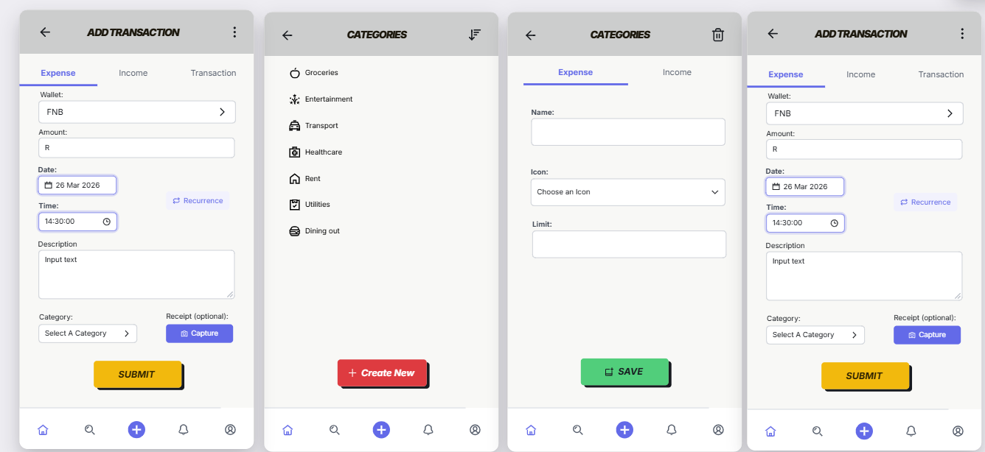
Figure 3: Process to record an Expense.

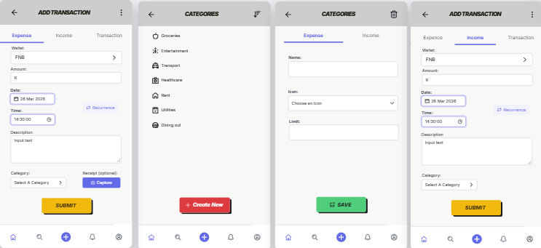
Figure 4: Process to record an Income.
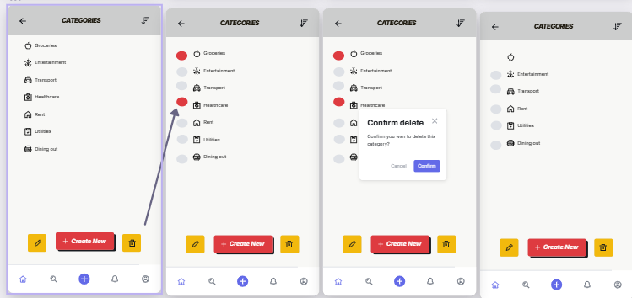
Figure 5: Process to delete a category.

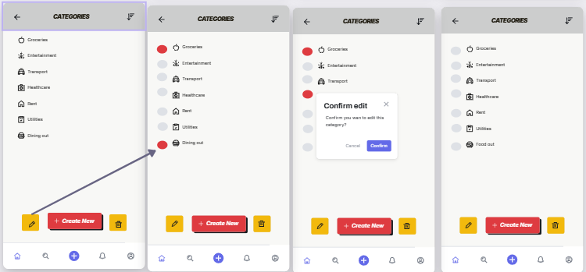

Figure 6: Edit Screen.
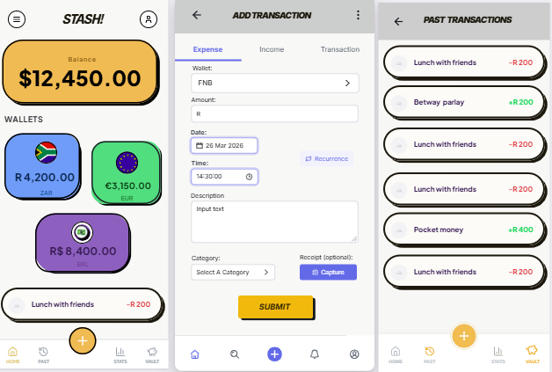
Figure 7: Logical Flow of Recording a Transaction through Add Transaction and Past Transactions Screen.

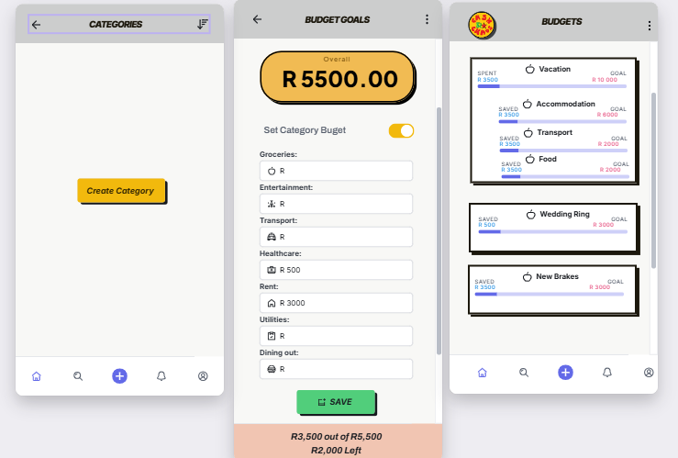
Figure 8: Create Category.

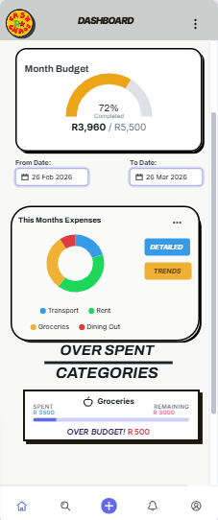

Figure 9: Dashboard and Donut Chart => Visualize expenditure across categories over customizable time period.
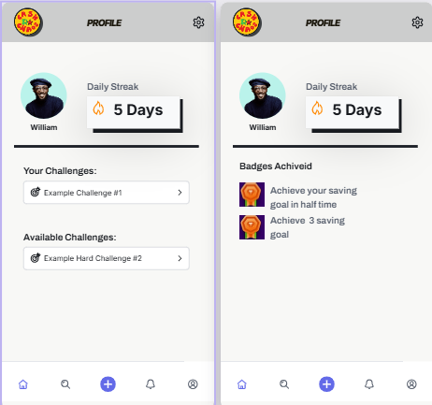
Figure 10: Gamification and Badges.
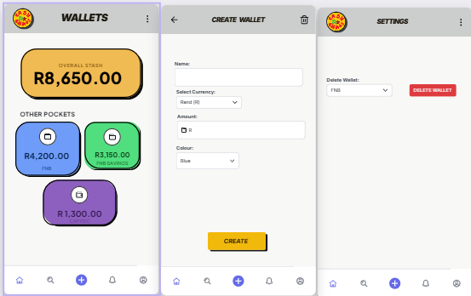
Figure 11: Multiple Wallets and Delete Wallet.
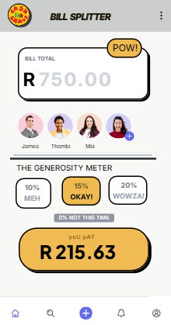
Figure 12: Bill Splitter View.

Navigation Diagrams:
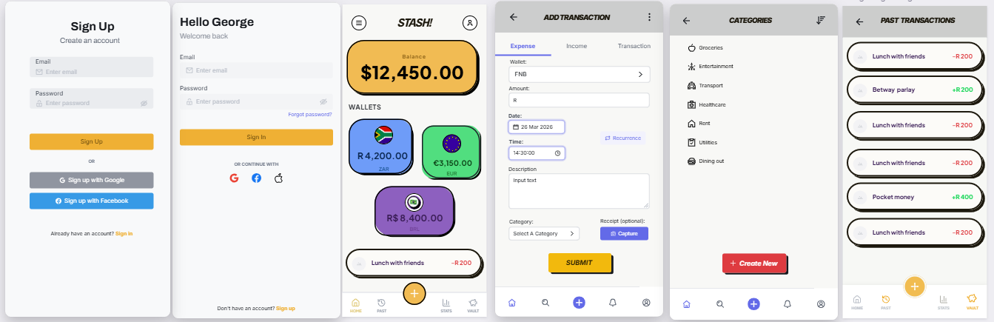
Figure 13: Navigation Sequence 1 => Sign In, Dashboard and Log Transactions.
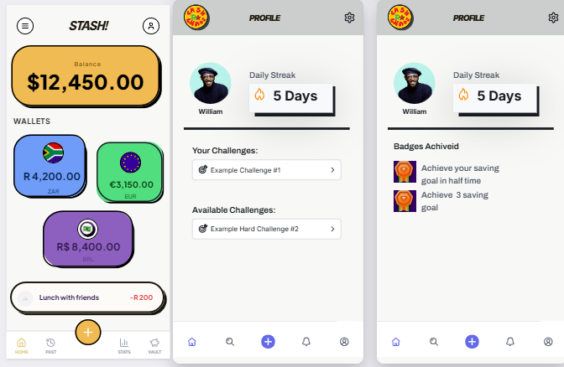
Figure 14: Navigation Sequence 2 => Wallet and Gamification Challenges.

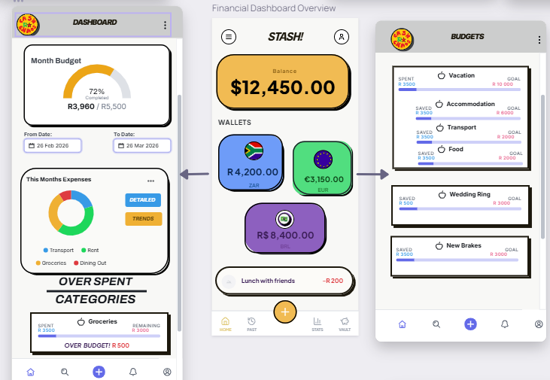
Figure 15: Navigation Sequence 3 => Dashboard and Analytics.
5. Project Plan
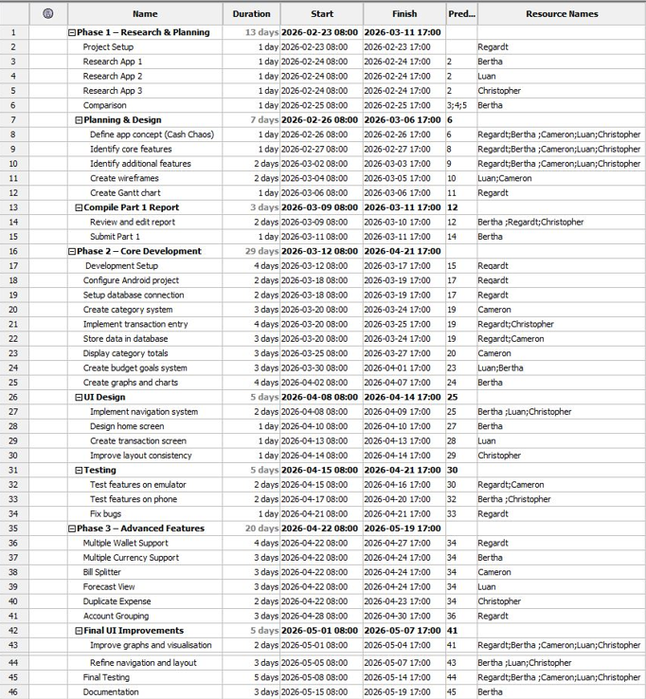
Figure 16: Project Plan.
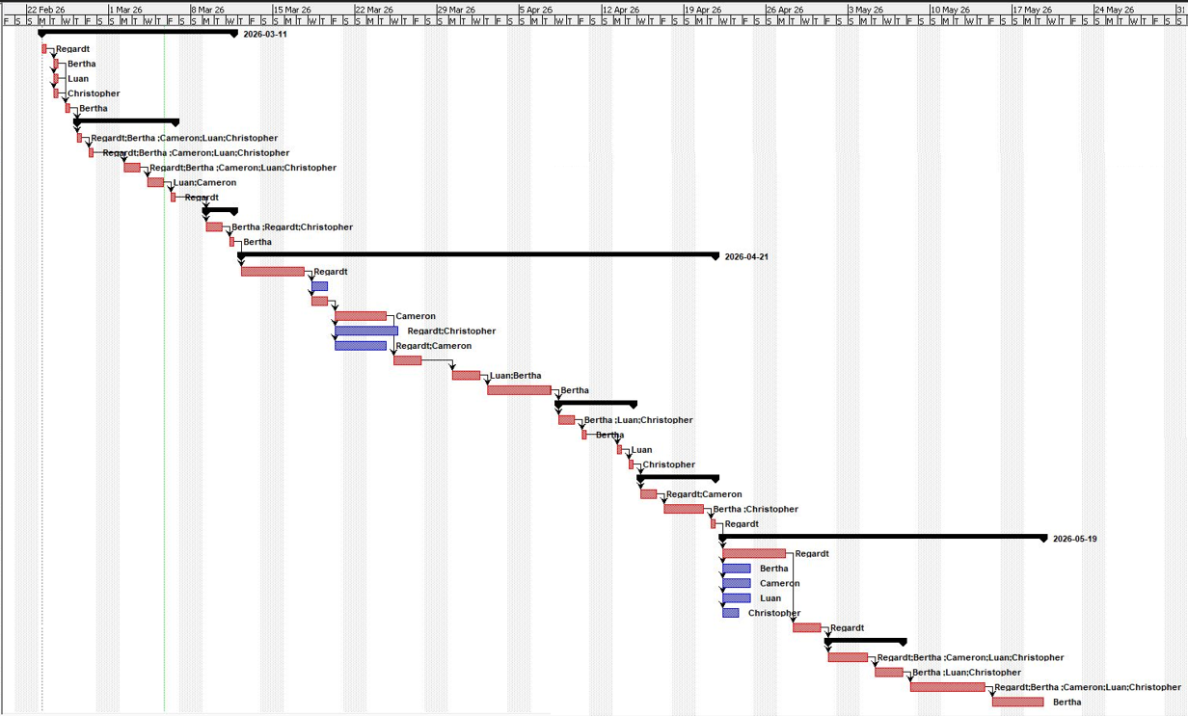
Figure 17: Gantt Chart.

6. Conclusion
In conclusion, the above design document provides a clear outline for the development of the Cash Chaos personal finance app. A realistic project plan and timeline for development is included. The detailed requirements list with additional innovative features, are illustrated with mockups that address these requirements and features. Three navigation diagram show the logical flow of the app. The inclusion of customizable data visualization tools, such as donut charts, illustrate how graphical visualizations assist users to better understand their spending habits. Following this project plan will ultimately create a personal finance app that guides users into curbing unnecessary spending, reaching savings goals and taking control of their personal finances.

References
Wolvaardt, B., 2026. Cash Chaos Logo. [Personal Drawing] Pretoria: Unpublished.

List of Figures:
Figure 1: Cash Chaos Logo.
Figure 2: Login/Sign up process with Landing Page, sign up page and Wallet screen.
Figure 3: Process to record an Expense.
Figure 4: Process to record an Income.
Figure 5: Process to delete a category.
Figure 6: Edit Screen.
Figure 7: Logical Flow of Recording a Transaction through Add Transaction and Past Transactions Screen.
Figure 8: Create Category.
Figure 9: Dashboard and Donut Chart => Visualize expenditure across categories over customizable time period.
Figure 10: Gamification and Badges.
Figure 11: Multiple Wallets and Delete Wallet.
Figure 12: Bill Splitter View.
Figure 13: Navigation Sequence 1 => Sign In, Dashboard and Log Transactions.
Figure 14: Navigation Sequence 2 => Wallet and Gamification Challenges.
Figure 15: Navigation Sequence 3 => Dashboard and Analytics.
Figure 16: Project Plan.
Figure 17: Gantt Chart.

Software Used:
Adobe Free Logo Maker. Available inline.
Project Libre (Project Plan and Gannt Chart). Available online.
Visily (WireFrames). Available online.

