p

PROG 7313
POE PART 1 – PLANNING AND DESIGN DOCUMENT

Group:
Bertha Wolvaardt (st10397382)
Cameron Lee Griffin (st10443441)
Christopher John Leonard Janse van Rensburg (st10434337)
Luan Gulamhussene da Silva (st10444978)
Regardt Estian Malan (st10434247)

Introduction
This document outlines how the research findings, system requirements and user interface design are integrated to create a functional, intuitive an easy-to-use personal finance app that is ready for the programming and build phase to commence. The wireframes and project plan also ensure that usability and intuitive interaction remain central in Cash Chaos’s design. The wireframes included in this document take their inspiration from the findings of the research document, which emphasizes the importance of a clean and simple interface that avoids unnecessary complexity while incorporating motivational features. Specifically, the design integrated gamification elements like “Daily Streak” and “Your Challenges”, this encourages the user to enjoy engaging with the app on a daily basis whilst improving their personal financial planning skills.
This document also outlines the system requirements and core functionalities that the Cash Chaos app must support, these include to name a few, the creation of expense categories and logging expenses. The research infographic comparing Cashew, You Need A Budget, and The Budgeting App has influenced the design by inspiring the wireframes to focus on simplicity, accessibility, and motivational design. Furthermore, the detailed requirements list, wireframes and project plan form a strong foundation and roadmap for programming and the build phase which is to follow next.
Finally, the inclusion of data visualization tools, such as the inclusion of donut chart that the amounts spent on each category in relation to one another, helps the user to better understand their spending habits and identify spending patterns, so that they can curb unnecessary spending, reach savings goals and take control of their personal finance.
Overview of the App
Cash Chaos allows the user to create expense categories and record expenses according to these, expense spending can then be tracked over time to isolate trends as well as visualized as donut charts to see spending distribution across different categories. The fact that expense categories and spending limits per category are customizable gives the user the power to organize their spending according to their own priorities.
A core functionality of the app is the user authentication system, once authenticated the user must set a monthly budget goal which corresponds to their overall spending limit, usually for a month but can be customized. The system will warn the user when category spending limits are being approached or exceeded. The Wallets screen is used for viewing account balances, the Budget Goals screen is used for setting and monitoring monthly spending limits, and the Expenses per Category Screen provides a breakdown of actual incurred expenses for each category.
The user interface has been designed around the idea of having a high energy effect. We have chosen comic book styling inspired fonts and bright primary colors to promote excitement and keep the user engaged.
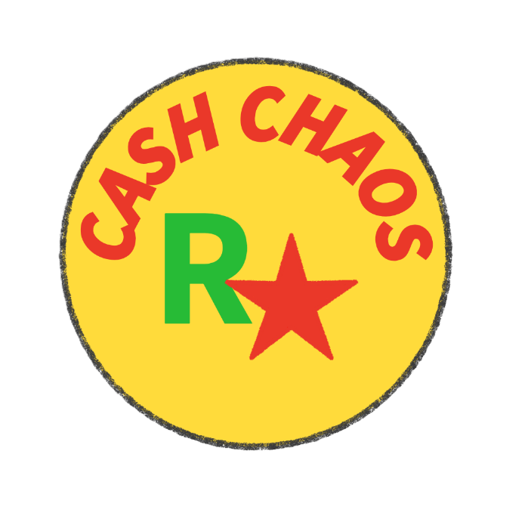

Figure 1: Cash Chaos Logo.
Gamification features such as Daily Streak and Your Challenges motivate users to log their expenses and to become cognizant of their day-to-day financial situation. In addition, innovative features such as a bill-splitting tool and included to assist users in managing shared expenses.
The Cash Chaos app integrates elements such has financial tracking, visual analytics and motivational design seamlessly without exposing the user to cognitive overload. This overview touches on subsequent sections in this document, which will elaborate in detail on the needed system requirements, wireframes and project plan that will lay the foundation for the programming, development and implementation phases of the Cash Chaos app.

Detailed List of Requirements for the App
1. User Registration and Login
The app will allow users to register by using a unique email and password combination. The user’s data is then securely stored using this combination.
2. Transaction Categories
The app will allow the user to create transaction categories. The app will allow the user to Create, Edit or Delete transaction categories. The user will be able to allocate transactions to categories as they see fit e.g. Transaction of R300 to buy food can be categorized under Groceries.
3. Adding Transaction Entries
The app will allow the user to record transactions, by adding transaction entries. Transaction entries will contain the following details: Amount, Date, the Type (Income or Expense), Description, an Optional Image for receipts etc. and an optional To Whom entry (for transactions between users? Or as a tracking item “How much have I sent/received form who?”)
4. Optional Attachment of Photo or Image Upload
The app will allow the user to attach an image to the Transaction to allow the user to store any documents like receipts etc. with the transactions.
5. Monthly Budget Goals
The app must allow the user to set a monthly budget goal amount. The app must compare this monthly budget amount with a total of the actual transactions as allocated by the user. The app must give daily feedback to users on whether the user is still within their target monthly budget goal amount.
6. Category Budget Limits
The app must allow the user to set spending limit goal amounts for expense categories. The app must give feedback and warn the user should they closely approach or exceed their set spending limit for any given expense category. An example expense category can be groceries or rent.
7. View List of transactions
The app will give list of Transactions grouped by category and sorted by date within a user defined time period.
8. Summaries of Spending per Category
The app will show the Spending habits of the user based on category and expenditure per day, week or month within a user defined time period.

9. Visualization and Graphs of Expenses
The app will use graphs to show the expenses of categories in order to allow them to be compared to one another with ease. The app will use graphs such as doughnut and time series graphs to the progress of Savings Goals at a glance.
10. Progress Dashboard
The app will show progress bars under all the savings goals to visually see how much has been saved towards a goal for every goal in a single centralized screen.
11. Storage of user data in a Local Database
The app will in the early stages of deployment will make use of local database to store the data associated with the application.
12. Gamification
The app will have elements under gamification such as award badges for the reaching of goals or possibly unlock of cosmetic options for different Goals. The app will also have a tutorial in the style of a Game.
13. Online Database Storage (multiple devices)
The app will for in final stages of deployment the database will be moved to an online service like FireBaseDB which will allow users to access their accounts from any device with the app and allow for other features like Milestone sharing and tab Splitting.
14. Goal Grouping
The user will be able to group goals under a parent or overall goal e.g. User wants to goal on vacation and is budgeting fuel, accommodation, food, and activities all under the overall goal of “Vacation”, the user will then be able to easily see their budget for the vacation at a glance.
15. Split Bill
The user will be able to load other users into a bill and decide how it should be split; there will be an option to add a tip to the bill. The users If registered with the app will receive a notification and be able to add the transaction to their account.
16. Multi-Currency Support
The app will be able to support the use of multiple currencies that the user can select such as the most common like; Rand (R), Dollar ($), and Euro (£)
17. Forecasting
The app will be able to use past transactions to attempt to predict a forecasted income and expenditure chart for the next month based on averages and recurring transactions.

User Interface Design (15 marks)
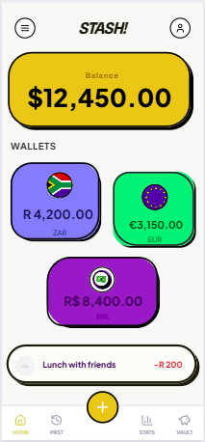

Landing page. Displays users wallets. View recent transactions. Prominent "+" to log new expenses to the system.
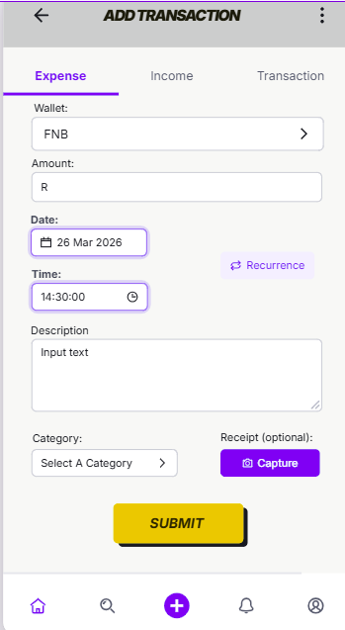
Add expense Screen- users can record expenses. Users select which wallet to deduct from, amount, date, time and category to keep track of expenses. Optionally, users can set the expense as recuring and a description.
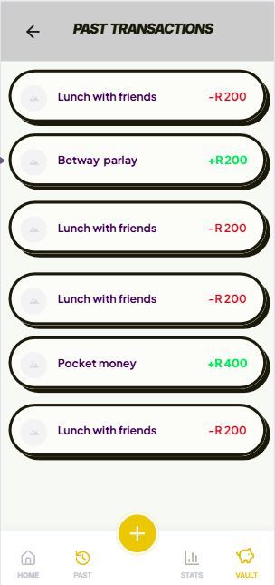

Past transactions screen – users can easily view income and expense records in chronological order
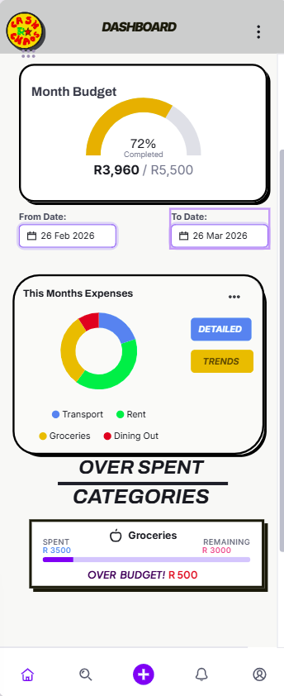
Statics page – user can easily view different reports to study their expenses patterns. Reports can cover custom time frames

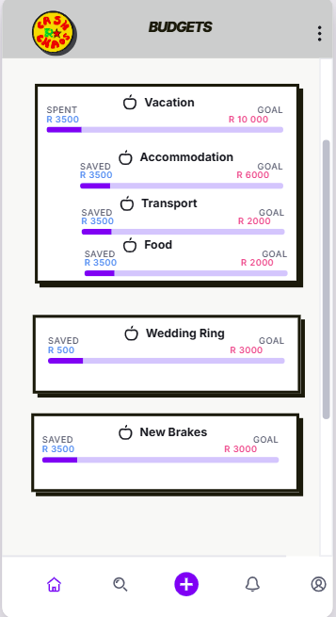
Budgets page - user can view budgets goals. Categories that they are saving towards. Budgets are grouped into categories to see the total.
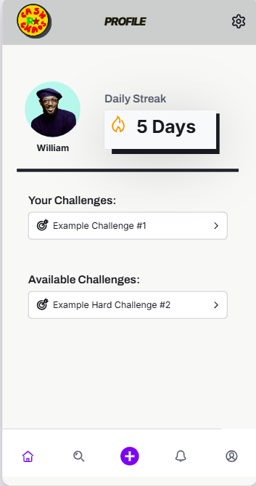
Game page- view streaks, number of consecutive days the user opened the app, and any challenges the user is working towards.
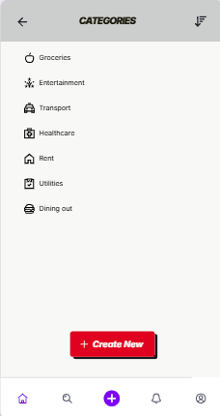
Create Category – create categories of expenses.
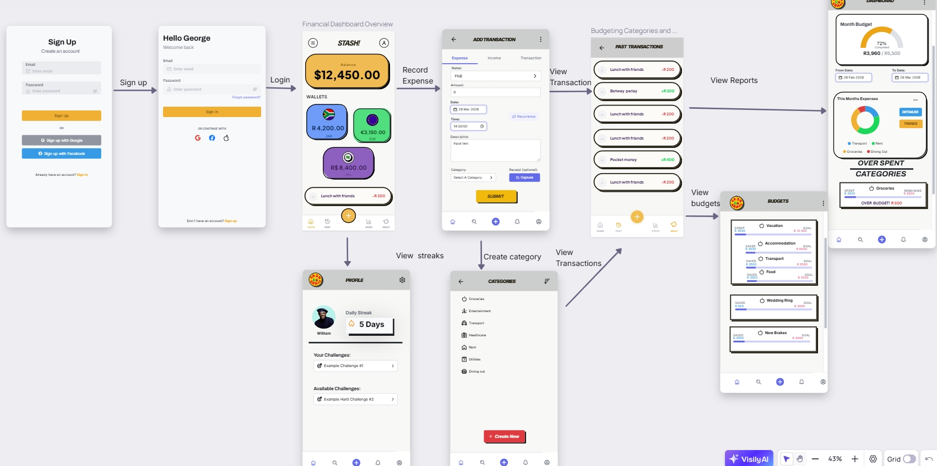User login/ sign up. From the landing page user can record income or expenses. User can also view streaks and badges. Once the user has logged expenses and income they can view their statistics and budgets to analyze trends over time

Project Plan (5 marks)
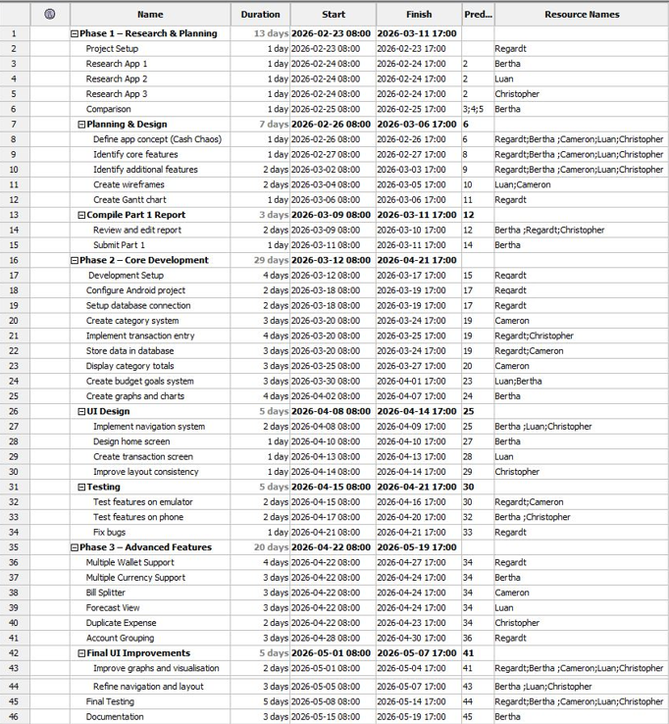
Figure 2: Project Plan.
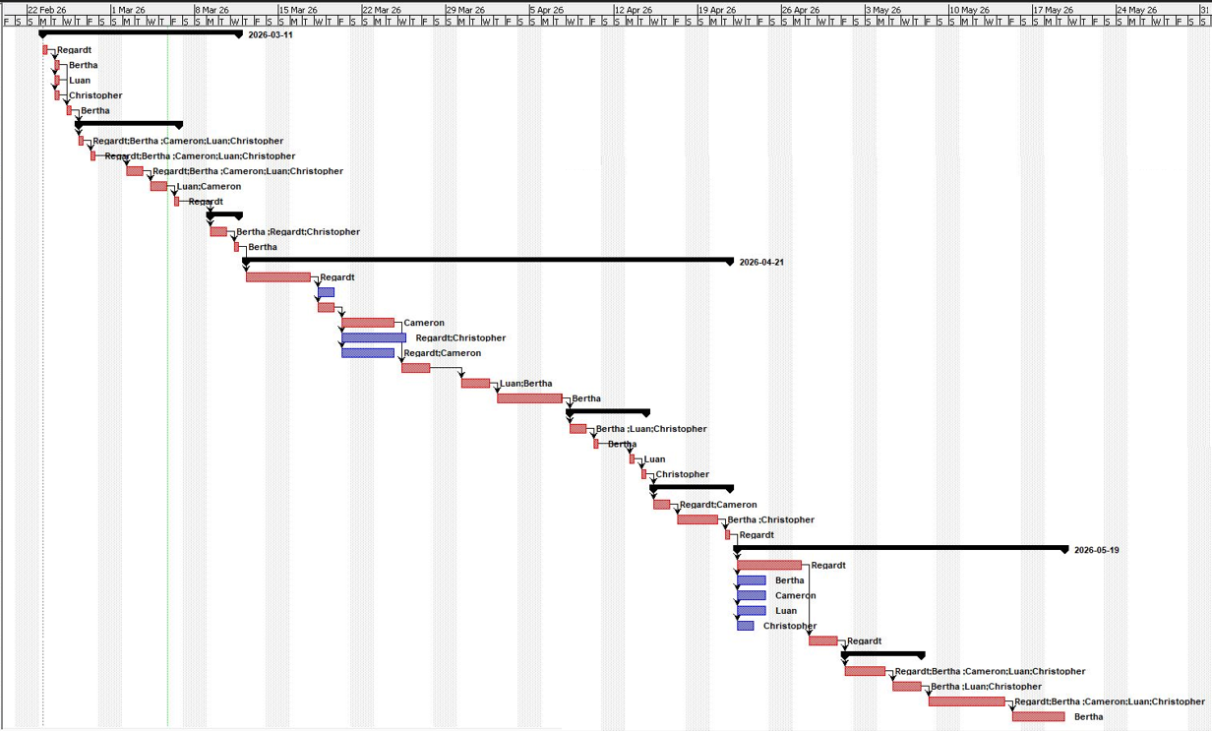
Figure 3: Gantt Chart.

Conclusion
In conclusion, this design documents links together the research findings, detailed system requirements, and the decisions about how the user interface will look into a coherent blueprint that will guide the development of the Cash Chaos app. In the next phase the clearly defined requirements and wireframes will be implemented, and the timeframes in which elements of this will be completed are detailed in the project plan. Furthermore features such as multi-currency support and bull splitting as well as gamification elements and data visualization all combine in the Cash Chaos app to motivate the user to gain financial awareness. This design document sets the foundation for successfully building the Cash Chaos app as it linked the research findings with a strong design outline.

References
Wolvaardt, B., 2026. Cash Chaos Budget App Logo. [Personal Drawing] Pretoria: Unpublished.

Software Used:
Adobe Free Logo Maker
Project Libre (Project Plan and Gannt Chart
Visily (WireFrames)

