prog 7313
POE PART 1



Group: Bertha Wolvaardt (st10397382) Regardt Estian Malan (st10434247) Cameron Lee Griffin (st10443441) Luan Gulamhussene da Silva (st10444978) Christopher John Leonard Janse van Rensburg (st10434337)

1. Introduction
The purpose of this research is to create a budgeting app that is relevant and competitive in the current personal finance space. Below we discuss the information collected by studying three personal finance management apps namely, Cashew Expense Budget Tracker, You Need A Budget and The Budgeting App. Each of the aforementioned personal budgeting app’s main objectives, strengths, weaknesses and unique features are identified and compared across the three apps.
This will ensure that our group’s personal expense tracking app namely, Cash Chaos will be of superior quality, as it will bring together the most exceptional elements and features from personal budgeting apps that are currently available in the Google Play Store.

2.1 Overview of the App: Cashew Expense Budget Tracker
Cashew allows the user to track income and expenses across multiple accounts that are displayed prominently at the top of the Home screen. Cashew understands that users want to monitor their saving and spending behavior, in order to learn what worked from past experience and better understand their what happens to their money, so that they can make improvements to their spending and saving habits (Teckwise, 2025). Cashew’s design and interface is much more sleek, attractive and modern than its competitors (Teckwise, 2025).
This app guides the user into setting up different “Budgets” which help you to set spending limits and savings goals, these can be tracked as percentages or amounts and can be customized to display on the Home screen, using graphs and pie charts as well different widgets (Teckwise, 2025). Start by navigating directly to Transactions and start adding ALL your expenses.
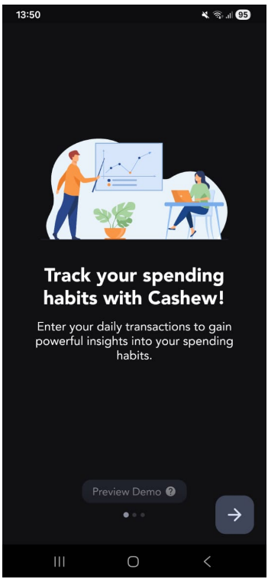
Cashew Screenshot 1: First Screen Upon Opening the App for the First Time.
The app starts with an optional tutorial of the main features of the app and how to use the app. It educates the user by making use of dummy data, so that the user will see how to use it intuitively once it is set up.
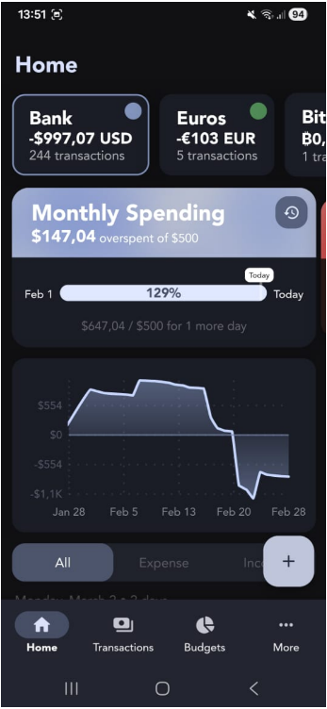
Cashew Screenshot 2: Navigation Bar (Bottom)
The bottom navigation bar has only four options, which is an optimal choice for two reasons. It limits the number of choices the user has, so that he/she has a smooth experience and not overwhelmed with too many choices. It also fall within thumb zones, which is on the bottom of the screen (where the user's thumbs are) making it easier to reach and allow them to navigate throughout the app effectively.

Cashew Screenshot 3: Home Screen.
The Home Screen covers various important features of the app including the different accounts at the top. Widgets for monthly spending, the user can see at a glance that he has already overspent according to the goals that he has predefined.
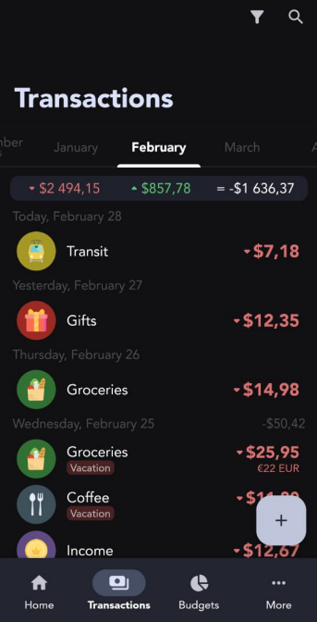
Cashew Screenshot 4: View All Transactions Screen.
With this View the user can track their expenses according to the different Categories that they set up previously.
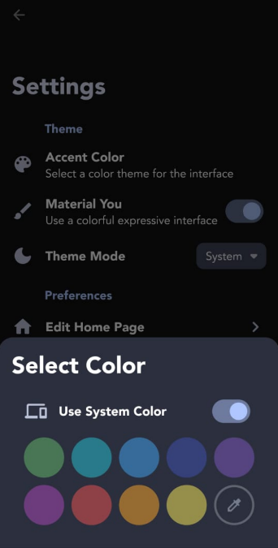
Cashew Screenshot 5: The Settings and Customization Options
It is a joy to use this app because it allows for personalization of the apps physical appearance making it more attractive to engage with for the user.
This app allows you to customize the Theme within Settings. The user can choose between System/ Light/ Dark mode and set the favourite accent colour by selecting a color theme for the interface.

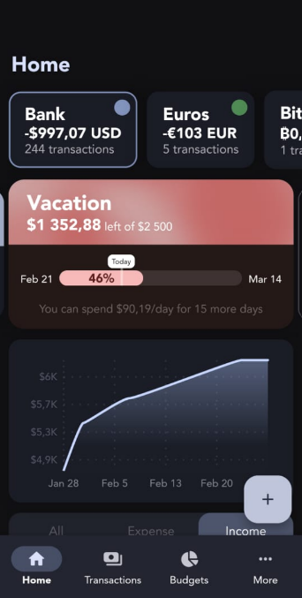
Cashew Screenshot 6: Income Tracker.
Being able to toggle between Income and Expense Views that are graphically displayed in this app is one of its best features. This makes it intuitively easy for the used to get a feeling for when and how they can save the difference, in order to reach their personal finance goals.
Cashew Strengths
- The strengths of this app are that it is extremely visually pleasing and easy to navigate.
- One can clearly see that much thought has been put into the design.
- Cashew is very feature rich. For example it boasts many features such as:
  - Calendar page,
  - All Spending Page,
- Preview Demo is helpful.

Cashew Weaknesses
- The app starts off by prompting the user to add a budget, the terminology here is unclear as “budget” could mean different things.(see Cashew Budgeting App Getting Started, 2025)
- The first reaction when someone opens the app is that they need a tutorial (see Cashew Budgeting App Getting Started, 2025)
- There are different accounts that need to be setup and you can also merge account (see Cashew Budgeting App Getting Started, 2025)
- (see Cashew Budgeting App Getting Started, 2025)
- One obvious drawback of this app is that it has many, many features that causes the user to feel anxious when first engaging with the app (see Cashew Budgeting App Getting Started, 2025).
- Transaction tracker (see Cashew Budgeting App Getting Started, 2025)
- (see Cashew Budgeting App Getting Started, 2025)
- Does not keep track of investing (see Cashew Budgeting App Getting Started, 2025)
- Don’t understand “Budget “ feature (see Cashew Budgeting App Getting Started, 2025)
- Adding subcategories very satisfying (see Cashew Budgeting App Getting Started, 2025)

Cashew Innovative Features
Innovative features of the app include :
- View a history of all spending periods with custom filters,
- Select certain accounts for budgets,
- Custom navigation bar shortcuts,
- Attach files to transactions Subcategories,
- Data Backup and Security features with Google Drive (Dapper App Developer, 2024),
- Emojis can be used as category icons (Dapper App Developer, 2024),
- Cashew boasts an abundance of visual aids such as pie charts and graph, this is especially helpful for people who find working with numbers challenging (Teckwise, 2025),
- Personalized expense setup called “budget” in Cashew, caters for different people with their unique spending habits (Teckwise, 2025),
- Bill Splitter (Teckwise, 2025).

2.2 Overview of the Android Personal Budgeting App: You Need A Budget
All available funds get budgeted towards an expense category based (Feasible Creative,2024).
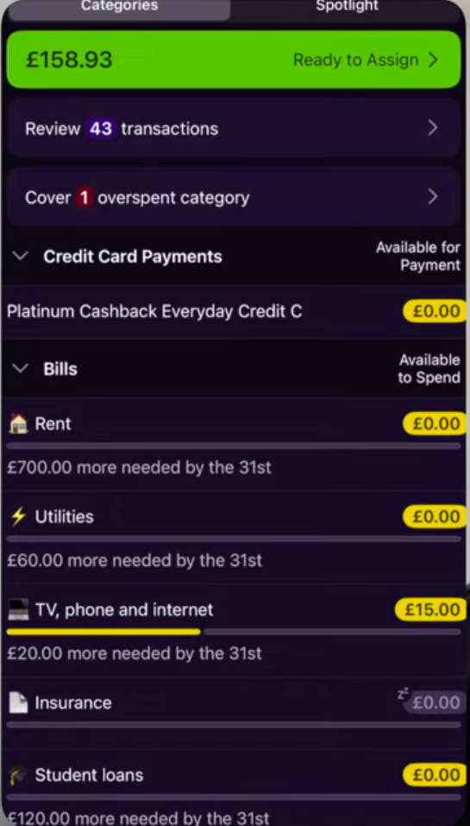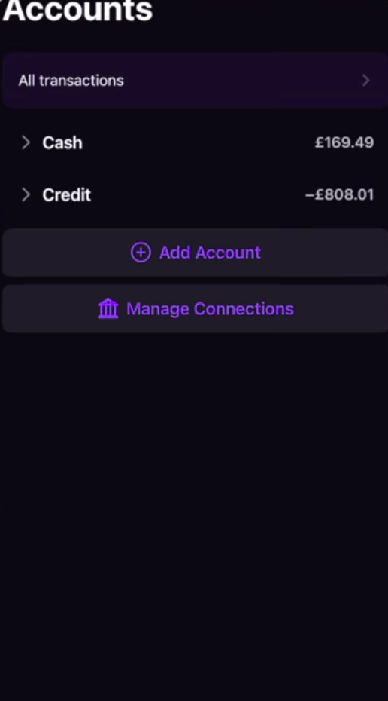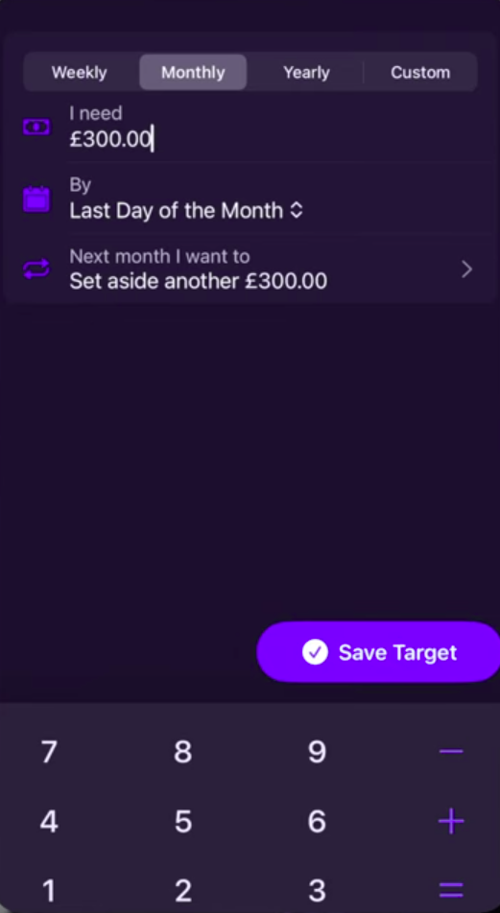
You Need A Budget: Screenshot 1: Expense Categories
User check their plan before spending to ensure they spend within set limit
All available funds get budgeted towards an expense category based (Feasible Creative,2024).

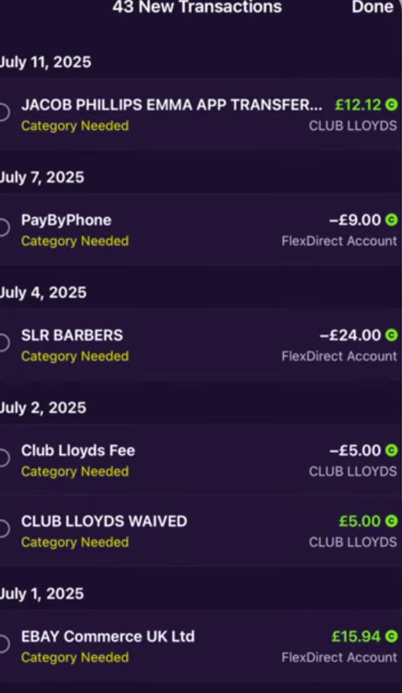
You Need A Budget: Screenshot 2: Accounts Screen Showing Transactions.
Connected accounts where income and expenses come from
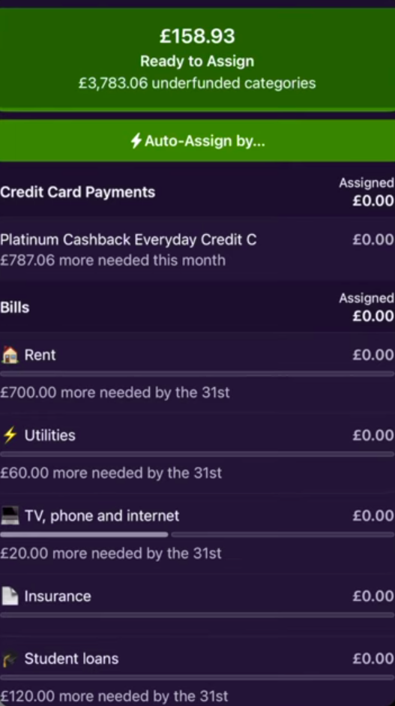
You Need A Budget: Screenshot 3: Setting a budget screen.
Setting amount and frequency of budget cycle

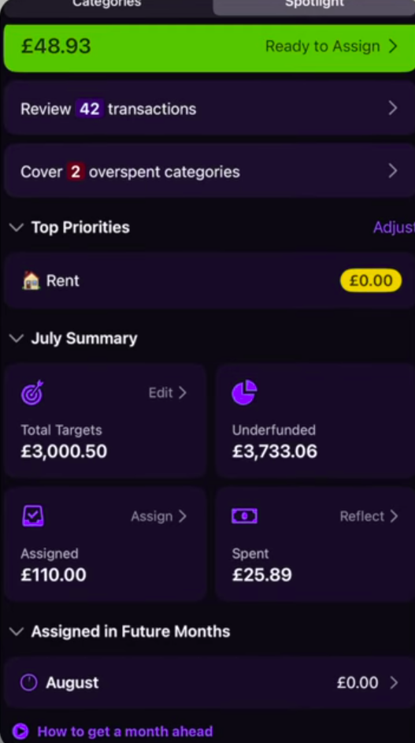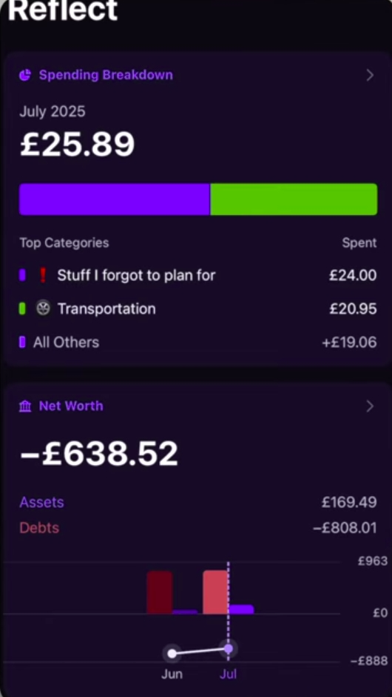
You Need A Budget: Screenshot 3: Setting a budget screen.

Accounts Screen. Connected accounts where income and expenses come from
Main screen. At a glance user see’s categories, budgets, progress and actions required
Setting a budget screen. Setting amount and frequency of budget cycle
Review transactions screen
Auto assign budget to expense categories
Spot light screen – reports and summaries of expenses
You Need A Budget: Strengths
- Multiple Device and bank sync – A single account can have multiple devices and can be connected to several bank accounts. Income and expenses are automatically uploaded to the app (Feasible Creative,2024).The user still needs to log to avoid double billings and encourages users to become aware of their finances (Feasible Creative,2024).
- Mobile and web support – users can access the platform on mobile and web browsers making uploading expenses very convenient. Reports on mobile are simple and easy to navigate (Feasible Creative,2024).
- Flexible budgeting – large expenses are broken down into monthly budgets. Money overspent in a one category can be removed from a different category for breakeven. User can budget for multiple items under the same category (Feasible Creative,2024)
- Ex. Bills category can have a budget for phone payment, rent and utilities (Feasible Creative,2024).
You Need A Budget Weaknesses
- No support of investment tracking – no real-time tracking of volatile assets such as crypto, stocks and other commodities real time. Therefore, user doesn’t get a holistic view of all the accounts
- Learning curve - App doesn’t guide users through how to use it. By using it like a tracker it becomes hard to actually use the app (Feasible Creative,2024).
- Load speed – the app pushes all transactions to memory to perform current calculations. Over time this would cause very slow load speeds, online reviews show this.
You Need A Budget Innovative Features
- Common Goal – multiple users can add funds to a shared account (Feasible Creative,2024).
- Forsee expenses – user sets budgets for large future payments (insurance, renews, payments) automatically the app creates a budget spread across a period of time to allow user to budgeted (Feasible Creative,2024)
- Public API – large pools of user made wrappers and integrations into already apps. Allows YNAB to integrate into other tools and user can create
- Money age – income is timestamped. The longer the app stays in the account the more “ages”. This gamification tool encourages good financial discipline by prompting users to save and not take in new expenses (Feasible Creative,2024)

2.3 Overview of the Android Personal Budgeting App: The Budgeting App
The Budgeting App: Screenshot 1:
The Budgeting App: Screenshot 2:
The Budgeting App: Screenshot 3:
The Budgeting App: Screenshot 4:
The Budgeting App: Screenshot 5:
The Budgeting App: Screenshot 6:
The Budgeting App: Strengths
The Budgeting App: Weaknesses
The Budgeting App: Innovative Features

3. Infographic comparison of the three apps (Bertha)
 | Rating | Description
Ease of Use
1. The Budgeting App
2. Cashew |  | Interface is beautiful, sleek and modern.  But too many options and customizable features are for the advanced user
3. The Budgeting App |  | Interface is a pleasure to use, as less features means less confusion and frustration, user is more likely to enjoy using the app.
Visualizations
1. The Budgeting App
2. Cashew |  | Graph & Pie Chart
3. The Budgeting App
Basic Features and Navigation
1. The Budgeting App
2. Cashew
3. The Budgeting App |  | Top right menu is easy to find and intuitive to use.  Bottom Menu has four options.  Bottom has plus sign to add transactions.
Unique Features
1. The Budgeting App
2. Cashew |  | Split Bill, Reminders to pay subscriptions like Gym Membership
3. The Budgeting App |  | Start an emergency fund  Excellent Gamification, budget ninja, streak and challenges

4. Best Features List to Include in Cash Chaos App
Features from the app You Need A Budget app to include in our own
- Money ageing – time stamping budgets to allow users to see how long they saved their money
- Creating multiple budgets under the same category/ sub categories.
- Automatic breaking down of financial saving target to track user progress over a period of time
The current financial budget space have several options for a variety of budgeting styles. After analyzing the pitfalls and strengths of the apps mentioned above development can start. The best features such as breaking down of expenses, The Budgeting App’s XXXX, Cashew Expense Budget Tracker XXX will be a starting block for development.
A major goal is to fulfill all functional requirements while avoiding the same weaknesses found in the apps researched to create a comprehensive budgeting app.

5. Conclusion
Personal Budgeting encompasses the concepts of setting spending limits and adhering to savings goals. Our research has shown that what makes a good budgeting app a great app, is the app’s ability to aid the user with easy to understand at a glance visualizations and a convenient way to keep track of ongoing daily expenses to stay on top of your financial goals. Both visualization and the ability to track metrics (expenses, account balances) over time is what sets personal budgeting apart from dated personal budgeting experience where most user used a simple spreadsheet. Working on this app is exciting because it brings value to ordinary people’s daily lives, also those people who don’t have experience in accounting or who feel that they aren’t “good with numbers”.

6. References

1. Dapper App Developer, 2024. Track Day Challenge, Top Gear: The Stig revealed. [video online] Available at: <> [Accessed 28 February 2026]
Skyscape, 2010. Skyscape medical resources. Version 1.9.11. [App]. Available from Google Play [Accessed 22 July 2021].
Department for Environment, Food and Rural Affairs, 2007. Sustainable development: the bigger picture. [video online] Available at: [Accessed 23 June 2012].

1. Cashew-Expense Budget Tracker. 2024. Dapper App Developer. Version 5.4.4. [App]. Available from Google Play [Accessed 28 February 2026].
2. Cashew Budgeting App Getting Started. 2025. YouTube video, added by Rebecca Sowden. [video online] Available at: https://youtu.be/UJ4mDc_WJ24?si=-RkZgGRrgVUFdSBn [Accessed 28 February 2026].
3. Feasible Creative,2024.YNAB Budget App: What I Wish I Knew Before Starting.[video online] Available at: https://www.youtube.com/watch?v=mqB_Vu2_le0 [Accessed 24 February 2026].
4. Jacob Phillips,2025.YNAB Tutorial & Honest Review (2025) | Complete Setup Guide & Pro Budgeting Strategies.[video online] Available at: https://www.youtube.com/watch?v=6smi9S8Rm7s&list=TLPQMjQwMjIwMjaQEQBlrtAcdA&index=3 [Accessed 24 February 2026].
5. App Review: Cashew, Finally a budget app for you. 2025. YouTube video, added by Teckwise [video online] Available at: https://youtu.be/BG8Z2DTAoLg?si=yNKX5eGLhAHHka3S [Accessed 28 February 2026].

