p

PROG 7313
POE PART 1 – PLANNING AND DESIGN DOCUMENT

Group:
Bertha Wolvaardt (st10397382)
Cameron Lee Griffin (st10443441)
Christopher John Leonard Janse van Rensburg (st10434337)
Luan Gulamhussene da Silva (st10444978)
Regardt Estian Malan (st10434247)

Introduction
This document outlines how the research findings, system requirements and user interface design are integrated to create a functional, intuitive an easy-to-use personal finance app that is ready for the programming and build phase to commence. The wireframes included in this document take their inspiration from the findings of the research document. These findings stipulated that it is important to build a clean, crisp interface that is not overly complicated with too many features but boasts motivational gamification features as well as a modest amount of clearly understand graphic and visualization aids to assist users gain insight into their spending habits and learn where they can make gains in terms of boosting their savings and minimizing their expenses.
Gamification is incorporated to help with the user capture their expenses on a daily basis and they are rewarded through the “Daily Streak” and “Your Challenges”
This document stipulates all the requirements and special features that will serve as the foundation for programming and build phase to commence.
This document outlines the project plan and wireframe design for the Cash Chaos app. It serves as the roadmap and foundation in order to start with the programming and build phase. The requirements list stipulates the functionalities that the app must be able to perform, for example the user must be able to add an expense category. Our research has shown that the latest personal finance tracking apps prioritize a user-friendly design with motivational features. The app wireframes included in this document exemplify the principles of usability, intuitive interface design,
Data visualization has been tackled in the following way. Positive and beneficial personal finance behaviors are strengthened and reinforced through gamification features such as “Daily Streak” and “Your Challenges” as can be seen in the “Profile” screen.
This document outlines how the design to link back to the original budgeting app research. The research will inform the design in the following ways xxx.
This document shows how the design will ensure that the app is functional, intuitive and ready to start with the programming or build phase.
The research infographic comparing Cashew, You Need A Budget, and The Budgeting App has influenced the design by creating wireframes that epitomize simple, intuitive and accessible for users who find financial management stressful. Furthermore the design includes data visualization features such as spending graphs and category summaries, this makes it easy for the user that finds personal finance complicated, to gain insight into their spending behavior recognize long term spending trends.

Customisation features allow users to create their own unique expense categories as well as set personlised budget limits.

Links requirements and user interface design.-

Overview of the App

The name of this app is Cash Chaos.
Cash Chaos allow the user to register and login securely, create spending categories and record expenses. Cash Chaos also allows the user to create a goal monthly spending amount which is the users budget when this budget is overspent the user is notified, also in the design you will see there is a Budget Goals Screen and a Expenses per Category screen.
User can see account balances at a glance under the “Wallets” screen.
“Budget Goals” screen. “Expenses Per Category” screen
“Dashboard” donut showing breakdown of this month’s expenses, clearly state “Over Budget!” and provide the categories on which the overspend took place for example spent R 3500 on groceries not R3000.00 as budgeted.
“Budgets” screen: All budgets

The user interface has been designed around the idea of having a high energy effect. We have chosen comic book styling inspired fonts and bright primary colors to promote excitement and keep the user engaged. A brief overview of the app and a description of the innovative features that are included. We will include a bill splitter feature.
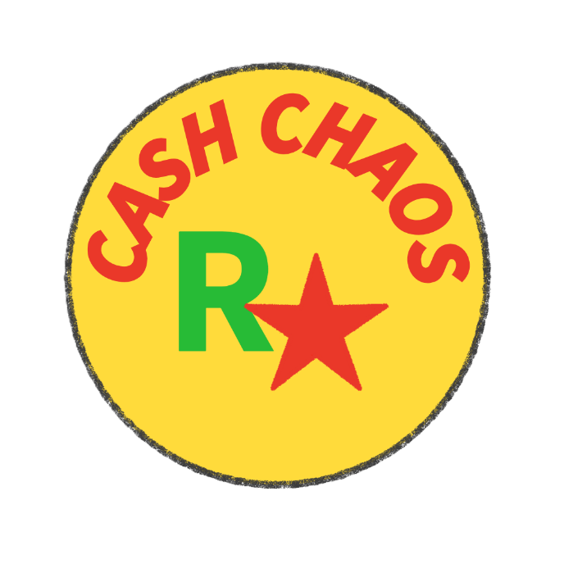

Figure 1: Cash Chaos Logo.
The rationale is that the user has the following personal budgeting priorities:
Check my account balance.
- Check on my expenses for the month (can be set for week, or longer timeframe). => Graph and Donut section
The Home screen displays account balances at the top for example: FNB (cheque R15 000.00), Cash R 454.00)
The Home screen prominently displays a donut chart (pie chart) showing the expenses

Detailed List of Requirements for the App
1. User Registration and Login
The app will allow users to register by creating a unique username and password combination. The user’s data is securely stored.
2. Expense Categories
The app will allow the user to create expense categories. The app will allow the user to edit or delete expense categories.
3. Adding Expense Entries
The app will allow the user to record expenses, by adding expense entries. Expense entries will contain the following details, amount spent, ????currency
4. Optional Attachment of Photo or Image Upload
The app will
5. Monthly Budget Goals
The app must allow the user to set a monthly budget goal amount. The app must compare this monthly budget amount with a tally of the actual expenses as inputted and captured by the user. The app must give daily feedback to user on whether the user is still within their target monthly budget goal amount.
6. Category Budget Limits
The app must allow the user to set spending limit goal amounts for expense categories. The app must give feedback and warn the user should they closely approach or exceed their set spending limit for any given expense category. An example expense category can be groceries or rent.
7. View List of Expenses
The app will
8. Summaries of Spending per Category
The app will
9. Visualization and Graphs of Expenses
The app will
10. Progress Dashboard
The app will
11. Storage of user data in a Local Database
12. Gamification
13. Online Database Storage (multiple devices)
14. Own feature
15. Own feature

User Interface Design (15 marks)
mockup for each screen
description of the purpose of the screen
diagram showing how users navigate between various screens

Navigation Diagram

Project Plan (5 marks)
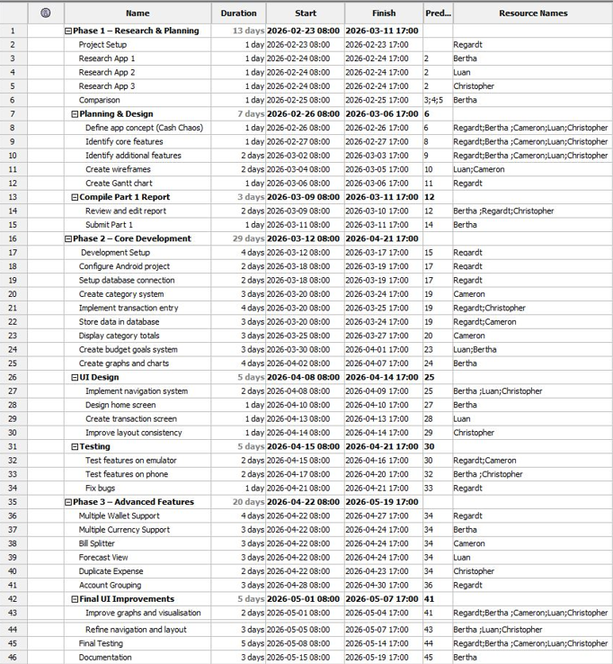
Figure 2: Project Plan.
Gantt chart
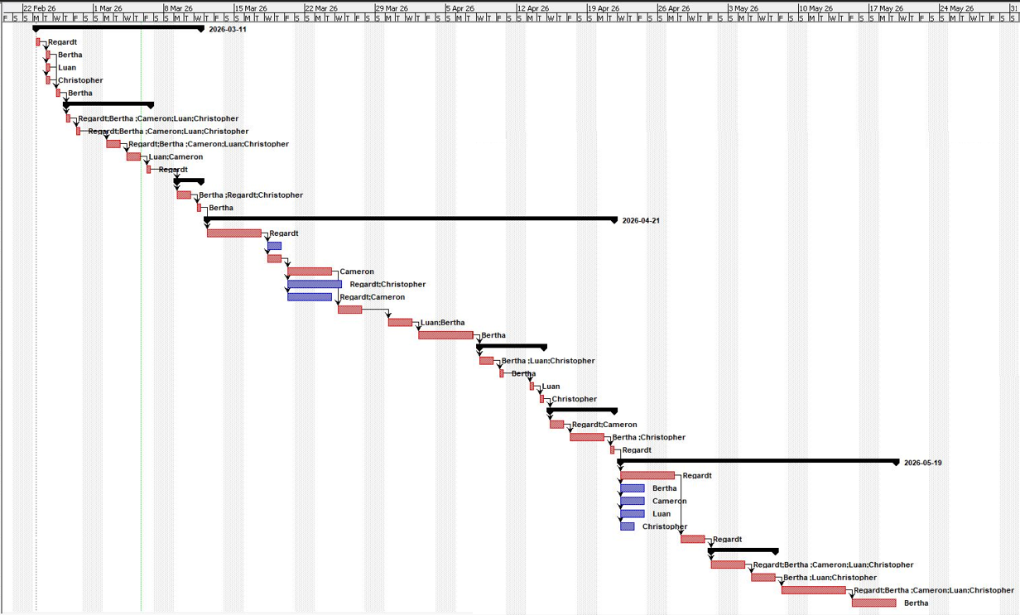

Conclusion
The Cash Chaos app is innovative as it incorporated unique features form the research phase namely bill splitter and multi currency wallet.

References
Wolvaardt, B., 2026. Cash Chaos Budget App Logo. [Personal Drawing] Pretoria: Unpublished.

Software Used:
Adobe Free Logo Maker
Project Libre (Project Plan and Gannt Chart
Visily (WireFrames)

