PROG 7313
POE PART 1 – RESEARCH DOCUMENT

da Silva, Luan Gulamhussene (st10444978)
Griffen, Cameron Lee (st10443441)
Janse van Rensburg, Christopher John Leonard (st10434337)
Malan, Regardt Estian (st10434247)
Wolvaardt, Bertha (st10397382)

1. Introduction
The research findings from studying three personal budgeting apps namely, Cashew Expense Budget Tracker, You Need a Budget and The Budgeting App are summarized in this document. This research document outlines the strengths, weaknesses and innovative features from the three above mentioned personal finance apps to determine their standard- and innovative features. An informative infographic contained within reiterates the most prominent research findings at a glance. The best features list bring together the most desirable features found from our research. The findings of this research document will inform the design mockups and requirements list that is to follow in the next development phase for our app, namely, Cash Chaos.

2.1 Overview of the App: Cashew Expense Budget Tracker
Cashew is a personal budgeting app. Cashew helps users set spending limits, saving goals, budgets and track expenses (Teckwise, 2025). Cashew is focused more heavily on a visually appealing interface than its competitors (Teckwise, 2025). Cashew also helps users visualize their money with sleek, attractive and modern graphs that are customizable and display on the home screen (Teckwise, 2025).
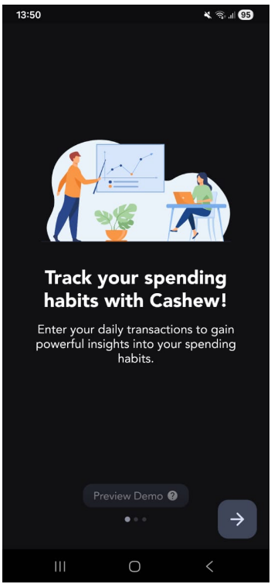
Figure 1: Helpful Demo Upon Opening the App for the First Time (Cashew).
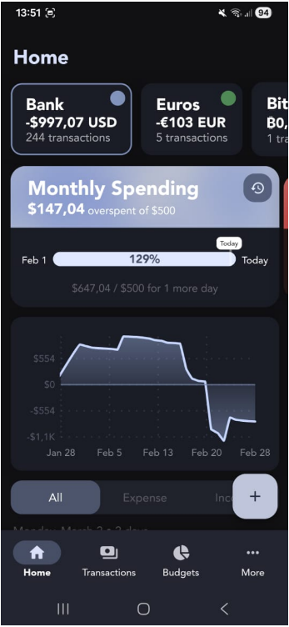
Figure 2: Home Screen with Bottom Navigation Bar (Cashew).

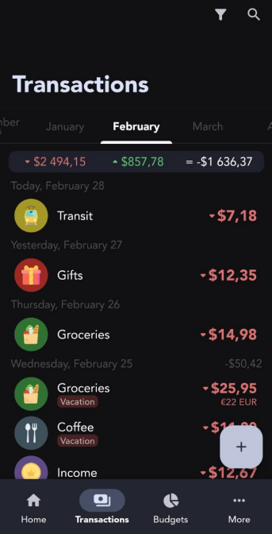
Figure 3: View All Transactions Screen (Cashew).

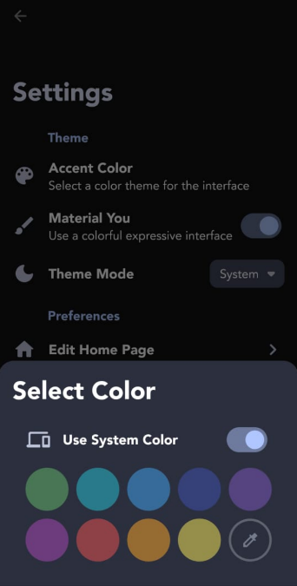
Figure 4: The Settings and Customization Options (Cashew).

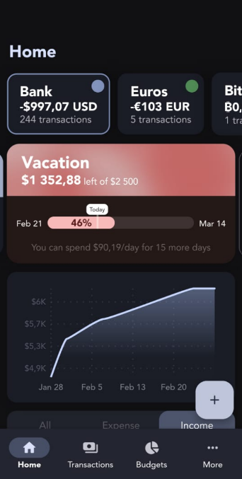
Figure 5: Income Tracker (Cashew).
Cashew Strengths
- Feature and customization rich. The app offers various personalization and customization settings, such as colour and theme selection (Dapper App Developer, 2024).
- Powerful visual aids and graphics. Being able to toggle between Income and Expense Views that are graphically displayed in this app is one of its best features (Dapper App Developer, 2024).
- Has a strong focus on interface and ergonomics. Home Screen covers various important features of the app including the different accounts at the top (Teckwise, 2025). The bottom navigation bar has only four options, making it easier to reach and allow them to navigate throughout the app effectively (Teckwise, 2025).
- Has a helpful demo when launched. The app starts with an optional tutorial of the main features of the app and how to use the app. It educates the user by making use of dummy data, so that the user will see how to use it intuitively once it is set up (Teckwise, 2025).

Cashew Weaknesses
- Terminology used is sometimes unclear. The app starts off by prompting the user to add a budget, the terminology here is unclear as “budget” could mean different things (see Cashew Budgeting App Getting Started, 2025).
- Abundance of options can be overwhelming for new users. One obvious drawback of this app is that it has too many features this causes the user to feel anxious when first engaging with the app (see Cashew Budgeting App Getting Started, 2025).
- Requires a lot of setup. The first reaction when someone opens the app is that they need a tutorial (see Cashew Budgeting App Getting Started, 2025). There are different accounts that need to be setup, and you can also merge accounts (see Cashew Budgeting App Getting Started, 2025).
- Only tracks personal finances, not investments. (see Cashew Budgeting App Getting Started, 2025).

Cashew Innovative Features
- View a history of all spending periods with custom filters (Teckwise, 2025).
- Data Backup and Security features with Google Drive (Dapper App Developer, 2024).
- Abundance of visual aids, pie charts, and graph (Teckwise, 2025).
- Bill Splitter (Teckwise, 2025).
2.2 Overview of You Need a Budget
You Need a Budget is a zero-based personal budgeting app (Philips, 2025). It prompts the user to disclose their entire income and allocate it to expense categories before it is spent (Feasible Creative,2024). It helps keep the user more accountable and promotes awareness of expenses by making the user explicitly allocate income (Feasible Creative,2024).

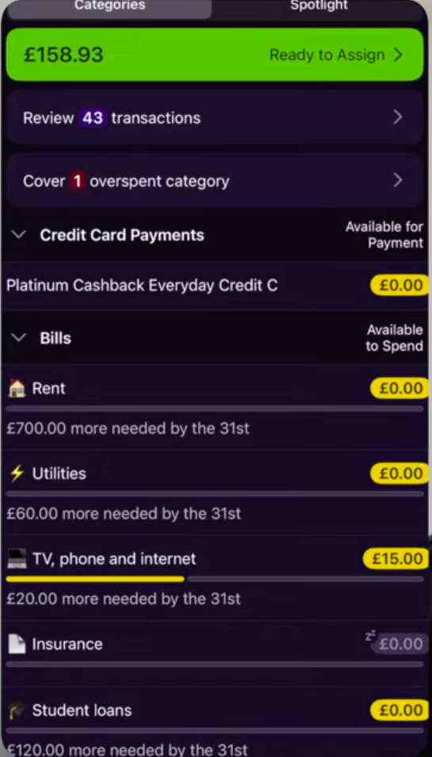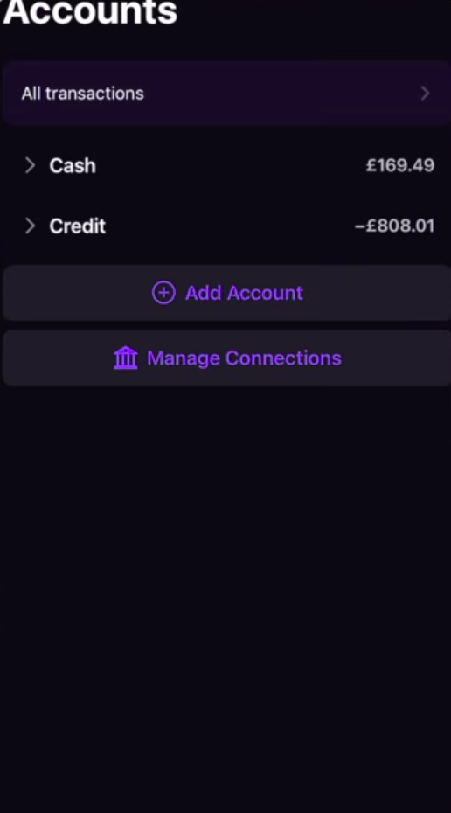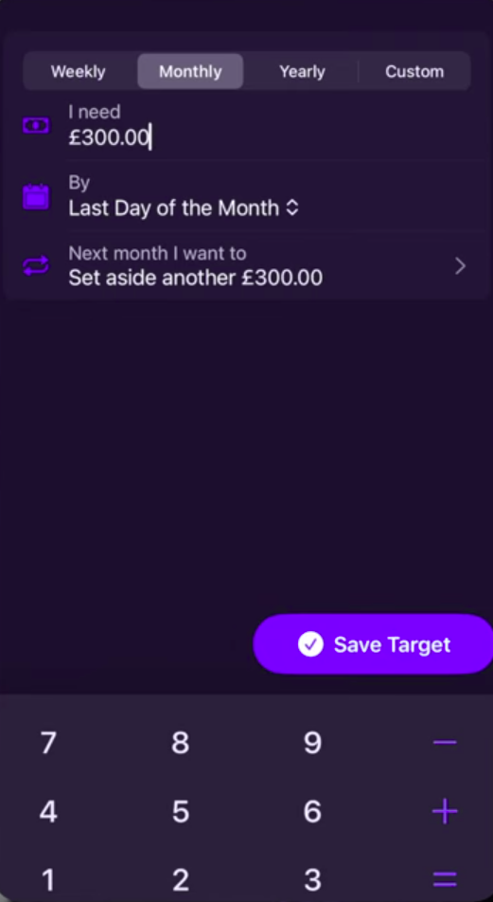
Figure 6: Expense Categories (YNAB).

Users check their plan before spending to ensure they spend within set limit (Philips, 2025).
All available funds get budgeted towards an expense category based (Feasible Creative,2024).

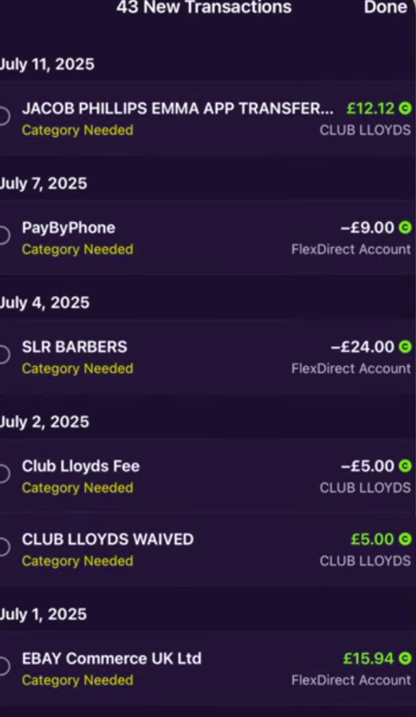
Figure 7: Accounts Screen Showing Transactions (YNAB).
Connected accounts where income and expenses come from.
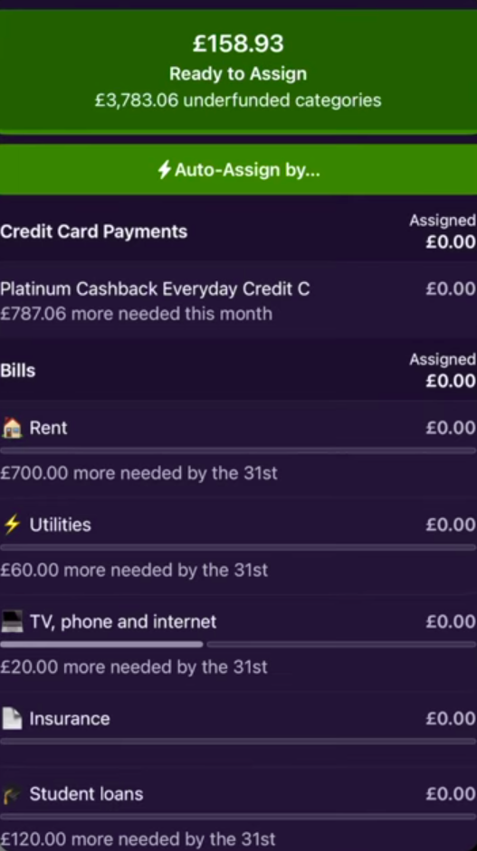
Figure 8: Setting a budget screen (YNAB).
Setting amount and frequency of budget cycle.

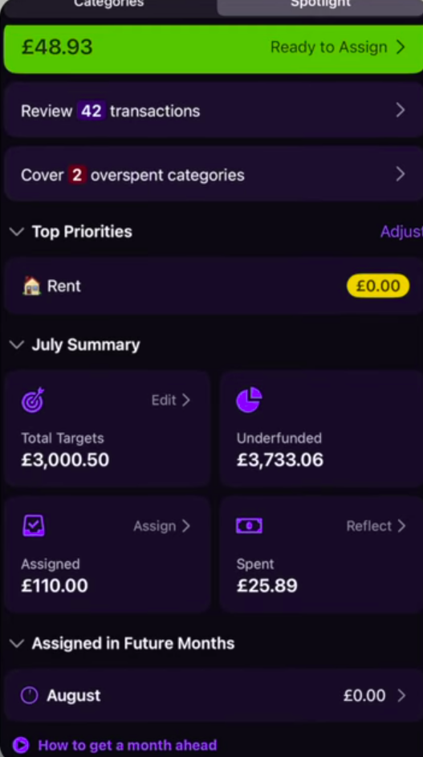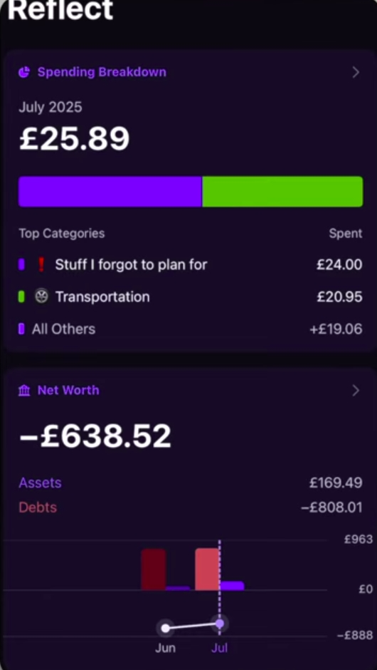
Figure 9: Spotlight screen – reports and summaries of expenses (YNAB).

You Need a Budget: Strengths
- Multiple Device and bank sync. A single account can have multiple devices and can be connected to several bank accounts. Income and expenses are automatically uploaded to the app (YNAB, 2026). The user still needs to log to avoid double billings and encourages users to become aware of their finances (Feasible Creative, 2024).
- Mobile and web support. Users can access the platform on mobile and web browsers making uploading expenses very convenient. Reports on mobile are simple and easy to navigate (Feasible Creative, 2024).
- Flexible budgeting. Large expenses are broken down into monthly budgets. Money overspent in a one category can be removed from a different category for breakeven. User can budget for multiple items under the same category (Feasible Creative, 2024).
Ex. Bills category can have a budget for phone payment, rent and utilities (Feasible Creative, 2024).

You Need a Budget Weaknesses
- No support of investment tracking. No real-time tracking of volatile assets such as crypto, stocks and other commodities real time. Therefore, user doesn’t get a holistic view of all the accounts (YNAB,2026)
- Learning curve. App doesn’t guide users through how to use it. By using it like a tracker it becomes hard to actually use the app (Feasible Creative,2024).
- Load speed. The app pushes all transactions to memory to perform current calculations. Over time this would cause very slow load speeds, online reviews show this (Philips, 2025).

You Need a Budget Innovative Features
- Common Goal. Multiple users can add funds to a shared account (Feasible Creative,2024).
- Forsee expenses. User sets budgets for large future payments (insurance, renews, payments) automatically the app creates a budget spread across a period of time to allow user to budgeted (Philips, 2025)
- Public API. Large pools of user made wrappers and integrations into already apps. Allows YNAB to integrate into other tools and user can create (Philips, 2025)
- Money age. Income is timestamped. The longer the app stays in the account the more “ages”. This gamification tool encourages good financial discipline by prompting users to save and not take in new expenses (Feasible Creative,2024)

2.3 Overview of The Budgeting App
The Budgeting App is a simple personal budgeting app that has been designed to minimize steps for people to track their income, expenses, and transactions between accounts (Gooch, 2025). The Budgeting App divides personal budgeting into books. Books are top level containers where you can log your budgets and track your savings and debts. Your book shows your actual balance across accounts including having an advanced search to find transactions.
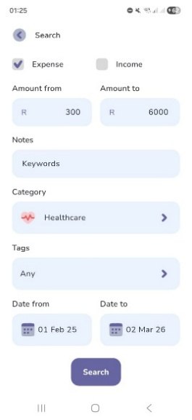
Figure 10: Books Advanced Search (The Budgeting App)

To log transactions conveniently the app focuses on capturing incomes and expenses with the amount and a category. Other optional meta data can be added such as notes, tags, reminders, and transaction recurrences. A focus is placed on your how often you get paid (The Budgeting App, [s.a.] a). You can view your book with the actual balances of your accounts and a grand total for your book. Or with the forecast view that also shows expected finances related to upcoming bills & incomes (TBA Jeremy, 2024). The onboarding process guides the user to set a budget per category of expected expenses and set goals for reaching target incomes. Challenges continue by letting the user discover how to create trackers for saving and debt management.

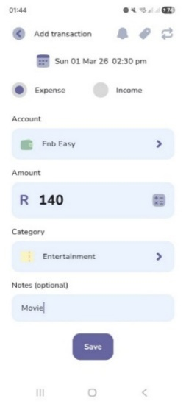
Figure 11: Log Transaction (The Budgeting App)

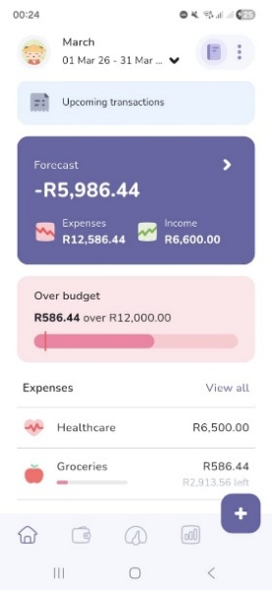

Figure 12: Budget Forecast (The Budgeting App)

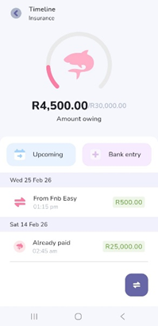
Figure 13: Loan Tracker (The Budgeting App)

Users collect achievements where the app encourages users to stay consistent with streaks, stay disciplined and consistent. Challenges are fallible meaning there are game like stakes when not completing a challenge.
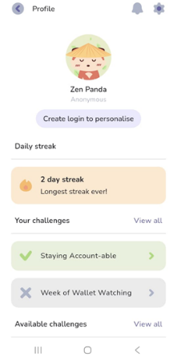
Figure 14: Profile Challenges (The Budgeting App)

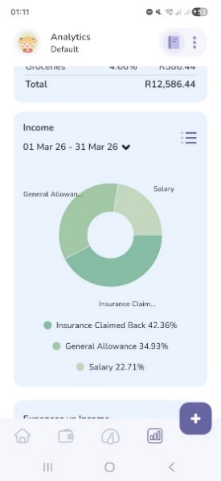
Figure 15: Income Pie Chart (The Budgeting App)

The Budgeting App: Strengths
- Simple and Intuitive user interface (The Budgeting App, 2022).
- Supports cloud sync with access on multiple devices (Natile, 2024).
- Onboarding and clickable pop-ups helps the user discover app features.
- Can customize views to show less details like income or the remaining budget.
- Data can be exported as CSV file.
- Numerous analysis tools.

The Budgeting App: Weaknesses
- Cannot import history via a CSV file.
- Does not automatically synchronize transactions with your bank.

The Budgeting App: Innovative Features
- Biometric App lock.
- Gamification for on boarding and fallible challenges.
- Can export data to CSV file.
- Set reminders to review budget.
- Built in calculator on logging page.

4. Infographic comparing three Personal Finance Tracking Apps

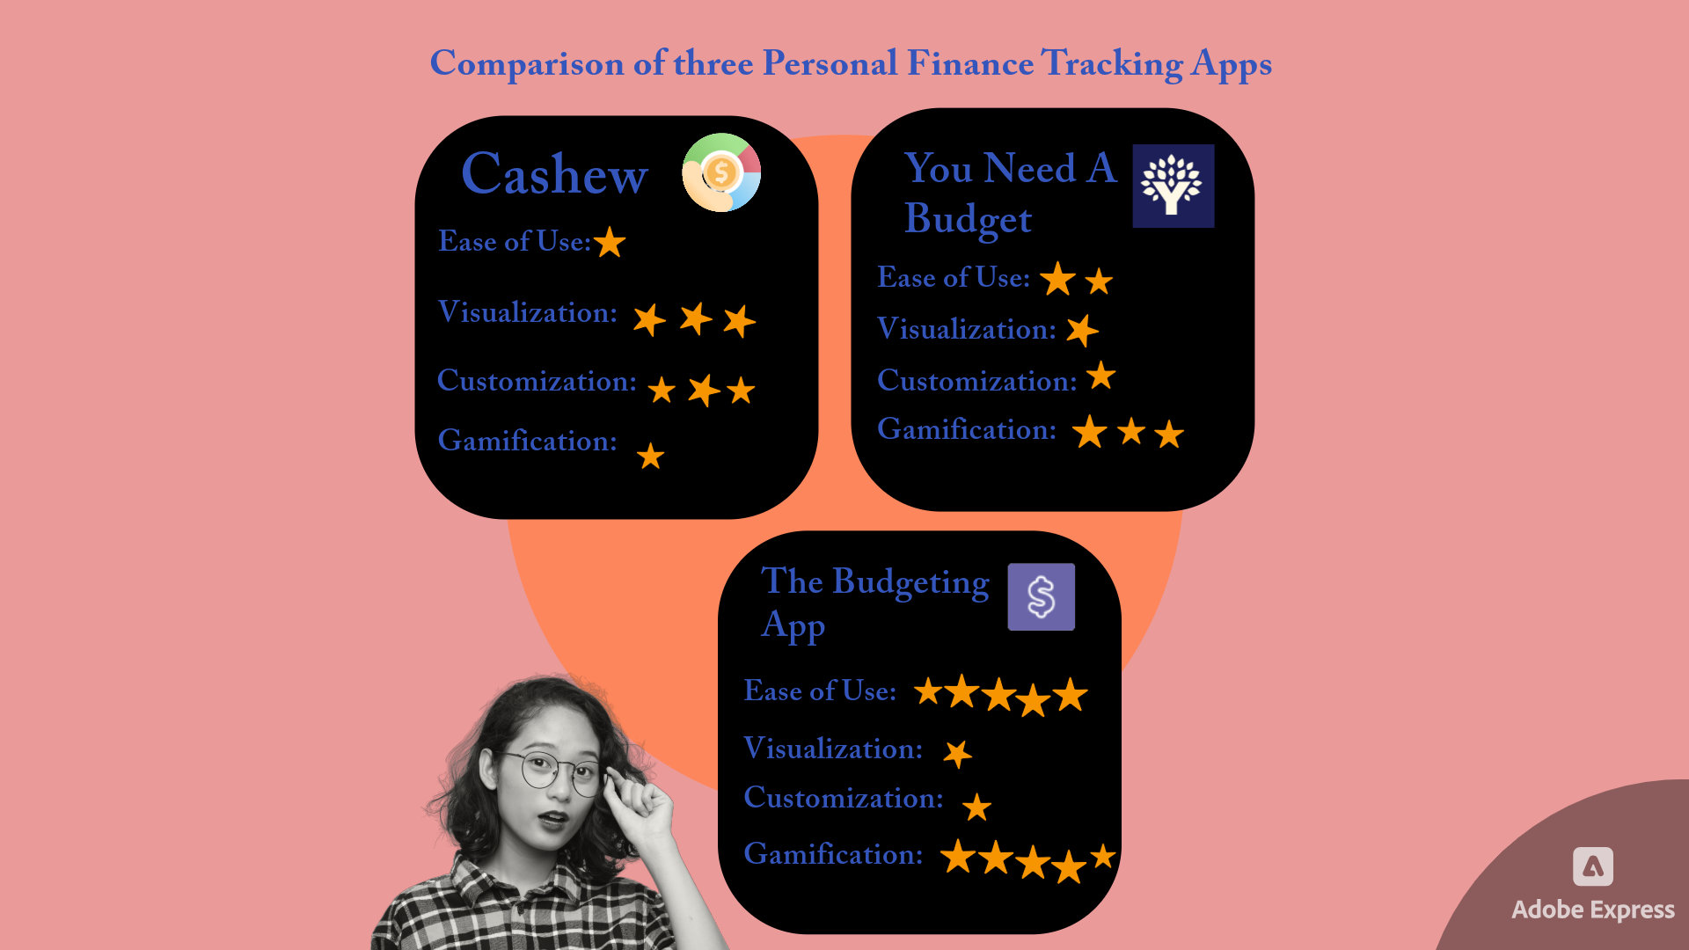
Figure 16: Infographic showing a comparison of three personal finance budgeting apps.
5. Best Features List to Include in Cash Chaos App
From our research on Cashew, You Need a Budget and The Budgeting App, we have identified the following desirable features to include in our own app:
- Multiple Wallet Support
For Example: FNB Cheque, Capitec Savings Account, Standard Bank (Credit Card) and Cash.
The app must be able to handle multiple accounts as well as negative account balances, overdrafts, and accounts that are in debt such as credit cards.

- Multiple Currency Support
For Example: This will allow for an account in the wallet to be expressed in foreign currency and payments or withdraws can be made using the exchange rate and viewed under wallet/accounts.

- Bill Splitter
For Example: A restaurant bill can be easily split between any number of guests and include a tip amount.

- Forecast View
For example: Seeing the expected amounts for a date in the future, this will work by predicting expenses and incomes of upcoming subscriptions and recurring costs such as subscriptions, rent, bank fees and gym memberships.

- Duplicate Expenses
For example: This helps the user to easily add an expense that is often made but is not a subscription, like a favourite R35.00 coffee at Starbucks or R 500.00 petrol purchase made. This aids the user to add an often-repeated expense quickly.

- Ability to Group Accounts
The user can make a “parent” account that can have “children” under it. For Example: Vacation can be a “parent” account while the associated costs such as food, accommodation and activities can be “child” accounts.
6. Conclusion
Our research has shown that, users prefer engaging with an app with fewer features, as this helps them to navigate and focus on the core functionalities of the app. Thus in Cash Chaos’s design we have decided to prominently display core features and compartmentalize additional features under menus to reduce visual clutter. Additionally, our research has shown that gamification is an effective feature for keeping users engaged, we will implement several gamification features such as streaks and achievements. We have identified the following innovative features to be included in Cash Chaos’s design: Multiple Wallet Support, Multiple Currency Support, Bill splitter, Forecast View, Duplicate Expenses and Ability to group Expenses. In conclusion, when taking the above-mentioned into consideration Cash Chaos’s design will be appealing, intuitive to use, engaging and encourage consistent use through gamification.

References
App Review: Cashew, finally a budget app for you. 2025. YouTube video, added by Teckwise [video online] Available at: https://youtu.be/BG8Z2DTAoLg?si=yNKX5eGLhAHHka3S [Accessed 28 February 2026].
Cashew Budgeting App Getting Started. 2025. YouTube video, added by Rebecca Sowden. [video online] Available at: https://youtu.be/UJ4mDc_WJ24?si=-RkZgGRrgVUFdSBn [Accessed 28 February 2026].
Cashew-Expense Budget Tracker. 2024. Dapper App Developer. Version 5.4.4. [App]. Available from Google Play [Accessed 28 February 2026].
Feasible Creative,2024.YNAB Budget App: What I Wish I Knew Before Starting.[video online] Available at: https://www.youtube.com/watch?v=mqB_Vu2_le0 [Accessed 24 February 2026].
Gooch. C, 2025. Young couple design their own budgeting app, save enough to buy a house. [Online] Available at: <https://www.thepress.co.nz/business/360564404/can-budgeting-really-be-fun-two-app-developers-think-so> [Accessed 1 March 2026].
Jacob Phillips,2025.YNAB Tutorial & Honest Review (2025) | Complete Setup Guide & Pro Budgeting Strategies.[video online] Available at: https://www.youtube.com/watch?v=6smi9S8Rm7s&list=TLPQMjQwMjIwMjaQEQBlrtAcdA&index=3 [Accessed 24 February 2026].
Natile, 2024. The Budgeting App. [Online] Available at: <https://betalist.com/startups/the-budgeting-app> [Accessed 1 March 2026].
TBA_Jeremy, 2024. How to use the roll-over budget feature. [Reddit] 1 December. Available at: <https://www.reddit.com/r/thebudgetingapp/comments/1h4d831/how_to_use_the_rollover_budget_feature/?utm_source=share&utm_medium=web3x&utm_name=web3xcss&utm_term=1&utm_content=share_button> [Accessed 1 March 2026].
The Budgeting App, [s.a.]. Plans. [Online] Available at: <https://thebudgeting.app/plans/> [Accessed 1 March 2026].
The Budgeting App, [s.a.]. The quick way to budget. [Online] Available at: <https://thebudgeting.app/> [Accessed 1 March 2026].
The Budgeting App, 2022. Budgeting App - Spend Tracker. Version 5.9.8. [App] Available at: <https://play.google.com/store/apps/details?id=com.thebudgetingapp.thebudgetingapp&pcampaignid=web_share> [Accessed 1 March 2026].

List of Figures:
Figure 1:
Figure 2:
Figure 3:
Figure 4:
Figure 5:
Figure 6:
Figure 7:
Figure 8:
Figure 9:
Figure 10:
Figure 11:
Figure 12:
Figure 13:
Figure 14:
Figure 15:
Figure 16:

